Principles of Teaching, Learning and Emergent Technologies
Reflection of 30-minute Micro Teaching to Fellow Cohort
Introduction
This reflection will contain the exploration and evaluation of a personal study and will combine some emergent technologies with traditional teaching methods.
By following Gibbs (1998) “learning by doing” model and Kolb’s (1974) “experiential Learning Cycle” a planned examination of the presentation will be produced.

What is Reflection
Reflection means thinking critically about an experience and learning from it by:
- Investigating the feelings and significant features of the experience
- Processing the significant features and identifying learning
- Finding new solutions to problems
- Using the process to help develop future practice.

Reflective writing therefore:
- Records for future reading how you feel about an experience before, during and after the event
- Provides a way of generalising feelings about specific events to similar events and situations
- Allows you to relate your feelings and experiences to the perspectives of others
- Enables you to stand back and evaluate your feelings.
(NOTTS University 2018)

Critical evaluation
The micro teach sessions

This reflection contains the explanation of the lesson plan, the choice of subject matter, the delivery of the micro teaching session and will conclude with the feedback from the cohort and how this information will be used for future professional development.
As I have a background within the construction/building industry I decided that this would be an easier project to teach.
Although the class was made up of graduates from all walks of life, by studying the age group, diversity of knowledge and by listening to conversations within the group during the previous week, it became apparent that the cohort had little or no knowledge of the construction industry so I would need to look at a lower level of skill.
As Schwarz et al (2007) suggests: “experienced teachers have a deeper pedagogic/andragogic knowledge and as such are more skilled at adapting the content to meet the needs of the classroom”.
After teaching previously on a BTEC qualification aimed at a Level 2 standard. I decided that this would be the correct level of teaching.

On Thursday 27th September at approximately 3.00 pm I gave my micro teaching lesson to the class, even though I had taught before, I was very nervous at the start and tended to rush through some of the slides on the presentation. I had never used Nearpod or Sway before, so after careful consideration, I gave this presentation with the media that I was familiar with, PowerPoint.

The lesson plan gave an indication of what the presentation was about, and I included elements of the HEA standards. I included 1 learning outcome but in hindsight this could have been expanded to 3 outcomes by including the differences between the construction industry and the building industry, and the difference between public and private funded projects

When delivering this presentation, I ensured that learners were allowed considerable opportunity to develop their knowledge, this was facilitated through use of a supervised activity (question and answer handout), allowing them to either work alone or in table groups, to demonstrate the theories,
“Learning involves any activities that develop new knowledge and abilities in the individual, who carries them out, or which cause old knowledge and abilities to acquire new qualities.” (Galperin, 1957, as confirmed by Arievitch and Haenen (2005)

It was intended that this presentation would provide learners with their first experience of the construction industry and an appreciation of the work contained within.
I was undecided about the introduction to the subject and debated about whether I should introduce it or show the beginning of a video based on the construction industry, I chose the latter.
I started off the session by saying that I would not introduce the session, but this video would, the feedback from the class was quite positive and suggested that I should just introduced myself and then play the video. The video was called Building Visions and was a documentary focussing on the building of Heathrow airports Terminal 5. I only played the introduction to this.
The video was embedded into the presentation, some of the previous presenters had difficulty in using embedded video, as they had to log on to you tube and play from there, but I explained that if they could download (free of charge) “YouTube downloader” then they can save the video onto any device in MP4 format, which is what I did.
I then went into explaining about how the construction industry is divided into 4 sections: -
The building industry
The civil engineering industry
The electrical industry
And the mechanical industry
As I introduced each part I explained about what each industry does. For example :-
Building involves the physical construction (making) of a structure.
Civil engineering involves the construction and maintenance of work such as roads, railways, bridges etc.
Electrical engineering involves the installation and maintenance of electrical systems and devices such as lights, power sockets and electrical appliances etc.
Mechanical engineering involves the installation and maintenance of things such as heating, ventilation and lifts.

I then went on to explain about the building industry as this is the one I know most about.
The building industry is then divided into 4 topics: -
New build - this refers to a building that is about to be or has just been built
Repairs/maintenance - this is when an existing building is kept up to an acceptable standard by fixing anything that is damaged so that it does not fall into disrepair.

Refurbishment/renovation work - this generally refers to an existing building that has fallen into a state of disrepair and is then brought up to standard by repair. It also refers to an existing building that is to be used for a different purpose, for example, changing an old bank into a pub
Restoration - this refers to an existing building that has fallen into a state of disrepair and is then brought back to its original condition or use.

And by using to the building we were in as a learning aid i.e. the library building is a new building with all the mechanical and electrical work easily seen.
I also explained the difference between private work and public work funding.
Public – the government pays for the work, as is the case with most schools and hospitals etc.
2. Private – work is paid for by a private client and can range from extensions on existing houses to new houses or buildings.
Assessment
There are many suitable forms of assessment that I have used throughout both formative and summative.
Summative assessment is assessment that is used to signify competence and for reporting student progress (O’Farrell, 2013)

Formative assessment is an integrated part of teaching, learning and assessment. The nature of formative assessment provides opportunities to develop more nuanced views about how students learn and adapt. Formative assessment provides feedback and information during the instructional process, while learning is taking place.

I adopted a handout question and answer sheet. The answers were already given on the sheet and the learner had to determine where to place them against the question. During this question and answer sheet I went to the individual tables to see progress. On the question sheet there were 2 answers that were not easy to complete so I offered the advice of “find the easy answers first then you are left with 2 then through deduction you can complete the questions”.
The answer slide was shown, and I asked the learners what the final answer was and by animating the slide I could then reveal the correct answer.

I think that due to my initial nerves and enthusiasm I did not use the time up fully
The good points about the experience were that If I do not impart my knowledge onto others then it will die with me and in some cases be lost forever also a bad point that in haste I can miss some of the points out.
I realise that over a 30 minute session not a lot of information can be given out, or retained, especially late in an afternoon, I maybe could have used a different question and answer session or a group task to identify different types of buildings i.e. commercial or industrial. transport e.g. tube trains etc. If I had to give this presentation again I would seriously look at expanding the types of work and having pictures of types of work as a group project.

No matter how good teaching may be, each student must take the responsibility for his own education. John Carolus S.J.

Learning Theories
Learning theories emphasizes learning with understanding. This means that instructional scaffolding, including assessment for learning, should also emphasize understanding rather than routine memorization. Teachers, being the facilitator of student learning, should assess for understanding rather than surface knowledge and simple recall of facts (Pattalitan 2016) This argument is also promoted by Rousseau (1762)

Blooms taxonomy
Bloom’s Taxonomy is a hierarchical ordering of cognitive skills that can, among countless other uses, help teachers teach and students learn.
The 6 Levels of Bloom’s Taxonomy
1. The first level is to Remember.
2. The second level is to Understand.
3. The third level is to Apply.
4. The fourth level is to Analyse
5. The fifth level is to Evaluate.
6. The sixth and final level is to Create

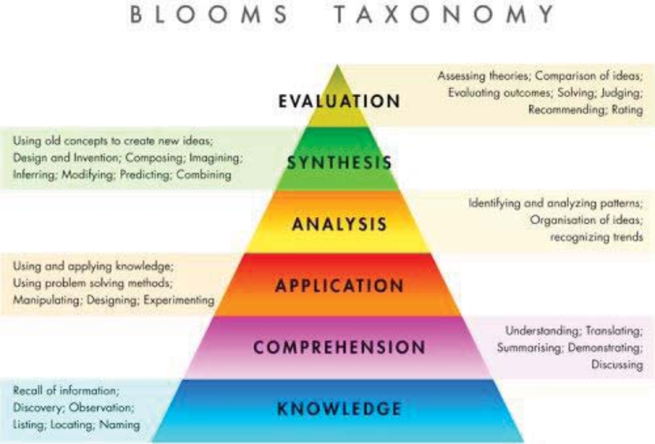

Many educators love Bloom’s because, it gives them a way to think about their teaching—and the subsequent learning of their students.
The framework can be used to create assessments, evaluate the complexity of assignments, increase the rigor of a lesson, simplify an activity to help personalize learning, design a summative assessment, plan project-based learning, frame a group discussion, and more. Because it simply provides an order for cognitive behaviours, it can be applied to almost anything
Although not part of the original work by Bloom, others went on to complete the definition of psychomotor taxonomies. For example, Harrow (1972) proposed these six levels:
Reflex (objectives not usually written at this "low" level),
Fundamental movements - applicable mostly to young children (crawl, run, jump, reach, change direction),
Perceptual abilities (catch, write, balance, distinguish, manipulate),
Physical abilities (stop, increase, move quickly, change, react),
Skilled movements (play, hit, swim, dive, use),
Non-discursive communication (express, create, mime, design, interpret).
And Churches' (2009) explaining the following
Remembering
Understanding
Applying
Analyzing
Evaluating
Creating

SOLO, which stands for the Structure of the Observed Learning Outcome written by Biggs and Collis (1982) can be used not only in assessment, but in designing the curriculum in terms of the learning outcomes intended, which is helpful in implementing constructive alignment. SOLO can also explain why those who use low complexity arguments in political or marital disputes usually win – in the short term. This type of learning allows the learner to move independently across the taxonomy, and dependant on the subject matter, the learner will feel as though they are more focussed working forwards at their own pace and not feeling demoralised as higher attaining learners or lower.
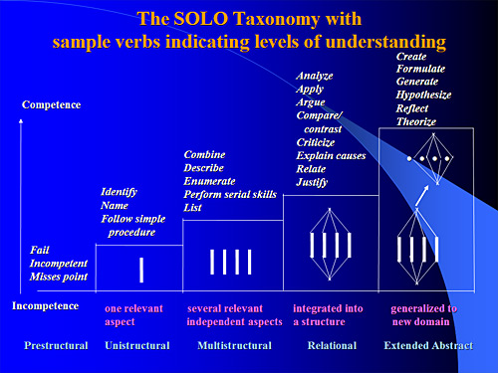
Effective learning and teaching must consider the fact that students prefer informality, and students prefer not to move around (Curzon, 1997): although this can clash with putting introverted students within the area of maximum interaction and extrovert students outside it, and the desire to move students around if there is a need to emphasise the place of the whole class (Smith 1988)

By overcoming these inhibitions to communication, the teaching and learning loop is more likely to function effectively.
Positively speaking, these improve communication:
Grammatically simple presentation
Appropriate language
Avoid padding language
Brevity, appeal and coverage
Main points early unless building up
Use analogy and metaphor [note: this can conflict with avoiding padding]
Repeat
Keep fluent
Emphasise and pause
(Child, 1997)

As teachers we must be aware that some students will have their own learning difficulties such as English being their second language as in this class. Problem areas in language learning can include: pronunciation difficulties, local dialects, issues with words that sound alike but have different meanings, lack of motivation, cultural misunderstandings and even simply forgetting what has already been learned. (My English Language 2018)

Local dialect issues
As stated earlier the class came from different backgrounds as well as different countries (Portugal, South Africa etc.) and we all have dialects. My home town was part of Manchester, and I still have a northern dialect. This can be problematic because of terminology to describe items, different areas may use different words to describe them.

As teachers we must be aware that not everyone will grasp the point of the lesson.

The mantra I always use is: -
1)Tell them you are going to tell them
2) Tell them
3) Tell them you have told them

So basically, I usually go over the subject 3 times

Another area that affected everyone, and is more relevant to adult education, is the time of teaching because late classes are perhaps the least effective. Even afternoons and Friday afternoons especially present problems of concentration for some, as evenings often follow a hard day's work. Some students may have eyesight difficulties, or hearing difficulties, or other personal medical needs, and many students are unwilling to discuss these, or the matter seems to never arise. So, there should be a confidential method in which the teacher finds out about and adjusts for such difficulties. It may mean being closer to them, larger than usual font sizes on handouts, projecting the voice more and speaking more slowly and staccato-fashion, and avoiding red and green contrasts in uses of colour. (Waterfield, J. and West, B. 2008)
Lectures are best bite-size with other methods as reinforcements, and as clarifiers to what was discovered by another method. However, there is a problem here. A repeated technique of a lecture segment that states what was discovered clumsily by students may cause students to think that their discovery phase is largely a waste of time, or could never be "as correct" as when the teacher speaks and gets it right. So somehow that mini-lecture has to add value to the classroom activity, not work as its correction. If it does, and the pattern is set, then the lesson will be seen as somewhat inefficient and time wasting.

The nature of feedback or reinforcement provides the basis for many early instructional principles, such as Deterline, (1962) especially in the context of programmed instruction. Markle, (1964) introduced the use of "prompting" (i.e., providing hints) in order to "shape" (i.e., selectively reinforce) the correct responses. Other principles concerned the choice of an appropriate "step size" (i.e., how much information to present at once) and how often feedback or reinforcement should be provided.
The behavioural theories such as Hull (1952), Guthrie (1935), Thorndike (1898), and Skinner (1938) focussed on the role of reinforcement in the motivation of the individual to behave in certain ways. One of the critical variables in is the length of time between the response and the feedback or reinforcement. In general, the more immediate the feedback or reinforcement, the more learning is facilitated.
Some learning strategies involve changes to the design of instruction. Ausubel (1968) stated that the use of questions before, during or after instruction has been shown to increase the degree of learning. Methods that attempt to increase the degree of learning that occurs have been called "mathemagenic" (Ropthkopf, 1970).
The Affective domain as supported by Krathwhol, Bloom & Masia, (1964) relates to emotions, attitudes of awareness, appreciations, and values, such as enjoying, conserving, respecting, and supporting. Which consisted of behaviours corresponding to: interest, attention, concern, and responsibility, ability to listen and respond and interact with others, also the ability to demonstrate those characteristics or values which are appropriate to the test situation and the field of study.

REFERENCES
Agaton P. Pattalitan Jr.. The Implications of Learning Theories to Assessment and Instructional Scaffolding Techniques. American Journal of Educational Research. Vol. 4, No. 9, 2016, pp 695-700. http://pubs.sciepub.com/education/4/9/9
Ausubel, D.P. (1968). Educational Psychology: A Cognitive View. New York: Holt, Rinehart & Winston
Biggs, J. B. and Collis, K. (1982) Evaluating the Quality of Learning: the SOLO taxonomy. New York, Academic Press
Bloom Benjamin S. and David R. Krathwohl, (1956). Taxonomy of Educational Objectives: The Classification of Educational Goals, by a committee of college and university examiners. Handbook I: Cognitive Domain. New York: Longman, Green.
Bloom, B. S., 1956. Taxonomy of Educational Objectives. Vol 1 ed. New York: McKay
Child, D (1997), Psychology and the Teacher, sixth edition, Cassell.
Churches A 2009 Blooms digital taxonomy
Curzon, L. B. (1997), Teaching in Further Education: an outline of principles and practice, fifth edition, Cassell.
Deterline, W.A. (1962). An Introduction to Programmed Instruction. New York: Prentice-Hall.
Gibbs, G., 1988. Learning by Doing. In: Learning by Doing: A Guide to Teaching and Learning Methods. s.l.:FEU.
Guthrie, E. R. (1935). The psychology of learning. New York: Harper & Row.
Harrow, A. (1972). A Taxonomy of the Psychomotor Domain. A guide for Developing Behavioral Objectives. New York: McKay.
http://www.myenglishlanguage.com/teacher-resources/problem-areas/ accessed on 4/10/2018
Hull, C. L. (1952). A behavior system: An introduction to behavior theory concerning the individual organism. New Haven, CT: Yale University Press.
Igor M. Arievitch & Jacques P. P. Haenen (2005) Connecting Sociocultural Theory and Educational Practice: Galperin's Approach, Educational Psychologist, 40:3, 155-165
Jean-Jaques Rousseau - Emille or Treatise on Education D. Appleton and company New York : 1762
Kolb, D.A. (1984). Experiential Learning. Englewood Cliffs, NJ: Prentice-Hall.
Krathwohl, David R., Benjamin S. Bloom, and Bertram B. Masia. (1964). Taxonomy of Educational Objectives: The Classification of Educational Goals. Handbook II: Affective Domain. New York: David McKay Co., Inc.
Markle, S.R. (1964). Good Frames and Bad. New York: Wiley.
Notts University Website, accessed October 4th 2018. https://www.nottingham.ac.uk
O’Farrell, C. A. Enhancing Student Learning Through Assessment: A Toolkit Approach. Dublin Institute of Technology. http://www.dit.ie/DIT/learningteaching/contacts/index.html.
Rothkopf, E. (1970). The concept of mathemagenic behaviour. Review of Educational Research, 40, 325-336.
Schwarz, C. V. et al., 2008. Helping elementary pre-service teachers learn to use curriculum materials for effective science teaching. Science education, Volume 92, pp. 345-377.
Skinner, B. F. (1938). The Behaviour of organisms: An experimental analysis. New York: Appleton-Century.
Smith, A. D. (1988), Starting to Teach: surviving and succeeding in the classroom, p43 Kogan Page.
Thorndike, E. L. (1898). Animal intelligence: An experimental study of the associative processes in animals. Psychological Monographs: General and Applied, 2(4), i-109.
Waterfield, J. and West, B. (2008) Meeting the specific requirements of Blind and Partially Sighted Students studying in Higher Education in the UK University of Plymouth: Plymouth

