Digital innovation

Introduction.
Digital devices and tools are becoming more widely used in the classroom, this however is not without its criticisms and education has been criticised as being ‘too slow to adopt new technologies’, Beetham and Sharp (2020). The purpose of this essay is to look at how digital technology is used in the classroom and how this works alongside professional practice. I will be looking at the different types of digital technology that is used, there has been a very fast growth of the use of digital technology since the release of the internet, mobile phones, laptops and tablets being easily accessible and affordable and with the invention of virtual reality, immersive rooms and digital tools readily available to be used in the classroom education is evolving to meet the digital innovation.
The role of creativity and digital innovation.
universities, colleges and schools, digital technology has been introduced more prevalently over the last couple of decades, at first it had very limited usefulness in education outside of basic systems on computers, Cuban (2001), however with the introduction of the internet and digital hardware such as, tpaper-basedtops and phones, education establishments predominantly replaced the paper based learning in favour of a digital counterpart, due the ease of accessibility, Shah (2014). Starkey (2016) inferred that digital technologies will be a driving factor for teaching and learning moving forward and that teachers should be prepared for the ever-changing digital technologies. This also gives students a greater opportunity to collaborate, create and gain knowledge in different style, Pitman and Gains (2015).
Schools, colleges and universities have adopted more digital learning tools more so since the 2019 covid pandemic hit when teaching was forced to go online which meant that teachers had to adapt their teaching styles. A number of theories have come from the advancement of the digital age of learning such as, Replacement, Amplification, and Transformation (RAT), SAMR, Technological Pedagogical Content Knowledge (TPACK), Connectivism and Digital Blooms. Each theory and framework add its own interpretation into digital innovation in teaching and learning.
Starkey (2020) conducted a study to look at the preparation that pre teachers do for the digital age in the classroom, she looked at a 4 year course that combined ICT skills and pedagogy teaching pre-teachers how to use digital tools in their teaching what she found was that by them utilising programmes on digital use in the classroom they where more efficient and better equipped to add digital tools to their classroom. They used TPACK framework in their learning of digital tools.
Mishra and Koehler (2006) came up with the framework of TPACK, the breakdown of TPACK is defined as three areas, Technical Knowledge, things such as multimedia videos and the internet, Pedagogical Knowledge, the processes involved with learning and teaching, strategies and procedures, their framework was a culmination of research by where they studied teachers of different age groups to see how they conducted their teaching, their framework was an advancement of Shulman (1986), framework which only had content knowledge, the knowledge of the subject that they are teaching and pedagogical knowledge how teaching methods are used, he stated there was an overlay of these 2 characteristics which he coined pedagogical content knowledge (PCK).
It was later that Mishra and Koehler (2006) added technology knowledge with the overlap being coined as technological Pedagogical Knowledge, this is stated as being the area where pedagogy, technology, and content merge with each other and advises that in order to have a suitable learning environment then all three must be taken into consideration in a teacher’s assessment of their teaching strategies.
Ferrari (2012) devised seven abilities that both students and teachers should be able to display in the modern era of education, information management, which was defined as using digital technology to store information that is needed for future work. ‘Collaboration’, this was put as the idea of students and teachers collaborating using online interactive tools. ‘Communication and sharing’, utilizing technology to engage with others with different materials that they have learned or taught from lectures. ‘Creation of content and knowledge’, was shown as the use of previous understanding and making new understanding of content in a different way using digital technology to achieve the greater understanding. ‘Ethics and responsibility’, looking at how to use digital technology in a safe way and in accordance with legal frameworks in accordance with the technology that you are using. ‘Evaluation and Problem solving’, the use of digital tools that can enhance people’s ability to problem solve during classroom and at home learning and teaching. ‘Technical operations’, using digital tools to enhance a teacher’s deliverance of intended learning outcomes.
As previously stated, the COVID-19 pandemic forced the education institutions to rapidly change to digital technologies, lots of schools struggled to adapt to the new way of teaching, and struggled with the use of technology in the classroom this was evident in a paper by Demirer and Dikmen (2018) who found that teachers where reluctant to use technology in the classroom as it was disruptive and was hard to manage whether the students where actually doing the tasks that they were supposed to do.
There are ever-growing changes in digital technology with such things as Artificial intelligence (AI), Virtual reality (VR) and different software that is adapted to learning, Timotheou et al, (2023), who conducted a study to answer the question ‘What is the impact of digital technologies on education’, they sought to answer this question by ways of a literature review, what they found was that there was a number of positive effects found in the use of digital technology and tools such as improved scores for students high and low achieving, this was evident in the literature for Additional Learning Needs (ALN) students also. The study showed a positive increase in students’ willingness to learn, attention, engagement and behaviour.
The emergence of Artificial Intelligence (AI) has brought about changes to the digital innovation in use in education by moving away from simply forwarding information onto screens to be read and used to now having intelligent systems that adapt to the teacheing and learning behavior of teachers and students, Chassignol (2018). AI has improved administration, syllabus and course evolution, it has improved the speed in which teachers grade and produced feedback using web designs and programs, AI is utilised by teachers in the designing content for the classroom and interactive learning environments and pedagogical methods, Sharma et al (2019). There are however ethical issues regarding AI some of these are noted in the idea that it will take in all different types of information, unrelated data or wrong data and wrongful comparisons, Sijing and Lan, (2018). out of AI came the virtual reality (VR)
VR was first created by Morton L Heilig in 1960 with his Telesphere mask since then VR has made vast improvements, it has made more of an appearance in the academic environment from primary school to university, it has been stated as giving students a more engaging learning experience and makes students learning more immersive affording students the opportunity to go into arears and scenarios that they wouldn’t normally be able to go to or do, Marougkas et al, (2023). VR has been shown to have many uses as stated in education such as it being a more cost-effective alternative to field trips with institutions being able to have 3D walk arounds of different areas throughout the world and space Tarng (2019), VR is also stated as being an effective collaborative tool between students and their peers, it can also be managed in the respect of what students can see and do. According to Friena et al (2015), inferred that VR has the capability to combine theoretical knowledge with practical knowledge. VR however is not without its limitations, it has been noted that the effects of long exposure to the goggles used can affect eye health due to then closeness to the screens, there has also been instances of nausea and loss of balance during the use of the VR goggles, with disruption to the sensory systems, Chang (2020).
In Wensurehe Digital 2030 framework was developed with the PCET sector in mind it was a culmination ensure post 16 sector, Jisc and the Welsh government, and aimed to show digital learning in the post 16 sector with good practice and association, show plans for the expectations of continuous development throughout the different areas, insure that investment in the development of use of digital technology in the post 16 sector is appropriately utilised and insure that there is a flow from secondary to post 16 learning objectives.
There has now become an extensive list of digital tools that can be used in the classroom for example and not limited to Google Classroom which was created to amalgamate a number of different features for both students and teachers such as showing students their grades, slides, calendar and when assignments are due in there are over 40 million people using google classroom worldwide with extensive extra attributes for teachers, Brown and Green (2016). The benefits of google classroom according to students in a study conducted by Hussaini et al (2020), inferred that both students and teachers found it to enhance the learning and teaching process and was stated as changing students from ‘passive to active learners’ it is also a way that students’ parents or guardians can have an active understanding and progress of their childrens work.
As shown there are different ways in which digital innovation has and will make a difference in teaching and pedagogy in years to come with the ever changing and evolving use of digital technology in the classroom and the invention of new technology all the time, as Haleem et al (2022) inferred that digital technology fills the gaps that traditional teaching can not fill, also inferring that with the devices now readily available for students and used in their everyday lives it makes sense that education making education more appealing, but will need the teaching community to be willing to adapt to the new way of producing and giving lectures, Cavas et al (2009).
Selection and justification of appropriate teaching tool.
It is important when starting a lecture to gauge the understanding that students have with regards to the lecture content Beichner and Saul (2003), who also stated that students learn more from being involved in their learning rather than just listening to a lecture, I choose Google Jamboard, Varghese (2016), as the digital tool that was going to be used, it is a collaborative document that both students and teachers can interact with using laptops, phones or tablets, this is a good way to monitor what was being put on display on the main board of the room, it entails the user writing notes on to post its and adding them to the screen via their own personal devices which accessed was through single media link, this is a free construct which anyone can use. It gave the opportunity to openly discuss their understanding of the chosen topic and is ideal for small group work as it has a limit of 50 users, Sweeney et al (2021).
The pros and cons were looked at before choosing this, the pros are that students do not need to have an account to access the content, students can remain anonymous thus would appeal to students that are less likely to speak up during discussion thus affording them the opportunity to add their thoughts on the content of the lecture and gives the students real time editing and involvement. The cons of using google jamboard is that you are limited to the number of contributors you can have at one time which means it is not appropriate for large classes which is what made it appropriate for this lecture due to the small number of participants, there is no audio so it would be difficult to open up discussion if it was a lecture that was conducted at home and that it could be used in a unfavourable way and become a disruption. After waying up the pros and cons and taking into consideration the class size and the students learning styles it was an appropriate digital tool to choose.
Secondly the mentimeter app was chosen for the latter part of the lecture, mentimeter is an Audience response system (ARS) and has a large number of functions appropriate to the classroom setting, such as, poles, quiz’s, presentation slides and forms. It is accessed though menti.com and when created by a lecturer gives a unique code that students enter to access the presentation when the lecturer changes the slides and added task the technology that the students are using will change as will giving the students real-time work, Mayhew et al (2020).
The use of mentimeter incorporates both qualitative and quantitative data, it can be used to show word clouds which can open up discussion within the class giving students greater interaction and an opportunity for them to engage with peers and give their own ideas on the topic, Sabo (2018), stated that using the poll option in the app is a good way to brainstorm ideas, using the quiz option can be used to gage understanding of the topics of the lecture and can also be used to gain feedback from the students to identify any areas that they are struggling with. The presentation option can be altered during the lecture It could afford the students the opportunity to shape their own learning.
During this time of digital innovation and with more and more teachers using digital tools to enhance their teaching and the learning of students it was important to find the tools that best suit a diverse group of learning styles, Differentiated Instruction (DI), Pozas and Letzel-Alt (2023), stated as being the teaching ability to educate diverse student populations, they posit that it is important for teachers to adapt learning environments, lecture content and products to learners differing needs, which mentimeter does.
There are advantages to using the digital tools that where chosen, such as learner centred learning, Reilley (2020), gives access to a multitude of data from one place, they help with the wellbeing of the learner, Alhalafawy et al (2019) and help with motivation and self-regulation. Alshammary and Alhalafawy (2023), conducted a meta-analysis looking at the effects of learning via digital platforms what they found was that there was a positive effect size for learning outcomes this however was only evident in certain subject areas and further investigation is needed with regards to this. There are a lot of differing views but for the purpose of this study the digital tools picked were ones that were thought of to be the best fit for the given lecture and the demographic of the peers that were taking part in the study.

Application of the chosen learning tool.
Students where asked what they thought ‘selective attention’ was, using the google Jamboard app, these are their comments.

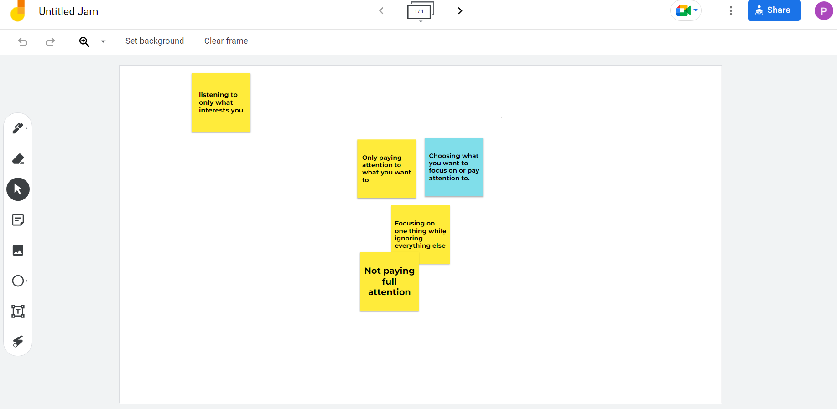
When the students where asked to watch a small video relating to selective attention they where asked to record their results on the mentimeter app, results of which are below:
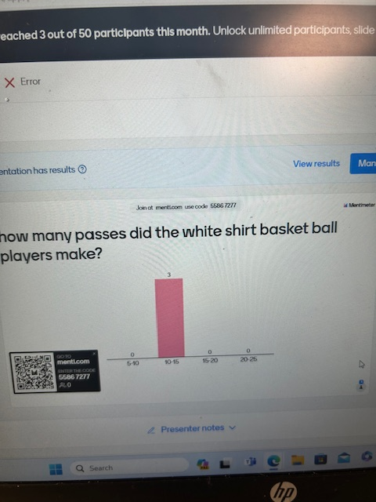

Lesson Plan Template



Lesson Plan

Topic: selective attention |  | Class: PCET
Date: | Length of lesson: 1 hour |  | Number of students: 6
Resources required: digital screen, laptops or handheld devices for students

Aim of Lesson
- Get basic understanding of selective attention.

Learning Outcomes – The Learners Should Be Able To:

- Basic understanding.
- Show different theories involved.
- Show practical aspect.

Previous student knowledge required for the session:
- No previous knowledge required as lesson was for basic understanding

Anticipated difficulties (if applicable):
- Problems with software.
- Student lack of engagement.

Professional Standards (where are these being met within the session)

Lesson Detail:

Stage | Focus | Strategy | Time
Introduction  Development  Plenary/conclusion | what is selective attention?  Theories of selective attention.  Selective attention in practice.  What was learned | use of google jamboard to obtain students understanding.  Powerpoint slides depicting the theories with open discussion on theories.  Use of youtube video to show and discuss what was observed, mentimeter used to track results  Open discussion to gage understanding of the given topic | 10 mins  15 mins  20 mins  15 minutes

Assessment Strategies: when and how are they included within the lesson?
The use of mentimeter and google jamboard shows student interaction with open discussion to gage understanding of the topic.

Informal reflection (to be completed after the session)

Evaluation and reflection.
I will be using Gibbs (1988) reflective cycle for the reflection. I was asked to produce a presentation using digital tools, I chose to use mentimeter and google jamboard, which was something I was not familiar with, this was given alongside a short presentation via PowerPoint.
The mini lecture started 10 minutes after my proposed start time due to issues with getting the presentation onto the main classroom board once the PowerPoint presentation onto the main screen In the room once everyone was sat down and ready I explained what the lesson outcomes where, I asked my peers if they knew what selective attention was and asked them to follow the link on the screen to the google jamboard, this took 5 minutes longer than originally planned due to the need for some peers to download the app on their tablets which for some peers didn’t work so they had to revert back to their laptops.
After the computers where sorted, they were asked to make suggestions as to what they thought selective attention was, this is shown in the screen shot above, after that we discussed each point that the peer group had added to the jamboard, this gave the peers a chance to ask questions and gather a better understanding of the learning outcomes from everyone in the room after a 5 minute discussion I went through what research and theories there were around selective attention such as cherry’s cocktail party affect, Cherry, (1953), Broadbents filter model, Broadbent (1958) and Triesmans attenuation model, Triesman (1964).
Once I had explained selective attention, the peers were shown a slide with a QR code and link which led them to the mentimeter app, I put a video on the board by which the peers were asked to count the number of passes conducted by the players in white shirts, I then stopped the video when the passing had finished, and the peers recorded their results via the mentimeter app, once the results had been record I restarted the video and the result come up on the number of passes it then went on to explain if anyone had noticed the moonwalking gorilla during the video, the peers where shocked and asked that the video be played again I put the video back on to show them the gorilla. When they had seen the gorilla we discussed how selective attention had played a part in the fact that no one had noticed the gorilla during the video, I then went on to finish the presentation and asked the peers to fill out a feedback form.
I felt that I had a bad start to the presentation with the fact that it took a few minutes longer than I had anticipated to get the materials onto the main screen in the lecture room this was conveyed by the peer group in their feedback, I thought once that aspect had been overcome then the lecture started to flow more better until I asked the peers to access the google jamboard with a couple of people being unable to access the app and had to wait for it to download or their laptops to come on at this point I was feeling a bit anxious due to the fact that nothing had gone to plan so early in the lecture.
My anxiety settled once everyone had manged to get their devices working and the rest of the lecture progressed more smoothly, until I got to the use of the mentimeter app which again took some time as some struggled to get the app to work when they had downloaded it and some struggled to get the QR code to work. The feedback that I had received from the peers confirmed that they had enjoyed and found the lecture to be inciteful and that they had enjoyed using the digital tools and that it had enhanced the lecture giving them something more to discuss rather than just listening to me speaking about selective attention, however they explained their struggle with the delays in trying to get the digital tools to work which caused them to become frustrated aswell.
There where a lot of positives and negatives to take away from this experience of teaching and mostly using the digital tools during lectures, I think I need to gain more experience around the use of digital tools with regards to when to use them and do more research on how to use the specific tools I struggled to get them to do what I intended due to my lack of knowledge. If I had to conduct this lecture again, I would make sure that I make myself available earlier than the peers arriving which would give me more time to address any issues I had with displaying the lecture on the main screen which could take away any waiting around that the peers had to do.
I would make sure that I have correctly learned how to use the specific digital tools that I used in the lecture and do research into how the digital tools can be used efficiently and in the appropriate place. A possible solution to the apps taking to long to download would have been to advise the peers much before the start of the lecture of the intention to use the specific digital tools which would allow them time to download and familiarise themselves with the tools this way it would make it a smoother transition through the lecture.

References
Haleem, A, Javaid, M, Qadri, M, A, Rajiv Suman, Understanding the role of digital technologies in education: A review, Sustainable Operations and Computers, Volume 3,2022,Pages 275-285.
Alhalafawy, W, S. Zaki, M, Z. (2019). The Effect of Mobile Digital Content Applications Based on Gamification in the Development of Psychological Well-Being. Int. J. Interact. Mob. Technol, 13, 107–123.
Alshammary, F, M, Alhalafawy, W, S. (2023) Digital Platforms and the Improvement of Learning Outcomes: Evidence Extracted from Meta-Analysis. Sustainability.15(2):1305.
Beetham, H., & Sharpe, R. (Eds.). (2019). Rethinking Pedagogy for a Digital Age: Principles and Practices of Design (3rd ed.). Routledge.
Cavas, B, Cavas, P, Karaoglan, B. and Kisla, T. (2009). A Study on Science Teachers' Attitudes Toward Information and Communications Technologies in Education. Online Submission, 8(2).
Chang, E. Kim, H.-T, Yoo, B. (2020). Virtual Reality Sickness: A Review of Causes and Measurements: Int. J. Hum.-Comput. Interact. 36, 1658–1682.
Freina, L. Ott, M. (2015). A Literature Review on Immersive Virtual Reality in Education: State Of The Art and Perspectives. In Proceedings of the International Scientific Conference eLearning and Software for Education. Bucharest, Romania.
Sijing, L, Lan, W,. (2018). "Artificial Intelligence Education Ethical Problems and Solutions," 2018 13th International Conference on Computer Science & Education (ICCSE), Colombo, Sri Lanka, 1-5.
Chassignol, M. Khoroshavin, A. Klimova, A, Bilyatdinova, A. (2018) "Artificial intelligence trends in education: A narrative overview", Procedia Comput. Sci., vol. 136, 16-24.
Pozas, M. & Letzel-Alt, V. (2023). Teacher collaboration, inclusive education and differentiated instruction: A matter of exchange, co-construction, or synchronization?, Cogent Education, 10:2.
Marougkas, A. Troussas, C. Krouska, A. Sgouropoulou, C. (2023). Virtual Reality in Education: A Review of Learning Theories, Approaches and Methodologies for the Last Decade. Electronics, 12, 2832.
Mishra, P.; Koehler, M.J. (2006). Technological pedagogical content knowledge: A framework for teacher knowledge. Teach. Coll. Rec, 108, 1017–1054.
Sabo, C. (2018). Tech to Try: Mentimeter.
Shulman, L, S. (1986). “Those Who Understand: Knowledge Growth in Teaching.” Educational Researcher, vol. 15, no. 2, 4-14.
Starkey, L. (2020). A review of research exploring teacher preparation for the digital age, Cambridge Journal of Education, 50:1, 37-56.
Sweeney, E. M., Beger, A. W., & Reid, L. (2021). Google Jamboard for virtual anatomy education. The Clinical Teacher, 18(4), 341–347.
Tarng, W. Chen, C, J. Lee, C, Y. Lin, C. M. Lin, Y, J. (2019). Application of virtual reality for learning the material properties of shape memory alloys. Appl. Sci, 9, 580.
Timotheou, S., Miliou, O., Dimitriadis, Y. et al. (2023) Impacts of digital technologies on education and factors influencing schools' digital capacity and transformation: A literature review. Educ Inf Technol 28, 6695–6726.
Ferrari, A., Punie, Y., & Redecker, C. (2012). Un-derstanding digital competency in the 21st century: An analysis of current frameworks. Springer Link.
Cuban, L. (2001). Oversold and underused: Computers in the classroom. Cambridge, MA: Harvard University Press.
Pittman, T., & Gaines, T. (2015). Technology integration in third, fourth and fifth grade classrooms in a Florida school district. Educational Technology Research and Development, 63(4), 539-554.
Shah, M. (2014). Impact of Management Information Systems (MIS) on school administration: What the literature says. Procedia - Social and Behavioral Sciences, 116, 2799–2804.
Dikmen, C. H., & Demirer, V. (2022). The role of technological pedagogical content knowledge and social cognitive variables in teachers’ technology integration behaviors. Participatory Educational Research.
Sharma, P. (2019). Digital revolution of education 4.0 Int. J. Eng. Adv. Technol., 9(2). 2249-8958.
Brown, A, Green, T. (2018). Beyond teaching instructional design models: exploring the design process to advance professional development and expertise: Journal of Computing in Higher Education
Hussaini, N., (2020). Economic Growth and Higher Education in South Asian Countries: Evidence from Econometrics. International Journal of Higher Education, 9(2), 118-125.
Beichner, R. J. Saul, J. M., (2003). Introduction to the SCALE-UP (student-centered activities for large enrollment undergraduate programs) project. Proceedings of the International School of Physics “Enrico Fermi,” Varenna, Italy, 1-17.
Mayhew, E., Davies, M., Millmore, A., Thompson, L. and Pena, A., (2020). The impact of audience response platform Mentimeter on the student and staff learning experience. Research in Learning Technology, 28.
Race, P., 2019. The lecturer's toolkit: A practical guide to assessment, learning and teaching. Routledge.

Action plan
SMART
Specific
- Familiarise myself with digital tools used in the classroom.
- Identify digital tools that work with different learning styles.
Measurable
- Keep record of different digital tools.
- Practice using digital tools in classroom scenarios.
Achievable
- Utilise library training resources.
- Use internet training programs to familiarize myself with the technology.
Relevant
- It is in line with the digital 2030 framework for wales.
Time-bound
- Due to the changing of technology continuously it will be ongoing training to keep myself up to date with the relevant technology.

