

Programme Name: MASTER OF BUSINESS ADMINISTRATION (MBA)
Module Name: Human Capital Management
Module Code: LCMB7023
Assessment Component 1: Individual Report

Assignment Title:
INNOVATING NEW WORKING PRACTICES AND BREEDING AN ENVIRONMENT WHERE TALENT MAY GROW

Lecturer's Name: Gladius Kulothungan (London) and Eno Maycock (Birmingham)
Name: Parth bhadreshkumar Lukhi
Student’s ID: 2611145
Word Count: 2627
Submission Date: 15th October 2026

Table of Contents
TASK A: Designing Innovative Working Practices 4
1. Overview of the Organisational issues 4
2. Critical Evaluation of Traditional Versus Contemporary Working Practices 4
2.1 Limitations of Classical Bureaucracy in Digital Health 4
2.2 Contemporary approaches of Modern software 6
3. Recommended Framework for Innovative Working Practices 7
3.1 Cross-Functional Collaboration and Agile Project Teams 7
3.2 Simplify the Hybrid Working and Digital Collaboration 7
3.3 Employee Autonomy and High-Involvement Management 7
4. Implementation and Performance Evaluation 8
TASK B: Breeding an Environment Where Talent May Grow 9
1. Overview of Talent Management at NHSX 9
2. Critical Evaluation of Talent Development Approaches 9
2.1 Learning Organisation and Growth Mindset 9
2.2 Psychological Safety and Employee Motivation 10
3. Comprehensive Talent Growth Ecosystem for NHSX 11
3.1 Inclusive, Skills-Based Learning and Development 11
3.2 Transparent Career Pathways and Internal Mobility 11
3.3 Psychological Safety, Coaching and Knowledge Sharing 12
3.4 Talent Governance and Measurement 12
4. Implementation and Expected Outcomes 13
TASK C: Reflective Report 14
1. AI as a Strategic Tool in Human Resource Management 14
2. Reflective Analysis: Three Examples of AI Use 14
3. Personal Capability Development Action Plan 15
Reference List 17

TASK A: Designing Innovative Working Practices

1. Overview of the Organisational issues
The organisation NexSpace Health Systems (NHSX) operates within the highly regulated healthcare system and is operating across different geographical jurisdictions, including the United Kingdom, India, and the United Arab Emirates. However, the company is facing issues that require a fundamental redesign. The fundamental issue with the structural misalignment is creating friction through the multi-layered decisions and functional boundaries, along with the fragmentation in the cross-border transfer of knowledge.

2. Critical Evaluation of Traditional Versus Contemporary Working Practices

2.1 Limitations of Classical Bureaucracy in Digital Health
The traditional approach to redesigning work is based on classic administrative theory and the ideology of standardisation, based on Taylorism. Vahrenkamp (2023) has mentioned that the application of Taylorism within work design includes standard operating procedures along with the chain of command and division of the workforce.
Traditional work design within manufacturing can be explained from the perspective of bureaucratic management that includes hierarchy, specialisation, standardised processes for tasks and central authority-based decision-making (Kiplimo, 2023). The fundamental issue at the organisation is excessive reliance on hierarchical approval and functional separation. This issue is further exaggerated by the geographical distance among UK, India and the UAE. This related to the problem of slow decision making, limited creativity and poor cross-border collaboration. This is also affecting leadership development among the employees, as it prevents them from experimenting and making decisions. Within the critical environment of healthcare at NHSX the decisions about algorithmic training or risk assessment to enhance user experience (UX) are currently passing through multiple layers of decision makers clearing delay in the system.
High-Performance Work Systems (HPWS): The HPWS theory provides a different perspective of the organisational changes through complementary practices like recruitment based on selective criteria, employee training, performance management, and incentives for team members (Khan, Haque and Bartram, 2023). Additionally, the study by Keramatiyazdi, Alizadesani and Hosseini (2023) mentioned that the application of HPWS has both benefits and drawbacks based on the utilisation of this framework in the workforce while maintaining effective coordination with HR practices. The image below highlights the framework's interconnected nature and the need for an integrated approach for further development. Despite implementing practices such as careful recruitment, skills development, incentives, and participative work design through HPWS, team productivity can suffer if unrealistic performance goals increase workload while reducing employees' autonomy and access to resources.
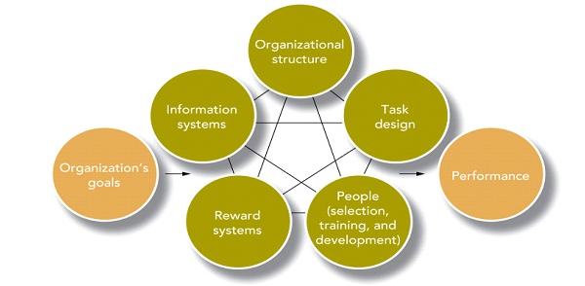
Figure 1: High-Performance Work Systems (HPWS)
(Source: ISME, 2026)
High-Involvement Work Systems (HIWS): This theory complements the HPWS and includes the workers in the processes of decision-making and information exchange for effective problem solving (Nguyen et al., 2024). The fundamental difference of the theory is that it does not proceed with a top-down approach and does not believe in the traditional process of sharing information following the top-down directions from managers. The theory recognises that the employees are contributors to the knowledge development of the organisation, and they are not responsible only for maintaining the instructions. However, the level of employee involvement should not be mere participation while the actual decision-making only considers the opinion of the managers alone (Putra, Arifin and Darmawan, 2024). Thus, NHSX must provide the employees with the opportunity to contribute towards the project methods, technical solutions and workflow improvements.

2.2 Contemporary approaches of Modern software
The contemporary environment of the organisation requires development approaches to deliver advanced software that can reduce functional issues and enhance multidisciplinary, creating self-organising teams. The application of agile approaches like SCRUM, KANBAN and so on, as represented in the image below, can help with multidisciplinary and self-organising units. According to Steegh et al. (2025), agile work and adaptive performance of the team have a direct relationship, to a certain extent, to higher goal achievement. This approach is relevant for NHSX as the development of health care platforms, remote-monitoring systems and clinical decision-support tools requires functional cross boarder team. The utilisation of SCRUM can help in short development cycles whereas the application of KANBAN helps in visualisation of the tasks and highlight the pending approvals. However, the utilisation of the agile approach within management practices can sometimes result in the development of a rigid approach. Therefore, a clear decision-making boundary needs to be implemented while using agile approach.
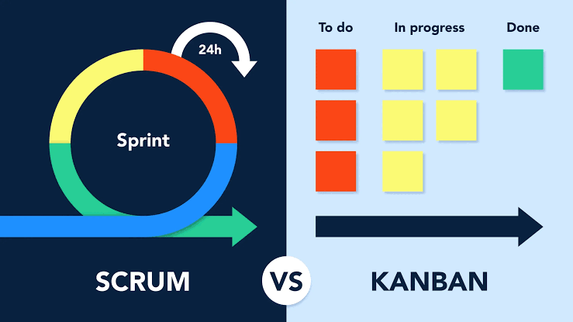
Figure 2: Agile Approaches Comparison (SCRUM and KANBAN)
(Source: BrightWork, 2026)

3. Recommended Framework for Innovative Working Practices
The development of the organisation requires establishing an Integrated Agile and High Involvement Work Design Framework while also focusing on staff engagement and flexibility for effective cross-functional digital collaboration at NHSX.

3.1 Cross-Functional Collaboration and Agile Project Teams
The organisation NHSX must focus on developing adaptive and multidisciplinary product teams to establish the agile and flexible framework, emphasising remote system monitoring and decision-making support through the AI platform. The product needs to establish priorities and team roles to deliver the pre-agreed outcomes. Previously, Junker et al. (2022), through a sample of 114 participants, established the correlation between the established agile practices and gradual increments in productivity or team performance.

3.2 Simplify the Hybrid Working and Digital Collaboration
To address the issue created by the geographical barrier and delays caused by the various time zones, NHSX must adopt the Asynchronous First Hybrid Model. The approach is effective for tracking tasks and projects through systems like automation, dependency mapping, and asynchronous approval to reduce delays in the process (Deskimo, 2026). This further includes flexibility, collaboration, focus, documentation and inclusivity as workplace practices for global teams.

3.3 Employee Autonomy and High-Involvement Management
The organisation NHSX must include the employees in the operational decisions while also defining the strategic boundaries for them. This approach represents the principles of HIWS that can increase participation and establish accountability in the process. It requires task allocation, task development, experiments, and daily priorities to remain static for the team members.

4. Implementation and Performance Evaluation
The change implementation process must include a 6-month pilot program to effectively identify the roles of the cross-functional teams (Kalluri, 2026). The fundamental measurement needs to be done based on the reduction of workflow barriers within the first 2 months, alongside cooperation with employees to develop the systematic change. The next 2 months will focus on developing agile teams, flexible work and digital collaboration. The last 2 months can be used for testing the results and iteration of the framework before final application and making this a default approach.

TASK B: Breeding an Environment Where Talent May Grow

1. Overview of Talent Management at NHSX
From the perspective of talent management, NexSpace Health Systems (NHSX) faces strategic challenges regarding limited career progression and inadequate learning opportunities for employees. These issues are relevant for the NHSX as the organisation is dependent on the specialised skills of the employees. The traditional talent management at the company is driven by backwards-looking observations, including annual performance-based appraisals and a rigid succession pipeline, which impacts the growth of the employees (Ingale, 2024). From the perspective of the Strategic Human Capital Consultant, it is advised to NHSX to transition towards the Integrated Strategic Talent Ecosystem to influence motivation among the employees.

2. Critical Evaluation of Talent Development Approaches

2.1 Learning Organisation and Growth Mindset
In the context of talent development at NHSX, these principles can help in the continuous learning of Artificial Intelligence (AI) developers, clinicians and international teams. The process of learning further needs to be an essential and integral part of the daily activities, as also mentioned by Beier et al. (2025). This further includes project reviews, mentoring, technical communities and sharing experiences of unsuccessful experiments. At NHSX, this approach needs to be included directly for the AI health platforms development, remote-monitoring systems building and effective clinical decision-support tools upgradation.
Growth Mindset: This concept was developed by Dweck, which states that skills can be enhanced through continuous practice, feedback and alterations of the mindset (Jeffs et al., 2023). NHSX must move away from the traits of the fixed mindset as represented in the image below and promote a growth mindset to influence learning through feedback, constructive criticism and experimenting with skills. Again, Bandura (2023) has noted that individual effort is not capable enough to mitigate the issues created by poor management, training and organisational obstacles. This requires a team effort to implement the changes successfully. The NHSX should implement this principle through the alteration of the management style where the employees can actively seek feedback or criticise the output in a constructive way for learning new skills rather than using any existing performance as a measurement point.
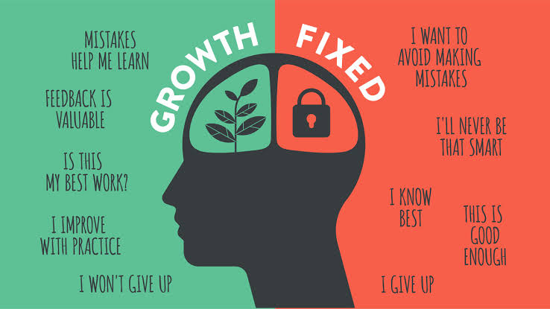
Figure 3: Comparative Analysis of Growth and Fixed Mindset
(Source: Sources of Insight, 2026)

2.2 Psychological Safety and Employee Motivation
Psychological safety refers to the freedom of staff members to ask questions, raise concerns, admit mistakes, and challenge assumptions. According to Edmondson and Bransby (2023), it is essential for the development of learning behaviours, leadership and performance in complex organisational settings. Managers within the organisation also need to promote openness and accept different viewpoints regarding the raising of concerns that address errors, creating more learning opportunities, as also mentioned by Akimov et al. (2023). However, this is also essential to ensure that the employees remain responsible for their professional practice, information security and patient safety.
Self-Determination Theory: The factors like autonomy, competence and relatedness are necessary to provide support and motivation to the employees (Olafsen, Marescaux and Kujanpää, 2025). NHSX needs to fill these requirements while also ensuring that employees do not lack guidance that can create any result in insecurity. The psychological safety is essential as this might result in development of the AI health platforms and decision-support while challenging potential flaws in results and be able to report technical glitches and discuss potential risks without fear of any retribution.

3. Comprehensive Talent Growth Ecosystem for NHSX

3.1 Inclusive, Skills-Based Learning and Development
The plan for Individual Development must be initiated by NHSX, focusing on the needs and requirements of the organisation, and its preferences. This includes AI literacy, clinical technology development, cyber security, data governance, leadership and cross-cultural collaboration (Hulus, 2026). This is also essential to make sure that the digital learning materials, certification and project-based mentoring or training are being provided to the employees.
Enhancement of skills will help HR to understand the requirements of future investment in new skills domains. As mentioned by Kapur (2022), talent development is one of the most essential areas for human resource management. For instance, the AI professionals can be trained based on the ethical AI and clinical risk. This also requires training the clinical team regarding the digital health technologies, data analysis and technical communication with the AI developers.

3.2 Transparent Career Pathways and Internal Mobility
Career development initiatives at NHSX must include two pathways including the employees who want to strengthen their technical or clinical skills, and another for those looking to develop managerial skills. Bouwmans et al. (2024) noted that the competency frameworks which are going to be published should reflect the skills, experiences and performance criteria an employee needs for advancement.
The processes need to be clearly established for employees to have access to internal vacancies and temporary project assignments (Duarte and Silva, 2023). Employees at NHSX must have the opportunity to move among the different segments, like AI development, product management and clinical implementation.
As stated in the systematic review of 43 studies conducted by Sinisterra, Peñalver and Salanova (2024), the talent management practices might lead towards the higher employee engagement and reduce the intention of the turnover intentions. However, the study has also highlighted the concerns regarding the actual definitions and measurements of talent management. Therefore, the NHSX must analyse the actual capability of the career initiatives for helping people with opportunities and retention.

3.3 Psychological Safety, Coaching and Knowledge Sharing
A workplace needs to be psychologically safe and must have opportunities for more knowledge through coaching and inclusive leadership, along with an environment for constructive criticism (Siyal, 2023). This can be developed through the creation of a community of practice at NHSX. In the long run, these communities can exchange technical knowledge among the UK, India, and UAE-based staff to resolve any critical problem through internal discussion at the NHSX.

3.4 Talent Governance and Measurement
The department of the Human Resources needs to take care of the ecosystem of the organisation through quarterly meetings with staff members, managers and business leaders through a talent review process. The discussions will include details like skill gaps, succession risks, development mobility and inequities across the different geographic locations (De La Mata et al., 2023). The success of NHSX for effective talent management can be evaluated against rates of high performers, promotion rates within the company, new skills acquired, employee engagement, psychological safety and so on.

4. Implementation and Expected Outcomes
The development discussions should not only emphasise performance evaluations, but also discuss the aspirations, barriers, and workload of the employees for effective learning progress.
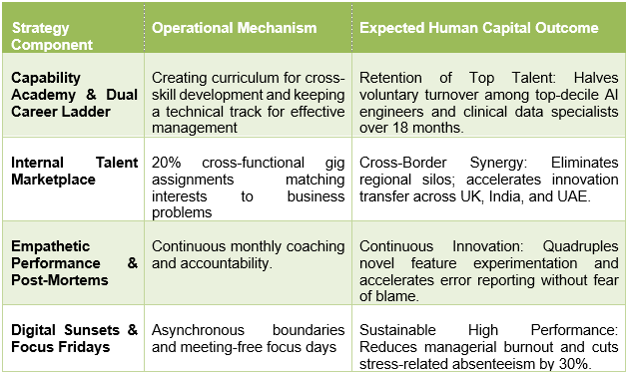
Table 1: Strategic Implementation and Expected Outcome

TASK C: Reflective Report

1. AI as a Strategic Tool in Human Resource Management
In recent times, Artificial Intelligence (AI) is not only an administrative approach for managerial decision-making aid within Human Resource Management (HRM) (Rodgers et al., 2023). Advanced techniques like machine learning can easily identify employees who tend to leave. Additionally, natural language processing is effective in the sentiment interpretation of staff members while emphasising the dynamic matching of employees' competencies.
Despite providing accurate recommendations, AI can be subjective sometimes, based on the nature of the data applied. The design of the algorithms and the assumptions made can also have a direct impact. If the data collected in the study has potential bias, this can create discriminatory employment practices. Therefore, the HR department must combine the analytical and human perspective to have empathy and professional ethics integrated within the system. Along with poor data transparency, lack of human involvement, and mismanagement of biases also impacts the regulations established by the European Union (2026).

2. Reflective Analysis: Three Examples of AI Use
Example 1- Academic research and information synthesis: In academic research, I have utilised AI for information organisation and explaining the complex ideologies regarding the concept of human capital management. This was very effective for evaluating theories and understanding the necessity to train or educate employees to improve the performance. However, I was cautious throughout the evaluation and utilisation of the AI after realising that the explanations provided by the AI do not capture the real-life arguments. Additionally, I have not used any references, as they might turn out to be incorrect.
Example 2- Academic writing and report structuring: I have utilised AI for the organisation of the report outline and selected the sources that can provide necessary information while improving my written communication skills. This has also been effective throughout the logical discussions and evaluation of concepts concisely. However, I have ensured the critical analysis of the topic along with the concepts for applying them to specific situations.
Example 3- Strategic problem-solving: I have taken help from the AI to evaluate the solutions recommended to HR. This has been effective in identifying the weaknesses of each of the solutions and mentioned which weaknesses can be overcome easily. AI helped me to observe the possible options and provided a different perspective to resolve any issue. This has been effective in generating more accurate recommendations for long-term development.

3. Personal Capability Development Action Plan
The action plan mentioned below is a 6-months development plan that can help with the future development for critical thinking, digital literacy and the effective development in the academic as well as the professional progress. The plan is further effective as this can be measured against the timeline and have relevancy for the development of the competency for the effective recommendation generation for the long run development of the company.
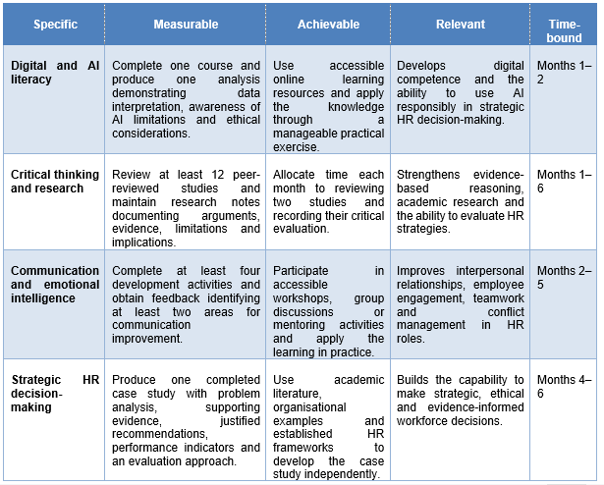
Table 2: Action Plan for Development

Reference List
Akimov, N., Kurmanov, N., Uskelenova, A., Aidargaliyeva, N., Mukhiyayeva, D., Rakhimova, S., Raimbekov, B. and Utegenova, Z., (2023). Components of education 4.0 in open innovation competence frameworks: Systematic review. Journal of Open Innovation: Technology, Market, and Complexity, 9(2), p.100037. https://www.sciencedirect.com/science/article/pii/S2199853123001397
Bandura, A., (2023). Cultivate self‐efficacy for personal and organizational effectiveness. Principles of organizational behavior: the handbook of evidence‐based management 3rd edition, pp.113-135. https://www.sciencedirect.com/science/article/pii/S2212420925002171
Beier, M.E., Saxena, M., Kraiger, K., Costanza, D.P., Rudolph, C.W., Cadiz, D.M., Petery, G.A. and Fisher, G.G., (2025). Workplace learning and the future of work. Industrial and Organizational Psychology, 18(1), pp.84-109. https://www.cambridge.org/core/services/aop-cambridge-core/content/view/4D115398B2D6E7F4F49EE27B20862D60/S1754942624000579a.pdf/div-class-title-workplace-learning-and-the-future-of-work-div.pdf
Bouwmans, M., Lub, X., Orlowski, M. and Nguyen, T.V., (2024). Developing the digital transformation skills framework: A systematic literature review approach. Plos one, 19(7), p.e0304127. https://journals.plos.org/plosone/article/file?id=10.1371/journal.pone.0304127&type=printable
BrightWork (2026) Agile Project Management Methodologies: Scrum vs Kanban, BrightWork. Available at: https://www.brightwork.com/blog/agile-methodologies-scrum-and-kanban (Accessed: 09 October 2026).
De La Mata, D., Berniell, L., Schargrodsky, E., Álvarez, F. and Alves, G., (2023). Inherited inequalities: The role of skills, employment, and wealth in the opportunities of new generations. https://scioteca.caf.com/bitstream/handle/123456789/2072/RED2022-RE-ENG.pdf?sequence=4&isAllowed=y
Deskimo (2026). Optimizing Collaboration in Asynchronous Hybrid Teams. Available at:https://www.deskimo.com/blog/optimizing-collaboration-asynchronous-hybrid-teams (Accessed: 09 October 2026).
Duarte, A.P. and Silva, V.H., (2023). Satisfaction with internal communication and hospitality employees’ turnover intention: Exploring the mediating role of organizational support and job satisfaction. Administrative Sciences, 13(10), p.216. https://www.mdpi.com/2076-3387/13/10/216
Edmondson, A.C. and Bransby, D.P., (2023). Psychological safety comes of age: Observed themes in an established literature. Annual review of organizational psychology and organizational behavior, 10(1), pp.55-78. https://www.annualreviews.org/content/journals/10.1146/annurev-orgpsych-120920-055217?crawler=true&mimetype=application/pdf
European Union (2026). Access to European Union law. REGULATION (EU) 2024/1689 OF THE EUROPEAN PARLIAMENT AND OF THE COUNCIL. Available at: https://eur-lex.europa.eu/eli/reg/2024/1689/oj (Accessed: 9 October 2026)
Hulus, A., (2026). A systematic response to ethical blind spots in AI education: cross-cultural insights and the role of digital literacy. Smart Learning Environments, 13(1), p.11. https://link.springer.com/content/pdf/10.1186/s40561-026-00437-1.pdf
Ingale, A., (2024). Succession planning and leadership development are important in creating a talent pipeline within human resource management. Available at SSRN 5031223. https://papers.ssrn.com/sol3/Delivery.cfm?abstractid=5031223
ISME (2026) High performance work system: A new system for efficient organizations: ISME: Best MBA/PGDM, MCA, BBA, BCom, BCA, Phd colleges in Bangalore: Ranked top 30 B schools in Indi, ISME. Available at: https://www.isme.in/high-performance-work-system-a-new-system-for-efficient-organizations/ (Accessed: 09 October 2026)
Jeffs, C., Nelson, N., Grant, K.A., Nowell, L., Paris, B. and Viceer, N., (2023). Feedback for teaching development: moving from a fixed to growth mindset. Professional Development in Education, 49(5), pp.842-855. https://www.tandfonline.com/doi/pdf/10.1080/19415257.2021.1876149
Junker, T.L., Bakker, A.B., Gorgievski, M.J. and Derks, D., (2022). Agile work practices and employee proactivity: A multilevel study. Human Relations, 75(12), pp.2189-2217. https://journals.sagepub.com/doi/pdf/10.1177/00187267211030101
Kalluri, R., (2026). Implementing agentic AI in project management: an evidence-based framework and maturity model from systematic analysis. International Journal of Managing Projects in Business, pp.1-28. https://repository.library.northeastern.edu/files/neu:76537137n/fulltext.pdf
Kapur, R., (2022). Significance of talent management in terms of human resources and organizations. International Journal of Information, Business and Management, 14(2), pp.37-46. https://www.researchgate.net/profile/Wilbert-Manyanga/publication/361739214_THE_EFFECT_OF_BRAND_IMAGE_ON_CUSTOMER_CHOICES_IN_THE_ZIMBABWEAN_FOOD_INDUSTRY/links/62c2dca15c293526ef88879e/THE-EFFECT-OF-BRAND-IMAGE-ON-CUSTOMER-CHOICES-IN-THE-ZIMBABWEAN-FOOD-INDUSTRY.pdf#page=42
Keramatiyazdi, Z., Alizadesani, M. and Hosseini, A., (2023). Investigating the effect of high-performance work systems (HPWS) on organizational performance. Interdisciplinary Journal of Management Studies, 16(3), pp.711-724. https://ijms.ut.ac.ir/article_89443_e23d2da05e8c322fcf5b62edcc8e362f.pdf
Khan, S.I., Haque, A. and Bartram, T., (2023). Unleashing employee potential: A mixed-methods study of high-performance work systems in Bangladeshi banks. Sustainability, 15(19), p.14636. https://www.mdpi.com/2071-1050/15/19/14636
Kiplimo, J.J., (2023). Formalization and Specialization in Organizational Design. African Journal of Emerging Issues, 5(11), pp.37-46. https://ajoeijournal.org/sys/index.php/ajoei/article/download/459/557
Nguyen, M., Pontes, N., Malik, A., Gupta, J. and Gugnani, R., (2024). Impact of high involvement work systems in shaping power, knowledge sharing, rewards and knowledge perception of employees. Journal of Knowledge Management, 28(6), pp.1771-1792. https://research-repository.griffith.edu.au/bitstreams/7f145be2-cd0a-42b3-b387-7931d5d14b11/download
Olafsen, A.H., Marescaux, B.P. and Kujanpää, M., (2025). Crafting for autonomy, competence, and relatedness: A self‐determination theory model of need crafting at work. Applied Psychology, 74(1), p.e12570. https://iaap-journals.onlinelibrary.wiley.com/doi/pdf/10.1111/apps.12570
Putra, A.R., Arifin, S. and Darmawan, D., (2024). Gamification-Based Learning that Preserves Cooperation and Empathy Among Employees. International Journal of Service Science, Management, Engineering, and Technology, 5(1), pp.43-50. https://ejournalisse.com/index.php/isse/article/download/229/300
Rodgers, W., Murray, J.M., Stefanidis, A., Degbey, W.Y. and Tarba, S.Y., (2023). An artificial intelligence algorithmic approach to ethical decision-making in human resource management processes. Human resource management review, 33(1), p.100925. https://www.sciencedirect.com/science/article/pii/S1053482222000432
Sinisterra, L., Peñalver, J. and Salanova, M., (2024). Connecting the organizational incomes and outcomes: A systematic review of the relationship between talent management, employee engagement, and turnover intention. Frontiers in psychology, 15, p.1439127. https://www.frontiersin.org/journals/psychology/articles/10.3389/fpsyg.2024.1439127/pdf
Siyal, S., (2023). Inclusive leadership and work engagement: Exploring the role of psychological safety and trust in leader in multiple organizational context. Business Ethics, the Environment & Responsibility, 32(4), pp.1170-1184. https://www.researchgate.net/profile/Saeed-Siyal/publication/371317289_Inclusive_leadership_and_work_engagement_Exploring_the_role_of_psychological_safety_and_trust_in_leader_in_multiple_organizational_context/links/6705617233ab504c04f54073/Inclusive-leadership-and-work-engagement-Exploring-the-role-of-psychological-safety-and-trust-in-leader-in-multiple-organizational-context.pdf
Sources of Insight (2026) What is a growth mindset?, Sources of Insight. Available at: https://sourcesofinsight.com/what-is-a-growth-mindset/ (Accessed: 09 October 2026).
Steegh, R., Van De Voorde, K., Paauwe, J. and Peeters, T., (2025). The agile way of working and team adaptive performance: A goal-setting perspective. Journal of Business Research, 189, p.115163. https://www.sciencedirect.com/science/article/pii/S0148296324006672
Vahrenkamp, R., (2023). Taylor and Taylorism. https://kobra.uni-kassel.de/bitstreams/b5913020-73fa-4de6-a96b-a0b84286f8c8/download

