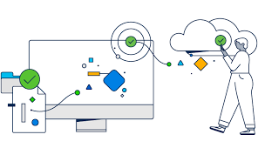

Cybersecurity Analyses

Prepared by:
Student Name: Mame Diara Dieng
Student ID: 2437938
The program: CERTHE Computing Skills for the Workplace
Module name: Networks and Cyber Security Essentials
Module code: ACCA4024
Lecturer’s name: Muhammad Azeem Abbas

1. Introduction
The healthcare sector increasingly relies on digital technologies to manage patient records, perform data analytics, and support clinical decision-making[1]. While these technologies enhance efficiency and service delivery, they also pose significant cybersecurity risks. Healthcare organisations process vast amounts of sensitive personal data, making them attractive targets for cybercriminals. Cyberattacks such as ransomware, phishing, and unauthorised access to cloud systems can compromise the confidentiality, integrity, and availability of healthcare information systems.
As the IT Security Manager for HealthPlus Analytics (HPA), I am responsible for ensuring that our organisation maintains robust cybersecurity practices to protect patient data and our company's infrastructure[2]. HPA provides data analytics services to hospitals and clinics across the United Kingdom and stores sensitive patient data on both cloud-based platforms and internal analytics servers.
Recently, our company experienced several cybersecurity incidents, including unauthorised access to cloud-stored patient data and a ransomware attack targeting our analytics servers. These incidents have highlighted weaknesses in our security controls and have created risks related to regulatory compliance, patient privacy, and the organisation's reputation.
In response to these concerns, the board of directors has requested the development of a comprehensive data security and governance framework[3]. This report identifies potential internal and external threats, proposes appropriate cybersecurity policies, recommends mitigation strategies, outlines a monitoring and incident response plan, and describes a staff training program to enhance cybersecurity awareness across the organisation.
2. Identification of Threats
Healthcare organisations face a variety of cybersecurity threats due to the sensitive information they handle. Threats to HealthPlus Analytics can come from both external attackers and internal sources[4]. Recognising these threats is crucial for developing effective security measures.
External Threats
Ransomware is one of the most serious cybersecurity threats facing healthcare organisations today. In a ransomware attack, malicious software encrypts an organisation’s files and demands payment in exchange for restoring access. Healthcare systems are frequently targeted because service disruptions can have severe consequences, leading to increased pressure to pay the ransom. For HealthPlus Analytics, a ransomware attack on analytics servers could disrupt services used by hospitals and clinics and compromise access to patient data.
Phishing is a form of social engineering where attackers send fraudulent emails pretending to be trusted organisations in order to trick employees into revealing login credentials or downloading malicious attachments. If an employee unknowingly provides their credentials, attackers may gain unauthorised access to internal systems and cloud platforms.
Another risk is cloud security breaches. HPA Analytics relies on cloud platforms to store patient data and conduct data analysis. While cloud computing offers scalability and flexibility, misconfigured cloud systems, weak authentication mechanisms, or insufficient access controls could allow attackers to access sensitive patient records stored in the cloud.
Distributed Denial of Service (DDoS) attacks occur when attackers overwhelm an organisation’s servers with large volumes of internet traffic, preventing legitimate users from accessing services. Such attacks could disrupt the analytics services used by healthcare providers.
Internal Threats
Internal threats can come from employees, contractors, or anyone else who has access to an organisation's systems. These insider threats can occur either intentionally or unintentionally[5]. For instance, an employee might accidentally expose sensitive data by sending it to the wrong recipient or access confidential patient information that is beyond what is necessary for their role.
Weak password practices also heighten the risk of unauthorised access. If employees use simple passwords or reuse them across multiple systems, attackers may successfully gain access to company accounts through credential-based attacks.
The increasing reliance on personal devices for remote work introduces additional security risks. Employees may access company systems using personal laptops or smartphones that do not comply with the organisation's security requirements[6].
Moreover, human error continues to be one of the leading causes of data breaches. Employees might click on malicious links, download infected files, or mishandle confidential information if they are not adequately trained in cybersecurity practices.
3. Security Policies
To address the threats outlined earlier, I propose implementing a series of cybersecurity policies that adhere to industry best practices and regulatory requirements.
First, the organisation should establish a role-based access control (RBAC) system. This will ensure that employees can only access the data necessary for their specific job responsibilities. By limiting access to sensitive patient information, the organisation can effectively reduce the risk of insider threats and unauthorised data access.
To enhance authentication mechanisms, I recommend enforcing strong password requirements and implementing multi-factor authentication (MFA). Employees should be required to create complex passwords and use additional authentication methods, such as mobile authentication applications or biometric verification[7].
Given the widespread use of personal devices for work, the organisation must implement a clear Bring Your Own Device (BYOD) policy. Under this policy, employees must install approved security software, enable device encryption, and permit the organisation to remotely wipe devices if they are lost or stolen.
The organisation must also ensure that all patient data is handled in accordance with UK GDPR requirements. Sensitive information should be encrypted, stored securely, and accessed only by authorised personnel. Additionally, data retention policies should be established to ensure that personal data is not stored for longer than necessary.
Finally, an incident response policy should be put in place to define procedures for identifying, reporting, and responding to cybersecurity incidents. This policy should clearly outline the responsibilities of the IT security team and provide guidance for managing security breaches.
4. Mitigation Measures
To mitigate the previously identified risks, I recommend that HPA implement several technical and organisational security measures.
One crucial measure is the deployment of multi-factor authentication (MFA) across all organisational systems. MFA significantly reduces the risk of unauthorised access because attackers cannot gain entry using stolen passwords alone.
Encryption should be utilised to protect sensitive patient data. Data must be encrypted both when it is stored (encryption at rest) and when it is transmitted across networks (encryption in transit)[8]. This dual approach ensures that data remains secure, even if intercepted by attackers.
It is also essential to install endpoint security solutions on all devices used to access organisational systems. These solutions include antivirus software, endpoint detection and response tools, and system monitoring applications that can identify suspicious activity.
Another effective security measure is network segmentation. By separating critical systems, such as patient databases, from the rest of the organisational network, attackers who gain access to one part of the network will face greater challenges in moving laterally to other systems.
Regular system updates and security patches must be applied to address known vulnerabilities. Many cyberattacks exploit outdated software, making patch management a vital component of cybersecurity.
Implementation Plan
Threat Type | Mitigation Measure | Implementation at HPA | Benefit to Organisation
Ransomware | Data Backups & Encryption | Regular automated backups and encrypted storage systems | Enables recovery without paying ransom
Phishing | Security Training & MFA | Staff awareness training and multi-factor authentication | Reduces risk of credential theft
Cloud Security Breach | Access Control & Encryption | Role-based access control and secure cloud configurations | Protects sensitive patient data
Cloud Security Breach | Access Control & Encryption | Role-based access control and secure cloud configurations | Protects sensitive patient data
Weak Passwords | Strong Password Policy | Enforce complex passwords and periodic updates | Strengthens authentication security
BYOD Risks | Mobile Device Management (MDM) | Secure personal devices and enable remote wipe | Prevents data loss from personal devices
Software Vulnerabilities | Patch Management | Regular system updates and security patches | Protects against known exploits

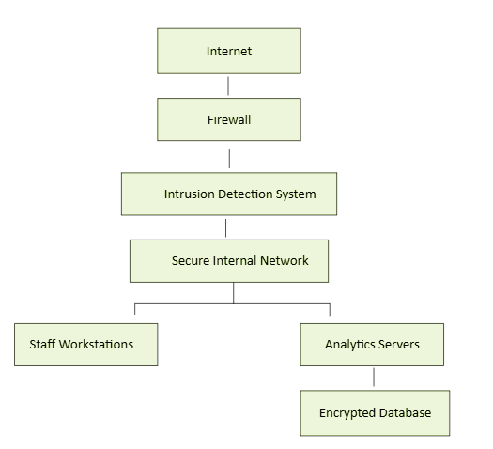
The diagram in Figure 1 shows how HPA’s systems should be protected.

Figure 1: HealthPlus Analytics Network Security Architecture

5. Monitoring and Incident Response
Continuous monitoring is crucial for detecting and responding to cyber threats in real time. So, I recommend HPA to install a Security Information and Event Management (SIEM) system to collect and analyse security logs from across the organisation’s network. This system will help identify unusual activities and generate alerts for the security team.
Intrusion Detection Systems (IDS) and network monitoring tools should be deployed to detect unauthorised access attempts and malicious traffic. These technologies allow the IT security team to identify potential threats before they cause significant damage[9]. When a security incident occurs, the organisation should follow a structured incident response process to contain and resolve the issue quickly.
To enhance visibility across all systems, I recommend that HealthPlus Analytics implement continuous log management and conduct regular security audits alongside real-time monitoring. Log data from servers, cloud platforms, and user devices should be centrally collected and analysed to identify patterns of suspicious behaviour over time. Periodic security audits and vulnerability assessments will enable the organisation to proactively pinpoint weaknesses before they can be exploited by attackers. Additionally, integrating automated response mechanisms within the SIEM system can help reduce response times by triggering predefined actions, such as temporarily disabling compromised accounts or blocking malicious IP addresses. This proactive approach ensures that potential threats are identified and addressed before they escalate into major security incidents.

The process shown in Figure 2 ensures that cybersecurity incidents are managed quickly and effectively.
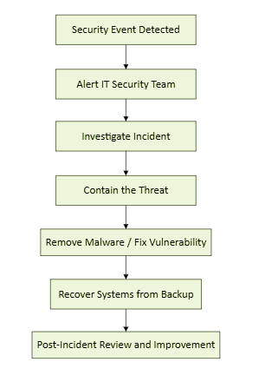
Figure 2: Incident Response Process
6. Training and Awareness Programme
Technology alone cannot protect an organisation from cyber threats; employees play a crucial role in maintaining cybersecurity. Therefore, training and awareness programs are essential.
As part of the proposed framework, I recommend that HPA implement mandatory cybersecurity training for all new employees during the onboarding process. This training will familiarise staff with the organisation's security policies, data protection practices, and procedures for reporting suspicious activities.
Regular training sessions should also be conducted to educate employees about emerging cyber threats and safe digital practices. Topics may include phishing awareness, password security, and the secure handling of sensitive healthcare information.
Simulated phishing exercises should be conducted periodically to assess employee awareness[10]. These exercises help identify employees who may need further training, enabling them to recognise suspicious emails and avoid phishing attacks, thereby improving the organisation’s overall security awareness.
Management should encourage employees to report suspicious activities without fear of blame. Creating a strong culture of cybersecurity awareness ensures that employees actively participate in protecting the organisation's systems and data.
7. Conclusion
Cybersecurity threats are constantly evolving, presenting significant risks to healthcare organisations that process and store sensitive patient information. HealthPlus Analytics has already experienced security incidents that demonstrate the urgent need for enhanced cybersecurity governance[11].
To address these challenges, I have suggested a comprehensive data security and governance framework. This framework includes identifying potential threats, implementing robust security policies, deploying advanced mitigation measures, and establishing continuous monitoring and incident response procedures. By doing so, the organisation can greatly improve its cybersecurity posture.
Implementing employee training and awareness programs will help cultivate a security-conscious culture within the organisation. These initiatives will ensure compliance with UK GDPR and NHS Digital Security Standards, while also protecting sensitive healthcare data and maintaining trust with our healthcare partners.
8. References
[1]M. Higgins, M. Regan, and J. J. Pauli, Cybersecurity. Minneapolis, Minnesota: Essential Library, an imprint of Abdo Publishing, 2017.
[2]FRANK UMBACH, EU POLICIES ON HUAWEI AND 5G WIRELESS NETWORKS: ECONOMIC–TECHNOLOGICAL OPPORTUNITIES VS CYBERSECURITY RISKS. S. Rajaratnam School of International Studies, 2022.
[3]L. Ayala, Cybersecurity for Hospitals and Healthcare Facilities A Guide to Detection and Prevention. Berkeley, Ca Apress, 2016.
‌[4] K. Hasegawa, N. O’Brien, M. Prendergast, C. A. Ajah, A. L. Neves, and Saira Ghafur, “Cybersecurity interventions in low- and middle-income country healthcare organisations: A scoping review (Preprint),” Journal of Medical Internet Research, vol. 26, pp. e47311–e47311, Sep. 2024, doi: https://doi.org/10.2196/47311.
‌[5] B. Kolosnjaji, H. Xiao, P. Xu, and A. Zarras, Artificial Intelligence for Cybersecurity: Develop AI approaches to solve cybersecurity problems in your organization, 1st ed. Birmingham: Packt Publishing, 2024. doi: 10.0000/9781805123552.
[6] M. Zarod, The Sociology of Cybersecurity: An Ethnography of a Science and the Profession, 1st ed. Oxford: Routledge, 2025. doi: 10.4324/9781003396871.
[7] G. Austin, Ed., Cybersecurity education : principles and policies, 1st ed. London ; Routledge/Taylor & Francis Group, 2022.
[8]A. Kucharavy, O. Plancherel, V. Mulder, A. Mermoud, and V. Lenders, Large Language Models in Cybersecurity: Threats, Exposure and Mitigation, 1st ed. Cham: Springer Nature, 2024. doi: 10.1007/978-3-031-54827-7.
[9] J. Steinberg, Cybersecurity for dummies, Second edition. Hoboken, NJ: John Wiley & Sons, 2022.
[10] A. Oni and publisher Packt Publishing, Birmingham, England. Risk management for cybersecurity managers (2022).
[11] M. Christen, The Ethics of Cybersecurity, 1st ed. 2020. Cham: Springer International Publishing, 2020. doi: 10.1007/978-3-030-29053-5.



