
Skills for the Workplace
Module Assignment Submission
Student Name: | Lyssa Muir
Student Number: | 1917752
Module No: | BMSK4002
Module Title: | Effective Team Working and Communication  Part 2

Statement of Confirmation of Authenticity
By the act of making this submission, the student declares that this is the work of the student named above. The work has not, in whole or in part, been knowingly presented elsewhere for assessment, or where assessment has been built on a previous assessment, this has been identified. Where materials have been used from other sources it has been properly acknowledged. If this statement is untrue, the student acknowledges that an assessment offence has been committed.
Attention is drawn to the plagiarism and unfair practice policies of both the University and of ILM.

Table of Contents
Part 2 Communication 3
1.0 3
Communication Cycle 3
2.0 5
Assessing Own Communication Skills 5
Gap Analysis 6
PDP 6
References 7
Appendix A 7
Skills You Need Communication Quiz 7
Mind Tools Communication Quiz 9

Part 2 Communication

In this report I will be looking at effective communication. I’ll explore the communication cycle and give a definition of what each process of the cycle means, then I will assess my own communication skills, before moving on to gap analysis and my personal development plan. I will also complete the skills you need communication quiz and the mind tools communication quiz.

1.0

Communication Cycle

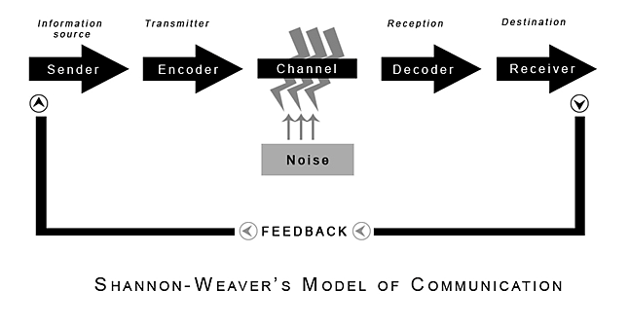
(Shannon and Weaver, 1949)

Sender
The sender is the one who instigates the communication. The sender is the communicator or the source of the message. The sender must plan the way he communicates with his audience, ensuring it is the most effective way and that his audience understands the message the sender is trying to get across. The sender may communicate via voice, letters, gestures etc.

Encoder
Once the encoder receives the message from the sender, they will then decide the most effective way to deliver it to the decoder and receiver in a way that they will understand it. The encoder will need to think carefully about the way they choose to get message across as they would not want the audience to interpret the message the wrong way. The encoder needs to take into consideration language barriers or if the audience has any sensory impairments etc.

Channel
A good communication channel is essential to ensure that the correct information reaches the receiver. Organisations and the workplace use many different methods of communication whether it be verbal, written etc. Some examples include Email, telephone calls, face to face meetings, video conferencing, faxing, letters and many more. They will choose which method they use depending on who they are trying to communicate with. For example, if a manager wants their employees to pick up an extra shift in work, they are more likely going to communicate with them via telephone call. But if there is a important message that a manager wants all of their staff to receive, then they are likely to pass the message on via letter or Email.

Noise
Noise is anything that can interfere with the communication process. Four different types of noise can include semantic noise- where the individuals communicating interpret the meaning of words differently, psychological noise- where an individual’s mind is wandering elsewhere and they are not concentrating on the message, physiological noise- physiological noise could be a hearing or sight impairment, this is why we need to ensure the correct method of communication is used. Lastly is physical noise, physical noise means background noise, such as loud music playing in the background, crowds of people talking over you etc.

Decoder
This process is where the message being delivered has to be looked at carefully and interpreted in the right way before it is passed on to the receiver. The decoder must figure out the meaning of the message that the sender is trying to get across.

Receiver
Everyone responds differently when they receive a message. The receiver must interpret the message the sender is trying to get across to the. Each person will interpret things differently.

Feedback
Feedback is essential in effective communication, especially with communication in the workplace. Feedback is used so the receiver can express their thoughts, feelings, reactions and to how they interpreted and if they understood the message that was being given.

2.0

Assessing Own Communication Skills

Having completed the communication questionnaire, I found that I am an assertive communicator. It identified that I communicate well with others, I listen to what individuals have to say to me and are always there to help others if they do not understand what is being communicated. I am happy to express my own idea’s but also take into consideration what others have to say.
Although for the most part I am an assertive communicator, my weakness is that I can sometimes interrupt others when they are trying to communicate, I should wait for others to finish what they are trying to communicate before jumping in and interrupting. I also on rare occasions get carried away when if I’m in a large meeting and lose interest. I should go into these situations with a positive attitude and open mind, those of which are qualities of an assertive communicator.

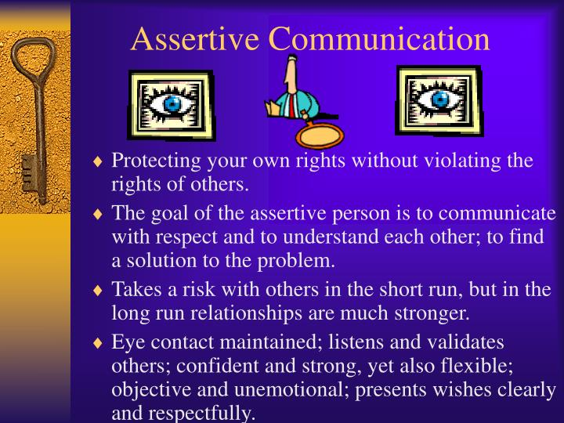
https://www.slideserve.com/archer/communication-skills-writing-prompt-write-1-paragraph-essay Accessed: 19.05.20

Gap Analysis

Objective | Current Position | Deficiency | Action
What do I want to do? | What can I already do? | What am I lacking? | How do I fix this?
Ask for help when needed. Speak up. | If I am in a small group of people or talking to someone one on one I can appear confident. | Confidence. I overthink when having to speak in large groups and get nervous. | Speak more ins smaller groups. By doing this often I will hopefully build up the confidence to speak up in larger groups.
Active Listen | I listen quite well, but sometimes I get carried away and lose concentration quickly. | Concentration | Go into a situation open minded and have a positive attitude towards the situation. Put more effort in to concentrate.
Absorb information in team meetings | I absorb most of the information in team meetings at the workplace, but sometimes I lack concentration towards the end. | Concentration/ note taking (minutes of meeting) | Speak to my fellow team members to see if they interpreted the meeting the same way as me or take notes when I attend meetings.

PDP

Objectives | Tasks | Success Criteria | Time Frame | Resources
List your Goals | What do you need to do to achieve these goals? | How will you identify your success? | When do they need to be done by? | Who or what do you need to help you?
Be able to express my ideas with my team | More confidence | By expressing ideas more often with my team | As soon as possible | Encouragement from team members and management and confidence
Active Listening without getting distracted/ bored | Go into meetings with an open mind and positive attitude | Knowing if I’ve taken all the information on board after team meetings | As soon as possible | Positive attitude and and open minded to new ideas
Ask my team members for help if needed | Confidence and not to worry about what others will think of me | By asking team members for help if I need it | As soon as possible | Support from colleagues and management in workplace.

References

Blenkinsop, P. (2010) The Communication Cycle. [online] Available at: http://manyana-education.blogspot.com/2010/10/communication-cycle.html Accessed: 15.05.19
MindTools (2019) How good are your communication skills? [online] Available at: https://www.mindtools.com/pages/article/newCS_99.htm Accessed: 15.05.19
Shannon, C. and Weaver, W. (1949) The Mathematical Theory of Communication. Urbana: University of Illinois Press.
Skills You Need (2019) Interpersonal Skills Self-Assessment. [online] Available at: https://www.skillsyouneed.com/ls/index.php/343479 Accessed: 15.05.19

4 types of noise that disrupt communication (the non-technical problem all podcasters face
https://onthego.fm/4-types-noise-disrupt-communication-non-technical-problem-podcasters-face/ Accessed: 19.05.20

https://www.slideserve.com/archer/communication-skills-writing-prompt-write-1-paragraph-essay Accessed: 19.05.20

https://www.skillsyouneed.com/ips/communication-skills.html Accessed: 19.05.2020

https://www.mindtools.com/pages/article/newCS_99.htm Accessed: 19.05.2020

Appendix A

Skills You Need Communication Quiz

Your total score is: 59%

Based on the answers you provided your interpersonal skills are about average – compared to other people. Although you have a basic grasp of the key interpersonal skills, there is still a lot you can do to improve them further. Spend some time practising and developing your interpersonal skills to enhance your relationships with others further.

Listening Skills
Your score: 48% (Average)
(You rated your listening skills as: Average)
Based on the answers you provided your listening skills are average. You may have picked up some bad listening habits or never previously thought about the active processes involved in effective listening. Although your listening skills are OK, you should think about developing them further by consciously practising effective and active listening.
See our pages: Listening Skills and Active Listening for more on developing listening skills.

Emotional Intelligence
Your score: 66% (Average)
You achieved an average score for the emotional intelligence part of the assessment. Emotional intelligence is a measure of how well you understand and deal with your emotions and the emotions of others. Developing a better awareness of emotions and understanding why you and others behave in certain ways will enhance your interpersonal skills. It is worth taking some time to understand and improve your emotional intelligence as it could be the most important aspect of personal development. Research has shown that people with higher emotional intelligence enjoy more satisfying and successful careers and relationships.
See our pages: Emotional Intelligence and Counselling for more information.

Verbal Communication
Your score: 64% (Average)
(You rated your verbal communication skills as: Average)
Your verbal or spoken communication is average, most people fall into this category. As with all elements of interpersonal skills you should aim to work on improving your ability to communicate effectively using your voice – saying the right things at the right times to enhance the communication process. When you speak to others take time to think about what you are saying and how you are saying it – remember that understanding is the goal of successful communication, how could you improve your message?
See our pages: Verbal Communication and Effective Speaking for more information.

Communicating in Groups
Your score: 56% (Average)
Based on the answers you provided you have average confidence levels when communicating in group situations. You are likely to handle most group situations adequately, although you may well be nervous in some situations. Communicating effectively in groups is an important part of your overall interpersonal skills and is useful in many different areas of life. Next time you’re in a group situation watch the other participants to pick up some ideas of what you can do, and what you can avoid doing, to improve your presence in group situations.
Read more at: https://www.skillsyouneed.com/quiz/343479

Mind Tools Communication Quiz
1 I try to anticipate and predict possible causes of confusion, and I deal with them up front.
2 When I write a memo, email, or other document, I give all of the background information and detail I can to make sure that my message is understood.
3 If I don't understand something, I tend to keep this to myself and figure it out later.
4 I'm surprised to find that people haven't understood what I've said.
5 I can tend to say what I think, without worrying about how the other person perceives it. I assume that we'll be able to work it out later.
6 When people talk to me, I try to see their perspectives.
7 I use email to communicate complex issues with people. It's quick and efficient.
8 When I finish writing a report, memo, or email, I scan it quickly for typos and so forth, and then send it off right away.
9 When talking to people, I pay attention to their body language.
10 I use diagrams and charts to help express my ideas.
11 Before I communicate, I think about what the person needs to know, and how best to convey it.
12 When someone's talking to me, I think about what I'm going to say next to make sure I get my point across correctly.
13 Before I send a message, I think about the best way to communicate it (in person, over the phone, in a newsletter, via memo, and so on).
14 I try to help people understand the underlying concepts behind the point I am discussing. This reduces misconceptions and increases understanding.
15 I consider cultural barriers when planning my communications.

Total = 55

36-55 | You're a capable communicator, but you sometimes experience communication problems. Take the time to think about your approach to communication, and focus on receiving messages effectively, as much as sending them. This will help to improve your ability to communicate

