Thesis Draft
By Stephen Morgan

Edit:- I am unsure whether I have done the data analysis and discussion chapters rights as I did struggle on them

Table of Contents
Literature Review 4
Methods 6
Results 6
Evaluation 6
Literature review 7
Conclusion 14
Research Methods 14
Qualitative research analysis 21
Quantitative analysis 25
Discussion 32

The role of a police constable may be considered the core of the criminal justice system as they are responsible for crime detection, prevention and also have to maintain a working relationship with local communities.
Due to the responsibilities of a police constable, the role is unexpectedly challenging both mentally and physically as they are required to deal with mentally distressing scenarios such as murder or a person undergoing a psychotic episode who requires protection under the Mental Health Act 2008 as police officers are the first point of contact when someone is in severe mental distress. Furthermore, the police officer’s interaction with victims may cause distress in the personal lives of police officers as some events may resonate with specific police officers such as parents. When a person applies to become a frontline police officer, the possibility of mental distress should be something they consider as naturally the role contains mentally disturbing incidents and if unprepared can cause significant damage to a person’s mental wellbeing and possibly quality of life. With 94% of all of Dyfed Powys Police’s police officers being frontline, it is essential that Dyfed Powys Police have effective frameworks and knowledge to protect frontline officers from psychological harm.
Under the College of Policing, there have been numerous frameworks such as the blue light framework or responding to trauma in policing provides guidelines which allows for the identification and assessment of stressful or traumatic scenarios and tasks which then allow for an attempt to reduce the trauma in these scenarios.
The topic of mental health and wellbeing in the police is well researched and there have been previous studies investigating what mental health illnesses frontline police officers may experience or why frontline police officers are more likely to develop mental illnesses and what can be done to protect them. However, there has been little investigation into whether the frameworks and protection schemes are effective and what can be done to improve any failings or make the frameworks easier for police managers to follow. Hale and Hunt (2019) is one of these previous studies which investigates the mental health and wellbeing of police officers and staff members in the Scottish Police Authority which identifies police stressors and police culture through anomalous interviews with current police officers. This project aims to identify the historical developments of psychological protection and support available to frontline police officers and whether the existing frameworks in place currently can be improved or amended to provide further support and protection to officers. Additionally, this project will also investigate whether the mental wellbeing frameworks are over stretching the abilities of police supervisors and managers and discuss if this may worsen the stigmatisation of mental wellbeing in police culture.

Literature Review
The mental health and wellbeing of frontline police officers is a well-researched area and the mental health conditions which may be developed through prolonged exposure to trauma or stress are well known. One most common illness amongst frontline police officers is Post Traumatic Stress Disorder (PTSD). PTSD is defined as “an event or series of events that cause (or threaten to cause) death, injury, or violation. This may be directly experienced, witnessed, or in some cases viewed on screen” (College of Policing, p. 5, 2018).
As the development of PTSD is so easily developed in frontline policing, it may be considered essential for frameworks and guidelines to be installed as this would provide support which in turn will dampen the effects of PTSD suffered by officers.
In the Blue Light Wellbeing Framework (2018) it is established that for a successful criminal justice organisation there has to be an acknowledgement and understanding of organisational stressors both operational and organisational.
The Post Traumatic Stress Disorder (PTSD) and Policing short Guidance report produced by the College of Policing in 2018, provides solutions to combatting poor mental health which include supervision and occupational health. These two areas provide police officers and staff a safe and confidential space to discuss their mental wellbeing in work and any symptoms they feel they have developed after a traumatic experience either in work or outside of the workplace.
Although these areas within the criminal justice department provide an opportunity for frontline police officers and staff to control and limit the impact of mental health illnesses developed, staff and officers using the service may become dependent or have high expectations from the service which may negatively impact the work relationship and work stressors which in turn may negatively affect their psychological issues. Furthermore, the supervisor intervention strategy will result in managers having to complete more training to be able to guide and support those who need support which will not only extend their ability but also limits it as with the reduction is budget as a result from the 2008 crash and possible further reductions due to the deflation of the economy because of COVID 19, supervisors may become over stretched. However, the risk of over stretching police supervisors can be mitigated through the formulation and correct implementation of trauma management frameworks.
The College of Policing’s Responding to Trauma in Policing a Practical Guide establishes 3 main areas of trauma. The first area is one of the largest areas of trauma as this affects police officers and staff responding to incidents and events. Here officers and staff are regularly exposed to scenes of murder, suicide or road traffic collisions (RTCs). The second area of this framework addresses officers specially trained to deal with domestic abuse and child abuse, counter terrorism, undercover work and road death investigations. As these officers have been trained to deal with incidents that regular officers would have to deal with, they require a more personalised approach to mental health support which includes trauma therapy and surveillance. The final area which may be considered the area which holds the most psychological trauma are officers who respond and handle disasters or major incidents. This area may be seen as a combination of the two previous areas, but the trauma is of a higher magnitude thus requiring a more tailored response to trauma.
To limit the impact of trauma from these 3 areas, the guide produced by the college of policing outlines what measures should be taken to allow responding police officers to mentally prepare for the trauma and to also establish an agreed process prior to the event so that officers that are suffering mental trauma can seek support as soon as possible so that it does not further develop and affect their work.
A study in 2017 conducted by the Home Office found that responding officers are the largest group in policing and due to this they also have the highest sickness absence. This report also establishes that there have been 2, 358 full time police officers on long term sick and 4, 111 officers have had adjusted or restricted duties in England and Wales. For the 43 police forces in Wales and the whole of England the statistics are low which may be due to either a stigmatisation of mental health in the Police or that the frameworks in place to support the police have been implemented effectively.

Methods
Research for this topic will be split into quantitative and qualitive methods. Qualitative data retrieval will consist of questionnaires given to participating retired police officers which will allow me to obtain a visualisation of the thoughts and opinions of the retired officers on the topic which can then be translated into digestible data and used in the analysis of the topic. Qualitative data in this project will consist of semi structured interviews online utilizing either Microsoft teams or another virtual meeting applications. The selection of semi structured interview is to allow for a natural discussion with the participant which will allow me to collect more primary data retrieved from the participant’s previous experience. A fully structured interview may inhibit my ability to retrieve data as it limits my scope and dehumanises the participant. Furthermore, the questions in a fully structured interview are subject to participant interpretation meaning there is the possibility for a less consistent response when interviewing multiple people.
The collection of information from police frameworks will allow me to retrieve reliable secondary information which can then be scrutinised and analysed for development against the historical support system available to police officers. This will also allow me to scrutinise the police frameworks against academic literature on the topic and evaluate whether more could be done to improve using the primary research I collected.

Results
Data will be collected mostly through the form of interviews which will provide data in the form of life stories which will be covered individually rather than moulded into one. The interviews will allow for the monitoring of common occurrences and anomalies which will then be discussed in depth and used in conjunction with academic literature.
The use of surveys will be subject to the number of participants collected in this project. If enough ten or more participants can be established, then the results of the surveys will be more reliable. The data retrieved from these surveys will be processed using Microsoft Excel in the form of graphs and charts to allow the data to become more digestible.

Evaluation
The subject of psychiatric support to frontline police officers is a well-researched and discussed area with the risks and causes of mental illness and the effect of mental illness being identified through studies such as the College of Policing’s Responding to Trauma guidance report. The well-being of frontline police officers is also monitored by the Home Office in publications such as the Police Work Force England and Wales 31 March 2017. Due to this, the core purpose of this research project is to determine the impact the introduction of psychiatric support to frontline police officers has had and whether the frameworks in place used by police forces currently can be improved.
The results gathered from this research project will not have an impact on the mental health and wellbeing frameworks of the police service, but will satisfy the curiosity of the reader and will also allow for the visualisation of the development of psychiatric protection and support in the Police as well as the historical development of psychiatric support available to frontline officers. The results of this project will however allow for the appropriate scrutinization of police mental health and wellbeing frameworks such as the College of Policing’s Responding to Trauma a Practical Guide as this will identify any improvements that can be made to further protect frontline officers.
The only limitations of this project is the amount of participants being interviewed and survey respondents. The limitations surrounding these areas are that retired officers may reject the invitation to be interviewed about their personal experience with mental health in the police service or they may agree to be interviewed to only reject at short notice or ignore all together.

Literature review

The roles and responsibilities of a police officer are shrouded in trauma as frontline police officers are amongst the first respondents at a scene, be it a road traffic collision (RTC), homicide or major incident. Additionally, with the deinstitutionalisation of people with mental illnesses with the goal of them being integrated and cared for in the community, the role of the frontline police officer has become more demanding psychologically. Due to this frontline police officers may require additional support than they did historically.
The mental health and wellbeing of frontline police officers is a well-researched area and the mental health conditions which may be developed through prolonged exposure to trauma or stress are well known. One most common illness amongst frontline police officers is Post Traumatic Stress Disorder (PTSD). PTSD although had been known about for generations, just under a different alias such as World War One’s shell shock first saw recognition in the 1980 Diagnostic and Statistical Manual for Mental Disorders which was published by the American Psychiatric Association. Despite the recognition of PTSD in 1980, the first guidelines published were in 2005 with the National Institute for Clinical Excellence (NICE) framework. As there was a considerable delay in providing guidance to aid in the treatment and protection for PTSD suffers in the Police service, the handling of PTSD possibly was inconsistent with police managers with some potentially using similar personal experiences to aid in the person’s distress.
Due to the lack of recognition PTSD had prior to 1980 it may be suggested that this created the stigmatisation of mental illness in police culture due to a lack of understanding and effective treatment. This literature review aims to provide the reader with a comprehensive review of the historical development of psychological illness protection in the police service and to also provide an insight into recent developments in psychological protection frameworks employed by the police service.
The current definition of PTSD is defined as “an event or series of events that cause (or threaten to cause) death, injury, or violation. This may be directly experienced, witnessed, or in some cases viewed on screen” (College of Policing, p. 5, 2018).
As the development of PTSD is so easily developed in frontline policing, it may be considered essential for frameworks and guidelines to be installed as this would provide support which in turn will dampen the effects of PTSD suffered by officers.
Post-Traumatic Stress Disorder (PTSD) may be seen as a base mental illness which left untreated can act as a foundation for the development of additional illnesses such as depression and anxiety which may lead to substance abuse as the illness is progressive.
In the ‘Policing: The Job and The Life’ survey which was based on the European Working conditions Survey which asked questions about psychological hazards, trauma hazards and trauma impact in routine policing. The survey included 17,000 police officers from 47 of the United Kingdom’s Police Forces, it was established that “66% of those reported a psychological or mental health issue which they felt was a direct result of police work” and “93% still go to work even when suffering from a work-related psychological issue” (Hampshire Police Federation, 2019). The number of officers attending work knowingly suffering from work related illnesses is concerning as stressful situations or incidents similar to what caused psychological distress may render the officer incapable of carrying out their duty to the same effect when compared to someone who is not suffering from a mental illness.
The role of the frontline police officer has been expanded through the implementation of the Community Care model. This care model allows patients with mental disorders to live amongst the community whilst still receiving treatment in hospital in an attempt to try to prevent institutionalisation. This however may put more strain on frontline police officers as they will be the first to respond if someone with a mental illness becomes a threat to society or themselves which exposes the officers to more psychological distress as apprehending a person with a mental illness is different from apprehending a common criminal.
Section 136 of the Mental Health Act 1986 provides police officers with the ability to take a person to safety if they believe they are either a danger to themselves or the community or they can detain a person if they believe they are in need or care or control. Thus this police power results in the police and social workers having similar care roles. Due to the modern shift in police responsibilities and pushed to become more like social workers, the injuries frontline police officers now obtain may be more psychological rather than physical.
The amount of police officers that knowingly suffer from PTSD is high possibly due to the generalisation of treatment and prevention for PTSD in the police with a heavy reliance on the NHS’s provisions on PTSD. This generalisation has the potential to allow some officers to fall through the net as the treatment for officers who are suffering from PTSD as the NHS generic treatment is not equipped to provide the specialist treatment required by officers.
As a response to this, on April 30th, 2019, the National Wellbeing Service was created through a £7.5 million investment from the Home Office and was overseen by the College of Policing which was working in conjunction with the National policing Lead for Wellbeing Chief Constable. This new service would “include mental health outreach support for police officers and staff as well as training and toolkits to improve the provision in individual forces” which will allow for the more specialised treatment of PTSD and will additionally allow for the ease of access to support. Additionally, the new service will no longer require officers to be granted consent for support of both physical or mental wellbeing. Some of the core aims of this service are to, “reduce stigma around seeking support or help, improve knowledge, understanding of help and support available, encourage people to support themselves and realise their own potential and improve personal resilience and self-help skills” (College of Policing, 2019). This Wellbeing service will also allow for the education of frontline officers and staff to identify the symptoms of PTSD which will allow frontline officers to monitor each other and inform the manager if mental health intervention would be required. This may aid in alleviating the stresses experienced by police managers and on the service as the mental illness may be controlled before it develops to a point where the wellbeing service would have to intervein through officer to officer intervention.
Additional to the core aims of the National Wellbeing service, it also provides police managers with training which will allow them to better recognise the causes of traumatic distress which will allow them to better identify the main symptoms in others. This additional training available to police managers will reduce the stigmatisation of mental illness in the police as managers will be educated into the severity of the illness. This education has the potential to be transferred to officers thus spreading awareness.
One issue prior to the implementation of the National Wellbeing Service where officers were treated under the generic NHS guidelines was that the support service was not equipped to allow suffering officers to learn how to combat PTSD on their own which had the potential for officers becoming dependant on the support service.
Possible issues may be drawn from the implementation of workplace health and wellbeing services in the NHS. In a study titled, ‘the Barriers and facilitators to implementing workplace health and wellbeing services in the NHS from the perspective of senior leaders and wellbeing practitioners: a qualitative study’ conducted by Quirk, H., Crank, H., Carter, A. et al. it was found that the implementation of the service was affected by the stresses of low staff numbers due to the budget cuts. The study identified 3 areas which pose a significant barrier to the wellbeing service implementation being, “busy and pressurised environments caused by staff shortages, financial barriers to implementation of HWB services and Perceptions of spending priorities - patients before staff” (Quirk, H., Crank, H., Carter, A. et al, 2018). These barriers are similar to what the Police may face as the budget cuts have reduced the force numbers resulting in police managers to take on more responsibility thus creating the risk of a burn out. In 2019, the UK Government cut the police budget by 19% which has resulted in the loss of 45,000 police officers and staff. This reduction in resources will result in police managers taking on more responsibility.
An additional issue the study identified in the implementation of the wellbeing service is strategic implementation. It is suggested in the study that a whole service approach is beneficial as it ensures a smooth referral system which will allow officers to be referred to different services provided by the wellbeing service or external services.
The Blue Light wellbeing framework is another framework available to police managers and is a representation of an up-to-date standard that provides police managers with a foundation where they can base their strategies and interventions are based on the evidence of need of the workforce. Additionally, the framework also “provides invaluable contemporary guidance, advice and support in the key areas of leadership, environment and resilience, including some of the emerging risks faced by staff, such as exposure to indecent imagery” (OscarKilo, 2020, online). Furthermore, the main focus of the framework is to provide a positive working environment which will strengthen the morale of the workforce as they will have a sense of purpose. This in turn may allow for a more efficient workforce.
In the Blue Light Wellbeing Framework (2018) it is established that for a successful criminal justice organisation there has to be an acknowledgement and understanding of organisational stressors both operational and organisational.
The Post Traumatic Stress Disorder (PTSD) and Policing short Guidance report produced by the College of Policing in 2018, provides solutions to combatting poor mental health which include supervision and occupational health. These two areas provide police officers and staff a safe and confidential space to discuss their mental wellbeing in work and any symptoms they feel they have developed after a traumatic experience either in work or outside of the workplace.
Although these areas within the criminal justice department provide an opportunity for frontline police officers and staff to control and limit the impact of mental health illnesses developed, staff and officers using the service may become dependent or have high expectations from the service which may negatively impact the work relationship and work stressors which in turn may negatively affect their psychological issues. Furthermore, the supervisor intervention strategy will result in managers having to complete more training to be able to guide and support those who need support which will not only extend their ability but also limits it as with the reduction is budget as a result from the 2008 crash and possible further reductions due to the deflation of the economy because of COVID 19, supervisors may become over stretched. However, the risk of over stretching police supervisors can be mitigated through the formulation and correct implementation of trauma management frameworks.
The College of Policing’s Responding to Trauma in Policing a Practical Guide establishes 3 main areas of trauma. The first area is one of the largest areas of trauma as this affects police officers and staff responding to incidents and events. Here officers and staff are regularly exposed to scenes of murder, suicide or road traffic collisions (RTCs). The second area of this framework addresses officers specially trained to deal with domestic abuse and child abuse, counter terrorism, undercover work and road death investigations. As these officers have been trained to deal with incidents that regular officers would have to deal with, they require a more personalised approach to mental health support which includes trauma therapy and surveillance. The final area which may be considered the area which holds the most psychological trauma are officers who respond and handle disasters or major incidents. This area may be seen as a combination of the two pervious areas, but the trauma is of a higher magnitude thus requiring a more tailored response to trauma.
To limit the impact of trauma from these 3 areas, the guide produced by the college of policing outlines what measures should be taken to allow responding police officers to mentally prepare for the trauma and to also establish an agreed process prior to the event so that officers that are suffering mental trauma can seek support as soon as possible so that it does not further develop and affect their work.
A study in 2017 conducted by the Home Office found that responding officers are the largest group in policing and due to this they also have the highest sickness absence. This report also establishes that there have been 2, 358 full time police officers on long term sick and 4, 111 officers have had adjusted or restricted duties in England and Wales. For the 43 police forces in Wales and the whole of England the statistics are low which may be due to either a stigmatisation of mental health in the Police or that the frameworks in place to support the police have been implemented effectively.
The culture surrounding the police service is a culture which favours physical ailments and mental health illnesses tend to have little to no attention in comparison. Additionally, officers who seek help either internally or externally are viewed as weak and are met with distrust. The development of this stigmatisation of mental illness stems from when the officers are selected for police training. In Soomro and Yanos 2018 it is identified that during this training process “an individual’s self-identity is broken down and rebuilt to fit the desired image of a persona exhibiting self-reliance, aggression, toughness, independence, and suppressing weakness. Deviation from the expected pattern of behaviour is not welcome and may be punished” (Soomro & Yanos, 2018, online).
The stigmatisation of mental health can be deconstructed into 2 areas, public-stigma and self-stigma. Public Stigmatisation may be defined as the, “awareness of stereotypes held by the general public about service users (9), and anticipated self-stigma refers to the application of such stereotypes to oneself, leading to internalized devaluation and disempowerment” (cited in Pattyn, M. Sc., Verhaeghe, Ph. D., et al. 2014). Self-stigmatisation may be perceived as, “when members of the stigmatized group internalize the stigma that is endorsed by the public” (Soomro & Yanos, 2018, online). To cope with these blockades, people may often develop coping mechanisms such as substance abuse, secrecy or social withdrawal. Additionally, it has been identified by Ramh, (a Scottish mental health charity) that women are more susceptible to developing mental illness than men however, it may be suggested that women are predisposed to seek support for mental health and are more open when talking about emotions which allows them to prevent the illness from developing to a chronic level.
If left untreated, a PTSD sufferer may seek to find ways to alleviate the symptoms of PTSD which may leads to substance abuse or other forms of coping which may be seen as self-destructive. A visualisation of the relationship between PTSD and substance abuse may be provided by a study produced by Ballenger, J., Beast, S., et al. as in 2007, this organisation conducted a study into alcohol abuse amongst urban police officers. The study consisted of 1200 participants and explores the relationship alcohol abuse and PTSD has. The study found that “11% of males and 16% of females had engaged in at-risk levels of alcohol use during the previous week, while over one third of male and female officers reported a binge drinking episode at some time during the past month” (Ballenger, F., Beast, S., et al, 2010). This indicates that police officers are more likely to participate in binge drinking with female police officers being two or three times as likely. Despite this, the study found no correlation between binge drinking and PTSD as the levels of symptoms of PTSD did not correlate with the levels of binge drinking. Additionally, the study also found no correlation between workplace stress and binge drinking but did find that women are less likely to binge drink under the conditions of higher workplace stress. Despite there being a lack of a correlations between binge drinking and PTSD in the police service, alcohol consumptions may still be used as a coping mechanism which may act as a gateway to harsher, more destructive substances.

Conclusion
To conclude, the roles and responsibilities of frontline police officers has changed considerably and is now more mentally demanding. With the creation of community care for psychiatric patients, the role of the police officer has now been expanded past crime prevention and social work is now an integrated part of modern-day policing. This additional role expected from police officers adds on additional psychological trauma and stress which in turn may cause more officers suffering from PTSD.
Due to the expanded responsibilities of the police, it may be seen as essential that the stigmatisation of mental health be broken down in order to retain the efficiency and effectiveness of the police. The creation of the national Wellbeing Service now provides suffering police officers with tailored support and aims to breakdown the stigmatisation of mental health in the police service through education and awareness of the destructive nature of PTSD. Additionally, through this service officers will be able to obtain support at will without the consent of managers which keeps the support discrete.
Without adequate support, a PTSD sufferer may find forms of coping which may be seen as unhealthy or destructive to one’s self or family. These coping mechanisms may include licit or illicit substance abuse including alcohol consumption which may be seen as a gateway to harsher more destructive substances. However, with supportive frameworks such as the Blue Light Wellbeing Framework and the National Wellbeing Service, suffering officers no longer have to suffer in silence.

Research Methods

The subject of social research contains many theoretical philosophies such as pragmatism, realism and Interpretivism which are still disputed by sociologists today. The definition of social research is more unanimously agreed in the sociology community as “a purposive and rigorous investigation that aims to generate new knowledge. It is the intellectual tool of social scientists, which allows them to enter contexts of personal and/or public interests that are unknown to them, and to search for the answers to their questions” (Sarantakos, 2013, p. 4). Using this definition, it may be deduced that social research is intended to broaden one’s knowledge through discovery and educate the community about the validity of theories and academic literature.
In the realm of social research there are two prominent areas of data collection consisting of Quantitative Data and Qualitative Data. The fundamental distinction between these two data collection methods is that qualitative data collection utilizes methods such as “participant observation or case studies which result in a narrative, descriptive account of a setting or practise,” whereas quantitative study is designed to “collect data and draw a numerical-based conclusion about that data. A conclusion that must reflect the numerical analysis and the study context.” (Albers, 2017, p. 1 and Guest, Namey, Mitchell, 2013, p.2).
Whether a researcher settles for quantitative or qualitative data collection methods, both harbour issues and disadvantages, however a good research agenda requires both methods to be used in tandem which allows for the neutralisation of these disadvantages.
A study utilizing qualitative data allows participants to be themselves and not be subject to the pressures of a structured interview or poll found in the quantitative method.
This allows for a more accurate and in-depth investigation which may yield more valuable data due to its flexibility and humanisation. However, this form of data collection has the disadvantage of not being measurable as it is based on participant perspectives and experiences only. Additionally, qualitive data is based on clear observation meaning a researcher must recognise data for it to be collected otherwise it will be lost. One solution to this issue is the recording of sessions either audio or visual. The amount of sessions required for data collection under this method is a further disadvantage as this extends the research time as to come to a conclusion, multiple perspectives must be analysed which adds to the cost and timescale of the project. Semi-structured interviews may be considered a common technique used in the collection of qualitative data as it “allows the researcher to collect open-ended data, to explore participant thoughts, feelings and beliefs about a particular topic and to delve deeply into personal and sometimes sensitive issues” (DeJonckheere and Vaughn, 2018).
In the realms of qualitative data exists 3 main areas consisting of interviews, observations and documents which form the foundation of which qualitative data is built on. The interpretation of the purpose of an interview may be “open-ended questions and probes yield in-depth responses about people’s experiences, perceptions, opinions, feelings and knowledge” (Pattern, 2002, p. 4). The interview method of data collection under qualitative research method may be considered to be the most common form of data collection possibly due to the reduction in stress and extraction of honest opinions from participants. This form of data collection is divided into semi-structured and non-directive. The non-directive form of interview is simply an interview which has no structure and is more like a conversation than an interview due to the lack of pre-planned questions. In addition to this, the focused interview method is where the “interviewer is well aware of the respondent and in times of deviating away from the main issue the interviewer generally refocuses the respondent towards key subject” (Jamshed, 2014).
In contrast to unstructured interviews, semi-structured interviews have a set of pre-planned, opened ended questions. This form of interview is most commonly used as an interviewing method by employers as the duration of the interview may only be thirty minutes to an hour meaning a researcher can collect more data with this method rather than the unstructured method as the interviews may be recorded either visually or audibly. In addition, this form of interview can allow a researcher to conduct group interviews which can allow for fast data collection but may be inappropriate when the subject is sensitive in nature or the participants are vulnerable.
Despite case study research being a respected tool for the collection of in depth and comprehensive data, it however does have its disadvantages that a researcher has to take into consideration when planning the project. One of the draw backs to this form of data collection is gaining permission from the targeted organisation and ensuring anonymity throughout the interview. Anonymity during an interview aids in the retrieval of data as the participant will be more relaxed as their identity will not be disclosed. However upholding anonymity during a semi-structured may be seen as a challenging task due to the nature of the semi-structured interview. For the assurance of anonymity permission sometimes has to be granted in order for a successful and ethical interview. This process involves informing an organisation or participant of any potential risks involved, the nature of the interview questions as participants may experience psychological distress through questioning depending on the topic and how the data will be stored. This process can be time consuming as the request has to be screened by a committee and the terms and conditions of the organisation or participant has to be met.
In addition to anonymity, confidentiality is another obstacle a researcher has to overcome to be successful with qualitative data collection. It is important that the participants be made anomalous as much as possible such as using code numbers for each participant, however, this is not so easy once the interview is conducted online through chatrooms or video link as internet information is stored and is accessible by system administrators or search engines. One possible solution to this issue would be to be granted access to the organisation’s intranet, however this increases the wait time as a researcher would require vetting by the organisation.
If a researcher wishes to explore the topic in a more panoramic view, they may adopt the mixed methods approach. This incorporates both qualitative and quantitative research methods which allows them to explore the topic from different perspectives or to gain more knowledge and understanding on connections and contradictions between the qualitative and quantitative data. The purpose of mixed method research is identified in Greene, However, this research approach may be seen as less common as “It often requires more resources (time and personnel) and additional research training, as multidisciplinary research teams need to become conversant with alternative research paradigms and different approaches to sample selection, data collection, data analysis and data synthesis or integration” (Shorten and Smith, 2017).
In order for a researcher who is utilizing qualitative data to establish the validity of the research, they will utilize the triangulation tool. Existing within the triangulation tool are five main areas consisting of data, investigator, theory, methodological and environmental triangulation. Data triangulation involves the researcher to source different data from a different point of view which allows for a review of their findings and can be used to also check selected perceptions or identify blind spots in the research data. The purpose of this method is only to scrutinise the data from another angle rather than to obtain a consensus.
Theory triangulation involves “the use of multiple professional perspectives to interpret a single set of data/information” (Guion, 2002, p. 2). One approach to the implementation of this type of triangulation is to include professionals from different outside the area of study.
The Investigator triangulation method utilizes the collaboration of investigators of evaluators which develops into an evaluation team. By using this method, a researcher can check the validity of the research data as the findings from individuals in the evaluation team would be compared and if the findings from different evaluators came to the same conclusion then the researcher will have confidence in the validity of their data. However, if the opposite occurs it may suggest the researcher conduct further research in a specific field to achieve complete validity. The methodological triangulation method includes the use of both qualitative and quantitative data collection methods to study the topic of interest. With this form of triangulation, validity is established if both conclusions of both qualitative and quantitative data are the same. Finally, the environmental triangulation involves, “the use of different locations, settings and other key factors related to the environment in which the study took place, such as time of the day, day of the week or season of the year” (Guion, 2002, p. 3). The purpose of this triangulation is to identify whether the data would be affected by environmental factors during the study. To achieve validity under environmental triangulation the data must show consistency in to varying environmental factors.
Once qualitative data has been collected it is essential that the data be displayed in an appropriate manner so that it can be easily analysed and illustrates theories a researcher has developed. The form of visual representation of emerging theories may be considered an essential and vital part of developing a theory as this provides validity and strength to criticism. In Verdinelli and Scagnoli 2013, this form of qualitative enquiry is identified as “the use of diagrams and figures to synthesize major theoretical concepts and their connections.” The use of qualitative data display not only illuminates and strengths a theory or message but also can “be used to represent exploratory, basic, or initial data, or at the other end of the process of analysis” (Verdinelli and Scagnoli, 2013, p. 360). The format of qualitative data display may vary depending on the needs of the researcher however, generally this form of data display usually consists of word clouds, flow diagrams, graphic timelines or infographic displays.
In comparison quantitative data display provides less flexibility as it is centred around the statistics of the data collected meaning the display may require additional narration unlike qualitative which can narrate itself. The visualisation of quantitative data is split into two areas, discrete and continuous data.
Discrete data may be identified by Frost 2020 as, “a count of the presence of a characteristic, result, item, or activity. These measures cannot be meaningfully divided into smaller increments.” This form of data may be seen as similar to qualitative data as it can be illustrated in a similar way, through the use of histograms which include graphs and charts. Continuous data however may be seen as the opposite of discrete as the data can take any value within a given range such as height or weight. Due to the unorderly nature of continuous data, it is organised into groups and displayed in either a bar or a scatter plot as continuous data is measured on scale.
The utilization of quantitative data may provide more stable results as the results can be replicated as and when desired which allows any hypothesis based on the research less susceptible to argument or criticism. Due to the nature of quantitative research, it may be used to firmly cement or disprove theories or assumptions. However, as this research method is based on solely statistics, a common assumption is that quantitative data may be more reliable and credible that quantitative data. This may be only true if the researcher is non-bias and has no errors in the setup of the research as mistakes or carelessness in the early stages in quantitative research could jeopardise the entire project. Additionally, it may be seen as easier to create bias using solely this method as the researcher can potentially influence the data in order to get a desired outcome through biased questionnaires or bias sample groups. The isolation of quantitative research also has the potential risk of missing out on valuable information which may not be picked up or expressed through statistical interpretation.
Once the analysis and validity checks of research data are complete, a researcher next step would be to generate a hypothesis of the findings. Here the method of grounded theory is at the researcher’s disposal. This theory enables someone to “offers an explanation about the main concern of the population of your substantive area and how that concern is resolved or processed” (Scott, 2009). This theory allows a researcher to uncover social processes such as group behaviours and social relationships which will allow for a richer and deeper understanding of the concept being investigated which makes it a useful tool when a researcher is trying to close gaps in data.
Under this theory lies two main areas which may aid in a researcher coming to a conclusion or developing a theory which are theoretical sampling and theoretical sensitivity. Theoretical sampling may be described as “a process of generating theory from data which includes collecting the data, then coding and analysing the data. Next the researcher makes a conscious decision about what further detail they feel needs exploring as the new theory develops” (Nobel and Mitchell, 2016). The process of theoretical sampling usually takes place after a conceptual theory is developed as it is used to expand and refine a theory and not create one. The area of theoretical sensitivity allows a researcher to add value and meaning to data and to discard any irrelevant research. Being theoretically sensitive enables a researcher to develop a more grounded and cohesive hypothesis.
The combination of theoretical sensitivity and sampling allows a researcher to develop a richer, more in depth and grounded conclusion to the research topic and also provides the researcher with the knowledge to develop a more solid hypothesis when discussing the data.
The main area of investigation in this study is to identify and compare the historical developments of mental health protection in the UK Police Service to the current protective frameworks that have been adopted to provide support and protection. Additionally, there will be an investigation into whether mental health frameworks have had an impact on the stigmatisation of mental health through police culture. The research conducted on this project topic will utilize mainly the qualitative research method through the use of semi-structured interviews as the topic is personal in nature and focuses on personal experiences of Post Traumatic Stress Disorder (PTSD), the personal opinion of the safeguards that were in place to limit the impact of PTSD. However, if enough participants can be collected then a mixed methods approach, utilizing both qualitative and quantitative data will be used which will allow for a more in-depth analysis of the topic. This project additionally explores police culture and the stigmatisation of mental health which again comes from personal experiences which is difficult to convey onto statistical charts without the aid of statistical grouping.
In order to check the validity of the research data, allowing for grounded theories and opinions to be made, the methodological theory will be used as this is the only validity screening tool appropriate for this study.
The main group of interest in this study is retired police officers as their experiences with previous mental health support frameworks and stigmatisation will be used to scrutinise or praise the modern developments of mental health protection. The dominant form of data collection will utilize interviews either telephone or video link due to the COVID-19 outbreak and due to the convenience of conducting telephone/video-chat interviews. Each interview should not exceed one hour per participant and if the total number of participants exceeds ten then the use of a survey will be employed to collect supplementary data to the initial qualitative data collected. Additionally, participation in this study is solely voluntary and carries no future repercussions for participants.
Analysis of the interview data will consist of the coding and grouping of themes and ideas which will then be displayed in a bar or pie chart. In addition, the data from the interviews will be also be interpreted and utilized in the evaluation of mental health protection which will aid in highlighting failings and strengths of the previous frameworks. Additionally, the experiences of the retired police officer participants will also be used to possibly layout improvements in the modern mental health protection, however this will only be possible if there is a reoccurring trend in the interview data.
The challenges contained within this project mainly stems from gaining access to retired police officers as they are protected under the National Association of Retired Police Officers (NARPO). For access to the targeted participants, a request has to be made and the intentions of the study have to be clearly communicated. In addition, the interview questions also have to be screened by the NARPO committee and deemed acceptable before access may be granted. However, if a substantial number of participants can be achieved then the qualitative data will be strengthened with the use of structured surveys in an attempt to collect additional data from another angle.

Qualitative research analysis
From the literary research conducted in the previous chapter, this chapter will contain and analyse the results from the primary research conducted in the form of semi structured interviews and an online survey.
The aim of this chapter is to investigate whether the protection of mental health within the police service has improved historically and to also determine whether the police service of the modern-day can improve upon existing frameworks or integrate new ideas into existing frameworks which may aid in the rehabilitation of suffering police officers.
From conducting semi-structured, conversational interviews with the National Association of Retired Police Officers (NARPO) Cardiff consisting of 8 retired police officers ranging in ranks from a Police Constable to a Detective Chief Superintendent and service time ranging from 11 years to 33 years, the general observation of the data indicates that frontline police did not receive official police mental health support as the general attitudes of the police service at the time the participants were active serving police officers was to “get on with it” and the support that was available was outside of work in the form of pub socialisation.
This conceptual idea is more defined and reinforced with participant C who was involved in a house fire rescue which left him with severe Post Traumatic Stress Disorder (PTSD). Subsequent to these events he did not feel protected by the police despite receiving counselling services. This suggests that there were basic support systems available but no specialised support mechanisms able to handle PTSD leaving participant C to believe that the only support that was available to him was the comradery offered by other police officers which usually was in the form of alcohol.
Participant C additionally makes an interesting statement saying

“once I had retired the counselling sessions stopped and I was not transferred to any other support system outside of the police.”

This indicates that potentially the police had no interest in the welfare and health of their officers once they had retired and it was down to the individual to seek out the appropriate support, which at the time and now may be hard to obtain. This then may lead the habits learned whilst being an active police officer to turn destructive such as the alcohol which may lead to a dependency on the substance. As the nature of alcohol is a depressant, it may be seen as a gateway drug to harsher, more destructive substances such as class A drugs.
Volpicelli et al, 1999 reinforces this hypothesis as it was discovered that alcohol consumption increases after the experience of trauma rather than during. Volpicelli offers an explanation as to why this occurs. It is hypothesised that the biology of extreme stress ignites the fight or flight response which in-turn releases beta-endorphins. Once an individual is removed from that environment, alcohol and other psychoactive substances relieve the effects of the endorphin withdrawal thus substance dependency is created.
It would be seen as essential that a transition of support be created for suffering retired police officers as to limit the destructive effect of alcoholism and to limit the person’s mental deterioration. However, during the time that the officers were active the police service, although limited were taking precautions to reintegrate officers who had sustained trauma. Alongside counselling, the police also changed the routine and duties of officers by pairing them with other officers for support. However, this strategy for reintegration had a short time frame meaning it did not have a chance to make an effective difference.
Participants B and D were knowledgeable about the reintegration strategy with Participant D stating,

“There was a change in duties option available where a police officer would be paired on the beat with another officer for rehabilitation, but this only lasted for a month”

What may come across as interesting is that Participants B and D were high ranking police officers, also they are the only participants that mention about the change in duties scheme which suggests that the procedures and schemes available to police officers were not widely known amongst the lower ranks in the service. However, Participant G contradicts this hypothesis as they received external Cognitive Behavioural Therapy (CBT) which was funded by the police service. This participant had received 35 CBT sessions between 2005 and 2008, however despite the participant believing the therapy sessions were helpful, they believe that the internal caring services care more about filling quotas and ticking boxes.
To cement his claim participant G had sustained a shotgun blast to the ear whilst on duty and when occupational health was approached, they had identified the hearing loss as ‘tractor ear’ which is a result of agricultural work and washed themselves of any responsibility of the injury.
Participant G also indicates that there was also little protection for whistle-blowers in the service as participant G was subjected to bullying and multiple investigations as a result of speaking up. The misuse of power and bullying Participant G had experienced had destabilised their mental health which caused them to experience suicidal thoughts. What Participant G had experienced is consistent with the reoccurring theme of machoism within the service which may provide an answer as to why the service would turn on one of its own in such a way.
Another reoccurring theme is the lack of compassion expressed by the police service during the operational time of the participants interviewed. With the most common belief being that the general attitude of the service at the time was to ‘get on with it’ which was the attitude towards mental and physical injury as displayed with Participant G.
The lack of compassion and stigmatisation of mental health in the police may have infected the organisation top to bottom as seen with Participant B who was a superintendent and served for 30 years. They have strong opinions on mental health saying,
“If you can’t take it, it’s not for you”

The strong stigmatisation of mental health from higher up in command may stem from the ignorance of the causes and effects of PTSD and the prevention the condition as those who were affected by the condition and sought after professional treatment, according to participant D were generally considered as weak and created mistrust amongst other non-suffering colleagues.
One area of policing that may be more prone to the development of illnesses related to the overexposure to stress are the traffic officers. The hypothesis that this branch of policing has a higher potential to create Post Traumatic Stress comes from the nature of the role. Traffic officers are subjected to scenarios and distressing scenes such as multiple fatalities caused by a road traffic collision which may be rare to a conventional Police Constable. It may seem sensible, due to the nature of the role of a traffic officer that there would be a more developed mental health care system developed, however traffic officers and regular police constables were treated the same.
In some instances, it may seem that traffic officers may have received less support than a standard constable as it was discovered with participant C that,

“some officers were dealing with three to four fatalities at a time with no support”

The lack of support may hypothetically be traced to the general attitudes of all members of the police at the time where men were not encouraged to express emotion which ultimately led to the bottling up of emotions and trauma which would result in suffering officers not reaching out for help.
The creation and implementation of the Community Care Act 1990 has represented a monumental political change in mental health care in the NHS which abandons the inhumane treatments and isolations utilized by the Victorians in an attempt to cure or conceal the mentally ill. The implementation of this act called for multiorganizational cooperation between the NHS and the police service to provide proper protection for the reintegration of the mentally ill back into society. However, such cooperation requires significant resources from the police in the form of manpower and since the financial crash of 2008, police resources have been overstretched which means the service has not been able to compensate for the natural wastage of police officers. Not only does the community care system create more stress for police officers, it also can use a lot of resources to detain and control a mentally ill person who is either a danger to society or themselves. Participant E provides a visualisation of the resources used to subdue one person by saying,

“There was one incident where it took 7 police officers to subdue one mental health patient”

In the King’s fund report on the effects of budget cuts on social services it was found that the amount of people receiving support dropped by 2% between 2015 and 2019. The amount of people who are failing to receive support from social services would result in a reliance of the police service to contain and control individuals who are in need of support.
Four out of the eight participants agree that the community care system is causing more stress to the frontline officers. This may be due to the perception of the public and of other organisations such as social services that police officers are generalists and are not equipped to deal with mentally ill people on the same level as social services.

Quantitative analysis
In order to achieve a contrast in the qualitative research a structured online survey which consisted of was created and provided to the National Association of Retired Police Officers (NARPO) Gwent where it was distributed amongst their internal systems. The survey was voluntary, and this would have contributed to the low turnout of participants.
The survey achieved 40 participants of which 78.9% of participants were male and 15.8% were female which reflects the machoistic environment the police service was and, to some degree, still is.
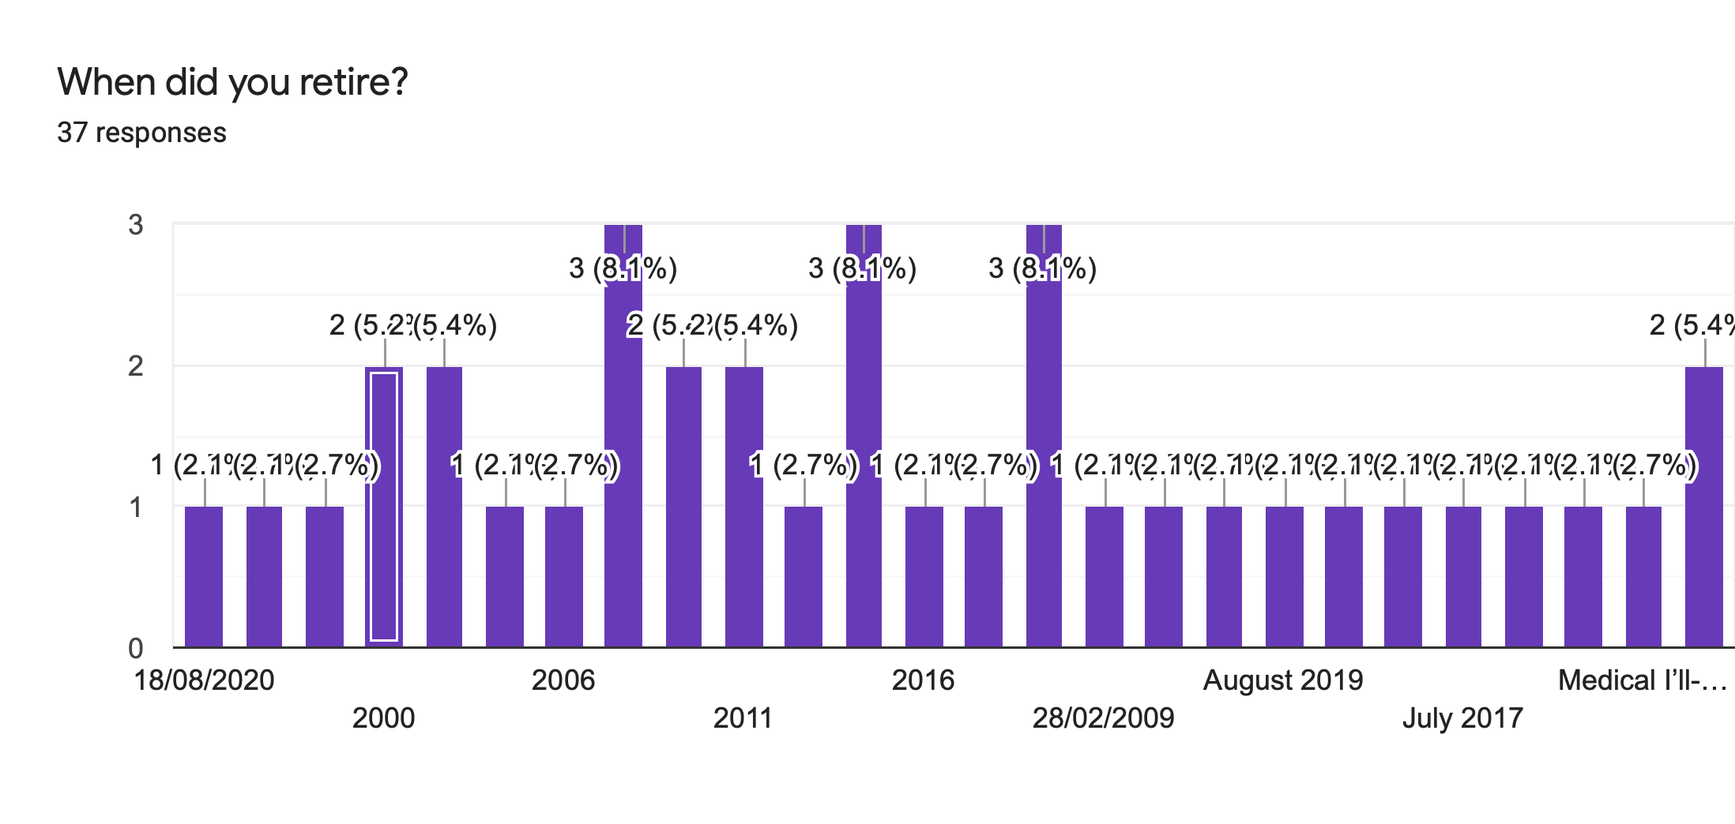
As the survey was focused on specifically retired police officers it would be a good decision to discover how long they have been retired for as this will provide an understanding of their treatment and views on mental illness. When asked, a wide range of retirement ages were discovered ranging from 2020 to 1997 which allows for a range of opinions and experiences with mental illness. This also allows for the visualisation of any changes in made in mental health protection in the police.
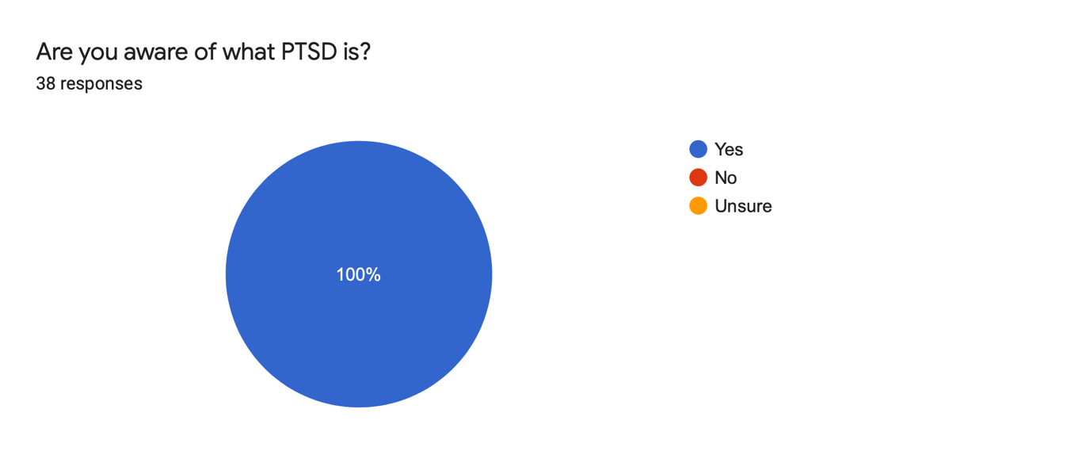
When the participants were asked whether they were aware of what Post Traumatic Stress Disorder (PTSD) is, 100% of all participants agreed they were aware of what PTSD is. This is most likely due to post retirement education on mental illness or the generalised awareness of mental illness as the taboo surrounding it has weakened over time and has been more accepted than what it was has been in the past. Additionally, this also may indicate that mental health awareness in the police has become more widespread through the introduction of training schemes as seen in the College of Policing’s Responding to Trauma in Policing Guidance Report (2018).
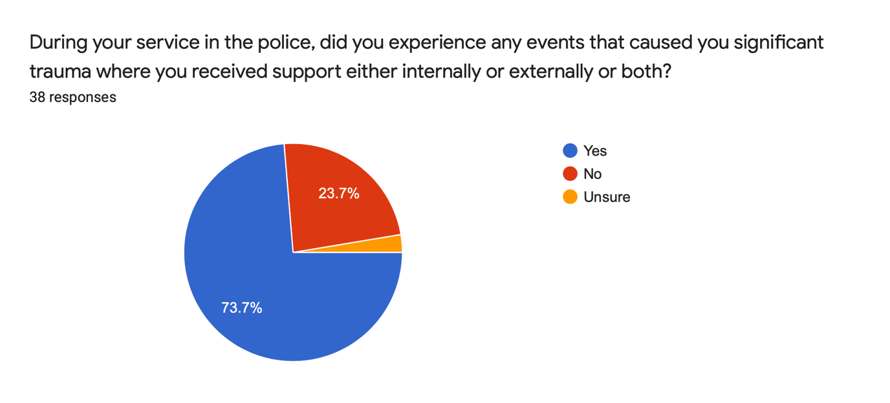

Unsurprisingly, when the participants were asked whether they had sustained trauma which required internal and/or external support, 73.7% agreed that during their operational time as a police officer they had experienced trauma which required professional assistance such as counselling or Cognitive Behavioural Therapy (CBT). This leaves 23.7% of participants who believe they did not sustain any trauma that required professional intervention. This may be because they were in the higher ranks of the service, thus significantly reducing the probability of them developing Post Traumatic Stress Disorder or they may still be ashamed to admit they are suffering from trauma as mental illness support and guidance has only been available to police officers and managers in the last decade.

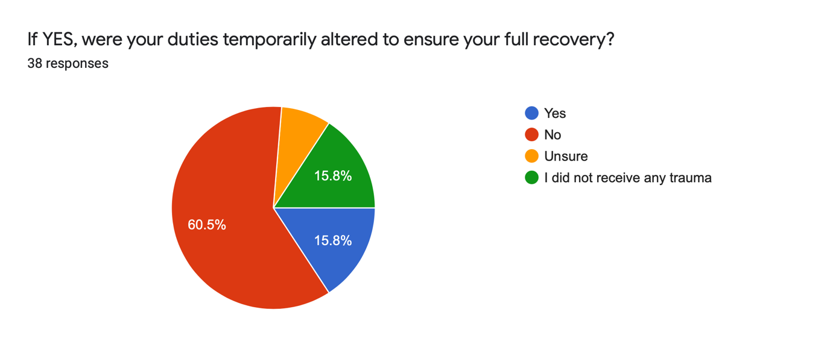
Question 6 reveals that 60.5% of participants did not have their duties altered to ensure a full recovery from their trauma and to ensure proper reintegration into the service. This indicates that either their trauma was supressed and the suffering officers ‘just got on with it’ or those who had received trauma received treatment which did not require the alteration of duties. Treatments such as Cognitive Behavioural Therapy (CBT) sometimes may be more than sufficient in tackling trauma and also a more effective treatment as changing a police officer’s duties may have service implications, depending on what the duties of the officer was. With the cuts to funding in the service and low staff numbers due to the cuts in budget, it may be considered wise that the police service explore new and alternative methods when tackling PTSD as this will maintain the number of officers on duty and limit the amount of time the duties of a suffering officer has to be altered either temporarily or permanently.
This suggests that the 15.8% of participants who did have their duties altered either suffered a significant amount of trauma from a particular duty which, if not removed from the duty would cause further psychological harm.

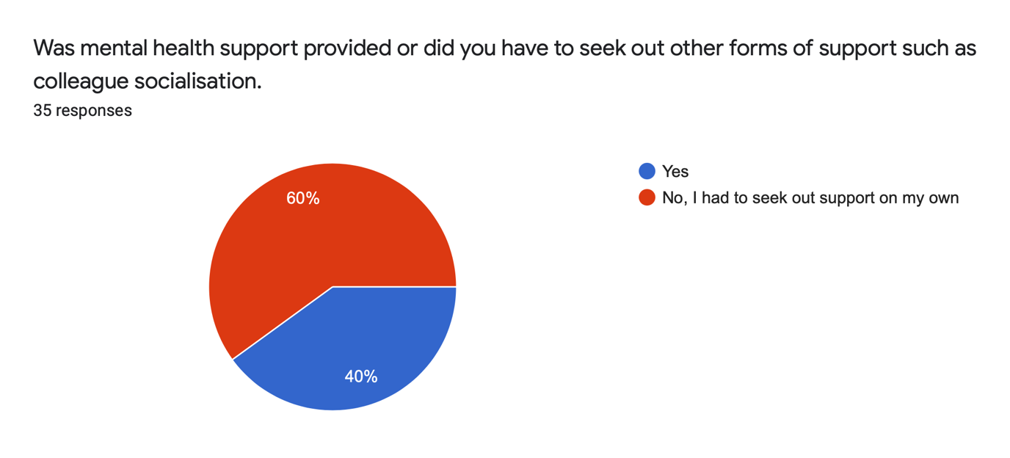
Interestingly, the analysis of the responses to question 7 supports and is consistent with the qualitative theme of did not receive support as 60% of participants believed they had to seek out support for themselves as they did not believe mental health support was available to them. This supports the hypothesis that the minimal support available when these retired officers were active was not distributed evenly amongst all ranks in the service. Additionally, question 7 also supports the theme of ‘widespread knowledge gap’ as it was discovered that the general attitude from the service was machoistic towards mental illness and suffers were encouraged to not show emotion. This exposes the ignorance the police once had towards mental illness as the it was not until the last decade that improvements were made which was the result of illuminating investigations and studies into police mental health.
The 40% of participants who received professional support from the police service may have either retired closer to 2021 or had suffered from advanced PTSD and had to be provided with support.
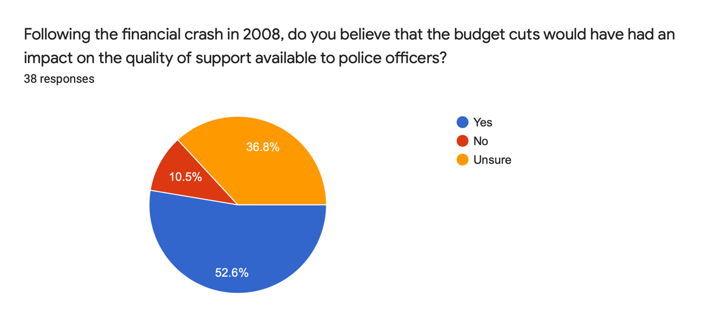
When analysing the support received by the participants who received it, a high majority of the support provided was counselling with one retired officer receiving support from the Trauma Risk Incident Management (TRIM) protocol and another received support from the trauma resilience training provided by the service. However, despite some participants receiving counselling support both internal and external, some believed it was too short or was somewhat effective which suggests that the service should explore new methods of addressing mental health issues to provide a more effective service. However, this comes at a cost and the government funding cuts to policing puts restrictions on the quality of support the police can provide.
This hypothesis is supported by question 11 as 52.6% of participants agree that the 2008 financial crash of 2008 would have a knock-on effect with the quality of mental health services provided to suffering officers and the duration of the care. Additionally, the recent changes caused by COVID 19 indicates that the police service as a whole will be expected to undergo additional austerity as services account for 80% of the UK economy.
The pandemic has forced the police services in England and Wales to spend a total of £100 million on personal protective equipment and computers which enable staff to work from home if need be. Furthermore, the service also faces government funding cuts of an estimated £250 million as the economy shrinks. Sadiq Khan, the current mayor of London expressed in the Guardian that a short fall in funding could, “jeopardise our ability to tackle violent crime at this crucial juncture” (Dodd, 2020). However, the cuts have the potential to worsen police mental health due to additional stress caused by the over stretching of budgets which may leave officers overburdened with responsibility as the promise the Prime Minister made to create 20,000 new police officers may be defaulted on due to the pandemic.
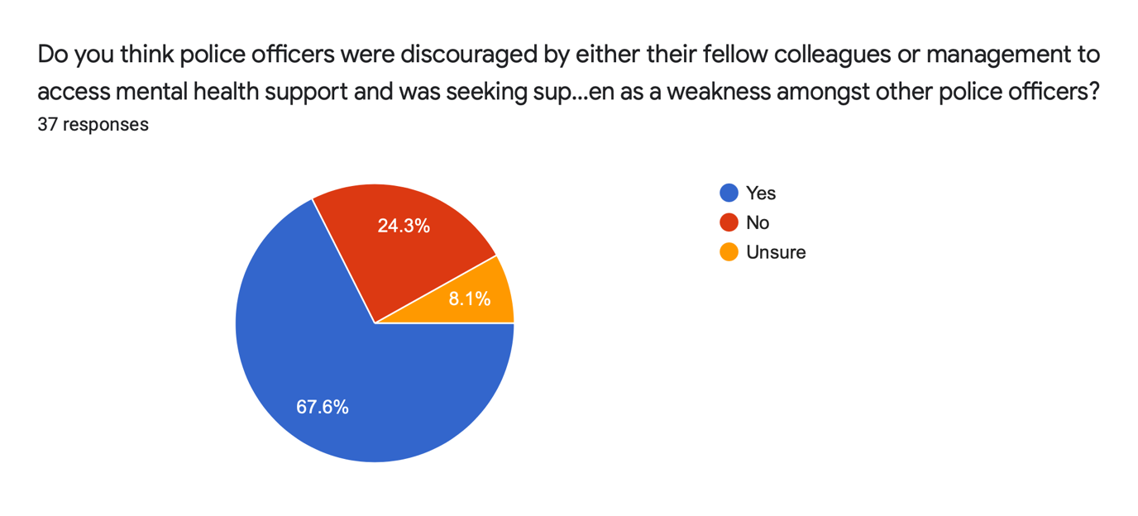
Consistent with the qualitative theme ‘lack of compassion’, question 12 reveals that 67.6% participants felt that suffering officers who sought after support for PTSD were viewed as weak and generally officers seeking support were discouraged which suggests the ignorance and lack of awareness of mental illness was causing an over reliance on the informal support provided by colleagues. Additionally, the views of the participants is also in line with the general hypothesis that the police service at the time, as a whole was a machoistic environment as suffering officers were considered weak if they were suffering from mental illness caused by trauma as at the time it was generally seen as a part of the role of a police officer. This in recent years has changed and
In addition to question 12, question 13, which was a discussion driven question explores the opinions of the participants as to whether or not they believe there is a stigmatisation of Post-Traumatic Stress Disorder in the police and what the cause may be. The responses to this question can be split into 2 categories lack of understanding and toxic masculinity as either the believe that society and the police service as a whole were ignorant towards the psychological health of police officers or they believe that the police had a complete disregard for the welfare of the police officers at the time as the phrases ‘get on with it’ and ‘just a part of the job’ are reoccurring.
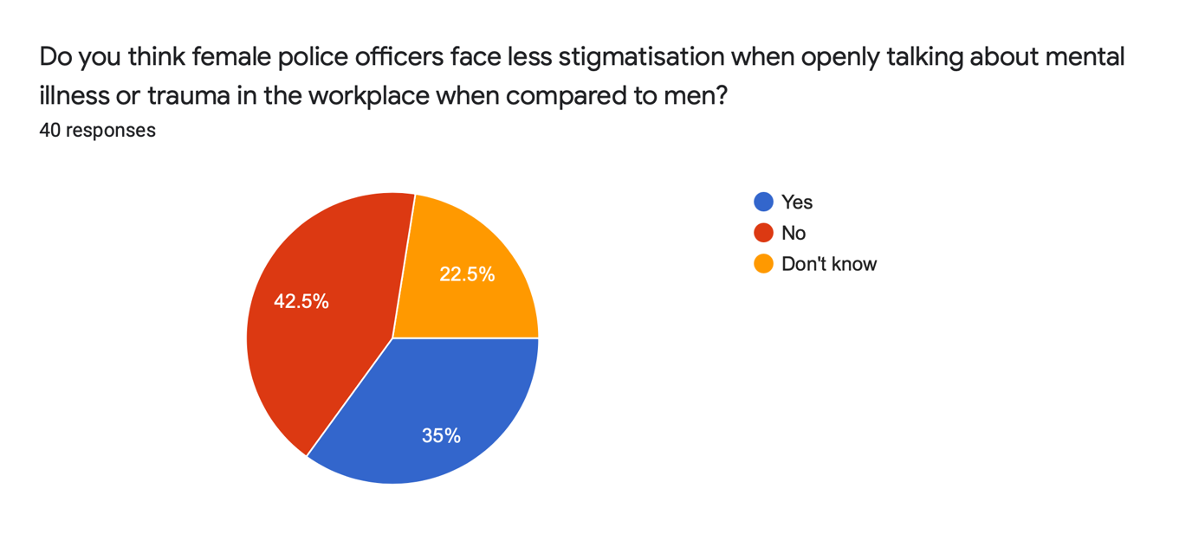
Whilst the protection from psychological illness in the police service until recently has been limited, it may be hypothesised that the service would provide more protection towards women as generally the toxic masculinity experienced by men would not be as harsh on the women and that perhaps women would be encouraged to open up.
The results from the survey invalidate this hypothesis as 42.5% of participants believed that women were just as protected from PTSD as the men. Additionally, this also indicates that women were not encouraged to talk about their experiences which suggests that female police officers were also affected by the toxic masculinity which was dominant when these officers were operational.
When asked in the survey whether the participants believed that the role of a police officer has become more challenging than it was in the past, the majority of participants believed it had become significantly more challenging with answers ranging from the cut backs affecting the amount of officers available, resulting in additional workload stress to the evolution of society where the police are expected to perform. Additionally, some participants also the complexity of criminal investigations also additional factor towards workload stress as the thorough procedures add more paperwork which further restricts what the officers are capable of doing.
The final survey question explored whether the participants believe the police service should adopt a similar strategy towards PTSD as the Ministry of Defence (MOD) does. This question was chosen to determine whether the strategies used by the MOD is known by other organisations which may aid in the cross-service protection of PTSD.
The response from the participants suggests that the policies and schemes utilized by the MOD is not well known across other services as most of the participants did not know of the policies and practises used by the MOD to prevent PTSD. A suggestion may be made that the blue light services and the MOD converge their concepts of how to control PTSD which will allow for the organisations to learn of one another and create a stronger foundation of PTSD protection.

Discussion
The target audience of retired police officers has provided some interesting and insightful experiences and opinions on how the police service handled post-traumatic stress disorder. The hypothesis that police officers did not receive any mental health support is strengthened by the findings of both the qualitative and quantitative data. It can be determined that indeed the police service did not provide and implement sufficient Post Traumatic Stress Disorder protection to its officers and that the toxic views of ‘getting on with it’ and ‘its just part of the job’ had infected all aspects of the service. However, there was a light support structure available to suffering officers, but the knowledge of this structure was not well known about as its knowledge was not well distributed amongst the lower ranks.
This in turn prevented suffering officers to speak up about their wellbeing concerns and were forced to compartmentalise their psychological issues which would worsen the condition and infest their private life. The only support and escape suffering officers had was the socialisation with other officers which usually involved alcohol consumption. This however has the potential of creating a dependency and addiction to the consumption of alcohol as it used as a coping mechanism.
The link between PTSD and alcohol consumption has been explored by Volpicelli et al, 1999 and it has been discovered that the consumption of alcohol in suffers has the potential of being a gateway to harsher substances such as class A drugs which confirms my hypothesis that if left untreated, PTSD can evolve into something more destructive which is why it is necessary for the police service to create and implement support policies and frameworks as this extends the longevity of a police officer’s career which is essential in a shrinking economy.
Surprisingly the data from the survey revealed that the toxic attitudes towards mental health was not limited to men but it also affected the women officers too as it was hypothesised that due to the nature of having women in the service at the time, they would have been more protected either as a natural phenomenon or through the encouragement to discuss and express their concerns of their mental health.
The time scale of when the participating officers had retired revealed to that the protection of mental health has only been implemented within the last decade with officers retiring in 2007 and experiencing little to no change in the way the mental health of officers was handled. It is surprising to see how long the mental health of police officers has been abused despite the effects of PTSD being known about by the mid to end of the 1st World War.
The survey did reveal, soberingly that there is improvements being made to protect police officer mental health such as the introduction of the Trauma Risk Incident Management (TRIM) protocol in 2017 which categorises the level of trauma risk an officer should expect to receive which allows them to mentally prepare for the scene. The protocol also allows for the allocation of support services to suffering officers.
From analysing the data it may be wise for the blue light services and the Ministry of Defence to compare and evaluate each other’s policies, protocols and frameworks on mental health so that all services have a good foundation of protection of which they can build their individual needs as today the blue light services and the Ministry of Defence share the same risks of trauma.

Bibliography
Albers, M. J. (2017) Introduction to Qualitative Data Analysis in the Behavioural and Social Sciences, USA: John Wiley and Sons, Inc.
Anne-Marie, E and Yasuhiro, K (2020) Mental health in the UK police force: A qualitative
Ballenger, J, F., PhD, Best, S., PhD, et al. (2010) Patterns and Predictors of Alcohol Use in Male and Female Urban Police Officers [online] available at https://www.ncbi.nlm.nih.gov/pmc/articles/PMC3592498/ accessed 07/09/20
Blakemore, E. (2020) How PTSD went from ‘shell-shock’ to a recognised medical diagnosis [online] available at https://www.nationalgeographic.co.uk/history-and-civilisation/2020/06/how-ptsd-went-from-shell-shock-to-a-recognised-medical-diagnosis accessed 07/09/20
Bolderston, A. (2012) Conducting a Research Interview, Journal of Medical Imaging and Radiation Sciences, [online] available at https://www.jmirs.org/article/S1939-8654(11)00132-9/pdf accessed 16/10/20
College of Policing (2018) Is modern policing social work? – Dr Hilary Cottam [online] available at https://www.college.police.uk/News/Newsletter/April_2018/Pages/social-work.aspx accessed 07/09/20
College of Policing (2018) Post-Traumatic Stress Disorder (PTSD) and Policing –
College of Policing (2018) Responding to trauma in policing a practical guide [online] available at https://www.college.police.uk/What-we-do/Support/Health-safety/Documents/Responding-to-trauma-in-policing.pdf accessed 21/08/20
College of Policing (2018) Responding to trauma in policing a practical guide [online] available at https://www.college.police.uk/What-we-do/Support/Health-safety/Documents/Responding-to-trauma-in-policing.pdf accessed 21/08/20
College of Policing (2019) Launch of National Police Wellbeing Service [online] available at https://www.college.police.uk/News/College news/Pages/National_well_service_launch_April_2019.aspx accessed 07/09/20
College of Policing (2020) Police Constable [online] available at https://profdev.college.police.uk/professional-profile/police-constable/ accessed 21/08/20
College of Policing (2020) Wellbeing [online] available at https://www.college.police.uk/What-we-do/Support/Health-safety/Pages/Wellbeing.aspx accessed 21/08/20
Crocq, L and Crocq, M. (2000) From shell shock and war neurosis to posttraumatic stress disorder: a history of psychotraumatology [online] available at https://www.ncbi.nlm.nih.gov/pmc/articles/PMC3181586/ accessed 07/09/20
DeJonckheere, M and Vaughn, L. M. (2019) Semistructured interviewing in primary care research: a balance of relationship and rigour, ‘Medicine and Community Health’ [online] available at https://fmch.bmj.com/content/7/2/e000057.info accessed 16/10/20
Devault, G (2019) Advantages and Disadvantages of Quantitative Research [online] available at https://www.thebalancesmb.com/quantitative-research-advantages-and-disadvantages-2296728 accessed 16/10/20
Dodd, V. (2019) Criminals going unpunished because of cuts, says police chief [online] available at https://www.theguardian.com/uk-news/2019/may/02/criminals-going-unpunished-because-of-cuts-says-police-chief accessed 07/09/20
Dr Coleman, R at al. (2018) Wellbeing in Policing: Blue Light Wellbeing Framework [online] available at https://oscarkilo.org.uk/app/uploads/2019/04/BLWF-Interim-Report-1.pdf accessed 21/08/20
Dr Coleman, R at al. (2018) Wellbeing in Policing: Blue Light Wellbeing Framework [online] available at https://oscarkilo.org.uk/app/uploads/2019/04/BLWF-Interim-Report-1.pdf accessed 21/08/20
Ehlers, A., Gene-Cos, N and Perrin, S (2009) Low recognition of post-traumatic stress disorder in primary care, London J Prim Care (Abingdon). [online] available at https://www.ncbi.nlm.nih.gov/pmc/articles/PMC3695460/ accessed 07/09/20
Frost, J (2020) Guide to Data Types and How to Graph Them in Statistics [online] available at https://statisticsbyjim.com/basics/data-types/ accessed 16/10/20
Guest, G., Namey, E. E, Mitchell, M, L. (2013) Collecting Qualitative Data A Field Manual for Applied Research, London: Sage Publishing
Guion, L. A. (2002) Triangulation: Establishing the Validity of Qualitative Studies [online] available at https://sites.duke.edu/niou/files/2014/07/W13-Guion-2002-Triangulation-Establishing-the-Validity-of-Qualitative-Research.pdf accessed 16/10/20
Hale, H and Hunt, K (2020) Understanding the mental health and wellbeing needs of police officers and staff in Scotland [online] available at https://www.tandfonline.com/doi/full/10.1080/15614263.2020.1772782?scroll=top&needAccess=true accessed 21/08/20
Hampshire Police Federation (2019) Post-Traumatic Stress Disorder widespread in policing [online] available at https://www.polfed.org/hants/news/2019/post-traumatic-stress-disorder-widespread-in-policing/ accessed 07/09/20
Hargreaves, J, Husband, H and Linehan, C (2017) Police Workforce, England and Wales, 31 March 2017 [online] available at https://assets.publishing.service.gov.uk/government/uploads/system/uploads/attachment_data/file/630471/hosb1017-police-workforce.pdf accessed 21/08/20
Hazelden Betty Ford Foundation (2015) Links Between Officer Trauma and Substance Abuse [online] available at https://www.hazeldenbettyford.org/education/bcr/addiction-research/alcohol-abuse-police-ru-716 accessed 07/09/20
HMICFRS (2020) Dyfed-Powys Police [online] available at https://www.justiceinspectorates.gov.uk/hmicfrs/police-forces/dyfed-powys/ accessed 21/08/20
investigation into the stigma with mental illness. International Journal of Mental Health and addiction. International Journal of Mental Health and Addiction [online] available at https://derby.openrepository.com/bitstream/handle/10545/624438/Mental%20Health%20in%20the%20Police%20Force.pdf?sequence=1&isAllowed=y accessed 21/08/20
Jamshed, S. (2014) Qualitative research method-interviewing and observation, Journal of Basic and Clinical Pharmacy 5(4): 87–88.
McLeod, S (2019) What’s the difference between qualitative and quantitative research? [online] available at https://www.simplypsychology.org/qualitative-quantitative.html accessed 16/10/20
NHS (2020) Overview Post-traumatic stress disorder (PTSD) [online] available at https://www.nhs.uk/conditions/post-traumatic-stress-disorder-ptsd/ accessed 21/08/20
Nobel, H and Mitchell, G. (2016) What is grounded theory? Evidence-Based Nursing: 19:34-35.
Oktay, J. S. (2012) Grounded Theory: New York, Oxford University Press
OscarKilo (2019) LEADERSHIP, PERSONAL RESILIENCE, TRAUMA Leadership [online] available at https://oscarkilo.org.uk/executive-leadership/ accessed 07/09/20
OscarKilo (2020) More about the Blue Light Wellbeing Framework [online] available at https://oscarkilo.org.uk/wellbeing-framework/what-is-the-framework/ accessed 07/09/20
Patton, M. Q. (2002) Qualitative Research and Evaluation Methods (3rd ed) London: Sage Publications
Pattyn, E., M. Sc, Verhaeghe, M., PhD, et al. (2014) Public Stigma and Self-Stigma: Differential Association With Attitudes Toward Formal and Informal Help Seeking [online] available at https://ps.psychiatryonline.org/doi/10.1176/appi.ps.201200561 accessed 07/09/20
Police Care UK (2018) Establishing the evidence base: 'Policing: The Job & The Life' Survey (2018) [online] available at https://www.policingtrauma.sociology.cam.ac.uk/survey accessed 07/09/20
Police Federation (2019) Post-Traumatic Stress Disorder widespread in policing [online] available at https://www.polfed.org/news-media/latest-news/2019/post-traumatic-stress-disorder-widespread-in-policing/ accessed 21/08/20
Quirk, H., Crank, H., et al. (2018) Barriers and facilitators to implementing workplace health and wellbeing services in the NHS from the perspective of senior leaders and wellbeing practitioners: a qualitative study, BMC Public Health, available at https://bmcpublichealth.biomedcentral.com/articles/10.1186/s12889-018-6283-y accessed 07/09/20
Ramh (2020) Gender differences in Mental Health [online] available at https://ramh.org/guide/gender-differences-in-mental-health/ accessed 07/09/20
Salmon, L. (2017) The importance of case studies in social research [online] available at https://www.changeworks.org.uk/news-and-events/blog/the-importance-of-case-studies-in-social-research# accessed 16/10/20
Sarahntakos, S (2013) Social Research (4th ed) London: Red Globe Press
Saunders, M., Lewis, P. and Thornhill, A (2009) Research Methods for Business Students (5th ed) Pearson Education Limited: Essex, England.
Shaw, D. (2019) PTSD 'at crisis levels' among police officers [online] available at https://www.bbc.co.uk/news/uk-48201088 accessed 07/09/20
Short Guidance Document [online] available at https://oscarkilo.org.uk/app/uploads/2018/11/C1095I1018_PTSD-College-Guidance-doc_digital-Upload.pdf accessed 21/08/20
Short Guidance Document [online] available at https://oscarkilo.org.uk/app/uploads/2018/11/C1095I1018_PTSD-College-Guidance-doc_digital-Upload.pdf accessed 07/09/20
Shorten, A and Smith, J. (2017) Mixed methods research: expanding the evidence base, Evidence-Based Nursing: 20:74-75.
Soomro, S and Yanos, P.T. (2019) Predictors of Mental Health Stigma among Police Officers: the Role of Trauma and PTSD Journal of Police and Criminal Psychology [online] available at https://link-springer-com.ezproxy.uwtsd.ac.uk/article/10.1007/s11896-018-9285-x accessed 07/09/20
The Open University (2020) Research Methodology [online] available at https://www.open.edu/openlearn/money-management/understanding-different-research-perspectives/content-section-8 accessed 16/10/20
Thebmj (2020) Data display and summary [online] available at https://www.bmj.com/about-bmj/resources-readers/publications/statistics-square-one/1-data-display-and-summary accessed 16/10/20
Verdinelli, S and Scagnoli, N. I. (2013) Data Display in Qualitative Research: International Journal of Qualitative Methods [online] available at https://journals.sagepub.com/doi/pdf/10.1177/160940691301200117 accessed 16/10/20
Wasserman, J. A, Clair, J. M and Wilson, K. L. (2009) Problematics of grounded theory: innovations for developing an increasingly rigorous qualitative method, Qualitative Research 9(3):355 [online] available at https://www.researchgate.net/publication/236159952_Problematics_of_Grounded_Theory_Innovations_for_Developing_an_Increasingly_Rigorous_Qualitative_Method accessed 16/10/20

