Joshua Thomas Douglass
1701538
Photography in the Arts
Independent Inquiry
Family photography: Reminiscence of things past

Submitted in partial fulfilment of the requirements for the degree of BA (Hons) University of Wales Trinity Saint David, Swansea. 10th December 2019.

Table of Contents
Chapter one: ……………………………………………………………………. 5
Chapter two: ……………………………………………………………………. 17
Word count: 5562

Illustrations list
Figure 1: Meatyard, E, R. Family album of Lucybelle Crater. (1972). [image] Available at: https://fraenkelgallery.com/portfolios/lucybelle-crater [Accessed 5 Dec. 2019].

Figure 2: Carucci, E. (2005). Dry Snot. [image] Available at: https://www.lensculture.com/articles/elinor-carucci-mother-the-images-i-still-love [Accessed 6 Dec. 2019].

Figure 3: Douglass, A. (2003). Hornsea pottery. Douglass family archive (2003).

Figure 4: Douglass, A. (2005). Flamingo Land. Douglass family archive (2005).

Figure 5: Zachmann, P. (2011). Mare Mater. [image] Available at: https://pro.magnumphotos.com/C.aspx?VP3=SearchResult&ALID=2TYRYDXPIH09#/SearchResult&ALID=2TYRYDXPIH09&VBID=2K1HZSJD5ZY1U&PN=1 [Accessed 9 Dec. 2019].

Figure 6: Douglass. S. (2002). ‘Untitled’. Douglass family archive (2002).

Figure 7: Nixon, N. (1975). The Brown sisters. [image] Available at: https://fraenkelgallery.com/portfolios/brown-sisters [Accessed 9 Dec. 2019].

Figure 8: Douglass, A. ’Untitled’. Douglass family archive (2003).

Figure 9: Douglass, A. ‘Untitled’. Douglass family archive (2003).

Summary of topic
This inquiry seeks to explore the complex relationship between the photographic image and our reminiscence of things past. In reality of everyday events, are we able to maintain an accurate mental representation of the memories that are made, or are they distorted or lost through interpretation and re-interpretation? This dissertation asks what significance, in terms of sentimental value, we place in a photograph, and how this differs from pure recollection.

Introduction
This dissertation will expand on memory and photography, memory through reminiscence and through interpretation. This investigation will explore the connection that memory has over individuals and as a collective, how memory can differ from person to person and how each person will instinctively interpret memory based on their involvement. Within this research my personal family memories will be referred to. A primary focus which revolves around the memories of my parents and my involvement within their lives at an early age and how they have chosen to display this through family photographs. Additionally, expanding on photography as a form of memory and how photography can help us with the remembrance of past events and points of interest within memory. A photograph acting as a storage bank for the entirety of past events that were documented, a look into how documentation of this can affect memory based on what is depicted. In addition to this there will be an exploration into the understanding of generation-based image-making and how that can alter the way photography is interpreted through a contemporary perspective. Moreover, looking at how photography can be used as ways to recreate past memories further than reminiscing by memory alone. Research into memory of photographs other than what is depicted, but the life of physical photographic images, what they have endured since they were first printed. An interest in how memories can be captured to portray time moving forward, an image is a visual that will remain unchangeable. Allowing for the present to connect with the past through change. Ultimately rounding a connection between family orientated photographs and reminiscence.

Chapter 1
The first part of this dissertation will look into photography and memory as a physical and mental form and attempt to distinguish how alterations through images can alter memory. Compared to the actual events and how memory can be changeable and deemed as not authentic, based on that changeable alterations both memory and photographic mediums share. An exploration into how past to present generations have changed the way photography as a form is perceived. To also address the importance that images have on our memory and how they can be used as a technique to store memories away. Research into how other artists have expanded on photography and memory and how the contemporary art world allows for this diversity. Moreover, address photography subjectively based on the perception of a specific memory and explore the fact that physical images have their own memories.

Physical memory. Photography allows for a pinpoint in time to be documented, but at what extent of importance does that have. For example, if a documentation of a child’s birthday and a daily journey to work, what would the significance of each really be. Why is it that we are more enticed by an event such as a birthday compared to a normal journey or a daily routine exercise. The interest in the instinct we have as humans is subconscious, the decisions and thoughts that we have without any control. It is fascinating that we as humans, are individual to one another and are able to make subjective decisions based on the individuality of each person. In support of perception based from individuality, Roland Barthes (2000) writes:
I cannot reproduce the Winter Garden photograph. It exists only for me. For you, it would be nothing but an indifferent picture, one of the thousand manifestations of the “ordinary”; it cannot in any way constitute the visible object of a science; it cannot establish an objectivity. (Barthes 2000. p 73).

In correspondence to this, single memory existing for an individual and only holding sentiment to that one person. Having a memory that is not only unreproducible but sentimental to that memory holder, to anyone who was not involved with that memory will not know the importance and sentiment held within it. Photography is the bridge that makes this memory an object, a physical moment only truly understood by the individuals involved within it.

In relation to this, lens-based image making allows an internal memory, a memory that will only remain internally for the individual or individuals involved to be made more than just internal. This thought is in light of my own personal images, images that my parents have taken to capture moments that are significant to them. Then follows the attempt to reconstruct the whole scene, subconsciously piecing visuals, scents, feelings, emotions and sounds together creating the memory again internally. For me on occasions the reminiscence of photographs affects my mood. Contrary to this the shift in mood happens almost instinctively going unnoticed to the individual. In correlation to this, moods can then develop alongside emotions, feeling a certain way towards a memory creates emotion around that specific memory which will ultimately decide on its authenticity as a reminiscent moment. Thinking about positive memories that have been shared with my parents a reflection is able to be made and remember countlessly. However, the authenticity of mind generated memories from the past can never really be exactly authentic, providing there is no physical attachments to it.

In conflict with mind generated memories from the past can be conflicted with the thought of it actually being correct or incorrect, the fact that they are memories gives it a small sense of unauthenticity through our minds not actively remembering every slight detail about the constructed memory. It’s interesting that memories also hold a sense of illusion, we believe what we chose to believe, just like memories. We as humans remember only great or terrible memories, moments that hold significance not moments that don’t. An example of this throughout my lifetime is my driving test, remembrance of the day I passed my test. What happened during the period of time my test was taken but no recollection of memories of what happened that day. It’s striking how our minds can fine-tune and filter certain events and actions that will self-manifest into memory.

An investigation into how memory can be interpreted differently based on the individual. Subjective to their involvement or lack of involvement could change how they interact with that memory. For someone that briefly remembers the event will not manifest a memory as boldly as an individual that was much more involved. Interpretation could affect how a certain memory performs, the individual who recalls a memory with inaccuracies to other individuals that were involved. Meaning a slightly different aspect change shows change of the authenticity of that memory for each individual involved. Another factor that could be included is physical formats of lens-based image making, photography or moving-image that could change the outcome of each individual’s interpretation. A photograph or moving-image piece could depict a truth or flaw in a reminiscence from the past showing an essence of truth. Something that must be a part of their life and their past, memories are subjective and will always remain.

A physical piece of information is a staple for truth but only through what it depicts, a photograph can fall short capturing true emotion, a feeling or thought of that moment is not able to be caught. A moving-image piece from the past may be of more authenticity than a photograph. Through the fact it portrays more than just a singular point, but dialogue, sounds and movement which is able to give a memory more of a body in which a photograph cannot always fulfil.

Furthermore, photography as a physical object is subject to change through time, showing the potential shift in generation. Hints towards this are clothes and appearance styles as well as background changes, cars on the streets style of interior and exterior, quality of image and other changeable factors that have shifted through generations showing time. This would more than likely be the decider on the time scale the image was taken in, however, may not always be fact. An image could have been altered to look newer or older than it actually is, a common example of this is being able to make mobile phone captured images to look as if they were of a more retro film camera design, this is through the alteration of the original image through editing applications and software’s. In doing this would ultimately change the authenticity of that selected image, making a modern image taken in the present to appear as it was taken years in the past. This juxtaposes the modernised generation through the emerging technology allowing for image making to become more accessible and increasingly changeable through technology. From the past, images were more sentimental to both the creator and receiver through the time and effort it took to create the image. Developing processes and printing to get to a final physical form that can then be distributed as desired. The idea of past and present photographic methods that are drastically changing through time from past to present. The whole concept and punctum of image-making has shifted through generations and some would argue has lost its sentimental value as well as its market value, photographs are more common than they once were. In addition to this, the concept of time and movement throughout generations preludes into what time contributes towards memory itself, how a shift in time will change what a memory can be perceived as. In relation to the idea of time, Damian Sutton, (2009) states that:
In the physical world, we generally understand the organisation of time through movement in space, a sensory-motor schema we can best describe through the sweep of the hands on the face of a clock. This is generally regarded as objective and incontrovertible, constant and knowable. (Sutton, 2009, p.34-35)

The linear construct of time is seemingly unchangeable, the passing of time is inevitable and will never be changed just as time will never be reversed. The inability of being able to go back in time means that remembrance from the time past will only ever be empowered by physical objects that are from that are significant from that moment. A photograph is a prime contributor to an object that reflects past events, they are very much time capsules. The subject of an individual photograph will never change unless manipulated in some way, it will always stay authentic to itself. A photograph serves the purpose to capture a snapshot of that moment, whatever may appear in that photograph is completely unchangeable. If the photograph was unsatisfactory another one may be taken to enlighten the original taken. An argument to this is that the new photograph taken replaces the original which would then become a memory in itself, the process of that image having to be reproduced as an upgraded version of that original. Subsequently, would this memory would then be cast out as a subconsciously filtered memory as I have previously mentioned. In light to this, Marianne Hirsch (1997) writes about photography as a physical and changeable form:
Family photos play an important role in the narrator’s self-definition as familial daughterly subject, and in each the photos are manipulated, transformed, mishandled, destroyed, and reinvented, so as to reveal what alternate stories may lie beneath their surfaces or beyond their frames. (Hirsch, 1997: p.192-193)

Additionally, as (Hirsch, 1997) writes about alternate memories that manifest through manipulation and change of the original photograph. The life sequence of a single photograph holds its own memories within themselves, the age of the photographs and how it has been handled through its lifetime. The photograph could well have spent its entirety in a box in an attic, to then be looked at and reminisced by from time to time. Every photograph is original to itself, another may have gone through traumatic events, a house on fire and partially burnt, misplaced and lost, ripped or bent. Each image has its own memory separate to what it is that the photograph depicts, it’s fascinating, to pick up an archival family image from years ago and discover more than just what the image displays, but the whole life’s journey of that single piece of photographic paper.
Following on from this, memory portrayed in a contemporary manner allows us to engage with memory and photography in a more contextualised and artistic manner. Furthermore, contemporary artists have used implemented memory and photography within their work and created a culture for intentionally misinterpreted uniform ways of creating memories. An example of this is the work of Ralph Eugene Meatyard and his creation of ‘Family album of Lucybelle Crater’ (1972):
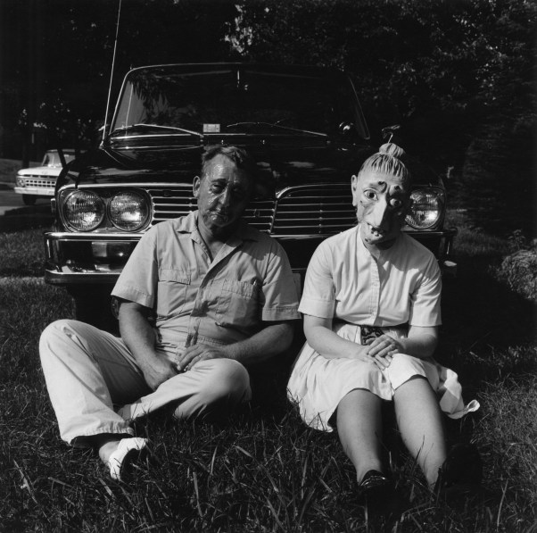

(Figure 1) Meatyard, E. R. ‘Family album of Lucybelle Crater’ (1972).
In response to this piece by (Meatyard, R. 1972), Meatyard toyed with the idea of what a formal family album image should look like, creating a theme of mystery and abstraction differentiating from how family album images should look or are desired to look. He used store-bought silicone masks for the subjects to use to completely erase the personality and individuality of them. In many respects this has completely erased the idea and legacy of what a family album image should be, if the subjects are wearing masks which makes them unrecognisable poses the question of if it really is a family album anymore. If the subjects have no identity there is no way to tell if they are of any relevance. Furthermore, Sarah Edwards (2017) comments on ‘The family album of Lucybelle Crater’ (1972):
features two characters, both masked and both named Lucybelle Crater. The images, each with a scrawled caption underneath, create the convincing illusion of a family album belonging to a clan of suburban, oafish monsters. (A typical, typically comic, caption reads, “Lucybelle Crater and successful peanut farmer friend’s gorgeous daughter - Lucybelle Crater. Edwards (2017).

Creating illusion with what is real and what is not changes the aim for family photographs, the whole reason for family albums are to remember family members through generations and through sentimental events and act as a memory. This is being completely contradicted by Meatyard’s work, the masks hide the faces of these family or friends and in turn leaves manufactured bodies that have no identity, changing our uniform idea of a family album through a more contemporary vision that Meatyard had. In addition to this, the lack of identity surely meddles with the sentiment of the memory, creating a family album of faceless individuals. Through a movement in innovation within the contemporary arts world affects what a family album is traditionally, creating a more abstract-angled version. Relating to the sentimental value of this is then somewhat decreased in the fact it lacks personality through people involved, toying with the systematic function of what it claims to be. The use of masks has allowed us to broaden our interpretation of who they really are or who they could be.
In correlation to this, the work of Elinor Carucci also disrupts the traditional notion of family photography through her work. The series ‘Mother’ (2005) contributes to a more intimate and personal range of family images with her children.
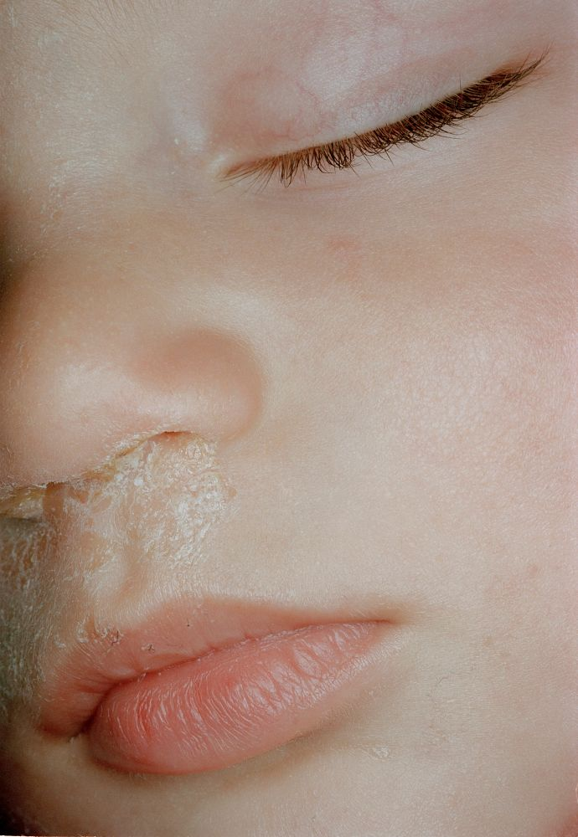

(Figure 2) Carucci. R ‘Dry snot’ (2005).
A photograph of her child, which captured the dried nasal mucus coming from their nose. This image capturing a moment that is not a usual depiction seen within that of a traditional family archive, it is something that would never get exposure. The image capturing truth rather than carefully staged scenes to remember the past by. Carucci captures the detail in that moment not in light of its beauty, but in light of its imperfection, she sees her child through perfect eyes. Elinor Carucci (2019) states that:
These are the photos I still love‎.
Photographs are like your own children. You see the beauty in them; you also see the flaws. Maybe they are not the popular kids at school, but you love them as they are. You must—they are yours. (Carucci 2019).

She made images of her and her children, their growth through childhood and her own growth though motherhood. The remembrance of her time as a young mother and the connection that is shown between her and her children. Showing reality and intimacy in their lives, not a uniform and structured body of images where posing is used to make staged images.

The function of memory is remembrance of things past, the important memories are locked in and seen to hold sentiment and value. The unimportant memories forever being subconsciously discarded on the basis of their importance. Therefore, meaning that although the memory is still present it is overlapped with the replacement of memories with higher importance. Our minds act as a biological storage for memory, but we are never able to remember every single detail about every single encounter that we have ever had within our lifetime. To a certain extent our memory consumption has a limit, this is where subconscious selection takes place and memories that do not hold significance are forgotten about. This filter that is inbuilt within our minds allow us to remember the memories that we should remember and forget the memories that we do not. Relating this to photography, the same algorithm applies when taking a photograph. Images are taken to remember, people, places, objects, events and times.

In summary, the interpretation of memory through individualism changes subjectively allowing for a change in tradition and generation. Additionally, compliance with the inevitability of time and how time can change an image and an individual’s viewpoint on a photographically prompted reminiscence. Furthermore, a summary on physical memories that photographs have suggest that memories do not just lie internally but physically and the interpretation of this suggests that time is a changeable factor of family photography.

Chapter 2
The secondary section of this dissertation will discuss the effect memory has on my own personal life and the effect it maintains over the past memories of myself and my parents. How my family’s memories have adjusted with time and how the perception of this is changeable through time and physical objects we have that associate with specific memories. An investigation into associative memory of my parents and I, how a conversation of one memory can then open a doorway to additional memories. Which only then will more memories unlock themselves through association with other memories. How my own memory and the memories that my parents have also impacted my own. An exploration into the interpretation on the perception of memories that I have compared with the memories my parents have and bridge the gap between those different perspectives. Create an open pathway between memories that we can all associate with but may interpret and remember slightly different from one another. In addition to this, display the importance photography has on my past as well as my parent’s past, to be able to confidently distinguish factual and self-manifested memories through archival family images.

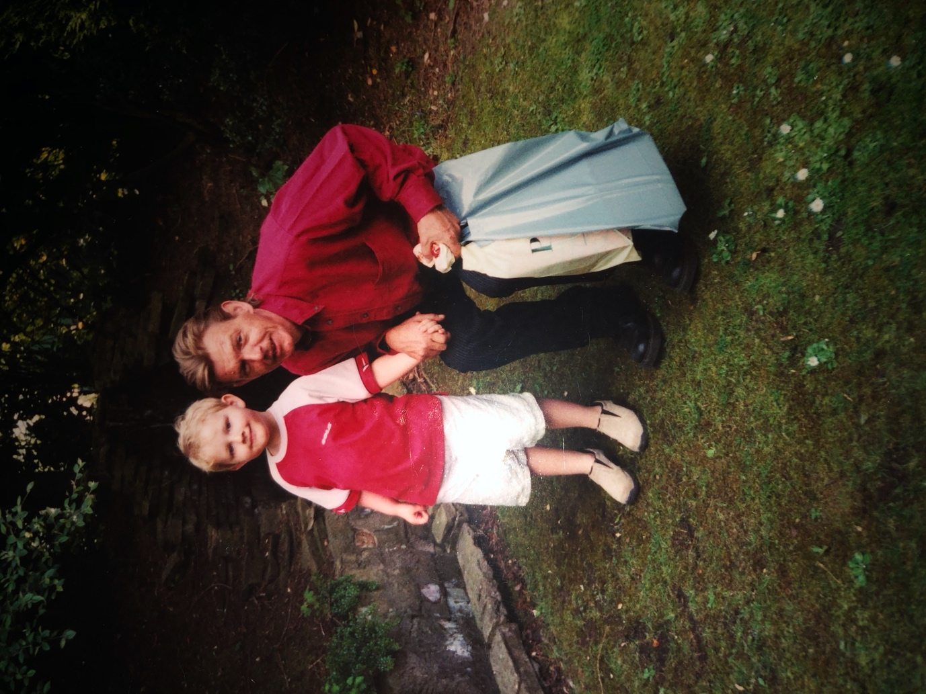
Family is a huge focal point in any memory, when we think of a memory it is very often based around a particular time revolving family, friends of people involved, other times perhaps an absence of friends and family. When I am prompted to think of a memory quickly, there is an almost immediate thought about family orientated memories. An act that happens subconsciously that we do not even attempt to decide whether it is based from family encounters or not, these memories are already pre-chosen. In addition to this the memories that we engage with are not always perfectly accurate, a photograph will add that level of authenticity and accuracy. Countless family memories that I have but cannot remember of my earlier days as a child, memories that my parents have captured though photography, but my personal connection cannot be made. An example of this is an image taken by my mother of my father and I, at around the age of four.

(Figure 3) Douglass, A. ‘Hornsea pottery’. (2003).
Both myself and my father are present in this image, my mother taking the photograph. Taken at Hornsea pottery, a family archive image from a day visiting the pottery as a family, at the age of four, everything so new and fresh, learning and adapting to the constructs of life. Merely a memory that is forgotten by age, too young to remember and engage. A memory that is unrecallable, I was involved yet I know nothing about that day, no remembrance or relation to what happened or who took this photograph. When in conversation with my parents, the location of this image and the time it was taken surfaced, learning more and more about the foundations of this image as they recalled. Why this image was even taken, questions of my involvement and what happened that day. For a day I was heavily involved in and a memory my parents cherish amongst many others, a reminiscence cannot be made. The connection of memory between both myself and my parents are broken in the sense that they can reminisce the memory more clearly, they were at an age of remembrance where four-year-old me was not, we were all included equally but remember differently.

In light of this, memories that are recalled and related with between multiple people will have different perspectives of a specific memory. An example of this is time itself, everyone who is involved in a memory will have different versions of the same memory which will ultimately form the original over many combined versions. Common points will form that are recalled by more than one individual, meaning if it is collectively remembered it is more viable as a truthful memory. One of my earliest memories as a child was a trip to flamingo land, a zoo and theme park as one. The visit was with a collective of family member, myself, parents, brother, cousins, aunt and uncle, it was my sixth birthday. A reminiscence from that time, the people involved, and the enjoyment of that day compiled to make a memory that will always be able to relate back to.
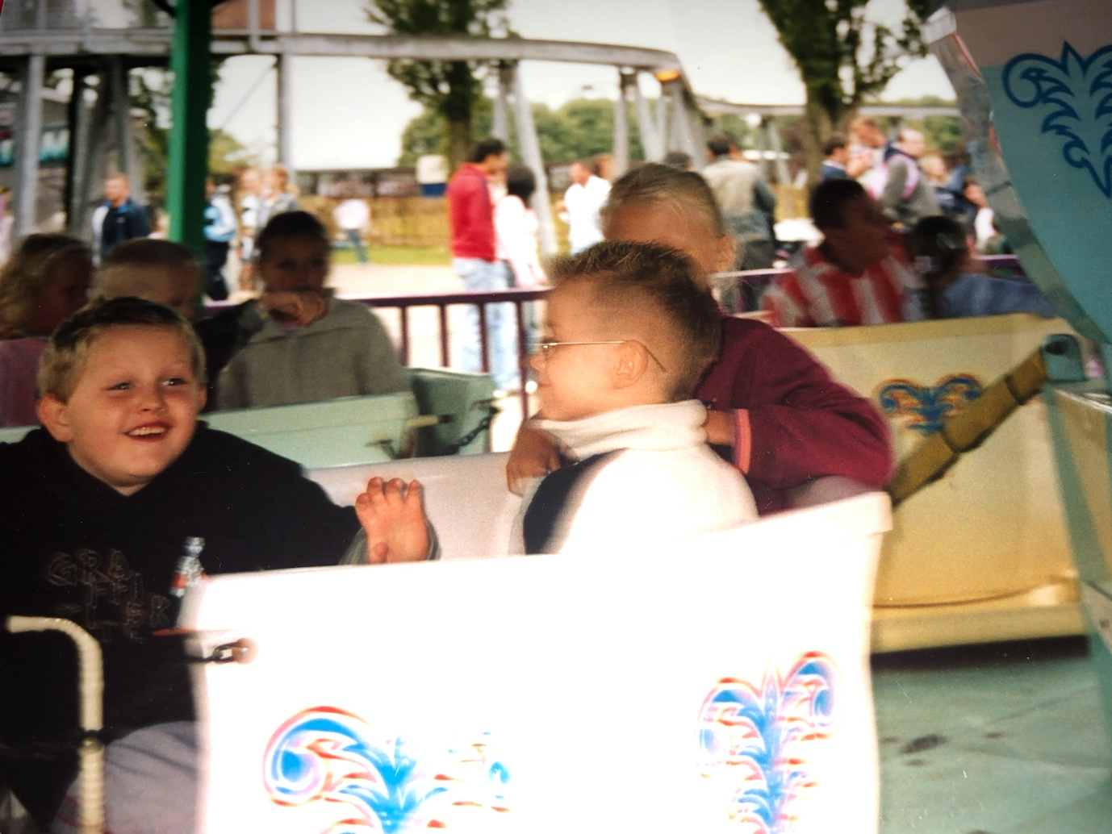

(Figure 4) Douglass, A. ‘Flamingo Land’. (2005).
An early moment that is remembered by myself and my parents, the reminiscence my parents had of this day was clearer and more detailed than my own. All I can remember is enjoying myself and feeling happy, overwhelmed by everything the park had to offer, a birthday celebration that will always be remembered. Although looking back through photographs of that day, of myself and my family the remembrance cannot entirely be made, a fragmented memory that only small subtleties can be remembered, even with the prompt of images from the entirety of that day. Without the remembrance of everything else that happened that day, remembrance of subtleties such as parts of the theme park, gifts from the gift shop and what shoe were on my feet. The details of what can be remembered are the things that were enjoyed and made me happy. Following this, the idea of fragmentation and remembrance of past times reflect the work of Patrick Zachmann which shows a similar thought of memory construction through his photographic work, he states about himself that:
I became a photographer because I have no memory. Photography allows me to reconstruct the family albums I never had, the missing images becoming the engine of my research. My contact sheets are my personal diary. (Zachmann, 2019).

Furthermore, some of Patrick Zachmann’s work portrays elements of family and memory but with a more abstract incentive, in explanation to this Veronique Poczobut (2005) writes:
Patrick Zachmann compares his own family story to that of today’s migrants. He tackles their relationship to the sea they cross and the mother they leave behind. He builds his narrative around the relationship between mothers and sons. (Poczobut, 2015).

In explanation of this Zachmann’s political reconstruction of memory and family follow migrants and make connections which create a false memory around individuals. Forging a connection between mother and son addressing a more intimate feeling that in reality is ultimately mother nature not a truthful and biological mother. This metaphor plays on the idea of traditional family images and creates a bubble of political incentive behind his images as well as a personal connection of his own family.

(Figure 5) Zachmann, P. ‘Mare Mater’. (2011)
Furthermore, connecting back to my personal experiences, another memory that is so highly important to my life is my own mother. How she has changed since my younger days, it’s interesting how photographs can show alterations to individuals, how a person looked years ago and how they look now, how age can be shown through images. An image below of my mother at the age of thirty-four:

(Figure 6) Douglass, S. ’Untitled’. (2002).
The seventeen-year difference between then and now are distinguishable through the past and present, the past of a photographic image and present through the current time. A photograph in this respect is never changing, the age my mother was at the time that photograph was taken will always remain the same, unchangeable. In correlation to this Ana Tostões and Ana Maria Braga (2013) write:
Photographs can play different roles: they can be just a visual record of structures in danger of loss, thus helping to preserve their memory; they can validate these objects as something worth preserving. (Tostões, A and Braga, M. 2013).

Maintaining a visual though photographic images maintain reality from that specific point. It holds factual history that is not directly changeable, a future reference can be made between past and present that allows us to remember past times.

The present is changeable through time, the passing of time will age and change the present. Similarly, my mother growing older and visually changing compared to past photographs that were taken of her. In relation to this, the work of Nicholas Nixon portrays a similar incentive of time moving forward through photographic images of his wife and her sisters over 42 years:
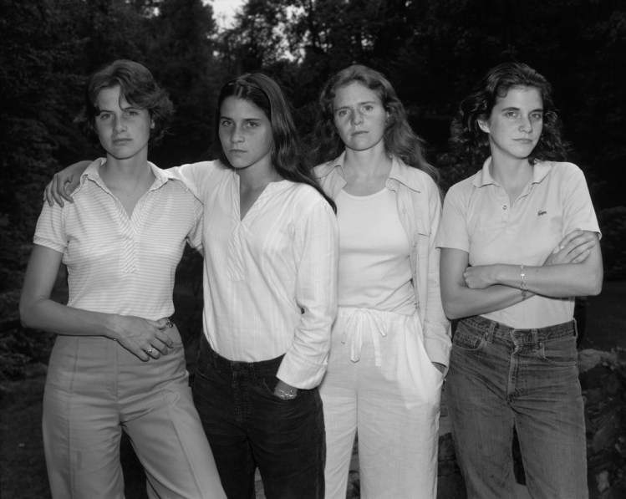
(Figure 7) Nixon, N. ‘The Brown sisters’ (1975).
Photography helps with a visualisation of time, how time continues forward indefinitely. A change through photographic images help us visualise and picture places, people and objects over time. People are a big factor in this, the passing of time for an individual is visually clear, they appear older, facial and bodily changes occur. Relating to (figure 6), my mother where she is younger, she has facial and bodily changes that differ from the present which implies she is getting older, wrinkles, face appearing older and more worn. A photograph has the ability to capture time in a specific moment, freeze time for a split second and have a single image captured. Capturing time and essence within images is subjective.

The collective of individuals who form the basis of a family is a major incentive for many people, the action of capturing family members through time, creating photographs to remember one another. The idea of an exclusive photograph from past time creating a memory for the photographer and the individuals being photographed. Based on the photographer that took the photograph has an impact on the memory in itself, and a memory the photograph has. If a family image was taken by an external photographer who knows little about the family and is just there to take the photograph, there is little significance. This is countered by actual family members taking family images, a sentiment lies with each photograph as each image were taken within the family. The sentimental value of my own archival family images is very high and mostly taken within the family, images of siblings and cousins and parents and mostly every other member. Family holds importance beyond words, photography is the foundation of which family archives are made, family memories rely on photography. In order for remembrance to become more than an internal memory from the past that will lose authenticity and ultimately the value and significance that memory has.

A Family photograph can tell stories of past relatives that younger relatives may not remember or even know directly. Photography can show age and past, how time is inevitable and will always leave its mark on the existing world. Memory is not always coherent; memories can be lost through time completely. An example of this is another family archival image by Alison Douglass (2003). An image of myself, brother Jamie and cousin Jordan:

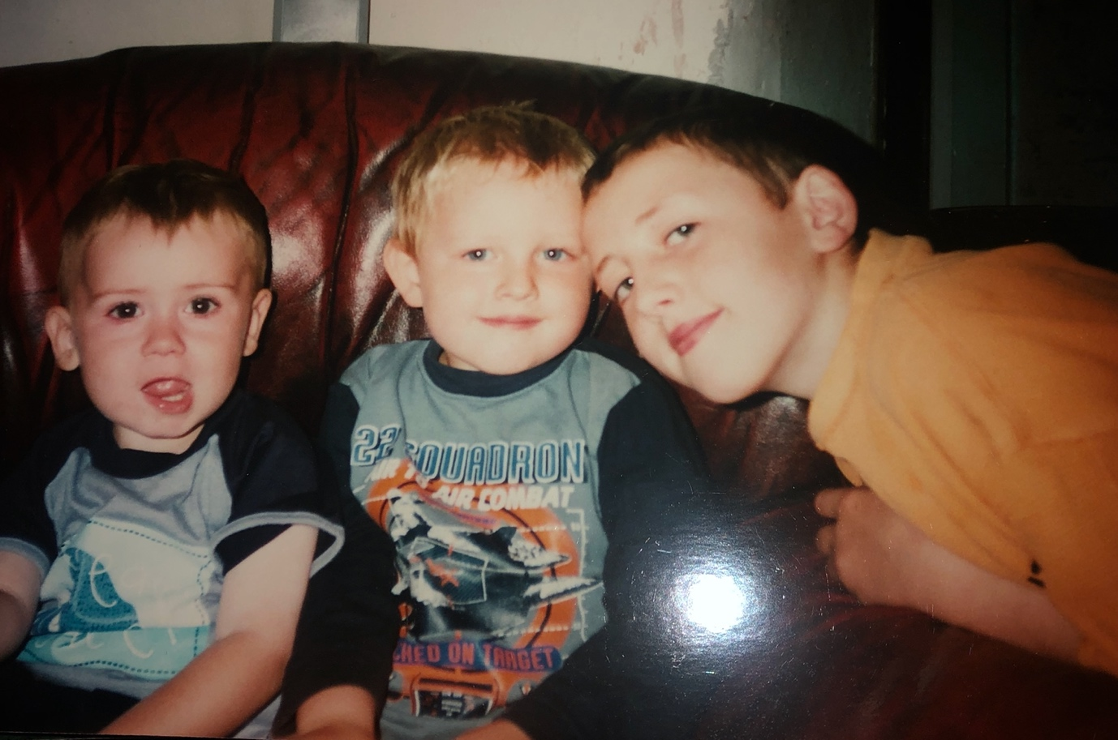
(Figure 8) Douglass, A. ‘Untitled’. (2003).
An image that is not remembered by all three participants. With the use of lens-based image making this memory is given a physical place in the world, but as an original, there is only one single version of this photograph physically. Arguably, within this dissertation images that were exclusively originals have been replicated digitally, allowing there to be more than one copy of said images. This thought contradicts the incentive of a photograph being physical and original. As the replication of images withdraw some of the sentiment that is attached to an image, it loses its exclusivity as a singular original.

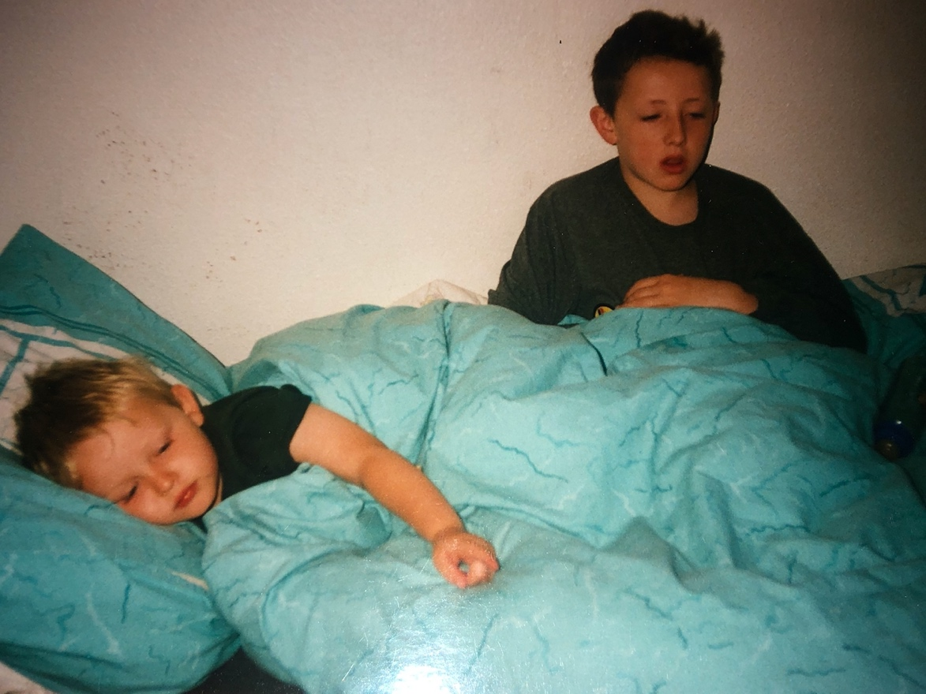
In contrast, not all family images captured are subject to positivity and happiness, although this is typically something that is always favoured when capturing photographic images. There are truths within images that display feeling and emotions. An example of this is another family archival image taken by Alison Douglass (2002):
(Figure 9) Douglass, A. ‘Untitled’. (2003).
This image displays my brother and I, both ill with a sickness bug. Capturing quite a sad and unpleasant experience shows that photography is subjective, not only happy moments were captured but moments that the photographer wanted to capture. A moment that was captured but not remembered by neither myself nor my brother but remembered by both of our parents. A brief moment of vulnerability, a moment that was lacking in happiness.
Furthermore, an aspect of family memories are story-based memories, memories that have been relayed from reminiscence alone, without the prompt of photography. A remembrance from the mind has no way of entirely being visually correct, our minds lose clarity from past memories. The interpretation of entirely mind generated memories lose sight of the factual event of the reality of said memory. Photographic practise is able to substantiate a memory with visibility of people, objects, places and world dynamics. A photographic visual allows us to connect more with a reminiscence that is told, these visuals support that memory. In contrast to this, the memories that are not present photographically are hard to distinguish between reality and fantasy.

In summary of this section, the aspects of family photography and memory sit hand in hand and compliment each other. A fully functioning memory needs a level of visual to form a more truthful reminiscence. Family photography does not become family photography without memory, remembrance is the sole reason for family album photographs. Conclusive to this, personal family images of myself and my family presented primarily around myself have been used within this chapter. Furthermore, explained how time itself has an impact on family images from past to present. Foreshown how emotions can be factored into family photography and address the fact that any emotion is able to be captured based upon the photographer, for my instances it was my parents. Finally, displaying how memory can alter the present thoughts of individuals based on their involvement within the memory.

Conclusion
In summary of this investigation, research into photography and memory were made. A look into how photography is a semi-permanent physical embodiment for memory beyond our minds. In addition, how photography had expanded through generations and in doing so allowing a shift in how photography shows memory and how it can be changeable through manipulation. A photograph can only account for a specific snapshot of what was captured. Sometimes disallowing the idea of emotion and feeling. Concluding this, the fact that a photograph itself obtaining additional memories based on its lifetime and history creating more than a memory of what it depicts literally and physically. Furthermore, this investigation concludes how the contemporary art scene has impacted the tradition of family images and how new ways of thinking allows for diversity within family photography and memory. In correspondence to this, delving into my own personal family images which are the incentive of my involvement with photography and memory. Connections between myself and my parents create a bridge for the difference and importance of both myself and my parent’s memory. Conclusive to this, an establishment of the importance individuals have over memory and their own involvement. Finalising how this can affect each memory holder based on the subjective significance to themselves allowing for memories that hold importance over others and will always be reminisced upon. Furthermore, the idea of selective memory based on the importance are filtered and kept subconsciously over others. Ultimately the bridge between photography and memory are significant and are in conjunction with one another. Enabling a memory specific event captured by photography to be made physically into a memory. Allowing it to be reminisced whenever desired, but the limit of reminiscence of that memory is based subjectively on the depiction of the photograph and what it portrays. In addition to this, research and understanding on family and significance photography has on preserving specific points within time that allow us to keep unchanged. Having researched into the understanding of family-based memories, allow us to control what we want to remember based on what is chosen to be documented. Ultimately, family photography and reminiscence of the past are in constant recollection and the interpretation and continuation of family photography will always continue.

Bibliography

Ana Tostões and Ana Maria Braga (2013). Preserving Collective Memory through Photography. Future Anterior: Journal of Historic Preservation, History, Theory, and Criticism, 10(2).

Barthes. R. (2000), Camera Lucida, (London, Vintage).

Cadava, E. (1997). Words of light. Princeton, N.J.: Princeton University Press.
Carucci, E. (2019). Mother—The Images I Still Love - Photographs and text by Elinor Carucci | LensCulture. [online] LensCulture. Available at: https://www.lensculture.com/articles/elinor-carucci-mother-the-images-i-still-love [Accessed 6 Dec. 2019].
Edwards, S. (2017). Ralph Eugene Meatyard’s Sweetly Southern-Gothic Family Album. [online] The New Yorker. Available at: https://www.newyorker.com/culture/photo-booth/ralph-eugene-meatyards-sweetly-southern-gothic-family-album# [Accessed 5 Dec. 2019].

Gross, D. (2000). Lost time. Amherst, MA: University of Massachusetts.

Hirsch, M. (1997). Family frames. Cambridge, Mass.: Harvard University Press.

LANGFORD, M. (2001). SUSPENDED CONVERSATIONS.: McGill-Queens University press.

Memento. (2000). [DVD] Directed by C. Nolan. Summit Entertainment.

Poczobut, V. (2015). Patrick Zachmann 'Mare Mater'. [online] PRIVATE photo review. Available at: https://www.privatephotoreview.com/2015/03/patrick-zachmann-mare-mater/ [Accessed 9 Dec. 2019].

Sutton, D. (2009). Photography, cinema, memory. Minneapolis, Minn.: University of Minnesota Press.
Wells, L. (2000). Photography. 2nd ed. Routledge.
Zachmann, P. (2019). Patrick Zachmann, Photographer Profile, Magnum Photos. [online] Magnum Photos. Available at: https://www.magnumphotos.com/photographer/patrick-zachmann/ [Accessed 9 Dec. 2019].
Photoworks (2013). Issue 20, family politics.

References
Ana Tostões and Ana Maria Braga (2013). Preserving Collective Memory through Photography. Future Anterior: Journal of Historic Preservation, History, Theory, and Criticism, 10(2).

Barthes. R. (2000), Camera Lucida, (London, Vintage).

Carucci, E. (2019). Mother—The Images I Still Love - Photographs and text by Elinor Carucci | LensCulture. [online] LensCulture. Available at: https://www.lensculture.com/articles/elinor-carucci-mother-the-images-i-still-love [Accessed 6 Dec. 2019].
Edwards, S. (2017). Ralph Eugene Meatyard’s Sweetly Southern-Gothic Family Album. [online] The New Yorker. Available at: https://www.newyorker.com/culture/photo-booth/ralph-eugene-meatyards-sweetly-southern-gothic-family-album# [Accessed 5 Dec. 2019].

Hirsch, M. (1997). Family frames. Cambridge, Mass.: Harvard University Press.

Poczobut, V. (2015). Patrick Zachmann 'Mare Mater'. [online] PRIVATE photo review. Available at: https://www.privatephotoreview.com/2015/03/patrick-zachmann-mare-mater/ [Accessed 9 Dec. 2019].

Sutton, D. (2009). Photography, cinema, memory. Minneapolis, Minn.: University of Minnesota Press.
Zachmann, P. (2019). Patrick Zachmann, Photographer Profile, Magnum Photos. [online] Magnum Photos. Available at: https://www.magnumphotos.com/photographer/patrick-zachmann/ [Accessed 9 Dec. 2019].

