Effective Team Working and Communication
Student Name: Daniela NicoletaFazakas
Student Number:1916669
Assignment Title: Effective Team Working and Communication
Module title:Effective Team Working and Communication
Module Lecturer's name:Shao-Lan Yuen

Table of Contents
Introduction 3
Literature and literature gap regarding communication skills 3
Analysis of communication of my workplace 4
Aristotle's model of communication 4
Barnlund's Transactional model of communication 5
Suggestion of improvement 7
Conclusion 8
Reference list 9

Introduction
Effective teamwork and communication are the primary elements in order to work within a workplace properly and effectively. Communication plays a major role in order to enhance the sustainable growth of the workplace. The report will follow some specific theories that are completely based on the communication skills within my workplace. Rather, this report also aims in analysing the communication skills of the workplaces. The report will tend to focus on some specific suggestions for the improvement of communication in my workplace in future. Therefore, the entire report aims in analysing communication skills and to develop some improvements of maintaining a good balance within my workplace. Therefore, the workplace can work with efficiency and properly in future smoothly and spontaneously.

Literature and literature gap regarding communication skills
Communication is the process through which two or more than two people engage themselves by sharing their ideas, emotions, thoughts with each other. It is very significant because through communication, the individuals are connected with each other and as a result, they develop a good relationship (Stanciu et al., 2016). It can be in the form of formal, informal, oral, written, intrapersonal, interpersonal, inter-departmental, inter-organisational. Staring from the learning process to developing skills, from decision making and leading teams to collecting feedback, communication serves as the active element within the organisational ecosystem. In fact, the communication network serves as the driving ability for an organisation to deal with both the internal and external changes as elucidated in the works of Stanciu et al. (2016). Communication plays a high role in the workplace. Therefore, there are found some specific theories and models in the literature that are completely based on the communication skills. There are some specific models namely Linear model of communication, Transactional model of communication and Interactional model of communication. Aristotle Model of Communication is very much effective and plays an immense role in the literature. The main theory of this communication is that the communication is held between the speaker and the listener in one way that means the speaker sends the message to the listener and the listener is not supposed to give feedback. On the contrary, the theory of Barnlund Model of communication is held in a process through which the speaker and the listener both take an immense part in the communication. As a result, the listener is supposed to give a feedback to the speaker after having the message. The literature gap can be recognized. The gap is that one model is giving the opportunity to the receiver while the other model is not providing any opportunity to the receiver. My workplace has followed both, Aristotle model of communication and Barnlund's Model of communication in order to develop the communication with different aspects and to perceive the behaviour of the employees.

Analysis of communication of my workplace
The theory of Aristotle model of communication is very much influential in my workplace. With this theory, my workplace has developed good communication skills. Through this theory, my workplace has been successful in enabling all the employees into one integration. Through this theory, the speaker plays an important role in the communication and seems to be very much active(Lamb, 2016). Through his activeness and agility, the employees of my workplace are very much influenced and thus, the workplace is having a good communication skill.

Aristotle's model of communication
Aristotle, a great philosopher has developed a communication system that contains five different elements namely Speaker, Speech, Occasion, Audience and effect. My workplace has followed these five components in its communication channel.
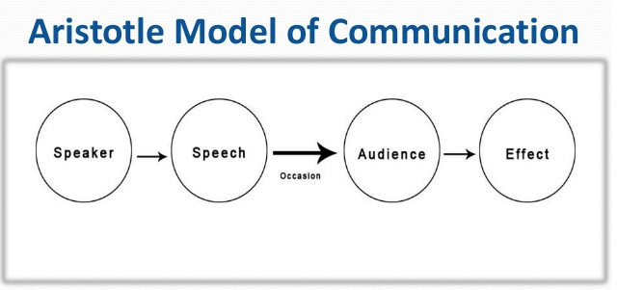
Figure 1: Aristotle model of communication
(Source: Ting et al., 2017)
Speaker: Speaker is the person who is supposed to deliver an essential speech to the public in order to provide a great deal of information. In this respect, my workplace is performing the role of the speaker. The workplace has taken the entire responsibility to give the thoughts and ideas with providing the details of information that is related to our work. My company has undertaken the job to create an influence on me and on the other colleagues in order to work with efficiency. In this respect, my all the colleagues including me have found that we are just playing the role of listeners since we do not have the right to present any point of view or utilize the innovative ideas and thoughts (Ting et al., 2017). Therefore, this communication is just maintained between the sender(workplace) and the listeners(us).
Speech: The speech is referred as the spoken details of piece of work to usein the workplace. In this respect, my workplace has taken the initiative to deliver a good speech in order to create a great impact on ourselves. The workplace plays a key role in giving full information of valid sources to us and then we can implement those important and essential information in our work. Through delivering a good speech, the workplace tends to impress us and, thus, it communicates with us within the workplace (Jana et al., 2018).
Occasion: Here, the occasion is referred as the time of working. In my workplace, we become so much busy in respect of our work. Therefore, the workplace observes every time through which my all colleagues and me have been going through. As a result, the workplace has found that somewhere, we are not effectively working and experiencing some complexities in our work (Jana et al., 2018). At that specific occasion, my workplace takes the initiative to solve the problems that have been encountered by all of us. In this way, my workplace attempts to communicate with us by solving the problems.
Audience: Here 'audience' refers to all my colleagues including me. After having a tremendous and influential speech, we find ourselves immensely influenced. In this respect, we play a major role for the welfare of the company and hence, the workplace has undertaken the job to impress us by communicating with us and hence, our expectations become high and we remain loyal to the workplace (Genç, 2017).
Effect: The 'effect' comes in the form of result. Through the communication, the workplace has provided all the details of information to us that results in the progression of our work (Ting et al., 2017). Hence, the workplace followed this communication system has been processed in one way from the speaker (workplace) to the receiver (me and the colleagues).

Barnlund's Transactional model of communication

The theory Barnlund's transactional model of communication is very much beneficial and influential. Through this theory, my workplace has achieved tremendous success in respect of business. Through this theory, my workplace is able to gain a greater participation from the employees since it provides us with the advantage to give the feedback after receiving the message from the speaker. As a result, this theory creates a great impact on the employees and satisfy us and further, the communication system is enhanced.
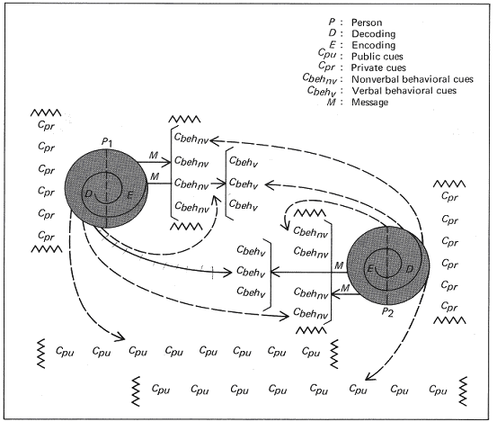
Figure 2: Barnlund's model of communication
(Source: Barnlund, 2017)
Public Cues: My workplace has taken the initiative to provide some valid information that is related to environment or nature and body language. The workplace has taken the initiative to communicate with me and my colleagues. The message from the speaker (workplace) is verbally spread to me within the workplace. In this way, I am able to give the feedback through the communication and as a result, the effectiveness is being progressed. The speaker and the listener are playing a major role in order to keep and foster the communication. In this respect, I listen to my workplace and this is the main principle of transactional model. Therefore, when I listen to my workplace and consequently, Ipossess the same right to give the feedback to the workplace. Therefore, the workplace is able to achieve the feedback from the listener that is the key material of transactional model of communication (Barnlund, 2017).
Private cues: Private cues are referred as the communication is developed among each other by sharing the ideas and information from an acquainted person to other. My workplace is willing to follow this principle of transactional model through which it enables all the employees in one integration. As a result, my all colleagues andI, are developing a good communication as they share same thoughts and ideas. Therefore, interactions and conversations of ours have developed a good communication skill (Genç, 2017). This initiative is provided by my workplace.As a result, I am able to give feedback to the workplace through which the effectiveness of the communication has been increased immensely and precisely.
Behavioural cues: Behavioural cues are related to the body language of the persons who work within the workplace. I have experienced a great advantage of developing a good communication skill, provided by the workplace. When the workplace shares some information through messages or through phones, I along with my colleagues find difficulties in realising the significance of the information. Then workplace takes the initiative to provide that same amount of information through face to face with me and my colleagues.As a result, we have successfully perceived the message sent from the speaker (workplace) Therefore, the workplace has followed this principle of transactional model through which the workplace has verbally sent the message to me and to mycolleagues and as a result, we are able to give feedback to the sender (Jana et al., 2018).

Suggestion of improvement
The communication is a major mean and one of the most significant aspects that every workplace tries to foster it among all the employees. At first, my workplace should develop a good leadership style in order to communicate with its employees. As a result, the employees become more attentive and concentrated in respect of work and then consequently, they develop a good communication system with the workplace (Genç, 2017). My workplace should provide an equal opportunity to its working employees in order to acquire the feedback of employees and to have our point of view regarding the topic, we have been taught.
My workplace can utilize the benefits of the internet in order to improve the communication system. Internet has become advantageous in the means of communication. As a suggestion, my workplace can use the emails in order to communicate with the employees formally. Through sending mails, the workplace can present a good and appreciated piece of work and when it receives a positive feedback from the employees, the communication is successfully improved (Shen et al., 2016). My workplace has to utilize the informal communication through social networking sites in order to make us informative about the importance of public cues, private cues and the behavioural cues. In this way, the workplace can develop a good communication skill with the employees. The employees are very much active on the social media. The workplace can make a great attempt in order to know us more personally by developing a good communication with us. Through social media, my workplace can chat with us and develop a good understanding with us personally (Shen et al., 2016).
According to Aristotle model, my workplace does not show any willingness to have the feedback, the workplace can summon a meeting over a month in order to get the feedback from the employees. Through this initiative, the workplace can receive a larger participation from the employees. As a result, the workplace can get a particular perspective view about the behaviour and attitude of the employees.Barnlund's transactional theory is too hard to be discernible and noise has hampered the process. Therefore, my workplace should make some possible methods in order to make us understand about the importance of transactional model and thus, in this process, the workplace steps in closer to develop a good communication with me and my colleagues (Lamb, 2016).

Conclusion
Throughout the entire report, it has been totally analysed that the communication within the workplace plays a crucial role. Through the communication system, the two major persons who playing an important role, are respectively the speaker and the listener. The listener listens to the speaker and then, the listeners possess a right to give feedback to the speaker. As a result, the communication is developed between the speaker and the listener. In order to improve communication in a better note, the benefits of internet have been advantageous and influential.

Reference list
Barnlund, D.C., 2017. A transactional model of communication. In Communication theory (pp. 47-57). Routledge.
Genç, R., 2017. The importance of communication in sustainability & sustainable strategies. Procedia Manufacturing, 8, pp.511-516.
Jana, M., Nieuwoudt, S., Kumwenda, W., Chitsime, A., Weiner, R. and Christofides, N., 2018. Measuring social and behaviour change communication capacity in Malawi. Southern African Journal of Public Health, 2(4), pp.69-73.
Lamb, M. and Lane, M., 2016. Aristotle on the ethics of communicating climate change. Climate justice in a non-ideal world, pp.229-254.
Stanciu, A.C., Condrea, E. and Zamfir, C., 2016. The importance of communication in quality management. Ovidius University Annals, Economic Sciences Series, 16(2), pp.393-396.
Ting, S.H., Marzuki, E., Chuah, K.M., Misieng, J. and Jerome, C., 2017. Employers’views on importance of english proficiency and communication skill for employability in malaysia. Indonesian Journal of Applied Linguistics, 7(2), pp.315-327.

