  ASSIGNMENT: Comparison of Two Hospitality Organizations Business Report. (Financial management for the hotel industry) | Executive Summary  This report compares the financial performance of Hayat and Marriott. Revenue, profitability, market position, growth, and sustainability evidence were the factors analysed in the report. Hayat and Marriott have strong market positions, but Marriott is more profitable and has more significant revenue than Hayat. In addition, Marriott and Hayat demonstrated sustainability efforts in their operations, with Hayat showing a higher growth rate than Marriott in 2020. Although Marriott performs better financially, Hayat is a close competitor, and both follow standard operating procedures.  Mohammad Shahidul Islam Chowdhury, Student Id: 2026960  Lecturer: Christopher Wilkin

Table of Contents:

Introduction 2
Total Revenue 2
Total Revenue of Hayat Group over the years 2
Total Revenue of Marriott Group over the years 3
Profitability 3
Profitability of Hayat Group over the years 3
Profitability of Marriott Group over the years…………………………………. 4
Market Position and Stability 4
Market Position and Stability of Hayat Group 4
Market Position and Stability of Marriott Group …………………………………. 5
Growth potential 7
Growth Potential (Hotel Hayat Group) 7
Growth potential (Hotel Marriott Group) …………………………………. 7
Sustainable Action Hyatt and Marriott 7
Recommendation 8
Recommendation About Hayat Group 8
Recommendation About Marriott Group …………………………………. 8
Conclusion 9
Reference 10

Introduction:
A significant role is played by the hotel industry worldwide. Planning, organising, and controlling are all business financial management components. In addition, they are developing and implementing monetary policies, procedures, or programs. The hospitality industry relies heavily on financial management. Effective financial management is crucial to the success of a hospitality business. Financial planning and control can ensure that a company meets its obligations and achieves its goals. The hospitality industry is highly competitive and dynamic. This sector has significantly impacted global economic growth over the past few decades. Globally, the hotel industry contributes a significant amount to the GDP. The hotel industry is competitive, with companies like Hayat and Marriott competing. A critical analysis and comparison of the financial performance of these two groups is presented in this report. Additionally, the information will examine profitability, market position, growth, and sustainability evidence.
Total Revenue:
A hotel group's financial success is determined by its total revenue. In addition to their hotel operations, the Hayat Group and Marriott Group also offer spas, fitness centres, and food and beverage services. The exact details of their total income are difficult to provide since it depends on several factors, including the chain size, location, seasonality, and global economic conditions. However, the long-term performance of the hotel Hayat can be assessed by analysing its financial statements over a long period. Likewise, Marriott's growth patterns, financial stability, and performance can be gathered from its long-term financial statements and reports.
Total Revenue of Hayat Group over the years: 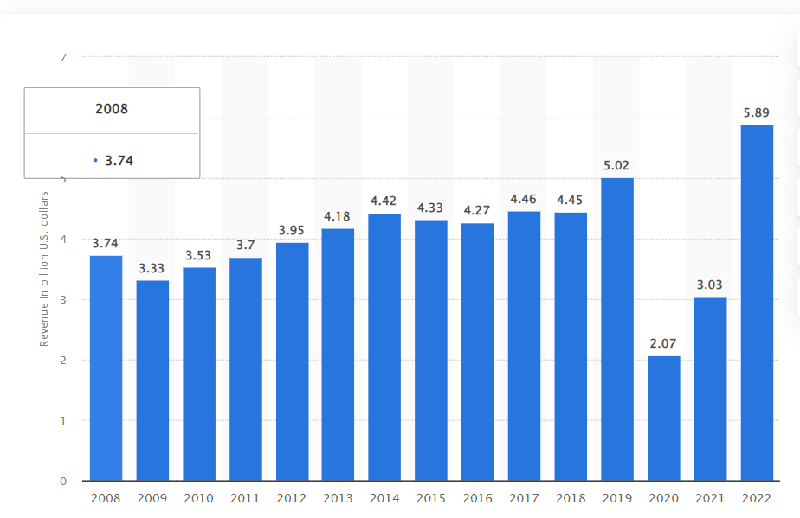
(Statista, n.d.)

Total Revenue of Marriott Group over the years:
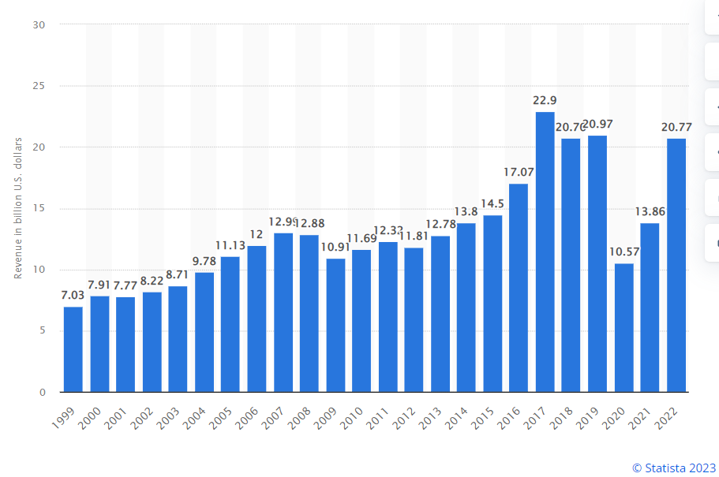
(Statista, 2023)
Profitability:
Measuring profitability is also essential. Marriott and Hayat have made money on it over the years. For a hotel to be profitable, operating profit margins, gross profit margins, and net profit margins should all be considered. Comparing these ratios can also give us an idea of the company's financial health. For example, we can determine Hotel Hayat's profitability by analysing key profitability ratios. Marriott's profit margins are higher than Hayat's.
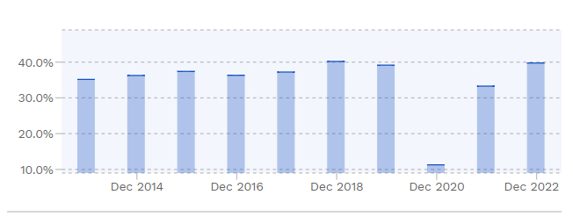
Profitability of Hayat Group over the years:

(Finbox.com, 2023)
Its latest twelve-monthly gross profit margin is 42.9%. From December 2018 to December 2022, Hyatt Hotels Group's gross profit margin was 39.2%. From December 2018 to December 2022, Hyatt Hotels Group generated a median gross profit margin of 39.2%. However, Hyatt Hotels' gross profit margin reached its five-year low by 11.3%. Hyatt Hotels Group's gross profit margin decreased in the following years: 2019 (39.2%, -2.6%), 2020 (11.3%), and March 2023 marked Hyatt Hotels' peak gross profit margin at 42.9%.
Profitability of Marriott Group over the years:
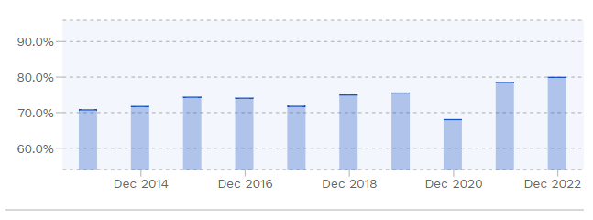
(Finbox.com, 2023)
Its latest twelve-monthly month gross profit margin is 82.9%. From December 2018 to December 2022, the gross profit margin for Marriott International in the fiscal years ending December 2018 to 2022 was 75.4%. Between December 2018 and December 2022, Marriott International generated a median gross profit margin of 75.5%. In 2020, Marriott International's gross profit margin dropped by 9.9% to 68.1%. 2018 saw a 4.5% increase in gross profit margin to 75.0%. In 2019, it increased by 0.7% to 75.5%. In 2021 and 2022, it increased by 14.5% to 78.5%. In 2021 and 2022, it increased by 14.5% to 78.5%. In March 2023, Marriott International's gross profit margin peaked at 82.9%.
Market Position and Stability:
Market share, customer satisfaction ratings, brand recognition, and regional presence can all provide indications of Hotel Hayat & Marriott's position in the market. In addition, hotel Hayat can be assessed for its financial stability based on its debt-to-equity ratio, liquidity ratio, and financial leverage. Therefore, Marriott's financial stability can be evaluated by analysing its debt-to-equity ratio, liquidity ratios, and financial power.
Market Position and Stability of Hayat Group:
The company has increased its revenue in both quarters due to its continued and sustained recovery from rock bottom in the last few years. The company is well-positioned in the market even though it is still undergoing massive changes. The company has struggled to capture demand since it launched limited operations two years ago. Therefore, its prospects for growth and recovery are more evident and promising. Although Covid-19 and monkeypox have caused fears, revenge travel remains popular. In addition, inflation does adversely affect leisure and business travel. Hyatt Hotels' market capitalisation is $12.11 billion. As a measure of company value, market capitalisation is the sum of the market value of the company's outstanding shares.
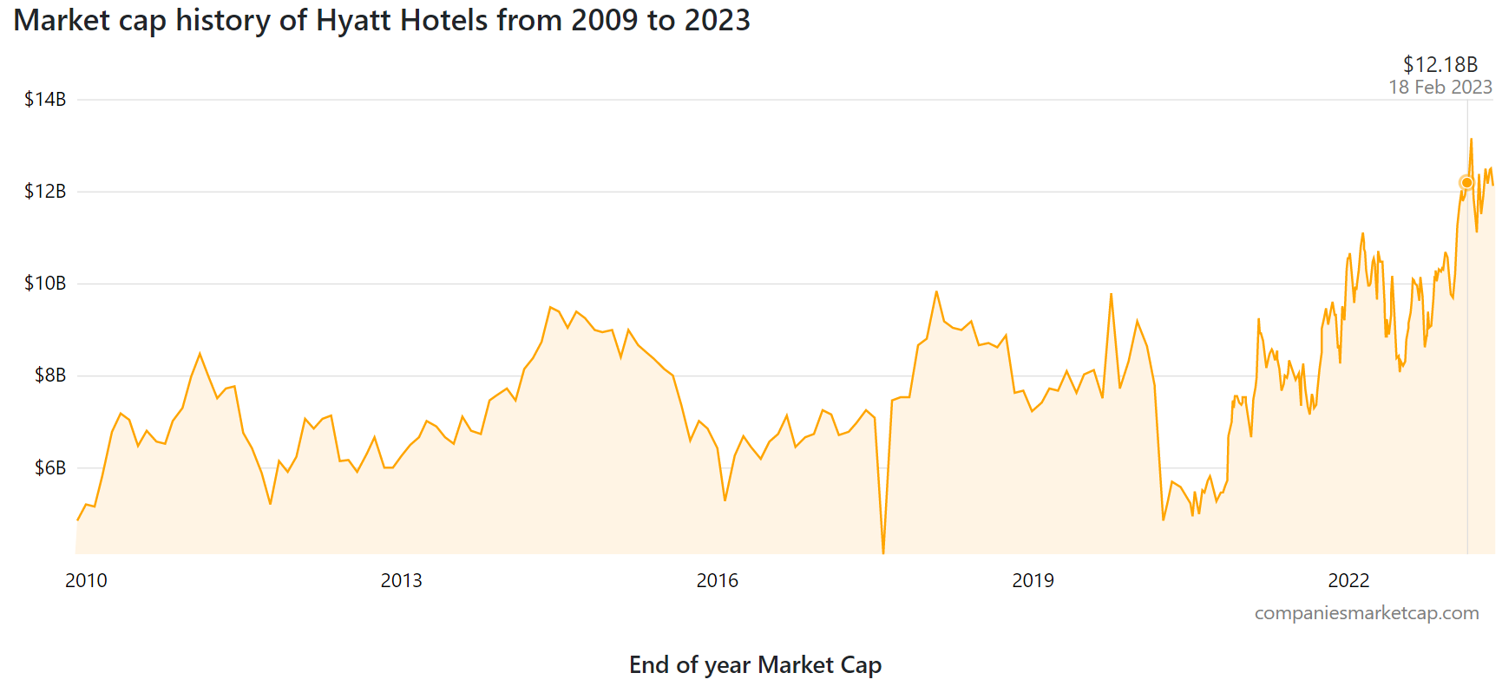(companiesmarketcap.com, n.d.)

Chart: End of year Market Cap
Year | Market cap | Change
2023 | $12.07 B | 24.59%
2022 | $9.68 B | -8.12%
2021 | $10.54 B | 40.36%
2020 | $7.51 B | -18.12%
2019 | $9.17 B | 27.29%
2018 | $7.20 B | -18.04%
2017 | $8.79 B | 21.61%
2016 | $7.23 B | 12.89%
2015 | $6.40 B | -28.64%
2014 | $8.97 B | 16.25%
2013 | $7.72 B | 23.52%
2012 | $6.25 B | 0.55%
2011 | $6.21 B | -21.9%
2010 | $7.96 B | 53.57%
Market Position and Stability of Marriott Group:
A major hotel chain in the world, Marriott is among the largest. It operates under several brands, including Marriott Hotels, JW Marriott, Ritz-Carlton, Sheraton, Westin, and others. With a strong market position and a reputation for quality service, Marriott enjoys a strong position in the industry. Marriott's stability can be attributed to several factors. The company's portfolio of brands caters to various market segments, from luxury to budget travellers. Risks can be mitigated by diversifying based on consumer preferences and economic conditions. As an additional benefit, Marriott Bonvoy rewards customers who stay at Marriott hotels with a robust loyalty program. Members receive various benefits, including free upgrades, exclusive experiences, and free nights when redeeming points. A large part of Marriott's stability comes from its loyal customers. In May 2023, Marriott International reached a market capitalisation of $54.50 billion. Marriott International is ranked 289th by market cap. The market capitalisation of a company is its total stock market value.
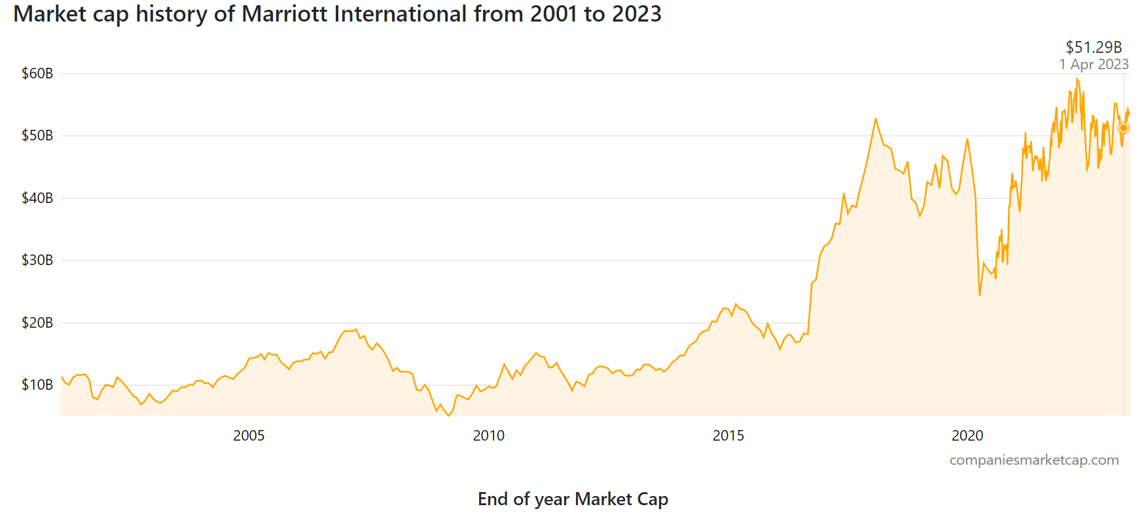(companiesmarketcap.com)

Chart: End of year Market Cap
Year | Market cap | Change
2023 | $53.78 B | 14.12%
2022 | $47.12 B | -12.42%
2021 | $53.81 B | 25.78%
2020 | $42.78 B | -13.58%
2019 | $49.50 B | 33.69%
2018 | $37.03 B | -25.16%
2017 | $49.48 B | 53.27%
2016 | $32.28 B | 87.9%
2015 | $17.18 B | -22.29%
2014 | $22.11 B | 50.35%
2013 | $14.70 B | 26.92%
2012 | $11.58 B | 18.53%
2011 | $9.77 B | -35.39%
2010 | $15.13 B | 55.43%
Growth potential:
Hotel Hayat and Marriott Group have significant growth potential, driven by their strong brand reputation and expanding market presence.
Growth potential (Hotel Hayat Group):
Capitalises on global macro trends by taking advantage of all-inclusive experiences and guest attractions, leisure travel's durability, and group and transient business demand. The Luxury, Lifestyle, and Resort brands are expected to represent 44% of Hyatt's rooms by 2020, up from 32% in 2017. The Company has taken proactive measures to become asset-light, cash-generative, and high-growth. As a result of acquiring high-growth platforms and launching new brands, Hyatt has used many of its leased assets. Improving a company's financial health is possible by making efficient operations, controlling costs, and managing finances effectively. Two of Hyatt's top priorities are growth and return of capital to shareholders. From 2023 to 2025, Hyatt anticipates generating approximately $3.3 billion in cash from asset dispositions and Free Cash Flow.
Growth potential (Hotel Marriott Group):
Marriott intends to drive additional growth in this market through its proven brands. Marriott International operates 28 all-inclusive properties in the Caribbean, Mexico, and Central America. Autograph Collection Hotels' first all-inclusive resort agreement in North Africa and Marriott's first all-inclusive resort agreement in North Africa set a company record for Marriott International in 2021. Marriott may have growth opportunities as customer preferences change and new markets emerge. Hotel operations must generate revenue, costs must be managed efficiently, profit margins must be healthy, and Marriott must invest strategically in new properties to maintain strong financial performance. In order to assess Marriott's financial situation, it is necessary to review its financial statements and reports. Marriott Hotels' demand and supply dynamics differ based on market segments and locations.
Sustainable Action Hyatt and Marriott:
Hyatt plans to achieve ambitious environmental sustainability goals by 2020. The goals of hotel chains are energy, water, and greenhouse gas emissions. Throughout the world, Hyatt donated 35,000 books to children, built 11 libraries, and supported 30 schools. Thirty thousand students in India have also benefitted from Hyatt's reading and writing programs. The hotel giant has also partnered with WWF to ensure that all seafood served in its restaurants is sustainable.
Marriott International pioneered a system that scored green buildings with resource-efficient designs in the early years of LEED. Besides reducing water consumption, carbon dioxide emissions will be reduced by 30%, waste to landfills will be reduced by 45 per cent, and food waste will be reduced by 50 per cent. Our business management, people empowerment, and advancing the rights of all are divided into four categories. As part of its commitment to sustainable success, the company invests in conservation initiatives, such as protecting the Amazon Rainforest. Small amenity bottles are replaced with recyclable dispensers at select hotels in North America. In addition, Marriott plans to attain LEED certification for 650 properties by 2025. By 2020, LEED standards will be integrated into building design and renovation (225 hotels have already achieved LEED certification).
Recommendation:
Marriott Group and Hotel Hayat have the potential to grow through sustainable practices, a strong market position, and meet evolving customer demands. Therefore, I would highly recommend exploring these avenues for more success.
Recommendation About Hayat Group:
Guest amenities and services at Hotel Hayat are standard. However, the hotel Hayat should offer a customised experience and upgraded facilities to differentiate itself and attract a broader customer base. Modern furnishings, comfortable beds, premium toiletries, and in-room entertainment systems are just some amenities Hotel Hayat could upgrade its rooms to include. A concierge service can also provide guests with recommendations based on their interests in local attractions and activities. In addition, a hotel's partnership with local businesses, such as spas and restaurants, can also offer guests exclusive discounts and packages.
Hotel Residence has faced financial challenges, such as stagnant revenue growth and declining profitability. Hotel Residence should focus on cost optimisation to improve its financial performance. Hotel Residence can conduct operational cost reviews to identify inefficiencies. Investing in energy-efficient technologies and analysing energy consumption patterns can reduce utility costs. A better deal can be negotiated with suppliers to minimise procurement costs. A sound inventory management system can reduce waste, prevent overstocking, and save money.
Recommendation About Marriott Group:
Marriott International can expand its presence in the luxury segment by partnering with an existing luxury hotel brand. As a result, Marriott could capture a more significant share of the luxury travel market by using the luxury brand's reputation and expertise. Additionally, Marriott can leverage its service and customer experience expertise to partner with an iconic luxury hotel brand. As a result, Marriott can gain instant recognition by collaborating with this brand and gaining access to a loyal customer base.
Marriott International can demonstrate its commitment to sustainability by using renewable energy sources to power its hotels. By installing solar panels, wind turbines, or other renewable energy systems, Marriott can reduce its dependency on fossil fuels. For example, Marriott might install solar panels on its hotels' roofs in partnership with a renewable energy provider. Thus, some of the properties' electricity needs could be met using clean, renewable energy. By doing so, Marriott can demonstrate its commitment to environmental conservation and reduce energy costs in the long run.
Conclusion:
The report concludes by critically analysing and comparing the financial performance of Hyatt and Marriott. Marriott has a stronger market position and a more recognisable brand, but both companies have shown consistent growth and profitability over the years. However, Hyatt has made significant strides in expanding its global footprint and increasing its brand recognition in recent years.
Additionally, Marriott has invested in renewable energy and implemented sustainable practices in its hotels, while Hyatt has implemented sustainable practices in its hotels. However, due to the COVID-19 pandemic, the hotel industry has suffered a significant impact. Still, both companies have taken measures to ensure their guests' and employees' safety and well-being, including enhanced cleaning and sanitisation measures, social distancing guidelines, and contactless check-in procedures.

Reference:
antaranews.com (n.d.). Hyatt Strengthens Position as Leader in Luxury, Lifestyle and Leisure in 2023 and Beyond with Record Global Pipeline. [online] Antara News. Available at: https://en.antaranews.com/news/270225/hyatt-strengthens-position-as-leader-in-luxury-lifestyle-and-leisure-in-2023-and-beyond-with-record-global-pipeline.

Breaking Travel News. (2023). Hyatt Hotels Corporation Sees Continued Growth in EAME Markets. [online] Available at: https://www.breakingtravelnews.com/news/article/hyatt-hotels-corporation-sees-continued-growth-in-eame-markets/.

companiesmarketcap.com. (n.d.). Hyatt Hotels (H) - Market capitalisation. [online] Available at: https://companiesmarketcap.com/hyatt/marketcap/.

companiesmarketcap.com. (n.d.). Marriott International (MAR) - Market capitalisation. [online] Available at: https://companiesmarketcap.com/marriott-international/marketcap/.

Clements, M. (2022). Positioning Strategy for 6 Leading Travel Brands. [online] Insight To Action. Available at: https://itoaction.com/positioning-strategy-for-6-leading-travel-brands/.

Finbox.com. (2023). The Complete Toolbox for Investors | finbox.com. [online] Available at: https://finbox.com/NASDAQGS:MAR/explorer/gp_margin/.

Free Essays. (n.d.). Hyatt Hotels Corporation and Industry Analysis - 8223 Words | Report Example. [online] Available at: https://ivypanda.com/essays/hyatt-hotels-corporation-and-industry-analysis/.

Hotel Tech Report. (2020). Hotel Brands & Chains: Marriott, Hyatt, Hilton, IHG (Who Owns What?). [online] Available at: https://hoteltechreport.com/news/hotel-brand-guide.

Hyatt Newsroom. (n.d.). Hyatt Reports Fourth Quarter and Full Year 2022 Results. [online] Available at: https://newsroom.hyatt.com/news-releases?item=124350.

investors.hyatt.com. (n.d.). Around the World of Care: Hyatt Shares Progress Update Across Environmental, Social and Governance Commitments and Initiatives. [online] Available at: https://investors.hyatt.com/investor-relations/news-and-events/financial-news/financial-news-details/2022/Around-the-World-of-Care-Hyatt-Shares-Progress-Update-Across-Environmental-Social-and-Governance-Commitments-and-Initiatives/default.aspx.

Lock, S. (2022). Marriott: hotels worldwide 2009-2018 | Statista. [online] Statista. Available at: https://www.statista.com/statistics/247285/number-of-marriott-international-hotels-worldwide/.

Macrotrends (2019). Marriott Revenue 2006-2019 | MAR. [online] Macrotrends.net. Available at: https://www.macrotrends.net/stocks/charts/MAR/marriott/revenue.

Marriott International Newscenter (US). (n.d.). Marriott International Provides an Update on Development Progress in 2021 and Overview of Key Trends Currently Shaping Hospitality Development. [online] Available at: https://news.marriott.com/news/2022/01/20/marriott-international-provides-an-update-on-development-progress-in-2021-and-overview-of-key-trends-currently-shaping-hospitality-development.

marriott-sustainability-goals-for-2025-and-beyond. (n.d.). Marriott Sustainability Goals for 2025 and Beyond. [online] Available at: https://www.ecolab.com/stories/marriott-sustainability-goals-for-2025-and-beyond#:~:text=Marriott%20has%20ambitious%202025%20sustainability.

Market, I.T.S. (2022). Hyatt Hotels: Strong Positioning Amidst the Summer Travel Splurge | Seeking Alpha. [online] seekingalpha.com. Available at: https://seekingalpha.com/article/4535325-hyatt-hotels-strong-positioning-amidst-the-summer-travel-splurge.

Silverstein, K. (2022). Marriott Reduces Water and Energy Use by Double-Digits. [online] Environment + Energy Leader. Available at: https://www.environmentalleader.com/2022/07/marriott-is-an-environmental-leader-reducing-water-and-energy-use-by-double-digits/.

Statista. (n.d.). Hyatt Hotels: Revenue 2019. [online] Available at: https://www.statista.com/statistics/257362/revenue-of-the-hyatt-hotels-corporation/.

Statista (2023). Marriott International: revenue 1999-2023 | Statista. [online] Statista. Available at: https://www.statista.com/statistics/266279/revenue-of-the-marriott-international-inc-hotel-chain/.

Stoller, G. (n.d.). New Study: Hyatt Has Best Hotel Policies During Pandemic. [online] Forbes. Available at:https://www.forbes.com/sites/garystoller/2020/08/03/new-study-hyatt-has-best-hotel-policies-during-pandemic/.

Trefis. (n.d.). Hyatt Hotels Revenues: How Does Hyatt Make Money? [online] Available at: https://www.trefis.com/data/companies/H/no-login-required/8QfVTU97/Hyatt-Hotels-Revenues-How-Does-Hyatt-Make-Money-.

www.fcmtravel.com. (n.d.). The rise of the sustainable hotel. [online] Available at: https://www.fcmtravel.com/en-gb/resources/guides/rise-sustainable-hotel.

www.businesswire.com. (2023). Hyatt Investor Day to Highlight Asset-Light Transformation and Expectations for Significant Expansion in Free Cash Flow. [online] Available at: https://www.businesswire.com/news/home/20230511005160/en/Hyatt-Investor-Day-to-Highlight-Asset-Light-Transformation-and-Expectations-for-Significant-Expansion-in-Free-Cash-Flow.

www.hpac.com. (n.d.). StackPath. [online] Available at: https://www.hpac.com/columns/engineering-green-buildings/article/20929978/sustainable-hospitality-global-lodging-grows-greener.

www.linkedin.com. (n.d.). Quality in Hospitality - Marriott Hotels Case Study. [online] Available at: https://www.linkedin.com/pulse/quality-hospitality-marriott-hotels-case-study-tsvetan-bankov.

www.macrotrends.net. (n.d.). Hyatt Hotels Revenue 2010-2022 | H. [online] Available at: https://www.macrotrends.net/stocks/charts/H/hyatt-hotels/revenue#:~:text=Hyatt%20Hotels%20annual%20revenue%20for.

www.macrotrends.net. (n.d.). Marriot Vacations Worldwide Revenue 2010-2020 | VAC. [online] Available at: https://www.macrotrends.net/stocks/charts/VAC/marriot-vacations-worldwide/revenue.

ycharts.com. (n.d.). Hyatt Hotels Gross Profit Margin (Quarterly). [online] Available at: https://ycharts.com/companies/H/gross_profit_margin
‌Xaif (2023). Detailed Marketing Strategy of Marriott International - A Case Study | IIDE. [online] Available at: https://iide.co/case-studies/marketing-strategy-marriott-international/#:~:text=Marriott%20is%20one%20of%20the.

