Aberbargoed Festival
  - Feasibility Report

Paige Ford P146228 M6X02113

Client Contact Details
Julia Evans – jmdavies36@aol.com

Executive Summary
Events in and around Aberbargoed have been sparse, but well attended when they have been held. In this sense, this feasibility report investigated whether a festival could be held in Aberbargoed in terms of best location, market research and wider feedback. The objectives covered Aberbargoed’s road infrastructure, accessibility and car parking, alongside target audience demographics, whether there is a demand for this type of event and what the residents of Aberbargoed and the surrounding areas wanted to see at the festival.
The consultants’ recommendations show that the best location for this event would be Aberbargoed recreation ground. The infrastructure surrounding this venue is substantial and would manage more cars being in the area due to the intertwining road structure surrounding the recreation ground. Furthermore, there is an application that can be submitted to Caerphilly County Council to apply for road closures for special events. Accessibility for the disabled was a priority of the client. The venue has wheelchair access and the hanger (indoor venue onsite) has wheelchair access at the front and the rear and disabled toilets. The rear of the hanger also has a small area of solid ground to gain entry onto the field. This can be set up as a viewing area for those who require disabled access. There is also car parking available, although the consultant would recommend the event to be advertised to pay for parking to limit cars or to advertise that due to limited parking alternative methods of transport should be taken.
The findings of the survey carried out by the consultant show that the potential target market is people aged 18-44 and mainly families. Participants stressed how important a family-oriented event would have a major positive impact on the community. The survey also presented the consultant with the findings to ensure there is a great demand from the local and surrounding area residents for this event to take place. Further investigation lead to wider feedback being obtained. The consultant spoke to members of the town council and gained the conclusion that the town council are very willing to back the project if it is ever to be planned and received documents that will aid the client in the future planning of the event.
The conclusion drawn from the project by the consultant was that this event is feasible to host in Aberbargoed if the advice is taken and if there is careful planning paired with good communication with Caerphilly County Council.

Acknowledgements
The consultant would like to thank the Bargoed town council for their cooperation. In particular Susan Hamer who was the main point of contact and demonstrated a great interest in the project. Many thanks also to all of the respondents who participated in the survey, without whom there would be no data to analyse. Finally, a thanks to everyone else who aided the project which therefore led to the consultant drawing a final conclusion.

TAble of
Contents
Executive Summary ii
Acknowledgements iii
1:0 Project Statement 1
1:1 Project Aim 1
1:2 Project Objectives 1
2.0 Research Methodology 2
2.1 Research Methods 2
2.3 Sample 3
3:0 Project background Research 3
4:0 Assessment of options 4
4:1 Table of Venue Options 4
4:2 Locations of Venues 5
4:3 Risk Assessment of Viable Options 6
5:0 Venue Recommendation 7
6:0 Market Research 9
7:0 Stakeholders 15
8:0 Conclusion 16
10:0 Appendicies 18

1:0 Project Statement
Make it Happen Events Management would like to host a family-friendly festival in the town Aberbargoed. This project intends to find an appropriate venue and generate market research to aid the client in terms of what type of event there is a demand for and what the demographic is for the main target audience.

1:1 Project Aim
The aim of this project is to conduct a feasibility report for hosting a family-friendly music festival in Aberbargoed.

1:2 Project Objectives
The project objectives are as followed:
- To examine whether the town of Aberbargoed has the appropriate infrastructure to host the event, including;
- Best location
- Road infrastructure
- Car parks
- Accessibility (for children and disabled individuals)

- To conduct market research on what type of event there is a demand for and identify the main target audience, including;
- What type of event is there a demand for?
- Which demographic showed the most interest?

- To administrate wider feedback to the client, that will aid in the progression of the event becoming a reality;
- Speaking to local council
- Speaking to local residents
- Finding potential stakeholders

2.0 Research Methodology
As stated in the project initiation document, this project required both quantitative and qualitative data in order to achieve the objectives. Quantitative data can be described as “research based upon the generation of numerical and statistical data” (Thomlinson, 2010). Whereas qualitative data is more descriptive in nature and explores opinions in more depth (Plonsky, Gurzynski-Weiss & Fäcke, 2014). Objectives 1 and 3 required detailed data that was acquirable through qualitative data, while objective 2 required a large response and less detail, making the acquisition quantitative data more beneficial. The project consisted of both primary and secondary research in order to present the most accurate results for the feasibility report.

2.1 Research Methods
Referring yet again to the project initiation document, to carry out this project numerous research methods were used to achieve each objective. Face-to-face semi-structured interviews were planned to gain an understanding of how business owners would feel about the festival and to build a rapport with them on behalf of the organisation. However, this proved difficult, and for the purpose of the report, the consultant chose to speak to professionals on the subject instead of local businesses. This led the consultant to communicate with the local town council which consisted of email correspondence. Finally, to collect the quantitative data for objective 2, the best research method identified was surveys, in order to reach as many participants as possible and to ask multiple questions.
For secondary research, maps and satellite images were used to study the infrastructure of the town and to research the grounds and areas of Aberbargoed.

2.3 Sample
For the survey, the target sample were the residents of Aberbargoed. They were all over the age of 18 in order to comply with the University Research Ethics Guidance (UWTSD, 2017) The sample size was anticipated to be approximately 100 participants. In order to be deemed valid, it was essential that the sample size reached at least 50 participants. The final sample size was 101 participants. The consultant deems this a good sample size for the purpose of this report.

3:0 Project background Research
Many years ago, Aberbargoed football field was the host venue of Aberbargoed Carnival. However, the carnival grew less successful throughout the years and finally stopped occurring. The organiser of the last Aberbargoed carnival said, “People don’t want to help and there are many who sit back and do nothing but have opinions on everything”. However, they also said that a potential for a new annual family festival “is a very positive step forward and it does bring the community together”. From this information, it is important for the client to understand that volunteers are crucial for this event to run smoothly and actually take place.

Aberbargoed neighbouring town Bargoed has held a similar event in the past which was successful for some time. It was a summer festival, which had aspects of music, entertainment, rides and games for families in the community, however this event concluded in 2011. During communications with council member Karen Halvey, she stated that the event was cancelled from there on due to “committee members thinking the event was a bad idea for the town”. She also suggested that “having good organisation and working with the Caerphilly County Borough mainly as all the venues available are owned by them”. She went on to suggested to work with the town council for funding, but added “don’t let them take over, it can be done with help elsewhere”. Ex-Mayor of Bargoed and current town council member Susan Hamer-Thomas also stated that the town council are very interested in an annual community event, so there is already a strong potential link for support from the town council, which will aid in gaining council permission to use the grounds.

4:0 Assessment of options
All possible venues are owned by Caerphilly County Borough. In order to gain permission from the council to use any venue please refer to the GOV.UK guidance available online at https://www.gov.uk/government/publications/can-do-guide-for-organisers-of-voluntary-events/the-can-do-guide-to-organising-and-running-voluntary-and-community-events

4:1 Table of Venue Options

Venue | Owned By | Pros | Cons
Aberbargoed Recreation Ground  Bedwelty Road  Aberbargoed  Caerphilly County Borough  CF819AY | Caerphilly County Borough Council | Very Large – Containing Football pitch, Rugby pitch and tennis courts.  Parking available on site although limited.  2 Children’s parks in close proximity. One right next to the venue and another, a 5-minute walk away.  Well known location  Bathrooms on site  Indoor space available (the hanger)  Disabled parking could be made available  Dry ground and indoor access for disabled. | Limited parking spaces.
Aberbargoed Welfare Ground  Ty Fry Road  Aberbargoed Caerphilly County Borough  CF81 9FL | Caerphilly County Borough Council | Large rugby pitch  Pathways that connect to Aberbargoed Wildlife nature reserve.  Well-known location | Pathways that connect to Aberbargoed wildlife nature reserve.  No facilities on site
Gelliwen Football Ground  Between Bedwelty road and Commin road  Aberbargoed/Elliots town  CF819BL/NP246NW | Caerphilly Country Borough | On top of the mountain  Lots of space  If dry, unlimited parking on mountain fields.  Easier to close roads if there needed to be road closures. | There are country roads on the mountain  People may not know where it is.  May cause to much disruption on the mountain.

4:2 Locations of Venues
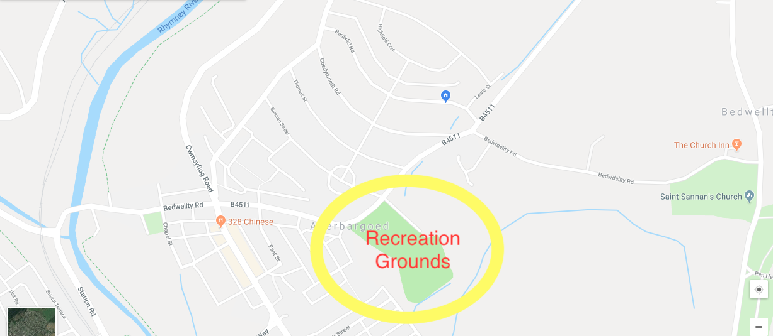
(Appendix 1)
The recreation grounds are situated towards the top of Aberbargoed and is the most known location in the area as it is used for the local football and rugby teams. It is also home to the hanger which used to be a skate park and is now used as a youth centre and hired out for other purposes. The recreation grounds are the biggest of the three venues.
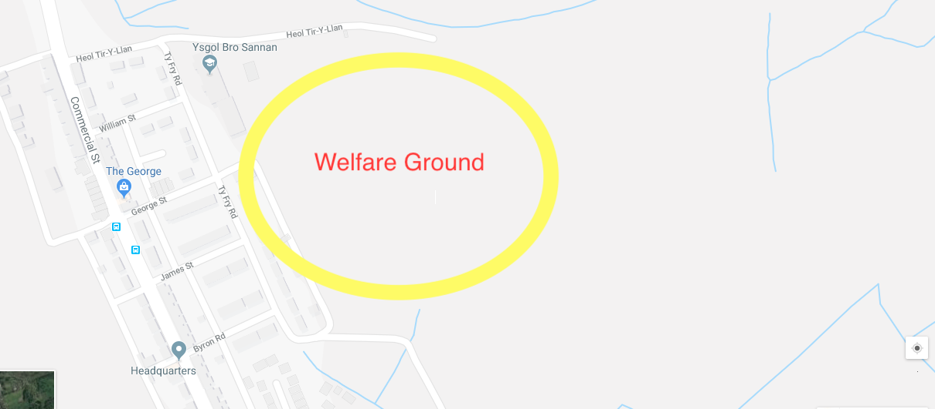
(Appendix 2)
The welfare ground is situated towards the bottom area of Aberbargoed and is a smaller venue option as it used to be the old rugby pitch.

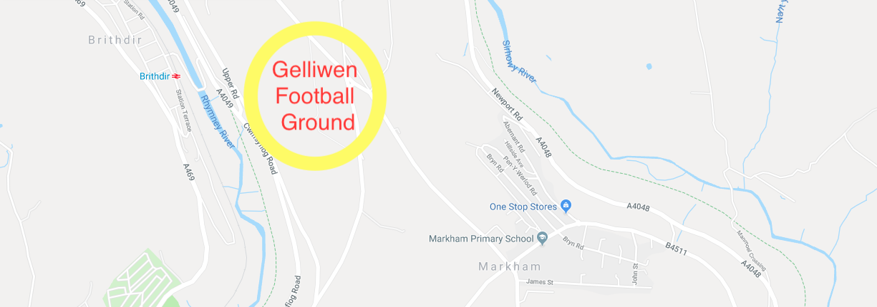
(Appendix 3)
The third venue Gelliwen football ground is situated on the outskirts of Aberbargoed on the top of the mountain and is still used as a football pitch.

4:3 Risk Assessment of Viable Options
Venue | Risks
Aberbargoed Recreational Grounds | - Aberbargoed tip is easily accessed from the venue, so this would need to be sectioned off with caution.  - The whole premises would need perimeter fencing for health and safety.
Aberbargoed Welfare Ground | - No parking, which can cause issues.  - Close to main road, which can be an issue with young children.  - No roads to access venue for emergency services.
Gelliwen Football Ground | - Unknown location that is hard to find.  - Open space on top of a mountain with lots of roads, where people can get lost or hurt.

5:0 Venue Recommendation
The consultant would recommend using the recreation grounds on Bedwelty road in Aberbargoed.

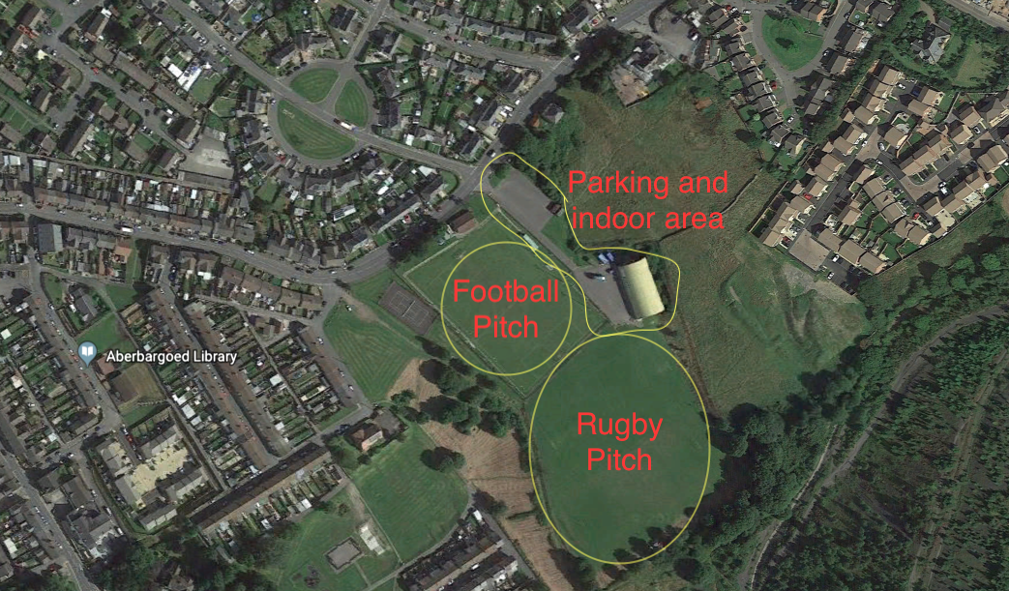
(Appendix 4)

As pictured in Appendix 4 it is clear of size of the venue, it can also be seen that there are two fully sized pitches, parking areas and an indoor venue available within the space. The premises can be accessed from numerous areas and so will require perimeter fencing. However, this also aids in setting up multiple fire exits, or emergency exits. Out of the three possible venues this space already has an appropriate infrastructure suitable to host a large event. It is an open space with lots of exits, with two roads that can be accessed on two opposite sides of the space in the case of emergencies. There is a large indoor venue with restrooms and disabled access. The venue is also in walking distance of most residents in the area and there are bus links and taxi services that run to the venue.

Accessibility is very important to the client. This venue mainly consists of grass, which in poor weather conditions is not very accessible to some. Yet, there is a concrete path leading from the main road onto the car parks and the car parks are all solid ground that stretch alongside both fields and lead into the hanger, which is the indoor area. The hanger has accessible entry and exit points at the front and the rear. On the rear of the hanger there is a small solid patch of ground linking onto the rear field.

Aberbargoed is a very small town and does not have a very strong road infrastructure that could support a large event. However, as this event would be advertised locally, residents of the area and people who live in the surrounding towns would be informed and other transport links would need to be advertised.
For the use of street floats or anything that may require a road closure, roads are easily diverted, so there should be no issue in gaining permission from the council to close any roads if necessary for the event. The county council require a special event road closure application form (attached under Appendix 18), once the application has been considered, road closures can be planned.

6:0 Market Research
100 people local of Aberbargoed took part in an online survey where they answered questions relating to the festival, to gain an understanding of what they would want in the festival and to identify the demographic of the target audience.
Appendix 5 (below) shows the areas in which the respondents live. 48 out of 100 were residents of Aberbargoed, whereas the other 52 participants were from other areas within the Rhymney Valley.
As most respondents are from the village and the surrounding towns, the sample is representative of the target population.
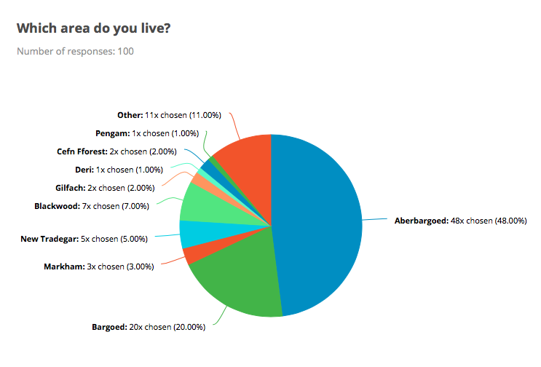
(Appendix 5)

The majority of the respondents were between the ages of 18 and 44 years old, with some respondents in the older age brackets (see Appendix 6 below). This may be due to the survey being an online survey and mainly advertised via social media. Though, since there is a large number of respondents between the ages of 18 and 44, this is still representative of the target population.
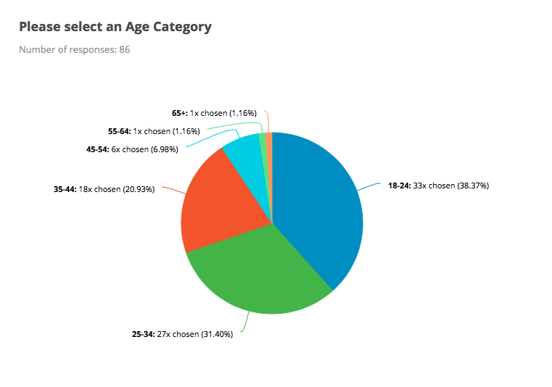
(Appendix 6)

Participants were also asked if they had children, and that as the festival would be family-friendly would they consider taking their children or any young family members to the event. Only 97 respondents answered these questions: 54 said they had children and 43 said they did not have children (see appendix 7 below). On the next question, the full 100 respondents answered the question, with 97 participants reporting they would indeed take young children to the festival, and only 3 participants responded ‘No’ (see Appendix 8).

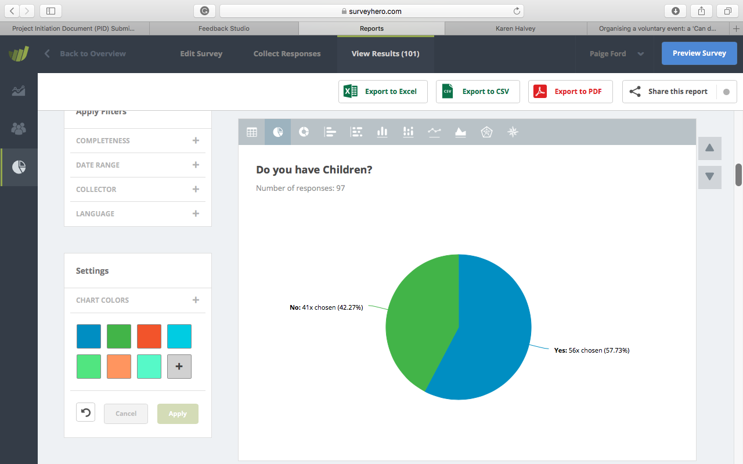
(Appendix 7)

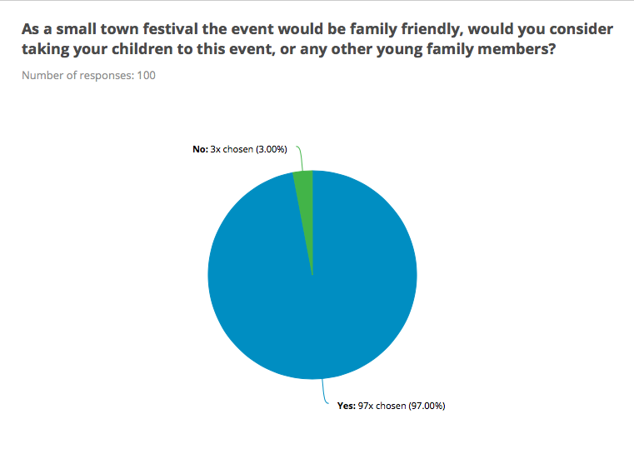
(Appendix 8)

From appendix 8 (above), it is clear to see that the majority of respondents would take their own children or other young family members to the event. This can also mean that there is a popular demand for a family-friendly event to take place in Aberbargoed.

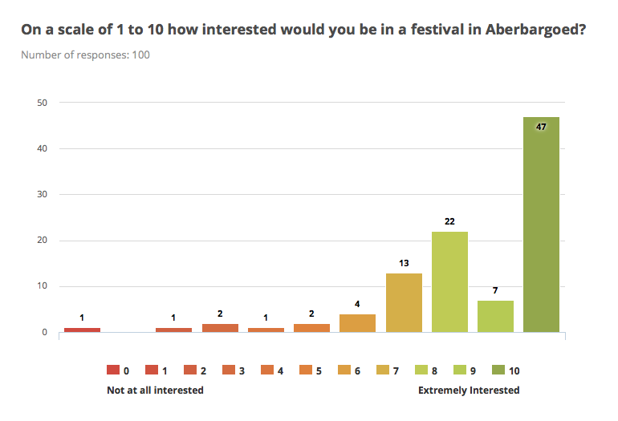
(Appendix 9)

During the survey, participants were asked to rate how interested they would be in an annual festival. As shown in appendix 9 (above), nearly half of the respondents submitted the highest rating of 10, indicating extreme interest; whereas the rest of the scale was roughly distributed, as only 5 participants submitted ratings lower than a 5, indicating a lack of interest. These responses demonstrate that there is a substantial amount of interest already for this type of event to take place in Aberbargoed.

From appendices 5 through 9, it can be concluded that there is a demand for a festival and a lot of interest already from local residents. What can also be gathered from these results is that the most interest is from people with children, which means that there is a positive interest for a family-friendly festival to take place.

As well as finding out if there was a demand for the event, the second objective of this document was to identify what the target audience would like to see at the potential festival. Appendix 10 (below) contains another question taken from the survey that asked the respondents what they wanted to see at the event.
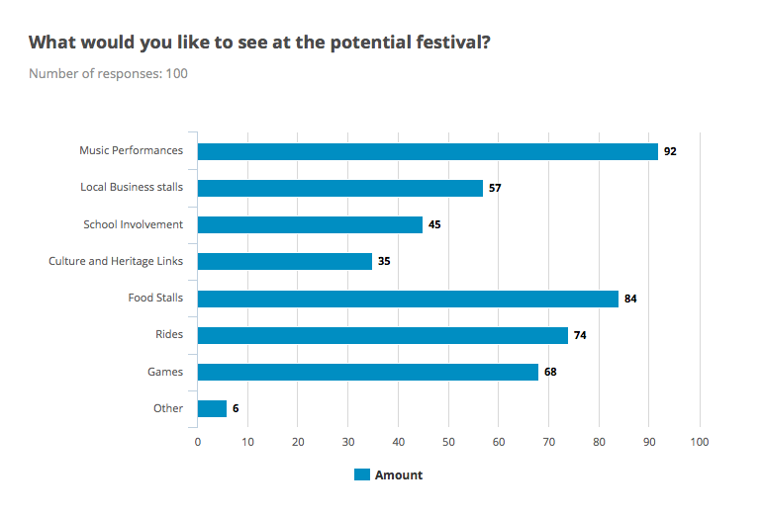
(Appendix 10)

As clearly seen in the graph above (appendix 10), the respondents were interested in an array of events, which seems to give the impression of more of a carnival setting than a festival. However, the event can still be classed as a festival. The suggestions from the survey that all seemed popular were music performances, local business stalls, school involvement, culture and heritage links, food stalls, rides and games. Some other suggestions written in by respondents were to add a bar, craft stalls, street floats, craft for children to take part in, simple physical activities for children (basic "circus" activity, balance, hooks etc.) and Jazz bands.

At the end of the survey, participants were asked if they would like to leave any recommendations or comments. 15 respondents left suggestions mainly of a similar nature. A number of the respondents stated that the community could benefit from an event that would provide them with a focus and a chance for individuals to get involved. Perhaps the main common suggestion was to make the event heavily focused on children. Respondents explained how there is very little for families and children to do in the area and having an event to look forward to each year would improve the lives of their children and spark further action to be taking to introduce more events for the younger population in the community. Some also referred to the area as being “depressed” and suggested that introducing this event could inspire a social boost in the community.

Overall, there is a strong demand present from people aged 18-44 who live in Aberbargoed and the surrounding areas. The interest seems to be in music performances, and other carnival-like activities that will engage families, and not just adolescents and young adults. This answers the client’s question as to who the target audience is and what type of entertainment and activities are desired for the festival.

7:0 Stakeholders
When planning any event, it is important to consider who the stakeholders are.
This diagram by Reid 2006 shows how many potential stakeholders there are to an event.
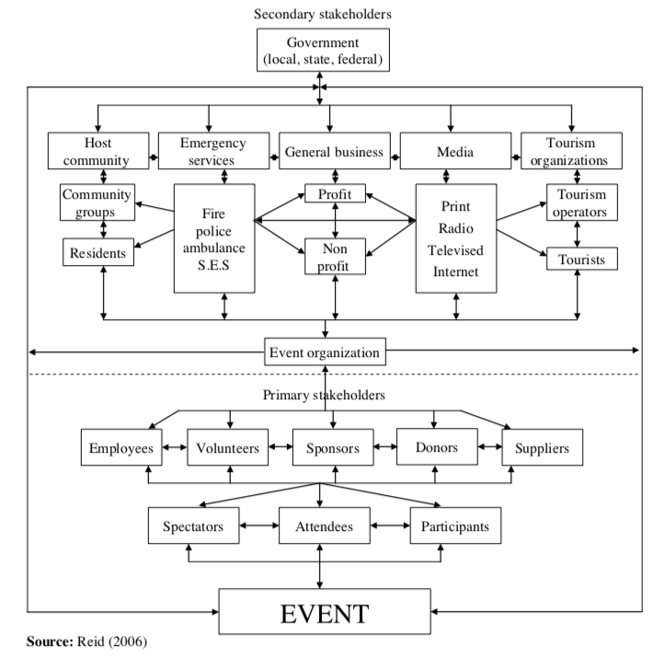

This diagram can be simplified in a table, which only consists of the stakeholders relevant to this event.
Primary Stakeholders | Secondary Stakeholders
Make it Happen Events Management | Town Council
Staff | Emergency Services
Volunteers | Local Residents
Attendees | Media Coverage
Sponsors
Suppliers

There are strong links with the town council and St John’s Ambulance when it comes to events in the local area, so it is definite to say that there will be medical staff available for the event in the case of emergency. There are already existing links with companies for facilities such as portaloos etc. However, the client does not have to use any links existing with the town council, these are just some options available.
The town council also offers financial assistance to organisations who they feel will have a positive impact on the community, although this grant is not guaranteed. There is an application process which consists of filling out a form and submitting it to the town clerk via email. The application form is attached under Appendix 17.

8:0 Conclusion
In conclusion, the consultant would recommend using the Aberbargoed Recreation grounds as the venue for the event as it has many of the required facilities available onsite. This venue also complies with the client’s wish of accessibility for disabled access and bathrooms. The premises is large enough for the event, and has accessibility for emergency services such as police, ambulance and fire services and also is an air ambulance landing plot. In terms of market research, the most interested party are aged between 18 and 44 years, making this the demographic age category for the target audience. It is also important to state that this demographic can be further segmented by those with children, as during the survey, most participants were either parents or more inclined to attend the event if it was based around children and family activities. There are many potential stakeholders that must be considered. As demonstrated in the table, the primary stakeholders are the event company, the attendees, the staff, volunteers, sponsors and suppliers, with the secondary stakeholders consisting of the town council, emergency services, local residents and the media. Wider feedback suggests visiting the Caerphilly County Council website or to examine the forms attached in the appendices. The consultant would suggest that this event is feasible as there is an available venue, the possibility of government funding, a strong demand for the event and an interest from the town council to support the project.

9:0 References
Beckford, J. (2010). A Critical Introduction, Third Edition . London: Routledge.

Caerphilly.gov.uk. (2018). Caerphilly - Planning an event. [online] Available at: http://www.caerphilly.gov.uk/Things-To-Do/Events/Planning-an-event

GOV.UK. (2018). Organising a voluntary event: a 'Can do' guide. [online] Available at: https://www.gov.uk/government/publications/can-do-guide-for-organisers-of-voluntary-events/the-can-do-guide-to-organising-and-running-voluntary-and-community-events

Greggsfoundation.org.uk. (2018). Local Community Projects Fund | Greggs Foundation. [online] Available at: https://www.greggsfoundation.org.uk/grants/local-community-projects-fund

Plonsky, Gurzynski-Weiss & Fäcke, C, 2014. Research methods. In Mouton De Gruyter, pp. Fäcke, C, (ed.) Manual of Language Acquisition. (pp. 31–49). Mouton De Gruyter: Berlin, Germany. (2014).

Sachdeva, J.K., 2009. Business research methodology, Mumbai [India]: Himalaya Pub. House.

Tomlinson, A., 2010. research methods. A Dictionary of Sports Studies, pp.A Dictionary of Sports Studies.

UWTSD, 2017. Research Ethics & Integrity Code of Practice

10:0 Appendicies
Appendix 1

Appendix 2
Appendix 3
Appendix 4

Appendix 5

Appendix 6

Appendix 7

Appendix 8

Appendix 9

Appendix 10

Appendix 11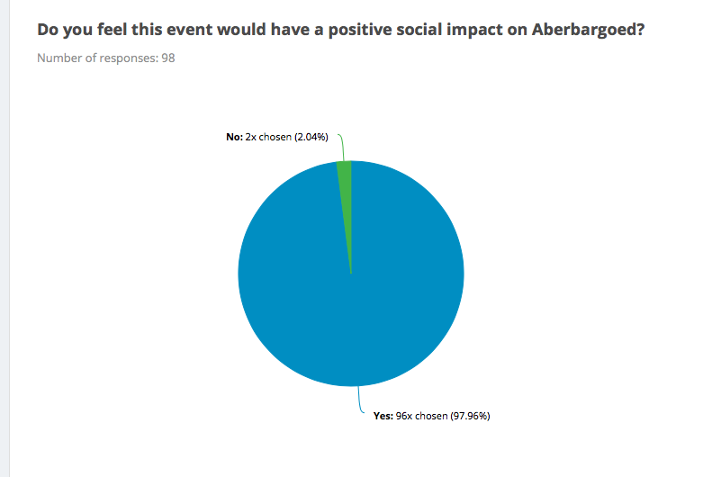

Appendix 12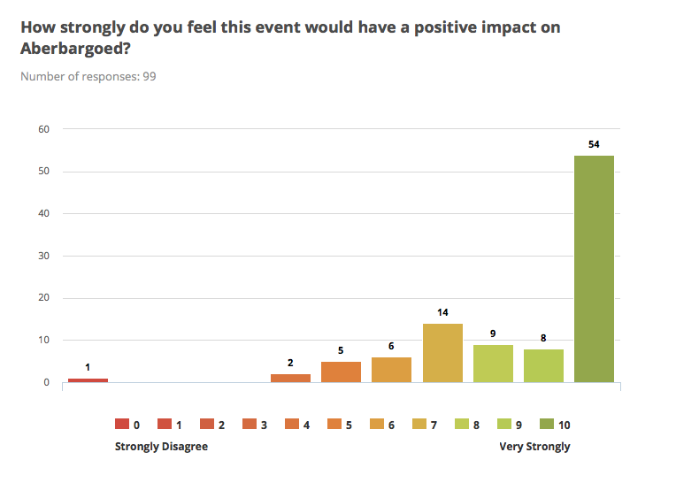

Appendix 13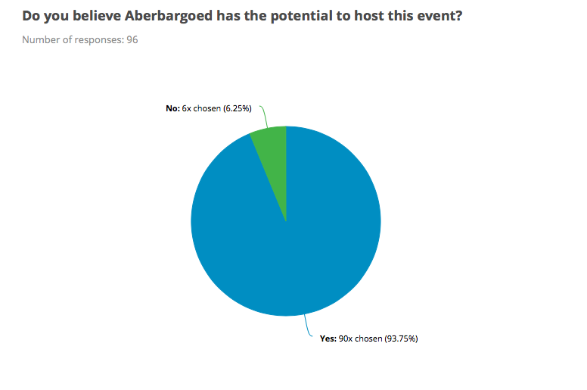

Appendix 14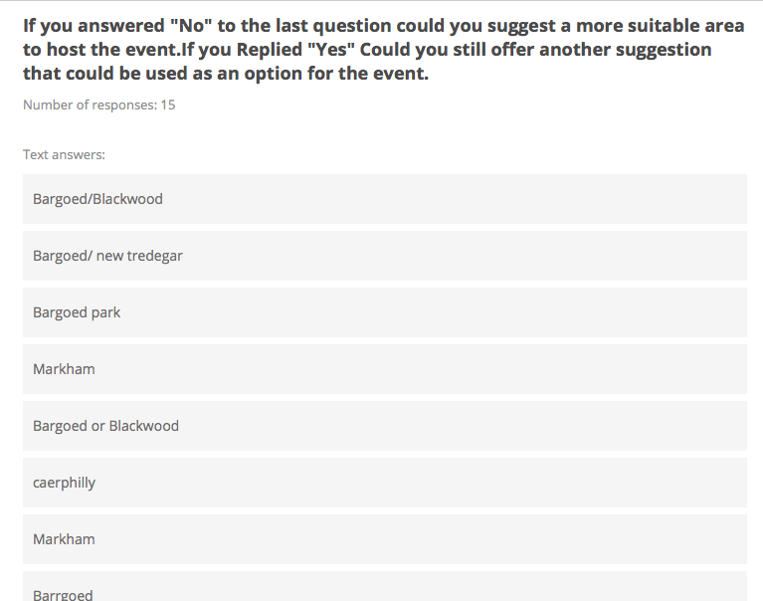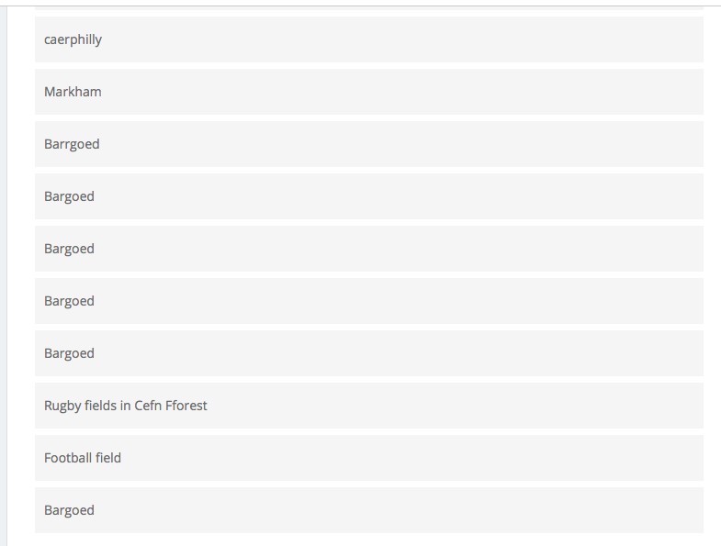

Appendix 15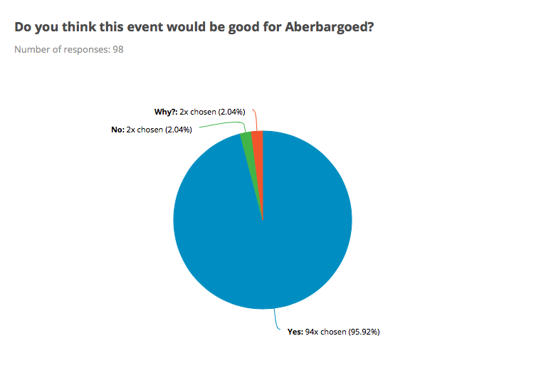

Appendix 16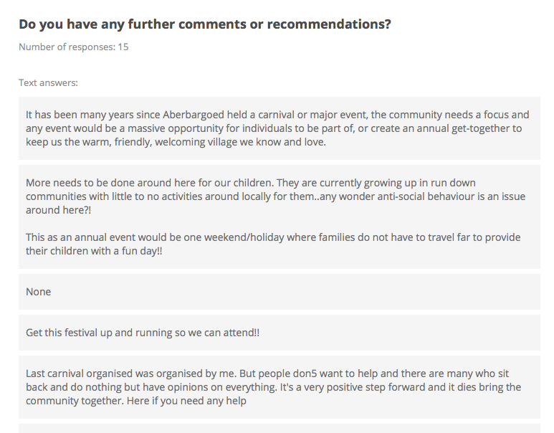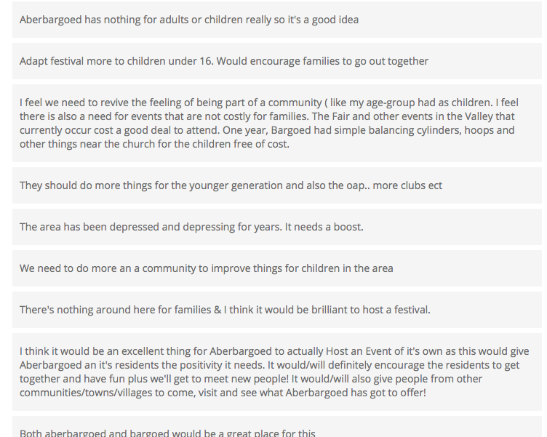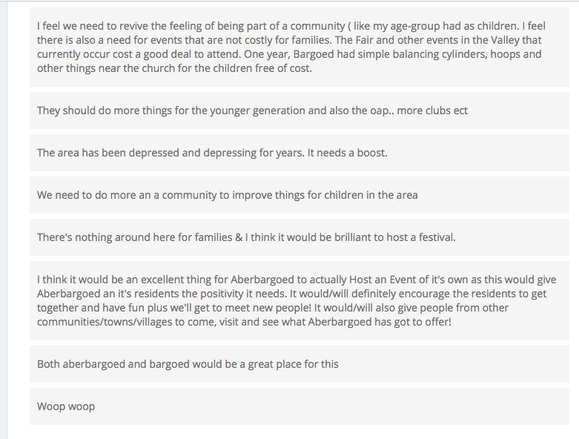

Appendix 17




Appendix 18

Appendix 19 



