Report Effective Teamworking for team success

Student name: GRUEV FLORENTIN ADRIAN
Student ID: 2029241
Module Code: BMSW 4002 (Effective Team Working and Communication
Assignment Title: Task 1 - Report Effective Teamworking for team success
Lecturer name: Dr.Isaiah Oino / Suzannah Ogwu

TABLE OF CONTENT:

Abstract………………………………………………………............................................. 2
INTRODUCTION ………………………………………………............................................... 2
1. How management at Trinity Social Care Home can develop an effective team ………. 4
2. The impact effective team working can have in a health and social care setting …………. 6
3. Barriers to effective teamwork ..............................................................................................8
4. The types of roles that are needed to create a cohesive and effective team…………….... 10
CONCLUSION: ………………………………………………………………..................... 11
BIBLIOGRAPHY: ………………………………………………….……..................................…. 12

Abstract

When it comes to providing health care, good cooperation may have an immediate and beneficial impact on patient safety and result. The necessity for successful teams is growing as co-morbidities and the complexity of care specialty increase. There was a time when a doctor, a dentist, or any other health practitioner in any health organization could merely provide quality treatment that satisfied his or her patients.
The evolution of health care and the global need for high-quality patient care necessitate concurrent professional growth in health care, with a strong emphasis on patient-centered cooperation. This can only be accomplished by putting the patient at the center of treatment and sharing a broad set of beliefs and principles. This will aid in the formation and development of an effective team capable of providing great care to patients.

Introduction

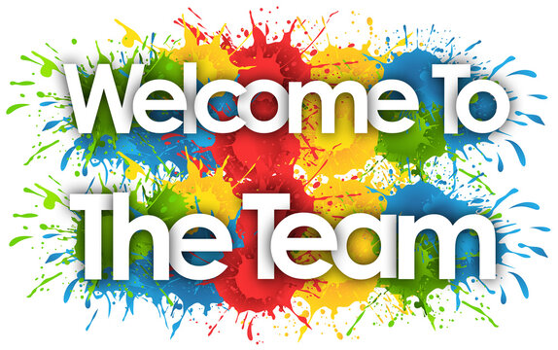

Team definition

A team is a group of people who work together toward a common goal.

Effective team definition
There are several ways to define effective teams. One of the most crucial things to emphasize that an effective team is a high-performing team.
Every great organization is built on strong teams. Companies that do not have well-functioning teams generally suffer, whereas successful teams assist to enhance quality, speed up project completion, and boost productivity and efficiency. To ensure that a firm operates at peak efficiency, it must form a team in which each member contributes his or her abilities and skills to the group's ultimate success. ( Mitchell P, Wynia M, Golden R, McNellis B, Okun S, Webb CE, et al. Core Principles and Values of Effective Team-Based Health Care Discussion Paper. Washington, DC: Institute of Medicine; 2012).

An effective team has several 'building bricks' in place.
Specific goals
There are mutually agreed-upon goals and objectives, and everyone understands them.
Roles that are balanced
There is a fair mix of talents, abilities, and goals. Team members have a clear grasp of each other's roles in attaining the overall team goals.
Processes that work
There are sound procedures in place for making, discussing, executing, and evaluating decisions. There are efficient information systems and resource coordination.
Excellent communication skills
Meetings are fruitful, and communication is effective at all levels of the organization.
Appropriate leadership
The team has faith in the team leader and believes that it is being led appropriately.
Encouragement and faith
People assist one another through listening, analyzing, sharing suggestions, promoting experimentation, and providing support.
Discretion and disagreement
People are open and honest in their communication. There is an openness to constructively resolving challenging situations or conflicts.
Collaboration between individuals
There is a willingness to participate and be dedicated. The team pooled and used the strengths, knowledge, and expertise of individuals. Each other's skills and flaws are acknowledged.
Personal development
'Mistakes' are discussed openly and used as a learning tool. Individuals are given the chance to learn new skills and gain experience.

Intergroup connections that are healthy
The team gets along well with other teams, departments, and agencies, with everyone appreciating and respecting one another.
Review on a regular basis
The team evaluates its performance and goals on a regular basis and adjusts its priorities and practices as a result of the evaluation.

1 - How management at Trinity Social Care Home can develop an effective team

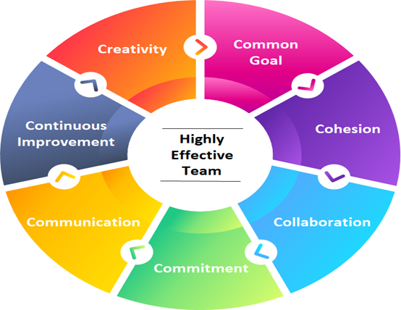

Regarding this point in the report, I consider that the first important aspect for building an effective team is clearly this: establishing leadership with each team member, knowing that the most effective team leaders, develop relationships based on trust and loyalty, not on fear or on the strength of their positions. [1]( Mitchell P, Wynia M, Golden R, McNellis B, Okun S, Webb CE, et al. Core Principles and Values of Effective Team-Based Health Care Discussion Paper. Washington, DC: Institute of Medicine; 2012).
The management team should consider each employee's suggestions as important.
The management team should be aware of the unspoken emotions of its workers and set a good example to the team members, being transparent and attentive to their dispositions and feelings.
His management team acts as a balancing force, looking for opportunities to referee and resolve minor misunderstandings, but also taking into account the team's bigger goals at all times.
The management team should be concise in communication, making sure to clarify any instructions.
Encourage trust and collaboration between team members. given that the relationships that team members form with each other are as essential as those that the management team forms with them.
Encourage team members to share information, emphasizing the value of each team member's contribution and illustrating how all of their duties work together to bring the entire team closer to their goal.
His management team delegates tasks to solve team problems allowing the team to collaborate on innovative solutions.
Facilitate communication knowing that communication is the most important ingredient of successful cooperation. [2]( World Health Organization. Being an effective team player Available from: URL: http://www.who.int/patientsafety/education/curriculum/who_mc_topic-4.pdf Accessed 5 October 2021).
The management team should set the team's values and goals and evaluate the team's performance.
Make sure they have a clear understanding of what they need to do, that they know what the success criteria will be, that they have created clear time periods, and that team members understand their tasks.[3] (Frampton S, Guastello S, Brady C, et al. Patient centered care improvement guide. VII.A. Communicating effectively with patients and families Boston: Planetree, Inc. and Picker institute; 2008. pp 77–199. Available from: 1. URL: http://www.patient-centeredcare.org/chapters/chapter7a.pdf Accessed 10 October 2021. [Google Scholar] )
Leadership to use consensus. Set goals, address obstacles and develop an action plan. Although much more is needed to reach an agreement, this strategy ultimately results in better decisions and more production, as it ensures the dedication of each employee for all phases of the task.
Establish basic rules for the team. These are the guidelines that the management team together with the employees should follow to ensure efficiency and success.
Creating a procedure to make a decision. They could organize an open debate on the benefits and disadvantages of the various suggestions or form study groups to explore topics and submit conclusions.
Encourage others to listen and come up with ideas. As a manager, the first priority to reach an agreement is to spark debate. Workers are often scared to disagree with each other and this fear can lead to substandard decisions in the Trinity Social Care Home team. When promoting the discussion, promote innovation, which will lead the team to greater success.

2 - The impact effective team working can have in a health and social care setting

This can be defined as that aspect when team members share the task equally and tasks are assigned according to the talents and abilities of each team member, the work being completed faster and more efficiently, resulting in a visible increase in the quality of services provided to patients , in a health and social care sector.
Healthcare teams can achieve the following goals by working together and effectively:
a) Improve patient safety. Proper patient engagement, promoting patient happiness, and listening to patients are all key components of supporting patient safety.
b) Improve clinical performance.Effective teams have the potential to improve clinical care because they can aggregate, modify, integrate, and apply a greater amount and diversity of information in order to make choices, solve issues, produce ideas, and execute tasks more effectively and efficiently than any individual working alone.[4]( 8. Williams RG, Silverman R, Schwind C, Fortune JB, Sutyak J, Horvath KD, et al. Surgeon information transfer and communication: factors affecting quality and efficiency of inpatient care. Ann Surg 2007; 245:159–169. [PMC free article] [PubMed] [Google Scholar]).
c) Reduce medical errors. The effective team is intended to increase care delivery performance while lowering the amount of clinical mistakes. It encourages team members to actively cooperate and assist one another throughout clinical task performance by utilizing work team structure.

d) It helps patients overcome their fears about treatments and procedures. Professionals need to make sure that patients and their caregivers understand the treatment and can help avoid medical mistakes

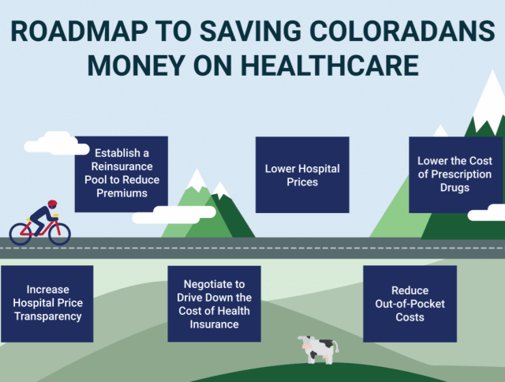

e) Increase efficiency while reducing healthcare costs. There are some ways in which the healthcare business can minimize excessive spending and improve treatment efficiency:
- recognition of overtreatment situations;
- reduction of clinical errors.
- improving care coordination
- administration should be easier.
- increase the pace of medical research to reduce prices.
- fighting fraud and abuse.
[5] (Olsen L, Young PL. The Healthcare Imperative: Lowering Costs and Improving Outcomes: Workshop Series Summary National Academies Press; 2010. Available from: http://www.nap.edu/openbook.php?record_id=12750 Accessed November25, 2014. [Google Scholar])

Among the attributions of an effective team in social care department is also team spirit. This refers to assisting patients in managing pain through the use of appropriate pain medications and other pain relief measures. Providing emotional support to the family and caregivers during and after the patient's illness. But it also refers to providing religious care for patients, especially for those who have a serious state of health that leads them to imminent death.[6]( Compassion in practice – nursing, midwifery and care staff – our vision and strategy, the Chief Nursing Officer for England’s Conference. 4 December 2012. Available from: http://www.england.nhs.uk/wp-content/uploads/2012/12/compassion-in-practice.pdf Accessed 11October 2021.)

3- Barriers to effective teamwork

There are many barriers for a team to be truly effective. Among them are :

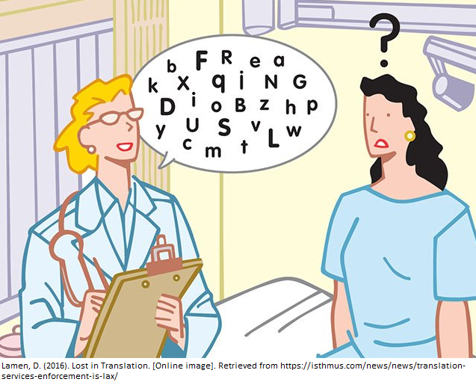

1) Language barriers
Language problems are a major source of misunderstanding between medical practitioners and patients, and they have a detrimental impact on the quality of healthcare services and patient satisfaction. Previous research has found that most healthcare facilities have little or no access to interpretation services.
Common instances of linguistic obstacles include individuals from various nations engaging with one another, people from different countries greeting one another differently, and people speaking the same language speaking in distinct dialects. Linguistic barriers are greatly influenced by culture.
A way to communicate with patient language barriers is to use body language. Head nodding, hand gestures, facial expressions, eye gaze, touch, and demonstration are all global modes of communication. Before the patient and family arrive, the effective team should be familiar with body language or culturally incorrect gestures.

2) Poor working environment

Factors such as health and safety, safety and working hours all have an impact on the work environment. A hazardous work environment can be harmful to health and endanger safety. The employer is legally responsible for ensuring safe working conditions, but the team of employees is equally responsible for safe work.
Which causes a bad working environment are: lack of appreciation, favoritism, unhealthy communication, gossiping, and excessive turnover are just a few of the factors that contribute to a burnout work culture. Toxicity in the workplace also involves inadequate leadership, weak management abilities, a lax code of behavior, and a lack of communication.
3) Poor working conditions
Working conditions are at the heart of paid work and labor relations. Working conditions, in the broadest sense, encompass a wide range of concerns, from working hours, rest times and working hours, pay scales and physical and mental stressors which are also a significant component. of the office environment.
Poor working conditions favor an environment that reduces employee productivity. Unproductive staff is slow and demotivating, slowing down the growth of the organization. So, in the long run, maintaining attractive working conditions has benefited both the health and social care institution and the employees.
Working conditions are in principle the expectations, environment and circumstances of a work that have a direct influence on the pleasure and activity of its employees. Various care centers are usually in competition that provide attractive conditions to keep good resources for the institution.
The following are the most prevalent working circumstances that should be addressed:
- Factors affecting hygiene
- Health and security
- Remuneration
- Employee advantages
- Workload
- Workplace stress
- Work-life integration
- Travel and commuting
- Organizational culture
- Management of performance
- Job stability
[7]( Famadas JC, Frick KD, Haydar ZR, Nicewander D, Ballard D, Boult C. The effects of interdisciplinary outpatient geriatrics on the use, costs and quality of health services in the fee-for-service environment. Aging Clinical and Experimental Research 2008; 20:556–561. [PubMed] [Google Scholar] )

4 -The types of roles that are needed to create a cohesive and effective team

There are many ways which helps us to build a cohesitive and effective team like:
Make a mission statement. The purpose of the team is the most crucial element to consider when selecting individuals.
Look for variety.
Teamwork should be practiced.
Make use of individual strengths.
Communicate clearly....
Please provide comments.
Request feedback.
Success should be celebrated.

There are some types of roles that are needed to create a cohesive and effective team. Among theese are : Leader, Facilitator, Coach or a Member.
All these are the components of a team, but theese need not be exclusive.

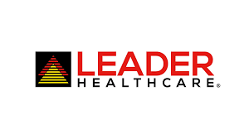

A leader's responsibility is to offer direction to the team, vision to the team, motivation to the team, and to set ground rules for working together. What kind of communication will take place, and how will events be reported? The leader establishes all of these ground rules.
[8]( Ahearn, K.K., Ferris, G.R., Hochwarter, W.A. et al. (2004) Leader political skill and team performance. Journal of Management, 30(3), 309–327)
The facilitator frequently does not have official power; instead, the facilitator assists the team in understanding objectives and making decisions.
Even if a leader is serving as a facilitator, the leader is asking or assisting the team in making such decisions.
Coach provides one-to-one support after training.
[9] (Ainsworth, M.D.S. (1982) Attachment: Retrospect and prospect, in The Place of Attachment in Human Behavior (eds C.M. Parkes and J. Stevenson-Hinde), Basic Books, New York, pp. 3–30).
Members' roles are to attend team meetings, perform whatever is allocated to them, and actively engage in brainstorming, idea generating, and any other assistance that is required. Members are actively involved in the team.

Conclusion

The goal of providing high-quality patient care is contingent on excellent performance by patient-focused teams. However, we must bridge the gap between conventional procedures and the new mindsets required of an effective team in order to attain such lofty goals.
As a result, health care companies should strive to provide great patient care by instituting a broad team-based culture in which specific values and concepts are shared and clearly communicated among team members, including patients, who should be put at the center of care.

BIBLIOGRAPHY:

1. Mitchell P, Wynia M, Golden R, McNellis B, Okun S, Webb CE, et al. Core Principles and Values of Effective Team-Based Health Care Discussion Paper. Washington, DC: Institute of Medicine; 2012.
2. World Health Organization. Being an effective team player Available from: URL: http://www.who.int/patientsafety/education/curriculum/who_mc_topic-4.pdf Accessed 5 October 2021.
3. Frampton S, Guastello S, Brady C, et al. Patient centered care improvement guide. VII.A. Communicating effectively with patients and families Boston: Planetree, Inc. and Picker institute; 2008. pp 77–199. Available from: 1. URL: http://www.patient-centeredcare.org/chapters/chapter7a.pdf Accessed 10 October 2021. [Google Scholar].
4. Williams RG, Silverman R, Schwind C, Fortune JB, Sutyak J, Horvath KD, et al. Surgeon information transfer and communication: factors affecting quality and efficiency of inpatient care. Ann Surg 2007; 245:159–169. [PMC free article] [PubMed] [Google Scholar].
5. (Olsen L, Young PL. The Healthcare Imperative: Lowering Costs and Improving Outcomes: Workshop Series Summary National Academies Press; 2010. Available from: http://www.nap.edu/openbook.php?record_id=12750 Accessed November25, 2014. [Google Scholar]).
6. Compassion in practice – nursing, midwifery and care staff – our vision and strategy, the Chief Nursing Officer for England’s Conference. 4 December 2012. Available from: http://www.england.nhs.uk/wp-content/uploads/2012/12/compassion-in-practice.pdf Accessed 11October2021.
7. Famadas JC, Frick KD, Haydar ZR, Nicewander D, Ballard D, Boult C. The effects of interdisciplinary outpatient geriatrics on the use, costs and quality of health services in the fee-for-service environment. Aging Clinical and Experimental Research 2008; 20:556–561. [PubMed] [Google Scholar].
8. ( Ahearn, K.K., Ferris, G.R., Hochwarter, W.A. et al. (2004) Leader political skill and team performance. Journal of Management, 30(3), 309–327).
9. Ainsworth, M.D.S. (1982) Attachment: Retrospect and prospect, in The Place of Attachment in Human Behavior (eds C.M. Parkes and J. Stevenson-Hinde), Basic Books, New York, pp. 3–30.

