Introduction

In this learning journal I will report on the development of my animation material, looking at my progress, changes, success and failures throughout my module. This will be done to show how I tackled the assignment, what I learned throughout the process and who I can use this to improve upon my work in the future.
I will be starting from my research for the work as I tried to get a better understanding of what I wanted to do in my animation. Originally, I had planned to go in a different direction with the animation something heartfelt and emotionally captivating rather then the action sequence that I had decided to go ahead with. This was done due to my interest in trying to create an action set piece as it was something, I was interested in doing. Looking back on this decision I am a bit regretful that I moved to the action sequence as I had many difficulty’s in trying to accomplish it and it didn’t work out the way I had originally planned.

Research

Firstly, I wanted to gain a better understanding of what I wanted to accomplish during the action sequence, were they soldiers in a battlefield, warriors on equal standing or was it a David vs goliath situation. I also wanted to figure out how they were going to fight, what weapons should they use was it fantasy styled or futuristic. During this time, I looked at different comics, films, mythology’s etc in order to put together an understanding of what I wanted to move on with in the animation. Ultimately, I decided that I would go with a historical setting using spartan styles however applying bits of fantasy elements into my story. My research resulted in my story, “the bond of brothers” which originally featured two brothers facing a fight to the death after one was possessed by a cursed sword and killed his whole family with only the eldest brother remaining seeking revenge. I problem I quickly came to with this idea however was the fact that it would be very time consuming and difficult for me to be able to complete. With this in mind I decided to simplify the story in order to make it more manageable for me to complete, to do this I removed the family backstory as it would have taken up to much time to design and model every family member, with this in mind I decided on only two characters however I decided to keep the possessed fighter for my story as it made it easy to promote to the audience why these two were fighting each other if there is a unnatural physical change in one of the fighters.
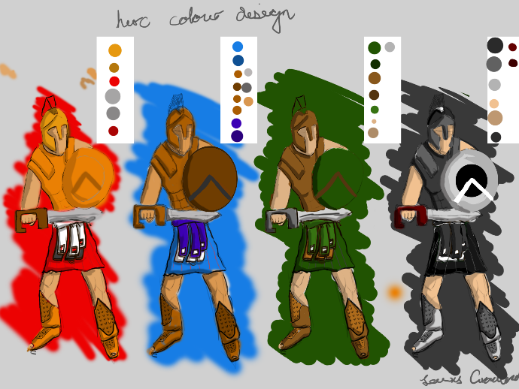
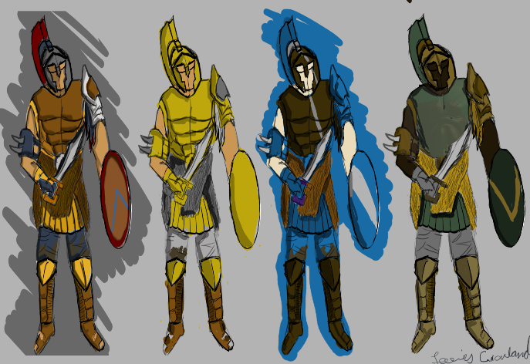
When it came to design the characters, I wanted to stick to the spartan theme using films like 300 and gladiator as examples of Armor design however giving them stylised looks and colours to create a more unique feel to the design. For the colour scheme of the characters I wanted to give them distinct colours in order to make them stand out better to the audience so its easier to determine the hero from the villain, in order to show this I did a verity of colour tests on the hero and villain design to see what best made them stand out for their respected roles.

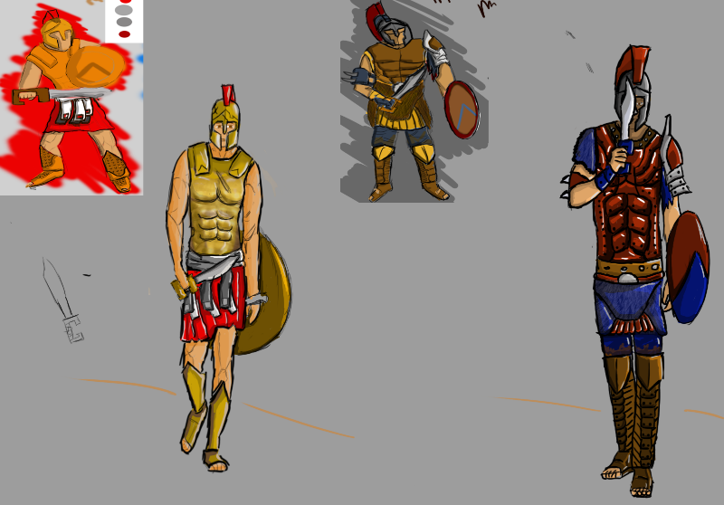
When looking at the designs I concluded that I wanted my hero to have bright clean Armor to highlight his confidence as well as young and brash behaviour whereas my villains’ designs would take on a darker more worn look creating a veteran feel of and older more experienced fighter.

Using this design, I went about finalising the character designs with the gold and red textures for the hero and a dark red with blue designs for the villain. Originally, I wanted to give the villain a more animalistic look using fur across the skirt and arms however I give up on these designs as I felt that I wouldn’t be able to create it to the standard that I wanted and would have spent too much time on trying to achieve it. With this in mind when it came to the modelling faze, I toned down the designs for a more simplistic look.
For the weapons I initially wanted to use more unique style weapons such as spears, staffs, claws etc. However, I ultimately decided to go with the shield and short sword as I think it would have taken too much time to research and execute the fighting style for these weapons so giving them both the same weapon helped with speeding up the research in this area.

Modelling

One thing I wanted to do through this project was improve my knowledge of Z-brush as I was aware that it was a useful tool that I had not really utilised in my past work, this was a bit of a problem as I came into many issues while trying to learn the software which slowed down my work progress and resulted in many major mistakes throughout the project. However, I am aware of how beneficial the software is and would be able to avoid many of the mistakes made in future work.
One thing I needed to gain a better understanding of was the human anatomy in order to help improve the quality of my character, to do this I spent a lot of my time working on trying to create a fairly realistic but basic muscular character as they were meant to be too warriors, using references and talking to others I was able to improve upon my basic knowledge of the human anatomy
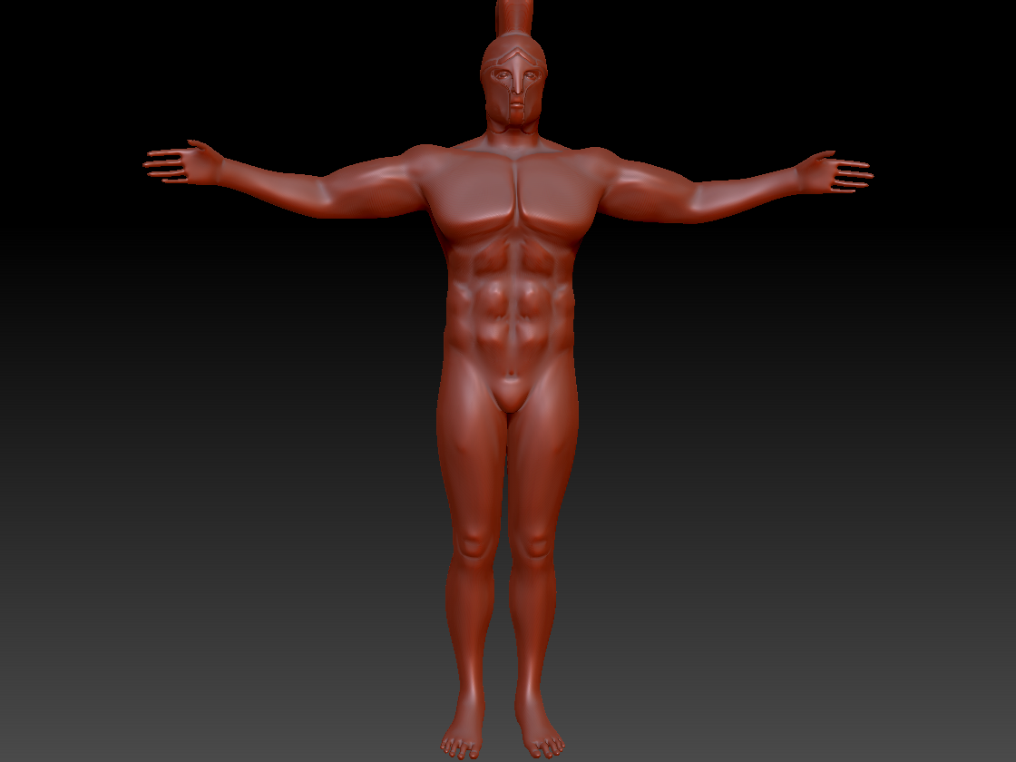

At this stage I was happy with the body proportions of the character as although he was meant to be muscular, I didn’t want to overdo it and make him too big as he was meant to be more of an agile fighter which would make more s sense in him being lighter.
At this point in time I was to prepare my fist Viva presentation for my work, I feel that I made too many mistakes in the presentation as I was unable to talk about the research for the project which I should have been a part of the presentation however I was able to give a basic design of the layout of my scene along with a storyboard, albeit one that ended up being drastically changed in the final product. I was also able to create a 3D animatic using the Maya models and the quick rig to help give a basic idea of what I wanted to do in the project.
after the Viva was done I started work on the armour for the characters to gain inspiration I looked at historical armours mainly Spartan as that was the style I wanted to portray in the animation. One of the design that I liked was the chest piece with the abs pressed into them so I decided to incorporate that into my design. To achieve this, I highlighted the body and extruded it in Z-brush 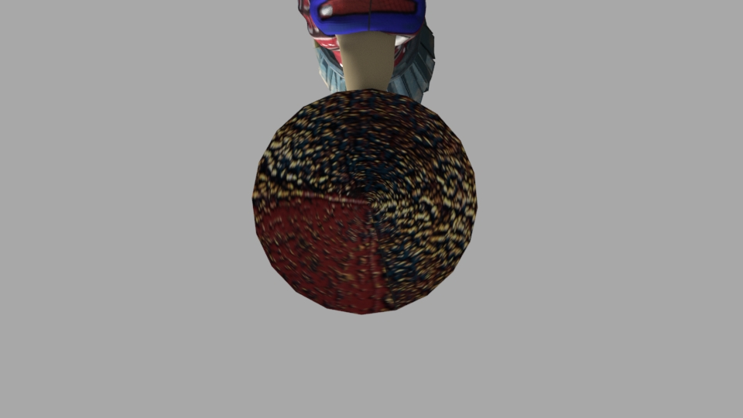and was able to get fairly good results after some small refining it was similar with the shoes and helmet although it did take more time to accomplish due to features such as the nose, ears and feet which took some time to my lack of ability in Z-brush however, it helped me gain a better understanding of the software and will help me to avoid these mistakes in the future. Finally, the skirt, I originally tried to create a basic skirt however I felt that it didn’t work well with the character so I decided to redesign it as a more stylised Spartan skirt which I think ended up looking a lot better than expected.
Sadly, due to me still trying to understand and use Z-brush effectively I made several time consuming mistakes one being my lack of understanding in dynamesh as the models mesh was too high and I wasn’t aware of how to lower it without losing the quality so I decided to redo the typology from scratch in Maya, this was a useful experience as it gave me a better understanding of how the character’s mesh should look like and the best way to do it to get the most out of your animation. However, it was very time consuming and is one of the reason why my work suffered during the end of the module. If I had just used the dynamash effect effectively than I would have not needed to have spent so much time on the new character’s body and that would have saved a lot of time for me in the other areas of the project.
When it came to applying textures onto my characters I originally tried to draw them using Z-brush’s polypaint on the villain’s chest piece as I wanted that to stand out and I feel that it came out fairly well however I had a bit of issue when it came to unwrapping due to my lack of understanding. Once I gained a better understanding of unwrapping my work it was a lot easier to work with although at this point I decided to give substance painter a try, it was an incredibly useful software that help make my textures stand out much more then I originally expected and was a great software to learn although it did take a bit of time. Using the software, I was able to give my design some vibrant colours and wear and tear to my characters which I felt really helped put my own unique spin on their Spartan designs.
When it came to rigging the character I had originally intended to create my own rig for my characters however, I came into some issues with my rig as I had trouble getting the Ik handles to work effectively on my characters so I decided to use the quick rig tool instead as it was able to give me a working rig as I had no time to keep trying to fix the original rig due to the need to start animating. This caused some issues in the final animation as the quick rig had no hand joint causing me to need to hid the hands as much as possible in the animation as it didn’t work very well at some moments.

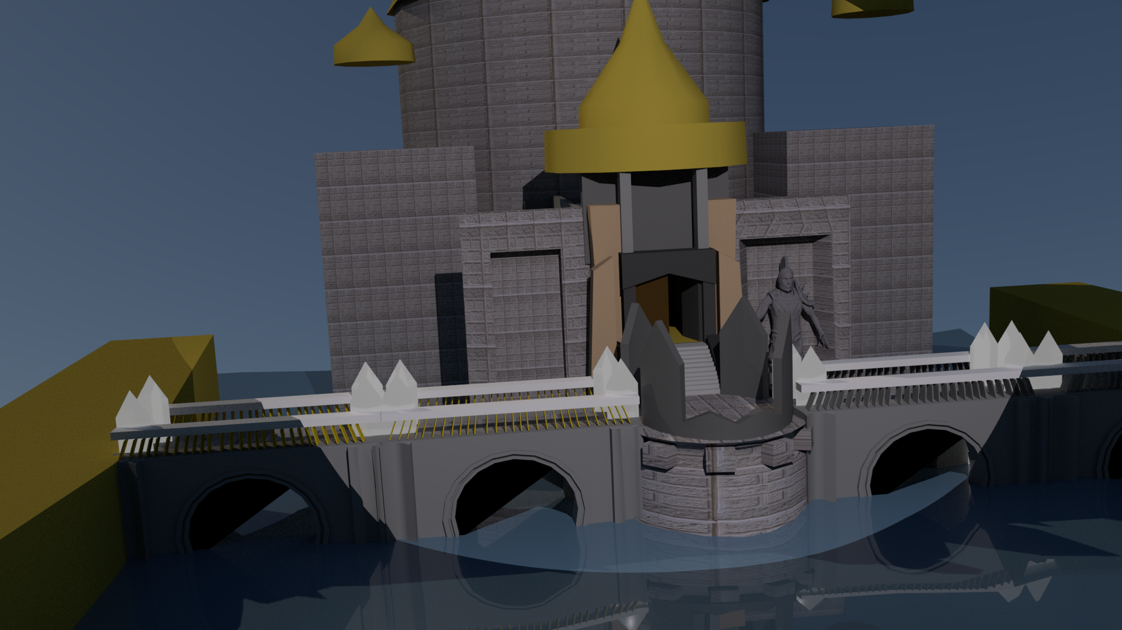Environments

Working with the location design that I used in the Viva I decided to further work on editing the designs. I looked at different castle designs with a more fantasy style to them as I wanted to get a better understanding of the creepy possessed castle that I wanted to portray in the design. I decided that I wanted to give the background a forest look to them so I tried to use plains to create the illusion of trees however it wasn’t working out for me as well as I had hoped it would until I was made aware of Maya paint brush which could create different environment objects such as grass and trees which I decided to incorporate into my work as they were only going to be in the background and were to serve no more purpose in the animation.
Outside of the project I had been working with water effects in Maya with a few tests in Houdini however Houdini proved to be very difficult and would be too time consuming so I decided to focus on the Maya water using Boss effects this created a plain that could be manipulated to give the effects of water with a fairly wide range of options to edit the effects which ended up giving me a nice water effect around that castle that works really well with Arnolds light biased renders.
One Arnold light effect that I’ve really utilised in my scene is the mesh lights. I fantastic light that takes an object and replaces it with a light I was able to create some cool crystals with these mesh lights that were fairly customisable. I tried a variety of different colours and intensities to figure out what kind of light I wanted in my scene and came to the conclusion that I wanted to use a fain light blue as I felt that it gave off an eerier style that I wanted to create for my scene and it also gave me the idea of changing the villain’s eyes into mesh lights which made his feel more natural to the scene as if he and a purpose to be there working with the possessed vibe I wanted to portray. The main lighting in the scene is the mash lights although there is a spot light over the top to simulate the moon light in a nice but subtle hint. Which Is covered overall by a 3D mesh light to simulate the sky.
Another piece that I added to the final scene is the original villain as a stature in the right hand corner as I felt it was a waste to have spent so much time designing it only to completely forget about him and the mesh lights gave a nice touch to the scene.
During the second Viva I planned to show my work in a better way then I originally did on the first Viva however I had issues with my power point having it remove some of my scenes as well as not having an animation to show due to the issue. It was disappointing for me to be unable to show any real quality in my work and continuously having issues that I am unable to prepare and work around is extremely disappointing.
The animation sequence was the place I failed to correctly work in and resulted in a huge issue in my overall animation. I had decided that I wanted to try to use the graph editor as I felt that it would be able to improve the quality of my animation, as I tried to learn it I came to understand about tangents so I tried to utilise the stepped animation to linear animation however it ended with me having many issues in the animation where it went from linear to stepped and caused huge problems for my animation that I was unable to re-do due to time constraints. This is something I will want to improve upon so I can avoid this issue sin order to present the work as it should be presented.

Originally, I had planned to render the shots at 1080p on Arnold renderer however this was taking a long time to complete while I was also utilising a large number of computers, with this in mind I came to the conclusion that it would be better to render the shot at 720p as it was much faster to render making it a much more reliable choice for me to use. However, during my render, I came across several issues that needed to be take care of as well as the unfortunate timing of starting my renders around the Easter break period where I was unable to enter the Uni while my render was there from Friday to Wednesday stopping me from seeing my renders and giving me hardly any time to fix the problems that came from these renders. Due to this fact I decided that I would not be able to re-render all of the scenes with issues so I decided that I would try to get around this issue through editing the shots the best I could to compensate and hid some of the faults.
I went about this through taking the shots into Adobe After Effects which became a really useful tool for me as it improved the quality of my rendered shots. Because of this I was able avoid using effects from Maya such as smoke and rain which would hindered the render times of the shots while giving great effects that were just as good. For the effect I used I applied a rain water simulation which created a really nice rain effect on the scene which I believe was better than the Maya rain I would have used otherwise, as well as the blur effect to help create a rain mist effect in the scene.
Finally, I needed sound effects and music, so I looked into the YouTube sound library which was very useful in finding unique sound effects however some of the desired sound were unavailable in the library so I tried to edit some of the available sound files in premiere to try and give them the desired sound effect I wanted. I looked at a few of the different options for the music and decided that I wanted something with a sadder tone to it and was able to come across a sound file that I feel was fairly close to the desired effect.
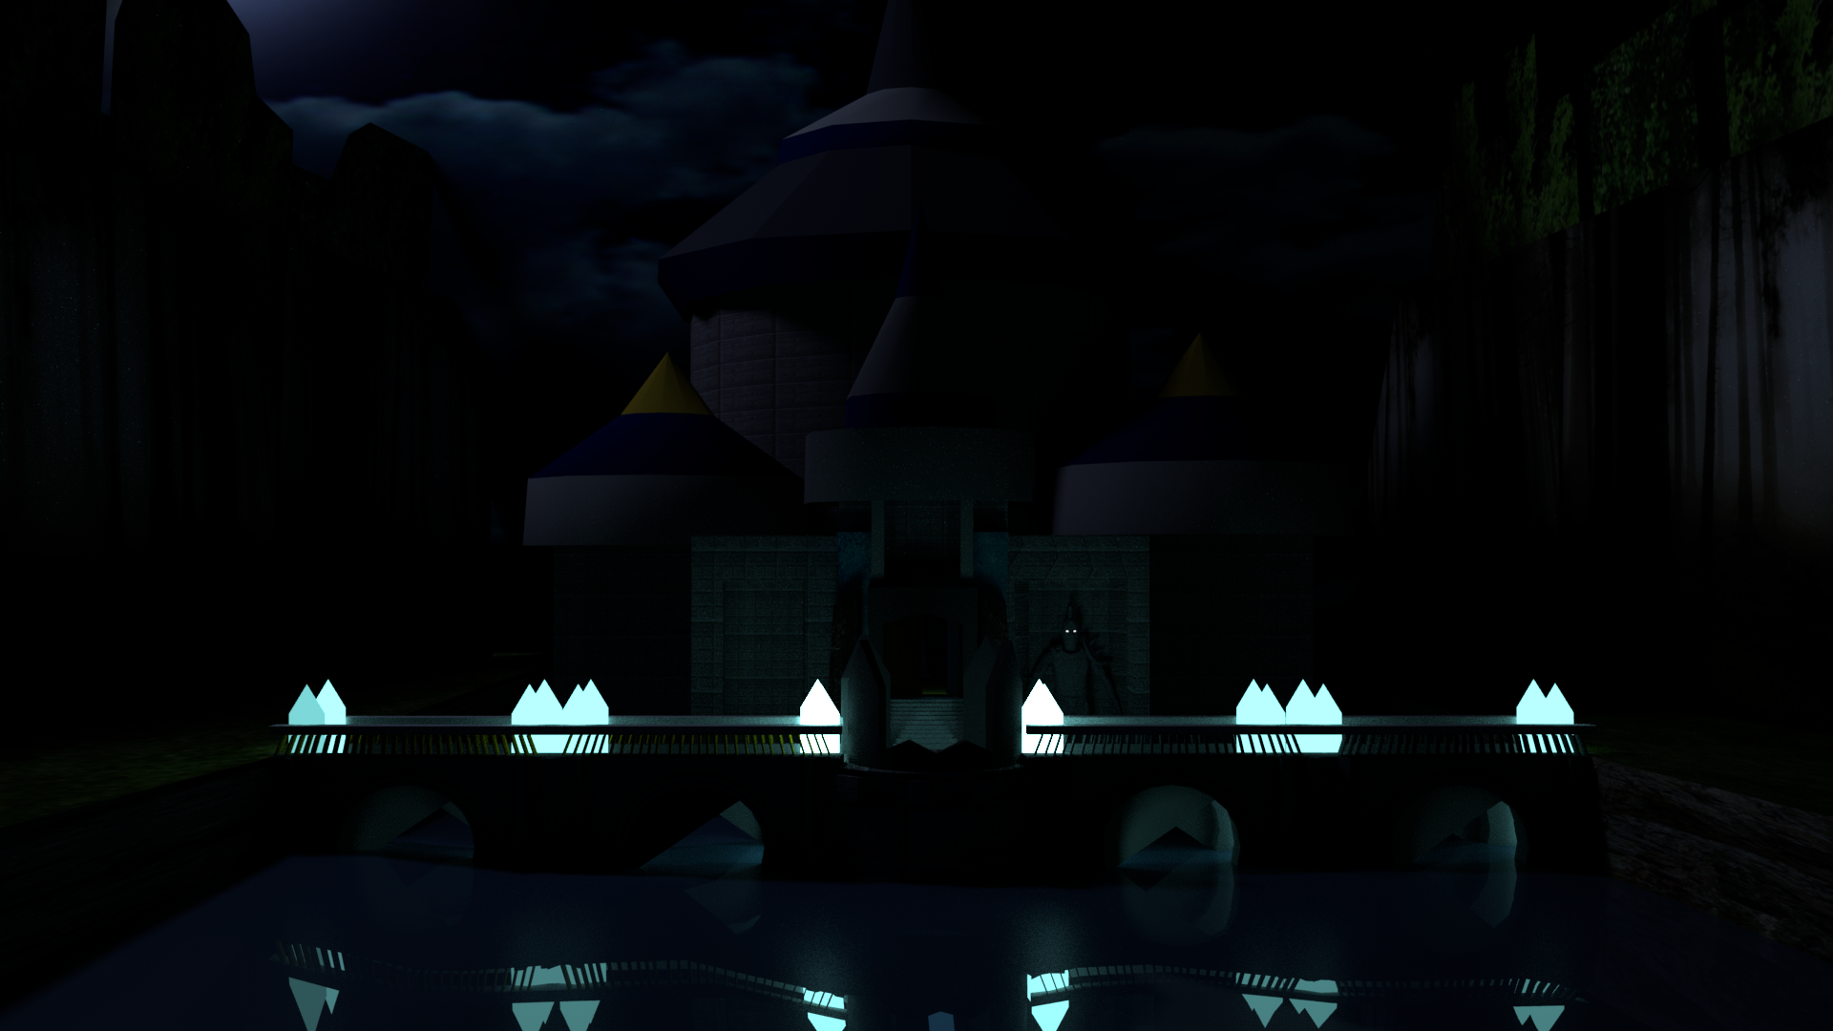Overall, although I was able to learn a lot from this project ginning much more knowledge in different software that will be useful for me in the future there are many parts that I feel I have let myself down in one of the biggest for me was the quality of the final animation which was sloppy and is something I will want to take note of to avoid in my future projects. But I was able to gain some knowledge and I feel that it is in the animation albeit highly masked due to the poor quality of the animation.

