TITLE: MARKETING MANAGEMENT
COURSE: LCMB7024
TUTOR: TAONGA KAONGA SOBERE SNITHERS
STUDENT: PETER FRANCIS
NUMBER: 2236501
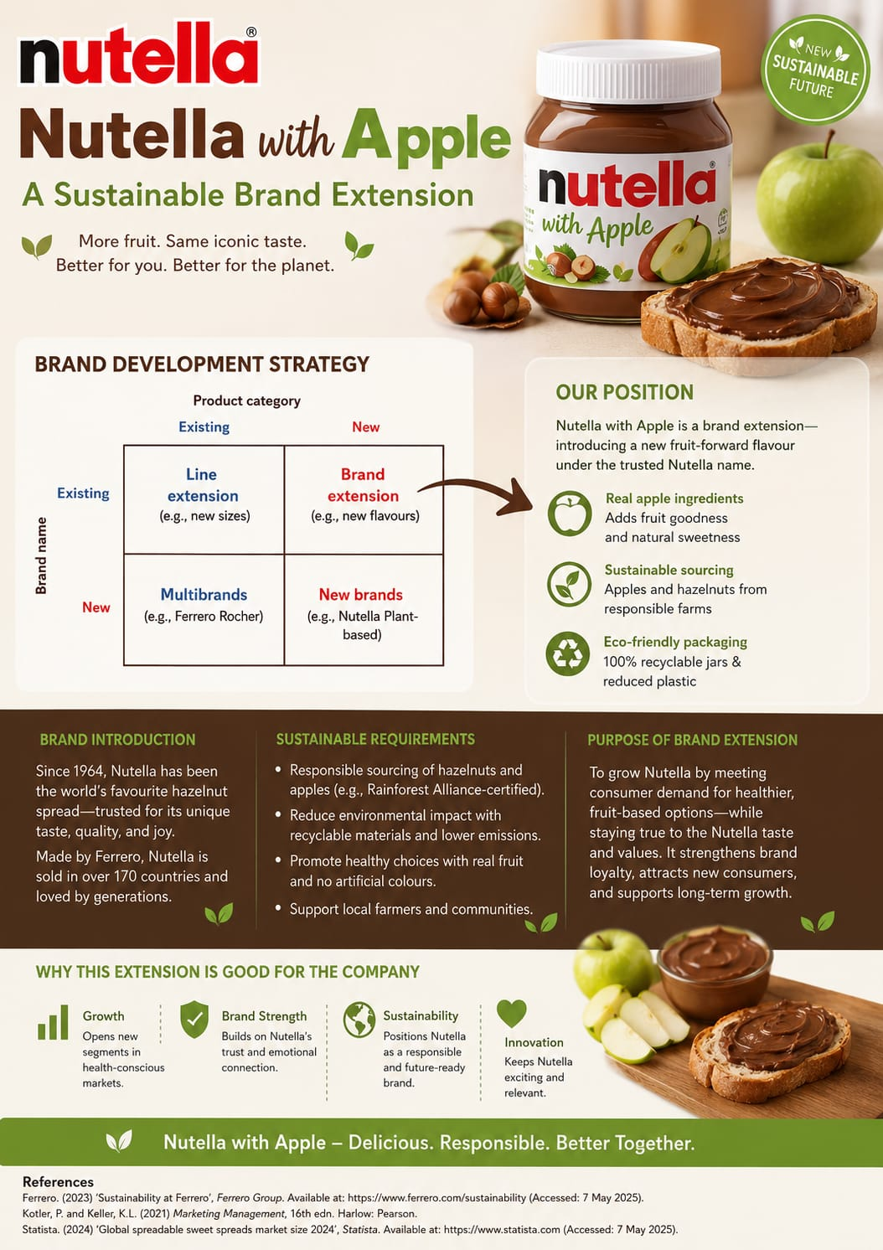
Segmentation, Targeting, Differentiation and Positioning (STDP) Analysis for Nutella with Apple Brand Extension
The proposed Nutella with Apple brand extension is designed to respond to increasing consumer demand for healthier, natural and more sustainable snack choices while maintaining the familiar Nutella taste. The product combines Nutella's iconic hazelnut cocoa spread with real apple ingredients, offering a fruit-based alternative aimed at consumers seeking balanced indulgence. This strategy enables Ferrero to expand Nutella into the growing healthy snacking market while strengthening its sustainability commitments through responsible sourcing and recyclable packaging. Ferrero's sustainability strategy emphasises responsible ingredient sourcing, improved nutrition, and environmentally friendly packaging, making this extension consistent with the company's long-term objectives.
Market Segmentation
Nutella with Apple can be segmented using four key variables:
Geographic Segmentation
The primary markets include the United Kingdom, Western Europe, North America and Australia, where consumers have high purchasing power and increasing awareness of health and environmental issues. Urban and suburban locations provide the strongest opportunities because consumers are more likely to purchase premium food products and actively seek healthier alternatives. These regions also demonstrate growing demand for sustainably produced foods and convenient breakfast and snack options (Kotler and Keller, 2021).
Demographic Segmentation
The target demographic includes:
Adults aged 25–45 years
Parents with children aged 4–15 years
Young professionals
Middle- and upper-middle-income households
Consumers with higher education levels who understand nutrition and sustainability
These consumers are generally willing to pay slightly higher prices for products that offer improved nutritional value, quality ingredients and environmentally responsible packaging. Parents are particularly attracted to products that provide healthier lunchbox and breakfast options without sacrificing taste.
Psychographic Segmentation
The psychographic profile focuses on consumers who value:
Healthy lifestyles ( interested in trying a healthy option )
Balanced nutrition ( Apples are nutritious)
Environmental sustainability
Natural ingredients
Brand trust
Family wellbeing
Premium quality foods
Rather than eliminating indulgent foods completely, these consumers prefer products that provide moderation and healthier ingredients. They appreciate trusted brands that continually innovate while maintaining consistent quality.
Behavioural Segmentation
Behaviourally, the extension targets consumers who:
Frequently purchase Nutella
Regularly buy fruit-based snacks
Read nutritional labels before purchasing
Prefer sustainable packaging
Demonstrate strong brand loyalty to Nutella
Purchase products for family breakfasts and school lunches
Are willing to try innovative flavours from trusted brands
These customers seek convenience without compromising health or environmental values.
Target Market
The primary target audience consists of young health-conscious adults aged 25–40 years and parents looking for healthier snack choices for their children.
Young adults increasingly seek foods that fit active lifestyles while still delivering enjoyable flavours. They value products containing recognisable ingredients and prefer brands demonstrating strong environmental responsibility. Nutella with Apple satisfies this demand by combining the familiar Nutella taste with real apple ingredients, creating a snack perceived as more natural than traditional chocolate spreads.
Parents represent an equally important market segment. Many parents want to reduce their children's intake of highly processed snacks without removing enjoyable foods from their diets. Nutella with Apple offers an attractive compromise by incorporating fruit ingredients while maintaining the taste children already enjoy. This reduces perceived guilt while encouraging healthier eating habits.
The target audience also includes consumers interested in sustainability. Ferrero has strengthened its commitments to responsible sourcing, improved nutrition criteria and recyclable packaging through its sustainability strategy, making this product attractive to environmentally conscious shoppers.

Differentiation Strategy
Nutella with Apple differentiates itself from competing chocolate and fruit spreads in several important ways.
First, unlike traditional chocolate spreads that focus primarily on indulgence, Nutella with Apple combines the iconic hazelnut chocolate flavour with real apple ingredients, providing additional fruit content and natural sweetness.
Second, the extension benefits from Nutella's strong global reputation for quality and consistency. Consumers already trust the brand, reducing perceived risk when trying a new product. Established brand loyalty provides a significant competitive advantage over newer healthier snack brands.
Third, sustainability forms a major point of differentiation. The proposed extension uses responsibly sourced apples and hazelnuts alongside recyclable packaging, supporting Ferrero's wider environmental commitments. Consumers increasingly favour brands demonstrating genuine sustainability initiatives rather than relying solely on marketing claims.
Finally, the product occupies a unique position between indulgent chocolate spreads and healthier fruit spreads. Competitors such as Bonne Maman fruit spreads or chocolate hazelnut products generally focus on either fruit or chocolate, whereas Nutella with Apple successfully combines both categories into one innovative offering.
Positioning Strategy
The positioning statement for Nutella with Apple is:
"A deliciously balanced hazelnut and apple spread that combines the iconic Nutella taste with real fruit ingredients and sustainable values for families seeking healthier everyday enjoyment."
The positioning strategy focuses on four core benefits.
Healthier Choice
The inclusion of real apple ingredients creates a fruit-forward alternative that appeals to consumers wanting healthier snack options without sacrificing enjoyment.
Trusted Brand
Nutella's long-standing reputation provides reassurance regarding quality, taste and reliability. Consumers are more willing to adopt innovative products introduced by brands they already know and trust.

Sustainability
Environmentally responsible sourcing and recyclable packaging reinforce Ferrero's commitment to protecting natural resources while supporting farming communities. This enhances brand credibility among environmentally conscious consumers.
Innovation
Rather than replacing the original Nutella, the extension broadens consumer choice by offering an exciting new flavour that addresses changing dietary preferences while preserving the brand's core identity.
Overall, this positioning enables Nutella with Apple to compete successfully within the growing healthy snack market while strengthening Nutella's image as a modern, innovative and responsible global brand.
Marketing Mix (5Ps) for the Nutella and Apple Brand Extension
The success of a new product depends not only on meeting customer needs but also on creating an effective marketing mix that supports the overall brand strategy. The proposed Nutella and Apple brand extension combines Nutella's well-established chocolate-hazelnut spread with fresh apple slices to create a healthier, convenient snack. This product aims to appeal to health-conscious young adults and parents seeking nutritious snacks for their children while maintaining Nutella's strong brand identity. Applying the marketing mix (Product, Price, Place, Promotion and People) ensures the extension delivers customer value while supporting Ferrero's sustainability objectives and long-term competitive advantage.
Product
The product represents the core element of the marketing mix because it provides the value customers are purchasing (Kotler et al., 2022). The Nutella and Apple brand extension consists of fresh, pre-sliced apples accompanied by a smaller portion of Nutella in recyclable packaging. Unlike traditional Nutella products, this extension focuses on healthier snacking without removing the indulgent experience associated with the brand.
This product aligns with growing consumer demand for healthier convenience foods. Modern consumers increasingly seek snacks containing natural ingredients, fewer artificial additives and balanced nutrition (Euromonitor International, 2024). Parents are particularly interested in healthier lunchbox options, while young professionals require portable snacks suitable for busy lifestyles.
The product also supports Ferrero's sustainability strategy by using responsibly sourced cocoa and hazelnuts, recyclable packaging and locally sourced apples where possible. Reducing plastic usage and encouraging recycling strengthens Ferrero's environmental commitments while responding to consumer concerns about packaging waste (Ferrero, 2024).
From a branding perspective, the extension fits well within Nutella's existing image. According to Aaker (1991), successful brand extensions should maintain consistency with the parent brand while offering additional customer value. Nutella already represents quality, enjoyment and family moments. Adding fresh fruit enhances these associations by introducing health and convenience without weakening brand recognition.
However, maintaining product quality presents challenges because fresh apples have a shorter shelf life than traditional Nutella products. Effective cold-chain logistics and inventory management will therefore be essential to maintain freshness and minimise food waste.
Price
Pricing must reflect customer value while remaining competitive within the healthy snack market. A value-based pricing strategy is appropriate because consumers are willing to pay slightly more for products that offer convenience, nutrition and trusted brand quality (Kotler et al., 2022).
The proposed retail price would range between £2.00 and £2.50 per snack pack, positioning the product slightly above ordinary fruit snacks but below premium healthy snack brands. This pricing reflects Nutella's premium positioning while remaining affordable for frequent purchases.
Initially, Ferrero could adopt a market penetration pricing strategy, introducing promotional discounts, multi-buy offers and supermarket loyalty schemes to encourage trial purchases. Once consumer awareness and loyalty increase, prices can gradually return to standard premium levels.
Psychological pricing may also be applied through prices such as £1.99 or £2.49, creating stronger perceptions of affordability while maintaining profitability.
The pricing strategy also supports sustainability. Although environmentally friendly packaging and responsibly sourced ingredients increase production costs, research indicates many consumers are willing to pay a premium for sustainable food products (NielsenIQ, 2023). Therefore, communicating the environmental benefits strengthens perceived value and justifies slightly higher prices.
Nevertheless Ferrero must carefully balance premium pricing against increasing cost-of-living pressures, particularly in the UK market where consumers remain price sensitive.
Place
Place refers to making products available where customers can easily purchase them (Armstrong et al., 2021). Since the target market consists of busy young adults and parents, widespread product availability is essential.
The Nutella and Apple snack should be distributed through major supermarkets including Tesco, Sainsbury's, Asda, Morrisons and Aldi, where most grocery shopping occurs. Convenience stores, petrol stations and university shops should also stock the product to encourage impulse purchases.
The product should be positioned within refrigerated healthy snack sections rather than beside confectionery. This placement reinforces its healthier positioning and differentiates it from traditional chocolate products.
Online grocery retailers such as Ocado, Amazon Fresh and supermarket home delivery services further increase convenience for consumers who increasingly purchase groceries digitally. According to Statista (2024), online grocery shopping continues to grow, particularly among younger consumers and families.
Ferrero may also develop partnerships with schools, workplaces, gyms and cafés to expand distribution into locations where healthy snacks are regularly consumed. Such partnerships support both accessibility and healthier eating initiatives.
From a sustainability perspective, Ferrero should prioritise shorter supply chains by sourcing apples locally where possible. Local sourcing reduces transportation emissions, supports domestic farmers and improves freshness. Efficient logistics also reduce food waste, contributing to the company's environmental objectives.
Promotion
Promotion is critical in communicating the benefits of this new product and encouraging trial. An integrated marketing communications strategy should combine digital marketing, traditional advertising, public relations and sales promotions.
Social media platforms such as Instagram, TikTok and Facebook provide ideal channels for reaching younger consumers. Influencer marketing involving nutritionists, fitness experts and family lifestyle creators can increase product credibility and awareness. User-generated content encouraging customers to share healthy snack moments can further strengthen engagement.
Traditional advertising through television, outdoor billboards and supermarket displays remains important for reaching parents and family audiences. In-store product demonstrations and free sampling encourage trial and reduce perceived purchase risk.
Promotional messages should emphasise key benefits including:
Healthy and balanced snacking.
Convenience for busy lifestyles.
Trusted Nutella quality.
Sustainable packaging.
Responsibly sourced ingredients.
Cause-related marketing could further enhance brand image by supporting healthy eating programmes in schools or environmental initiatives such as tree planting. Consumers increasingly favour brands demonstrating genuine corporate social responsibility (Porter & Kramer, 2019).
However, promotional claims regarding health benefits must remain transparent and evidence-based to avoid misleading consumers. Marketing communications should emphasise moderation rather than suggesting Nutella itself is a health food.
People
People represent employees, suppliers, retailers and customers who influence the consumer experience. Within services marketing, people significantly affect customer satisfaction (Booms & Bitner, 1981), and this principle also applies to food products.
Ferrero employees require training to communicate the product's nutritional benefits, sustainability credentials and brand values consistently. Sales representatives should educate retailers on appropriate product placement and merchandising to maximise visibility.
Retail staff also influence purchasing decisions by maintaining attractive product displays and ensuring refrigerated products remain fresh and well stocked.
Suppliers play an equally important role. Long-term partnerships with local apple growers and certified sustainable cocoa and hazelnut suppliers ensure product quality while supporting ethical sourcing practices. These relationships strengthen supply chain resilience and reinforce Ferrero's sustainability commitments.
Consumers themselves contribute to brand development through online reviews, social media engagement and word-of-mouth recommendations. Encouraging customer feedback allows Ferrero to improve future product development while building stronger relationships with target audiences.
Finally, creating a customer-centred organisational culture ensures every stakeholder contributes towards delivering a consistent brand experience. This supports relationship marketing, where long-term customer loyalty becomes more valuable than short-term sales (Grönroos, 2017).
The proposed marketing mix effectively supports the Nutella and Apple brand extension by combining healthier product innovation with premium pricing, convenient distribution, integrated promotion and strong stakeholder engagement. Each element reinforces Ferrero's commitment to sustainability while remaining consistent with Nutella's established brand identity. By addressing changing consumer preferences for healthier, convenient and environmentally responsible food choices, this marketing mix positions the extension for long-term success within the competitive healthy snack market.
Reflection on Developing a Sustainable Brand Extension Strategy and Poster Presentation
Developing a sustainable brand extension strategy for the Nutella and Apple product and preparing the accompanying poster presentation has been a valuable learning experience that has enhanced both my academic knowledge and professional skills. Using Gibbs' Reflective Cycle (1988), I have reflected on the knowledge I gained, the challenges I encountered, and how this project has contributed to my future development.
During this project, I explored how marketing theories can be applied in a practical business context. Designing a sustainable brand extension required me to analyse consumer behaviour, market segmentation, targeting, positioning, and the marketing mix while ensuring that sustainability remained central to the strategy. I learned that successful brand extensions are not simply about introducing new products but about maintaining consistency with the parent brand while responding to changing consumer needs (Kotler et al., 2022). Researching Nutella's brand identity helped me understand the importance of balancing innovation with brand equity to build customer trust and loyalty (Aaker, 1996).
One of the most significant challenges was integrating sustainability into every aspect of the marketing strategy. I realised that consumers increasingly expect companies to demonstrate environmental and social responsibility alongside product quality (Peattie and Belz, 2010). This encouraged me to think more critically about packaging, sourcing, pricing, and promotional strategies rather than focusing only on profitability. As a result, I developed stronger analytical and critical thinking skills by evaluating different marketing approaches and supporting my decisions with academic literature.
Preparing and delivering the poster presentation further strengthened my communication skills. Initially, I found it difficult to summarise a large amount of research into a visually engaging and concise format. However, this process taught me how to prioritise key information and present complex ideas clearly and effectively. Delivering the presentation also improved my confidence in public speaking, organisation, and responding to questions. I recognised that effective communication is just as important as conducting thorough research because stakeholders need information that is both informative and easy to understand.
This project has contributed significantly to my personal and professional development. Academically, I have improved my research skills by locating and evaluating credible sources and applying Harvard referencing correctly. Professionally, I have developed skills in strategic planning, problem-solving, critical analysis, and presentation, all of which are highly valued in marketing and business management. I also became more aware of the importance of teamwork, time management, and planning, even when working independently, as these skills ensured the project was completed effectively.
In the future, I would like to strengthen my ability to use digital marketing analytics and data visualisation tools to support marketing decisions more effectively. I also aim to improve my presentation delivery by practising more frequently to increase confidence and reduce anxiety when speaking to larger audiences. Furthermore, I intend to deepen my understanding of sustainable marketing practices as consumer expectations and environmental regulations continue to evolve. Continuous learning through professional development, academic research, and practical experience will enable me to become a more effective marketing professional capable of developing innovative and sustainable business strategies.
Overall, this project has been a rewarding learning experience that has enhanced my understanding of sustainable marketing, strategic brand management, and professional communication. It has provided me with practical skills and greater confidence that will support my future academic studies and career development
REFERENCES
Aaker, D.A. (1991) Managing Brand Equity. New York: Free Press.
Aaker, D.A. (1996) Building Strong Brands. New York: Free Press
Armstrong, G., Kotler, P. and Opresnik, M.O. (2021) Marketing: An Introduction. 14th edn. Harlow: Pearson
Booms, B.H. and Bitner, M.J. (1981) 'Marketing strategies and organisation structures for service firms', in Donnelly, J.H. and George, W.R. (eds.) Marketing of Services. Chicago: American Marketing Association, pp. 47–51.
Euromonitor International (2024) Health and Wellness Snacks Global Report.
Ferrero (2024) Ferrero Sustainability Report 2023/24.
Ferrero (2025) Ferrero Sustainability Report 2025. Available at: https://www.ferrero.com/int/en/people-planet/sustainability-reporting⁠� (Accessed: 4 August 2026).
Gibbs, G. (1988) Learning by Doing: A Guide to Teaching and Learning Methods. Oxford: Oxford Polytechnic.
Grönroos, C. (2017) Service Management and Marketing. 5th edn. Chichester: Wiley.
Kotler, P. and Keller, K.L. (2021) Marketing Management. 16th edn. Harlow: Pearson.
Kotler, P., Keller, K.L. and Chernev, A. (2022) Marketing Management. 16th edn. Harlow: Pearson.
NielsenIQ (2023) Global Consumer Sustainability Survey.
Nutella (2025) Sustainability – Nutella UK. Available at: https://www.nutella.com/uk/en/inside-nutella/sustainability⁠� (Accessed: 4 August 2026).
Peattie, K. and Belz, F.M. (2010) 'Sustainability marketing—An innovative conception of marketing', Marketing Review St. Gallen, 27(5), pp. 8–15.
Porter, M.E. and Kramer, M.R. (2019) 'Creating shared value', Harvard Business Review, 97(1), pp. 63–77.
Statista (2024) Online Grocery Shopping in the United Kingdom.
Statista (2025) Healthy snacks market and consumer behaviour statistics. Available at: https://www.statista.com⁠� (Accessed: 4 August 2026).

