
Skills for the Workplace
Module Assignment Submission
Student Name: | Chloe Davies
Student Number: | 2016156
Module No: | BMSK4005
Module Title: | Professional Career Development

Statement of Confirmation of Authenticity
By the act of making this submission, the student declares that this is the work of the student named above. The work has not, in whole or in part, been knowingly presented elsewhere for assessment, or where assessment has been built on a previous assessment, this has been identified. Where materials have been used from other sources it has been properly acknowledged. If this statement is untrue, the student acknowledges that an assessment offence has been committed.
Attention is drawn to the plagiarism and unfair practice policies of both the University and of ILM.

Table of Contents
Section 1: Know how to identify development needs 3
1.1 Identify learning styles for self and another 3
1.2 Use a simple technique for identifying development needs for self & another 4
1.3 Identify potential barriers to learning for self and another. 6
1.4 Explain how these barriers to learning can be overcome. 6
Section 2: Know how to develop self & others to achieve organisational objectives 6
2.1 Analyse learning/development options to meet needs of self & another. 6
2.2 Identify support mechanisms for the development of self & another 7
2.3 Prepare development plans for self & another 7
Self 7
Person 2 8
2.4 Method used to monitor the development of self & another. 9
Section 3: Know how to prepare for the recruitment process 10
Reflection on the Recruitment Process 10
3.1 Description 10
3.2 Feelings 10
3.3 Evaluation 11
3.4 Analysis 11
3.5 Conclusion 11
3.6 Action Plan 11
References 12
Appendix A 12
Appendix B 12
Appendix C 12

Section 1: Know how to identify development needs

1.1 Identify learning styles for self and another

PERSON 1
Honey and Mumford
2 | 7 | 1 | 5
4 | 13 | 3 | 9
6 | 15 | 8 | 11
10 | 16 | 12 | 19
17 | 25 | 14 | 21
23 | 28 | 18 | 27
24 | 29 | 20 | 35
32 | 31 | 22 | 37
34 | 33 | 26 | 44
38 | 36 | 30 | 49
40 | 39 | 42 | 50
43 | 41 | 47 | 53
45 | 46 | 51 | 54
48 | 52 | 57 | 56
58 | 55 | 61 | 59
64 | 60 | 63 | 65
71 | 62 | 68 | 69
72 | 66 | 75 | 70
74 | 67 | 77 | 73
79 | 76 | 78 | 80
Total circled:11 | Total circled:9 | Total circled:14 | Total circled:15
ACTIVIST | REFLECTOR | THEORIST | PRAGMATIST

Here are my Honey and Mumford learning style questionnaire results. I agree that I am a pragmatist as I always try to apply a situation realistically. Although I agree with this questionnaire, I thought that my second highest score would be activist as I believe that I’m a hands -on person.

VARK
A’s = 5 . B’s = 5 C’s =20
These are my VARK questionnaire results. It’s clear to say that I am a strong Kinaesthetic learner, meaning that I’m a hands on/ practical learner. I learn best when trying things out for myself.
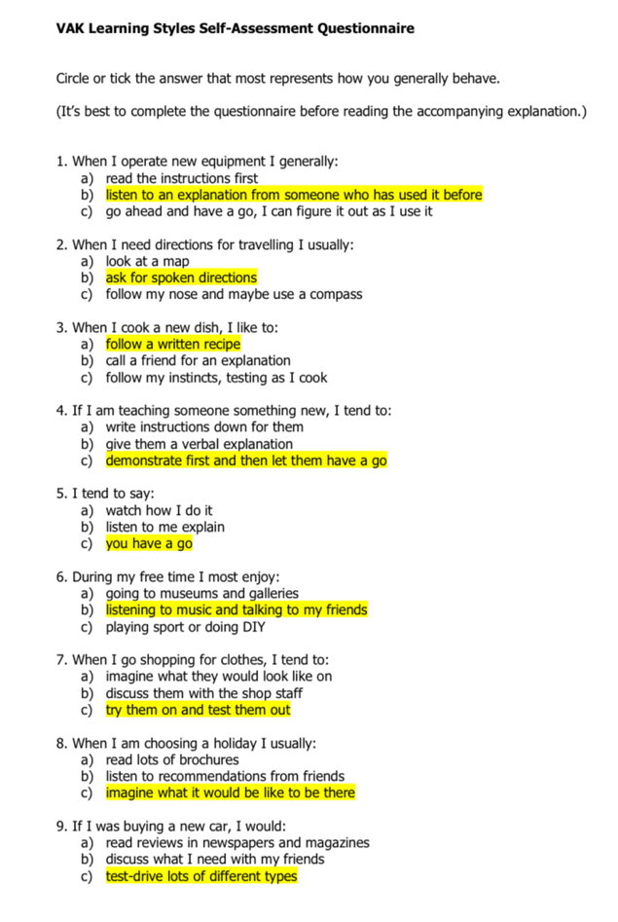

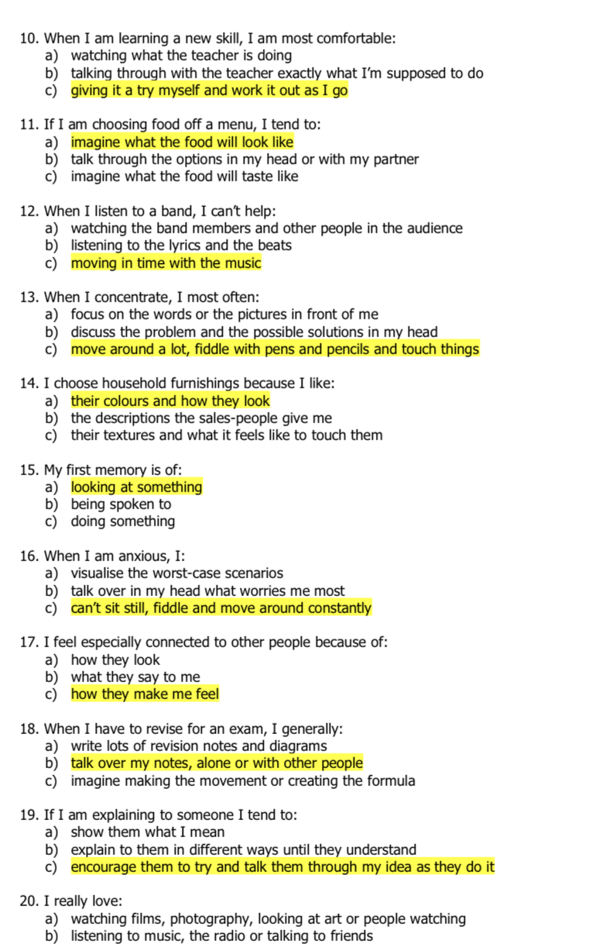

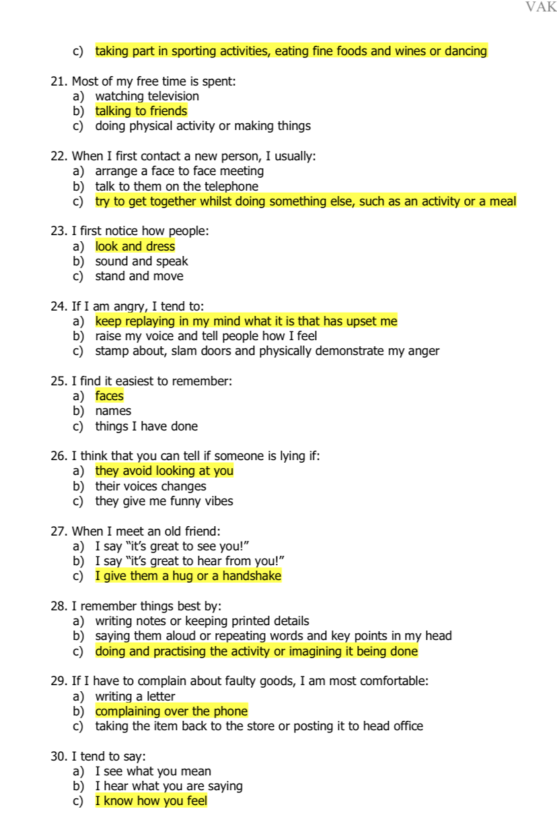

PERSON 2

2 | 7 | 1 | 5
4 | 13 | 3 | 9
6 | 15 | 8 | 11
10 | 16 | 12 | 19
17 | 25 | 14 | 21
23 | 28 | 18 | 27
24 | 29 | 20 | 35
32 | 31 | 22 | 37
34 | 33 | 26 | 44
38 | 36 | 30 | 49
40 | 39 | 42 | 50
43 | 41 | 47 | 53
45 | 46 | 51 | 54
48 | 52 | 57 | 56
58 | 55 | 61 | 59
64 | 60 | 63 | 65
71 | 62 | 68 | 69
72 | 66 | 75 | 70
74 | 67 | 77 | 73
79 | 76 | 78 | 80
TOTALS: Activist 11. Reflector 8. Theorist 7. Pragmatist 10
This Honey and Mumford learning styles questionnaire shows that person two is an activist. Person two is very hands on with new experiences. He doesn’t find it hard to take the lead in a team as he is enthusiastic and confident about everything. I agree with him being an activist. He was also scoring close to being a pragmatist as he focusses on more practical solutions.
VARK Questionnaire
RESULTS-
A=7 B=7 C=16
Person two’s results show that he has a Kinaesthetic learning style. Like shown in the previous questionnaire, it shows that he’s more of a hands-on person when it comes to learning. Person two agreed with these results as although sometimes he has to apply the different learning styles to his everyday work life, he said he benefits more with physical experience.

1.2 Use a simple technique for identifying development needs for self & another
SWOT Person 1
STRENGTHS-  Driving  Communication  Organised  Management | WEAKNESSES-  Numeracy  Overthinking  Problem Solving
OPPORTUNITIES -  Maths tutor  Looking back on class notes | THREATS-  Not enough time  Customers bad attitude
Strengths
Driving- I passed my driving test when I was 17, it took great effort and determination to pass. This is a great achievement as I’m able to go wherever I want to go, such as work, university and even out with my friends. This make more independent as a person and I also have a high knowledge of the road highway code.
Communication- this is one of my main strengths that’s developed over the long period of time that I’ve been working in a bar. Meeting new people and socialising with different types of people has boosted my confidence and now I’m more than willing to speak to anyone. I’m able to adapt and empathise to different personalities in order to relate to other people. This strength developed my team building skills massively as I’m more confident working with other people.
Organised- I always like to be one step ahead and I like everything to fall into place perfectly, which means that I prepare beforehand. Before I start my Uni call, I like to make sure my notepad is ready / laptop charged etc. In order to do my class assignments, I make sure all my class notes are neatly written out so that it’s easy to look at. Being organised saves time by not looking for equipment. It’s also essential to university students as it gives students more time to focus on assignments / projects etc.
Management- this skill started off as a weakness, but It’s been developed since I’ve been given more managerial roles in work. My boss shares some of her roles with me as she knows I would like to develop my skills in that area. Having good management skills will be an ongoing skill that I will keep developing over time and it will benefit me in the future as I would like to become a manager to an efficiently run business.
Weaknesses
Numeracy- this is definitely my weakness as I am not confident when having to work out mathematical equations without a calculator. When I have a calculator, I feel more confident. Not succeeding the grade that I wanted when studying GCSE’s has always made me consider re-doing my GCSE in Maths.
Overthinking - this weakness causes hassle on a day to day basis as I stress and worry about almost everything. This weakness is likely to clash with my university course as I worry that my work isn’t up to a certain standard.

Problem Solving- I am quick to make a judgement with most things, so I try to come to a conclusion too fast sometimes meaning that I don’t give myself time to figure the issue out.
Opportunities
I could see a maths tutor or re-do my GCSE to gain more numeracy skills. Or in work I could try to use the tills less and work things out in my head rather than letting the calculators doing it for me.
In order to overcome my overthinking barrier in Uni, I could look back on all class notes and specs, and then check that I’ve included everything to the best of my knowledge.
Threats
Not having enough time to study numeracy due to university and work is definitely a main threat.
A threat in work could be a customers bad attitude, which could potentially link to my weakness of overthinking, if they said something inappropriate I would most likely go home after work and overthink about what was said.
COVID is a threat as I’m not able to work, meaning that I’m not being paid. This means that I’ve had to budget and be more weary with bills etc so that I can keep up with payments.

SWOT Person 2
STRENGTHS-  Confident  Driving Licence  Good Dad  Financially Stable.  Time Keeping | WEAKNESSES-  Stubborn  Numeracy  Organisation
OPPORTUNITIES –  Studying in spare time  Prepare more | THREATS-  Heated discussions  No spare time  Covid
Strengths
Confident- He is willing and able to speak with confidence. E.g large group discussions. Especially about his passions and interests. This skill has been developed through years of staff meetings/ large group discussions. Being a manager if his own company means that he has no option but to be confident in what he says as people look up to him for support.
Driving License- He is able to travel long distance for work. He’s also able to travel to courses and meetings. He has worked hard to make it to the top of his job, in order to become a manager, he’s had to travel to different cities and countries to do courses and training.
Good Dad- Although work can be a time-consuming barrier, he always makes time to see his children + fit their needs.
Financially Stable- he is able to pay for online courses to benefit his work lifestyle. Also able to buy a nice car, as its needed for his type of job.
Time Keeping-He is always on time to any event that he goes to, allowing him to be punctual. Having good time keeping skills will lessen the chance of stress and will help you focus on the task that you’re completing.

Weaknesses
Stubborn-He is strong minded, meaning that sometimes he doesn’t consider other possible ideas/ thoughts as he thinks his are the best.
Numeracy- Not very confident with his numeracy but this can be resolved by using a calculator.
Organisation- In his office, there’s sometimes paperwork and work equipment everywhere, which then leads to him not knowing where certain things are.
Opportunities
Studying in spare time so that he can educate himself mathematically.
Preparing his office before he starts work, so that everything’s in place. This will allow him to concentrate better.
Threats
Being opinionated could lead to arguments/ heated discussions.
Not having spare time to study and improve numeracy skills.
COVID has a large impact on his work as he’s not able to do staff meetings, and meet clients.

1.3 Identify potential barriers to learning for self and another.
1.4 Explain how these barriers to learning can be overcome.

SELF
COVID is a big barrier to everyone’s day- to – day lifestyle as we have to make very careful precautions. Universities are now doing online lectures to stop the spread of the virus. This has affected me in many ways, such as not being able to do lectures in classes. I am more of a visual learner, meaning I would benefit more being in a classroom. When face- to- face lectures on, masks are to be worn at all times and all students are expected to distance.
In work, it is my job to make sure every single customer that enters the pub has filled in a Track and Trace form, this allows the customers to be informed if they have been in contact with anyone that has had the virus. Masks are to be worn in work too at all times. To overcome this barrier safely and efficiently, I follow the guidance on the GOV.UK website with all the latest Coronavirus Rules and Regulations.
My work life balance is also another barrier as I try to balance out enough time to fit assignments and my work life into one. Due to all my lectures being online, it suits my work fairly well as I’m able to carry on with shifts, and then do my assignments around work. This barrier can be overcome by speaking to my boss about working shifts around my university lectures.
Sometimes I have to look after my younger brother while both parents are in work, this childcare barrier can be overcome by asking my grandparents to look after him while I’m in a lecture/ doing work. If my grandparents aren’t available to look after him, I prepare films/ food etc for him so that I can peacefully carry on with my uni work. Another way for this to be overcome would be to have a babysitter, then it will become a financial barrier and babysitters aren’t cheap
PERSON 2
Being a manager of his own company means that a lot of people rely on him for guidance/ support, meaning that when he’s not there to support his staff when they need help, they are stuck and unable to do anything.. In order for this to be overcome, he could prepare guidance sheets for staff to use when they’re stuck. Having an assistant manager is another solution which could benefit him.

Childcare is barrier to their learning as sometimes his work clashes into time when he has his children. This barrier is easily overcome as his parents are willing to babysit while he works. His parents are retired so are free any time of the day/ night.
Some of his classes/ work training is away in different cities/ countries, meaning that he has to travel long distance in order to complete them. This can then become an issue as he isn’t investing his time into his work at home. This could potentially be overcome by searching for training classes that can be done via online, or searching for training closer to home. Worst case, he could do the training on his quietest days, so that he doesn’t miss as much as he would on a busy day.

Section 2: Know how to develop self & others to achieve organisational objectives

2.1 Analyse learning/development options to meet needs of self & another.

SELF
In order to progress my development in work, I could attend frequent staff training sessions. This would enable me to have a broader knowledge of how things are done in my workplace. Having trained staff means that workers are learning new skills that can improve production, reduce production costs, reduce mistakes, build confidence in your workforce, and create a better working environment.
Attending university is an option which I have decided to do, so that I can use the knowledge and grades I learn to go into future jobs/ pathways. This course will benefit me in any career pathway I go down as it broadens my network and I will learn life skills . I will then leave university with professional qualifications.
In order to deal with my nerves better, I could take tablets that calm nerves and anxiety. This way I’ll be able to focus on what matters.
PERSON 2
In order to develop his numeracy skills, it would be beneficial for him to do numeracy courses online to re-jog his memory. Developing this skill will help him in his day- to – day life as well as work.

2.2 Identify support mechanisms for the development of self & another

Myself
There are numerous support mechanisms in University, such as my lecturer, HWB, classmates etc. If I need support with any of my assignments, I am able to email my lecturer and then be guided by her. HWB is another good support mechanism, if I have any technical issues, I can call a number and speak to a professional in that certain area.
To tackle my nerve and confidence issues, the best suggestion would be to go see a local GP as they could advise me to take certain medication for my nerves. Another support mechanism for nerves could be friends and family, as they could check over whatever I’m nervous/ not confident about and give their honest opinion.

Person 2
Person two could use night session classes in order to broaden his support mechanisms. This would be beneficial as he can still work during the day and attend classes at night. There are a wide variety of online college courses in order to develop his knowledge.

2.3 Prepare development plans for self & another

Self

Part 1: Personal Analysis
See SWOT Analysis in 1.2

Part 2: Setting Goals

What do I want to learn? | What do I have to do? | What support and resources will I need? | How will I measure success? | Target Date for Review
Working out weekly takes in work (pub). | Be willing to do them as when given the opportunity to, I avoid doing it because I’m not confident doing them. | Either my boss or an experienced member of staff to support me while I’m not confident. | By having my figures checked over by my boss, if they figures are correct, then I will know that I’ve been successful. | 01.12.20
How to do referencing properly for my university assignments. | Go on my university files and go through the referencing file. Read it in detail. | Microsoft Teams  My lecturer | When I get my assignment handed back to me, my lecturer will be able to show me if its been done right/wrong. | When assignment is due.
Running for a prolonged period of time. | Go to the gym more frequently and train my cardiovascular system. | Gym membership  Running machine  Running gear | By tracking how far I’ve run during each session. | 01.01.21

Part 3: Personal Objectives

Short Term Goals (next 12 months)
My short -term goal is to complete my university course. This will take hard work and determination.
Be able to run 10 miles without stopping. This goal will be achieved by going to the gym on a daily basis, and having a strict diet so that I’m getting the right nutrients before exercising.
Medium Term Goals (2-3 years)
My medium -term goal is to consider doing a degree. If I succeed with my short -term goal and feel the urge to want to progress it further, I could then go onto doing a degree. This will be beneficial because I will have good qualifications behind me for when I go into a job.
Save £10,000. Having two incomes makes this realistic as its over 2-3 years

Long Term Goals (3-5 years)
Within the next 3-5 years, my goal is to be settled into a job that I enjoy and have a genuine passion for, with a good salary.

Own my own house, hopefully I will be in a secure job with a good income, meaning that I can afford to step onto the property ladder.

Person 2

Part 1: Personal Analysis
See SWOT Analysis in 1.2
Part 2: Setting Goals

What do they want to learn? | What do they have to do? | What support and resources will they need? | How will they measure success? | Target Date for Review
An efficient way to conduct non- contact meetings with customers and colleagues. (due to COVID). | Do research online  Potentially ask other similar businesses how they’re dealing with the new COVID rules. | Computer  Phone  Work colleagues | When they figure out which way is the most efficient way to do so. | 25.11.20
Lose two stone | Train frequently in the gym. Or go on long walks/ runs | Gym membership  Gym equipment  Fitbit/ gym workout recorder | By using a fitbit which record heart rate, how far they’ve run etc. | 01.05.21

Part 3: Personal Objectives

Short Term Goals (next 12 months)
Be able to carry on running his business efficiently during this pandemic.
Train to achieve his ideal body physique. This will take up to a year as losing weight takes time. If weight were to be lost extremely fast, it could cause body damage/strain.
Medium Term Goals (2-3 years)
Make his work team bigger by applying more staff. More staff would mean that his company will grow due to more helping hands.
Long Term Goals (3-5 years)
Open more work offices around Swansea/Wales or even potentially worldwide so that his business grows.

2.4 Method used to monitor the development of self & another.

We will use my Personal Development Plans as a method to monitor our development as we can revisit them at every Task Review Target Date to see if the tasks have been achieved and if not, we can examine the reasons for this and set new target dates as required.

Section 3: Know how to prepare for the recruitment process

Reflection on the Recruitment Process


Gibbs (1988)

3.1 Description
I’ve looked on numerous search engines to look for a job which would really suit me. After looking on a variety of different job sites, I found mine on Indeed. I also created a CV, but before I started it, I took the time to look online at CV templates/ covering letters and ideas from other people. I also did the same for covering letters so that I have a good understanding of what should be included

3.2 Feelings
I think that using a variety of different job sites definitely benefit me as I had such a variety to pick from, after having a variety I could then narrow my options down and pick a very well-suited job for myself. When I was researching CV’s and covering letters online, I was able to see what was needed to put into my CV. I have learnt that when doing a covering letter, I have to make to specifically for the job that I’m applying for; ideally, people shouldn’t use the same covering letter for a number of jobs that they’ve applied for.
I learned that CV’s can be kept short and sweet, as long as they have all the important facts in. Employers don’t always pick the CV with the most writing in it. As long as its got a good summary of yourself in, it’ll be fine.

3.3 Evaluation
Throughout the whole process, I think gathering information on how to write a covering letter was the part I enjoyed the most. I could’ve potentially improved this by specifically looking up a covering letter for the type of job I’m going into. Instead I found a few templates and changed it completely into my own.
I think my CV was my weak point as I don’t like boasting about myself. But after looking at other people’s ones online, I was able to see what was meant to be in a CV.

3.4 Analysis

I didn’t enjoy the job application process, as it was very time consuming and I don’t have that much experience and knowledge in that aspect. If I were to do another job application for a future job, I would try research how to fill in an application form to its full potential, or possibly even asking someone I know in that working sector to help fill it in with me. If someone who works in that certain sector were to help, they could use their experience and knowledge to help. When writing my CV, I found it very hard to write positives about myself without thinking I was bragging myself up, but after doing research, it was clear that CV’s are all for positives about yourself.

3.5 Conclusion

All in all, I think from preparing for the recruitment process, I have gained a lot of new skills and knowledge. I am now able to use these skills and knowledge when applying for future jobs/ pathway careers. I have learned that CV’s and covering letters don’t have to be pages long, as long as they have all the important details, they can be kept short and sweet.

3.6 Action Plan
In order to progress my career, I’m going to complete this course, and potentially go onto doing a degree. I think this would be beneficial to me as it would help me make my way up in whatever career pathway I decide to go down.

References

Gibbs, G. (1988) Learning by doing; A guide to teaching and learning methods. London: FEU

Appendix A

Appendix B

Chloe Eliszabeth Davies
24 Cyncoed Close
Dunvant
Swansea
SA2 7RS
Email- chloee_davies@icloud.com
Mobile- 07769295179
Summary
I am currently working full time in a sports bar and grill. Before I started working, I was full time in Gower College Swansea. I studied my GCSE’s in Olchfa Comprehesive.
I am a self-motivated individual who can work in all types of environments, with great people skills and able to manage and control everyday life occurrences with a professional manner.
I have a good knowledge and understanding of computer operations and would strive to implement this into any occupation or career path.
Experience
The Lewis Jones-
I have worked here for 3 years and I have gained an immense amount of experience. Such as customer care- Each person is different, and my job is to adapt and empathise with them. I have also gained a large amount of technical experience such as using the till and answering phone calls organising bookings and dealing with query’s. I have also had the managerial roles in this workplace, such as doing weekly staff rotas and stock takes.
Poseidon Swim School- As well as attending college, I used to lifeguard for a swim school, to become a lifeguard I had to pass a First Aid course. Having the knowledge of this course is a huge benefit as health and safety is particularly important in all aspects. I worked at Poseidon Swim School for just over a year. My role was to make sure that everyone in and out of the water was safe.

Dunvant Primary School- I assisted a schoolteacher at Dunvant Primary School for six months. My role was to help any of the children that needed that extra bit of guidance during their lessons. This taught me to be able to adapt to the younger children’s age.
Education
Olchfa Comprehensive School (2010-2015). During my 5 years of education at Olchfa I would say that I was successful with my standards of learning. I found this especially in year 10 and 11 (GCSE) where I achieved the following grades.
English- C
Religious Studies- C
Science- C
Health and Social Care- C
Maths- C
Physical Education – B
Duke of Edinburgh- Bronze and Silver
Gower College Swansea (2015-2017)
During my two years of further education I feel that I was successful as I achieved my pass grades in both years.
Year 1 Gower College, Sport (BTEC): Pass Grade, BTEC Level 3
Year 2 Gower College, Sport (BTEC): Pass Grade, BTEC Level 3
References
Available upon request

Appendix C
Dear Store Manager,
I would like to express my interest in your recent job application shown on your website.
I have served the last five years working in the retail sector. For the last year of working in retail, I have been given some managerial roles to build my experience and knowledge. From my past experience, it’s clear that the main aspects of working in retail are teamwork, good communication with customers and high standard of customer service.
I would make a great supervisor for Joules. This career pathway would be beneficial to myself and the company as I’m a hard-working, motivated individual who’s always willing and eager to learn new skills.

Sincerely,
Chloe Davies

