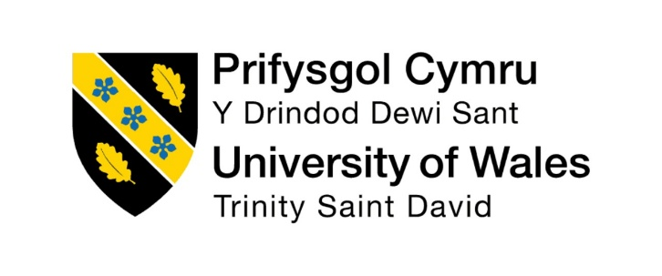

Programme: Master of Business Administration
Module: International Marketing: Principles and Practices
Module code: LCMB7026
“A Comparative Analysis of Coca-Cola’s Marketing Strategies in the United Kingdom and Japan”
Student Name : Patel Nishit Jagdishbhai
Student I’d : 2433620
Lecture’s name: Taonga Kaonga Sobere-Snithers

Word Count: 5255
Submission date : 14/11/2025

Table of Contents
1. Introduction 4
2. Brand Overview: Coca-Cola in the United Kingdom and Japan 4
2.1 Global Overview of The Coca-Cola Company 4
2.2 Coca-Cola’s Operations in the United Kingdom 5
2.3 Coca-Cola’s Operations in Japan 5
3. Comparison of the Socio-Cultural Context and Macroenvironment (PESTLE) 6
3.1 Socio-Cultural Context and Macroenvironment for United Kingdom 6
3.2 Socio-Cultural Context and Macroenvironment for Japan 8
4. Comparison of Coca-Cola’s STP Strategies in the United Kingdom and Japan 10
4.1 Segmentation Strategies 10
4.2 Targeting Strategies 12
4.3 Positioning Strategies 13
5. Comparison of Marketing Mix (7Ps) for Coca-Cola in the United Kingdom and Japan 15
5.1 Country A: United Kingdom 15
5.2 Country B: Japan 17
6. Evaluation of Performance of Marketing Strategies for Coca-Cola in the United Kingdom and Japan 19
6.1 United Kingdom 19
6.2 Japan 20
7. Evaluation of Ethical Issues Related to Coca-Cola’s Marketing Mix in the United Kingdom and Japan 21
7.1 Ethical Considerations in the United Kingdom 21
7.2 Ethical Considerations in Japan 22
8. Conclusion 23
References 24
Appendix 28
Appendix 1: Comparison of Coca-Cola’s STP Strategies in the United Kingdom and Japan 28
Appendix 2: PESTLE Comparison: Coca-Cola in the United Kingdom and Japan 28
Appendix 2:Comparison of Coca-Cola’s STP Strategies in the UK and Japan 30

1. Introduction
In the present competitive nature of the global market, good marketing strategies are very significant in determining the success of the brand in the various cultural and economic backgrounds. The present report critically examines the international marketing practices of Coca-Cola, which is among the most successful beverage companies in the world, with reference to its operation in the United Kingdom (UK) and Japan. The two markets also suggest a range of socio-cultural, economical and regulatory backgrounds, which offer significant information about the ways Coca-Cola shapes its Segmentation, Targeting, and Positioning (STP) and Marketing Mix (7P) strategies to suit the local consumer tastes without sacrificing its global brand.
UK is a mature and health-conscious market, where sustainability and low sugar consumption define the consumer culture; Japan is an innovative and convenience-driven society, with its own unique products demands. By analyzing the way with the assistance of market and industry reports, academic sources, and other findings the company Coca-Cola adjusts its marketing strategies to suit the local tendencies, rules, and values to consumers, the research questions are answered.

2. Brand Overview: Coca-Cola in the United Kingdom and Japan

2.1 Global Overview of The Coca-Cola Company
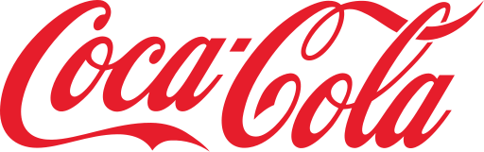
Figure 1: Coca Cola
Source: (Coca-Cola, 2024)
Established Legacy and Global Presence: Coca-Cola was founded in 1886 in Atlanta, Georgia, and it has today become one of the most recognizable brands in the world with its operations spread across more than 200 countries (Coca-Cola, 2024). The secret of success of the company is its ability to reconcile a stable global brand, and local adaptations.
Core Brand Philosophy: Coca-Cola mission statement- to refresh the world and make a difference- indicates the emotional engagement, happiness and sustainability of Coca-Cola brand (Nyako, 2019). Its global marketing approach has emotional foundation of branding based on common themes of joy and togetherness.
Diversified Portfolio: Coca-Cola has more than just its flagship cola in the product portfolio; the company sells Diet Coke, Coca-Cola Zero Sugar, Sprite, Fanta, and water-based products such as Smartwater (duyen, 2019). This diversification enables it to act in a flexible manner to the local consumer tastes and changing health trends.

2.2 Coca-Cola’s Operations in the United Kingdom
Market Entry and Growth: Coca-Cola was introduced in the UK in 1900 and it has grown to be among the market leaders in the non-alcoholic beverages industry. The Coca-Cola Company operates under the Coca-Cola Europe pacific partners (CCEP) which deals with production, distribution, and marketing in Europe (Vrontis and Sharp, 2020).
Strategic Market Positioning: The UK market portrays the adjustments of Coca-Cola to a mature, health conscious and regulation hostile market. After the implementation of the Soft Drinks Industry Levy (Sugar Tax) in 2018, Coca-Cola intelligently reinvented the products and promoted Coca-Cola Zero Sugar more aggressively to conform to the trends of health and wellness (Melnikas, 2024).

2.3 Coca-Cola’s Operations in Japan
Market Entry and Localization: Coca-Cola was introduced in Japan in 1957 and turned its operations to the specifics of the Japanese consumer culture. Japanese is among the most creative markets of Coca-Cola company, and it offers over 800 localized products which include Georgia canned coffee, Ayataka green tea and limited-edition drinks which are offered on a seasonal basis (Khan, Ahmed and Munir, 2023).
Technology Implementation: Coca-Cola Japan was the first to implement a technical vending machine, payment options, and AI proposals- Japan is one of the most technological consuming nations (Khan, Ahmed and Munir, 2023). This is a new strategy that has distinguished the marketing model of Coca-Cola in the Western markets.
Cultural and Market Adaptation: Japanese customers place emphasis on novelty, quality and aesthetics display. Coca-Cola takes advantage of this by introducing limited-edition packaging, anime partnerships, and culturally-relevant advertising.
Summary
Coca-Cola has high brand equity that is superior on a global scale, showing consistency in identity and varying products, marketing and operational aspects to suit local culture.

3. Comparison of the Socio-Cultural Context and Macroenvironment (PESTLE)

3.1 Socio-Cultural Context and Macroenvironment for United Kingdom
Political Factors
The UK is a very regulated political place which is stable, and has a direct impact on the marketing and operational tactics of Coca-Cola. Sugar Tax, or Soft Drinks Industry Levy, which was introduced in 2018, forced the re-formulation of high-sugar products by the beverage manufacturers, indicating the change in the policy towards the regulation of the public health (Melnikas, 2024). Coca-Cola reacted by developing sugar-free versions and doubling efforts to promote coca-cola zero sugar. Besides, the trade changes experienced after Brexit have impacted on the cost of import/export and the efficiencies of the supply chain and required strategic reconfiguration of Coca-Cola Europacific Partners (Mbithi, Muturi and Rambo, 2019). The high level of corporate responsibility and sustainability maintained by the UK government also puts pressure in the Coca-Cola company to match the national environmental targets and how a political stability is harmonized with the tightening of regulatory measures that influence marketing and production policies.
Economic Factors
The economy of UK is developed and mature and it presents both opportunities and restrictions to Coca-Cola. Consumers have comparatively high disposable income levels, which means that they can afford high-end and luxurious brands. Inflationary pressures and the cost-of-living crisis have however impacted purchasing behavior and consumers are moving towards value-based purchases. The pricing model of Coca-Cola should then be able to strike a balance between affordability and high brand positioning (Vardopoulos et al., 2021). Moreover, the market environment in the UK soft drinks industry, where PepsiCo and Britvic dominate the market, requires innovation that is sustained to ensure that the market share is not lost.
Social Factors
In the UK, the social tendencies focus on the following: the trend towards health consciousness and well-being, the principles of ethical consumption and environmental responsibility. Low sugar content or natural drinks are becoming very popular among consumers, with Coca-Cola being forced to switch to the health sector (duyen, 2019). The emergence of Generation Z consumers as a group of consumers focusing on sustainability and social ethics makes Coca-Cola advertise its recycling efforts and community involvement programs.
Technological Factors
The engagement mode of Coca-Cola in the UK has changed with the digitalization. With the combination of social media platforms, influencer marketing, and data analytics, it is possible to promote in a very targeted way. Coca-Cola uses the power of AI consumer insights and mobile apps to offer personalized marketing experiences. Distribution has also been transformed by the growth of e-commerce and digital distribution relationships, in particular, after COVID (Maria Teresa Costa et al., 2023). Nevertheless, the use of technology must be accompanied by constant investment and a compliance with the requirements of data protection according to the UK legislation of GDPR that manifest the two-sided problem of innovation and responsibility in a digital economy.
Legal Factors
There are strict legal systems in place in the UK with regard to advertising, labeling and safe food standards. Coca-Cola has to follow the guidelines of Advertising Standards Authority (ASA) to achieve the transparency of marketing in relation to the campaigns aimed at children. In this way, the UK operations of Coca-Cola show a rather active attitude towards the legal compliance, which serves as one of the bases of ethical marketing.
Environmental Factors
Coca-Cola has been motivated by its climate policies and the need of the people to ensure the sustainability of the environment, hence its commitment to the World Without Waste program (Maria Teresa Costa et al., 2023). As Coca-Cola markets its 100 percent recyclable bottles, and pours funds into recycling economy initiatives, environmentalists condemn the fact that the company remains among the biggest plastic polluters in the world today.

3.2 Socio-Cultural Context and Macroenvironment for Japan
Political Factors
Japan is a politically stable environment, as well as, a business-friendly environment, which enables multinational activities in it. Since 1957, the entry of Coca-Cola has been favorable due to the stable trade policies and low rates of political risk in Japan (Murayama, 2022). The government programs of corporate responsibility towards the environment are in harmony with the objectives of Coca-Cola Japan on green packaging.
Economic Factors
The fact that Japan has a highly developed economy with high purchasing power and technological advancement is a promising market to Coca-Cola. Nonetheless, the growing older generation of people and lack of wage increase have changed the consumption patterns, as more people demand convenient and practical drinks. Coca-Cola Japan is reacting by diversification in ready-to-drink coffees, teas, and health drinks. High concentration of vending machines (more than 2 million in the country) adds to accessibility at the cost of high maintenance and energy.
Social Factors
Japanese culture is extra high on quality, innovation and variation of seasons and this has a direct impact on the marketing strategy of Coca-Cola. Localized strategy of the company in terms of unique flavours, seasonal packaging, and partnership with anime or pop culture is a sign of strong cultural adaptation. The launch of functional drinks by Coca-Cola is a response to the changing lifestyle needs, which proves cultural sensitivity as a significant success factor in Japan.
Technological Factors
The reputation of Japan as a technological innovator is an opportunity that will allow Coca-Cola to test new marketing and distribution technologies. The company uses AI-powered vending machines that can analyze the preferences of consumers, give them product recommendations, and allow them to make payments without cash (Leopizzi, 2024). Digital marketing incorporates the use of mobile apps like the Coke ON, which rewards customer interaction by use of loyalty programs.
Legal Factors
Coca-Cola Japan is subject to the overall legal regulation of food label, advertising, and the environmental regulation. The Food Sanitary Act stipulates that there is a transparency in the disclosure of ingredients and the Act on Recycling of Containers and Packaging that requires accountability in the management of waste. The legal compliance of Coca-Cola will reinforce its brand image of a reliable and compliant brand (Rejeb, Rejeb and Süle, 2025). However, any violation of these conventions might result in a serious reputational loss in the Japanese trust-based market system.
Environmental Factors
The Japanese society is also very dedicated towards environmental conservation focusing on waste minimization and recycling. The label-free bottles as well as green manufacturing activities of Coca-Cola Japan is in line with national sustainability objectives. The other activities of the company include carbon footprint reduction and eco-packaging technologies. However, large scale use of vending machines is also questionable in terms of energy use, and this has brought a dilemma over convenience and sustainability. This duality indicates the greater dilemma of commercial innovation and ecological responsibility in the highly aware market in Japan.
Summary
UK focuses on health conscious and sustainability minded consumers, Japan focuses on innovation, convenience and culturally oriented beverage experience among urban and youth markets.

4. Comparison of Coca-Cola’s STP Strategies in the United Kingdom and Japan
The STP framework Segmentation, Targeting, and Positioning- is the key to the success of Coca-Cola in overseas marketing. Though its international brand focuses on joy, rejuvenation and bonding, Coca-Cola considers specific socio-cultural and market existence in countries to adjust STP approach. Under the differentiated STP strategies, this section critically analyzes how Coca-Cola implements differentiation in STP in the United Kingdom and Japan based on local consumer expectations and lifestyle trends and competitive environment.

4.1 Segmentation Strategies
Coca-Cola in the United Kingdom
The segmentation strategy that is used by Coca-Cola in the UK is quite advanced to the mature and health conscious market. The company has been segmenting the market using demographic, psychographic and behavioural segmentation in order to target specific consumer groups. Coca-Cola demographics is rather wide; teens to middle-aged consumers are the ones who associate the brand with their lifestyle and emotion. On the psychographic level, it addresses the group of buyers who want to achieve a compromise between a luxurious feeling and something healthy, and puts zero-sugar versions in the role of the guilt-free decisions (Wang, 2021). Critically, Coca-Cola’s segmentation in the UK demonstrates adaptive marketing: the introduction of Coca-Cola Zero Sugar and Diet Coke aligns with the national health narrative driven by the Soft Drinks Industry Levy.
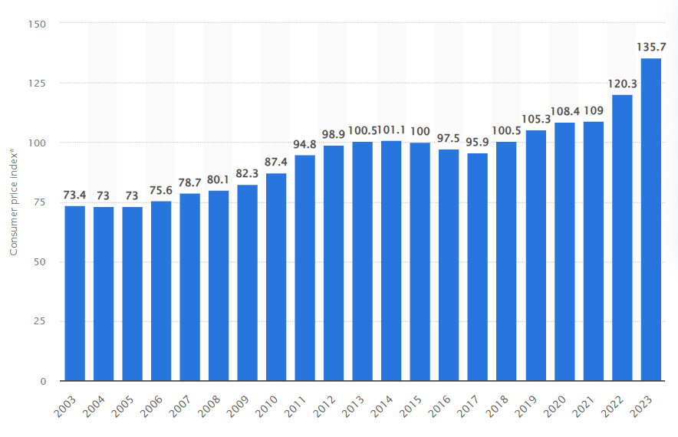
Figure 2: Annual Average Soft Drinks & Juice Consumer Price Index in the UK (2003–2023)
Source: (Statista, 2023)
Between 2003 and 2023, the UK’s soft drinks and juice consumer price index (CPI) increased significantly from 73.4 in 2003 to 135.7 in 2023, reflecting a steady rise in beverage prices. The CPI growth accelerated after 2017 due to factors such as sugar taxation, inflation, and changing production costs, indicating increased consumer expenditure on non-alcoholic beverages (Statista, 2023).
Coca-Cola in Japan
Conversely, Coca-Cola Japan uses micro-segmentation, given the disjointed market of beverages in Japan and consumption culture. In Japan, segmentation goes more than fundamental demographics to occasion, regional, and cultural segmentation (Murayama, 2022). A diversification of products, such as Georgia Coffee, Ayataka Green Tea, Aquarius, and I Lohas Water, suggests the presence of the highly segmented strategy that satisfies the needs of niche tastes and preferences in Coca-Cola.
Japanese consumers do appreciate newness, seasonal and beautiful packaging and encourage Coca-Cola to launch limited-edition flavours and packaging depending on the location (i.e. sakura-themed bottles). Behavioural segmentation is oriented on convenience and vending machines purchases which is a predominant consumption platform in Japan (Liu, 2021). Such a degree of segmentation depicts the strong knowledge of the cultural subtleties of Coca-Cola and its ability to localize its product offer, which is sometimes referred to as glocalization. Nevertheless, market fragmentation this much requires constant innovation, which might put a strain on profitability and efficiency of operations.

4.2 Targeting Strategies
Coca-Cola in the United Kingdom
In the UK, Coca-Cola uses the differentiated targeting approach by delivering the products to various segments with varying products. The main target groups of the company include young adults and millennials who appreciate social connectivity, pleasure, and sustainability. The marketing campaigns of Coca-Cola are focused on emotional appeal and inclusivity, and mutual experiences (Open Happiness and Share a Coke).
The increasing population of health conscious consumers in the UK has also pushed Coca-Cola embrace a new market structure comprising of health-conscious consumers and such a change has been realized by its focus on low-calorie beverages and prominently labeled nutrition (Melnikas, 2024). Moreover, it also encourages its connections with active and social-active audience as its associate of sporting and music events such as the titles of the Premier League.
Coca-Cola in Japan
Using a developing concept of consumer lifestyle, use situation and emotional value, Coca-Cola in Japan has developed a targeted and behavior-oriented targeting model. It appeals to urban professionals, students, and tech-savvy buyers who value convenience, innovation, and customization (Leopizzi, 2024). The widespread use of vending machines allows Coca-Cola to micro-target customers through location-based data, offering customized promotions and product suggestions via the Coke ON mobile application (Coca-Cola Bottlers Japan, 2025). Unlike the UK, Coca-Cola Japan leverages local pop culture and anime collaborations (e.g., with One Piece or Demon Slayer) to target younger consumers. Limited-edition beverages are strategically launched to stimulate purchase excitement and collectability, reinforcing emotional engagement (Refer to Appendix 2).

4.3 Positioning Strategies
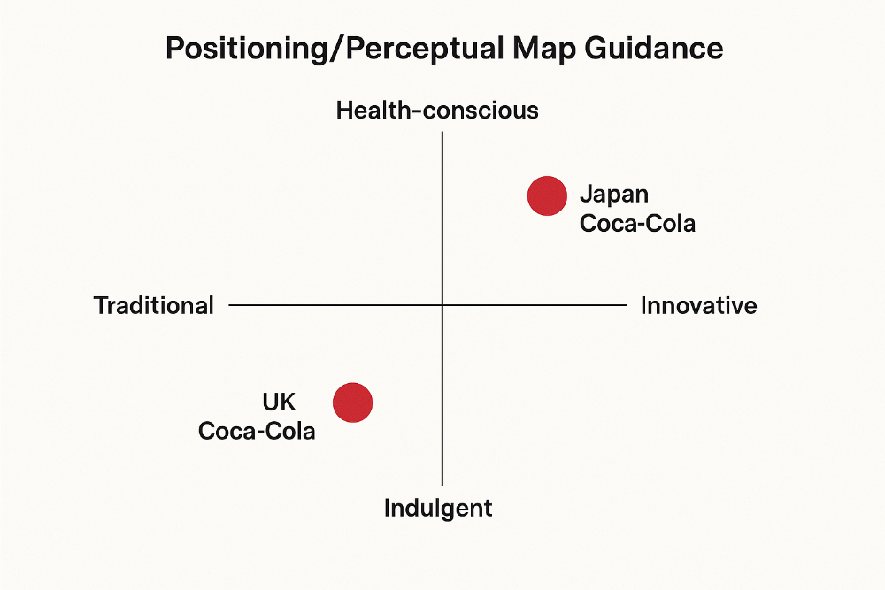
Figure 3: Positioning Map
Source: (Hanlon, 2023)
Coca-Cola in the United Kingdom
The UK positioning of Coca-Cola is based on happiness, companionship and sustainable refreshment. The brand identifies with the values of health and environmental awareness, which are popular among the people. Its advertisements, like the campaign Choose Happiness and the campaign World Without Waste portray a responsible and civic company image. The innovations in packaging, sustainable materials, and collaborating with recycling programs such as Recycle Now support this positioning.
The product diversification of Coca-Cola enables the company to position Coca-Cola Zero Sugar as a solution to a healthy choice and Coca-Cola Original as an old classic. Critically speaking, the company has not only managed to achieve emotional resonance, but Coca-Cola has lost credibility in its claims of doing CSR through its sustainability messages due to environmental watchdogs accusing the company of greenwashing (Guo and Wen, 2021). The effectiveness of positioning any brand is pegged on how authentic the ethical obligations of the brand seem, rather than the marketing story.
Coca-Cola in Japan
At Japan, the positioning of Coca-Cola reflects innovation, cultural relevance and convenience. The company is not merely a brand of drinks, but a constituent of the everyday life of the Japanese, It can be consumed anywhere and anytime (Paluchowski, 2022). The focus on the prevalence of vending machines makes Coca-Cola look like a highly developed and customer-focused brand.
The seasonal campaigns promoted by Coca-Cola like special sakura bottles or flavors available in a specific region place the company in the role of innovative and culturally responsive (Coca-Cola Bottlers Japan, 2025). Coca-Cola successfully infiltrates the Japanese national culture with the help of emotional narration, which, in accordance with the Japanese aesthetics of harmony (wa) and the enjoyment of seasons, is akin to Japanese culture.
Summary
Coca-Cola UK is aimed at the ethically-oriented young adults, with the priority being placed on health; in Japan, the target market is the urban youth, with particular emphasis on the novelty, personalization and occurrence of culturally-relevant consumption events.

5. Comparison of Marketing Mix (7Ps) for Coca-Cola in the United Kingdom and Japan
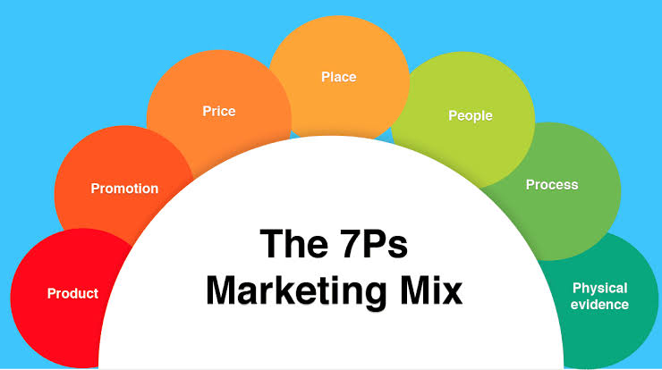
Figure 4: Marketing Mix (7Ps)
Source: (Hanlon, 2023)

5.1 Country A: United Kingdom
Product
Coca-Cola has its flagship product in the UK market alongside other products like Coca-Cola Zero Sugar and Diet Coke. As the example of a 330 ml can of Coca-Cola Original in the UK, the label shows that the product has 35g of sugar, which is 10.6g per 100 ml (UK Frozen Food, 2023). In the meantime, the Zero Sugar one shows 0g of sugars in 330 ml. These numbers indicate a product repositioning of the UK health-and-nutrition-consciousness and regulation (in this case, the Soft Drinks Industry Levy). The product strategy has reformulation aimed to cut the sugar. Coca-Cola UK itself position this as same great taste but less sugar, critical commentary has proposed that reformulation like this could result in brand heritage dilution (some consumers still feel that the original taste is being changed) and competitive marketing of the different versions within the company (Szolgayová, 2022).
Price
The UK pricing is mostly based on the competitive retail pricing (supermarkets, convenience stores) and promotional pricing (multibuys, club cards). To illustrate, a 24-can of the general pack Coca-Cola Zero Sugar can be sold at about £13.75 (about 26.75/330 ml) in some offers. (An example of one of the online retailers in the UK) (Your Coca-Cola UK, 2021). Price promotion serves to sustain a high level of volume in low switching cost of a mature market. The task is maintaining the margin and value pricing, particularly in the situations when there is inflationary pressure and the expenses of the sugar tax. It is important to point out that the price leadership is a challenging concept to achieve in the UK soft drinks industry because of the retailer bargaining strength and frequent discounting.
Place (Distribution)
The UK distribution is largely supermarket-and-convenience-store distribution with e-commerce and home-delivery fulfilment on the rise. Coca-Cola UK operates via bottlers and retail partners (e.g., Coca Cola Europacific Partners) in order to guarantee shelf-space, promotional end-caps and associated online/offline promotions. The UK channel is already mature and saturated and therefore incremental growth due to the addition of new outlets is minimal and growth should come in through product mix or channel innovation (e.g., e-commerce) (Szolgayová, 2022). The retailer power is so high that logistic and promotional expenses can marginally squeeze.
Promotion
Promotional strategy in UK focuses more on brand heritage, common experiences (Share a Coke campaign), and messaging more about health/sustainability (e.g. World Without Waste). This is in line with the UK consumer values of corporate responsibility (Guo and Wen, 2021). As an illustration, the presence of the zero-sugar version and communications concerning the possibility to recycle the signal reflects the adaptation to regulatory and social trends.
People
The UK has customer-facing activities that focus on retail partner relations, field sales, in-store promotion personnel and service to consumers. Coca-Cola UK also participates in diversity, community engagement teams and sustainability teams in response to the UK socially orientated expectations.
Process
The processes in the UK involve logistics of supply chains, replenishment of stocks, promotion mechanics (coupons, club cards), and adherence to regulation (nutritional labeling, report on sugar tax, ASA advertising standards). The complexity of the process is growing since the Coca-Cola UK has to deal with various types (regular, zero, smaller packs) and ensure the support of digital ordering and direct-to-consumer channels (Lacy-Nichols, 2022). Competitive advantage may be lost to inefficiencies in the process in a low-growth environment.
Physical Evidence
Physical evidence used in UK market entails packaging design, in-store displays, branding and feel/experience in the product. Packaging now puts emphasis on recyclable materials and on the 100 per cent recyclable message. Coca-Cola UK advertises in multipacks (24 cans × 330 ml) and occupies high shelf-space in the retail space.

5.2 Country B: Japan
Product
Coca-Cola product strategy in Japan puts much emphasis on localization, variety and novelty. An example is given of a laboratory test carried out on a so-called Coca-Cola soda sold in Japan, which contained 11.3 g of sucrose in 100 mL (or 3738 g in 330 ml) of one sample (Ando et al., 2023). In the meantime, the beverage market of Japan is offered more than 800 localized stock-keeping unit (SKU) such as tea, coffee, seasonal development. In Japan, the volume base that the bottler had dealt with was approximately 500 million cases as of 2020 (CCBJ, 2020). Hence, product strategy in Japan is highly differentiated other than the main core cola. Importantly, this variety approach will allow Coca-Cola to address the preference of Japanese consumers to novelty and regional flavour, but will also increase cost, introduce complexity in SKUs and possibly blur brand focus.
Price
In Japan, heavy vending-machine channel and regional costs differences are reflected in pricing. As an example, the vending machine cost of Coca-Cola at the 2025 Osaka/Kansai Expo was 200 yen per can (GIGAZINE, 2025). On a broader scale, reports show that a standard 500 ml bottle in the vending machines is headed towards ¥190-¥200. These prices are very high (in real terms) compared to most of the bottle prices in the supermarkets, which are in the convenience channel.
Place (Distribution)
Japanese distribution is highly channelled across vending machines. The bottler of Coca-Cola Japan states about 700,000 vending machines in the system of Japan (Coca-Cola Bottlers Japan Inc., 2024). This provides a very broad coverage (anytime, anywhere) and produces consumer convenience which is not easily replicated in many markets. Location based marketing and impulse buying are also available since the retail maturity in vending provides. The problem is the maintenance of the machine, the cost of the energy, and the possible saturation or decreasing foot traffic in certain areas (particularly, as younger consumers change the habits).
Promotion
The focus of promotion in Japan is more on technological and cultural interaction: e.g., the Coke ON app to earn loyalty and vending machine integration, regional/seasonal-themed limited-edition packaging, anime collaborations and product tie-ins (Paluchowski, 2022). This is a strategy that is in line with the expectations of the Japanese consumer to consume something new and in fashion.
People
Japan is characterized as having a people dimension, an aspect that gives more weight to field service (servicing vending machine, retail partnerships, regional marketing) and high customer service standards (omotenashi) culture. The employees and bottlers distribution channel in Coca-Cola Japan are required to sustain quick SKU turnover, machine maintenance and high-tech interconnection.
Process
The processes of Japan are particularly complicated: installing and servicing hundreds of thousands of vending machines; online transactions (mobile payments through the Coke ON application); regular product releases (limited-edition versions) and local release promotion. Indicatively, Coca-Cola Japan tested dynamic-pricing in fountains/machines (reduction of price by night) and machine sales are maximised.
Physical Evidence
The physical evidence in Japan entails the visuality of the vending machines in the streets, the packaging of limited editions (designs of the regions and seasons), the type of the premium bottles and the digital interface of the vending machines (touch screens, application integration). England: Special design: In Japan, the special design In the example, Slim Bottle Regional Design, carbohydrates per 100 ml were 11.3 g (Shibuya, 2019).
Summary
The products, pricing, promotion and place are adjusted to the local demand: UK has health and sustainability, Japan has innovation, convenience and seasonal diversity.

6. Evaluation of Performance of Marketing Strategies for Coca-Cola in the United Kingdom and Japan

6.1 United Kingdom
The marketing strategies of Coca-Cola in the United Kingdom (UK) have their strengths as well as significant headwinds. As of March 2025, the UK soft drinks market is worth USD 25.32 billion, although the largest market share is in terms of value (34 per cent) and volume (38 percent) of carbonated drinks (FoodManufacture.co.uk, 2025). The UK soft drinks manufacturing industry (including carbonates), as per IBISWorld, is approximately 8.7 billion pounds in 2025 and Coca Cola europacific partners Great Britain Ltd is recognized as a company that has the greatest market share in the industry (IBISWorld, 2025).
The following data points are indicative of the fact that Coca-Cola has established a firm foothold in the UK market. Its dominance in the industry confirms the opinion that its marketing strategies in the UK (including the promotion of variants, collaboration with retailers, and sustainability messages) are quite general (Huse et al., 2022). Specifically, the localization of product variations such as coca-cola zero sugar will fit the UK consumer culture of health consciousness.
It has some severe caveats. The UK soft drinks market is reported to have shown a value sales drop (−1.1) in the year ending March 2025 as a result of health worries over the use of carbonated drinks and the low consumer spending (FoodManufacture.co.uk, 2025). This is not a positive growth and it means that even such market-leaders as Coca-Cola are exposed to structural headwinds: changing tastes of consumers (to still water), pressure form regulatory bodies (sugar tax) and pressure in costs.

6.2 Japan
The marketing strategies used by Coca-Cola in Japan seem to have succeeded in the level of scale, localization and reach. As Coca Cola Bottlers Japan Holdings Inc. states, annual revenues are 892.7 billion yen and annual volume of sales is approximately 500 million cases. The firm also gives an experience of approximately 650,000 vending machines and more than 340,000 customer-outlet relationships (Coca-Cola Bottlers Japan Inc., 2024).
According to other publications, the number of vending machines linked to the presence of Coca-Cola in Japan is approximately 880,000, and Japan is the second largest market of the company outside the U.S (Globaldeal.io, 2024). These data represent a good market penetration and solid infrastructure among the most notable cases is the wide network of vending-machines that strengthens the accessibility and impulse buying. The scaling and relevance seem to have been converted into localization of product variants and marketing campaigns that are targeted to satisfy Japanese tastes (e.g. seasonal bottles, limited editions).
With that said, success should be conditional. One of the articles indicated that although Coca-Cola is the largest beverage producer in Japan, the flagship item of Coca-Cola carbonated soda is not always its leading product; non-carbonated products (teas, coffees) constitute the bulk of the volume (Isdell, 2024). Therefore, the marketing concept has worked so well in this context in terms of localization and scale; however, the main product, the cola, might not be as strong as it is in other markets, and this begs the question of the quality of the initial brand positioning.
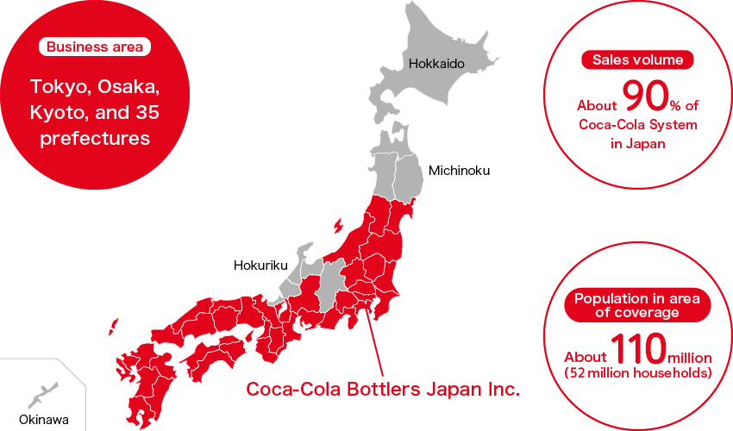
Figure 5: Coca-Cola Bottlers Japan Inc.
Source: (Coca-Cola Bottlers Japan, 2025)
The main areas under which Coca-Cola Bottlers Japan Inc. operates include Tokyo, Osaka, Kyoto, and 35 prefectures and it serves 90 percent of the total volume of sales of Coca-Cola System in Japan. This large business segment has a population of approximately 110 million individuals comprising of 52 million households, and this is an indication of the hegemony nature of the brand in the country.
Summary
Japan has a high success of Coca-Cola with a broad market presence and innovation whereas it continues to dominate the UK in the maturity of the market and regulatory issues.

7. Evaluation of Ethical Issues Related to Coca-Cola’s Marketing Mix in the United Kingdom and Japan

7.1 Ethical Considerations in the United Kingdom
The marketing mix used by Coca-Cola in the UK has experienced a number of ethical issues which mainly concerned health, environmental sustainability and transparency. Sugar tax on the UK government, which was introduced in 2018, compounded criticism regarding the ethical nature of advertising beverages that contain sugar in. Despite Coca-Cola launching “Coca-Cola Zero Sugar” and repositioning certain of its products, some critics claim that its ongoing vigorous advertising of high-sugar versions of the product, and in particular to younger consumers, is still ethically dubious (Lacy-Nichols, 2022). Health activists have condemned the brand as making the use of sugary beverages related to happiness and social success, which in effect, may overshadow the dangers of obesity and diabetes on health.
On the environmental front, the Environmental protection groups like Break Free From Plastic have frequently singled out Coca-Cola as one of the largest polluters of plastic in the world. On the other hand, although the company has implemented bottles made of 100 percent recycling material, and is committed to ensuring that it collects and recycles 1 bottle per every 1000 bottles sold by 2030, it is still faced with ethical issues about the overall plastic footprint and carbon emissions (COCA-COLA COMPANY, 2022).

7.2 Ethical Considerations in Japan
The marketing strategy of Coca-Cola in Japan is highly diversified in the product marketing and also it has the largest number of vending machines in the world with over 650,000 machines. Although this is the convenience and accessibility, ethics concerns also raise the question of the environmental cost of energy-consuming vending machines and waste generation. In addition, the ever-present nature of sweet drinks in vending machines might be regarded as something that contradicts the health objectives of the population that is now more aware of the nutritional concerns.Coca-Cola Japan has been practicing ethics by encouraging low sugar beverages, recycling programs in the community, and plastic waste reduction by initiating lightweight bottle programs.
Summary
Every country has ethical issues related to it: sugar content advertising, environmental issues and sustainability, yet the attempts to mitigate them are becoming more corporate.

8. Conclusion
The international marketing strategies exhibited by Coca-Cola are an excellent case of adjusting to various socio-cultural, economic and competitive settings. The presence of the company in the United Kingdom and Japan also demonstrates its globalized brand and local need awareness. Coca-Cola in UK has established itself by diversifying its healthy and sustainable business strategy, thanks to its response to the increasing demand for healthier and ethically marketed beverages among its consumers. Its strategy in Japan is focused on convenience, innovation and cultural fit, backed by an extensive vending system and product differentiation.
As much as the corporate strategies of STP and the marketing mix have kept Coca-Cola companies leading the markets, the issues of sugar consumption, environmental sustainability, and transparency continue to affect the two markets. The key to the future success of the brand is balancing profitability and responsibility, that is, optimizing its global aspirations to changing values in society.
Coca-Cola needs to increase the speed of innovation that is health-focused, implement the concepts of a circular economy, and be more transparent in its international activities. By integrating sustainability, health and ethical marketing into its global strategy, Coca-Cola will be in a position to enhance the brand equity, consumer confidence and remain competitive in the dynamic world market.

References
Ando, Y., Ohta, Y., Eiji Munetsuna, Yamada, H., Nouchi, Y., Kageyama, I., Mizuno, G., Yamazaki, M., Fujii, R., Ishikawa, H., Suzuki, K., Hashimoto, S. and Ohashi, K. (2023). Laboratory analysis of glucose, fructose, and sucrose contents in Japanese common beverages for the exact assessment of beverage-derived sugar intake. Fujita Medical Journal, 9(2), pp.126–133. doi:https://doi.org/10.20407/fmj.2022-009.
CCBJ (2020). Consumers in sales area About million About million households About million cases Annual sales volume Customer outlets About Brands Manufacturing plants bottlers March bottlers From April to present bottlers Sales coverage. [online] Available at: https://en.ccbj-holdings.com/ir/pdf/en/annualreview/ccbji/2020/3.pdf [Accessed 27 Oct. 2025].
Coca-Cola (2024). The Coca-Cola Company. [online] The Coca-Cola Company. Available at: https://www.coca-colacompany.com/.
Coca-Cola Bottlers Japan (2025). Coca-Cola Bottlers Japan Holdings Inc. [online] Available at: https://en.ccbji.co.jp/csv/pdf/report/ccbji/csv_report_2022_en.pdf.
Coca-Cola Bottlers Japan Inc. (2024). Coca-Cola Bottlers Japan Inc. [online] Available at: https://en.ccbji.co.jp/corporate/activity [Accessed 27 Oct. 2025].
COCA-COLA COMPANY (2022). THE COCA-COLA COMPANY 2022 BUSINESS & SUSTAINABILITY REPORT. [online] Available at: https://investors.coca-colacompany.com/_assets/_074e48505c30879b71a006a34118b8f5/cocacolacompany/db/880/10234/annual_report/coca-cola-business-and-sustainability-report-2022.pdf [Accessed 27 Oct. 2025].
duyen, tran (2019). COCA-COLA: International Business Strategy for Globalization. [online] Academia.edu. Available at: https://www.academia.edu/download/59436430/1820190529-118116-pl2ol8.pdf.
FoodManufacture.co.uk. (2025). The Drink Report 2025: Soft drinks. [online] Available at: https://www.foodmanufacture.co.uk/Article/2025/07/28/uk-soft-drinks-trends-2025.
GIGAZINE. (2025). At the Osaka Kansai Expo, the vending machines sell water for 160 yen, Coke for 200 yen, and Aquarius for 200 yen. [online] Available at: https://gigazine.net/gsc_news/en/20250409-osaka-kansai-expo-vending-machine [Accessed 27 Oct. 2025].
Globaldeal.io. (2024). How to Enter the Japanese Market: The Case of Coca-Cola. [online] Available at: https://www.globaldeal.io/blog/how-to-enter-the-japanese-market-coca-cola.
Guo, X. and Wen, M. (2021). Research on Competitive Strategy of Coca-Cola Company. Proceedings of the 2021 3rd International Conference on Economic Management and Cultural Industry (ICEMCI 2021), 203.
Hanlon, A. (2023). How to Use the 7Ps Marketing Mix. [online] Smart Insights. Available at: https://www.smartinsights.com/marketing-planning/marketing-models/how-to-use-the-7ps-marketing-mix/.
Huse, O., Reeve, E., Bell, C., Sacks, G., Baker, P., Wood, B. and Backholer, K. (2022). Strategies Used by the Soft Drink Industry to Grow and Sustain sales: a case-study of the Coca-Cola Company in East Asia. BMJ Global Health, 7(12), p.e010386.
IBISWorld (2025). Soft Drink Production in the UK - Market Research Report (2015-2030). [online] Ibisworld.com. Available at: https://www.ibisworld.com/united-kingdom/industry/soft-drink-production/690 [Accessed 27 Oct. 2025].
Isdell (2024). Inside Coca-Cola. [online] Google Books. Available at: https://books.google.com/books?hl=en&lr=lang_en&id=YW83Q_Mg0_UC&oi=fnd&pg=PR9&dq=coca+cola+in+Japan&ots=sGOqFPTyf4&sig=ZdlyY3s8PSB9fOCjfBLOlu6Ph5k [Accessed 27 Oct. 2025].
Khan, Y., Ahmed, I. and Munir, Z. (2023). Analyzing Business Ethics in International Markets: A Case Study of Coca-Cola. Open Journal of Social Sciences, [online] 11(9), pp.530–560. Available at: https://www.scirp.org/journal/paperinformation.aspx?paperid=127995.
Lacy-Nichols, J. (2022). Corporate Harm Minimisation: Promises and Perils; Comment on ‘Understanding Marketing Responses to a Tax on Sugary Drinks: A Qualitative Interview Study in the United Kingdom, 2019’. International Journal of Health Policy and Management. doi:https://doi.org/10.34172/ijhpm.2022.7649.
Leopizzi, F. (2024). Beverage Marketing in Japan: how marketing can affect consumer’s view about a certain product. Cineca.it. [online] doi:https://hdl.handle.net/20.500.14247/14137.
Liu, S. (2021). A Report on Strategic Analysis and Recommendations of Coca-Cola. International Journal of Frontiers in Sociology, [online] 3(17), pp.69–75. Available at: https://francis-press.com/uploads/papers/HF00A1bIeKjadcyjye9861hTJNwsalKQGAA7snui.pdf.
Maria Teresa Costa, Maria Lurdes Calisto, Ana Teresa Machado, Santos, Z., Nunes, S. and Severino, F. (2023). The Macro Context for Entrepreneurship in Tourism: A Review of Emerging Trends. 6(1), pp.74–82. doi:https://doi.org/10.34190/ictr.6.1.1327.
Mbithi, B., Muturi, W. and Rambo, C. (2019). Macro environment moderating effects on strategy and performance. Macro Environment Moderating Effects on Strategy and Performance, [online] 2(5), pp.197–209. doi:https://doi.org/10.21276/haya.
Melnikas, B. (2024). Innovation management studies: technological advance and challenges of globalization. Vilniustech.lt. [online] doi:https://doi.org/2029-4441.
Murayama, T. (2022). Making Foreign Subsidiaries up into Intelligent Players in the International Franchise Companies: Investigating a Case of the Coca-Cola’s Canned Coffee Newly Launched in Japan. [online] Available at: https://researchmap.jp/Murayama_T/published_papers/41050216/attachment_file.pdf.
Nyako, Y. (2019). The Coca-Cola Company Want more papers like this? [online] Available at: https://www.academia.edu/download/44703116/strategic_analysis_of_coca-cola_sandra_baah.pdf.
Paluchowski (2022). Coca-Cola in Pop Culture. [online] Available at: https://www.siena.edu/files/resources/gleanings-2021-publication.pdf#page=94.
Rejeb, A., Rejeb, K. and Süle, E. (2025). A systematic review of female entrepreneurship using co-word and main path analyses. Quality & Quantity. doi:https://doi.org/10.1007/s11135-025-02281-w.
Shibuya (2019). ‘Coca-Cola’ Slim Bottle Regional Design. [online] Available at: https://en.ccbji.co.jp/upload/files/180801-3_E.pdf.
Statista (2023). UK: Soft drinks & juice annual CPI trends 2003-2023| Statista. [online] Statista. Available at: https://www.statista.com/statistics/285156/soft-drinks-annual-average-uk-consumer-price-index-cpi/?srsltid=AfmBOoqXp2-PBa5-gCPvWowT8VSqdfhGxMoa4695LPD3y790Ym-2NJdT [Accessed 27 Oct. 2025].
Szolgayová, B. (2022). Adaption of Marketing Mix for Selected Country. SHS Web of Conferences, 135, p.01014. doi:https://doi.org/10.1051/shsconf/202213501014.
UK Frozen Food (2023). Coca Cola Original - UK Frozen Food. [online] UK Frozen Food. Available at: https://www.ukfrozenfood.com/product/coca-cola-original [Accessed 27 Oct. 2025].
Vardopoulos, I., Tsilika, E., Sarantakou, E., Zorpas, A., Salvati, L. and Tsartas, P. (2021). An Integrated SWOT-PESTLE-AHP Model Assessing Sustainability in Adaptive Reuse Projects. Applied Sciences, 11(15), p.7134.
Vrontis, D. and Sharp, I. (2020). The Strategic Positioning of Coca-Cola in their Global Marketing Operation. The Marketing Review, 3(3), pp.289–309.
Wang, J. (2021). How Coca Cola and Pepsi Use Segmentation in Consumer Product Industry. [online] Available at: https://www.atlantis-press.com/article/125961640.pdf.
Your Coca-Cola UK. (2021). Coca-Cola Zero Sugar 24 x 330ml. [online] Available at: https://www.yourcoca-cola.co.uk/p/coca-cola-zero-sugar-24-x-330ml/12657922/.

Appendix

Appendix 1: Comparison of Coca-Cola’s STP Strategies in the United Kingdom and Japan
Element | Coca-Cola – United Kingdom | Coca-Cola – Japan
Segmentation | Demographic (age 18–45), psychographic (health-conscious, eco-aware), and behavioral (on-the-go consumers, social drinkers). | Demographic (youth and working professionals), psychographic (innovation-seekers, convenience-driven), and behavioral (frequent vending machine users).
Targeting | Focuses on health-oriented consumers with low-sugar and zero-calorie variants (e.g., Coca-Cola Zero Sugar, Diet Coke). | Targets urban professionals and young consumers with diverse product lines (e.g., Coca-Cola Clear, Coca-Cola Plus with health benefits).
Positioning | Positioned as a sustainable, refreshing, and responsible beverage brand promoting active lifestyles and environmental awareness. | Positioned as a culturally adaptive, innovative brand emphasizing personalization, variety, and modern lifestyle convenience.
Target Audience | Health-conscious adults, students, and working-class consumers prioritizing sustainability and balanced living. | Young adults, office workers, and tech-savvy consumers seeking novelty, convenience, and functional beverages.

Appendix 2: PESTLE Comparison: Coca-Cola in the United Kingdom and Japan
Factor | United Kingdom | Japan
Political | Stable government with strong regulations on sugar content and plastic waste (Soft Drinks Industry Levy introduced in 2018). Encourages sustainable packaging initiatives. | Stable political environment with government support for health innovation and recycling; policies promoting eco-friendly packaging and vending machine efficiency.
Economic | Mature market with moderate growth; CPI for soft drinks rose from 100 in 2018 to 135.7 in 2023, reflecting rising costs and inflation. | Strong economy with high purchasing power; demand for premium and functional beverages. Coca-Cola benefits from vending machine culture and economic stability.
Social | Shift toward healthier lifestyles and reduced sugar intake. Increasing preference for eco-conscious and ethical brands. | Culturally emphasizes innovation, convenience, and health. Consumers value unique flavors and product personalization.
Technological | Advanced digital marketing, use of AI-driven campaigns, and investment in recycling technology (e.g., reverse vending machines). | Highly technological society with smart vending machines and mobile payment integration driving beverage sales.
Legal | Stringent advertising and labeling laws, especially around health claims and environmental standards. | Compliance with Food Sanitation Act and labeling regulations; strong government oversight of functional food claims.
Environmental | Strong focus on sustainability and carbon reduction; Coca-Cola UK aims for 100% recyclable packaging by 2025. | Environmental awareness drives use of plant-based bottles and energy-efficient vending machines; focus on circular economy initiatives.

Appendix 2:Comparison of Coca-Cola’s STP Strategies in the UK and Japan
STP Element | United Kingdom (Country A) | Japan (Country B) | Critical Analysis / Insight
Segmentation Approach | Demographic (age 18–45), psychographic (health-conscious, eco-aware), behavioral (brand loyalty, social drinkers), and occasional consumption (parties, sports events). | Demographic (youth, urban professionals), psychographic (innovation-seekers, convenience-driven), behavioral (frequent vending machine purchases, seasonal flavor adoption). | UK segmentation emphasizes health and lifestyle, while Japan focuses on cultural relevance, convenience, and novelty, reflecting different consumption motivations.
Target Market | Young adults, families, and health-conscious consumers seeking ethical, low-sugar, or zero-calorie options. | Urban youth, working professionals, and tech-savvy consumers seeking variety, seasonal flavors, and convenient consumption. | Both target younger demographics, but UK focuses on ethical/health positioning, Japan targets experience and convenience, showing adaptive market orientation.
Positioning Strategy | Positioned as a symbol of happiness, refreshment, and sustainability, highlighting health-conscious variants and responsible consumption. | Positioned as an innovative, convenient, and culturally integrated brand offering seasonal, limited editions, and functional beverages. | UK emphasizes emotional and ethical attributes, while Japan emphasizes functional and experiential attributes.
Product Attributes / Differentiation | Classic Coca-Cola, Coca-Cola Zero Sugar, Diet Coke; focus on flavor, sugar reduction, and ethical packaging. | Coca-Cola, Coca-Cola Clear, Coca-Cola Plus, seasonal flavors; focus on novelty, convenience, and health-oriented options. | Product variants demonstrate Coca-Cola’s local customization strategy to match consumer preferences.
Usage / Competitor Context | Competes with Pepsi, local beverages; consumption mostly social or at-home. | Competes with Pepsi Japan, local tea and coffee drinks; consumption on-the-go, vending machines, and seasonal occasions. | Competitor context influences positioning: UK emphasizes heritage and trust, Japan emphasizes innovation and accessibility.

