Business Plan

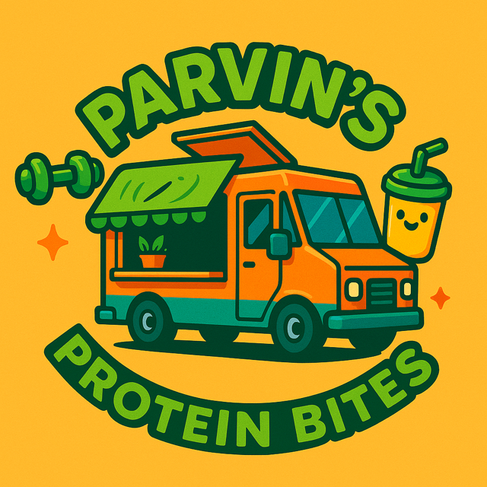
PARVIN’S PROTEIN BITES

Clare Parvin – 2431351

EXECUTIVE SUMMARY
Parvin’s Protein Bites is an exciting new mobile food van venture dedicated to providing convenient, nutritious, high-protein, low-calorie meals and snacks to busy, health conscious customers. The mission is simple, to make healthy eating easy, tasty, and accessible for everyone whether they’re on their lunch break, heading to the gym, or looking for a guilt free snacks on the go.
The key to healthy eating is having a balance of different foods and nutrients in your diet.
British Nutrition Foundation, (2025) A healthy balanced diet.
The idea behind Parvin’s Protein Bites was created from a clear gap in the market. While fast food options are everywhere, finding quick, affordable food that supports fitness goals and healthy lifestyles is still a challenge for many people. Parvin’s Protein Bites food van solves this problem by bringing fresh, balanced meals directly to the customers, whether they are in work, at home or heading off to their local gym.
Parvin’s Protein Bites colourful and quirky van will serve a menu packed with variety, high protein wraps, salads, smoothie bowls, protein shakes, snack pots, and healthy treats. All dishes will be designed to deliver high nutritional value with carefully controlled calories, appealing to gym goers, busy professionals, students, and families who care about what they eat but do not want to sacrifice taste or convenience.
The business plan will detail how Parvin’s Protein Bites will operate, including the target market, marketing strategy, menu development and the sourcing of fresh local ingredients. The focus will be on building strong relationships with local gyms and community hubs, hopefully to create loyal customers providing healthy food on the go.
Financially, the plan lays out realistic start up costs for purchasing and outfitting the van, A screen print is included within the appendices for reference of the van chosen for Parvin’s Protein Bites. It is necessary for licenses and permits to be applied for, and funding initial marketing and stock. Parvin’s Protein Bites mobile food van will test multiple sites, adjust routes based on demand, and keep overheads low compared to a traditional café or restaurant’s.
Parvin’s Protein Bites is more than just a food van it’s convenient and a healthier option to most fast food outlets. The vision is to grow into a trusted name in nutritious mobile dining, with the potential to expand into additional vans. With the right funding and community support, Parvin’s Protein Bites will deliver healthy, high-protein goodness wherever the customers need it most.

INTRODUCTION
Now in the UK the Healthy Food Standard Agency now mandates retailers to increase healthier product sales which they hope will help in targeting obesity reduction and easing NHS burden. Cornwell,Ben(2025),uk government launches healthy food.
As these new mandates are now in the process Parvin’s Protein Bites will consume of home cooked, protein rich meals that will be healthy, low in calorie and all made from natural, wholesome ingredients. The menu will be designed to offer a healthy alternative to traditional unhealthy fast foods which will hopefully support busy lifestyles, help fitness goals, and general wellbeing of the customers.
The aim is for Parvin’s Protein Bites to be a sole trader business owned and operated by the sole trader Clare Parvin, with the aim of providing delicious, nutritious, and convenient high protein meal options for health conscious individuals. Operating as a sole trader allows to maintain full control over all aspects of the business from product development to customer service ensuring a personal, high quality experience for every customer.
Parvin’s Protein Bites will operate through a combination of direct face to face customer sales from the food van which will be situated outside the local gym and over the phone orders that will be for local delivery. In addition to selling the product, Parvin’s Protein Bites aim to provide exceptional service, regular reliable local delivery service and to ensure customer satisfaction all while building a strong, lasting customer relationships.
Through Parvin’s Protein Bites, the mission is to make healthy meal and snacking simple, tasty, and accessible to everyone, while building a trusted brand known for quality, care, and a personal touch.
It is anticipated that Parvin’s Protein Bites can succeed by focusing on authentic branding and community building, maintaining high quality and a clear nutritional value food menu and to stay agile to adapt to trends by building strong partnerships to expand in the future.
To enable all of this Parvin’s Protein Bites aims to well positioned in a growing health conscious market, but will still need to be different from established brands, maintaining strict food safety standards, keep up with health trends and eco-friendly practices, use up to date technology for marketing and distribution and to also navigate possible supply chains and cost fluctuations.

SWOT ANALYSIS FOR PARVIN’S PROTEIN BITES

STRENGHTS

- Health focused product, Taps into growing demand for high protein and healthy, convenient meals and snacks.
- Unique branding, Parvin’s protein Bites can target a wide range of customers, an example could be gym goers, busy professionals or parents.
- Flexibility, Parvin’s Protein Bites will be a small business so menus can be adaptable quickly based on trends and customer feedback.
- Potential for unique recipes, Parvin’s Protein Bites can stand out with flavours, dietary adaptations, or added benefits such as added fibre, low sugar and low calorie.

WEAKNESSES
- Limited brand recognition, Parvin’s Protein Bites will be a completely new and small business, some new businesses struggle to compete with established companies.
- Small scale, Parvin’s Protein Bites will produce smaller volumes of meals and snacks compared to larger fast food companies so this can mean higher per unit costs.
- Cash flow, As Parvin’s Protein Bites is a fresh new business proposal the Initial setup costs may strain finances during the first year.

OPPORTUNITIES
- Health trends, There is a rising demand for protein rich, healthy and convenient snacks.
- Partnerships, Parvin’s Protein Bites could have the opportunity to collaborate with gyms, which would enable the unique food vans to be situated outside of their premises.
- Convenience, Parvin’s Protein Bites can attract health conscious customers as they finish their gym session, quick and convenient.

THREATS

- Strong competition, bigger fast food brands have a large customer base so can afford larger delivers of produce which can lead to cheaper alternatives for them, that can squeeze margins.
- Price, healthy meals and snacks are often more expensive.
- Supply chain risks, Ingredient shortages, price spikes, or quality issues can disrupt production.
- Change in regulations, Food labelling laws, health claims, or new taxes could affect the product line.
- Customer trends change, a new diet fad or change in tastes could reduce demand for products on the menu.

PEST ANALYSIS FOR PARVIN’S PROTEIN BITES

POLITICAL
- Food regulations, the business must comply with local and national food safety laws for example the labelling must contain all allergens, and the van must comply with hygiene standards by law.
- Trade policies, if sourcing ingredients internationally like nuts, whey, or plant protein the tariffs or import and export restrictions could affect cost.
- Government incentives, some regions offer grants or tax incentives for small businesses, healthy food start ups, or local manufacturing.

ECONOMIC
- Customer spending, during tough economic times, people might cut back on premium snacks. However, healthy food tends to stay in demand, as many still prioritize their health and well-being.

- Cost of ingredients, the prices of protein-rich ingredients like nuts, dairy, and soy can go up or down depending on supply chain disruptions or global events.

- Competition, competing with big, established brands means you'll need to offer competitive prices and highlight what makes your food van unique.

- Disposable income, how much extra money your target customers have will affect your sales, people with higher disposable income are usually less concerned about price.

SOCIAL

- Health trends, increasing focus on fitness, protein intake, and convenience foods are very favourable.
- Lifestyle changes, busy lifestyles drive demand for grab and go healthy snacks.
- Diet preferences, trends like veganism, keto, and allergen free diets might create niche product lines.
- Consumer trust, transparency about ingredients, sustainability, and ethical sourcing builds trust.

Technological
- Food preservation, modern food production, packaging, and technology can help extend shelf life and keep your products fresh and high-quality.

- Online sales, technology makes it easier to sell directly to customers through an online store, social media, and food delivery apps.

- Product innovation, creating unique recipes with trendy ingredients like collagen or adaptogens can help your brand stand out from competitors.

- Supply chain tools, tech can help you manage inventory, track suppliers, and predict demand, making your operations more efficient.

LEGAL
- Food safety standards, must comply with food labelling laws, nutritional information, allergy warnings, and possible health claims.
- Intellectual property, trademarking the brand name and packaging design can protect your identity.
- Employment law, if hiring staff for production or sales, must comply with local employment regulations.
- Advertising laws, health claims must be accurate and compliant with advertising standards.

COMPETITOR ANALYSIS – PARVIN’S PROTEIN BITES
Parvin’s Protein Bites is part of the fast growing healthy food industry, serving fresh, high protein snacks and meals from a mobile food van. As more people look for convenient and nutritious food on the go, competition in this space is increasing. To stand out and succeed, it is important to understand both direct and indirect competitors in the market.
Direct Competitors - These are businesses that offer similar high protein, healthy snacks and target a similar customer base. These would include, health food vans and meal prep trucks.
Examples of this include mobile vendors selling smoothies, protein packed salads, wraps, and bowls. While some focus on plant based or vegan food, few specialize in protein focused options. Another direct competitor could be local high protein snack brands at supermarkets.
Some shops sell protein balls, protein bars, and high end high protein ready meals.
Indirect Competitors - These businesses do not sell the same type of foods as Parvin’s Protein Bites but serve similar customer needs that are convenient and healthy eating. Fast and convenient salads or wrap chains like Subway ect. These businesses provide quick, seemingly healthy meals, though not all are genuinely high in protein.
Competitive Advantage of Parvin’s Protein Bites - Parvin’s Protein Bites stands out in the mobile food industry by focusing on specific needs that many other food vans do not fully meet. It offers freshly prepared, protein packed snacks and meals that are designed especially for people who care about their health, stay active, or have busy lifestyles. Whether it is fitness enthusiasts looking for a post workout boost, health conscious individuals wanting clean, nutritious food, or professionals needing a quick but healthy meal on the go, Parvin’s Protein Bites provides a convenient and satisfying option.
Key Differentiators – Parvin’s Protein Bites will focus on offering clean, whole ingredients and high protein content, which will be healthy, and convenient. Having a food van, which will be mobile, allows flexible location targeting gyms, business districts and markets. Parvin’s Protein Bites will have a strong emphasis on nutritional transparency, portion control, and taste
Market Opportunity - While the health food market is competitive, there is a clear gap for affordable, protein rich meals and snacks sold from a mobile platform. By focusing on this niche, Parvin’s Protein Bites can carve out a loyal customer base and build strong brand equity.

MARKETING OBJECTIVES – PARVIN’S PROTEIN BITES
Parvin’s Protein Bites aims to become a well known brand that stands for healthy, high protein food that’s easy to access and perfect for busy lifestyles. To make this happen, Parvin’s Protein Bites will focus on marketing and reaching out to the right people, those who care about their health, stay active, and those who are always on the go. Parvin’s Protein Bites will use targeted promotions and get involved in the community to connect with them. Below are the main marketing goals for the first 6 to 12 months of the business.
The first priority is to introduce Parvin’s Protein Bites to the local community and establish the food van’s presence. This will include launching a Facebook page to target more of the community. It is also planned to attend the local markets, fitness events, and community gatherings to display the brand. The next goal is to collaborate with local gyms, health clubs, and yoga studios to create partnerships. Parvin’s Protein Bites have developed a clear logo, which is very bright, and extremely eye catching.
As a business, the aim is to increase foot traffic to the van by making it easy for customers to find and to encourage repeat visits. To make this possible it is planned to share weekly van locations and menus online via Facebook. It is also planned that a loyalty scheme will be implemented by offering loyalty rewards, an example of this would be buy 5 bites, get 1 free through a stamp card system.
By working toward these marketing goals, Parvin’s Protein Bites will be able to grow its reputation within the local community and become a well known and trusted business. These efforts will help attract repeating customers who enjoy and rely on healthy, protein rich snacks and meals. Over time, building this loyal customer base and strong brand recognition will open the door to exciting future opportunities such as adding more food vans, partnering with retail stores, or even launching our own line of packaged protein products for sale.

REVENUE AND PRICING STRATEGY – PARVIN’S PROTEIN BITES
At Parvin’s Protein Bites, the main goal is to provide food that is not only healthy and full of protein, but also high in quality and reasonably priced. It is understood that people want nutritious options that do not cost too much, especially when they are busy and on the go. To create a fair and effective pricing strategy, the aim was to look closely at several important factors. These include the actual cost of the ingredients and packaging, what similar businesses in the area are charging, how much customers are willing to pay for convenient, healthy food, and the level of profit we need to keep the business running successfully over time. By taking all of this into account, the aim is to set prices that are affordable for the customers while also making sure the business can grow and stay financially healthy in the long run.
To help determine the pricing for Parvin’s Protein Bites menu’s several key factors were used, The first was Cost of Goods Sold (COGS), the total cost of ingredients were calculated along with the packaging and preparation for each item to ensure profitability. Extensive market research was also carried out to analyze the prices of similar offerings from other health food vans, protein snack retailers, and fast food outlets. A sample of those finding will be added to the appendices section of this business plan. Most high protein, healthy snacks and meals range from £4 to £10 depending on size, ingredients, and location. More research was conducted within the local community with a target for customers who are health conscious individuals, gym goers and busy professionals to find out what they are generally willing to pay for convenient, nutritious food, especially if it is fresh and made with clean ingredients.
Parvin’s Protein Bites have developed a menu that includes a variety of high protein healthy based snacks and small meals. There is an example of a menu produced included within this business plan, prices will range as follows,
- Protein wraps (x3 ingredients) £4.50
- Protein Bowls with Rice, Meat, Vegetables From £9.00
- Smoothies and Shakes high in protein £6.50
- Combo Meals which include bowl, wrap + drink from £13.00
These prices ensure that each item has a healthy profit margin while staying competitive in the local market.

CASH FLOW FORECAST

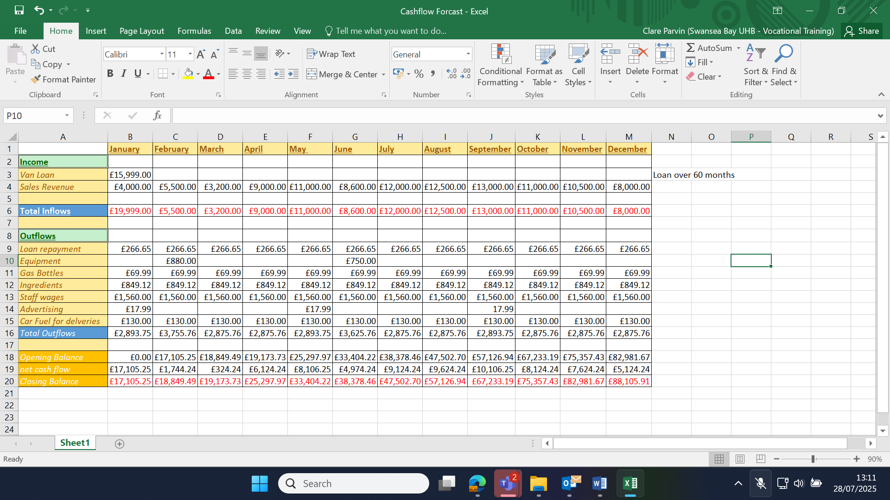

THE OPERATIONS FOR PARVIN’S PROTEIN BITES
Production and Distribution Plan - At Parvin’s Protein Bites a batch production process will be used for some of the menu, this process will allow for carefully controlled quality and ensuring that every product meets high standards for taste, freshness, and nutritional value. This approach will allow for the flexibility for demand while maintaining consistent customer satisfaction.
All of the high protein healthy food bites will be handmade in small batches, which will help maintain better control over the quality and freshness of each snack. Parvin’s Protein Bites will carefully source high quality, natural ingredients from trusted local suppliers where possible. These include good quality meat, rolled oats and wraps, plant based whey protein powder, nuts, seeds, dried fruits, and natural sweeteners. Each batch will be prepared with precise measurements which will be weighed and measured accurately, the cooking and preparing process will be carried out with attention to detail. We also aim to use sustainable and recyclable packaging as part of our commitment to environmental responsibility.
The planned distribution process is designed to be fast, flexible, and centred around the customer. As a mobile food van, Parvin’s Protein Bites will create freshly made, high protein snacks directly to customers at various local hotspots, events, and gyms. The van will operate in and around Swansea serving customers on the go. All products will be prepared fresh and stocked in the van each day, ensuring maximum freshness and quality. Parvin’s Protein Bites will also offer a pre orders and call ahead pick up service which allows customers to place orders in advance and collect them from the van at a time that suits them.
By operating from a mobile food van this helps to reduce overhead costs, and directly connect with our target audience. This setup keeps our operations efficient while maintaining our commitment to freshness, quality, and excellent customer service.
The team will include the founder of the business, Clare Parvin who will oversee all recipe development, quality control and build relationships with suppliers and all legal aspects of the business. A kitchen assistant who will help with meal preparations, cooking and cleaning within the food van and a delivery driver who will deliver locally from over the phone or Facebook orders. The plan is to work with a small group of trusted suppliers for the core ingredients prioritizing sustainability and consistency.
As a food business all the food production within the van on site will comply with local food safety regulations and undergo regular inspections. Clear labelling will be used to identify allergens such as nuts or dairy to protect the customers health. All staff involved in the production of food will be trained in food and safety handling and hygiene. According to a scientific review by the Food Standards Agency, an estimated 2.4 million cases of foodborne illness occur in the UK each year. This figure underscores the critical importance of maintaining high standards of food safety and hygiene across all businesses involved in preparing, handling, storing, or serving food. Chartered Institute of environmental Health (2024), online food safety training.
Parvin’s Protein Bites will be registered with the local council and environmental health office and comply with all food business requirements. Swansea local council do not charge a fee for registering a new food business so this is not an extra expense but for anyone starting a new business it must be registered within 28days as this is a legal requirement. Swansea Council (May 2025), how to register for your new food or drink business.

REFRENCES

• Aldi. (2025). ALDI UK | Homepage. Aldi.co.uk. https://www.aldi.co.uk/
• British Nutrition Foundation. (2024). A healthy balanced diet | British Nutritional Foundation. British Nutrition Foundation. https://www.nutrition.org.uk/creating-a-healthy-diet/a-healthy-balanced-diet/
• Byrons Butchers. (2024). Byrons Butchers. Byrons Butchers. https://byronsbutchers.co.uk/
• eBay. (2023). Electronics, Cars, Fashion, Collectibles & More. EBay. https://www.ebay.co.uk
• How to register your new food or drink business - Swansea. (2025). Swansea. https://www.swansea.gov.uk/howtoregisterfoodbusiness
• Online food safety training | Allergens, HACCP and more. (2024). CIEH. https://www.cieh.org/training-and-courses/online-training-courses/food-safety/
• UK government launches Healthy Food Standard mandating healthier products. (2025, June 30). New Food Magazine. https://www.newfoodmagazine.com/news/252828/uk-government-launches-healthy-food-standard-mandating-healthier-products/

APPENDICES

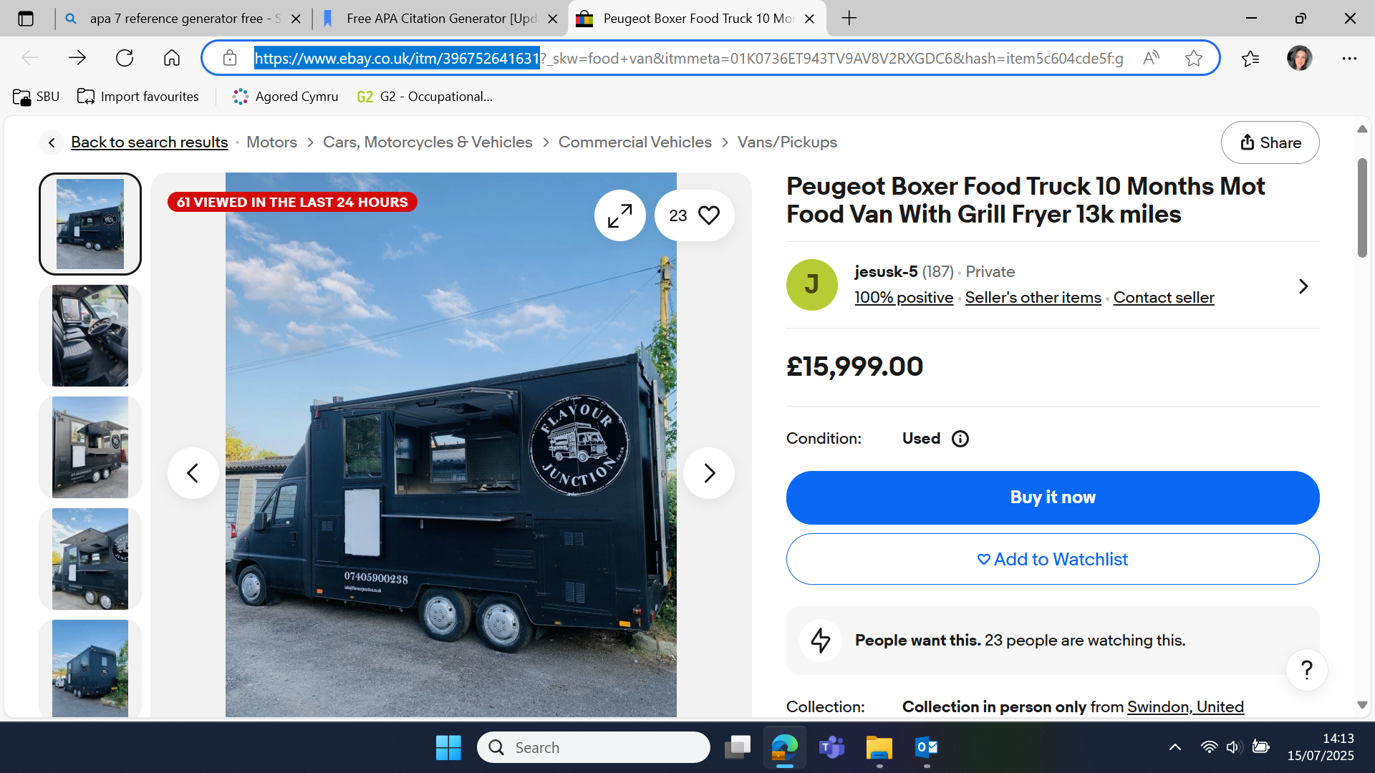

Ebay(2025)

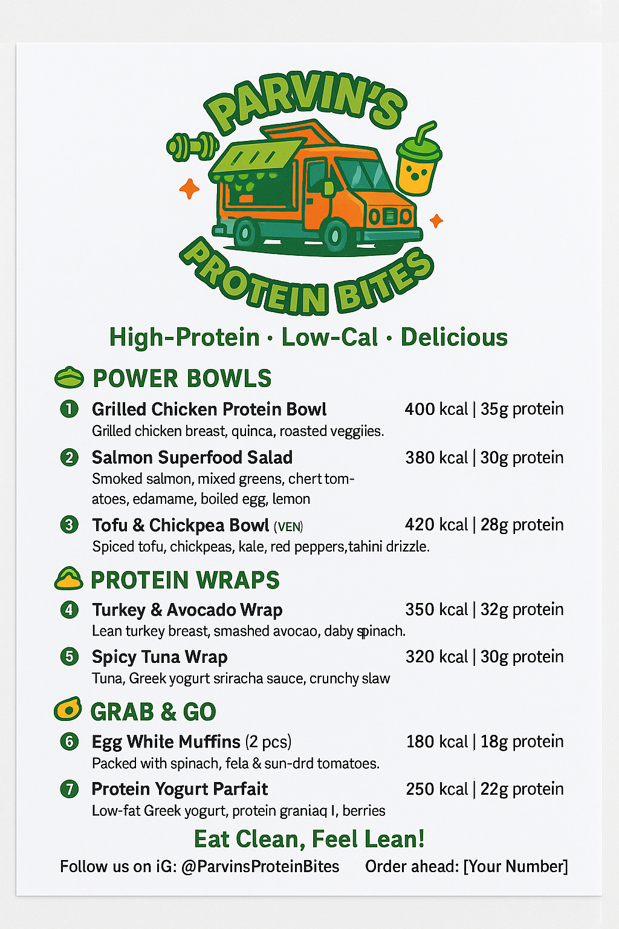
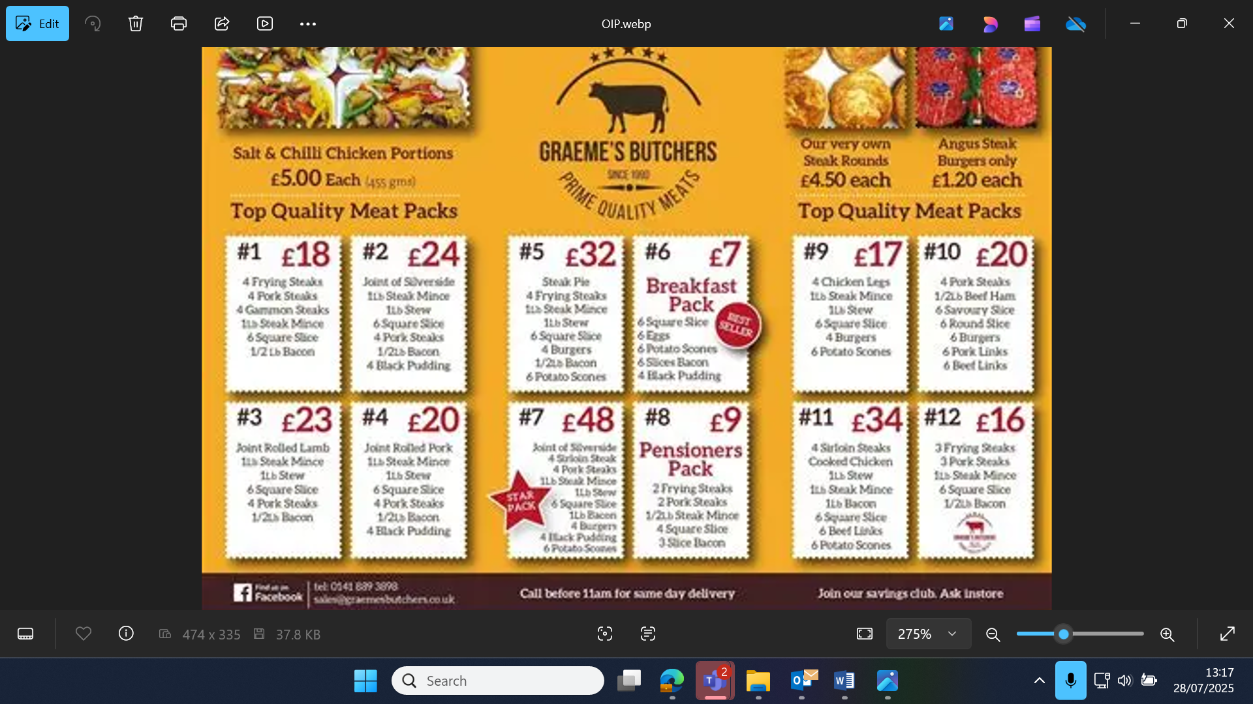
Byrons butchers Ltd(2024)

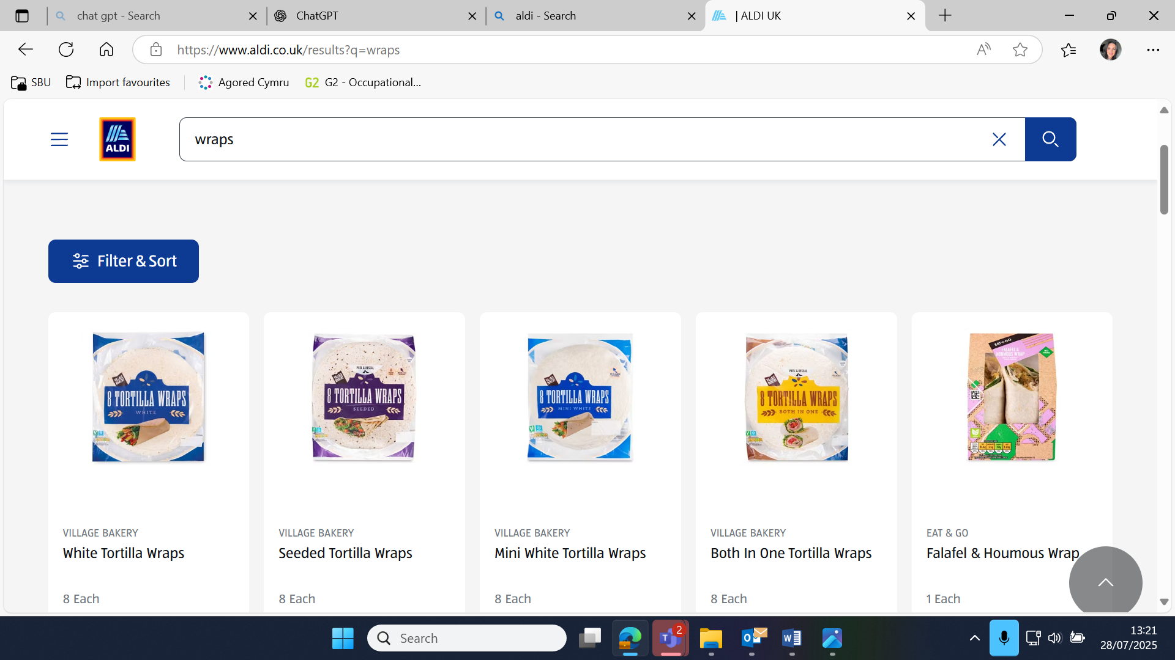

Aldi(2025)

