Sean Leach (2004817)

A Report Identifying the Primary Structure and Enclosure of SA1 Project.

Prepared for:
D. Hughes
Prepared by:
S. Leach

Contents
1 Introduction 2
2 Primary Structural System 2
2.1 Site Considerations 2
2.2 Foundations 2
2.3 Structural Columns and Beams 3
2.4 Flooring 4
2.5 Walls 4
2.6 Roof 5
2.7 Accommodation of Wind Loads 5
3 The System of Enclosure 5
3.1 Project Specific Considerations 6
3.2 Rainscreen Cladding 6
4 Summary 6
5 References 7
6 Appendices 9

1 Introduction

This report aims to describe a primary structure system that would be best suited for the building proposed to be built in SA1 which can be seen in the appendices. It aims to cover in detail the appropriate foundation type for this building. It will identify the appropriate materials and structural system for the columns, beams, floors and roof. This report will cover appropriate considerations and regulations for dealing with wind loading on the proposed structure. It will then identify a system of enclosure that will be conducive to the structural system.

2 Primary Structural System

The structural system of a building is the method in which structural elements have been assembled. The structural system of a building must support and transmit applied loads through the structure and into the ground. It is vital members of the structure don’t exceed their stress limits, (Britannica, 2018).

2.1 Site Considerations

Before any work commences on site, a full site survey is to be undertaken to ensure all desktop study conclusions are correct. From looking at Digimaps, the site history shows a canister works on the proposed site from the 1950’s. We can presume contaminants went into the soil during its building life cycle. From the desktop study we can see a local borehole log near to the proposed site. As seen in appendix one, the first five meters of earth is made ground. We can see by the makeup of this ground ash has been used as a back fill. This made ground is unsuitable for load bearing and will be major consideration when deciding the sub structure of this project.
As stated in (Swansea Museum, 2022), the German air force, known as the Luftwaffe, dropped 1273 high explosive bombs and 56,000 incendiary devices on the area of Swansea during the second World War. There is a high probability that some of these munitions could have landed within our site boundary and remained unexploded. Therefore, before works on site commence, it would be strongly advised that a UXO survey be carried out to ensure safe conditions for all operatives.

2.2 Foundations

As stated above, appendix one shows a local borehole log close to our site. As we can see the first 5 meters of ground are made ground and won’t provide support to structures. Therefore, for the structure to be able to provide support for the proposed building, the foundation type will need to a deep foundation. End bearing piles will allow the foundations to reach down and transfer the applied load of the structure directly into the grey mudstone, which is firm enough to support the sheer forces transferred from the super structure.
BS EN 1993 parts 3-5 is the relevant British standard to be considered when designing pile foundations and should be used in conjunction with BS EN 1991 and BS EN 1997 to ensure safe design consideration. Due to the nature of the ground seen in the borehole log, it is recommended that for this project, piles are to be driven piles and are to be to be made of steel. Steel piles provide many advantages required for this project. As (The Constructor, 2020) highlights, the properties of steel mean that its tensile strength enables the piles to be driven through the stiff boulder clay to reach the required depth as per the borehole log. Other benefits of using steel piles include, less soil being displaced during pile driving. This means there will be less disturbance to other local buildings. By using deep pile foundation, it also means there should be less settlement. However, steel can be more prone to corrosion than concrete. To mitigate any future corrosion of the piles, corrosive soil identified on the borehole log can be removed and replaced in the locations where steel piles have been put in. If further protection is needed, the top part of the pile can be encased by concrete. As British Standard BS EN 1993-5:2007 part 5 states, a minimum thickness can be required to offset the potential for corrosion.
After the steel piles have been placed correctly and signed off by the engineer they can then be capped. This involves encasing them with reinforced concrete which provides a flat surface on top where part of the structural frame can be attached via a base plate. The pile cap must be able to transfer the load successfully from the structure to the foundation. To aid in visualising this, an illustration of this can be seen in appendix two.

2.3 Structural Columns and Beams

When choosing the structure of a building it is important to remember the intended use of the building. As this building looks to provide an internal space for various users within a professional setting, a steel frame will provide the most internal space to the building and yet offer adequate support as a framing structure. BS EN 1993 covers general rules for using steel as a structural frame; it also covers structural fire design considerations in part 1-3. Steel columns will be attached to the concrete pile cap through the use of a steel base plate which will anchor the steel column firmly to the foundations, (Victor, 2020) was a good source of information for this.
Due to the tensile strength of steel, it can span large open areas without the need for columns so frequently, offering more space to the user. This also allows more flexibility within the structure and can accommodate for large openings such as conference rooms or large communal areas.
Before being used as a framing structure the steel is galvanised. This mitigates the chance of rust forming and compromising the strength of the beams and columns. Providing the steel is properly treated and maintained, it can outlast its counterparts concrete and timber, as it does not crack, split, or creep. It is also impermeable to insect attacks and mould.
As steel frames are made off site in factory conditions, they offer precise accuracy to specification. This allows a faster build time as steel members can be brought to site at the required time and can be bolted or welded together in place. Unlike in-situ concrete there is no need to wait for materials to cure before continuing construction.
Due to the geographic location of the site in Swansea, it will also be possible to source the steel locally from Tata Steel, this reduces the carbon footprint of the project. (Buildsteel.org, 2020) and (ESSF,2018) were good sources of information for this.

2.4 Flooring

The structural flooring to be used on all levels of this project is going to be block and beam, otherwise known as Bison beams. This flooring has been chosen due to the benefits it offers this structure. Bison beams are concrete beams that are made off site to the required span. They are pre-stressed which means their tensile strength is higher and that they can span further. The Bison beams can have concrete blocks placed on the grooves in between each beam side by side or if required they can have larger precast Holloway concrete panels craned into place. By using Bison beams it offers a solid floor with good fire resistance. More advantages are that it has a very good acoustic performance and can be built in place at good speed. Further information and specifications can be found at (Bison, 2018)

2.5 Walls

As the structural steel frame supports the whole building, there is no need for the walls to be load bearing. However, it is essential that external walls provide support to the system of enclosure. The wall construction for this project will be Metsec steel walls. Metsec steel walls are prefabricated off site to the required specification and offer great fire protection, precise accuracy and great acoustic performance. Because they are made off site, they can be brought to site at the required time and craned into place and bolted together at great speed. (Metsec Plc, 2015) is a great video that shows how the steel panels can be put together and the variety of options they offer. More technical information on a Metsec’s steel frame can be found here, (Metsec, 2022)

2.6 Roof

As seen in the elevations for the building, a flat roof is to be constructed. A flat decked roof will offer the structural support required for this building. The make up of the roof shall consist of an EPDM rubber roof covering. As (Anon, 2019) highlights, this is durable and impermeable; essential for keeping moisture out. Under the roof covering is thick adequate roof insulation offering the required U value. By placing the insulation above the vapour control layer, we can eliminate any thermal bridging and offering a better thermal performance. Under the insulation is a vapour control layer to stop moisture penetrating the structure. Although called a flat roof, to ensure water doesn’t pond and ingress into the building, metal decking can be angled to create a fall ensuring the water runs off the roof and into the drainage system. Supporting the structure of the roof is a steel deck provided by Metsec which will be bolted to the steel frame and internal steel Metsec walls. To aide this description, a visualisation of a flat warm roof construction can be seen in appendix 3. (Kingspan, 2017) and (NHBC standards, 2019) were good sources of information for this.

2.7 Accommodation of Wind Loads
For a building of this size, when considering the structure and location, it is vital that the structure can transfer all applied forces safely into the ground without compromise to the structural elements. (INCA, 2014) highlights methods to deal with negative and positive pressures caused by wind loading.
BS EN 1991-1-4:2005 + Amendment1:2010 gives guidance on how to measure the impact of natural winds on loaded areas of the building under construction and can also apply to civil engineering works. It offers recommendations that cover the whole structure or just individual parts or components such as cladding.
Building Regulations Approved Document A for use in Wales, gives regulations and guidance on buildings when it comes to loading and how this affects ground movement. To ensure regulation compliant the project must adhere to wind loading regulations set out in this document.

3 The System of Enclosure

A system of enclosure, or commonly known as a building envelope, is there to separate the external environment from the interior environment of the building. It is vital that the system of enclosure works alongside the structural system and that it can be fixed to the structure without any compromise to its strength. The external environment affects the choice of material when selecting the appropriate system of enclosure. Although aesthetics can be important, protection from the external environment is its main purpose.
It’s important that the system of enclosure can be maintained by future users because it is exposed to the elements. Parts of the enclosure will deteriorate and this needs to be considered when designing the building. (Assetsinsights, 2022).

3.1 Project Specific Considerations

(Wbdg, 2016) highlights the principles of enclosure design and taking into consideration the location of the site – SA1, the system of enclosure will need to offer extensive protection from heavy rain, and sea water blown from the coastline as well as extensive control of water vapor flow. The system of enclosure will need to be connected to the steel frame and Metsec walls. Fixings for this can be provided through Metsec.
A look into the weather patterns in Swansea over the last few decades will give a good average on rainfall to plan off and will aide in designing drainage systems to be used on the structure.

3.2 Rainscreen Cladding

The best system of enclosure for this building is a rainscreen clad. As (Building, 2017) explains, rainscreen cladding consists of an impermeable outer leaf. An air gap is then made using the correct fixings which provides a ventilated cavity to help prevent moisture from reaching the inner leaf of the building. Insulation can be put in the air cavity providing an air gap is left. This can ensure that the thermal performance of the building can reach the required U value. Just like a traditional building, it is vital to use a vapor control barrier too. The rainscreen clad material can come in a few different options such as, high-pressure laminate, aluminium, stone, or glass.
One advantage of using rainscreen cladding is its versatility. It can come in a range of different colours and styles, offering designers and architects more designability when designing the building. As (Rainscreen info, 2022) highlights, not only does rainscreen cladding offer protection from rain, snow and ice, it also offers great protection from UV rays and can offer great shading if required. Rainscreen cladding offers an extremely durable external clad and as (Bilda.net, 2020) mentions, it requires virtually no maintenance which is an added benefit for the end user and the life cycle of the building. An example of a rainscreen cladding detail can be seen in appendix four.

4 Summary

The aim of this report was to cover structural elements that would be best suited to the proposed project in SA1. This report has highlighted considerations that have affected the choice of material and structural elements. Important and relevant codes of practices and building regulations that apply to this project have been included in their relevant parts of the report.
A steel frame structure was identified as the best framing material for this project due to the benefits it can offer over other framing materials. The steel frame will be situated on base plates connected to the pile caps. Due to the ground, it was identified that the foundation for this project would need to be piles. This ensures all forces can be safely transferred into the ground without compromise to the structure.
The system of enclosure best suited for this project was identified as rainscreen cladding. This offers great protection from the external environment and is extremely durable and versatile. It also offers great designability to the architects and benefits this project greatly due to the adverse weather conditions Swansea experiences on a regular basis. The rainscreen clad can be attached by the correct fixings to the exterior leaving a ventilation gap which helps keep moisture out of the structure.

5 References

(Britannica, 2018) The Editors of Encyclopedia Britannica (2018). Structural system | building construction. In: Encyclopædia Britannica. [online] Available at: https://www.britannica.com/technology/structural-system.

(ESSF, 2018) Edmonton Structural Steel Fabrication. (2018). How to Prevent Steel Beams and Plates from Rusting. [online] Available at: https://northern-weldarc.com/prevent-steel-beams-plates-rusting/ [Accessed 17 Feb. 2022].

Assetinsights (2022). Enclosure System. [online] Available at: https://www.assetinsights.net/Glossary/G_Enclosure_System.html [Accessed 17 Feb. 2022].
‌Bilda.net (2020). Rainscreen cladding system advantages. [online] BILDA. Available at: https://bilda.net/rainscreen-cladding/ [Accessed 1 Mar. 2022].
Bison (2018). Beam and Block Floor Suppliers - Bison Precast Concrete. [online] Available at: https://www.bison.co.uk/products/beam-and-block/. [Accessed 17 Feb. 2022].

Building (2017). CPD 7 2017: Rainscreen cladding. [online] Available at: https://www.building.co.uk/cpd/cpd-7-2017-rainscreen-cladding/5087063.article.

Buildsteel.org (2020). 10 Reasons to Frame Your Next Project with Steel. [online] BuildSteel.org. Available at: https://buildsteel.org/why-steel/cold-formed-steel-101/10-reasons-to-frame-your-next-project-with-steel/ [Accessed 1 Mar. 2022].
Kingspan | Great Britain. (2017). Flat roof constructions. [online] Available at: https://www.kingspan.com/gb/en-gb/products/insulation-boards/insulation-technical-hub/articles-and-advice/flat-roof-constructions. [Accessed 23 Feb. 2022].

Metsec Plc (2015). Metsec Metframe System. [online] Available at: https://www.youtube.com/watch?v=kMGiqIoUtao [Accessed 23 Feb. 2022].

Metsec. (2022). Metframe Steel Framing | Specification Manual. [online] Available at: https://www.metsec.com/products/metframe/. [Accessed 23 Feb. 2022].

NHBC Standards (2019). 7.1.5 Profiled metal decks. [online] NHBC Standards 2019. Available at: https://nhbc-standards.co.uk/2019/7-roofs/7-1-flat-roofs-and-balconies/7-1-5-profiled-metal-decks/ [Accessed 1 Mar. 2022].
NHBC Standards (2022). 4.4 Raft, pile, pier and beam foundations. [online] NHBC Standards 2022. Available at: https://nhbc-standards.co.uk/4-foundations/4-4-raft-pile-pier-and-beam-foundations/ [Accessed 1 Mar. 2022].
Rainscreen info (2022). How It Works - The Rainscreen Principle. [online] Bendheim Rainscreens. Available at: https://rainscreeninfo.com/how-it-works/ [Accessed 1 Mar. 2022].
Swansea Museum (2022). The Blitz. [online] www.swanseamuseum.co.uk. Available at: http://www.swanseamuseum.co.uk/swansea-a-brief-history/world-war-two/the-blitz [Accessed 1 Mar. 2022].
The Constructor. (2020). Steel Piles - Types, Advantages, and Disadvantages [PDF]. [online] Available at: https://theconstructor.org/structural-engg/foundation-design/steel-piles/40266/. [Accessed 17 Feb. 2022].

Victor, O. (2020). Design and Detailing of Column Base Plates. [online] STRUCTURES CENTRE. Available at: https://structurescentre.com/design-and-detailing-of-column-base-plates/ [Accessed 6 Mar. 2022].
Anon (2019). Benefits of EPDM Rubber Roofing | Blog. [online] RubberBond. Available at: http://rubberbond.co.uk/blog/benefits-epdm-rubber-roofing/ [Accessed 6 Mar. 2022].
INCA (2014). Wind Load Design Considerations. [online] Available at: https://www.inca-ltd.org.uk/wp-content/uploads/2016/09/INCATechnicalGuide03-WindLoadDesignConsiderationsforEWISystems.pdf [Accessed 6 Mar. 2022].
Wbdg (2016). Building Enclosure Design Principles and Strategies | WBDG - Whole Building Design Guide. [online] Wbdg.org. Available at: https://www.wbdg.org/resources/building-enclosure-design-principles-and-strategies.

6 Appendices

Appendix 1 (3 Pages) Taken from the Assignment brief.
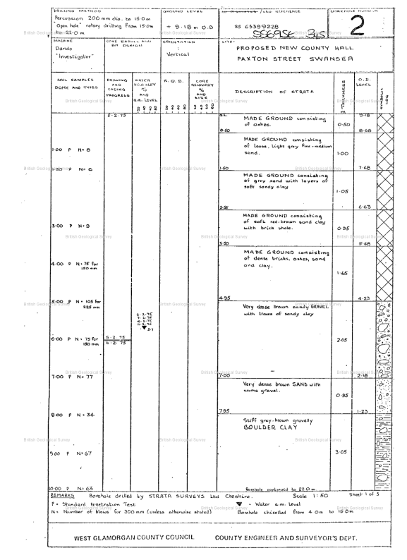
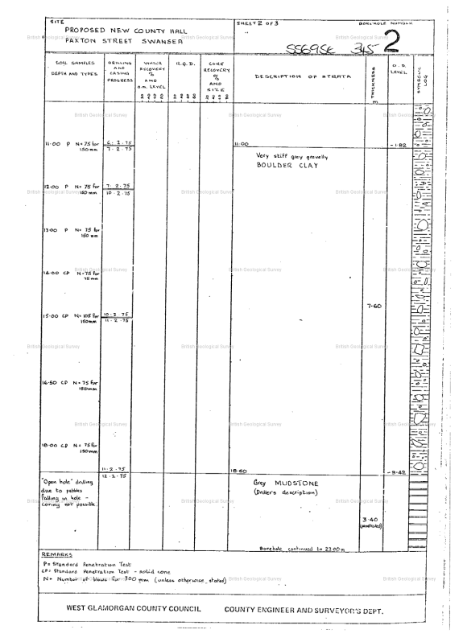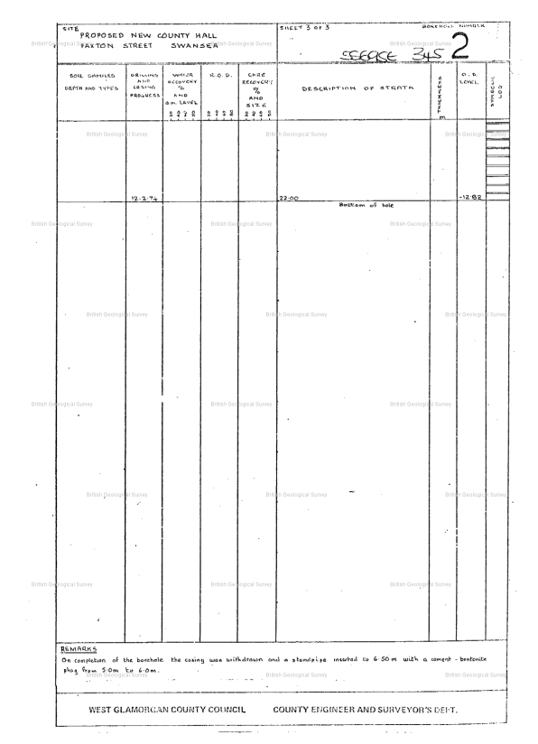
Appendix 2
Image taken from (Google, 2022)
Google (2022). pile cap - Google Search. [online] Available at: https://www.google.com/search?q=pile+cap [Accessed 17 Feb. 2022].
‌

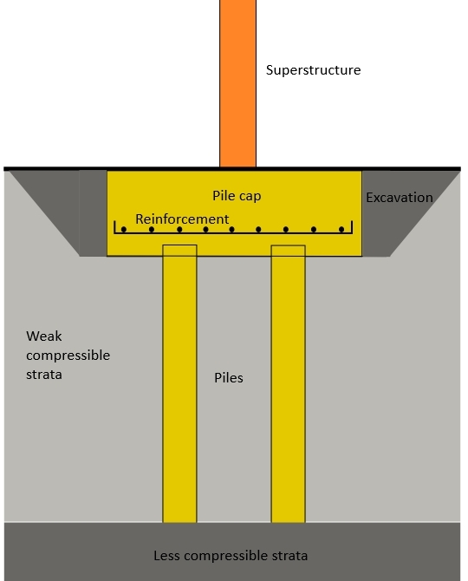

Appendix 3 – Warm roof visual aide. Taken from (NHBC Standards, 2019)
NHBC Standards (2019). 7.1.5 Profiled metal decks. [online] NHBC Standards 2019. Available at: https://nhbc-standards.co.uk/2019/7-roofs/7-1-flat-roofs-and-balconies/7-1-5-profiled-metal-decks/ [Accessed 1 Mar. 2022].
‌

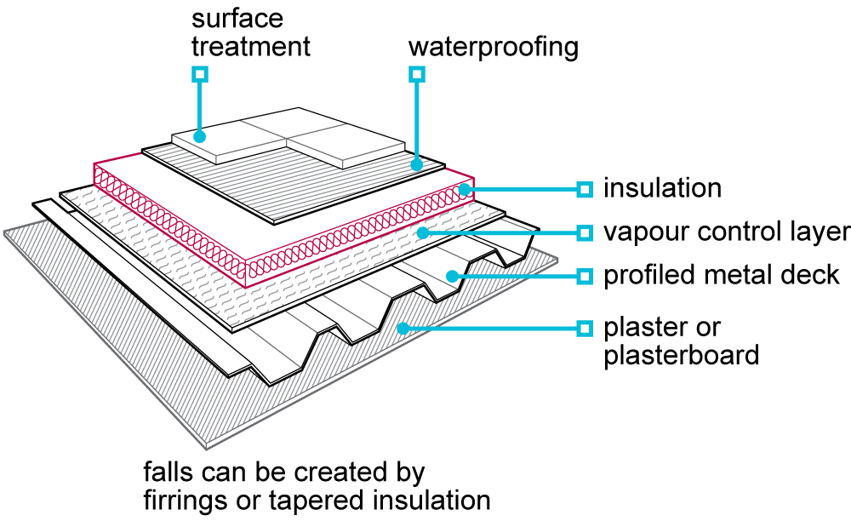

Appendix 4. Rainscreen cladding visual aide. Taken from (Rainscreen info, 2022)
Rainscreen info (2022). How It Works - The Rainscreen Principle. [online] Bendheim Rainscreens. Available at: https://rainscreeninfo.com/how-it-works/ [Accessed 1 Mar. 2022].
‌

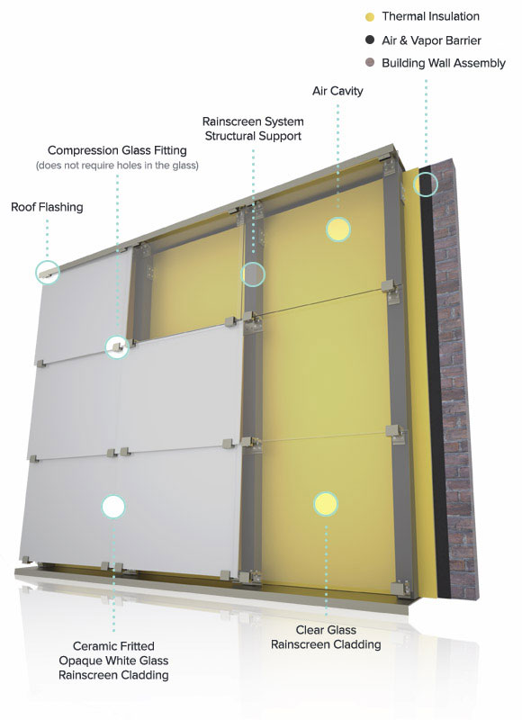

Appendix 5 – Structural frame columns highlighted with an orange dot.

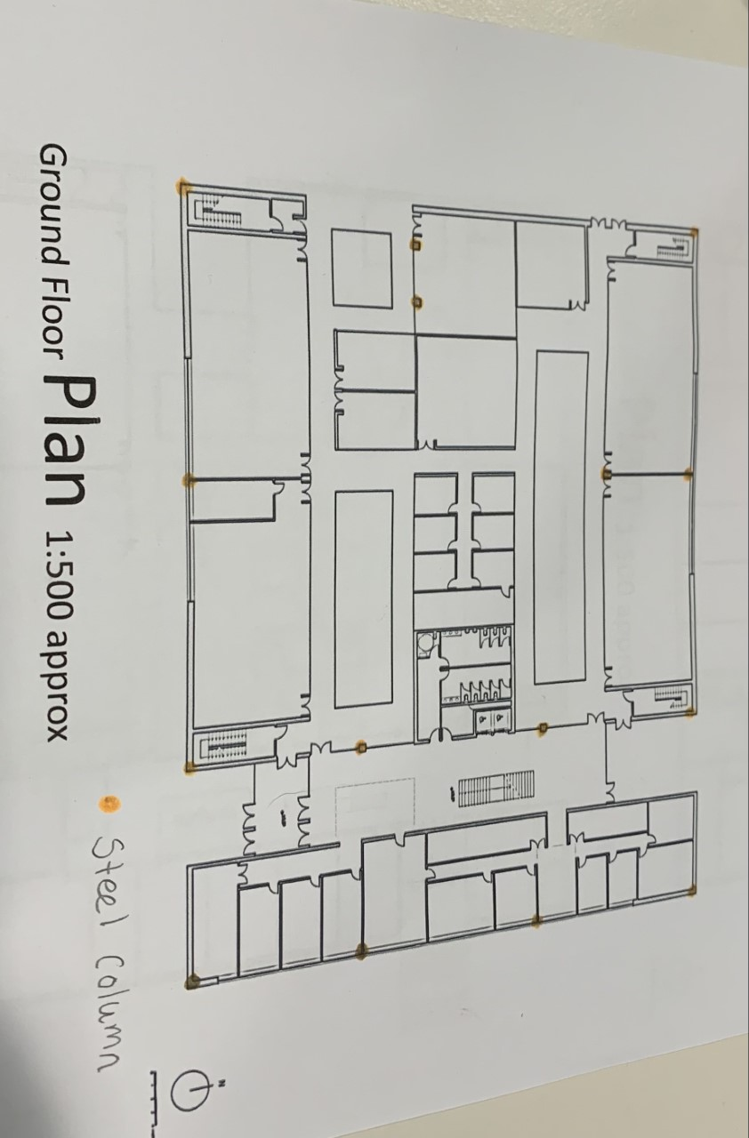

Appendix 6 – Structural elements annotated on elevations.
On the West elevation you can see the steel frame grid system drawn in place.
Underneath the structure, the end bearing pile foundations have been annotated.
On the East elevation the rainscreen cladding has been annotated.



