Consultancy Report

Chain-affiliated Hotel Premier Inn, Pontypool,
South Wales, UK

Nexus Consulting

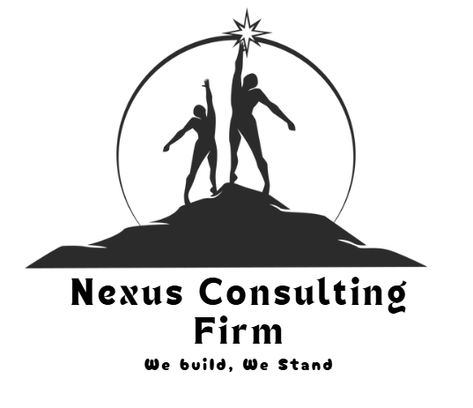
Student Name: Elena Silvia Cazacu
Student ID number: 2207618
Module Title: Organisational Consultancy BMIH6013
Lecturer Name: Dr. Ernest Balutie Wavei

Executive Summary
The report is based on a detailed study of the operations of Premier Inn Hotel, located in Pontypool, South Wales, UK. The hotel industry is currently highly dynamic and competitive, which has increased the significance of evidence-related decision-making. The report has been developed from the viewpoint of Nexus Consultancy Firm, which has taken the initiative to provide appropriate initiatives to various hotels in the UK. The factors considered by the consultancy while developing this report included their commitments related to corporate social responsibility. The current problems recognised as a part of this analysis include workforce management issues, employee instability and reputation control and feedback management. The operational issues of the hotel were examined thoroughly in this report, to understand its current position in the industry. Moreover, the report also provided a precise evaluation of the external environment of the hotel using the STEEPLED framework. The STEEPLED framework was quite effective in understanding the macro environment aspects that have a significant influence on the current operations of the hotel. STEEPLED framework evaluation showed that the technological advancements supported the growth of Premier Inn in Pontypool, UK.
Through in-depth analysis, it is evident from the report that Premier Inn faced major issues in managing costs after the massive impact of the COVID-19 pandemic. It also struggled to maintain and balance the workforce count, thus experiencing labour shortages during peak seasons. Moreover, operational lags have been faced in daily activities, creating customer dissatisfaction and losing profitability. Considering these problems, strategic solutions have been devised within the action plan. The adoption of smart workforce planning techniques can help the company address the issues related to labour shortages. Profound evidence-based strategies have been determined to tackle the disengaged workforce at Premier Inn. It has been viewed that use of rewards strategy and opportunities for building a career can help to motivate workers and drive high productivity. Hence, this strategy has been identified and expected to be integrated within 5-6 months for achieving seamless positive outcomes.
The economic factors related to Brexit implementation have a negative influence on the hotel. While the environmental factors enhanced the significance of sustainable investments, political turmoil led to significant job cuts in the organisation. Moreover, the legal, ethical and demographic aspects increased the changes implemented by Premier Inn, to maintain its operations. The report also provided an analysis of the internal factors, such as strengths and weaknesses, that help Premier Inn to enhance its operations. On the contrary, the opportunities and threats have a significant impact on the current operations and position developed by Premier Inn in the hospitality sector of the UK.
On the contrary, to address operational problems at the company, key aspects related to human errors have been noted. To overcome these problems, it was viewed that the use of digital tools and automation can help Pontypool to redefine its services and enhance potential business outcomes. Furthermore, digital tools can help in personalising guest assistance, which can drive high satisfaction among customers. The report has identified the key solution to mitigate cost control issues with the integration of sustainable practices. This is because sustainability can help in integrating energy-efficient activities, which help in reducing water wastage and managing electricity bills. Moreover, the strategic integration of sustainability initiatives can create a positive brand image for Premier Inn, thus accelerating guest visits and enhancing profitability. With strategic views of inducing business outcomes and profits, the company can improve its revenue generation and boost customer loyalty by acquiring the title of sustainability leader in the hospitality sector.

Table of Contents
1. Introduction 5
1.1 Overview of Nexus Consultancy Firm 5
1.2 Background of the Premier Inn Hotel 5
1.3 Understanding of Theoretical Approaches 6
2. Analysis 7
2.1 Key Issues in the Premier Inn Hotel 7
2.2 STEEPLED Analysis 9
2.3 SWOT Analysis 13
A SWOT analysis is used to determine the internal and external factors that affect the performance of the Premier Inn. 13
2.4 TOWS Analysis 14
3. Recommendations and Change Management 16
3.1 Recommendation 1: Optimisation of strategic workforce for retention 16
3.2 Recommendation 2: Improving the consistency of services via strong standards and processes 18
3.3 Recommendation 3: Balancing the cost via sustainability investments 19
4. Action Plan 21
5. Conclusion 23
Reference List 25

1. Introduction

Overview of the Nexus Consultancy Firm
The Nexus Consultancy Firm, located in Pontypool Town, UK. includes external experts to help organisations solve issues, improve their performance, and achieve their organisational goals to create a better culture and employee wellbeing. The modern hotel industry is functioning in a more complex and competitive environment. It is focusing on the growing customer demands, labour market pressure, cost inflation and fast technological advancement (López‐Gamero et al., 2023). The Nexus Consulting Firm has undertaken a pro bono initiative. Hotels which are chain-affiliated need to consistently provide standardised brand promises and address the local market conditions. The consulting firm introduces the expertise of a specialist in the operations of the hospitality sector, organisational behaviour, and strategic change management. The Premier Inn hotel has been selected through personal visit of the Nexus Consultancy Firm, giving this report an objective analysis, comparing the Premier Inn with best practise in the industry and make strong recommendations.

Background of the Premier Inn Hotel
Premier Inn is one of the well-known British limited-service hotel chains and is the biggest hotel brand in the UK. The Premier Inn based in Pontypool was founded in 1987 in the South Wales region of the UK (Premier Inn, 2023). Premier Inn hotel in Pontypool is in a perfect position for exploring the Monmouthshire, South Wales valleys and peaks of the national parks (Premier Inn, 2025). The location of this hotel is in Tyr'Felin, UK. The Premier Inn brand has good national awareness and operational standardisation. Still, the individual properties remain susceptible to localised operations issues, in the workforce, consistency in service delivery and customer satisfaction. Figure 1 shows the hotel logo.

Figure 1: Logo of Premier Inn, UK
Source: (Premier Inn, 2023)
Mission Statement: The mission of Premier Inn in Pontypool is to be a force for good (Premier Inn, 2025). This highlights that Premier Inn is focusing on helping their customers and employees' lives by improving their team diversity and making positive contributions to the communities.
Vision Statement: The vision of Premier Inn in Pontypool is depending on establishing people-focused hotels for value, quality (Premier Inn, 2025).
Core Values and Strategy: The operational model used by Premier Inn in Pontypool is a vertically integrated model for making a strong brand loyalty via diversity, sustainability and consistent customer experiences (Whitbread PLC, 2025). This model helps in sustainable profitable growth and maintains strong competitive advantages in the UK market.
Products and Services: Premier Inn in Pontypool's products focus on the budget-friendly, consistent comforts with providing clean rooms under the CleanProtech strategy, Hypnos beds, free wifi and en-suite bathrooms (Premier Inn, 2019). They give value to customers’ choices.
Organisational Culture: Premier Inn in Pontypool’s organisational culture creates a safe place where employees can trust, respect and be motivated by maintaining the highest standards. Overall, Premier Inn's organisational culture is being forced for good by the initiatives like people promise for more growth and belonging (Premier Inn, 2024).
Workforce and Customer Base: As of 2023, there were 847 hotels belonging to Premier Inn. In 2023, more than 39000 people were employed in this hotel (Whitebread, 2023). Premier Inn has served over five million customers every month (Whitebread, 2023). Customers are mostly leisure and business clients at this hotel.

Understanding of Theoretical Approaches
A STEEPLED analysis is applied to assess the external macro-environmental issues that affect the industry in the UK hospitality sector and Premier Inn,having operational issues that should be interpreted in a broader strategic and environmental scope. High inflation rates and a lack of labour in the UK have been key concerns that have led to increased costs for Premier Inn in the recent past. The UK economy has been hit by the high inflation rate due to Brexit regulations (Bank of England, 2021). Another issue that the Premier Inn has experienced following the COVID-19 pandemic is a labour shortage (Ambrose, 2021). The opportunity to analyse operational issues on the property level is a strategic requirement of the brand integrity and profitability in the long run. This is followed by a SWOT analysis to assess internal and external weaknesses as well as external opportunities and threats of the hotel, and a systematic overview of the present performance. The TOWS analysis is utilised to translate diagnostic findings into strategic alternatives so that the problems identified are transformed into strategic action plans.

2. Analysis

Key Issues at the Premier Inn Hotel
Workforce Management: The UK hospitality sector has faced significant shortages, with 48% after the Covid-19 pandemic situation (UK Hospitality, 2024). This has led to heavy dependence on a small number of core employees to work under more stressful work pressures and staffing shifts. Such conditions are transformed to service delays, less attention to details, and employee burnout in a low-budget hotel scenario, where labour efficiency is at the centre of the business. The high turnover rate of the staff also increases such problem, as recruits need training and time to achieve desired performance levels (Yin et al., 2022). The hospitality industry of the UK has the highest turnover rate, about 60% (CIPD, 2024). It is difficult to maintain operational consistency, and it puts the chance of service failures at risk of compromising the brand promise. Figure 2 shows UK’s Turnover Rate, 2022-23.
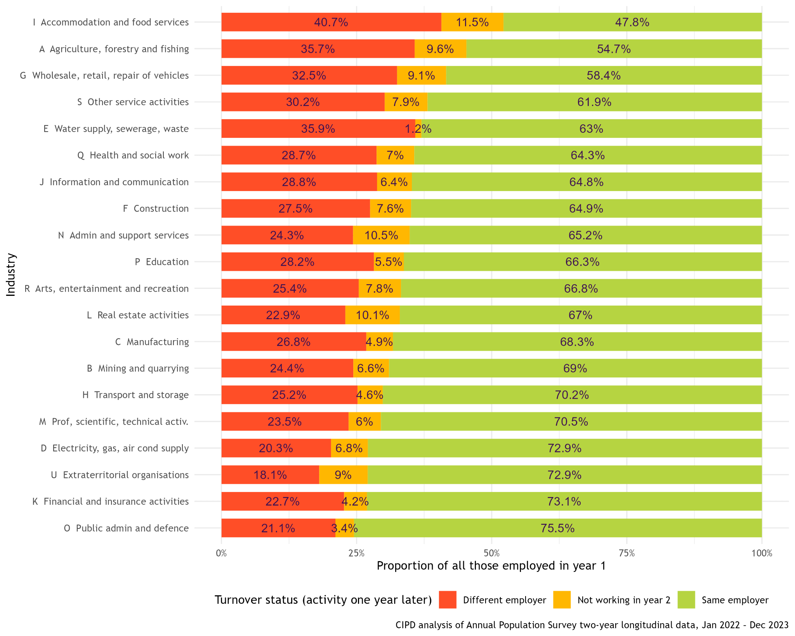
Figure 2: UK’s Turnover Rate, 2022-23
Source: (CIPD, 2024)
Employee instability: In the hospitality industry, employee instability is caused due to poor work balance in work, toxic environment, high turnover rate and lack of career growth (Giousmpasoglou, 2024). The consistency and reliability in the guest experience is one of the value propositions that draws a lot of coverage to the Premier Inn. However, service delivery may get uneven when there is inadequate training and engagement of the employees. In the UK, more than half of the job losses occurred after the last budget in 2025. There have been around 89,000 job losses since 2025 in the UK hospitality sector (Masud, 2025). This can be indicated in a variation in room preparedness, housekeeping or responsiveness to client requests at Premier Inn.
Feedback management and reputation control: The other operational issue faced by hotels is customer feedback management and reputation control. Online reviews and rating websites have a significant impact on the choices made by consumers in the digital era (Fernandes et al., 2022). Guests in the budget hotel are having good and bad experiences. The service gaps remain and the cumulative effect of these negative reactions may be detrimental to the online image of the hotel as well as future demand. However, the use of corporate-level reputation management systems helps to deal with the cause of negative feedback at the operational level.
These operational issues are further compounded by the effect of the lack of costs and financial constraints. In the UK, prices in the hospitality sector have increased by 3.8%, mainly due to high air fares and food prices (Masud, 2025). The increase in wages from £11.44 to £12.21 per hour has led to a high economic burden on Premier Inn employees and in the UK hotels in the budget segment, where the margins are being highly managed (Redfern, 2025). Subsequent cost containment strategies can consequently constrain the efforts toward staff development, technological improvements or other supplies. In the case of the Premier Inn, one of the most critical operational difficulties is the need to balance cost and service excellence. All these operational issues have a compounding effect on the performance of the Premier Inn. The unstable staffing situation leads to the inconsistency of the services, influencing the guest satisfaction and the online image.
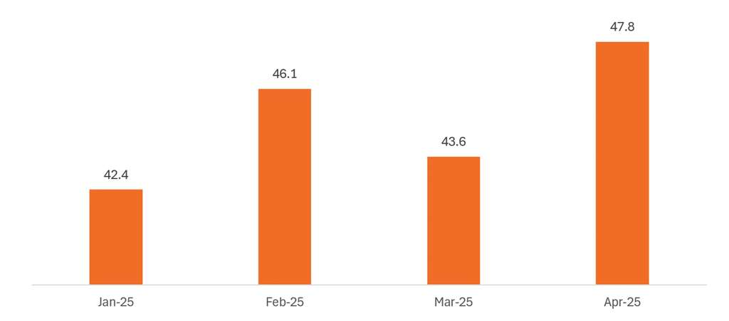
Figure 3: UK’s increased living wages, 2025
Source: (Redfern, 2025)

STEEPLED Analysis
Social Factors: After the COVID-19 situation, there have been changes in the customers' expectations in the budget hotel sector in the UK. Regardless of the price, guests are becoming more conscious about cleanliness, efficiency and responsiveness. According to the theory of planned behaviour, it can be leveraged by understanding people about specific behavioural patterns (Zinn, Greene and Dolnicar, 2024). The room cleanliness, responsiveness, and attitudes indicated customers were more conscious about the comfort, hygiene, personal and physical spaces. This suggests that the preferences and needs of the guests can lead towards more positive changes. The inability to realise them may lead to poor perception and criticism posted as feedback on social media platforms. The increase in domestic tourism has added to the competition levels of the hotels in the region in the UK. In 2024, the business trip rose 45.4% and the holiday travel rose 53.1% in the UK (Savills, 2024). These added more pressure on the consistency of value delivery and services.
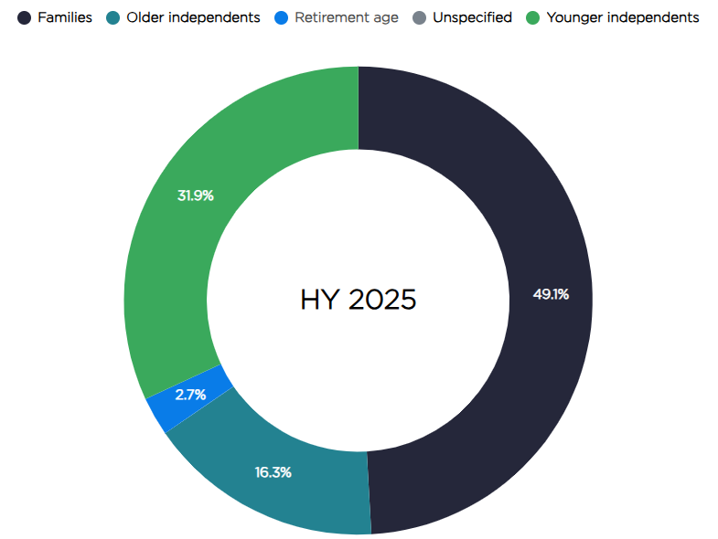
Figure 4: Domestic city holiday trips in the UK
Source: (Savills, 2024)
Technological Factors: The impact of technology is significantly high on the operational processes as well as the perceptions of guests. Visitors are demanding strong digital communications such as online booking, quick check-in and speedy issue solutions (Tan et al., 2025). According to AMIRULLOH, Deliana and Suyamto (2024), the Technology Acceptance Model (TAM) emphasises the importance of adopting technology that can help to improve guest experience and overall hotel operations. By the application of AI and Internet of Things (IoT) technologies, this will help to maintain the level of cleanliness by automated cleaning systems and provide convenience and safer experiences after the COVID-19 pandemic situation. Centralised technological systems are advantageous to Premier Inn. The use of these tools at Pontypool depends on the competency and interest of the staff.
Economic Factors: In the UK hospitality industry, Brexit plays an essential role in the labour market. Brexit disrupts the UK trades and falls in the labour supply and also raises costs and new challenges (French, 2018). In 2022, in the UK, the net loss of workers was around 330,000 (Springford and Portes, 2023). Also, the increasing inflation and wages are prime threats to the Premier Inn, also the UK hospitality sector. In the case of a low-end hotel with low margins, these situations restrict financial ability and dependency on labour efficiency.
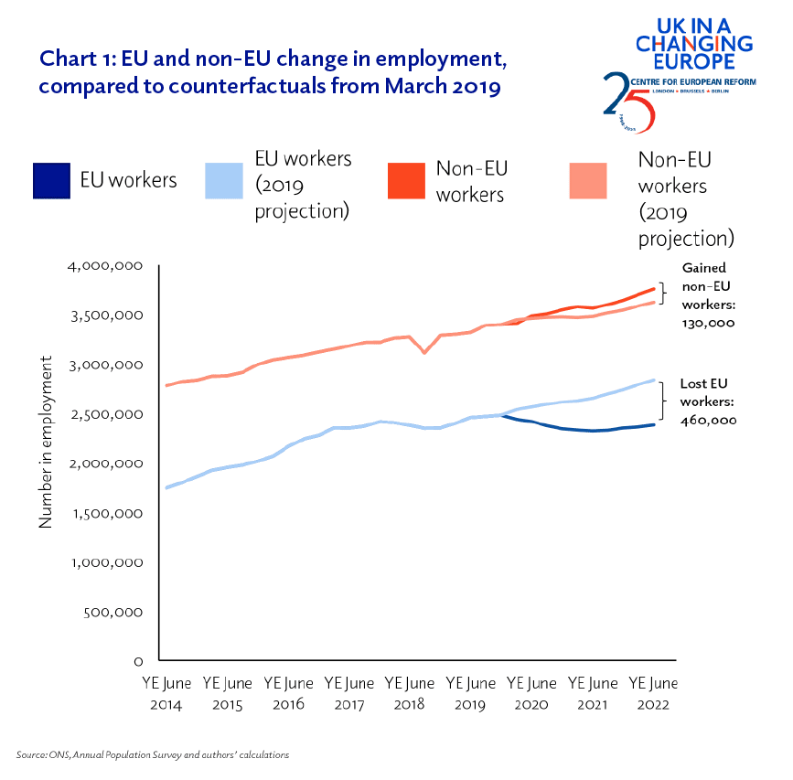
Figure 5: EU and non-EU Employment in the UK, 2014-22
Source: (Springford and Portes, 2023)
Environmental Factors: Hotels are now being urged by their guests, corporate clients and regulators to show sustainable practices such as less use of energy and proper management of waste (Commey, Latifatu and Ashley, 2025). The UK government focuses on net-zero by 2050 through food waste reduction, single-use plastic elimination, to strengthen the hospitality management and recognise the social value of the hospitality industry (GOV UK, 2023). The sustainability commitments at Premier Inn are on a corporate level. Their key focus is to reduce water consumption, waste to landfill and save energy, which is driving towards the Net Zero achievement in 2030 (Premier Inn, 2025). In Pontypool, Premier Inn lacks a strategic approach and needs to focus more to staff training and operational processes, adjustments requiring targeted improvements.
Political Factors: The UK has a strong political stability with 0.51, which indicates that in the long term, the UK economy has stable growth (The Global Economy, 2023). However, due to Brexit regulations, the UK economic sector faces high inflation and labour shortage issues. Due to the COVID-19 pandemic situation, the UK's political environment has included potential changes in its new policy of immigration, which increases labour shortage and costs (Spital and van Aerssen, 2023). In the lockdown situation, Premier Inn cut nearly 6000 jobs (Kollewe, Neate and Neate, 2020). Adherence to the UK employment law, though necessary, adds to administrative and financial costs.
Legal Factors: One of the major legislations that addresses different environmental concerns, including hospitality waste and the management of hotel waste, is the Environment Act 2021 (Maddison, 2024). At Premier Inn, the constraints can restrict the staff scheduling flexibility resulting in staffing issues when demand changes.
Ethical Factors: Ethical issues are associated with workforce well-being and organisational culture. The growing social and regulatory attention to employment practices puts pressure on hotels to avoid unfair workloads, workers’ involvement and favourable management (Giousmpasoglou, 2024). The possibility of not meeting these ethical expectations could lead to a bad image and loss of employees.
Demographic Factors: The population variables affect the availability of labour in Pontypool,where Premier Inn hotel is located. Recruitment is limited due to a small city and local labour and the competition with other service industries, which adds to the problem of staffing instability (Houston et al., 2025). The population fact strengthens the necessity of proper retention strategies and planning for the flexible workforce.

SWOT Analysis

A SWOT analysis is used to determine the internal and external factors that affect the performance of the Premier Inn.
Strengths | - The identified strengths depict the established brand equity and the standardisation of its operations that offer a stable basis for delivering consistent services and earning the trust of its customers.  - The strengths in the low-end hotel market, where price is sensitive, and brand recognition may be a determining factor in the decision to book (Pelet, Lick and Taieb, 2021).  - The success of these strengths within the area of Premier Inn in Pontypool is limited by the weaknesses associated with workforce instability and restricted property-level operational flexibility.
Weaknesses | - High turnover rates and a lack of staff are one of the severe internal weaknesses, as they have a direct negative impact on service quality and employee involvement (Ghani et al., 2022).  - The standardised procedures are suggested to bring about efficiency, but they also limit the dynamic nature of the hotel in responding to local demand changes and the availability of labour.  - Such inflexibility can decline operations when occupancy rates are at their highest, and this is likely to lead to service failures.
Opportunities | - There are opportunities to use digital technologies, sustainability programmes and employer branding plans to make operations resistant and stable in terms of workforce.  - Premier Inn gives focus on higher pay rates to their employees up to £12m-£13m (BBC, 2021). This initiative helps to reduce the staff shortage.
Threats | - The key threats are the increasing cost of operation, competition in the budget hotel industry and the reputational risks involved in bad reviews by customers (Ye et al., 2022).  - Premier Inn faces threats due to high competition in the dynamic hospitality industry.  - The external threats imply the necessity of strategic interventions that enhance the position of the hotel in the long-term competitive environment.
Table 1: SWOT Analysis

TOWS Analysis
The TOWS Analysis uses diagnostic findings which are converted into implementable strategic actions of the Premier Inn Pontypool.
Internal Factors
External Factors |  | Strength (S)  - Strong brand recognition  - Standardised operational procedure  - Market-based competitive pricing | Weaknesses (W)  - Employee shortage  - High turnover rate  - Reduced employee ethics due to high work pressure
External Factors | Opportunities (O)  - Growth opportunity in the domestic and international markets  - Implementation of digital tools  - Aligned with sustainability initiatives | Strength Opportunity (SO)  - SO, strategies are centred on leveraging the existing brand reputation and scale of operations of Premier Inn to improve the value of the guests and the resiliency of its operations.  - With digital efficiencies and by strengthening sustainability efforts at the property level, Premier Inn can stand out in a competitive regional market while keeping cost discipline. | Weakness Opportunity (WO)  - The WO strategies emphasise the need to convert the internal weaknesses into opportunities that lead to the growth of the organisation.  - One of the critical operational issues highlighted as problems concerning the workforce can be resolved with the enhancement of employee engagement, encouraging skills growth, and the use of technology to automate routine activities (Nikolić, 2023).  - Such efforts can boost the retention of staff and improve the consistency of the services.
External Factors | Threats (T)  - High competition  - High UK inflation rate  - Negative online reviews by guests | Strength Threats (ST)  - The ST strategies focus on the defensive deployment of the existing strengths in response to the external threats.  - The brand standards and centralised support systems may assist in protecting the quality of services and maintaining online reputation in an ever-competitive and review-driven market environment (Açikgöz et al., 2024). | Weakness Threats (WT)  - The WT approaches provide an emphasis on the importance of risk reduction.  - The external threats of increasing costs and labour shortages can grow with the lack of intervention, leading to the instability of staffing and the rigidity of the processes (CBI, 2025).  - The workforce planning and operational flexibility should then be adjusted strategically in order to stabilise the performance to avoid permanent decline.
Table 2: TOWS Analysis

3. Recommendations and Change Management

Recommendation 1: Optimisation of strategic workforce for retention
The most significant identified operational concern in the case of the Premier Inn is instability in the workforce. This has been characterised by shortages in staffing, high turnover and workload pressures. They should follow a more adaptable workforce planning strategy. This can involve the implementation of multi-skilling in housekeeping and front-of-house jobs, where the staff can do more job assignments during the peak times. The flexibility would take the strain off each department and improve the supply chain resilience of the operations without having to raise labour costs significantly in the hospitality sector (Aigbedo, 2021). Better scheduling of shifts with the aid of demand forecasting applications would enable the management to distribute resources in a more efficient way (Adekunle et al., 2021). Although Premier Inn has to work with limited financial resources, non-financial rewards like better recognition programmes, improved career progression opportunities and specific training courses can be a significant boost in engaging the employees.
Change Management Practice
According to Lewin’s Three-Stage Change Model, the management must unfreeze the current behaviour by communicating the reason for change, that is needed and the benefits that will be bring to the staff and guests (Isiche and Mandere, 2024). As the change process progresses, employees are to be engaged actively by consultation and training and a sense of ownership should be developed. The unfreezing stage prepares guiding the employees towards change by provoking the current behaviour and perceptions (Adam, 2022). Changes to working hours, multi-skilling in other departments and changes to job descriptions can be seen as additional workload and unclear role expectations. To prevent resistance, the management should explain the reasons behind the change in an open manner with a focus on the connection between workforce optimisation, better working conditions and better service quality (Rehman et al., 2021). Performance monitoring, feedback systems and support by the management should be used to refreeze new practices to be adopted in the long term. New workforce practices need to be introduced and implemented during the changing stage. This stage must be supported by special training programmes to provide skills to the employees to work in multi-functional roles and flexible working hours. Supervisors are very crucial in offering direction, observing staff adjustment and resolving issues in real time (Tan, Van Dun and Wilderom, 2024). Revision of shift patterns can be used in pilot testing to minimise disruption and permit adjustment before the scale implementation. The refreezing stage involves the implementation of new practices in the daily running of the operations to make them permanent (Vasel, 2025). At Premier Inn, such change must be done by ensuring that the performance appraisal systems and recognition schemes are in line with the new workforce model. The consistency and accountability will be supported by clear records of amended roles and procedures.
Potential Benefits for Premier Inn Pontypool
Key performance indicators that should be used to measure the success of the change initiative should be the rate of employee turnover, absenteeism, staff satisfaction scores, and guest service ratings (Marrucci, Daddi and Iraldo, 2024). Consistent analysis of these indicators will allow the administration to measure the effect, determine the points of improvement and make sure that workforce optimisation will help Premier Inn to improve their operations in the long term.

Recommendation 2: Improving the consistency of services via strong standards and processes
The issues of service inconsistency proved to be one of the operational issues of significant concern and directly related to staffing instability and rigidity of the processes (Petropoulos et al., 2025). Since the organisation depends on the reliable brand promise, a minor service failure can threaten the reputation of the whole Premier Inn. It can be suggested that Premier Inn is required to engage in a focused process review to establish operational weaknesses contributing to the fluctuation of services. The key guest touchpoints should be reviewed, and they will include check-in, room readiness and problem-solving solutions. Weakening the work and simplifying processes, assigning clear task responsibilities and eliminating procedural complexity can allow the staff to attend to more people even during stressful situations (Venegas, 2024). The automatic implementation of digital tools that are already present in the Premier Inn system can be used to automate the routine, allowing the staff to attend to guests and ensure quality services. However, the negative guests' feedback can be an indicator of underlying operational issues; the inability to effectively respond can increase the reputational harm (Boukis, Harris and Koritos, 2024). Premier Inn should be more active and methodical in managing guest feedback. It is necessary to be clear to the management to respond to feedback in a professional manner. This will show that they are responsive and dedicated to improving the services of Premier Inn.
Change Management Practice
Kotter's Eight-Step Change Model can provide a comprehensive approach in a chain-affiliated hotel where routine operations are implanted and variation from ordinary processes can create resistance. The initial stage is to develop a sense of urgency by demonstrating the possible risks of the service inconsistency through the clear communication of the risks. These include the deterioration of guest satisfaction and negative online reviews. The data of guest feedback and performance rates should be used by the management to show the effects of service lapses (Gul et al., 2025). This is an evidence-based practice that can be used to minimise the low motivation and create a force behind change. Build a guiding coalition and form a strategic vision that highlights that the managers and senior frontline employees of the Premier Inn should participate in designing new service processes. This can make these practices more acceptable and practical. To communicate, the vision must focus on consistency, efficiency and less pressure in operation as opposed to more control or more workload. This should be effective to deal with employee concerns when the process improvements include workflow, altering duties and coordinating the shifts. According to the theory of change visualisation, briefings, visual process maps and informal dialogues can be used to explain the expectations and reiterate the value of change (Lambert et al., 2024). In this stage, empowering the broad-based action, obstacles like vague procedures or poor training should be eliminated. Implementing practical training and access to operational support tools will help the staff to adjust to processes (Blanchard and Thacker, 2023). Enable action by removing barriers, focusing on generating more change through improving the processes, according to the feedback from staff and performance data. This cyclical methodology, ascertained, ensures the enhancement is receptive to business realities. The short-term wins stage is very crucial in keeping the engagement going. The improvements, even initial ones, include the decreased delay during check-in and better rating of the readiness of rooms. This should be tracked and communicated to the staff to strengthen positive behaviour and confidence in the new processes. In the institute change stage, organisational culture needs to be anchored on the new methods by incorporating the revamped processes into the standard operating procedures, performance appraisals and training programmes.
Potential Benefits for Premier Inn
Key indicators that should be used to measure the success of process improvements include the level of satisfaction of the guests, the ratings on online reviews, the time taken to serve and internal quality audits (Singgalen, 2025). Frequent observation of these metrics will allow the management to assess the impact and ensure that increased service consistency will become a permanent characteristic of operations at Premier Inn.

Recommendation 3: Balancing the cost via sustainability investments
A significant issue faced by Premier Inn is related to the operational problems caused by the online reviews provided by customers and the lack of appropriate reputation control. The financial constraints and inappropriate cost control of the hotel had a negative influence on the financial budget and overall reputation of the hotel (Lima Santos et al., 2024). The global pandemic had a severe impact on the tourism sector. The crisis period affected the stock prices negatively and affected the financial resources of the tourism and hospitality organisations. The survival of the tourism companies may be hugely influenced by the financial strength levels (Crespí-Cladera, Martín-Oliver and Pascual-Fuster, 2021). Premier Inn faced a significant issue regarding the lack of proper cost control, which in turn increased the financial pressures on the hotel. Moreover, the online reviews of customers hurt the overall reputation of Premier Inn in the hospitality sector.
Change management practice
The ADKAR model is a fundamental change management model based on the Prosci methodology. The five levels of change considered in this model include awareness, desires, knowledge, ability and reinforcement (Thekkekara, 2023). Different levels of this model can be implemented in the case of Premier Inn to solve the current issue faced by the organisation.
Awareness - During the awareness stage, the employees of the company will be informed about the change being planned in the organisation. The increase in sustainability investment made by the company will be the most significant part of the recommendation provided to Premier Inn. Moreover, proper cost control measures will help the organisation to reduce its financial pressures (Joshi, 2024). The hotel can make appropriate investments in making the organisational processes more sustainable.
Desires - The second stage of this change process will be related to increasing the desires among employees to become involved in the change implementation.
Knowledge - The knowledge stage is related to the ways the management of Premier Inn can provide the required information about the change to the employees.
Ability - The ability stage is based on delivering sustainability training to the employees so that they can use the sustainable systems of the hotel effectively (Osolase, Rasdi and Dato, 2022).
Reinforcement - The last stage of this model is based on sustaining the change being implemented in the organisation. The implementation of this new change will be based on the feedback that can be gained from the employees of Premier Inn.
The management of Premier Inn can develop an appropriate reward and recognition system. The formation of a rewards framework will help the organisation to ensure that the best-performing employees during the change management process can be rewarded appropriately.
Potential benefits for Premier Inn Pontypool
The potential benefits that can be acquired by Premier Inn will be related to the improvement of its reputation in the hospitality sector. Moreover, the reduction of costs based on investments made in the sustainable processes of the hotel can help in releasing the financial pressures (Prakash et al., 2023). The future operations of the organisation in the hospitality sector can be improved by ensuring that the investments in the hotel are sustainable. Sustainability has currently become a significant concern for various sectors, along with the hotel sector. Sustainability is a crucial aspect that helps in gaining economic growth, fulfilling social responsibilities and enhancing environmental conservation (POPȘA, 2023). Premier Inn can also improve the sustainable investment levels to strengthen its reputation and reduce the overall operational costs. The improvement of the position developed by Premier Inn in the hospitality sector will be related to the ways the organisation solves its current issues related to finances and proper reputation in the industry.

4. Action Plan

Number | Problem | Solution | Desired outcomes | Time scale | Planned budget
1 | Labour shortage issues at Premier Inn Pontypool | To optimise the workforce by integrating adaptable workforce planning strategies. This will enhance matching staffing levels and skill development through strategic training facilities. Rewards and career development opportunities can be provided to strengthen retention. It is evident that effective change management strategies need to be integrated into the optimisation of workforce retention so that the shortage of talented individuals can be addressed. | The strategic integration of multi-skilling in housekeeping and front-of-house jobs can facilitate high retention of employees. Staff can feel motivated and engaged through the training operations, which can drive growth in labour numbers effectively. Hence, the solutions can achieve the desired outcomes of a retained workforce during peak seasons. | Achieved within 6 months.  Indicating positive changes through retained staff numbers. | An estimated budget of £25000 has been adopted for conducting training and implementing the rewards strategy.
2 | Operational Issues | To improve the consistency of services using strong standards and processes is the primary strategy for addressing the operational issues at Premier Inn. For enhancing hotel activities and automating key activities, digital tools will be implemented. Complexities within check-in, room readiness and hierarchical barriers will be removed to facilitate easy operations and clear guidelines. This can offer autonomy to staff and make them responsible towards the business effectively. | The expected outcomes from these solutions include heightened customer satisfaction due to streamlined service assistance during their stay at the hotel. Premier Inn can develop a positive perception among customers and drive higher occupancy rates through positive promotion and marketing. This can help the company to gain operational efficiency and enhance its customer service and assistance provided to the customers. | Achieved within 8 months.  Ensuring enough time for the integration of automation and digital tools, and appropriate training of staff. | It is estimated that around £85000 is necessary for the technological tools required to achieve efficiency in operations.
3 | Cost management and sustainability-related issues | To integrate sustainability investments for balancing cost control within hospitality operations and achieve a positive reputation. It is evident that ESG practices can foster positive views towards a firm and enhance customer loyalty. Moreover, Premier Inn can overcome its costing problem through sustainable practices such as energy-efficiency in rooms, use of solar power and renewable energy. This can minimise the energy usage, reduce water wastage and create a positive image among the customers. | The achieved benefits through sustainable practices at Premier Inn include better impact and compliance with industry standards. The brand can become a leading hotel chain following sustainable ideals. Not only that, it can accelerate positive reviews from the customers, enhance an eco-friendly image and gain global recognition. These practices can strategically help the hotel chain to manage costs and ensure effectiveness in energy as well as finances. | Implemented and navigated within 10 months.  Facilitating innovative systems to achieve energy efficiency and sustainability. | A total of £75000 has been estimated for fostering changes into the energy systems and transforming sustainable practices at Premier Inn.
Table 3: Action Plan

5. Conclusion
The consultancy report has taken a critical overview of the organisational performance at the Premier Inn hotel based in Pontypool, South Wales, in the environment of highly competitive and operation-intensive UK hospitality operations. The report focuses on the underlying operational challenges, compares them on the basis of strategy and presents evidence-based remedies that are in line with corporate standards and local realities of operation. The main interrelated issues that Premier Inn has encountered are workforce instability, service delivery and operational efficiency. The high employee turnover and staffing shortages were found to be among the causes of service variability and high operational demands. The external forces that support these internal weaknesses include the labour market limitations, increased costs of operation and guest demand as evidenced by the STEEPLED analysis. Since Premier Inn enjoys a high degree of brand recognition and standardisation of its operating procedures, these are not adequate to reduce the risks of performance, unless interventions are done at a property level. The report has also implemented the diagnostic findings into strategic directions through the use of SWOT and TOWS frameworks. This process brought into focus the need to capitalise on the already existing strengths of Premier Inn to take advantage of emerging opportunities. Also includes managing the internal weaknesses that make the hotel vulnerable to external threats. The TOWS analysis served as a strategic link between the problem identification and actionable solutions, which supports the consultancy nature of the report.
The recommendations given contain an emphasis on strategic workforce optimisation, service process enhancement, proactive guest feedback management and balanced cost control via sustainable investments. The recommendations included change management models, such as the Three-Stage Change Model by Lewin, the Eight-Step Change Model by Kotter and the ADKAR model. These models ensure that recommended changes are not only functional but also implemented and integrated into the organisational culture. The recommendations are enhanced by allowing the management to track progress as well as gauge the success in the long run. In the action plan, the time scale and planned budgets were highlighted according to the solutions for the Premier Inn. The Nexus Consulting firm is grateful to have a chance to work on this project, as the knowledge and suggestions made aim to support effective decision-making and lasting improvement in the organisation.

Reference List

Açikgöz, F.Y., Kayakuş, M., Zăbavă, B.Ș. and Kabas, O. (2024) ‘Brand reputation and trust: The impact on customer satisfaction and loyalty for the hewlett-packard brand’, Sustainability, 16(22), p.9681.
Adam, N.A. (2022) ‘Employees’ innovative work behavior and change management phases in government institutions: The mediating role of knowledge sharing’, Administrative Sciences, 12(1), p.28.
Adekunle, B.I., Chukwuma-Eke, E.C., Balogun, E.D. and Ogunsola, K.O. (2021) ‘Predictive analytics for demand forecasting: Enhancing business resource allocation through time series models’, Journal of Frontiers in Multidisciplinary Research, 2(01), pp.32-42.
Aigbedo, H. (2021) ‘Impact of COVID-19 on the hospitality industry: A supply chain resilience perspective’, International Journal of Hospitality Management, 98, p.103012.
Ambrose, J. (2021) Premier Inn warns over staff shortages as hotel bookings recover. Available at: Premier Inn warns about staff shortage as hotel reservations recover (Accessed: 14 December 2025).
AMIRULLOH, A.F., Deliana, D. and Suyamto, S. (2024) ‘Digital transformation in the hospitality industry: Improving efficiency and guest experience’, INTERNATIONAL JOURNAL OF MANAGEMENT SCIENCE, 4(2), pp.428-437.
Bank of England (2021) The UK economy during Covid-19: insights from the Bank of England’s Citizens’ Panels. Available at: The UK economy during Covid-19: insights from the Bank of England's Citizens' Panels | Bank of England (Accessed: 15 December 2025).
BBC (2021) Premier Inn owner Whitbread warns of staff shortages as demand recovers. BBC News. Available atPremier Inn owner faces protests over job cuts despite profits boom | Money News | Sky News (Accessed: 16 December 2025).
Blanchard, P.N. and Thacker, J.W. (2023) ‘Effective training: Systems, strategies, and practices’, Sage Publications.
Boukis, A., Harris, L. and Koritos, C.D. (2024) “Investigating customer threats in the hospitality industry’, Tourism Management, 104, p.104927.
CBI (2025) The true cost of labour shortages. Available at: employment_trends_survey_2022.pdf (Accessed: 17 December 2025).
CIPD (2024) Benchmarking Employee Turnover: What Are the Latest Trends and Insights? Available at: Benchmarking employee turnover: What are the latest trends and insights? | CIPD (Accessed: 18 December 2025).
Commey, V., Latifatu, A. and Ashley, I. (2025) ‘Sustainable Green Practices in Hotel Operations: Reducing Waste and Energy Consumption in Ghana Hotels’, INTERNATIONAL JOURNAL OF RESEARCH AND INNOVATION IN SOCIAL SCIENCE (IJRISS), 9(14), pp.2454–6186.
Crespí-Cladera, R., Martín-Oliver, A. and Pascual-Fuster, B. (2021) ‘Financial distress in the hospitality industry during the Covid-19 disaster’, Tourism Management, 85, p.104301.
Fernandes, S., Panda, R., Venkatesh, V.G., Swar, B.N. and Shi, Y. (2022) ‘Measuring the impact of online reviews on consumer purchase decisions–A scale development study’, Journal of Retailing and Consumer Services, 68, p.103066.
French, S. (2018) ‘Between globalisation and Brexit: Migration, pay and the road to modern slavery in the UK hospitality industry’, Research in Hospitality Management, 8(1), pp.23-31.
Ghani, B., Zada, M., Memon, K.R., Ullah, R., Khattak, A., Han, H., Ariza-Montes, A. and Araya-Castillo, L. (2022) ‘Challenges and strategies for employee retention in the hospitality industry: A review’, Sustainability, 14(5), p.2885.
Giousmpasoglou, C. (2024) ‘Working conditions in the hospitality industry: the case for a fair and decent work agenda’, Sustainability, 16(19), p.8428.
GOV UK (2023) Hospitality strategy: Reopening, recovery, resilience. Available at: Hospitality strategy: reopening, recovery, resilience - GOV.UK (Accessed: 19 December 2025).
Gul, S., Zulfiqar, B., Khan, F., Jabeen, N. and Fareed, G. (2025) ‘Impact of AI-powered chatbots on customer retention: Moderating role of service quality perception’, Journal of Management Science Research Review, 4(1), pp.100-117.
Houston, D., Lindsay, C., Stewart, R. and Byrne, G. (2025) ‘Local labour markets, workforce planning and underemployment’, Economic and Industrial Democracy, 46(2), pp.522-545.
Isiche, V. and Mandere, E.N. (2024) ‘Analysıs Of Refreezıng Change Model On Performance Of Kenya Broadcastıng Corporatıon’, Asian Journal of Management, Entrepreneurship and Social Science, 4(04), pp.21-46.
Joshi, B.R. (2024) ‘Impact of Cost Control Mechanism on Financial Performance’, Journal of Durgalaxmi, 3, pp.19-43.
Kollewe, J., Neate, R. and Neate, J.K. (2020) Premier Inn owner Whitbread to cut 6,000 jobs amid Covid crisis. Available at: Premier Inn owner Whitbread to cut 6,000 jobs amid Covid crisis | Whitbread | The Guardian (Accessed: 20 December 2025).
Lambert, S., Heimlick, M., Marzano, M., Mark-Shadbolt, M. and Smith, V. (2024) ‘Theory-of-Change Visuals: Using Diagrams, Metaphors, and Symbols to Communicate Complex Ideas and Get Buy-In’, Canadian Journal of Program Evaluation, 39(2), pp.288-312.
Lima Santos, L., Gomes, C., Malheiros, C., Crespo, C. and Bento, C. (2024) ‘Factors influencing hotel revenue management in times of crisis: Towards financial sustainability’, International Journal of Financial Studies, 12(4), p.112.
López‐Gamero, M.D., Molina‐Azorín, J.F., Pereira‐Moliner, J. and Pertusa‐Ortega, E.M. (2023) ‘Agility, innovation, environmental management and competitiveness in the hotel industry’, Corporate Social Responsibility and Environmental Management, 30(2), pp.548-562.
Maddison (2024) Hotel Waste Laws and Regulations in the UK. Available at: Hotel Waste Laws and Regulations in the UK (Accessed: 21 December 2025).
Marrucci, L., Daddi, T. and Iraldo, F. (2024) ‘Creating environmental performance indicators to assess corporate sustainability and reward employees’, Ecological Indicators, 158, p.111489.
Masud, F. (2025) Half of UK job losses in hospitality, say bosses. Available at: Half of UK job losses in hospitality, say bosses - BBC News (Accessed: 22 December 2025).
Nikolić, J.L. (2023) ‘The impact of digital technologies on employee engagement: Case study of company “A” in Serbia’, The European Journal of Applied Economics, 20(2), pp.29-40.
Osolase, E.H., Rasdi, R.B.M. and Dato, Z.B. (2022) ‘Greening of human resource development subsystems for environmental management and performance: the ADKAR model perspective’, International Journal of Academic Research in Business and Social Sciences, 12(4), pp.141-161.
Pelet, J.É., Lick, E. and Taieb, B. (2021) ‘The internet of things in upscale hotels: its impact on guests’ sensory experiences and behavior’, International Journal of Contemporary Hospitality Management, 33(11), pp.4035-4056.
Petropoulos, F., Akkermans, H., Aksin, O.Z., Ali, I., Babai, M.Z., Barbosa-Povoa, A., Battaïa, O., Besiou, M., Boysen, N., Brammer, S. and Brandon-Jones, A. (2025) ‘Operations & supply chain management: principles and practice’, International journal of production research, pp.1-184.
POPȘA, R.E. (2023) ‘Importance of sustainability in the hotel industry’, Expert Journal of Business and Management, 11(2).
Prakash, S., Sharma, V.P., Singh, R., Vijayvargy, L. and Nilaish (2023) ‘Adopting green and sustainable practices in the hotel industry operations-an analysis of critical performance indicators for improved environmental quality’, Management of Environmental Quality: An International Journal, 34(4), pp.1057-1076.
Premier Inn (2019) Hotel facilities | Premier Inn. Available at: Our Hotel Facilities | FAQs | Premier Inn Facilities (Accessed: 23 December 2025).
Premier Inn (2023) Why We’re Premier. Available at: About us | Premier Inn (Accessed: 24 December 2025).
Premier Inn (2024). THE WAY WE WORK AT PREMIER INN BUSINESS PRACTICES AND STANDARDS OF BEHAVIOUR Middle East Version 2023. Available at: mena.premierinn.com/media/cejnvhzg/codeofconduct_premierinn-middleeast.pdf (Accessed: 26 December 2025).
Premier Inn (2025) Pontypool: Premier Inn Hotel. Available at: Pontypool Hotels | Book Hotels In Pontypool | Premier Inn (Accessed: 27 December 2025).
Premier Inn (2025) Sustainability. Available at: Sustainability (Accessed: 28 December 2025).
Premier Inn (2025). Why We’re Premier. www.premierinn.com. Available at: About us | Premier Inn (Accessed: 29 December 2025).
Redfern, M. (2025) UK Hotels Face a New Challenge: Rising Wages, Squeezed Margins. Available at UK Hotels Face a New Challenge: Rising Wages, Squeezed Margins | By Matthew Redfern (Accessed: 30 December 2025).
Rehman, N., Mahmood, A., Ibtasam, M., Murtaza, S.A., Iqbal, N. and Molnár, E. (2021) ‘The psychology of resistance to change: the antidotal effect of organisational justice, support and leader-member exchange', Frontiers in psychology, 12, p.678952.
Savills (2024) Spotlight: UK Hotel Market 2025. Available at: Savills UK | Spotlight: UK Hotel Market 2025 (Accessed: 17 December 2025).
Singgalen, Y.A. (2025) ‘Uncovering Service Gaps in Hospitality: A Thematic Analysis of Guest Reviews for Service Quality Improvement’ Journal of Business and Economics Research (JBE), 6(1), pp.105-117.
Spital, T. and van Aerssen, K.F. (2023) ‘The impact of Brexit on UK trade and labour markets’, Available at: The impact of Brexit on UK trade and labour markets (Accessed: 20 December 2025).
Springford, J. and Portes, J. (2023) The impact of Brexit on the UK labour market: an early assessment. Available at: The impact of Brexit on the UK labour market: an early assessment - UK in a changing Europe (Accessed: 22 December 2025).
Tan, A.B., Van Dun, D.H. and Wilderom, C.P. (2024) ‘Lean innovation training and transformational leadership for employee creative role identity and innovative work behavior in a public service organisation’, International Journal of Lean Six Sigma, 15(8), pp.1-31.
Tan, Y., Jiang, G., Merajuddin, S.S. and Zhao, F. (2025) ‘Analysing the impact of digital technology on consumers’ travel intentions’, Journal of Innovation & Knowledge, 10(2), p.100685.
The Global Economy (2023) United Kingdom Political stability - data, chart | TheGlobalEconomy.com. Available at: United Kingdom Political stability - data, chart | TheGlobalEconomy.com (Accessed: 24 December 2025).
Thekkekara, J.V. (2023) ‘Change Management: A Survey of Literature in View of Analysing the Advantages of ADKAR Model’, RGUHS Journal of Allied Health Sciences, 3(2).
UK Hospitality (2024) Worker Shortages. Available at: Worker shortages - UKHospitality (Accessed: 26 December 2025).
Vasel, H. (2025) 'Factors shaping the implementation of educational organisational change: An analysis of Lewin's model in the context of teaching innovations', Social Sciences & Humanities Open, 11, p.101599.
Venegas, C. (2024) ‘Flow in the office: implementing and sustaining lean improvements’, CRC Press.
Whitbread PLC (2025) Our business model and strategy. Available at: Our business model and strategy - Whitbread PLC (Accessed: 14 December 2025).
Whitebread (2023) About us. Available at: About us - Whitbread PLC (Accessed: 16 December 2025).
Ye, F., Xia, Q., Zhang, M., Zhan, Y. and Li, Y. (2022) ‘Harvesting online reviews to identify the competitor set in a service business: Evidence from the hotel industry’, Journal of Service Research, 25(2), pp.301-327.
Yin, J., Qu, M., Liao, G., Jia, M. and Li, M. (2022) ‘Exploring the relationships between team leader’s conflict management styles and team passion: From the emotional perspective’, Frontiers in psychology, 13, p.921300.
Zinn, A.K., Greene, D. and Dolnicar, S. (2024) ‘Communicating default changes to hotel room cleaning without reducing guest satisfaction’, Journal of Cleaner Production, 483, p.144266.

