Alex Paul Thomas (1352162)
1352162@student.uwtsd.ac.uk
Lecturer: Gordon Dickers
OO Programming
ACCB5011

Contents
Introduction 3
1. Use Case 3
2. Car Park System Diagram 3
3. Classes Responsibilities Collaboration 0
Cark Park 0
Responsibilities 0
Collaborator 0
Barrier x 2 0
Responsibilities 0
Collaborator 0
Sensor x 2 0
Responsibilities 0
Collaborator 0
ID Reader x 2 0
Responsibilities 0
Collaborator 0
Number Plate Reader x 2 1
Responsibilities 1
Collaborator 1
Bar Code Reader x 2 1
Responsibilities 1
Collaborator 1
Full Sign 1
Responsibilities 1
Collaborator 1
4. Description of Classes 1
4.1 Car Park Class 1
4.2 Barrier Class 2
4.3 Sensor Class 3
4.4 Full Sign 3
4.5 ID Reader 3
4.6 Barcode Reader 3
4.7 Number Plate Reader 4
5. Test – Car Enters Car Park 4
Test Schedule 4
Test Schedule 5
Test Schedule 5
Test Schedule 6
Test Schedule 6
Test Schedule 6
Test Schedule 7
Test Schedule 7
Test Schedule 8
Test Schedule 9
6. Test – Car exits Car Park 9
Test Schedule 10
Test Schedule 10
Test Schedule 11
Test Schedule 11
Test Schedule 12
Test Schedule 12
Test Schedule 13
Test Schedule 14
Test Schedule 15
Test Schedule 15
7. Test - Error Checking 16
Test Schedule 16
Test Schedule 17
8. Test – Capacity 18
Test Schedule 18
9. Code Instructions 19
References 20
10. Copy of code from project 20

Introduction
For the purpose of this report students have been asked to develop a car park application using OOP (Object Orientated Programming) in C++. The author will provide details of the classes implemented and their relationships using object orientated concepts, the application will be tested and the results documented in the report.

Use Case
- Car is present at entrance sensor
- There are available spaces, full sign is off
- Occupant selects zone
- Occupant enters barcode
- Occupant barcode is validated, check is done of available spaces
- System gets barcode
- Occupant is registered
- Check if barcode is valid
- If successfully registered raise barrier, if not display error
- Car passes
- Deduct available spaces
- Lower barrier

Car Park System Diagram
The class diagram below shows the design to be implemented for the car park. The car park is the system responsible for managing the capacity, available spaces, occupant IDs and the zone in which the occupant operates in. The filled diamond highlights composition, indicating this class will have members which are objects of other classes [1], whilst the clear diamond shape for number plate reader and barcode reader indicates inheritance. The number plate reader and bar code reader are inherited from the ID Reader allowing use of the class members without redefining the class [2].

Classes Responsibilities Collaboration

Cark Park
Responsibilities | Collaborator
Know the zone in which the occupant operates, entrance or exit.
Know size of capacity for car park.
Know number of available spaces the car park has | Barrier.
Register the occupant on entry | Id Reader entrance, entrance zone
Deregister the occupant on exit | Id Reader exit, exit zone.
Add to spaces when car exits | Exit barrier.
Deduct from spaces when car enters | Entrance barrier.

Barrier x 2
Responsibilities | Collaborator
Raise when car enters | Car Park
Lower when car exits | Car Park

Sensor x 2
Responsibilities | Collaborator
Check if car is present on entrance | Id Reader entrance.
Check if car is present on exit | Id Reader exit.

ID Reader x 2
Responsibilities | Collaborator
Read the card at entrance and check if valid | Entrance sensor, is ID valid
Read the card at exit and check if valid | Exit sensor, is ID valid

Number Plate Reader x 2
Responsibilities | Collaborator
Read the number plate at entrance and check if valid | ID Reader, Entrance sensor, is ID valid
Read the number plate at exit and check if valid | ID Reader, Exit sensor, is ID valid

Bar Code Reader x 2
Responsibilities | Collaborator
Read the bar code at entrance and check if valid | ID Reader, Entrance sensor, is ID valid
Read the bar code at exit and check if valid | ID Reader, Exit sensor, is ID valid

Full Sign
Responsibilities | Collaborator
Switch on full sign when there is no capacity  Switch off when capacity is available | Car Park

4. Description of Classes

4.1 Car Park Class
The class that is the system, encapsulating the methods and variables that are bound together in the program [3]. Firstly, the private members providing composition, which are the objects created from other classes, there are two objects instantiated for each of the following classes, sensor barrier and barcode reader, one instance for entry and one for exit.
Sensor Object - The sensor object is related to the reader, once a car is present the id will be read by the reader. The barrier object is related to private variable of integer type occupant ID, once the ID is validated and registered only then is the barrier object called.
Barrier Object - The barrier object is related to the reader class, only when the result from the reader is authenticated can the object be called and the methods, raise or lower be implemented
Barcode Reader Object - The barcode reader is derived from base class id reader and is related to the sensor class once the sensor object accesses the read method the ID reader object is called which in turn accesses two methods of its class, read and isValid and the isFull method.
Full Sign Object - The last object created from another class is fullSign which works with the isFull method its two states are called based upon a check with private integer member capacity and integer vector occupantID if these are equal the full sign returns true if not false.
Data members
m_occupantID – Integer variable used to store id entered by users of the car park entrance and exit, variable is stored in the vector.
m_nAvailableSpaces – Integer variable set to capacity checked against vector size by the isFull method
m_nCapacity – Integer variable passed stores capacity passed into the car park constructor and is then set to available spaces, used to test in increment and decrement methods
m_nZone – Integer variable that stores the choice selected by the user from the menu will interact with operateZone methods for entry and exit
m_vOccupantID – Integer vector used to store and release occupant ids from the system.
Car Park Methods
Update – Method used to place all update logic
incrementSpaces – Method used to check the available spaces are not less than the capacity, then the increment is actioned. Used with exit barrier class.
void decrementSpaces – Method used to check available spaces are greater than zero there must be spaces to deduct spaces. Used with entrance barrier class.
bool isFull – Method used to check the size of the vector is equal to the capacity if it is the car park is full if not there is available spaces. Works with ID Reader on entrance to check availability.
bool registerOccupant – Method used with the vector and occupant id variable to register and store an id, checks system if ID exists if it does error. Works with ID reader who passes ID on to this method. In turn this method passes result to entrance barrier.
bool releaseOccupant – Method used with vector and occupant ID to release IDs from the system again checks this time if it exists it passes test and is erased if it doesn’t error. Works with ID reader who passes ID to this method. In turn this method passes result on to exit barrier.
void setZone – Method that sets zone to entrance or exit.
void operateEntranceZone – Method to contain all logic for entry to car park.
void operateExitZone – Method to contain all logic for exit from car park.

4.2 Barrier Class
The class for barrier containing two methods and one private data member, two instances of object in car park class one for entry one for exit, interacts with data received from ID reader.
Update – Method used to place all update logic
void raise – Raise barrier on entrance takes result from register occupant, on exit takes result from release occupant
void lower – Lower barrier on entrance is called after decrement spaces method on exit is called after increment spaces.
bUp – Data member of bool type set to true for raise, false for lower

4.3 Sensor Class
The sensor class containing no data members and two methods, does not hold information but passes information to another system.
Update – Method used to place all update logic
carPresent – Method is set true to test system ensuring a car is always present, method can be adapted to take a value to test if present or not.

4.4 Full Sign
The full sign class contains one private data data member and three methods. The class is used with car park class method isFull which checks if the capacity is equal to the size of the vector, if this test is true the full sign method is called.
Update – Method used to place all update logic
fullSignOn – Method has mb_signOn variable set to true
fullSignOff – Method has mb_signOn variable set to false
mb_signOn – Data member of bool type used to set full sign method

4.5 ID Reader
The base class ID Reader is the parent to barcode reader and number plate reader. The protected keyword is used to ensure only the derived classes have access to the data member m_nSerial_Number [4]. The word virtual is placed before the methods in the class allowing access for derived members. ID reader interacts with the sensor class, car present method, once ID is validated it then passes the ID entered on to register/release occupant method depending on entry zone.
Update – Method used to place all update logic
isIDValid - Method is a bool type to check serial number is greater than zero
read – Method prompts user using cout, reads serial number from user using cin.
getSerialNumber – Method used to get and return serial number
m_nSerial_Number – Integer used to store ID entered by user

4.6 Barcode Reader
A class derived from ID Reader inheriting its methods and data member, and has “is a” relationship with ID Reader, the barcode “is a ” type of reader[5]. In this case the author has only amended the accepted range of numbers and the message displayed in the read and isValid methods, however further members and methods can be added if required. This class will again interact with sensor class passing on the validated ID to register/release occupant method depending on entry zone.
Update – Method used to place all update logic
isIDValid - Method is a bool type to check serial number is greater than forty and less than fifty
read – Method prompts user with different message using cout, reads serial number from user using cin.
getSerialNumber – Method used to get and return serial number
m_nSerial_Number – Integer used to store ID entered by user

4.7 Number Plate Reader
A class derived from ID Reader inheriting its methods and data member, and has “is a” relationship with ID Reader, the number plate “is a ” type of reader[5]. In this case the author has only amended the accepted range of numbers and the message displayed in the read and isValid methods, to highlight the dervived class being used, however further members and methods can be added for number plate a string method could be added to accept more realistic input.
Update – Method used to place all update logic
isIDValid - Method is a bool type to check serial number is greater than twenty and less than forty
read – Method prompts user with different message using cout, reads serial number from user using cin.
getSerialNumber – Method used to get and return serial number
m_nSerial_Number – Integer used to store ID entered by user

Test – Car Enters Car Park

Test Schedule
Test No | Test Description | Expected Result | Actual Result | Pass/Fail
0001 | Test correct zone applied for enter car park after user enters 1 | Pass choice correctly to set zone value to 1 for enter | Zone value set to 1 | Pass

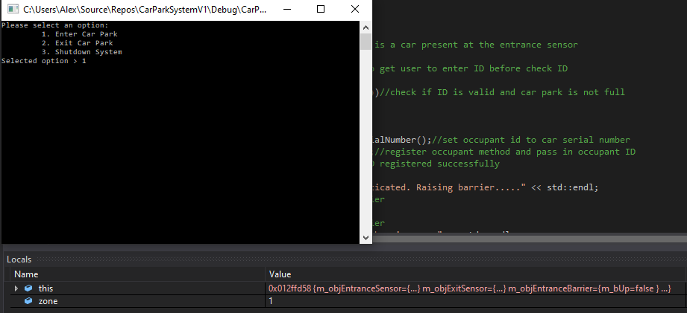

Test Schedule
Test No | Test Description | Expected Result | Actual Result | Pass/Fail
0002 | Test sensor class method carPresent returns true | Return true value after zone is set to 1 for operateEntranceZone method | Value returned true | Pass

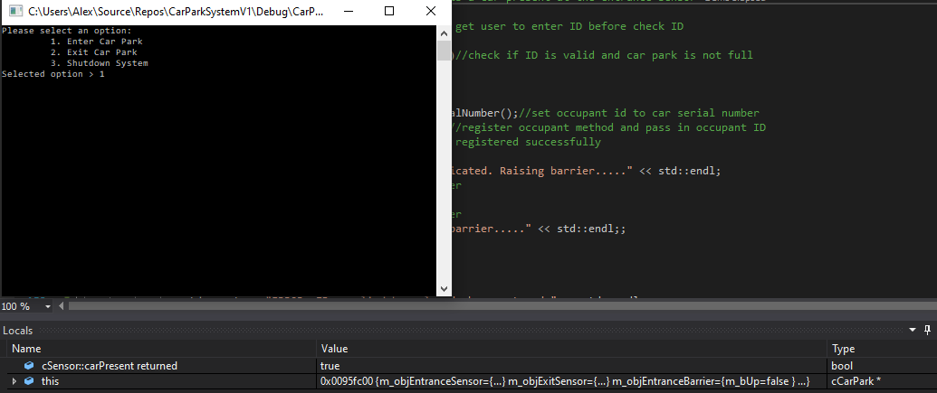

Test Schedule
Test No | Test Description | Expected Result | Actual Result | Pass/Fail
0003 | Test bar code class read() and stores number 41 in m_nSerial_Number variable | m_nSerial_Number=41 | m_nSerial_Number=41 | Pass

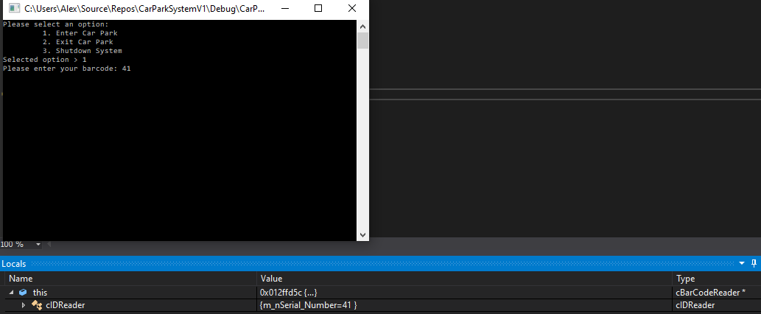

Test Schedule
Test No | Test Description | Expected Result | Actual Result | Pass/Fail
0004 | Test if the value 41 is valid ID > 40 && < 50 and there are spaces | Return true | Return true | Pass

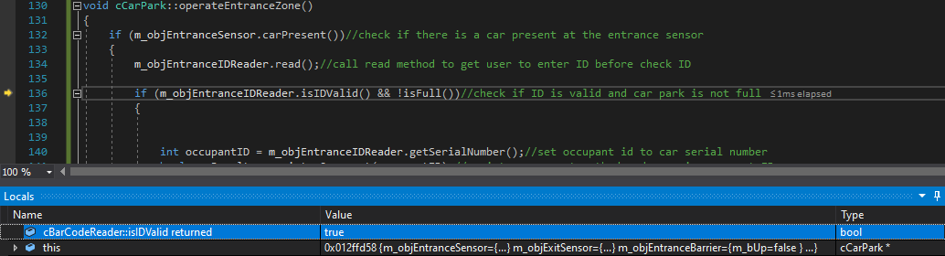

Test Schedule
Test No | Test Description | Expected Result | Actual Result | Pass/Fail
0005 | Test getSerialNumber method to get the number entered 41 and store in occupant id | occupant id = 41 | occupant id = 41 | Pass

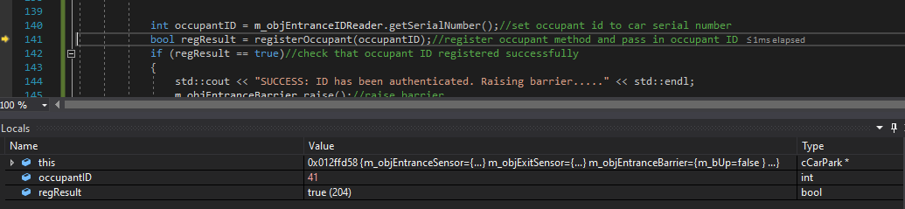

Test Schedule
Test No | Test Description | Expected Result | Actual Result | Pass/Fail
0006 | Test if the value 41 exists in vector if not add | 41 added at index 0 of vector | 41 added at index 0 of vector | Pass

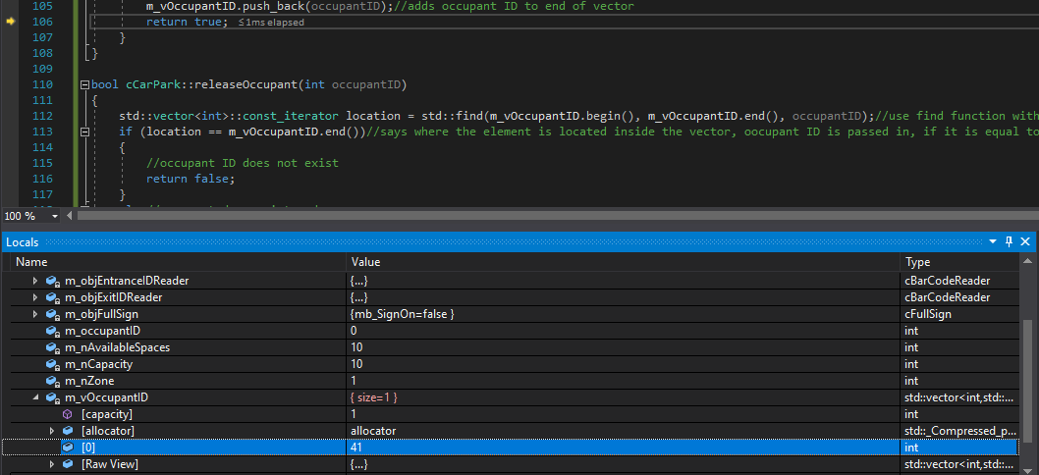

Test Schedule
Test No | Test Description | Expected Result | Actual Result | Pass/Fail
0007 | Test if the registration was a success and display message | Bool regResult returns true | Bool regResult returns true | Pass

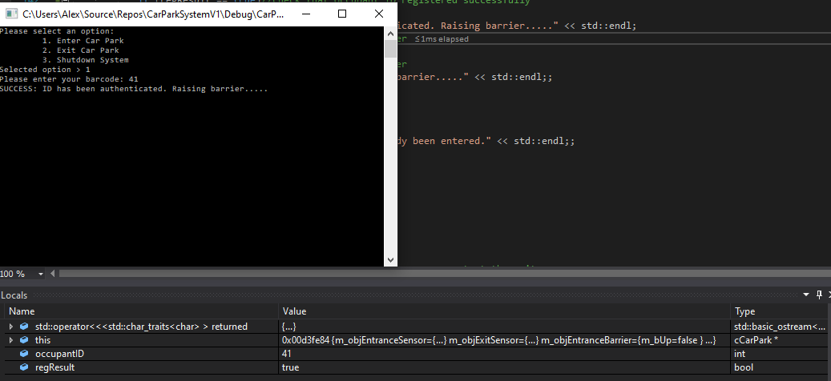

Test Schedule
Test No | Test Description | Expected Result | Actual Result | Pass/Fail
0008 | Test entry barrier class raise barrier method | m_bUp variable set to true | m_bUp variable set to true | Pass

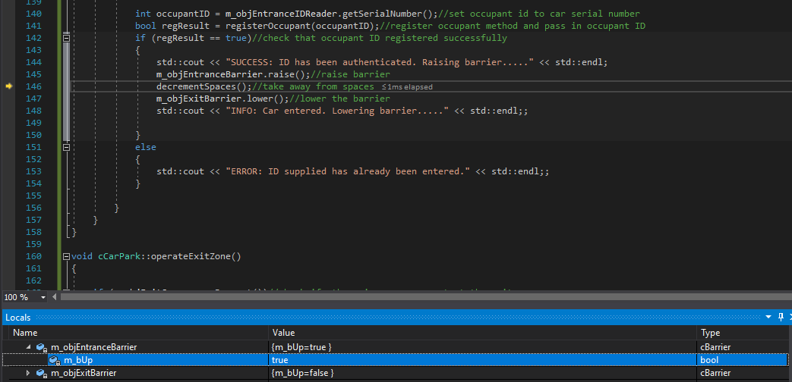

Test Schedule
Test No | Test Description | Expected Result | Actual Result | Pass/Fail
0009 | Reduce spaces by one as car has entered | Available spaces now 9 capacity set to 10 initially | Available spaces now 9 capacity set to 10 initially | Pass

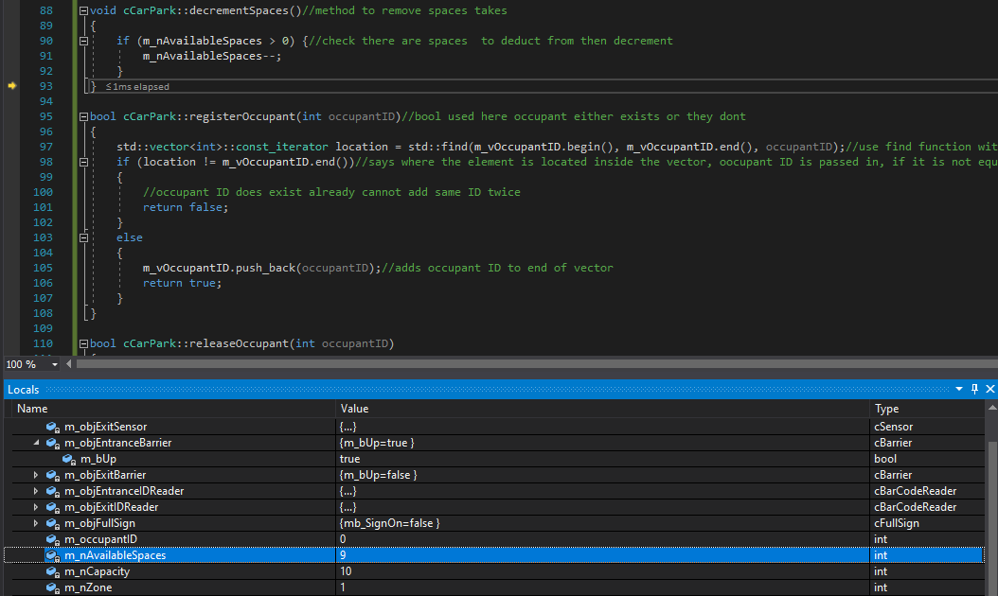

Test Schedule
Test No | Test Description | Expected Result | Actual Result | Pass/Fail
0010 | Test entry barrier class lower barrier method then display message | m_bUp variable set to false | m_bUp variable set to false | Pass

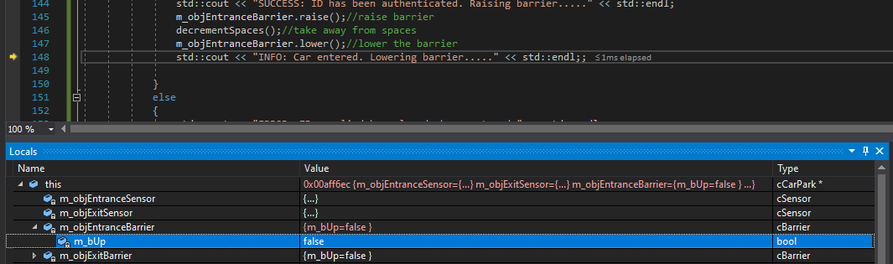
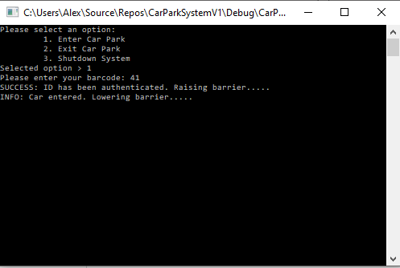

Test – Car exits Car Park
Test No | Test Description | Expected Result | Actual Result | Pass/Fail
0001 | Test correct zone applied for enter car park after user enters 2 | Pass choice correctly to set zone value to 2 for exit | Zone value set to 2 | Pass

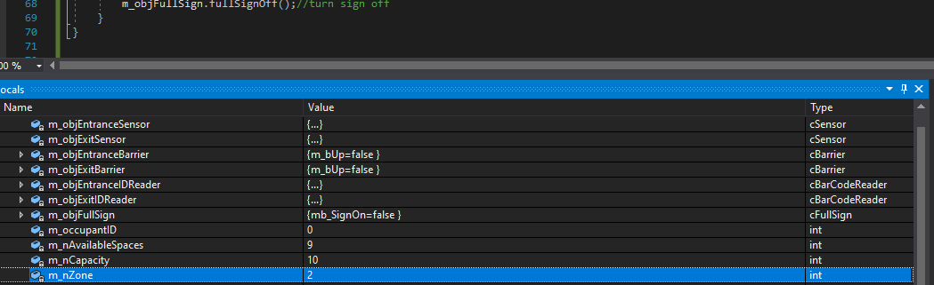

Test Schedule
Test No | Test Description | Expected Result | Actual Result | Pass/Fail
0002 | Test sensor class method carPresent returns true | Return true value after zone is set to 2 for operateExitZone method | Value returned true | Pass

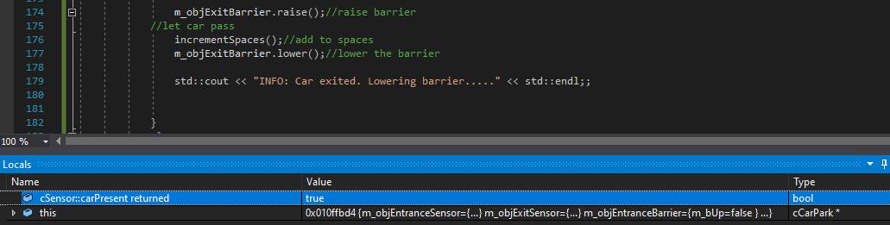

Test Schedule
Test No | Test Description | Expected Result | Actual Result | Pass/Fail
0003 | Test bar code class read() and stores number 41 in m_nSerial_Number variable on exit | m_nSerial_Number=41 | m_nSerial_Number=41 | Pass

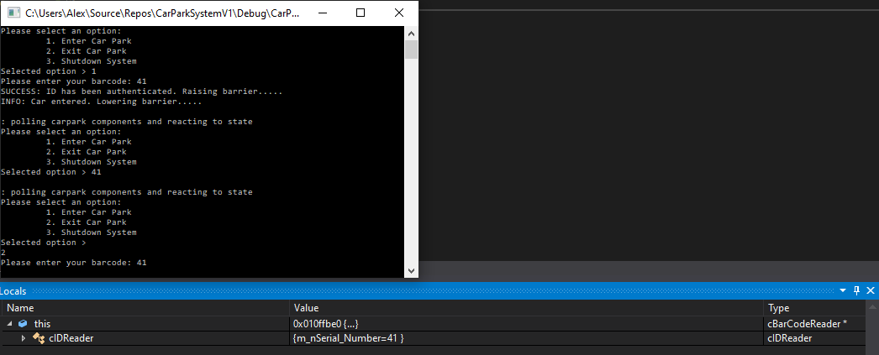

Test Schedule
Test No | Test Description | Expected Result | Actual Result | Pass/Fail
0005 | Test getSerialNumber method to get the number entered 41 and store in occupant id | occupant id = 41 | occupant id = 41 | Pass

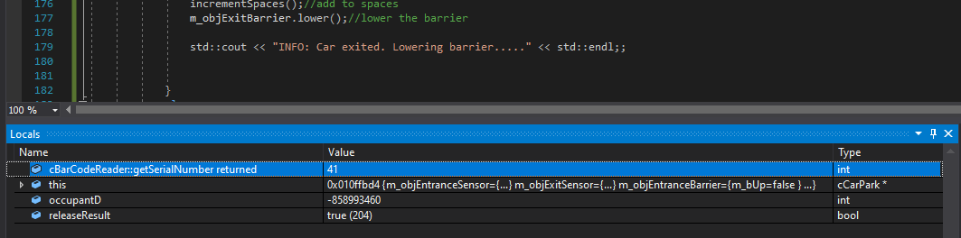

Test Schedule
Test No | Test Description | Expected Result | Actual Result | Pass/Fail
0006 | Test the iterator location can find value 41 in system before it erases | Location ={41}  occupant id = 41 | Location ={41}  occupant id = 41 | Pass

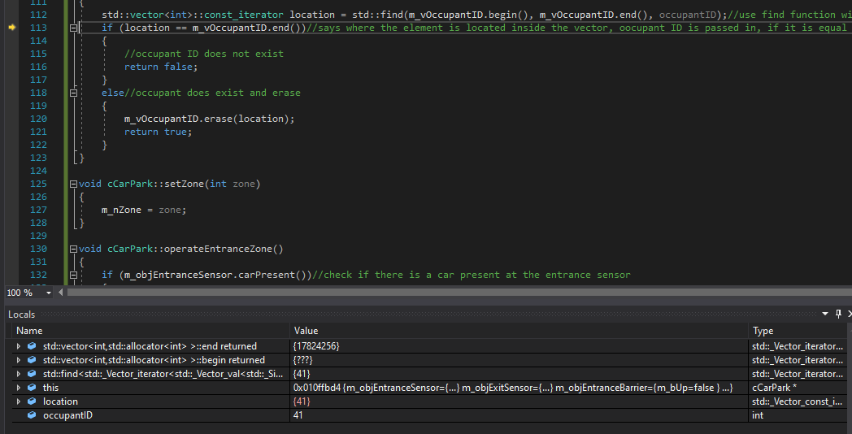

Test Schedule
Test No | Test Description | Expected Result | Actual Result | Pass/Fail
0007 | Test to check element successfully removed from vector | m_vOccupantID  size = {0} | m_vOccupantID  size = {0} | Pass

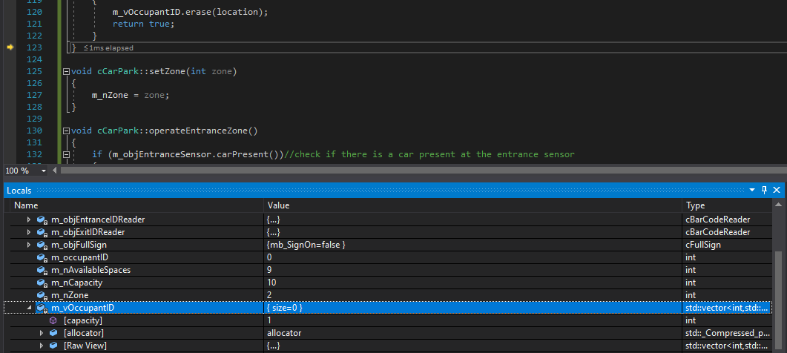

Test Schedule
Test No | Test Description | Expected Result | Actual Result | Pass/Fail
0008 | Test release result returns true display message | m_vOccupantID  size = {0} | m_vOccupantID  size = {0} | Pass

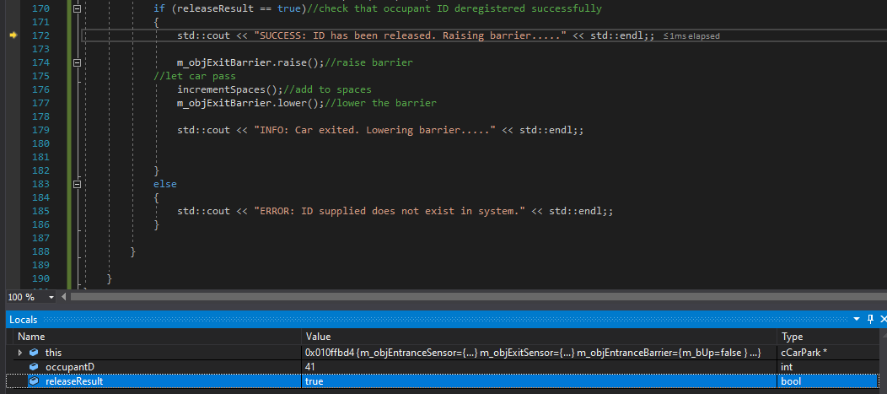
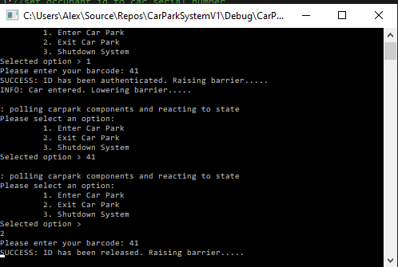

Test Schedule
Test No | Test Description | Expected Result | Actual Result | Pass/Fail
0009 | Increase spaces by one as car has exited | Available spaces now set back to 10 | Available spaces now set back to 10 | Pass

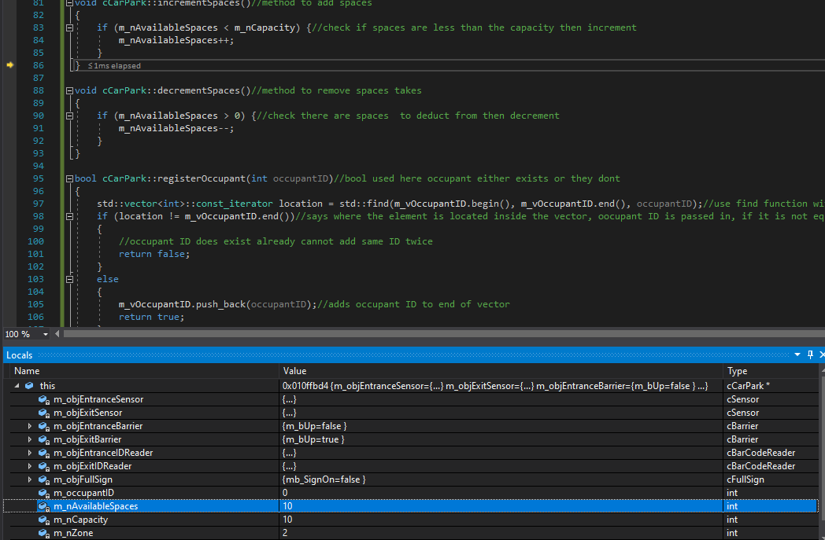

Test Schedule
Test No | Test Description | Expected Result | Actual Result | Pass/Fail
0010 | B_Up variable set to false barrier lowered upon exit and display message | m_Bup = false | m_Bup = false | Pass

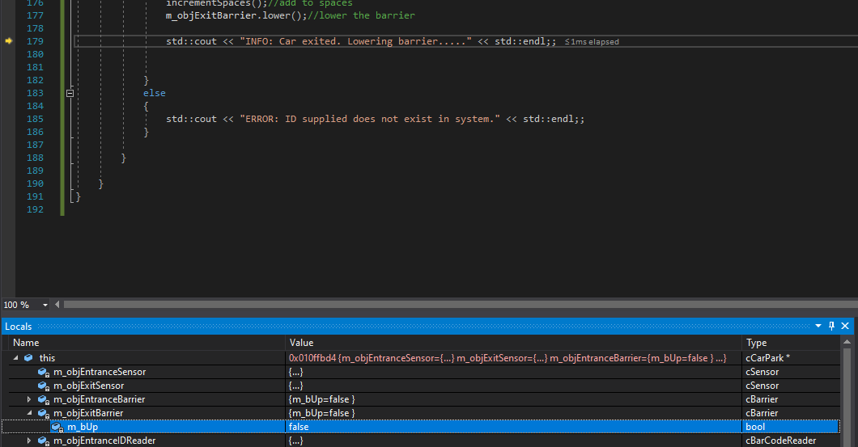
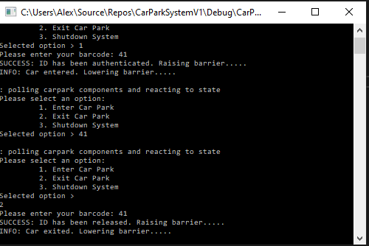

Test Schedule
Test No | Test Description | Expected Result | Actual Result | Pass/Fail
0011 | Test isFull method | isFull = false | isFull = false | Pass

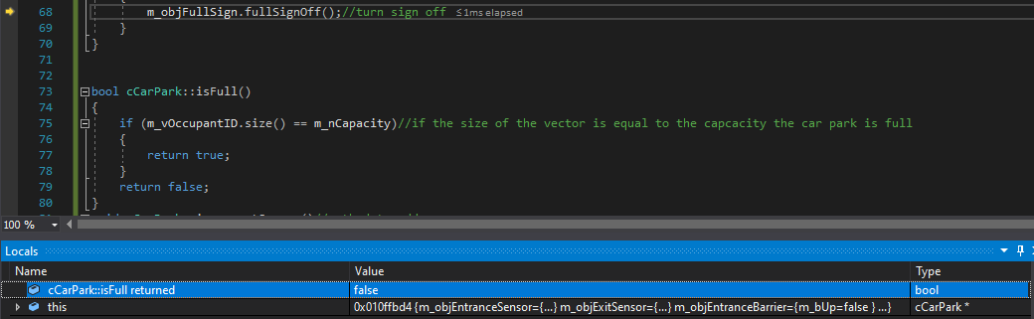

Test Schedule
Test No | Test Description | Expected Result | Actual Result | Pass/Fail
0012 | Exit program by selecting 3 as the choice | choice = 3 | choice = 3 | Pass

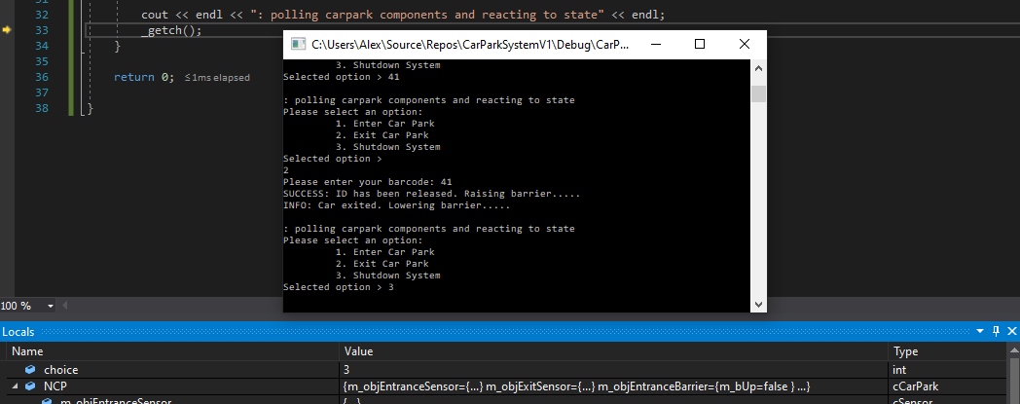

Test - Error Checking

Test Schedule
Test No | Test Description | Expected Result | Actual Result | Pass/Fail
0013 | Test ID 41 already entered into system | regResult returns false | regResult returns false | Pass

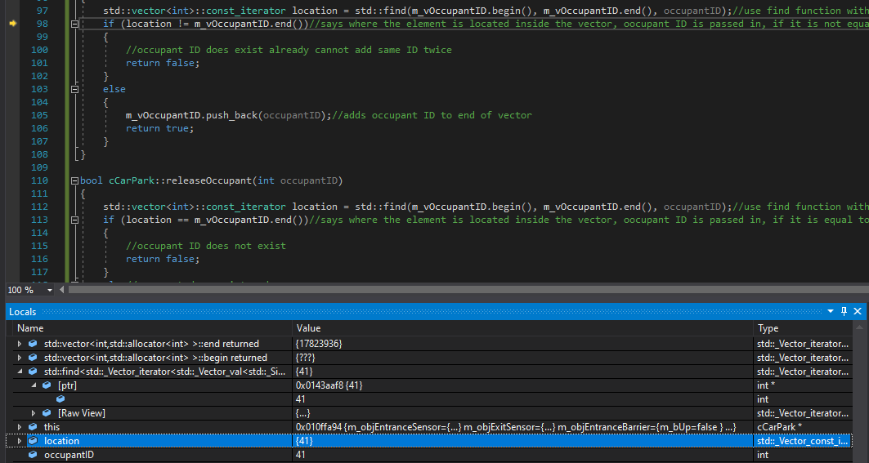
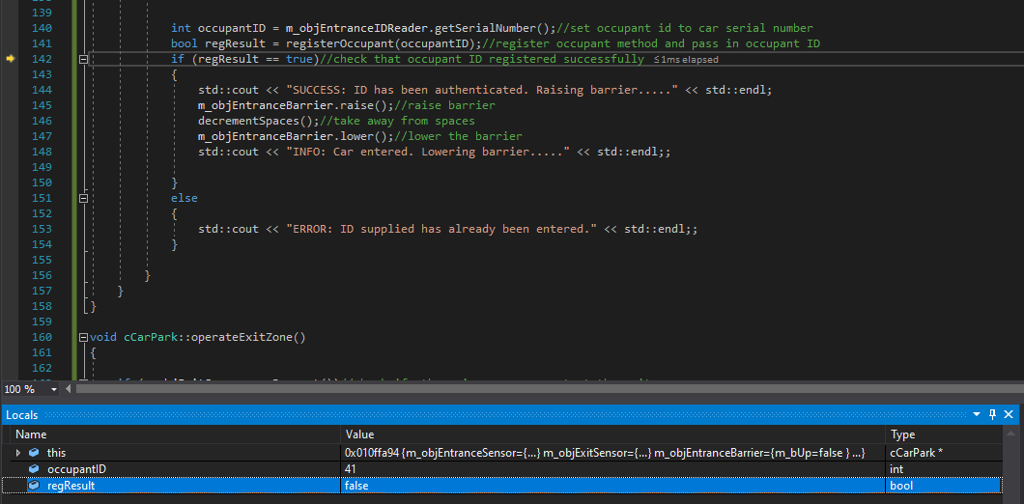
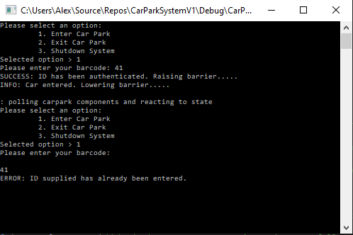

Test Schedule
Test No | Test Description | Expected Result | Actual Result | Pass/Fail
0014 | ID 42 does not exist in system | releaseResult returns false | releaseResult returns false | Pass

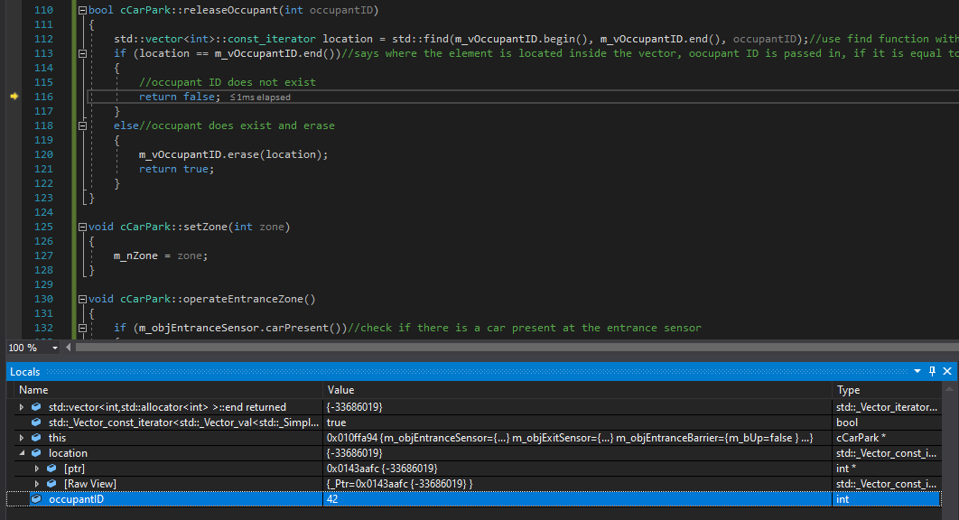
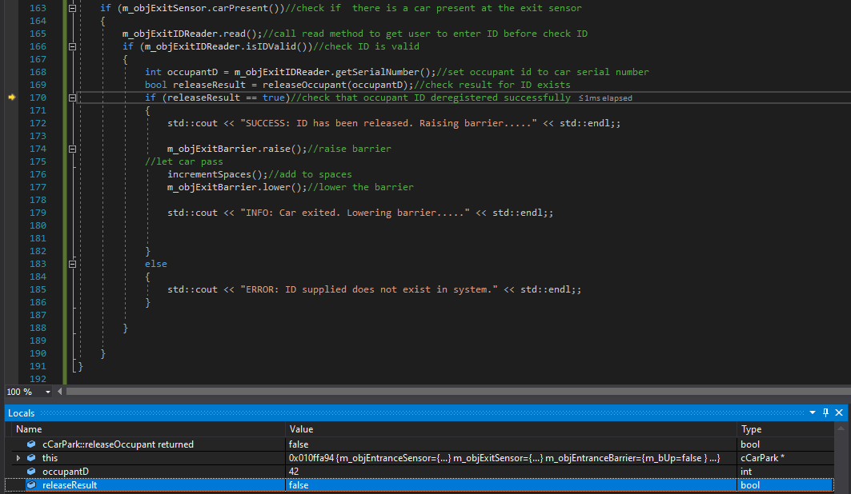
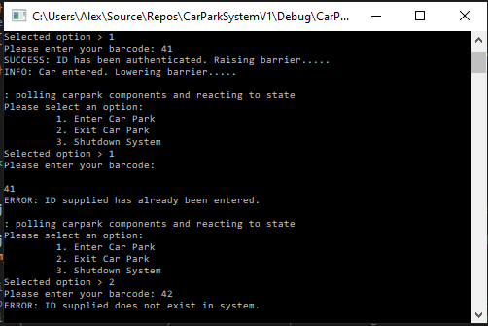

Test – Capacity

Test Schedule
Test No | Test Description | Expected Result | Actual Result | Pass/Fail
0001 | Capacity equal to size of vector switch full sign on, capacity set to 1 for test | isFull returns true | isFull returns true | Pass

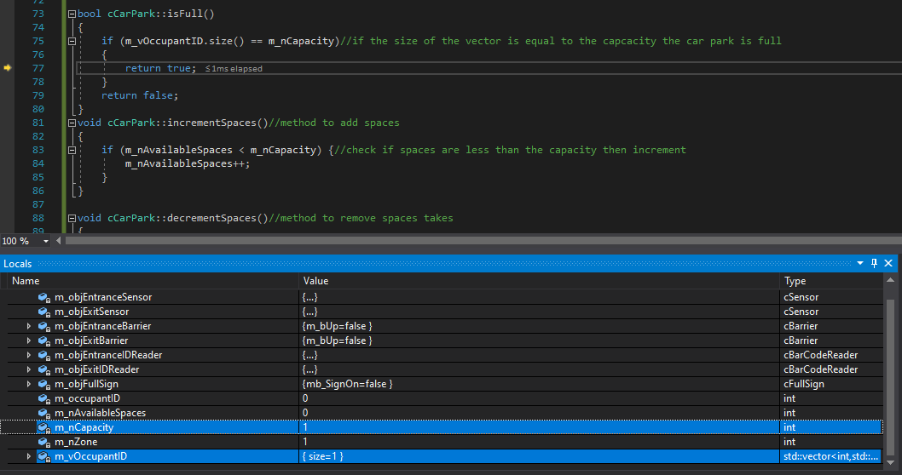

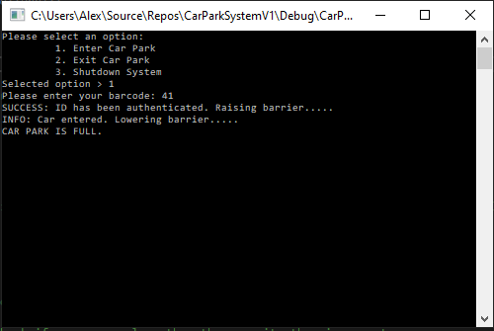

Code Instructions
- Click main.cpp add pass in parameter for capacity to NCP object of car park class
- Select 1 to enter car park and register car
- Barcode reader is set to except numbers greater than 40 and less than 50
- Enter 41 press return
- When “polling components…..” comes up on screen press a key
- Takes you back into menu select 1 to enter another car or 2 to exit
- If exit selected enter ID set initially e,g 41 or to test another out of range number
- Car has now exited
- To quit system select 3

References

[1] | D. &. Dietel, “Composition,” in How to program C++, New Jersey, Prentice Hall, 2000, pp. 462-463.
[2] | R. Hartley, “C++ Inheritance,” 2003. [Online]. Available: https://www.cs.nmsu.edu/~rth/cs/cs177/map/inheritd.html. [Accessed 30 January 2021].
[3] | D. Bolton, “Definition of Encapsulation in Computer Programming,” 10 February 2019. [Online]. Available: https://www.thoughtco.com/definition-of-encapsulation-958068. [Accessed 1 February 2021].
[4] | D. &. Dietel, “Inheritance,” in How to program C++, New Jersey, Prentice Hall, 2000, pp. 580-581.
[5] | Tutorialspoint, “C++ Inheritance,” Tutorialspoint, [Online]. Available: https://www.tutorialspoint.com/cplusplus/cpp_inheritance.htm. [Accessed 1 February 2021].

Copy of code from project
Main.cpp
#include<iostream>
#include <conio.h>
#include"cCarPark.h"
using namespace std;

int main() {

cCarPark NCP(10);
//for (int i = 0; i < 2; i++)
while(true)

{
//menu
int choice = 0;
cout << "Please select an option: " << endl;
cout << "\t 1. Enter Car Park" << endl;
cout << "\t 2. Exit Car Park" << endl;
cout << "\t 3. Shutdown System" << endl;
cout << "Selected option > ";
cin >> choice;

if (choice == 3) //exit if user selects shutdown
{
break;//break out of loop
}

NCP.setZone(choice);//pass in choice to set zone
NCP.update();

cout << endl << ": polling carpark components and reacting to state" << endl;
_getch();
}

return 0;

}
Sensor.cpp
#include "Sensor.h"
#include "cSensor.h"

cSensor::cSensor()
{
}

cSensor::~cSensor()
{
}

bool cSensor::carPresent()
{
return true;
}

void cSensor::update()
{
}

Numberplatereader.cpp
#include "cNumberPlateReader.h"
#include<iostream>

cNumberPlateReader::cNumberPlateReader()
{
}

cNumberPlateReader::~cNumberPlateReader()
{
}

bool cNumberPlateReader::isIDValid()
{
//valid serial numbers for number plates are 20 - 30
if (m_nSerial_Number > 20 && m_nSerial_Number < 30)
{
return true;
}
else
{
std::cout << "Invalid number plate entered" << std::endl;
return false;
}
}

void cNumberPlateReader::read()
{
//std::cout << "Welcome to the Car Park" << std::endl;
std::cout << "Please enter your number plate: ";
std::cin >> m_nSerial_Number;
}

int cNumberPlateReader::getSerialNumber()
{
return m_nSerial_Number;
}

void cNumberPlateReader::update()
{
}
IDReader.cpp
#include "cNumberPlateReader.h"
#include<iostream>

cNumberPlateReader::cNumberPlateReader()
{
}

cNumberPlateReader::~cNumberPlateReader()
{
}

bool cNumberPlateReader::isIDValid()
{
//valid serial numbers for number plates are 20 - 30
if (m_nSerial_Number > 20 && m_nSerial_Number < 30)
{
return true;
}
else
{
std::cout << "Invalid number plate entered" << std::endl;
return false;
}
}

void cNumberPlateReader::read()
{
//std::cout << "Welcome to the Car Park" << std::endl;
std::cout << "Please enter your number plate: ";
std::cin >> m_nSerial_Number;
}

int cNumberPlateReader::getSerialNumber()
{
return m_nSerial_Number;
}

void cNumberPlateReader::update()
{
}
FullSign.cpp
#include "cFullSign.h"

cFullSign::cFullSign()
{
}

cFullSign::~cFullSign()
{
}

void cFullSign::fullSignOn()
{
mb_SignOn = true;
}

void cFullSign::fullSignOff()
{
mb_SignOn = false;
}

void cFullSign::update()
{

}

CarPark.cpp
#include <vector>
#include "cCarPark.h"
#include<iostream>

cCarPark::~cCarPark()
{
}
cCarPark::cCarPark(int capacity)//paremitzed constructor
{
m_nCapacity = capacity;//create variable for capacity
m_nAvailableSpaces = capacity;//set the available spaces to capacity
m_nZone = 1;//always at entrance zone
}

void cCarPark::update(void)
{

//Place your carpark update logic here.
//The pseudo code illustrates some of the actions required
// in conjunction with other classes and will need further refinement.

//1. poll car park components (sensor/etc).
//************************************************
//2. if car present at entrance then
//4. if ID valid && car park not full then
//5. raise barrier and let car pass
//6. update records and decrement spaces
//7. endif
//8. endif
//************************************************
//9. if car present at exit then
//10. raise barrier and let car pass
//11. update records and increment spaces
//12. endif
//************************************************
//13. if carpark full then
//14. turn on full sign
//14: else
//15. turn off full sign
//15. endif
//************************************************
//...and so on

if (m_nZone == 1)
{
operateEntranceZone();
}
else if(m_nZone == 2)
{
operateExitZone();
}

if (isFull())//call is full method
{
m_objFullSign.fullSignOn();//turn sign on if full
std::cout << "CAR PARK IS FULL." << std::endl;;

}
else
{
m_objFullSign.fullSignOff();//turn sign off
}
}

bool cCarPark::isFull()
{
if (m_vOccupantID.size() == m_nCapacity)//if the size of the vector is equal to the capcacity the car park is full
{
return true;
}
return false;
}
void cCarPark::incrementSpaces()//method to add spaces
{
if (m_nAvailableSpaces < m_nCapacity) {//check if spaces are less than the capacity then increment
m_nAvailableSpaces++;
}
}

void cCarPark::decrementSpaces()//method to remove spaces takes
{
if (m_nAvailableSpaces > 0) {//check there are spaces to deduct from then decrement
m_nAvailableSpaces--;
}
}

bool cCarPark::registerOccupant(int occupantID)//bool used here occupant either exists or they dont
{
std::vector<int>::const_iterator location = std::find(m_vOccupantID.begin(), m_vOccupantID.end(), occupantID);//use find function with vector to return location -
if (location != m_vOccupantID.end())//says where the element is located inside the vector, oocupant ID is passed in, if it is not equal to the end it doesn't exist in the vector
{
//occupant ID does exist already cannot add same ID twice
return false;
}
else
{
m_vOccupantID.push_back(occupantID);//adds occupant ID to end of vector
return true;
}
}

bool cCarPark::releaseOccupant(int occupantID)
{
std::vector<int>::const_iterator location = std::find(m_vOccupantID.begin(), m_vOccupantID.end(), occupantID);//use find function with vector to return location -
if (location == m_vOccupantID.end())//says where the element is located inside the vector, oocupant ID is passed in, if it is equal to the end it does not exist in the vector
{
//occupant ID does not exist
return false;
}
else//occupant does exist and erase
{
m_vOccupantID.erase(location);
return true;
}
}

void cCarPark::setZone(int zone)
{
m_nZone = zone;
}

void cCarPark::operateEntranceZone()
{
if (m_objEntranceSensor.carPresent())//check if there is a car present at the entrance sensor
{
m_objEntranceIDReader.read();//call read method to get user to enter ID before check ID

if (m_objEntranceIDReader.isIDValid() && !isFull())//check if ID is valid and car park is not full
{

int occupantID = m_objEntranceIDReader.getSerialNumber();//set occupant id to car serial number
bool regResult = registerOccupant(occupantID);//register occupant method and pass in occupant ID
if (regResult == true)//check that occupant ID registered successfully
{
std::cout << "SUCCESS: ID has been authenticated. Raising barrier....." << std::endl;
m_objEntranceBarrier.raise();//raise barrier
decrementSpaces();//take away from spaces
m_objEntranceBarrier.lower();//lower the barrier
std::cout << "INFO: Car entered. Lowering barrier....." << std::endl;;

}
else
{
std::cout << "ERROR: ID supplied has already been entered." << std::endl;;
}

}
}
}

void cCarPark::operateExitZone()
{

if (m_objExitSensor.carPresent())//check if there is a car present at the exit sensor
{
m_objExitIDReader.read();//call read method to get user to enter ID before check ID
if (m_objExitIDReader.isIDValid())//check ID is valid
{
int occupantD = m_objExitIDReader.getSerialNumber();//set occupant id to car serial number
bool releaseResult = releaseOccupant(occupantD);//check result for ID exists
if (releaseResult == true)//check that occupant ID deregistered successfully
{
std::cout << "SUCCESS: ID has been released. Raising barrier....." << std::endl;;

m_objExitBarrier.raise();//raise barrier
//let car pass
incrementSpaces();//add to spaces
m_objExitBarrier.lower();//lower the barrier

std::cout << "INFO: Car exited. Lowering barrier....." << std::endl;;

}
else
{
std::cout << "ERROR: ID supplied does not exist in system." << std::endl;;
}

}

}
}
Barrier.cpp
#include "cBarrier.h"

cBarrier::cBarrier()
{
}

cBarrier::~cBarrier()
{
}

void cBarrier::raise()
{
m_bUp = true;
}

void cBarrier::lower()
{
m_bUp = false;
}

void cBarrier::update()
{
}
BarCodeReader.cpp
#include "cBarCodeReader.h"
#include<iostream>

cBarCodeReader::cBarCodeReader()
{
}

cBarCodeReader::~cBarCodeReader()
{
}
bool cBarCodeReader::isIDValid()
{
//valid serial numbers for barcode reader are 20 - 30
if (m_nSerial_Number > 40 && m_nSerial_Number < 50)
{
return true;
}
else
{
std::cout << "Invalid bar code entered" << std::endl;
return false;
}
}

void cBarCodeReader::read()
{
//std::cout << "Welcome to the Car Park" << std::endl;
std::cout << "Please enter your barcode: ";
std::cin >> m_nSerial_Number;
}

int cBarCodeReader::getSerialNumber()
{
return m_nSerial_Number;
}
void cBarCodeReader::update()
{

}
Sensor.h
#pragma once
class cSensor
{
public:
cSensor();
~cSensor();
bool carPresent();
void update();
};

NumbePlate.h
#pragma once
#include "cIDReader.h"
class cNumberPlateReader :
public cIDReader//base class
{
public:

cNumberPlateReader();
~cNumberPlateReader();

bool isIDValid();//methods from base class
void read();
int getSerialNumber();
void update();

};

IDReader.h
#pragma once
class cIDReader
{
public:
cIDReader();
~cIDReader();
virtual bool isIDValid();//use virtual keyword for method allow access for child class numberplate reader
virtual void read();//method to read ID
void update();
virtual int getSerialNumber();
protected://protected used to enable inherited (child) classes to access variable
int m_nSerial_Number;
};

FullSign.h
#pragma once
class cFullSign
{
public:
cFullSign();
~cFullSign();

void fullSignOn();
void fullSignOff();
void update();
private:
bool mb_SignOn;
};

CarPark.h
#pragma once
#include<vector>
#include"cSensor.h"
#include"cBarrier.h"
//#include"cIDReader.h"
//#include"cNumberPlateReader.h"
#include"cFullSign.h"
#include"cBarCodeReader.h"
class cCarPark
{
public:
//cCarPark();//take out force entering capacity into object in main
~cCarPark();
cCarPark(int capacity);//paramaetized constructor
void update(void);//Update method public for system access
void incrementSpaces();//Increment spaces public for system access
void decrementSpaces();//Decrement spaces public for system access
bool isFull();//Method to check capacity size against vector size
bool registerOccupant(int occupantID);//method to store id in vector
bool releaseOccupant(int occupantID);//method to release id from vector
void setZone(int zone);
private:
void operateEntranceZone();//method for user to enter system
void operateExitZone();//method for user exit system

private:
cSensor m_objEntranceSensor;//instantiate object of the sensor class to enter car park
cSensor m_objExitSensor;//instantiate object of the sensor class to exit car park
cBarrier m_objEntranceBarrier;//instantiate object of the Barrier class to enter car park
cBarrier m_objExitBarrier;//instantiate object of the Barrier class to exit car park
//cIDReader m_objEntranceIDReader;//instantiate object of the ID Reader class
//cIDReader m_objExitIDReader;//instantiate object of the ID Reader class
//cNumberPlateReader m_objEntranceIDReader;//instantiate object of the number plate reader child class
//cNumberPlateReader m_objExitIDReader;//instantiate object of the number plate reader child class
cBarCodeReader m_objEntranceIDReader;//instantiate object of the number plate reader child class
cBarCodeReader m_objExitIDReader;//instantiate object of the number plate reader child class

cFullSign m_objFullSign;//instantiate object of the full sign class

int m_occupantID;//declare data members private not accessible
int m_nAvailableSpaces;
int m_nCapacity = 50;//set default capacity to 50
int m_nZone;
std::vector<int> m_vOccupantID;//create vector to store ID

};

Barrier.h
#pragma once
class cBarrier
{
public:
cBarrier();
~cBarrier();

void raise();//methods to raise and lower carrier
void lower();
void update();
private:
bool m_bUp;//up data member for method
};

BarcCodeReader.h
#pragma once
#include "cIDReader.h"
class cBarCodeReader :
public cIDReader
{
public:
cBarCodeReader();
~cBarCodeReader();

bool isIDValid();//methods from base class
void read();
int getSerialNumber();
void update();
};

