ACBA5001 PROJECT PLANNING FOR CONSTRUCTION

MANAGEMENT AND QUALITY MANAGEMENT IN CONSTRUCTION

QUALITY ASSURANCE AND QUALITY CONTROL FOR EFFECTIVENESS IN CONSTRUCTION AND MANAGEMENT

kERRI FARMER – 2100037

INDEX

INTRODUCTION PG. 3
what is quality in construction
QUALITY ASSURANCE PG. 4
THE NEED FOR QUALITY ASSURANCE IN CONSTRUCTION
quality assurance in the construction industry
QUALITY CONTROL PG. 5
The need for quality control in construction
quality CONTROL in the construction industry
total quality management PG. 9
CONCLUSION PG. 10
REFERENCES PG. 12

INTRODUCTION

QUALITY ASSURANCE AND QUALITY CONTROL FOR EFFECTIVENESS IN CONSTRUCTION AND MANAGEMENT

Defining these statements will allow for a better understanding as to what each of these processes or procedures do and, how these two concepts operate in the construction industry, the need for Quality Assurance and Quality Management systems in the construction sector, how to manage construction quality and assurance and conclude with how effective these systems in place are in a construction project and why, using a Total Quality Management (TQM) approach can ensure organisations are less likely to fail and hand over substandard projects as opposed to not using any quality management system.
The definition of Quality Assurance in construction is. “Quality assurance is a method of avoiding potential mistakes in a construction project by creating ‘rules’ about minimum quality while ensuring all decisions meet these standards.”(Harenberg, 2022)
Quality Control can be defined in construction as. “Construction quality control is a management system aimed at ensuring the final deliverable meets the standards and guidelines set by the client”(Buma, 2021)
Quality Assurance as mentioned above is based on a prevention strategy when putting into place a Quality Assurance system into the construction process or project while, Quality Control is more focused on identification of issues going wrong on a construction project and working to fix them.
Quality Assurance is all in the preparation, prior to construction, this ensures that the decision making prior and throughout the process is correct by ordering the correct materials for a construction project and ensuring you know what you are getting. By setting out these standards Quality Assurance is met, and Quality Control is checking the standards are met. (Harenberg, 2022)
ISO 9000 is the family of standards ‘Quality Management Systems’ set out for all organisations across the globe to improve their quality of their products and services, it can also be used by any organisation regardless of their size, it has a very strong customer focus, laying out Quality Management principles. (ISO,n.d)
ISO 9001:2015 is the international standard that sets out the specific requirements for a Quality Management System (QMS). (ASQ, n.d)

WHAT IS QUALITY IN CONSTRUCTION?
Quality in construction can be determined by no defects, getting it right the first time, completing the project build on time and within the budget, using innovative systems of work, little waste, design accurately the first time and using materials that meet a certain standard along with the work produced being of quality (trained operatives.) This then ensures that the total package exceeds the customer expectations, therefore reducing after sales costs. (Croner-I, 2019)
The concept of quality in this report is defined as the compliance of a requirement that creates value for money, customer satisfaction, and fitness for purpose. (Ashford, 1990, p. 1)

quality assurance
The definition of quality assurance is. “Quality assurance is a method of avoiding potential mistakes in a construction project by creating ‘rules’ about minimum quality while ensuring all decisions meet these standards.” (Harenberg, 2022)
THE NEED FOR QUALITY ASSURANCE IN CONSTRUCTION
There has been a lot of research over the years with pinpointing the source of failure in the construction industry. With many sharing different views and disagreements on where failure lies and with who blame ultimately sits. It is recognised though, that the major sources of cost related error lay within the design team and construction management.
- Mismanagement of designers where calculations are produced, leading to major changes in construction detail and variations.
- Incorrect specifications at tender stages.
- No clear definition and responsibility allocations to management and construction teams, such as contractors and office staff on site.
- Poor communication leading to confusion and cost related delays.
- Inadequate training of labour on site.
- Verification routines not in place to ensure all meet the specified requirements.
Time is the biggest thief of quality in construction projects. Quality Assurance tries to set out proper pre-planning thought into what needs to be achieved in a construction project. (Thorpe & Sumner, 2017)
quality assurance in the construction industry
Quality Assurance is a formal means of control, therefor allows with various audits within their assurance systems of a company evidence that all assurances are being applied. (Duncan, et al., 1990)
Most construction companies tend to be forced into applying Quality Assurance to ensure they don’t lose their competitiveness and to win tenders. As during the tender stages, they could be requested to provide evidence of their Quality Assurance operations.
A Quality Assurance system can be effective as the realisation of getting things done properly, on time and within budget are much greater when there is a proper management and control system in place. (Duncan, et al., 1990, p. 39)
Every industry and even more so the construction industry communication is the key to each department within an organisation as well as each individual. Not communicating effectively will ensure failure right from the start. Calculations need to be accurate, and documents clear and unambiguous. Therefor formalising all types of communication within the construction industry among the various professionals ensures effective communication. The main cause of disasters in construction projects have been down to lack of formal training, and inadequacy of those in charge of key responsibilities. Thus, having a Quality Assurance system in place requires training policies in place for all levels and members of staff. This means qualified and competent staff to handle each activity. Quality Assurance system in place also ensures that all levels of staff are clear on their responsibilities and their limits within the construction project.
From the design stages a Quality Assurance system and policy in place ensures that there are formal records, that are accurate and clear are kept through design and archived once completed. (Duncan, et al., 1990, pp. 10 - 13)

QUALITY CONTROL
Quality Control can be defined in construction as. “Construction quality control is a management system aimed at ensuring the final deliverable meets the standards and guidelines set by the client” (Buma, 2021)

THE NEED FOR QUALITY CONTROL IN CONSTRUCTION
Controlling the quality of a small business is a lot easier as a single person can observe and check on the organisations entire workforce and work being produced. However, in larger organisations it becomes a lot more difficult, therefore it is common practice for organisations to have policies and procedures in place to ensure quality control is managed. At this point responsibility gets delegated amongst responsible managers and various staff to handle different areas of work. It is also at this point management needs definitive policies and procedures in place that establish the organisations’ objectives.
It is vital that management in control of quality have authority to reject work that is not meeting qualities set out and prevent this from happening again. (Thorpe & Sumner, 2017)
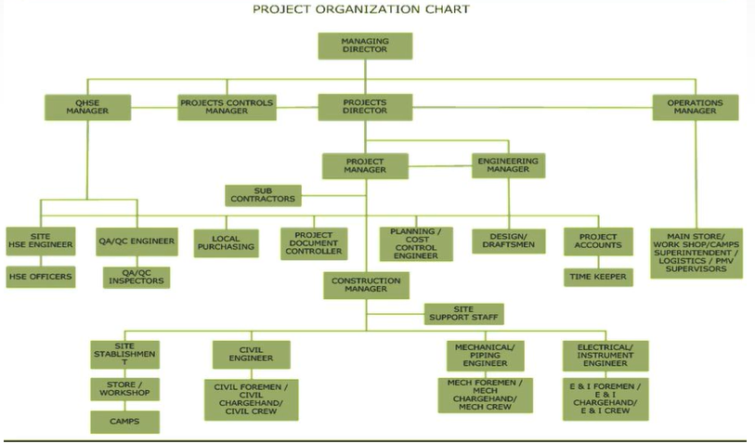
Image 1 Typical Construction Project Organisation Chart (Slide Player, n.d)

quality CONTROL in the construction industry
Managing the quality of work on a construction site is usually completed in three stages.
- Planning of the work to be done
- Controlling and the execution of the planned work
- Verification of the work carried out in accordance with the plan

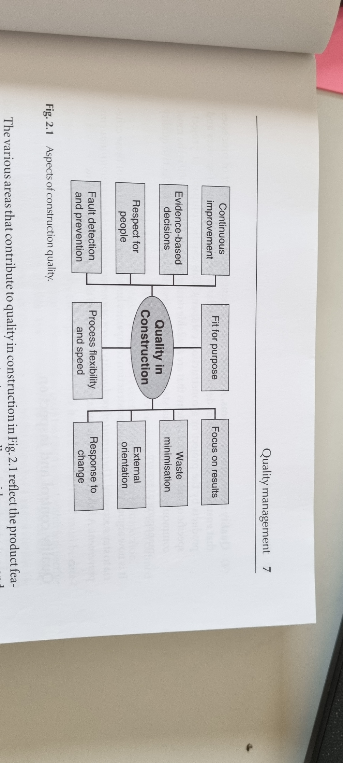
Image 2 Construction Quality, these are the features and processes that affect construction quality and organisation. A construction companies’ quality is not seen as one single thing on its own but more as an industry standard that compare against their competitors. (Harris & McCaffer, 2006, p. 7)
Implementing quality control in construction is based on two documents produced prior to construction project taking place, these are Specifications and Contract drawings, these determine the quality required in any construction project.
As a construction project has no physical fixed timings and boundaries in the entire process and each project varies in all aspects, the timing of inspections cannot be pre-planned. Therefor all quality inspections take place as each sub operation and operation is completed, mostly as a visual inspection ensuring compliance with the set-out specification and contract drawings mentioned earlier. There are however some quality inspections that can be completed by testing for example strength testing of concrete, checking brickwork alignment and service installations.
With every testing and system in place, there is always a chance for weakness. The mentality and culture developed in the construction industry by contractors tends to be on setting their standards of work to ‘get past the inspector’ This can be an expensive task if re-work needs to be completed. Therefor giving all the contractors, engineers, and operatives clear standards and understanding of the quality to be reached this then leads to getting it done right the first time, you can self-regulate the work completed with self-inspections. (Harris & McCaffer, 2006, pp. 9 - 11)
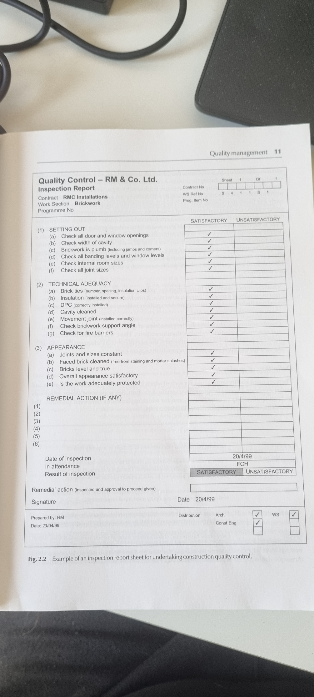
Image 3 Inspection Report Sheet for Quality Control Example (Harris & McCaffer, 2006, pp. 9 -11)
ISO/TS 9002:2016 Quality management systems – guidelines for the application of ISO 9001:2015 is the guidelines for Quality Assurance in production, servicing, and installation, this would apply to many construction contractors, where evidence of inspections, and tests, during the construction process takes place to ensure quality control and client objectives are met. ISO 9004:2018 Quality of an organisation – Guidance to achieve sustained success. (ISO, n.d)

total quality management - tqm
Total Quality Management in a general term for all industries and organisations can be described as “a management approach to long-term success through customer satisfaction. In a TQM effort, all members of an organization participate in improving processes, products, services, and the culture in which they work.” (ASQ, n.d)
There are in essence five core principles for Total Quality Management.
- Intensely customer focused
- Continuous improvement
- Quality improvement
- Accurate measurement
- Empowerment of all employees

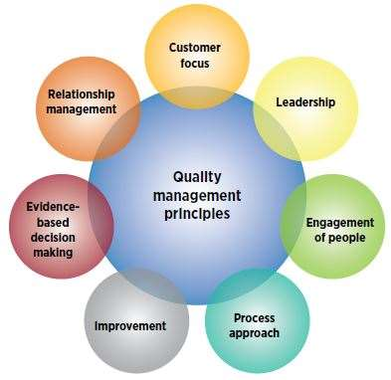
Image 4 The Seven Principles of ISO 9001:2015 (ASQ, n.d)

Total Quality Management encourages every person or organisation involved in a project to contribute effort into the entire process and improvement of quality and service. This also includes professionals outside the control of the organisation when it comes to the construction sector for instance, Architects, Surveyors, and suppliers of materials. (Steven, 1998)

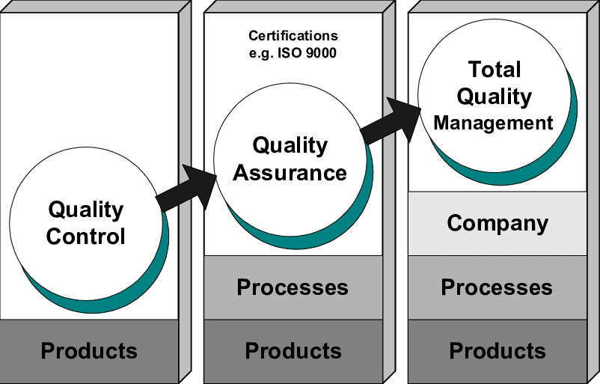
Image 5 The evolution toward TQM Total Quality Management (Mangelsdorf, 1999)

conclusion
In the construction industry it is vital to ensure the product is fit for purpose, completed on time and within budget as well as without defects to ensure customer satisfaction and quality. By using the systems and methods such as Quality Control, Quality Assurance, and a Total Quality Management approach. Total Quality Management approach needs to be lead from senior management and create the culture within the organisation.
Quality Assurance focuses mainly on the prevention of defects and being proactive with a process-based approach to manage assurance. Quality Control’s main objectives and focus is on the identification of defects and is more of a reactive approach to quality with the base of control being on the product. Quality assurance manages quality and Quality Control verifies the quality.
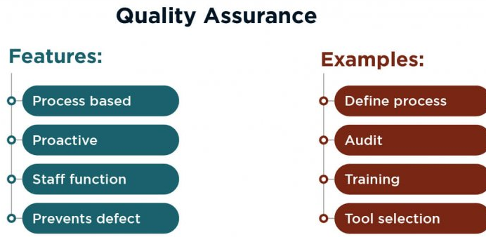
Image 6 Quality Assurance Preventative Proactive Approach (Yusov, n.d)

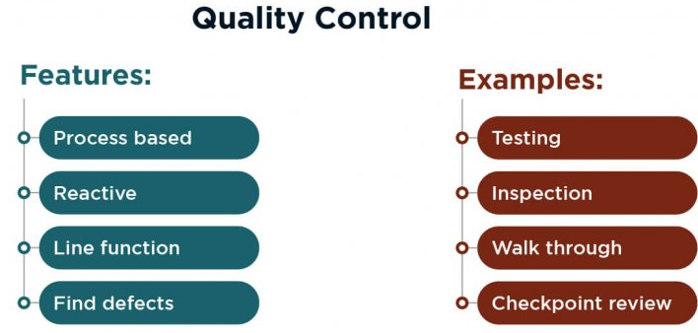
Image 7 Quality Control Reactive Identification Approach (Yusov, n.d)
In the construction industry Total Quality Management ensures quality and productivity. The advantages completely out way the disadvantages of TQM.
ADVANTAGES | DISADVANTAGES
- Lower costs  - Good reputation  - Customer satisfaction  - Employee engagement and morale  - High productivity  - Increased profits  - Job security  - Innovative and improved processes | - Resistant to change  - Time consuming
(ASQ, n.d)

All construction projects are a balance of COST – TIME – QAULITY therefor implementing a Total Quality Management system in an organisation ensures that quality and control is of the utmost importance.

references

Duncan, J., Thorpe, B. & Summer, P., 1990. The State of the Art. In: Quality Assurance In Construction. Aldershot: Gower Publishing Company Limited, p. 10.
Harris, F. & McCaffer, R., 2006. Quality Management. In: n/a, ed. Modern Construction Management. Oxford: Blackwell Publishing, p. 7.
Mangelsdorf, D., 1999. Evolution from quality management to an integrative. The TQM Magazine, 11(6), pp. 419 - 424.
Steven, M., 1998. Total Quality Management. In: Quality Improvement Techniques In Construction. Berkshire: Englemere Limited, pp. 13 - 14.
ASQ, n.d. Learn About Quality. [Online]
Available at: https://asq.org/quality-resources/iso-9001
[Accessed 9 November 2022].
Buma, R., 2021. Project Manager. [Online]
Available at: https://www.projectmanager.com/blog/construction-quality-control
[Accessed 25 October 2022].
Harenberg, M., 2022. Planradar. [Online]
Available at: https://www.planradar.com/gb/quality-assurance-in-construction-5-golden-rules-saving-money/#:~:text=What%20is%20quality%20assurance%20in,all%20decisions%20meet%20these%20standards.
[Accessed 25 October 2022].
ISO, n.d. ISO 9000 Family Quality Management. [Online]
Available at: https://www.iso.org/iso-9001-quality-management.html
[Accessed 11 November 2022].
Slide Player, n.d. Project Organisation. [Online]
Available at: https://slideplayer.com/slide/8841013/
[Accessed 29 October 2022].
Yusov, K., n.d. Qualit Assurance vs Quality Control. [Online]
Available at: https://jelvix.com/blog/quality-assurance-vs-quality-control
[Accessed 11 November 2022].

