Name: Tasmia Begum
Student Number: 2129438
Module Number: LCHS4005
Module Name: Professional Careers Development in Health and Social Care.
Lecturer Name: Farah Islam.
Assignment Title: Personal Development Portfolio.

Curriculum Vitae

Tasmia Begum
19, Chestnut Road
Moseley
B13 9AJ
E-Mail: tbegum8880@gmail.com
I am a hardworking housewife and dedicated mother of four children. I am excellent at organising and prioritising tasks, to ensure they are completed on schedule. I am a good listener and enjoy meeting new people in different situations. I look forward to challenges and enjoy resolving problems. I enjoy gardening, embroidery, and sewing and gain satisfaction from creating small projects at home.
Qualifications
GCSE at Swanshurst Girls School 1991- 1996.
Subject. Grade
English Language B
English Literature B
Maths B
Science (double award) B and B
R.E. A*
French A
History A
Business Studies A
Health and Social Care Level 4 from April 2022 till March 2023 at UWTSD Birmingham Campus
Results Pending

Work Experience
In Year 10 at Swanshurst School, I did work experience as a Classroom Assistance at Kings Heath Junior School, for Year 1 and 2 children, for 2 weeks in 1995. I helped set up and lead activities independently and thoroughly enjoyed it. I also helped the playtime and lunchtime supervisors by organising games/ activities to occupy the children positively in the playground.
For the last 2 years, I have volunteered as a helper at RB Childminders in Sparkhill. I have helped set up and tidy up activities for children 2 years old and above, giving me an insight into the planning and organisation skills for these activities. Reference available on request.
Skills
I enjoy meeting and interacting with new people and helping in whatever way is relevant to the task. I have learned how to send and reply to E-mails and maintain a professional tone when answering telephone calls and sending letters. My Level 4 course in Health and Social Care has taught me a lot about the NHS and the various skills required in this field, especially interpersonal and social skills, and how best to communicate with various individuals according to their needs. I have worked with different groups from varied backgrounds within my course and enjoy learning about other peers’ viewpoints and learning to listen actively. I have also gained a lot of new IT computer skills during my studies. I have learned how to format Word, Excel, and PowerPoint documents for my assignments. I have learned how to critically analyse different problems and situations and apply these solutions, as well as how to take criticism constructively. The Level 4 course has taught me how to self-reflect and encouraged me to actively think about my progression in this field of work. It has also taught me the value of coaching and mentoring in this sector, and how important it is to have goals to develop myself as a future professional in Health and Social Care. I have learned how to manage my time wisely, with studying and research as well as other commitments, to meet assignment deadlines and present PowerPoint presentations. I have also learned how to attend meetings in Teams for lectures online.
Hobbies/ Interests
I enjoy keeping fit and healthy at the gym and going for a workout. I like gardening, sewing, and embroidery in my spare time. I love meeting new people and learning new skills. I have gained a wide variety of IT and communication skills through my recent Level 4 course in Health and Social Care. I enjoy new challenges and working with the resources available for the best possible solution for them.

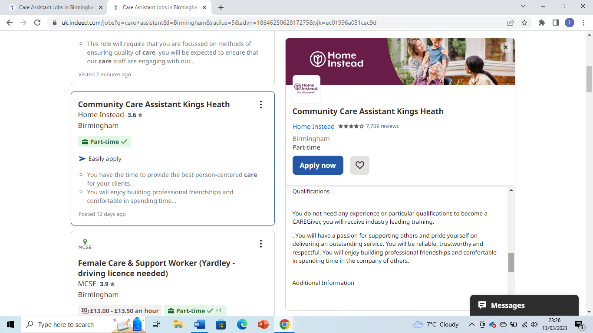
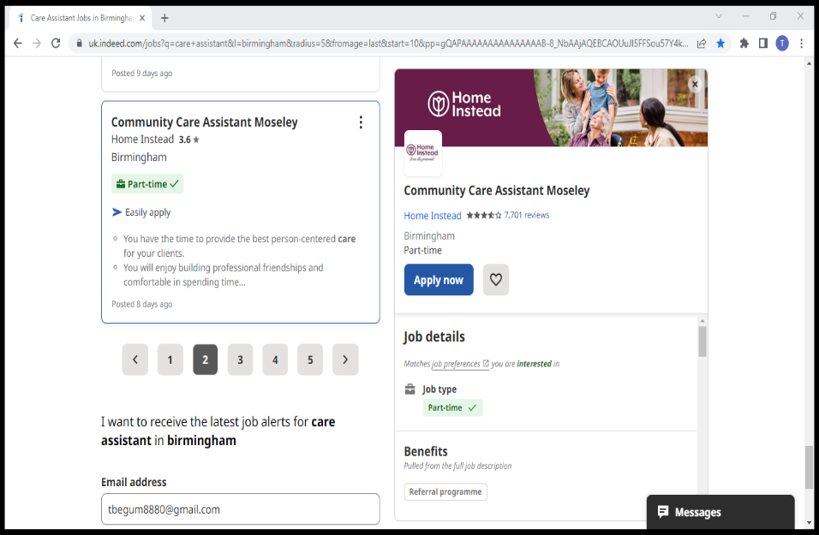
Screenshot of Job Advertisement
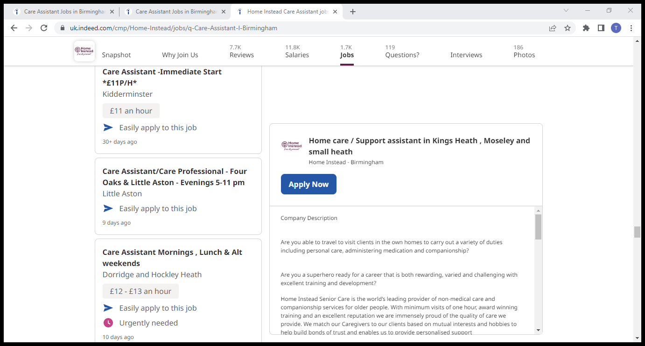
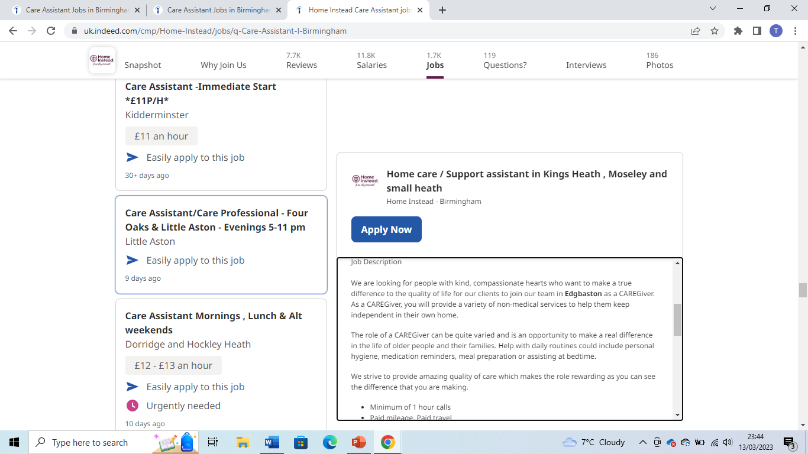

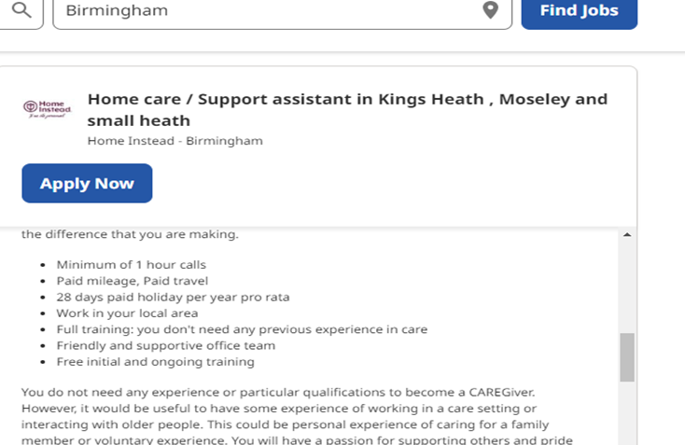

Cover Letter
Home Instead Senior Care Tasmia Begum
66-68 Radclyffe House, 19, Chestnut Road,
Hagley Road, Moseley,
Edgbaston Birmingham,
Birmingham B13 9AJ.
B16 8PF.
E-Mail: info.edgbaston@homeinstead.co.uk.
14th March 2023.
Dear Sir/ Madam,
I am writing to apply for the job role of Care Assistant in the Moseley/ Kings Heath/ Small Heath areas in Birmingham, as advertised on the Indeed website on the above date.
I am interested in applying for this job, as it is something that I feel I would enjoy making a positive difference in someone else’s life. I have almost completed my Level 4 in Health and Social Care at the University of Wales Trinity St. David on their Birmingham campus and feel this would be an excellent start to a fruitful and satisfying career in this field.
I have personal experience at home caring for my family, especially my husband, who has a long-term chronic condition making it difficult for him to sometimes carry out his daily tasks, with which I then help him as well as ensure that he has taken his medication at the right times and the correct doses. In this way, I feel I have some experience to be able to carry out the tasks required in this job. I find it rewarding and satisfying to help another person in this way and I hope to continue to do so if I am successful in gaining this job.
I have excellent communication skills and enjoy meeting new people and making a positive difference in their lives to enable them to be cared for in the comfort of their homes. I am willing to learn and adapt new skills to enable me to care better for prospective clients. My Level 4 course has given me a deeper insight into the NHS and the necessary rules and regulations covering the areas of home care. I have enclosed my CV and hope to hear from you soon.
Yours faithfully,
Tasmia Begum.
Strengths | Weaknesses
- Enjoy challenges.  - Good communication skills.  - Get the tasks completed.  - Attention to fine details.  - Enjoy meeting new people.  - Good timekeeping.  - Have more spare time available.  - Confident in utilising new I.T. skills gained from the level 4 course.  - Enjoy helping people. | - Not utilising time to its full potential.  - Perfectionist.  - Side-tracked easily.  - Not very flexible.  - Not amenable to profound changes.  - Worry/ stress a lot.  - Recent acquisition of IT skills.  - Still new to the world of learning after a long break.
Opportunities | Threats
- Currently qualifying for Level 4 Health and Social Care.  - Actively looking for a part-time job.  - Created portfolio to aid in the job search.  - Acquiring new skills for the workplace- I.T, communication, reflection, et.. | - Illnesses- myself/ family.  - Family commitments.  - Poor timekeeping/ utilising time.  - Staying in my comfort zone.  - Financial difficulties.
Personal SWOT analysis

A SWOT Analysis is an acronym and in the form of a table( as below) to guide you to focus and reflect on your Strengths, Weaknesses, Opportunities, and Threats (Berry, 2018).

My Personal Development Plan.
A Personal Development Plan is a means of reflecting on yourself and developing yourself and then setting clear targets and goals that are realistic and achievable, within a set period (Moon, 2001).
Personal Development Plan
Target | How will I achieve this? | Why will this target benefit me? | What will change when I achieved this? | When do I want to meet this target by?
Volunteering/ shadowing at a care home/ hospice. | Actively searching in the local and wider community for volunteering opportunities, websites, etc. | Allow me to gain much-needed experience in this field, for future job roles, looks good on C.V. | Better chances of gaining a paid job in the Health and Social Care sector. | May 2023.
Register online with job recruitment services e.g. Indeed. | Read and research online agencies and register with C.V. | Allow me to gain insight into jobs available for my level of qualification and experience. | Hopefully to gain employment in this sector. | July 2023.
Pass level 4 Health and Social Care and continue to Levels 5 and 6. | Apply now at UWTSD. | Gain further qualifications and increase job opportunities. | Gain higher qualifications to increase the range of jobs available. | In two years.

Personal Statement
I am a self- motivated, hardworking, reliable, and responsible person. I have exemplary communication and listening skills. I am a mature team worker as well as able to work confidently on my own. I have consistently proven my ability to achieve assignment objectives and met deadlines to achieve this. I have helped to solve complex problems by prioritising crucial tasks, by setting targets to achieve these goals. I have worked well under pressure to meet deadlines. I enjoy meeting new people and would find satisfaction in the opportunity to make a positive difference in their lives.
I am currently completing Level 4 Health and social Care at University of Wales Trinity St. David, Birmingham, and am committed to further my career in this field. I am looking to pursue a part-time job role in this field. The Level 4 course has taught me new digital skills required to work within the Health and Social Care sector as a professional. I have learnt the latest up to date rules and regulations governing this sector, e.g The Equality Act, The Data Protection Act etc.. I have acquired knowledge on Public Health Guidelines post Covid, and the necessary use of PPI in a Health and Social Care setting, and know the basic guidelines should an outbreak of any such disease/pandemic occur. I am committed to implementing such guidelines for the safety and wellbeing of all patients involved and would help them in any available means necessary. This course has taught me how to work collaboratively in a team to achieve set goals and targets, through use of PowerPoint presentations, research projects and written reports and assignments, thereby meeting set deadlines. I have consistently achieved Merit awards in the bulk of my assignments, reflecting my passion for learning in this field. I hope to gain my diploma in Health and Social Care by June 2023, when I will be graduating.
My interests include gardening, sewing, embroidery and keeping my self fit and healthy at the gym. I speak and write Urdu and English fluently and speak Hinko and can understand and speak Punjabi. I feel these language skills would be of benefit in this job role for effective communication to the wide variety of patients under your care services. My passion and commitment to helping others would be utilised effectively in this job role, by making a positive difference in patients lives. The part-time position would be suited as I am looking for such a role, to begin my career path in the Health and Social Care sector, and this job role would be the perfect stepping stone for my future aspirations. I am flexible and would be able to schedule the home visits as required. I have previous first-hand experience caring for a close family member with a chronic illness and know the limitations and expectations such a carer role would require. I am familiar with the mental health issues and frustrations
experienced by patients and would approach such issues with empathy and patience and perseverance. I hope to hear from you soon.

Reflection
Teamwork is a skill I feel is crucial to providing integrated care for patients, so I chose to present this skill in my presentation. I was very apprehensive throughout the planning and creating of the PowerPoint slides, as I felt I had a lot of information that all seemed necessary. I felt as if the time allocated- five minutes- was too less for the information I needed to present. Whilst presenting, I ran out of time with two slides still left to present, leaving me very anxious that I had not done well at all and not looking forward to the results. My lecturer was very assuring and made me feel better, by praising the rest of my work, especially my use of visuals.
I was pleasantly surprised and extremely happy with my results, despite not finishing my presentation. My lecturer gave a very positive and insightful feedback, which I hope to implement in any future presentations. My first point to improve on is to critically analyse the amount of information I have and cut it to the minimum to fit into the time allocated for the presentation, by summarising it carefully without losing vital information. For example, using only one Model for the explanation of teamwork, rathe than the two that I used. The second point requiring improvement is the use of relevant heading to clarify the points being presented in individual slides, thereby clarifying the information to set out in each slide.
I spent a lot of time on the research and presentation of individual slides and was glad that the lecturer noticed and praised my efforts. Overall, even though I started off apprehensive at the time of the presentation, I am extremely pleased with my results and that my efforts had been taken into consideration when marking my presentation.

Reference List
Berry, T., 2018. ‘What is a SWOT analysis’. B Plans. Available at: chrome-extension://efaidnbmnnnibpcajpcglclefindmkaj/https://www.sobtell.com/images/questions/1499828304-SWOT%20Analysis%20-%20printable.pdf. ( Accessed on: 25 March 2023.)
Moon, J., 2001. ‘PDP working paper 4: Reflection in higher education learning’. Higher Education Academy, pp.1-25.

