

LOCATION: SWANSEA | LLEOLIAD: ABERTAWE
LEVEL 6 | LEFEL 6
EXAMINATION PERIOD | CYFNOD ARHOLIADAU
may 2022 | Mai 2022

MODULE CODE: ACBA6000
CONSTRUCTION MANAGEMENT

TIME: 2 HOURS
ANSWER Two out of three questions given in SECTION A AND ONE QUESTION OUT OF TWO QUESTIONS GIVEN IN SECTION B

Equipment or materials required – Calculators
Adnoddau neu ddefnyddiau sydd eu hangen - Calculators

Section A

QUESTION 1 (25 marks)

The table below shows the contractors project budget and profit distribution for a new contract. Interim payments are paid monthly in arears minus an 8% retention. Profit is 9% of the value. Half of the retention is payable with the final certificate and the other 50% payable 12 months later.

Month | 1 | 2 | 3 | 4 | 5 | 6 | 7 | 8 | 9 | 10 | 11 | 12
Value of work (£000) | 4 | 3 | 6 | 7 | 8 | 9 | 7 | 6 | 5 | 3 | 2 | 5

- Determine the net monthly cash flows
(15)

- Clearly identify the retentions stating the final retention amount held for the 12 month snagging period.
(10)

QUESTION 2 (25 marks)

Delay occurred in the previous activities of this job. For this reason we have to reduce the total duration of works in the last part of our arrow diagram shown below. We talked with all subcontractors and calculated normal time, normal cost, crash time and crash cost for every activity as shown in table below. We also know that indirect costs are estimated at £160/week.

10

11

14

15

12

13

 | Normal time | Normal cost | Crash time | Crash cost
10-11 | 6 weeks | £12,000 | 4 weeks | £15,000
10-12 | 9 weeks | £19,000 | 8 weeks | £28,000
11-13 | 7 weeks | £18,000 | 5 weeks | £20,000
11-14 | 8 weeks | £15,000 | 7 weeks | £17,000
12-14 | 6 weeks | £26,000 | 4 weeks | £30,000
13-15 | 10 weeks | £30,000 | 8 weeks | £38,000
14-15 | 5 weeks | £23,000 | 4 weeks | £26,000

Answer the following questions:
- The project manager is convinced the cheapest way to reduce the total duration for 2 weeks is with activities 10-12 and 14-15. Do you agree with him? (show your calculations)
(10)

- We need to reduce the total duration for 4 weeks. Which activities would you choose? (justify your choice)

(10)

- How much is the total project cost?
(5)

QUESTION 3 (25 marks)

The diagram below presents an arrow network without event numbers but showing the duration for each activity in days:

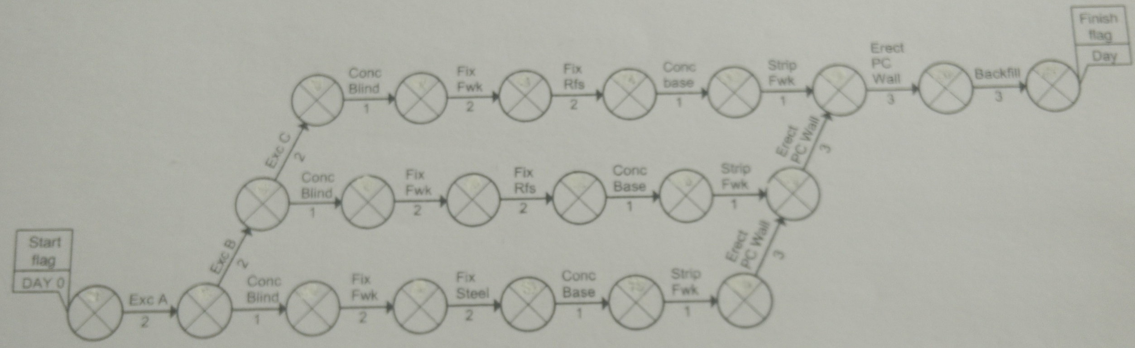

- Number the events.
(3)
- Calculate the earliest and latest event times.
(10)
- Identify the activities that are critical.
(6)
- Calculate the total float and free float of the non critical activities
(6)

Section B

CHOOSE ONE OF THE FOLLOWING QUESTIONS TO ANSWER

QUESTION 1 (50 marks)

In 2019 planning permission was sought for Partial demolition of the rear section of Grade II listed building, erection of replacement extension and change of use of whole building to mixed use community facility comprising cafe (A3), hall (D2), multi-purpose rooms (D2), gymnasium (D2) and ancillary facilities, 2no A1/A2/A3 units, offices (A2/B1) and associated car parking, cycle store, bin store, employee amenity area, drainage, highways and engineering works. This building is the Plaza in Port Talbot town centre. The planning application was P2019/5237.

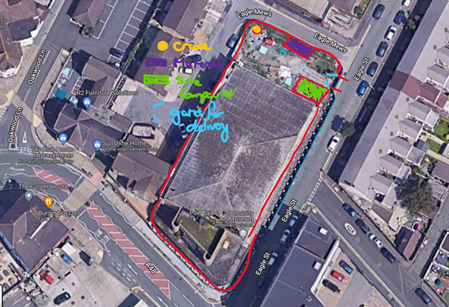

  - Identify the facilities, storage etc required on a typical construction site
(10)
  - Comment on and critique the present site layout of equipment, building materials and access roads for the alteration of a commercial building.
(10)
  - List the constraints you can identify from the information provided.
(10)
  - Suggest an improved site layout with justification (sketches are advised).
(20)

QUESTION 2 (50 marks)

  - The construction process results in a lot of waste. The importance of reduce, reuse and recycle has taken on more and more urgency over the past decade or so. The waste management of different construction materials requires different handling methods, describe these. Give examples where possible.
(20)

  - The construction industry is using more off site production processes. How can off site production feed into waste management?
(15)
  - Materials such as plaster board can not be recycled and end up in landfill. What can clients do to help to reduce the amount of plasterboard that goes to landfill?
(15)

Diwedd/End

Page Break

