INDEX
Name and ID No: Isaiah Eseosa Ojo – 1907284
Course Title: Effective Team Working and Communication
Tutor: Dr. Molly Jack

INTRODUCTION
Team-work
Teamwork is the effective and efficient completing of a task in a collaborative of two or more people. Teamwork is usually much more appreciated when a group of independent individuals can come together to complete a common goal. Teamworking is important because by working together teams can bring up multiple ideas, skills and abilities and solutions can be found for most problems.
This skill is important as it improves the atmosphere around you, builds friendships, and can create loyalty. Teamwork is also very important as more difficult task can be completed quicker and more efficiently through the views or experiences of more than one person.
Communication
Communication is the exchange of information from one person, place, or group to another through speech, writing, or some other medium.
This common skill is very important because we use communication to do simple things like passing on information, expressing our wants and/or needs, and in developing relationships. Effective communication is a powerful and reliable tool for any business owner. Your ability to get your point across is and can be the difference between closing a deal and losing a potential business opportunity.
As a business owner especially, you should be able to explain all the policies in a company to your customers or clients and be able to answer any questions or queries that may come up about your services or products. It is vital to communicate eloquently and effectively in negotiations to make sure you reach all your desired goals.
Communication is also very important within the business and workplace. It builds and grows good friendships, builds trust, and can improve moral and efficiency. (business.qld.gov.au, communicating effectively for business, Sep 2016)

Communication at My Place of Work
I am a footballer and a business consultant. I play with Oadby Town Football Club in the Midlands and I work with PJHS Consultancy. At my football club it is very crucial that I as team captain can communicate very well with players around me to achieve our similar goals.
In this organization we play at a very competitive level as a semi-professional club and obviously have serious goals to achieve to keep fans, owners and shareholders happy. I have been entrusted with the captaincy in the meantime because I come across as powerful and can communicate well and eloquently with my players around me.
We as players must also go out and do fundraisers, meet up with fans and talk on camera before or after a game and it is also an essential skill to be able to talk properly in a respectful and classy manner.
At work I am a Protection Master. My job is to field a team of ten to thirty engineers on a site. Our roles is to ensure that trains, stations and train tracks are safe to use and hit all their intended requirements. As the Protection Master, I must ensure that before my workers go out and work there must be no risk or endangerment of lives. The power supply on tracks must be cut off, my workers must receive individual instructions, and pedestrians must also be kept away from the work we do. I talk a lot at work and give a lot of instructions because if anything goes wrong, I am held liable.

Verbal Communication
Verbal communication is the transfer of information to others by the spoken word. Simply talking to people or groups is considered verbal communication. This is important in the workplace as it builds and helps maintain successful business relationships. Good and effective communication will literally boost productivity, errors in the workplace will decrease, and all operations will run very smoothly.
Written Communication
Written communication is the transfer of information to others by the written word, e.g. emails, letters, posters etc. As the manager or the CEO of a business it cannot be easy to talk to all your employees, customers, and/or partners. Therefore, a very common and effective way of speaking to the people you need to reach out to would be through writing. Emails and Faxes are the most common way of communicating to others. Written communication helps in defining goals, identifying all the problems, and coming up with suitable solutions for any problems. It is also a very good way to give directions and instructions to a bigger group of people without having to speak to them all face to face.
Non-Verbal Communication
Non-verbal communication is the transfer of information or messages through a non-verbal platform. This can be done though gestures, eye-contact, facial expressions, posture, and even something as simple as body distance. Non-verbal communication is important because it’s the best way to build a relationship with others. It shows emotions like sadness, anger, disappointment, pleasure, hope, etc. People show these emotions without even knowing they are doing so. Good non-verbal communication builds a healthy relationship in the workplace, builds and strengthens trust, and can make approaching you a much easier convenience especially if you own or manage a business.

Theories of Communication
There are three models of communication that I studied this year. They are:
- The Shannon-Weaver Model of Communication
- Berlo’s Model of Communication
- The Schramm Model of Communication

The Shannon-Weaver Model of Communication
The Shannon-Weaver model of communication argues that communication is split into six major concepts: The sender, the encoder, the channel, the noise, the decoder, and the receiver. This model is also known as ‘Information Theory’ or better know as the ‘Shannon Theory’ because Shannon was the main developer of this theory.
( http//helpfulprofessor.com/Shannon-Weaver Model of communication, Chris Drew, 2020)
How this model works is by allowing the sender to convert the message into codes that a machine can understand. The message is then sent in codes through a medium. The receiver then has to decipher the coded message before understanding and translating it. The receptor machine can also work as a decoder in some cases.

Berlo’s Model of Communication
Berlo’s Model processes and presents the message in its simplest form and for me is the best model of communication. This model consists of four major components that are all individually influenced by different factors. They are: The source (who encodes the message), the message, the channel, and the receiver (who decodes the message). To ensure that the message is delivered as well as possible, the receiver and sender must share some common ground. Here you can see the model perfectly:

(www.communicationtheory.org, Berlos SMCR Model of Communication, 2016)

Schramm’s Model of Communication
The Osgood-Schramm model of communication is the most unique of the three models of communication. It appears circular opposed to the usual linear styles used by Shannon and Berlo. This theory involves a sender who encodes a message, and a recipient who then decodes it. The receiver and sender tend to have both roles in this model therefore the idea of interpretation is central in this model. This model takes communication as a never-ending process which constitutes messages and their feedbacks.
Below you can see Schramm’s Theory of communication:
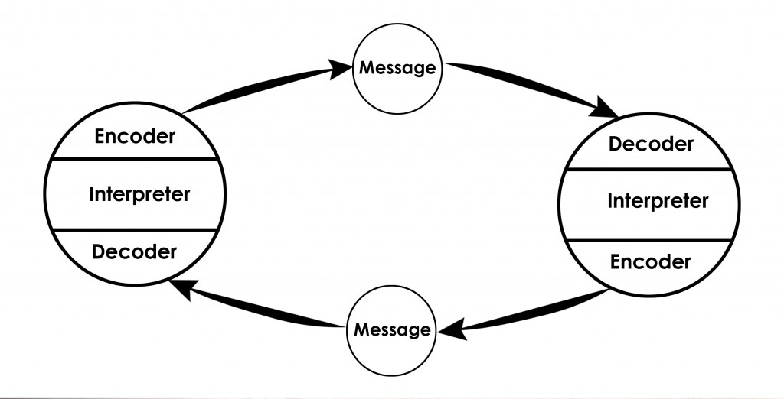
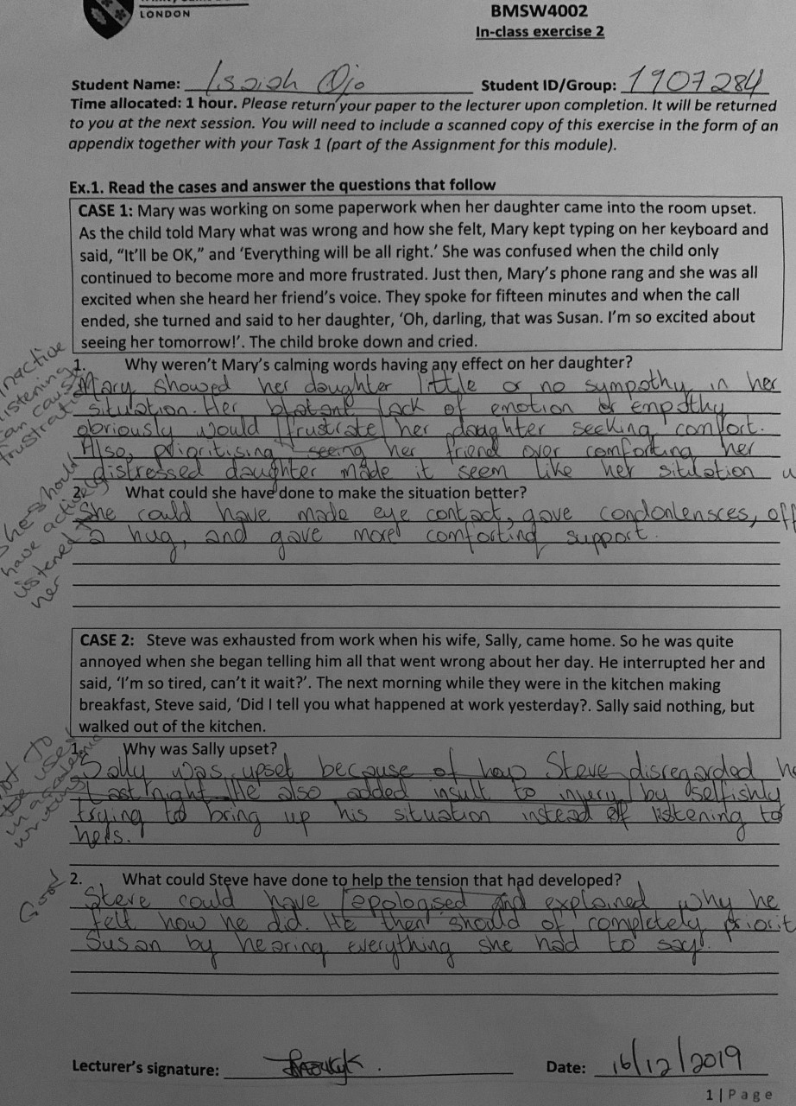
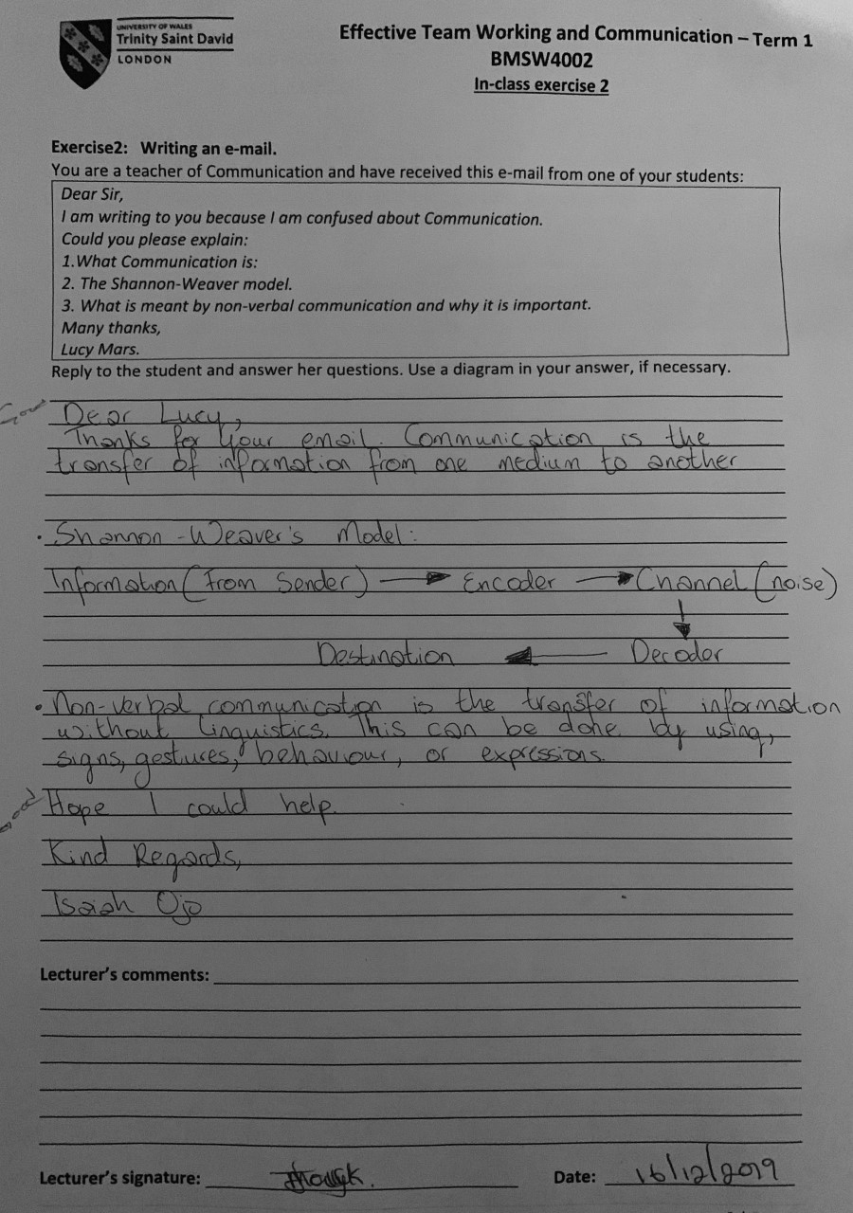

REFERENCES
- (www.communicationtheory.org, Berlos SMCR Model of Communication, 2016)
- ( http//helpfulprofessor.com/Shannon-Weaver Model of communication, Chris Drew, 2020)
- (www.business.qld.gov.au, communicating effectively for business, Sep 2016)

