Marketing Management (SBMA7102D)
Bell Canada: Marketing Strategy and Effectiveness
Assignment Part 2
Aqeel Shakir
July 31, 2018

Table of Contents
Introduction 1
Role of Marketing within the Organization 1
Marketing Mix 2
Strategy of Bell Canada and Its Competitive Edge 3
Segmentation, Targeting and Positioning (STP) 5
The Appropriate Media Channels 7
Measuring Success of Marketing Strategy 10
Conclusion 11
Recommendations 12
References 13

Introduction
The purpose of this report is to critically evaluate and explain the role of marketing department at Bell Canada (also referred as “the Company”) by assessing the effectiveness of their marketing strategies. Bell Canada is a National Telecommunication Company based in Canada and has spread its operations across Canada. The Company was formed in 1880 and has spread its operations since then; the competitive advantage of Bell Canada is its operations across the country, where other businesses in the same industry stand at regional level (Bell Canada, 2018). In accordance with a press release by BCE Inc. (2003), the structure of Bell Canada in general and its marketing department in specific has been simplified in the recent periods. It is due to the creation of consumer, large enterprises and small businesses divisions by Bell Canada. These divisions will look for different type of customers and different operations respectively; for example: Consumer Markets Group will include Bell Canada's residential wire line service, its Mobility services and numerous other retail services. The report covers numerous aspects to highlight the marketing strategy of Bell Canada in specific based on concepts and tools learnt in the module.

Role of Marketing within the Organization
In the view of Hollensen (2010), the role of marketing in any organization is significant as no business can survive without appropriate marketing activities. The marketing activities help businesses create market awareness and ultimately generate the sales of company’s products. In the context of Bell Canada, it can be analyzed that the marketing department has a very high significance given the nature of its business. The Company operates across Canada so the role of marketing department in attracting and retaining the customers plays a key role. Numerous concepts and theories of marketing are employed to cater the retail and business customers. According to Hutt and Speh (2005), businesses globally are recognizing the importance of marketing concept over other concepts such as selling concept and numerous others previously incorporated by the companies. Bell Canada is focused on marketing concept as the management focuses on generating the demand for their products to create a “Pull” for the products suggesting application of Pull Strategy (Cook et al., 2007). The strategy is based on the belief of the Company, which believes that push strategy is a short-term strategy; instead, pull strategy allows the marketing department to attract consumers in the long-run by ensuring quality products and consumer satisfaction.

Marketing Mix
In accordance with Shaw (2016), the marketing mix is one of the fundamental concepts of marketing and it is applied by majority of the companies focused on marketing approach. The marketing mix is focused on 4P’s of marketing referring to product, price, place and promotions. The module discussions in week 5 clearly reveal that the formation of marketing mix is crucial for the success of a product or company as a whole because the customer relationship management and marketing mix are closely linked. As the business is a retail chain for cell phones and other technical products, its marketing mix has to be different when compared to businesses involved in manufacturing or services sector.
- Product: The concept of product covers the range of products offered by Bell Canada and the brands that are made available at different stores of Bell Canada. Bell Canada offers mobile phones, TV, Internet and Home Phone Service suggesting a diversified product range with reference to telecommunication sector. As per the nature of products sold by Bell Canada, the Company is not involved in repackaging of the products and they are sold as presented by their original manufacturers (MBA Skool, 2018).
- Price: Considering the nature of the business of Bell Canada, the Company is involved in “market penetration pricing” as the business aims to target people across Canada relating to different social classes and income groups. In the view of Doyle and Stern (2006), the market penetration pricing is the counter strategy of market skimming pricing and it refers to catering the major chunk of target market by charging a lower price than competitors so that majority of the social and income groups can be targeted.
- Place: The availability of products in different provinces of Canada is another point of differentiation for Bell Canada. As the products are placed across different cities of Canada, it offers a competitive edge to Bell Canada as the Company can target larger pool of target market due to awareness in different provinces.
- Promotions: The promotions strategy is a key determinant of the sales generated by a business. The promotions strategy employed by Bell Canada is focused on both Above The Line (ATL) and Below The Line (BTL) activities; however, a major focus is placed upon the ATL activities as the business is involved in newspaper ads, radio ads and social media advertising. In addition, the BTL activities are conducted by means of promotional activities inside and outside shopping malls to ensure the customer engagement with the potential customers (MBA Skool, 2018).
In order to further evaluate the marketing mix, the Company can consider the application of extended marketing mix which is based on 7P’s and is considered more effective in the modern era (Hollensen, 2010).

Strategy of Bell Canada and Its Competitive Edge
In the view of Porter (2007), the strategy referred by organization can be based on any of Porter’s generic strategies. One of these strategies is adopted to develop the competitive edge for any given business. Four types of generic strategies have been proposed by Porter (2007), which can be generalized to any business operating in any segment or industry. These strategies are illustrated in the figure below:
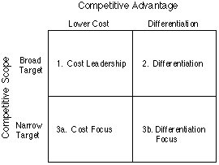
Figure 1 - Porter's Generic Strategies (Porter, 2007)
Further, the discussions in module forum in week 7 by Nick Batty reveal that the disruptive change in products or the transformational change is highly important in developing the competitive edge for a business. However, every business is not able to undertake this sort of transformational change as experienced over the years. Considering the nature of the industry and business model of Bell Canada, it can be illustrated that Bell Canada has undertaken low cost leadership to ensure that its costs are lower than the industry peers and it can charge a lower price as a result. In addition to the pursuance of low cost leadership strategy, the Company also pursues differentiation in terms of its marketing and promotions strategy in particular. Bell Canada promotes its products by a combination of ATL and BTL activities; however, its key competitors i.e. other telecom retail chains have no or very little involvement in the BTL activities. Therefore, it can be highlighted that the generic strategy opted by Bell Canada is a combination of low cost leadership and differentiation as illustrated from the discussion and analysis above (Management Paradise, 2018). The table below compares the marketing strategy of key competitors of Bell Canada with the Company:
Competitor | Marketing Strategy
Rogers Communication | Involved in extensive advertising but no involvement in BTL after the new CEO has taken charge (Blinch, 2017). It highlights that Bell Canada’s competitive advantage relating to focus on BTL activities is existent.
Telus Corporation | Telus Corporation has a marketing strategy highly focused on customers and it achieves the marketing objectives by advertising on traditional and digital mediums of marketing (Telus Corporation, 2018). It also implies an absence or lack of BTL activities on part of Telus Corporation.

Segmentation, Targeting and Positioning (STP)
STP is a marketing process focused on segmenting the market, selecting the target market and determining appropriate positioning for the business as to how the product is going to be placed in the minds of target consumers. The segmentation is performed on the basis of different factors and is used to divide a potential market in different divisions and then the business targets one or few of those to select the target market. Lastly, a positioning is developed considering the target market in view (Kotler and Keller, 2006). The market segmentation for Bell Canada can be divided on the basis of geography, demography and social or income classes. On the basis of geography, Bell Canada has selected entire Canada as its target market leaving some already mature areas as exception. Demographically, Bell Canada targets both genders and individuals aged 18 and above. In terms of social classes, Bell Canada targets all three major classes ranging from lower class to upper class. The segmentation also describes the target market for Bell Canada as illustrated in the discussion above. It can be illustrated that the major audience for the marketing department of Bell Canada is individuals aged 18 and residents of Canada irrespective of their gender and social class (Ellson, 2004; Moore and Pareek, 2009).
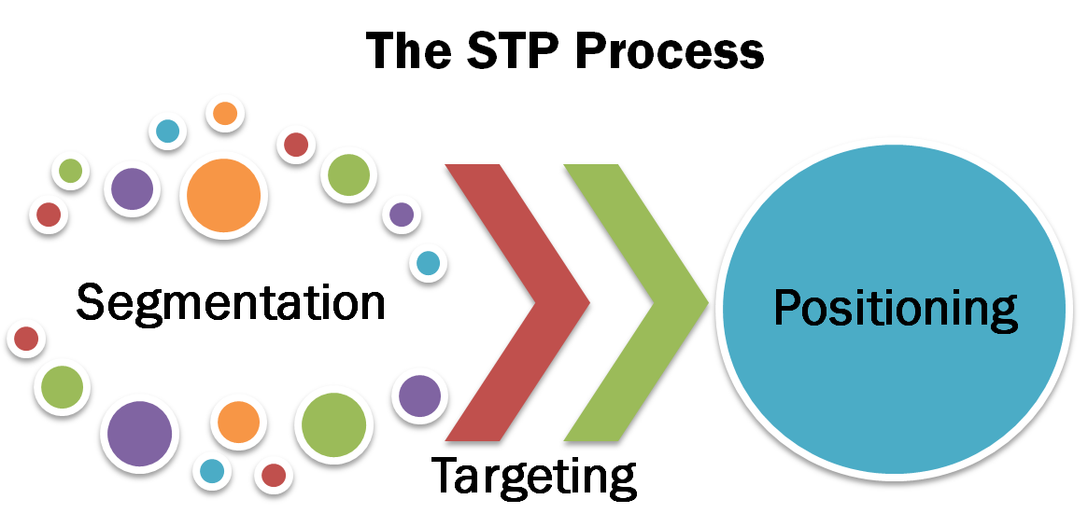
Figure 2 - Segmentation, Targeting and Positioning (Marketing Journal, 2017)
Further, the positioning undertaken by Bell Canada is based on communicating the image as “technology for all” as the Company believes that Mobile Phones and other technology sold by it needs to be a part of everybody’s life. From the analysis of the segmentation, targeting and positioning of Bell Canada, it can be analyzed that the segmentation performed so far is generic and applicable to all the Company’s products and target consumers in general. However, it has been observed around the globe that multi-brand companies select their target markets and position the products based on the nature of product. Conversely, Bell Canada can also position its different products differently so that the specific target market can be attracted towards product. For example: the target market for cell phones and Home Landline Telephones may be quite different and the two categories may require different positioning strategies to attract them. As discussed inn the module forum by peer students, the positioning needs to be unique for each product offered by a multi-brand company so that the product can be positioned considering the target market and it’s characteristics (Morgan et al., 2011).
Further, the discussion in the module forum by Siu O in week 4 activities, it is important for the businesses to ensure that their positioning is considering the nature of target market. By exemplifying Apple, he explained that the repositioning of a brand may be required for multinational businesses as well due to the frequent changes in the needs of target market. Overall, the discussion illustrates that Bell Canada has utilized the concept of STP but the execution of the concept can be improved as illustrated from the discussion.

The Appropriate Media Channels
The media marketing is an important area of marketing which eventually decides the promotional channels to be employed by the company and how each type of media channel shall be used by the marketer. Different types of media channels are utilized by the marketers around the globe especially in the modern era as the range of media channels has been widened due to the emergence of internet based media channels, which also fall under the umbrella of digital media. Numerous traditional media channels that can be opted by Bell Canada can include publications including newspapers, TV ads, radio, billboards and face to face. In addition, new media channels, which are introduced recently, include websites, blogs, social media including all mediums like Facebook, YouTube, Email, mobile, search engine optimization (SEO) and videoconferencing (Cravens and Piercy, 2006; Gaski and Nevin, 1985). As illustrated by Yang et al. (2011), the selection among different marketing channels is based on the marketing strategy of the company. If a company is involved in direct marketing then the marketing channels employed are going to be quite different when compared to the one involved in indirect marketing. Conversely, the marketing channels employed by a business having advertising as its key strategy will be different when compared to a business having BTL activities as its key strategy to attract the potential consumers.
In the case of Bell Canada, the Company has employed different types of marketing channels to communicate with its potential customers; these channels include both traditional and digital media channels. The traditional channels used by Bell Canada are TV ads, publications and Radio ads. In addition, the digital media channels used include SEO and Social Media Marketing. The Company has placed more focus on Facebook, YouTube and Google as the maximum target market can be reached using these channels. Besides these social media marketing channels, Bell Canada has a specific focus on publications and TV ads as well and these marketing channels are employed in specific areas, where the viewership to these types of media is higher. These are the marketing channels employed by the Company; further, model illustrating the process to select marketing channels by companies in general and Bell Canada in specific are also discussed in this section.
The figure below highlights a model that can be used for selection of appropriate channel strategy:
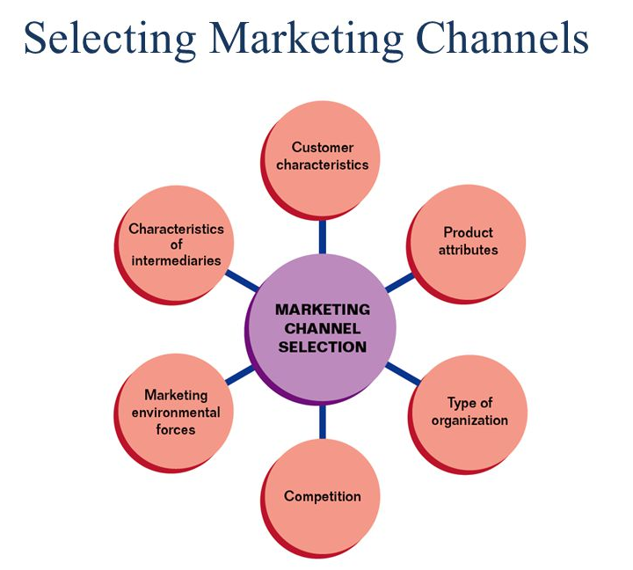
Figure 3 - Selecting Marketing channels (Doyle and Stern, 2006)
As illustrated from the figure above, the selection of channel strategy is a multi-dimensional decision varying from areas including analysis of marketing factors, product factors and competitive factors. Each of the areas should be analyzed as detailed in the figure above to reach upon the channel strategy (Shaw and Jones, 2005). In the case of Bell Canada, the business firstly accounts for customer characteristics including demography and geography of the target buyers as knowing the customers in-depth is important before deciding the marketing channel. In addition, the analysis of product attributes plays a significant role in selection of marketing channels given that different types of products need to be promoted differently to the target market. In addition, the type of organization also matters; Bell Canada is Canada based retail store, it also plays an important role in determining the marketing channels.
The competitive and environmental forces of Bell Canada are also important determinants of its marketing channel strategy. As the competitive forces in the industry are high and environment also promotes competition, the channel strategy must be selected, which can help overcome the competition. Further, the characteristics of the intermediaries can also determine the marketing channels of Bell Canada as the Company identifies intermediaries and their characteristics so that the promotional channels are synced with the intermediaries’ characteristics.
The discussion above as a whole clarifies the selection of media channels by Bell Canada and implies that various media channels are utilized by Bell Canada to communicate its products to the target market; these include both the digital and traditional marketing channels as illustrated in the section.

Measuring Success of Marketing Strategy
Establishing the strategy to measure success of a marketing strategy is highly important for all marketing campaigns in order to ensure the effectiveness and identify areas that need improvement. The criteria for measuring success of a marketing campaign can be formed in four steps as illustrated below:
Step #1 - Plan the campaign and how to track it
In the case of Bell Canada, the Company can track the effectiveness of the marketing campaign by means of enhancement in customer base and quantity of goods being sold to the target market. In order to analyze the effectiveness of different marketing campaigns initiated at a single time, it is important to establish criteria against each of the campaigns (Brown, 2016).
Step #2 - Define the channels to be tracked
Unless the channels under tracking are not well-defined, it is difficult to assess the success of each channel being traced. Bell Canada has already identified the channels being used to market the products; therefore, these channels must be tracked carefully to be able to measure the success of the marketing strategy of the Company.
Step #3 - Define the marketing metrics to be measured
After the definition of the channels, it is highly important to define the marketing metrics as may be desired to measure the success of the campaign.
Step #4 - Measuring the campaigns
Different metrics developed can be used to monitor the success of a marketing campaign or the marketing department in general. In cases, where the chances of success of a marketing department turn out to be lower, the corrective measures may be designed by the management of the business.

Conclusion
On the basis of discussion carried out in this report, numerous conclusions are drawn to conclude the report. Firstly, it can be concluded that the role of marketing department is highly important in the context of Bell Canada as illustrated from the discussion on marketing mix and strategy of the Company. It can further be highlighted that the targeting and positioning strategy utilized by Bell Canada is less effective as there is a significant room for improvement; it can be improved by applying the concept differently for different brands being sold by Bell Canada. The lower effective positioning is due to the single positioning strategy employed by Bell Canada for different brands falling under its umbrella. In addition, it can also be concluded that the selection of appropriate marketing channel is important and it is also illustrated what factors are accounted for by tBell Canada while determining the media channels. Lastly, it is concluded that the management of measuring the success of a marketing campaign at Bell Canada is simply similar to the one suggested by academic theory. In addition, the recommendations to Bell Canada are summarized in the section below.

Recommendations
Bell Canada is recommended the following:
- The business is recommended to account for extended market mix as the concept is contemporary and helps in detailed analysis.
- The business currently has a single targeting and positioning for different product categories and brands; this needs to be changed. Bell Canada must employ different segmentation, targeting and positioning for the different product categories offered to the customers so that there is separate positioning and target market for different product categories.
- Further, it is highlighted from the discussion that Bell Canada uses a mix of traditional and digital channels of marketing. The Company is recommended to place an even higher focus on the digital marketing channels given that the target market is increasingly attracted towards the digital marketing channels due to increasing use of internet by the target market.
- Lastly, the measurement of the success of marketing campaigns needs to ensure that each of campaigns is successful and highlight the weak areas of each campaign that shows ineffectiveness in some areas.
These are the recommendations that can improve the overall marketing strategy of Bell Canada considering the analysis in the given case.

References
BCE Inc. May 7 2003 (2017). BCE and Bell Canada simplify operations. [Online] Available at <http://www.bce.ca/news-and-media/releases/show/bce-and-bell-canada-simplify-operations> [Accessed on 30-07-2018].
Bell Canada. (2018). Home Page. [Online] Available at < https://www.bell.ca/> [Accessed on 28-07-2018].
Blinch, M. (2017). Rogers CEO unveils strategy to improve customer service, build on wireless momentum. [Online] Available at <https://www.theglobeandmail.com/report-on-business/rogers-tops-forecast-profit-jumps-35-per-cent/article35749036/> [Accessed on 29-07-2018].
Brown, S. (2016). Postmodern marketing: dead and buried or alive and kicking?. In The Marketing Book (pp. 43-58). Routledge.
Cook, S. M., Khan, Z. R. and Pickett, J. A. (2007). The use of push-pull strategies in integrated pest management. Annual review of entomology, 52.
Cravens, D. W. and Piercy, N. (2006). Strategic marketing (Vol. 7). New York, NY: McGraw-Hill.
Doyle, P. and Stern, P. (2006). Marketing management and strategy. Pearson Education.
Ellson, T. (2004). Segmentation, Targeting, and Positioning. In Culture and Positioning as Determinants of Strategy (pp. 21-34). Palgrave Macmillan, London.
Gaski, J. F. and Nevin, J. R. (1985). The differential effects of exercised and unexercised power sources in a marketing channel. Journal of marketing research, 130-142.
Hollensen, S. (2010). Marketing management: A relationship approach. Pearson Education.
Hutt, M. D. and Speh, T. W. (2005). Edition: Business Marketing Management. South-Western Publishing Company.
Kotler, P. and Keller, K. L. (2006). Marketing management 12e. New Jersey.
Management Paradise. (2018). Marketing Strategy of Bell Canada. [Online] Available at < http://www.managementparadise.com/forums/marketing-management/209897-marketing-strategy-bell-canada.html> [Accessed on 26-07-2018].
Marketing Journal. (2017). Segmentation, Targeting and Positioning. [Online] Available at < http://marketingsubbu.blogspot.com/2014/09/segmentation-targeting-and-positioning.html> [Accessed on 29-07-2018].
MBA Skool. (2018). Bell Canada Marketing Mix. [Online] Available at < https://www.mbaskool.com/marketing-mix/services/16900-bell-canada.html> [Accessed on 27-07-2018].
Moore, K. and Pareek, N. (2009). SEGMENTATION, TARGETING AND POSITIONING. In Marketing: The Basics (pp. 44-71). Routledge.
Morgan, N., Pritchard, A. and Pride, R. (2011). Destination brands: Managing place reputation. Routledge.
Porter, M. (2007). Porter's generic strategies. Retrieved June, 14, 2009.
Shaw, E. H. and Jones, D. B. (2005). A history of schools of marketing thought. Marketing theory, 5(3), 239-281.
Shaw, S. (2016). Airline marketing and management. Routledge.
Telus Corporation. (2018). Our strategy and values. [Online] Available at <https://www.telus.com/en/bc/about/company-overview/strategy-and-values> [Accessed on 29-07-2018].
Yang, Z., Zhou, C. and Jiang, L. (2011). When do formal control and trust matter? A context-based analysis of the effects on marketing channel relationships in China. Industrial Marketing Management, 40(1), 86-96.

