Student: Adelaida Terente
Student number: 2224223
Module: Aplication of the Advanced Coaching and Mentoring Process (BMSM5007)

In-Class Test 1

THEME 1
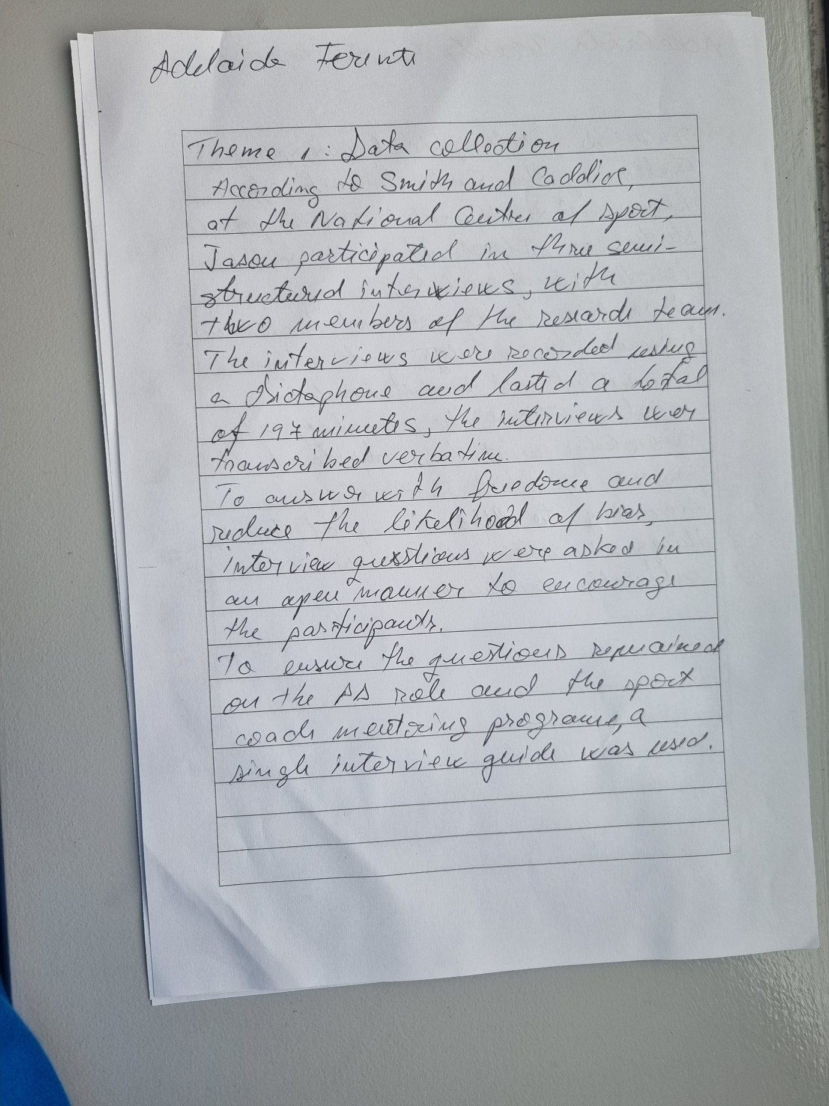

THEME 2

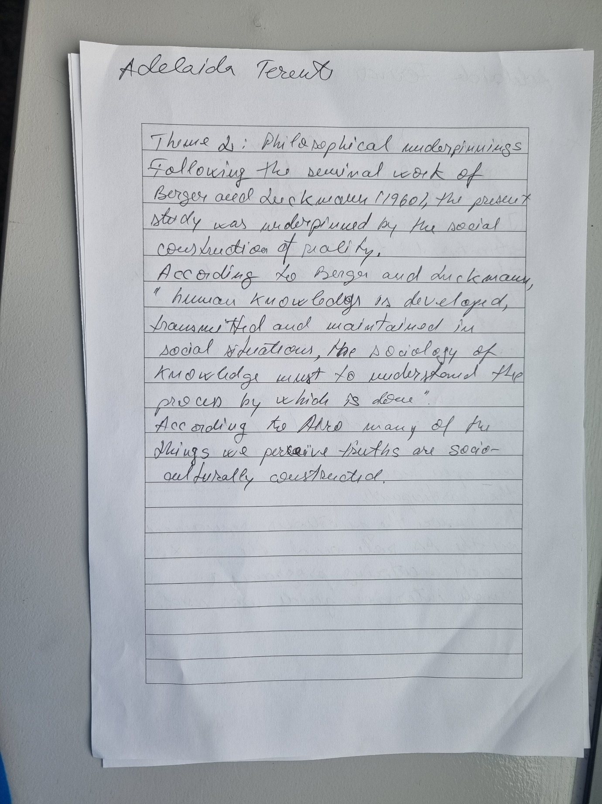

THEME 3
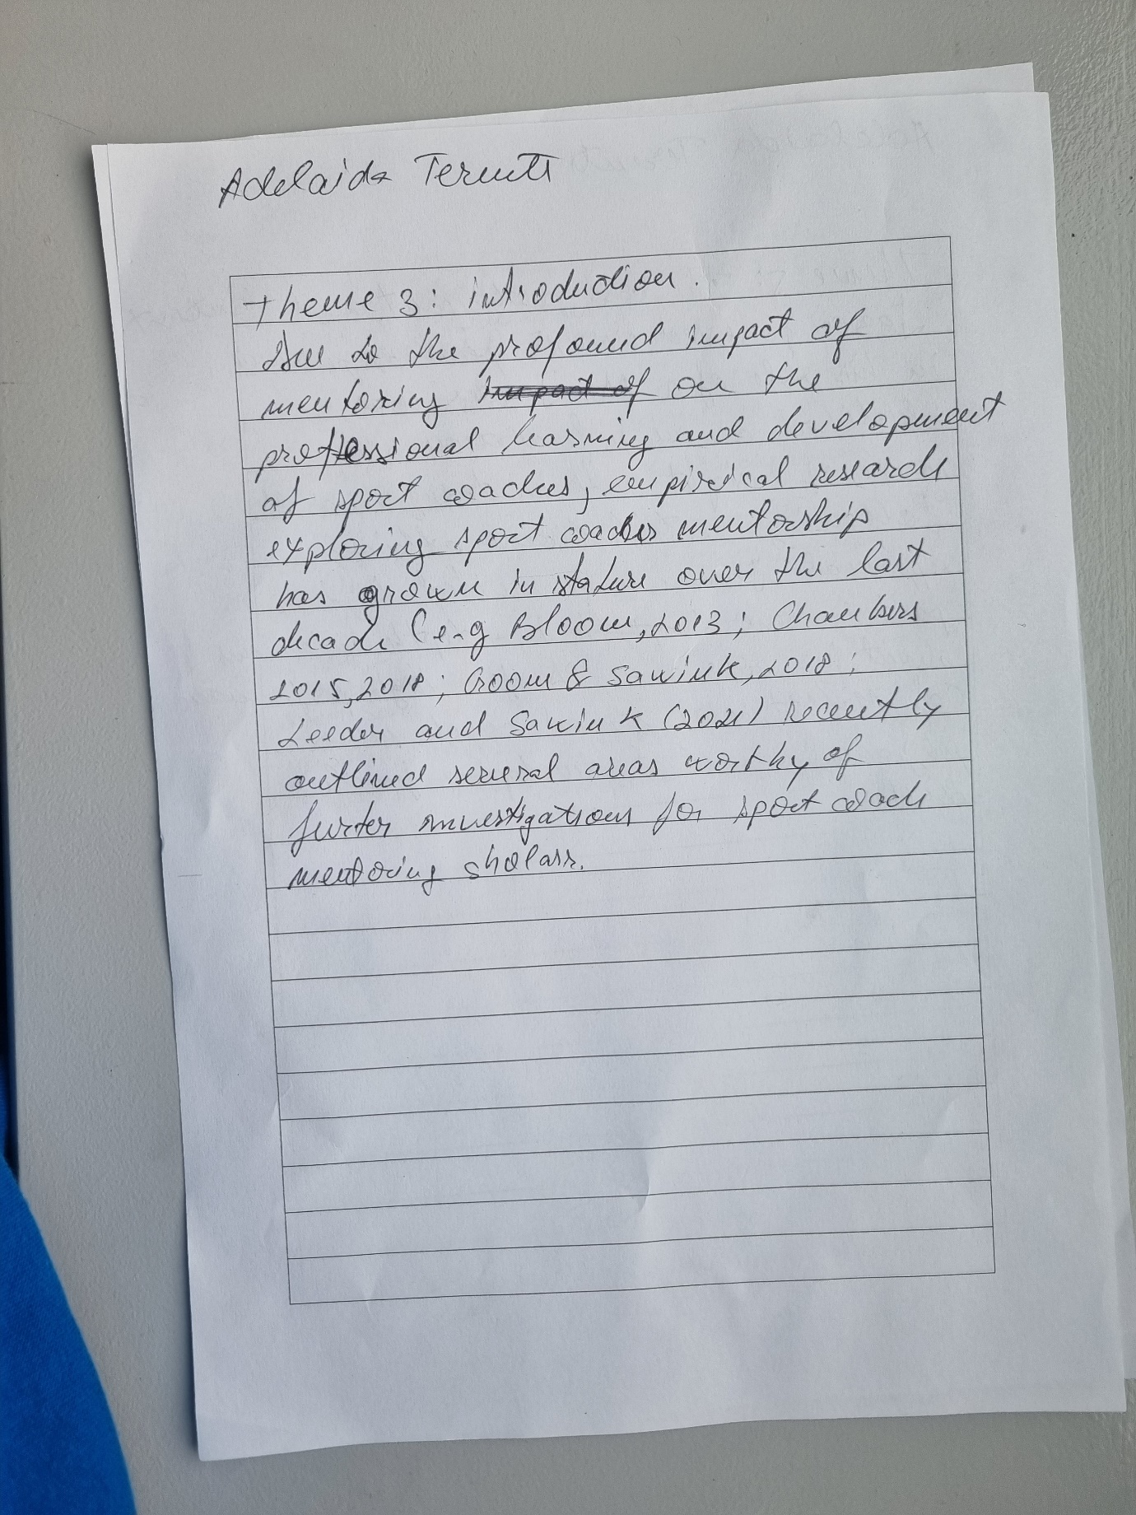

THEME 4
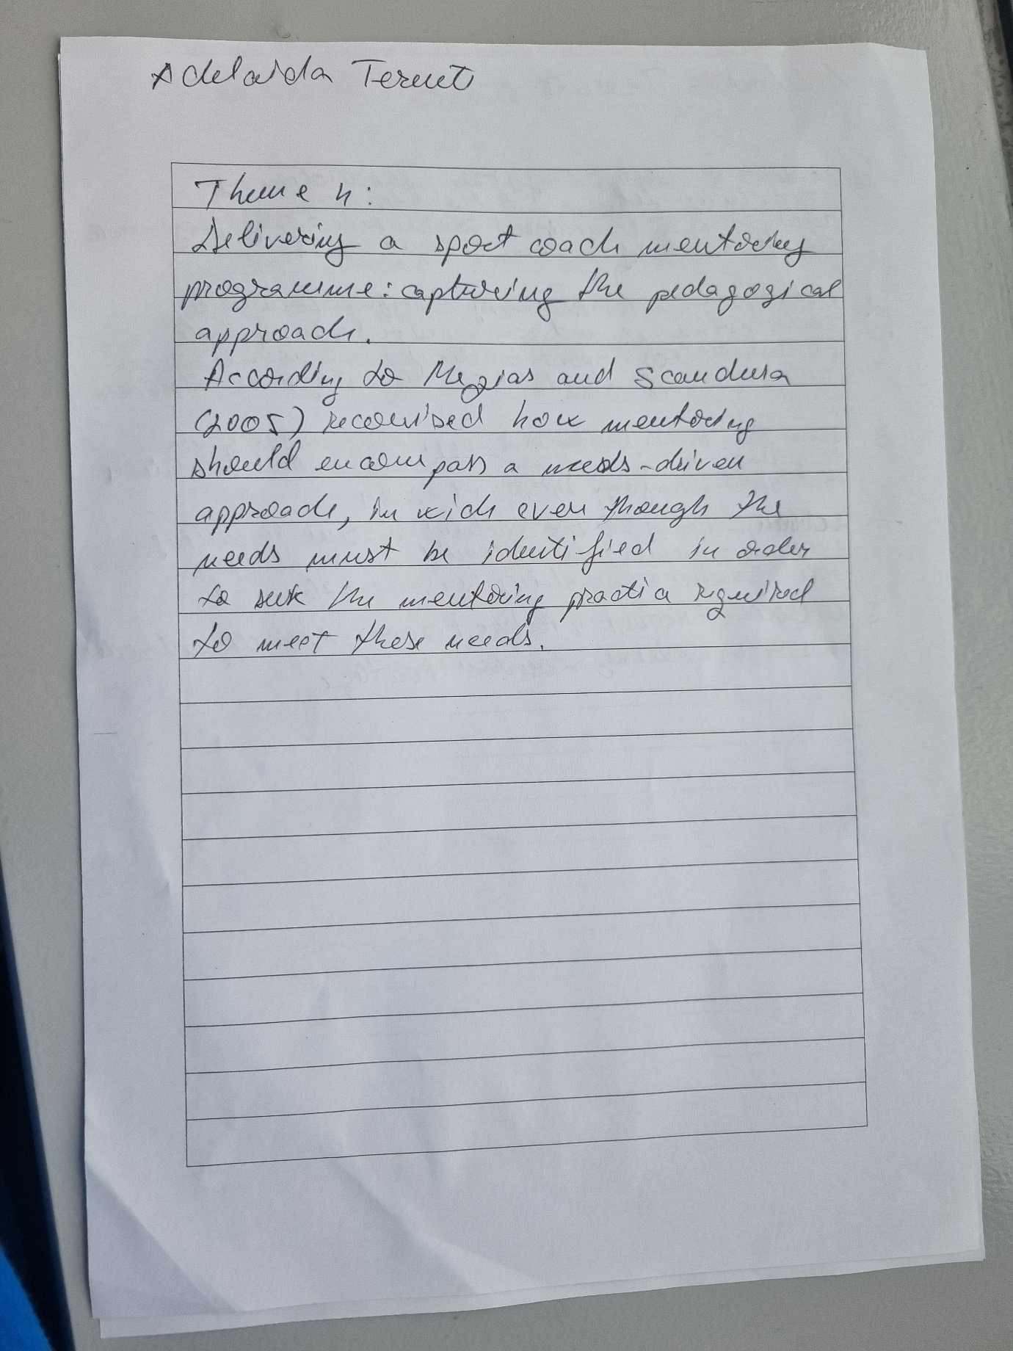

THEME 5
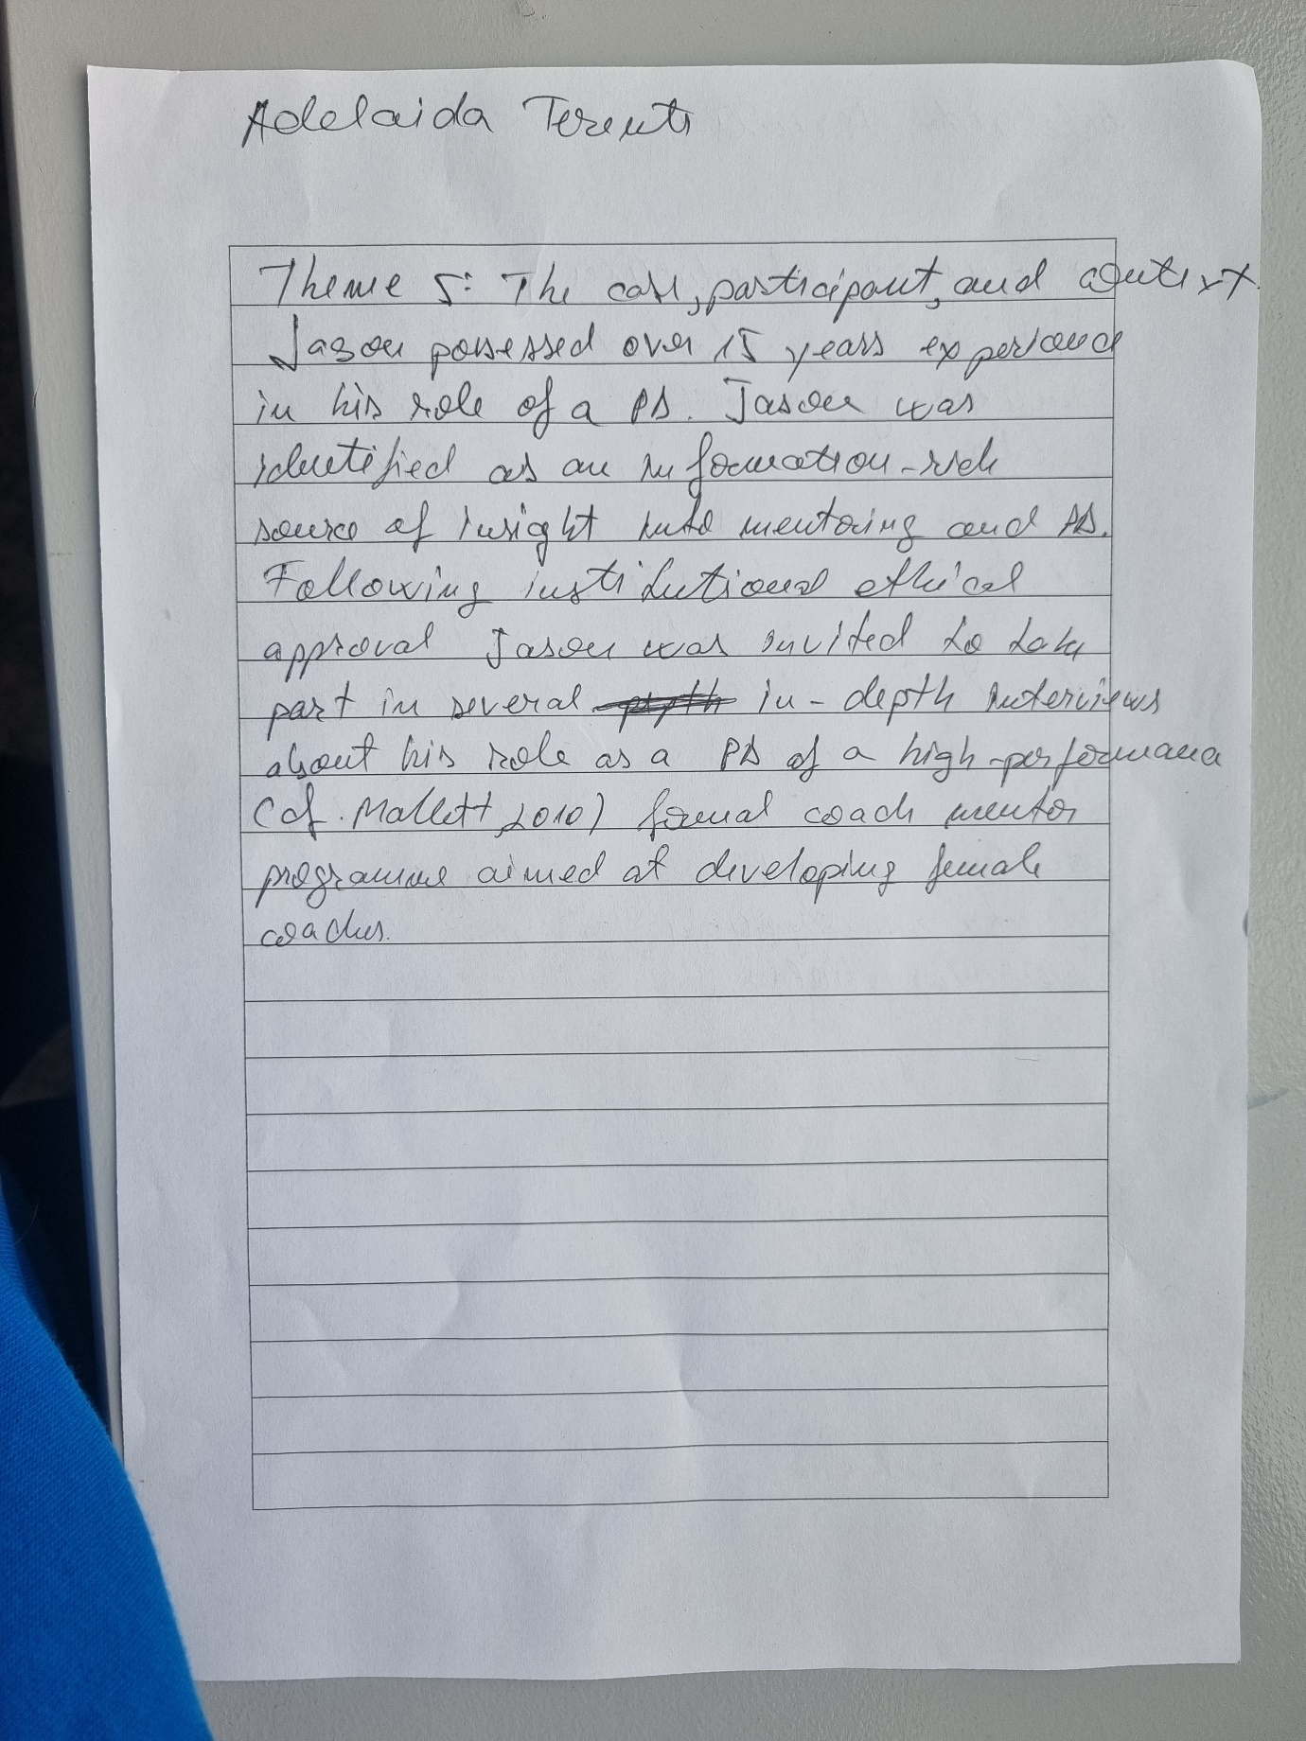

REFERENCE:



