MARKETING PLAN

Ana-Maria Burada
Student ID:2233131

Marketing essentials BMIH4005
Lecturer: Chris Wilkin
Word count: 1534

One of the most recognised hospitality managements since 1995, the infrastructure was identified named "Six senses". It was known for its sustainability, high-end services, and uncompromised facility and for its responsibility. The value of the organisation is to connect with people and provide them with valuable moments with loved ones or meaningful work. The intention is to evoke all the senses of customers, to make them feel alive, from both sides of the world and towards spirituality. The marketing theory is creating value for customers, the practice of sustainability and brand value. The organisation is spread in 17 countries, with 20 resorts and hotels; it offers inclusive amenities with nature surrounding providing the luxury of spas and exotic cuisine restaurants.

Situation analysis
Regarding Strengths, Six Senses has the ability to access and be flexible towards changes and also owns infrastructure with sustainable services.
The Weaknesses of Six Senses would be the weather that must support farming and similar emerge of hospitality management company.
The Opportunities of Six Senses are the sustainable goods that give initiative towards a healthy environment. And the production of environment friendly products.
The Threats for Six Senses are the appearance of companies producing sustainable products and the competition among the existing opponents.

Customers Segmentation and Targeting Customer
The customer type which is been targeted in hotels like "Six senses" is those who are founding of luxury stays (Çınar, et al. 2020). Hilton Hotel offers an eco-friendly environment both from the internal and external of its infrastructure (Bin,2022). The customers are being categorized according to their demand and geographic location, psychographic, behavioural and sociographic characteristics. Thus, the customers, are being targeted according to the small segments.
Competitor's Perceptual positioning map, Bowman's strategy clock
The Bowman strategy clock defines the position of 8 competitive threats that may appear. These are enlisted as 1st position says low price and low value, position 2 discussed as low price. The third segment indicates moderate differentiation or moderate price (Müller et al. 2020) Position 4 demonstrates differentiation, the 5th position focuses on differentiation, and the 6th position evaluates the quality of the products and increases prices [Refer appendix 1]. Position 7 describes the high price but less product value. The last 8th position says about moderate price but less value.
Collaboration:
The collaboration of this organisation has recently signed an agreement with international property developer “Magnolia Quality Development Corporation Limited (MQDC)". As stated by Fu, et al (2020) the Jo and Joe has also tied up with the first membership with club Asia, the ceremony was conducted to flourish the success of the creative and sustainability centre.
An awareness of your organization’s B2B Relationships
The study illustrates the factor of self-governance that business-to-business a digital platform economy. The social media platform reduces strategic perspective as its focuses on the tactical use of social media (Monios and Wilmsmeier, 2022). Sheraton is mainly focused on three segments, which involve integrated communication, sales facility, and employee engagement.
Partnership and franchises
“Neil Jacob” is the founder of the hotel "Six Senses", its franchises are spread over 17 countries where they are serving customers, with an exotic nature present in the internal and external of the property.
Objectives
The creation of a marketing plan is followed by the vision of the organisation and the mission needs to operate. Six Senses has some more objectives like market channelling, market strategies come along should enlist analysing of market, price and competitor. This organisation has aim to act in accordance with the objectives to achieve its goals (Alon et al. 2021). The marketing strategies are being expanded toward digital marketing, where the organisation can reach its targeted audience. Social media offers an opportunity to provide offers and brand value to existing customers and non-existing customers. The offers which are been provided by the organisation get easily informed.

Strategies
Hotel “Six senses" is a renowned five-star hotel which expanded globally, sharing more than 42 properties that offer resort and hotel facilities. The organisation is known as the most sustainable and ego friendly in nature. The organisation has chosen to construct its infrastructure in exotic beach places like Maldives and many other places. This organisation ensures to provide relaxing and emotional hospitality, which will create an environment of relaxation and peace (Pollitt, 2022). This organisation believes in using natural and organic goods, which have created environmental sustainability. This organisation has also started farming the goods they offer to the customers so that every customer can taste and experience the goodness of organic earth. The organisation is majorly plastic-free and does not use any plastic goods on its property. It offers the consumer warm hospitality and services that differentiate it from its competitor. Most of the other hospitality organisation has replaced the use of plastic straw with paper, and plastic bags with paper bag, but changing entirely identifies its uniqueness.

Tactics
Marketing mix:
As the Six Senses known for providing its five-star luxury hotels to a wide range of customers worldwide was established in the year of 1995 with the proper set of strategies, planning and also with the vision to accomplish great success in this particular industry. The destination, which is currently offering or providing by the six sense hotels or five-star luxury resorts, is, "promote responsible practices in top-tier hospitality" (Bang et al. 2022). There are various ranges of destinations that are being offered by these well-structured Six Sense hotels for example, "exotic resorts and spas to private clubs and luxurious residences, developments are innovative ideas, sustainable and representative of the unique and outstanding beauty of their location". According to the opinion of Silva (2018), the Six Sense hotels or spas "offers a wide range of holistic wellness, rejuvenation, and beauty treatments administered under the proper direction and guidance of expert therapists".
Currently, there are many channels to locate the area of six sense hotels. Six Senses has its own individual and popular website. From there the customers can locate the hotels, and spas of the six senses (Younis and Elbanna, 2022). Moreover, there are also various sites on the internet nowadays to properly locate the required hotels of Six Senses.
Absolutely the authorities of Six Senses hotels have assigned a set of marketing and price range strategies. They do believe in the experimental marketing factors, which are eventually helping them while enhancing and improving their marketing as well customer attraction strategy. As opined by Li et al. (2022), they mainly believe and focus on five physical senses (sight, sound, smell, taste and touch) to communicate a brand's persona to its key audiences. This is classified as the various or multi-sensory approach to marketing. It is also true that the actual feat or accomplishment is eliciting or stimulating the sixth sense.
Various ways need to be followed to deal with the advertising or the promotion part of these Six Sense hotels. The factor that is affecting is differentiate From Competing established Luxury Hotels the next factor is Be Innovative & Add Value Emotion and User-Generated Content", "Post Your Resort Advertisements on Social Media Platforms", "Use Influencer Marketing" and lastly "Establish a Sense of Exclusivity with Luxury Hotel Ads" (Alabid et al. 2022). These are very important in order to promote the hotels and it can help to gain the customer attraction at its best.

Action
Gantt chart of marketing activities
The campaigns extend in measure and ranking, and Gantt charts can be priceless in blotting workflow problems and keeping everything conducted on schedule. When an organisation refers to a Gantt chart, it can convey more virtually, organise more efficiently, and employ more elegant planning [Refer appendix 3]. These Gantt charts display beginning and ending dates, as well as scheduling, reliance’s, and deadlines, including how broadly the project is finished per phase and who is the task proprietor (Tsiligkiris and Ilieva, 2022). In successfully tackle such a campaign means running many interdependent projects and there is market analysis, content design, and promoters to be assigned, supplied, and prepared. Gantt chart makes it easy to look up and comprehend how all these exercises are linked.

Control
The three main financial statements that can use to measure the success of the business are the "income statement, balance sheet, and cash flow statement". The income report calculates the profitability of the business by ascertaining the earnings and losses during a specific duration. The balance sheet displays the company's financial wellness, estimating how much it owes and owns and cash flow demonstrates how fluid cash is in the company. The most important measurement of the company's success is consumer happiness or satisfaction as they help us to enhance the services and products (Wang et al. 2022). Comprehending or by averaging how many new customers the company is acquiring is a significant way to measure the company's success and forecast development. By executing performance reviews, organisations can discover employees' perspectives regarding their work satisfaction, employ them in more tasks, and improve workforce productivity.

Conclusion
This report concluded by illustrating the marketing strategies of the hotel “Six Senses". The organization has demonstrated the market senses, market strategies and tactics, partnerships and franchises and the objects of hospitality management. The targeted customers for marketing the managements are being evaluated on the content.

References
Alabid, J., Bennadji, A. and Seddiki, M., 2022. A review on the energy retrofit policies and improvements of the UK existing buildings, challenges and benefits. Renewable and sustainable energy reviews, 159, p.112161. https://doi.org/10.1016/j.rser.2022.112161
Alon, I., Apriliyanti, I.D. and Henríquez Parodi, M.C., 2021. A systematic review of international franchising. Multinational Business Review, 29(1), pp.43-69. https://www.emerald.com/insight/content/doi/10.1108/MBR-01-2020-0019/full/html
Bang, G., Rosendahl, K.E. and Böhringer, C., 2022. Balancing cost and justice concerns in the energy transition: comparing coal phase-out policies in Germany and the UK. Climate Policy, 22(8), pp.1000-1015. https://doi.org/10.1080/14693062.2022.2052788
Bin, L., 2022. Goods tariff vs digital services tax: transatlantic financial market reactions. Economics, Management, and Financial Markets, 17(1), pp.9-30.
Çınar, K., Yetimoğlu, S. and Uğurlu, K., 2020. The Role of Market Segmentation and Target Marketing Strategies to Increase Occupancy Rates and Sales Opportunities of Hotel Enterprises. In Strategic Innovative Marketing and Tourism: 8th ICSIMAT, Northern Aegean, Greece, 2019 (pp. 521-528). Springer International Publishing.
Fu, S., Cheng, X., Su, L., Bilgihan, A. and Okumus, F., 2020. Designing collaboration process facilitation in hotel management teams to improve collaboration performance. International Journal of Hospitality Management, 88, p.102527. https://doi.org/10.1016/j.ijhm.2020.102527
Hargreaves, C.A., 2015. A comparative analysis of hotel ratings and reviews: an application in Singapore. American Journal of Marketing Research, 1(3), pp.118-129. https://doi.org/10.1016/j.jjimei.2021.100021
Hofacker, C., Golgeci, I., Pillai, K.G. and Gligor, D.M., 2020. Digital marketing and business-to-business relationships: a close look at the interface and a roadmap for the future. European Journal of Marketing, 54(6), pp.1161-1179. https://www.emerald.com/insight/content/doi/10.1108/EJM-04-2020-0247/full/html
Li, Z., Zhang, D., Zhang, Q. and Liu, X., 2022. Constructing online destination brand experience and bilateral behavioral intentions: a sensory conduction perspective. Current Issues in Tourism, pp.1-17. https://doi.org/10.1080/13683500.2022.2122782
Monios, J. and Wilmsmeier, G., 2022. Maritime governance after COVID-19: how responses to market developments and environmental challenges lead towards degrowth. Maritime Economics & Logistics, 24(4), pp.699-722. https://doi.org/10.1057/s41278-022-00226-w
Müller, L.M., Mombaerts, L., Pankin, A., Davis, S.J., Webb, A.A., Goncalves, J. and von Korff, M., 2020. Differential effects of day/night cues and the circadian clock on the barley transcriptome. Plant Physiology, 183(2), pp.765-779.
Pollitt, M.G., 2022. The further economic consequences of Brexit: energy. Oxford Review of Economic Policy, 38(1), pp.165-178. https://doi.org/10.1093/oxrep/grab044
Silva, S.D.S.B., 2018. Wellness tourism in Southeast Asia: the case study of Six Senses Hotels Resorts & Spas (Doctoral dissertation). https://bibliotecadigital.fgv.br/dspace/handle/10438/24797
Tsiligkiris, V. and Ilieva, J., 2022. Global engagement in the post‐pandemic world: Challenges and responses. Perspective from the UK. Higher Education Quarterly, 76(2), pp.343-366. https://doi.org/10.1111/hequ.12390
Wang, F., Zhang, R., Ahmed, F. and Shah, S.M.M., 2022. Impact of investment behaviour on financial markets during COVID-19: A case of UK. Economic Research-Ekonomska Istraživanja, 35(1), pp.2273-2291. https://doi.org/10.1080/1331677X.2021.1939089
Younis, H. and Elbanna, S., 2022. How do SMEs decide on international market entry? An empirical examination in the Middle East. Journal of International Management, 28(1), p.100902. https://doi.org/10.1016/j.intman.2021.100902

Appendices

Appendix 1 Bowman strategy
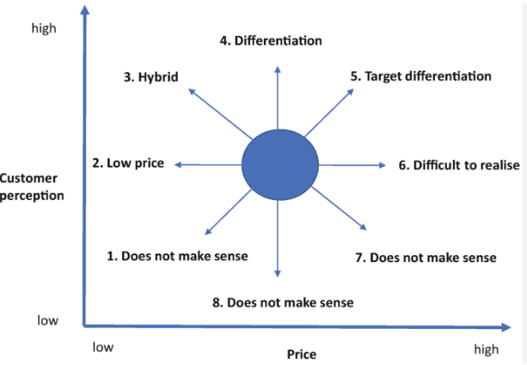

Appendix 2: Perceptual positioning map
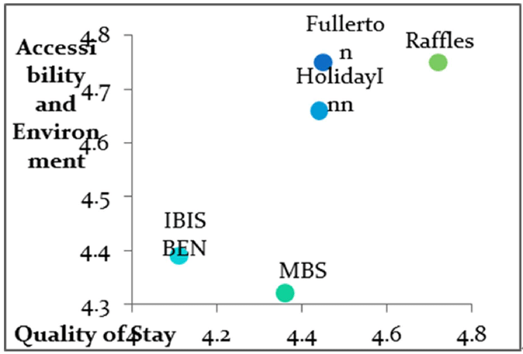
(Source: Hargreaves, 2015


