

Postgraduate/Distance Learning
Assignment coversheet & feedback form

THIS SHEET MUST BE THE FIRST PAGE OF THE ASSIGNMENT YOU ARE SUBMITTING (DO NOT SEND AS A SEPARATE FILE)
For completion by the student:
Student Name: Margo Schall
Student University Email: 2204802@student.uwtsd.ac.uk
Module code: HPCA 7015  Module title: Foundations in Cultural Astrology and Astronomy | Student ID number:  2204802 |  |  | Educational support needs:  Yes/No
Assignment title: Essay Based on a Sky Journal
Assignment due date: 1 December 2022
This assignment is for the 1st X 2nd 3rd 4th 5th 6th module of the degree
I confirm that this is my original work and that I have adhered to the University policy on plagiarism.
Signed ……………………………………………………………
Email submission: if you are submitting this form via email, please tick this box □
(as a substitute for your signature) to confirm that you agree to the above declaration.
Assignment Mark
1st Marker’s Provisional mark
2nd Marker’s/Moderator’s provisional mark
External Examiner’s mark (if relevant)
Final Mark

NB. All marks are provisional until confirmed by the Final Examination Board.
For completion by Marker 1:
Comments:
Marker’s signature: |  |  | Date:
For completion by Marker 2/Moderator:
Comments:
Marker’s Signature: |  | Date:
External Examiner’s comments (if relevant)
External Examiner’s Signature: |  | Date:
Essay Based on a Sky Journal
Exploring Where and How Enchantment Exists in a Disenchanted World

Introduction
This essay analyzes a Sky Journal focused on the moon, from the last quarter on October 18, 2022 to the waning gibbous phase on November 15. Van Gogh observed the sky’s enchantment and wrote, ‘be clearly aware of the stars and infinity on high. Then life seems almost enchanted after all.’ However, Max Weber lamented that the rationalized, scientific Western world is disenchanted. This essay compares the four main themes, responsibility, orientation, relationship, and mutuality, that emerged from the Sky Journal with scholars’ theories of enchantment to explore where, and how, van Gogh’s enchantment exists within Weber’s disenchanted world.

Enchantment
To consider Van Gogh’s claim of enchantment requires a definition of the term. Enchantment can mean filled with awe and wonder, or attraction and pleasure. The word originates from incantare, to ‘cast a (magic) spell upon,’ which contains the Latin root cantare, meaning ‘to sing.’T This essay uses this inclusive range of definitions for enchantment.

Enchantment within the Sky Journal
This essay analyzes the Sky Journal as a primary source from a phenomenological approach. Most entries followed the moon’s time, an hour and a half after it appeared on the horizon, and were conducted from the intersection near my home in Philadelphia, PA. A few observations were made from other times and places. The journal included external descriptions of the physical moon and sky, internal descriptions of my experience observing the moon, and photographs. Four main themes emerged in the journal: (1) responsibility, (2) orientation in space and time, (3) relationship and connection, and (4) reciprocity and mutuality. These themes are ordered, chronologically, based on how they emerged. The practice of keeping a Moon Journal shifted from a burdensome experience, to an orienting and relational one, and finally to one of enchanting, mutual attention. The Sky Journal realized Van Gogh’s idea that enchantment can be found the cosmos.

The Where and How of Enchantment
The experience of growing enchantment that emerged through the sky journal counters Max Weber’s declaration that the Western world is disenchanted. Weber made the case that intellectualism, rationalization, and science created a world in which ‘there are no mysterious incalculable forces.’ He claimed this ‘disenchantment,’ had been underway in Western culture ‘for millennia.’ However, many scholars following Weber have questioned the theory of disenchantment and argued against its purported hold on Western epistemologies. The phenomenological experiences of enchantment within the Sky Journal, examined in the context of scholars’ theories enchantment, together offer understanding about where and how enchantment exists in a rationalized world.
Responsibility
During the first observations, enchantment was not a salient theme. Instead, responsibility and upkeep were central. Waking up in the middle of the night was a ‘commitment’ (day 3). I noted that without enough sleep, by the end of the month ‘I will be malúca,’ a Portuguese word from lúa (moon), meaning crazy (day 1). Before I knew the moon’s schedule, I had to navigate timetables and apps to track the moon’s path (day 1, 2). The photographs of the moon were also disappointing in contrast with the moon’s gentle glow (day 2, 3). As the month continued, though, the theme of responsibility and effort faded, and observations ‘stopped being so mechanical’ (day 23).
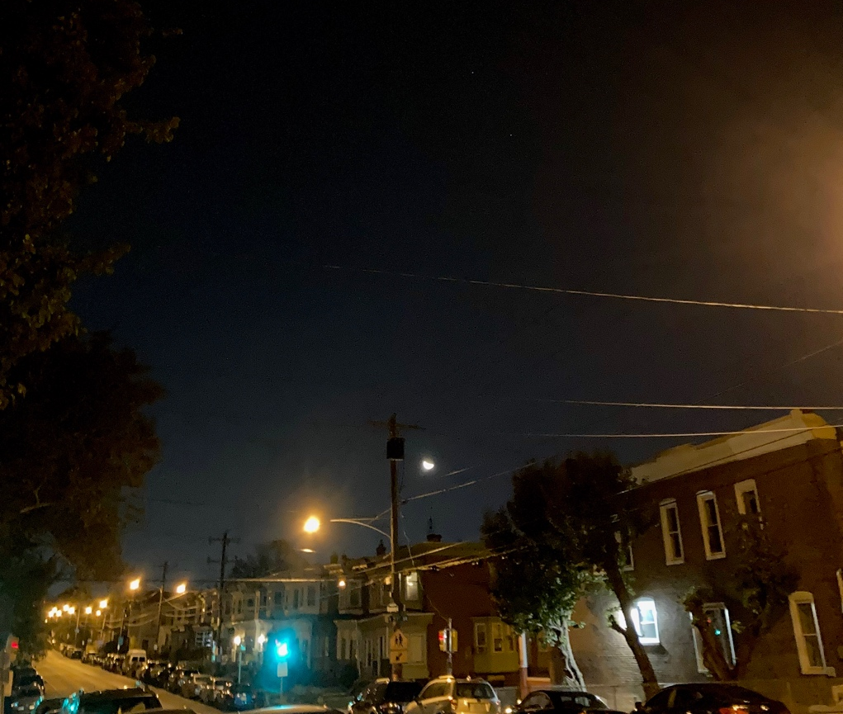
Day 2, Oct 19, 1:54am. Waning crescent. In Philadelphia, PA at the corner of my block where most moon journal observations were conducted.

Allison Coudert’s article, ‘Rethinking Max Weber’s Theory of Disenchantment,’ offers an explanation for the Journal’s transition from disenchantment to enchantment. Coudert argued that enchantment always existed in Western history amidst the enlightenment and science. She clarified that many of the scientists considered responsible for disenchantment, like Boyle, Newton, Locke, and Descartes, were, in fact, enchanted by the newness and wonder of science; thus, ‘mechanical philosophy was not triumphant’ over enchantment. Instead of lamenting a disenchanted Western reality, as Weber did, Coudert maintained that disenchantment and science co-exist, and ‘disenchantment cannot be a permanent feature of life.’ Taking a historical view, she identified enchantment as a recurring feature of experience that ‘moved from outside of individuals into the human imagination.’ The Sky Journal proved consistent with Coudert’s theory. Alongside scientifically measured moon tables and the modern technology of iPhone apps, enchantment emerged.
Patrick Curry also discussed enchantment in his article, ‘Divination, Enchantment and Platonism.’ He focused on divination, ‘an excellent instance of what Max Weber described as “enchantment.”’ To Curry, divination represented the survival of one worldview underneath another. It is evidence of historical compromise between discourses, ‘a dominant one whose mode entails disenchantment and a subaltern one whose modus vivendi is enchantment.’ Drawing on two examples of spontaneous divinatory experiences, he wrote, ‘I would venture to assert that divination is a natural human faculty,’ inherent within people. Curry’s assertion mirrors moments of enchantment in the Journal that emerged, seemingly spontaneously, from what began as disenchantment. Applying Curry’s theory to the Sky Journal, disenchantment in the first entries can be understood as evidence of dominant, scientific discourse, which then ceded to the subordinated, ‘subaltern,’ epistemology of enchantment. Coudert and Curry offer two explanations about where enchantment exists: within and underneath the disenchanted world, respectively.

Orientation
The second theme emerging from the Journal was a growing sense of orientation in space and time. This appeared in 10 of 29 observations. I chose to ‘observe from home’ (day 1) and ‘face the east’ (day 2). At first I could not locate the moon and described disorientation as ‘I spun trying to see the moon’ (day 1). Knowing the moon’s location was ‘comforting,’ so I searched Night Sky app when clouds or rain obscured visibility. On day 19, two friends simultaneously texted me photographs of the moon and I remarked that the moon is ‘visible from so many places at once,’ and we are all within its purview.
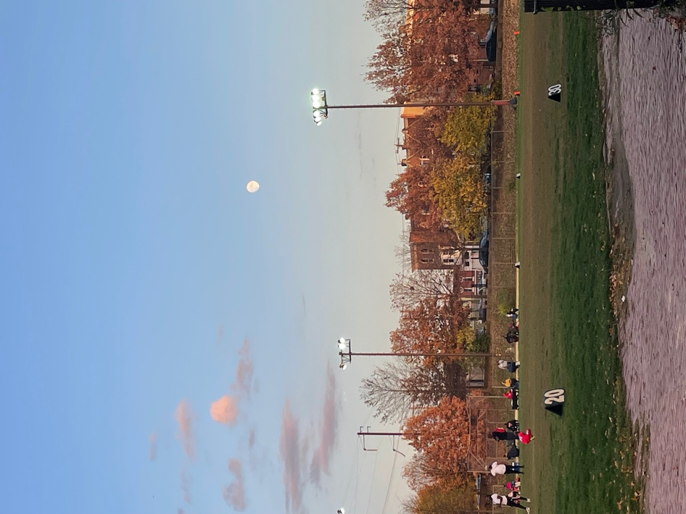
Day 19, Nov 5. Two photographs of the moon, taken in different locations in Philadelphia, received via text from different friends

Entry 23 reads, ‘I am home, and we have settled into mutual orientation.’ Where ‘once I spun, disoriented, now I spin more slowly, able to anticipate your position.’ I asked, ‘I know where you are. Do you know where I am too? Or is it that I know where I am as a result of knowing you?’ The perception described here is that because I connected with the moon’s location, I also knew my own location more clearly. César Esteban described a similar sense of connection to time and place because of his astronomical observations. He wrote, ‘it is difficult to explain what one feels… it is like receiving a message from the distant past, reliving an experience after centuries or millennia of being forgotten.’ Esteban described the connection to time, to the past, that observing celestial cycles engendered. His experience of enchantment parallels the sense of deepening orientation found in the Sky Journal.
Within the Sky Journal, there were several occasions when I experienced the moon ‘accompanying’ or ‘stalking’ me. On day 18 I took a long walk to pick-up spare house keys, and I was aware of the moon’s ‘witness.’

Day 18, Nov 4, 5:43pm. Waxing gibbous. Outside my house after I locked myself out.

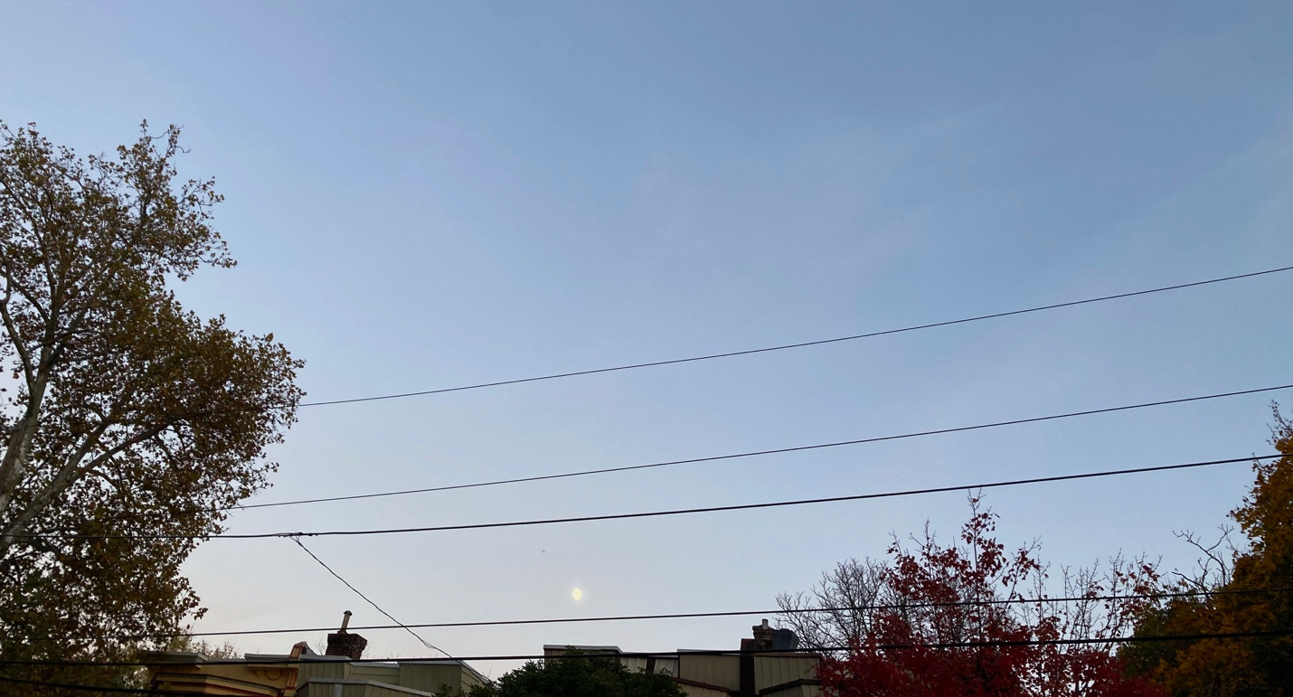
Day 18, Nov 4, 5:55pm. Three blocks down the street from my house, moon ‘watches’ while I walk to pick up keys
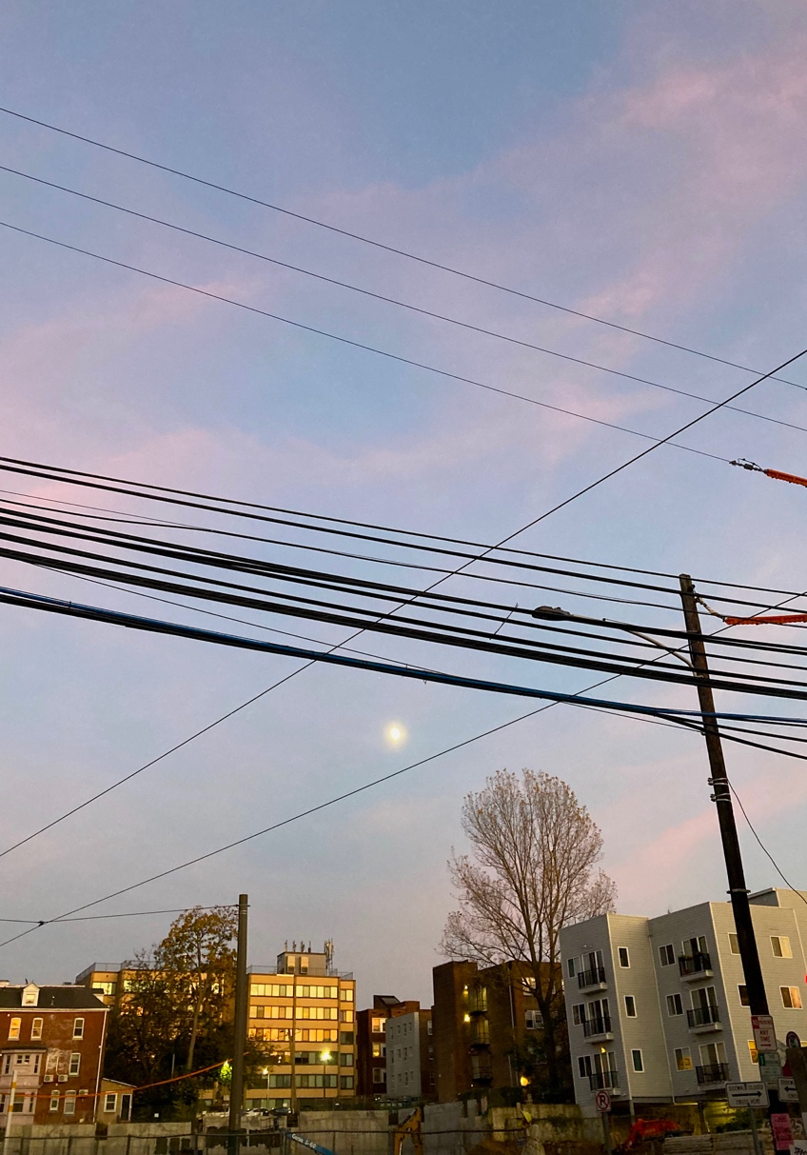
Day 18, Nov 4, 6:09pm. Sunsetting while the moon accompanies me on a walk. Above construction site.

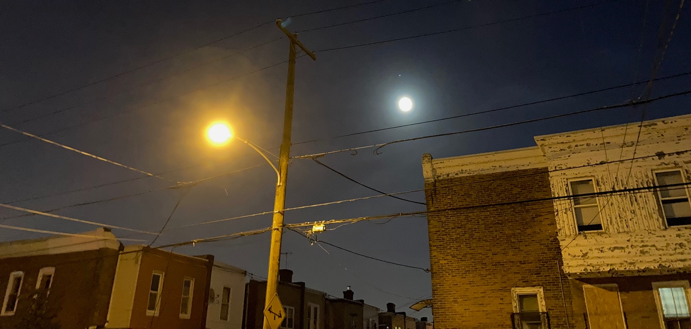
Day 18, Nov 4, 6:39pm. Moon on my block when I returned home, after the sunset.
Finally, on day 27, I reflected: ‘this corner [outside my home] will forever be different.’ Esteban’s experience and the Sky Journal’s findings suggest enchantment can be found through the sense of interconnection, belonging, and orientation in time and space that sky observations engender.

Day 27, Nov 13, 10:07pm. The corner of my block. Same view as day 2 of observation but also ‘forever changed’ (day 27).

Relationship
The third theme was a growing sense of connection and relationship. This took the form of deepening inter-personal relationship with other people, intra-personal relationship with emotionality, and attunement with the moon itself. It appeared in 20 entries. While sitting with a group of friends, I mentioned the moon journal and that I had not been able to see the moon for multiple days. When one friend later stepped outside to go home, she ‘texted that the moon was visible, and I ran outside.’ I felt grateful that she was attentive to the moon, too (day 13).
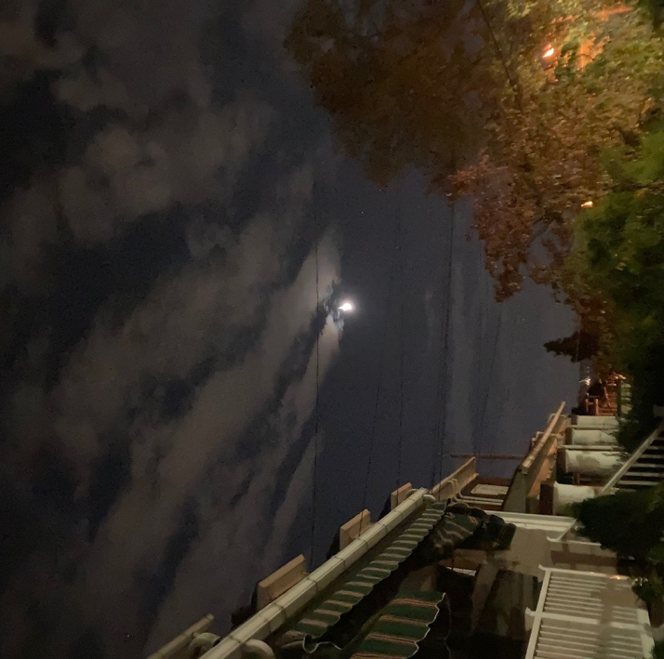
Day 12, Oct 29, 6:42pm. Before the moon was visible. In Day 12, Oct 29, 7:41pm. Same location, after a friend
Pittsburgh, PA. notified me about the moon
Day 17, a colleague greeted me by asking, ‘how is the moon?’ Many friends texted me moon photos, writing ‘I thought of you’ (day 19, 22, 26), and once I received a lengthy voice memo from a friend about her family celebrating Lunar New, and how the moon feels ‘cozy.’ ‘You are my moon friend,’ she closed. Because of the Journal, I heard new stories from old friends and connected in shared wonder with new acquaintances. The moon was a source of communion. Patrick Curry observed that enchantment exists as a ‘natural’ capacity present within people that ‘Weber’s thousand years of rationalization…have failed to entirely suppress.’ Through my attention to the moon, this natural capacity appeared present not only in me, but also within those around me and between us, in relationship.
As relationship to others deepened, so did the experience of attunement with my internal emotions and the moon. Day 8, I queried, ‘could I track the moon without looking?’ It seemed that even on a cloudy day, I could sense the moon. This experience reflects Coudert’s analysis of how the Romantics encountered enchantment through emotions. She quoted Andrea Wulf that Romantics believed ‘“nature must be experienced through feeling,” not numbers or abstract mathematics.’ Enchantment is an affective experience, so emotions allow access where abstractions do not. Coudert also cited Johann Wolfgang Goethe, that Nature ‘manifests her presence’ so much ‘that a blind man…can still comprehend an infinite vitality.’ Goethe’s enchantment perceiving the natural world without sight parallels the Sky Journal’s wonder about whether the moon could be experienced through felt perception.
When I could not see the moon ‘I feel out of whack, like holding my breath’ and ‘disconnected’ (day 11). One day before the full moon, I described the sense of emotional ‘peak-ness,’ commenting that the moon appeared more frequently and with more emotional impression when it was full (days 21-23). In Esotericism and the Academy, Wouter Hanegraaff also mentioned emotions as a point of access, noting the way someone is ‘dimly aware of an emotional response’ in connection with esoteric material. To Hanegraaff, emotions were a subtle cue.

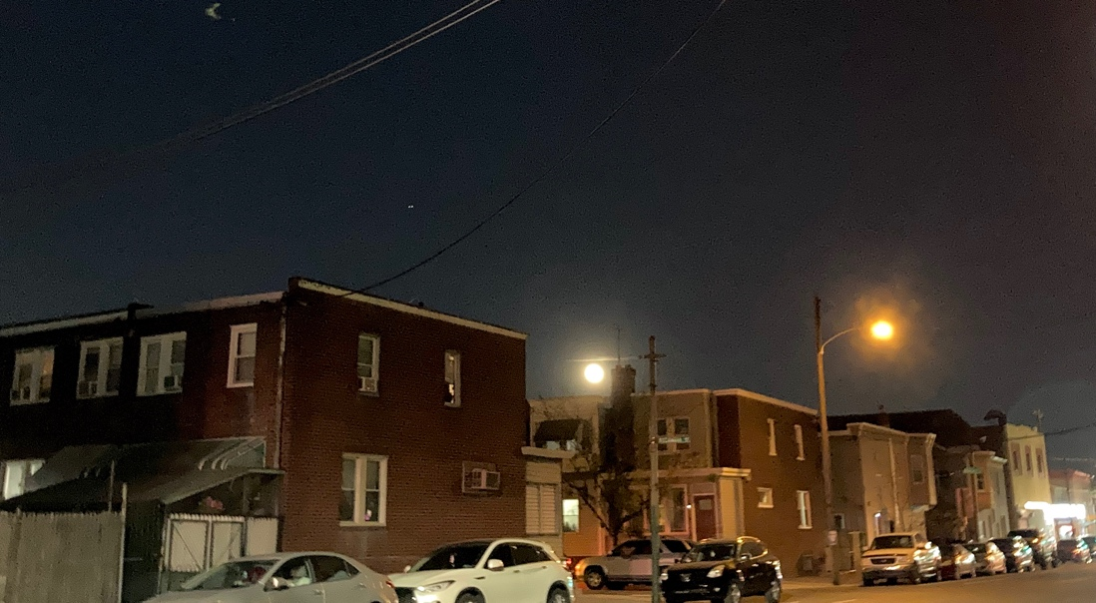
Day 21, Nov 8, 6:44pm. Full moon. Election day in Philadelphia and I felt a sense of ‘peak-ness.’

Day 22, Nov 9, 7:04am. Day after full moon. Moon directly in front of the car on the horizon as I drive on my commute to work

Mutuality and reciprocity
Lastly, a sense of mutuality and reciprocity emerged. This theme appeared 9 times, and mostly in the latter half of the month. On days 15 and 21, the moon woke me up as if it ‘called my name,’ pouring its light through my window and interrupting my sleep.
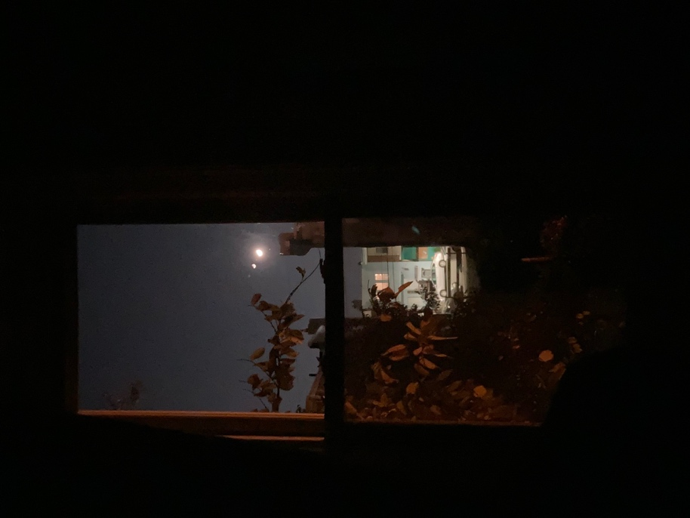
Day 15, Nov 1, 11:09pm. Waning moon shone through the window of my bedroom, waking me up.
Day 19 I wrote, ‘I don’t have to work so hard’ at observations. They were ‘less forced.’ Entry 22 and 27 described the moon’s ‘silent communication’ and ‘response to a call,’ like the cantare of enchantment. I reflected a shift from ‘influence’ to ‘internalization,’ following the ‘hard to shake sense that moon knows.’ Influence seemed too distant and ‘crude’ (day 23). Several entries were written to an animated and anthropomorphized moon. ‘Yes, I personify you, but not stupidly,’ I wrote, rationalizing the blurry line between the personal and the scientific tone of observations (day 23). What emerged in theme 4 was a reciprocal and mutually animated relationship in which the moon and I both played an active part. The experience of mutuality reflects Clive Ruggles’s discussion of how ‘the “natural world” does not exist as a separate objective reality in which the individual can be conceived as a passive observer.’ Ruggles identified this experience of being-with as a feature of various Indigenous cosmologies, but the sense of being part of the moon’s experience, rather than a separate observer, appeared in the Sky Journal as well.
Relatedly, Coudert described the fuzzy line between cognition and wonder among the Romantics. ‘While people could distinguish fact from fiction, they took pleasure in the blurred of the boundary between the two,’ so the relationship between objective cognition and subjective enchantment was one of choice. This blurred line is how enchantment exists in the Sky Journal, wherein entries about enchantment, intimacy, and animation of the moon wove together with passages grounded in objective, factual observations. The Journal toggled back and forth, sometimes referring to the moon as ‘it’ or an entity out there, sometimes describing experiences with the moon, with ‘her,’ or addressing the moon directly, ‘you.’ Personal, subjective and impersonal, objective understandings co-existed and blurred.
Lehoux took this idea a step further, suggesting the divide is overemphasized. His discussion centered astrology, but applies to enchantment too. He proposed, ‘an important way in which many treatments of astrology have failed us is in their tendency to overemphasize a disjunction in the methodology and epistemological standards across the great modern/premodern, or science/pseudoscience divides.’ Perhaps the disjunction between ‘science’ and ‘pseudoscience’ is not as pronounced as it has been repeatedly deemed, Lehoux proffered. One does not ‘cease being rational’ when considering a premodern discourse as true, or a discourse that defies scientific measure, like enchantment..
Hanegraaff also considered this idea of betweenness, arguing that esotericism is the ‘terra incognita’ in academic research. He noted how binary extremes are imposed on esoteric topics, which are either ‘avoided and ignored, or emulated as a source of inspiration.’ Such ideas are encountered in the ‘hard-to-define no-man’s-land,’ at the liminal in-betweens of disciplinary topics. Taken together, the four scholars reinforce the idea that enchantment can be found, by blurring, or by simply not overemphasizing, the divide between scientific and non-scientific epistemologies.

Conclusion
Coubert, Curry, Esteban, Hanegraaff, Lehoux, and Ruggles all demonstrated the continuance of enchantment, addressing both where and how enchantment exists in Weber’s Western, scientific, disenchanted world. Whether enchantment exists as a natural human faculty ‘subaltern’ to dominant discourse, as an inherent feature of life, through interconnection within time and space, by being part and participant in the moon’s experience, or at the blurring of epistemological dividing lines, the consistent conclusion was this: enchantment exists. Scholars’ theories echo and contextualize the themes of responsibility, orientation in place, deepening relationality, and mutuality that emerged during the Sky Journal observations. Through moon gazing, life indeed seemed enchanted, as Van Gogh suggested.

Reference List

Coudert, Allison, P., ‘Rethinking Max Weber’s Theory of Disenchantment,’ In Magic and Magicians in the Middle Ages and the Early Modern Time: The Occult in Pre-Modern Sciences, Medicine, Literature, Religion, and Astrology, ed. by Classen, Albrecht (Walter de Gruyter GmbH, 2017) <https://ebookcentral.proquest.com/lib/brynmawr/detail.action?docID=5116172> [accessed 12 November 2022]

Cambridge Dictionary, ‘Enchantment,’ (Cambridge University Press, 2022) <https://dictionary.cambridge.org/us/dictionary/english/enchantment> [accessed 12 November 2022].

Online Etymology Dictionary. ‘Enchantment’ (May 2020) <https://www.etymonline.com/word/enchantment> [accessed 12 Nov 2022]

Curry, Patrick, ‘Divination, Enchantment, and Platonism,’ in The Imaginal Cosmos ed. by Lall, Jean H., and Voss, Angela, (Canterbury: University of Kent, 2006) pp. 35-46. <http://www.patrickcurry.co.uk/papers/Divination.pdf> [accessed 15 November 2022]

Esteban, César, ‘Struggling for Interdisciplinarity: Reflections of an Astrophysicist Working in Cultural Astronomy,’ Culture and Cosmos, Vol. 18 No. 1 (Spring/Summer 2014) pp. 5-19. <http://www.cultureandcosmos.org/pdfs/18/18-1_esteban_astrophysicist.pdf> [accessed 15 November 2022]

Hanegraaff, Wouter, J., Esotericism and the Academy: Rejected Knowledge in Western Culture. (Cambridge: Cambridge University Press: 2012). <https://doi-org.proxy.brynmawr.edu/10.1017/CBO9781139048064>

Lehoux, Daryn. ‘Tomorrow’s News Today: Astrology, Fate, and the Way Out,’ Representations. Vol. 95, No. 1 (Summer 2006), pp. 105-122. <https://doi.org/10.1525/rep.2006.95.1.105>

Ruggles, Clive, ‘Indigenous Astronomies and Progress in Modern Astronomy’ In Accelerating the Rate of Astronomical Discovery by Norris, Ray and Ruggles, Clive, (Rio de Janeiro, Brazil: Special Session 5, IAU General Assembly, August 11-14 2009). <https://doi.org/10.48550/arXiv.1010.4873>

Weber, Max, Gerth, H. H., and Mills, Wright, From Max Weber: Essays in Sociology, (London and New York: Taylor & Francis Group, 2009)

Van Gogh, Vincent, and de Leeuw, Ronald, The Letters of Vincent Van Gogh, (London: Penguin Books, 1997) p.392

Gogh, Vincent van, and Ronald de Leeuw. The Letters of Vincent Van Gogh. London: Penguin Books, 1997, p.392
Max Weber, H. H. Gerth, and Wright Mills, From Max Weber: Essays in Sociology, (London and New York: Taylor & Francis Group, 2009)
Cambridge Dictionary, ‘Enchantment,’ (Cambridge University Press, 2022) <https://dictionary.cambridge.org/us/dictionary/english/enchantment> [accessed 12 November 2022].
Max Weber, H. H. Gerth, and Wright Mills, From Max Weber: Essays in Sociology. p. 139.
Ibis. p 139.
Allison P. Coudert, ‘Rethinking Max Weber’s Theory of Disenchantment,’ In Magic and Magicians in the Middle Ages and the Early Modern Time: The Occult in Pre-Modern Sciences, Medicine, Literature, Religion, and Astrology, ed. by Classen, Albrecht (Walter de Gruyter GmbH, 2017) <https://ebookcentral.proquest.com/lib/brynmawr/detail.action?docID=5116172> [accessed 12 November 2022]
Allison Coudert, ‘Rethinking Max Weber’s Theory of Disenchantment,’ p 707.
Ibis. p. 722.
Ibis. p. 708.
Ibis. P. 707.
Patrick Curry, ‘Divination, Enchantment, and Platonism,’ in The Imaginal Cosmos ed. by Jean H. Lall and Angela Voss, (Canterbury: University of Kent, 2006) pp. 35-46. <http://www.patrickcurry.co.uk/papers/Divination.pdf> [accessed 15 November 2022].
Patrick Curry, ‘Divination, Enchantment, and Platonism,’ p. 3.
Ibis. p. 7.
Ibis. p. 7.
Ibis. p. 11.
César Esteban, ‘Struggling for Interdisciplinarity: Reflections of an Astrophysicist Working in Cultural Astronomy,’ Culture and Cosmos, Vol. 18 No. 1 (Spring/Summer 2014) pp. 5-19. <http://www.cultureandcosmos.org/pdfs/18/18-1_esteban_astrophysicist.pdf> [accessed 15 November 2022]. p. 19.
César Esteban, ‘Struggling for Interdisciplinarity: Reflections of an Astrophysicist Working in Cultural Astronomy.’ p. 19.
Ibis p. 11.
Coudert, ‘Rethinking Max Weber’s Theory of Disenchantment,’ p. 732
Ibis. p. 731
Wouter J. Hanegraaff, Esotericism and the Academy: Rejected Knowledge in Western Culture, (Cambridge: Cambridge University Press: 2012). <https://doi-org.proxy.brynmawr.edu/10.1017/CBO9781139048064> p 1.
Clive Ruggles, ‘Indigenous Astronomies and Progress in Modern Astronomy’ In Accelerating the Rate of Astronomical Discovery by Ray Norris and Clive Ruggles (Rio de Janeiro, Brazil: Special Session 5, IAU General Assembly, August 11-14 2009). <https://doi.org/10.48550/arXiv.1010.4873> p. 6.
Ibis. p 739.
Daryn Lehoux, ‘Tomorrow’s News Today: Astrology, Fate, and the Way Out,’ Representations. Vol. 95, No. 1 (Summer 2006), pp. 105-122. <https://doi.org/10.1525/rep.2006.95.1.105>
Lehoux, ‘Tomorrow’s News Today: Astrology, Fate, and the Way Out.’ p. 119
Ibis. p 119.
Wouter J. Hanegraaff, Esotericism and the Academy: Rejected Knowledge in Western Culture, p 2.
Hanegraaff. p 2.
Hanegraaff. p 1.
Curry, ‘Divination, Enchantment, and Platonism,’ p. 7.
Coudert, ‘Rethinking Max Weber’s Theory of Disenchantment.’
Esteban, ‘Struggling for Interdisciplinarity: Reflections of an Astrophysicist Working in Cultural Astronomy,’ p. 19.
Ruggles, ‘Indigenous Astronomies and Progress in Modern Astronomy.’
Lehoux, ‘Tomorrow’s News Today: Astrology, Fate, and the Way Out,’ p 119.
Van Gogh, and de Leeuw, The Letters of Vincent Van Gogh, p. 392.

