Exploring Literacy Barriers.
Donna Smith – 1707573
Portfolio of Evidence critically exploring the impact of using specific resource and/ or programme to support learning.
Overview.
This portfolio will discuss the learner’s Additional Learning Need (ALN) and the resources used to achieve his braille qualification from the RNIB. The learner is a pupil with Visual Impairment. Below is a pen picture of the pupil’s ALN needs.
- The learner has no vision in his right eye and significantly reduced vision in his left eye due to Retinopathy of Prematurity. Consequently, he is registered blind / severely visually impaired.
- The learner has learned to use his functional vision (in his left eye) well, and uses it effectively in group and paired tasks. However, extended periods of time reading results in severe visual fatigue, so all resources for written and individual tasks should be produced in tactile format / braille.
- If any tasks are in print format, the font size should be a minimum of size 28. The font style should be Comic Sans or Arial and presented on A4 size paper. Enlarging the page is not advisable.
- The learner also has Nystagmus (involuntary movement of the eye) resulting in him displaying a ‘face turn to the left and chin dip’ head tilt. This position should not be corrected as he has found this the best to focus.
- The pupil is a happy pupil who has settled well into secondary school with very few transitional issues, with the aid of 1:1 support.
- He currently has 1:1 provision and this full time support is essential for the learner to access the curriculum within the school setting.
- He needs to be appropriately seated during lesson times.
- His LSA will need to work closely with all class teachers in order to present all curriculum activities through both a tactile / sensory medium, with Braille being a literacy medium.
- To adapt all learning materials into Braille / tactile form requires 1:1 support from staff who are able to adapt print into Grade 2 Braille / raised diagrams, which is time consuming and requires extra time being allowed to his LSA.
- The learner continues to receive the benefit of sensory /tactile activities by using the school’s VI room.

Specialist equipment includes an Apex Braille note taker, an iPad and Perky Duck program on the desktop. The learner is capable of independently carrying and using both resources. With support in place, the learner is coping well and gaining more independence in his school life. However, staff should be aware that any knock to the head could be extremely damaging to the learner’s remaining eyesight, therefore the learner is not to be put in any contact situations, e.g. competitive/contact games (Pembrokeshire County Council, 2021).
The program and resource used is the Braille Translation Software from Duxbury systems. The website states, “Duxbury systems leads the world in software for braille” (Duxbury Systems Inc, 2021). Virtually all world leading braille publishers use the Duxbury Braille translator (Duxbury Systems Inc, 2021) and DBT supports over 170 languages in either uncontracted or contracted braille. The software can provide contracted and uncontracted literacy, maths and technical braille (Duxbury Systems Inc, 2021). The software is downloaded onto Windows on the desktop computer, on an application called “Perky Duck” (Duxbury Systems Inc, 2021). Perky Duck is a similar set-up to a word document, when clicking “file and new” it brings up a new page. The learner can then start typing in braille using the letters “S, D, F and J, K, L” in different combinations to type the braille symbols. When the learner has finished their work, they can save it and print it out on paper in text or it can be embossed. This means it will be printed out on an embosser (braille printer) in braille format. The other resource used is the “Perkins Brailler”, which the manufacturers claim is “the most widely used mechanical braille writer in the world since being invented in 1951” (Perkins, 2021). It is a durable braille-writing machine used by people of all ages to produce braille for school, work or leisure (RNIB Shop, 2021). It uses wide length paper for maths and literacy work. The cost of one is £749.00 (RNIB Shop, 2021), however the local authority provided the learner with a Perkins Brailler at the age of 5, and they still have the same one now, as it gets serviced each year. The project will now demonstrate how the learner uses the resource and program for braille lessons, progressing to examining the braille resource.

Evidence of Observation.
Within the evidence from the observation, this project will show the learner’s progress to prepare for the braille examination. This will be using the original plan of observation up until lockdown, and how it was extended to complete the examination the following March 2021. The original plan ran from January 16th 2020 to sitting the exam in the summer term of 2020. From January 16^{th,} the learner had fifteen weeks of preparation lessons, having two lessons per week. In the preparation lessons, the learner worked from the “Unified English Braille PRIMER” (RNIB, 2013). The PRIMER is a book provided by the RNIB to prepare the learner for the exam. The PRIMER contains twenty-nine lessons and practice test papers (RNIB Shop, 2021). Each lesson builds up the knowledge stage by stage. However, as the learner can already read braille he has a smaller period to work through the PRIMER. A non-braillist would have a year to complete the work and sit a number of assessments before doing the exam. As the learner can read braille, he will only be entered for one practice paper and the exam.
The learner’s progress was recorded on a monitoring chart and dated. This showed the progress week by week of what the learner had completed. The work was completed on either Perky Duck or the PRIMER, starting with the alphabet, lessons 1-4 in the PRIMER (see appendix 1). Lesson 4, alphabetical word signs, shows how to use single letters to represent words, for example “b meaning but” and “m meaning more” (RNIB, 2013) - see Appendix 2 for example; also Appendix 3 for monitoring chart progress. Following this progress, lesson 5 tested the learner’s knowledge of “strong” contractions. This means special signs for common words such as “and, for and with” (RNIB, 2013)(see Appendix 4 for example of lesson 5, and Appendix 5 for monitoring. Examples of completed work in braille for lesson 5 are shown in Appendix 6). On the 13th of March 2020 was the last lesson, this was lesson 7 (appendix 7). After this week the school closed, meaning the preparation for the braille exam in the summer term was postponed. However, the VI teacher kept in contact and was emailing the LSA comprehensions to be sent to the learner to complete at home on his Perkins, which were posted to the VI teacher to mark. On returning to school in September 2020, the learner was now in year 11. He was continuing the same method of completing work at home and sending it to the VI teacher as he was often off as his year group had to isolate: this continued in the second lockdown in January 2021. On returning to school in March 2021, the learner had been entered to sit the examination on the 24th of March. With this short period, the learner sat a practice exam that was marked by the RNIB; the learner failed this exam with a few minor mistakes. However, he went on to sit his examination and passed with a C grade braille qualification, making him bilingual in English and braille.

Theoretical framework
Louis Braille invented braille. He was born in 1809, and was blinded by an accident when he was three (Biography, 2020). He was educated at the National Institute for Blind Youth in Paris. He invented the system of raised dots that enables blind people to read and write that bears his name “Braille” (Survey of Opthamology, 2009). This revolutionary system has allowed blind people to access written culture, and is now considered a major advantage in quality of life for blind people (Survey of Opthamology, 2009).Originally, Charles Barbier de la Serre invented a raised alphabet; Charles was born in 1767, and created a language by touch designed for military and secret use. Louis Braille then modified this alphabet into the braille alphabet, practically the same alphabet is used today (Survey of Opthamology, 2009).
Throughout the years, more countries around the world started to recognise the braille system. However, “of all the countries with European-based languages, the U.S. took the longest to accept the braille system” (Survey of Opthamology, 2009). By the 1950’s braille was used throughout the world, although the adaptation of the braille system to oriental languages was particularly difficult, as systems such as Japanese use syllabic writing (Survey of Opthamology, 2009). However countries using syllabic writing have since adapted and modified braille so it is accessible to them. In February 2005, on “International Mother Language Day” they chose to highlight Braille System as a “Vital language of Communication” (Survey of Opthamology, 2009). Braille is as legitimate as all the other languages in the world (Survey of Opthamology, 2009).
In the United Kingdom, Thomas Rhodes Armitage was a wealthy physician who also had sight problems himself (RNIB, 2012). Thomas and a group of blind people founded The British and Foreign Society for Improving the Embossed Literature for the Blind (RNIB, 2012). In 1870, they made the decision that braille would be the best choice for Britain. His group later went on to become The Royal National Institute for the Blind (RNIB) (RNIB, 2021). Since the 1880’s braille has developed dramatically, and the RNIB published the first braille magazine “Progress” in April 1871, making people with no vision included when other people with disabilities were not included or given support (RNIB, 2021). By 1907, braille had a weekly edition of the Daily Mail, and in 1927, the first braille Radio Times was published (RNIB, 2021).
As braille was established in the United Kingdom, the RNIB has developed a specialist Visual Impaired (VI) Curriculum Framework (RNIB, 2021), supporting an estimate of 25,000 children and young people in England and Wales with VI that need specialist educational support (RNIB, 2021). The RNIB provide educational resources such as the RNIB book share, which gives free access to textbooks for learning, and the Perkins Brailler, used in schools and examinations (RNIB, 2021). For younger children the RNIB provide braille alphabet tools to support with learning. At GCSE level, they provide the learner books in braille (RNIB, 2021). The Welsh Government has also put in place support for children in education with Visual Impairment (Welsh Government , 2019). By “ensuring young people have fair and optimised access to the school curriculum”, they also want to “ensure young people have opportunities to develop their independence and social inclusion (Welsh Government , 2019)”.

Reflective Placement Diary

What happened?

What went well? | The Braille lessons went well, as the pupil already can read and write in braille. The lessons are for the pupil to prepare for the braille examination.  Before being in lockdown, the pupil was making great progress in the braille lessons.
What were the main challenges / problems/ difficulties you faced? | Cannot read braille; being in lockdown the Visual Impaired (VI) teacher from the local authority send work to the LSA, to be sent on to the learner. When the learner completed lessons, the learner posted the braille to the VI teacher to be marked; therefore the process took a lot longer.
How did you react to the challenges? | The challenges are a good learning experience, and helped to learn a new skill within the role of an LSA. Supporting a braillist was daunting at first, however the learner is an experience braillist and enjoyed helping when the LSA was unsure about any braille reading.
How did you feel? | Not confidant at first, as the LSA cannot read braille, and not familiar with the equipment and program.
What surprised you? | After a few lessons, getting familiar with the equipment made supporting the learner a lot easier even knowing the LSA could not read braille.
What were you familiar with? | Was not familiar with braille and it is a completely different language.  The only element that was a familiar part of the “Perky Duck” program is a familiar layout to a word document.
Have your beliefs and expectations changed or been challenged? | Yes, beliefs and expectations have changed, the learner can still access the curriculum the same with a visual impairment, also achieving a qualification in braille making the learner a bilingual learner.

Critiquing your experience

How well did you think you managed the challenging situation? | Very well as there was an LSA braillist in school. However taking over from this LSA has been challenging at first, managed the situation well as the pupil achieved a braille qualification.
Has this experience changed your mind or opinion in any way? | Yes, made me more determined to finish my braille training and qualification to go on to work with other Visual Impaired children in the future.
Were you given any feedback (formal or informal)? Can you seek further advice from anyone in order to give you another perspective? | Further feedback from the Visual Impairment teacher, given informal advice on how well the learner was supported, as she could not come into school to support in braille lessons due to the pandemic.  The VI teacher supporting the LSA when needed advice for examination preparation.
Is there any other reading or research you could follow up regarding the subject matter? | Using the same resources as the learner to support with the knowledge to learn braille, to then support other children with Visual Impairment
What skills do you need to develop to address this incident more effectively in the future? | The completion of braille training.
What conclusions have you drawn? | Even knowing the LSA was not a braille user and could not read braille or use the equipment, the result of the learner passing the braille exam with a C grade at GCSE was brilliant, especially given the learner had to be supported via virtual learning due to the pandemic.

What next?

Given the same event; would you do anything-different next time? | No, keep putting in 100% support to the learner who can still achieve and access the curriculum the same as their peers.
What are the key lessons learned for future use? | Adapting to different ways of leaning has made the LSA more confident within the job role.
How might your learning feed into your assignment/s? | The learner would feel supported, the learner was happy with the final grade achieved.

Evaluation
To evaluate the positives and the negatives the learner and LSA faced when using the resource the Perkins Brallier and Perky Duck program, it should be acknowledged that the learner, as always, worked to the best of his ability facing barriers within school and accessing the curriculum. The positive aspect when using the resource and program was that he has been using them from a young age so it is easy for him to use, giving the learner confidence in completing his preparation and achieving his braille qualification. On the other hand, the LSA had a more tentative approach to the resource and program, not being a braillist and having little knowledge on how they both worked. With the support of the VI teacher and the learner by showing how it all worked, the LSA now has more confidence in supporting the learner and she knows how it all works even though she cannot read braille. Within school and at home via on line learning, the LSA could have a greater impact to the learner by learning braille and finishing the braille course; this will enable the LSA to support the learner being bilingual the same as the pupil, thereby giving him full support.

Appendices
Appendix 1 (RNIB, 2013)
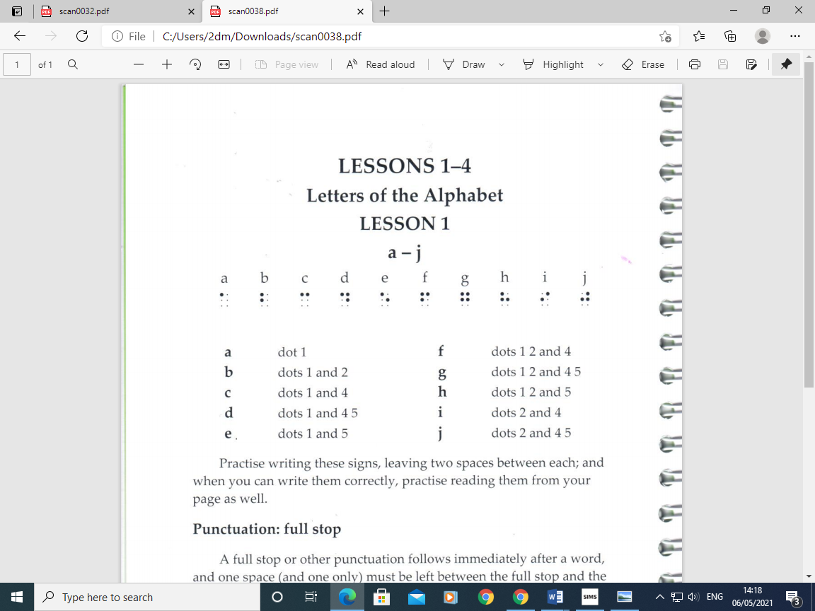

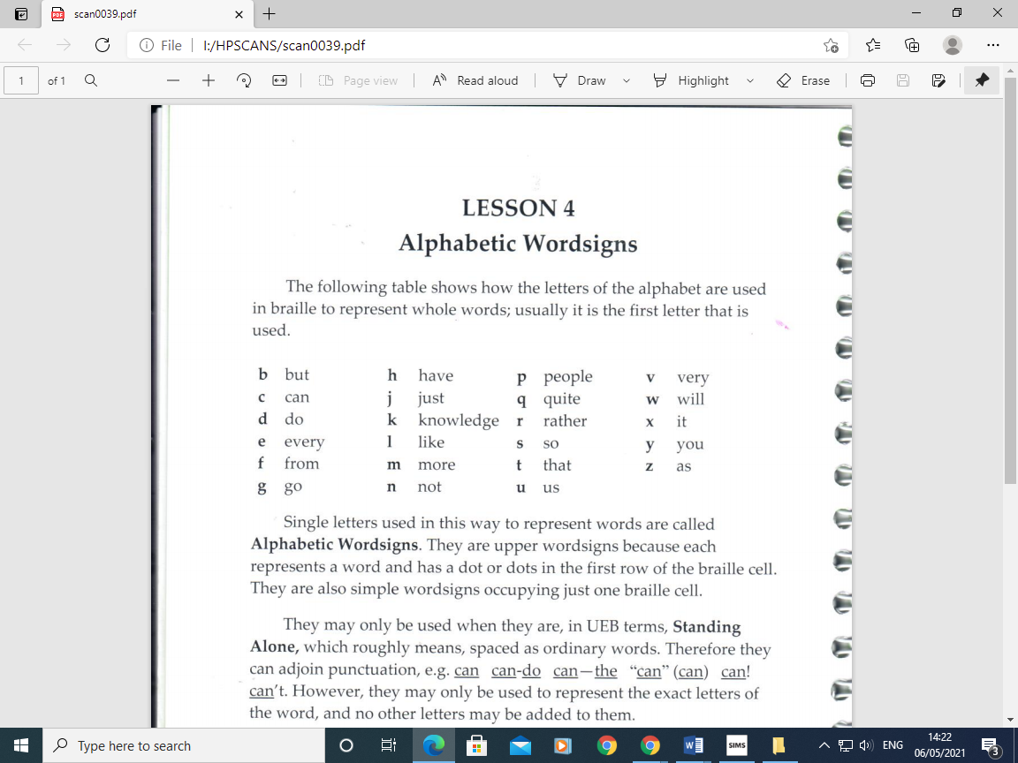
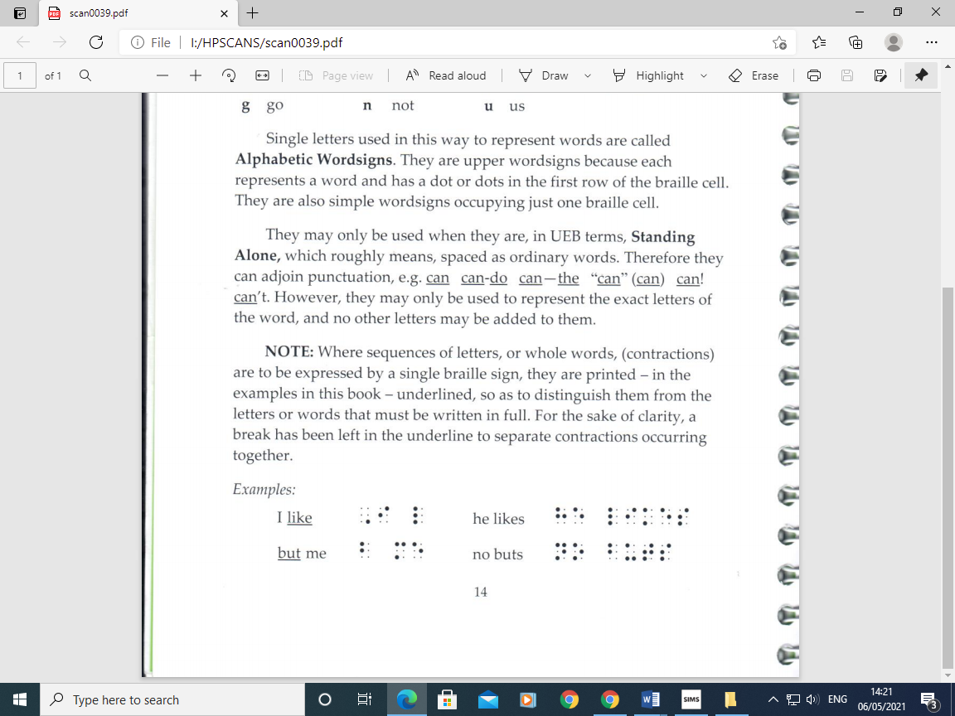
Appendix 2 (RNIB, 2013)

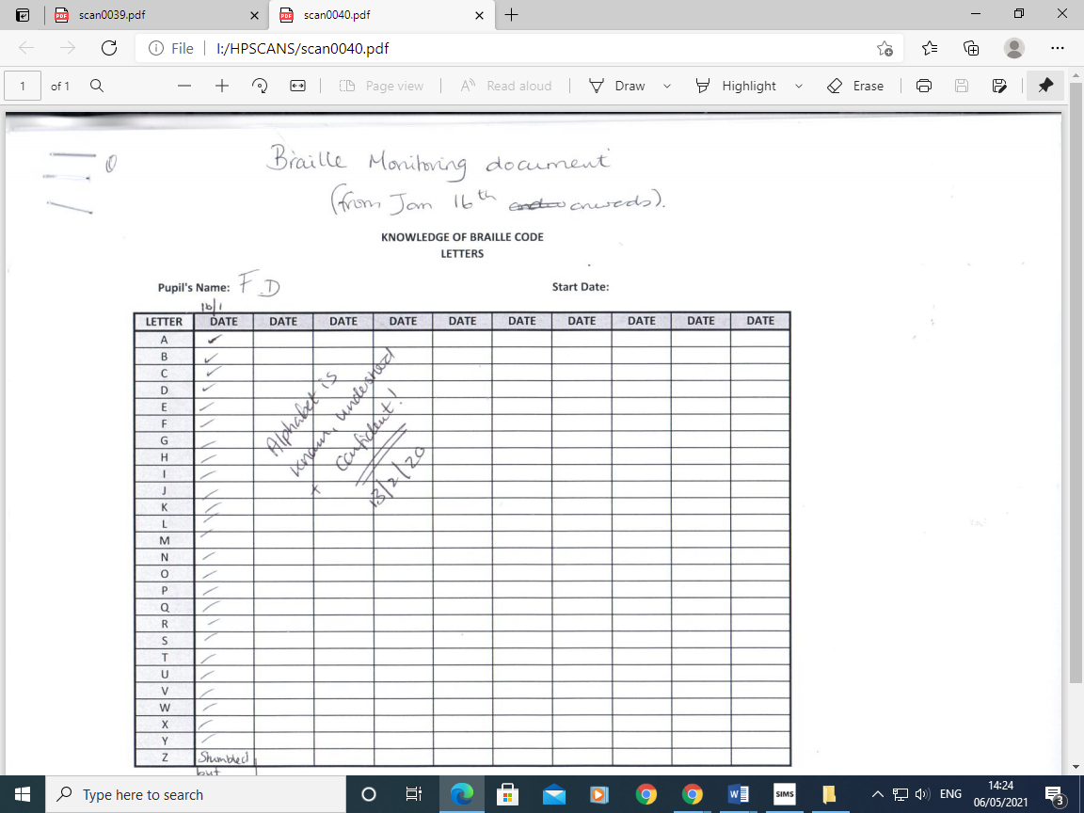
Appendix 3 (School A, 2020)

Appendix 4 (RNIB, 2013)
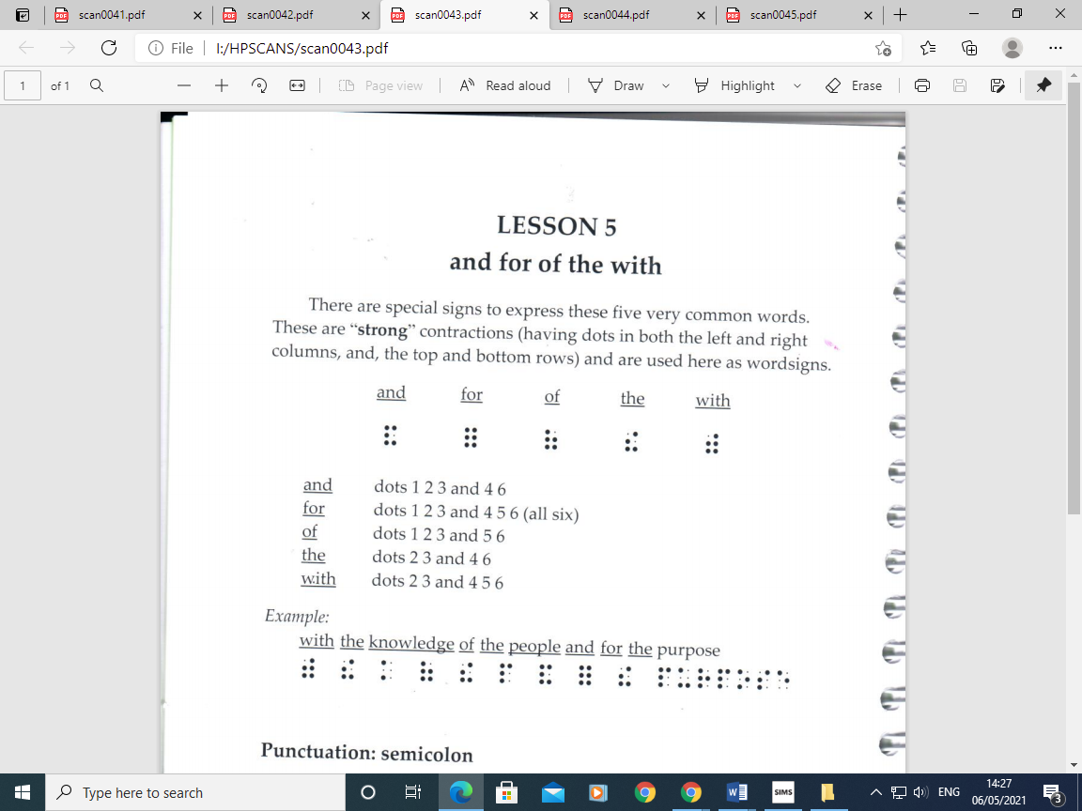
Appendix 5 (School A, 2020)
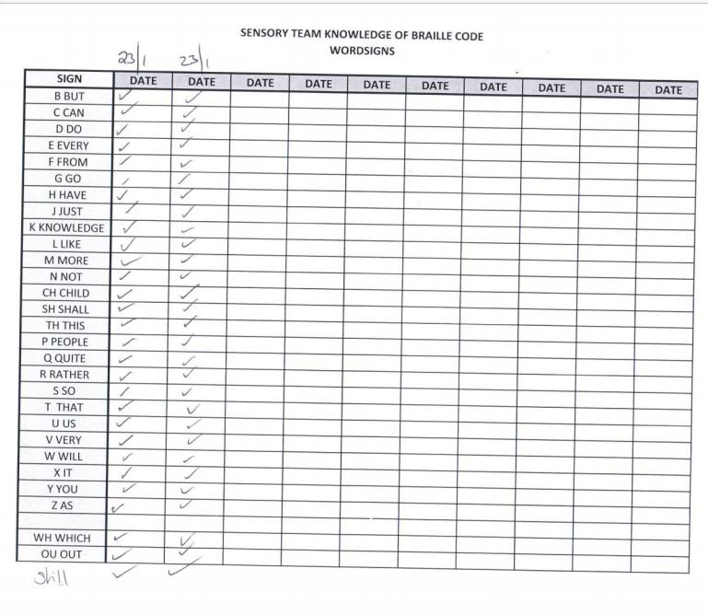

Appendix 6 (School A, 2020)
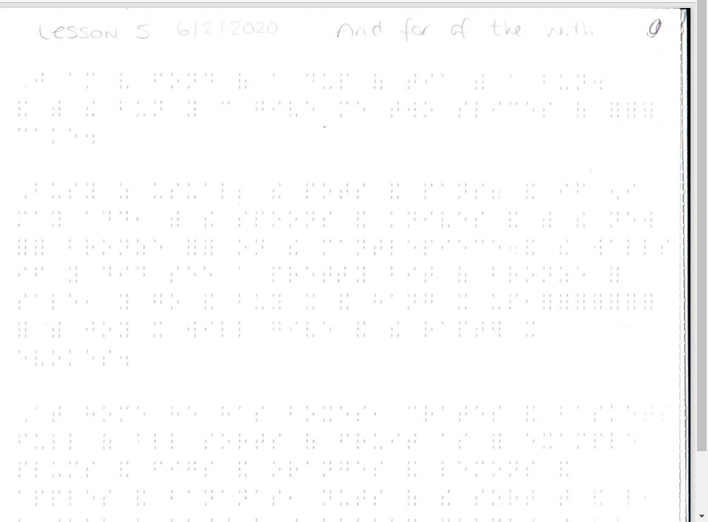
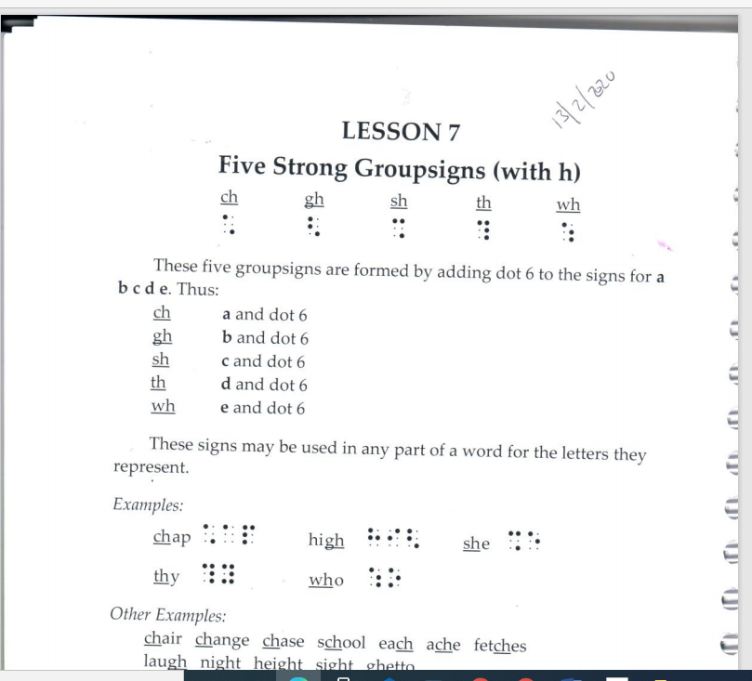
Appendix 7 (RNIB, 2013) (School A, 2020)

References
Biography, 2020. Louis Braille. [Online]
Available at: http://www.biography.com/scholar/louis-braille
[Accessed 29 April 2021].
Duxbury Systems Inc, 2021. Duxbury DBT: Braille Translation Softwear. [Online]
Available at: https://www.duxburysystems.com/default.asp
[Accessed 29 April 2021].
Pembrokeshire County Council, 2021. Pen Picture , Pembroke : YHT.
Perkins, 2021. Perkins Brailler. [Online]
Available at: http://www.brailer.perkins.org/pages/perkins-brailler
[Accessed 29 April 2021].
RNIB Shop, 2021. Perkins Classic Brailler. [Online]
Available at: https://shop.rnib.org.uk/perkins-classic-brailler?gclid=Cj0KCQjw1a6EBhC0ARIsAOiTkrG97ScFQUYyfwd2hU9yR6sb7iM5Vt5hKjM67Hl9hohUbckcO1Usfb8aAoT_EALw_wcB
[Accessed 29 April 2021].
RNIB, 2012. Invention of Braille. [Online]
Available at: https://www.rnib.org.uk/braille-and-other-tactile-codes-portal-braille-past-present-and-future/invention-braille
[Accessed 29 April 2013].
RNIB, 2013. Unified English Braille PRIMER. First ed. Peterbourough: Royal National Institute of Blind People .
RNIB, 2021. Education Professionals. [Online]
Available at: https://www.rnib.org.uk/services-we-offer-advice-professionals/education-professionals
[Accessed 29 April 2021].
RNIB, 2021. RNIB Factsheet, London: RNIB.
School A, 2020. Recording of work. Pembrokeshire: Unpublished.
Survey of Opthamology, 2009. History of Opthalmology. In: M. Marmor, ed. Biography of Louis Braille and Invention of the Braille Alphabet. s.l.:Elsevier Inc, pp. 142-149.
Welsh Government , 2019. Support for children and young people with vision impairment in educational setting. [Online]
Available at: https://gov.wales/sites/default/files/publications/2019-12/191209-support-for-children-and-young-people-with-vision-impairment-in-educational-settings.pdf
[Accessed 13 April 2021].

