8/17/2002026
University of Wales Trinity Saint David
London campus
SPC Assignment on
Smart Home Device Manager System for Bright Minds Academy
Module Name: Scripting and Programming Concepts
Module Code: ACCA 5036

Student Name: Mauricio Honorato Acordi
Student ID:2429788

Lecturer’s Name: Koushik Modak

Code Link: : https://github.com/mauriciohonoratoacordi-sys/smart-home-device.

Table of Contents
Introduction 2
1. Analysis 2
Requirements Analysis 2
Functional Requirements 3
Non-Functional Requirements 3
SDLC Model Chosen 4
2. Software Design and Development 5
a) Design 5
Flowchart 5
Pseudocode 6
b) Implementation Decisions 8
Data Structures 8
Programming Constructs 8
Python Modules and Libraries 9
c) Source Code 9
3. Testing and Debugging Report 16
a) Importance of Programme Testing 16
b) Types of Errors 16
c) Test Cases 17
4. Evaluation 21
Challenges Faced 21
Future Improvements 22
Self-Reflection 22
Conclusion 22
References 23

Introduction

Bright Minds Academy is a small private tutoring centre known for its personalised, one-to-one approach to teaching. As part of an effort to modernise its facilities, the centre has begun piloting a smart classroom setup, connecting devices such as smart lights, thermostats and projectors to a shared system. The intention behind this pilot is straightforward: give tutors more control over their teaching environment and reduce the amount of manual adjustment needed during a lesson. In practice, however, the pilot has created a new problem rather than solving one. The devices themselves work, but the centre has no organised way of keeping track of them.
At present, staff manage these devices manually, which in this context means relying on memory, verbal handovers between tutors, and occasionally a handwritten note left in the staff room. This works reasonably well while there are only a handful of devices, but it breaks down quickly as more are added. Staff report difficulty knowing which devices are actually connected to the system, what each device's current status is, and when it was last checked or used. A projector that stops responding in Room 204 might not be noticed until a tutor walks in for their lesson and finds it unresponsive, and there is no record showing whether the fault has already been reported or when it started. A smart light left switched on overnight in an empty room goes unnoticed until someone happens to walk past it. None of this is a fault in the devices themselves; it is a gap in how the centre records and shares information about them.
This project addresses that gap directly. Bright Minds Academy needs a simple, centre-specific tool that lets any member of staff, regardless of technical background, register a device once, update its status as circumstances change, and look up a device's location and status in a matter of seconds. Given the size of the pilot, a full database system or a networked application would be disproportionate to the actual problem; a lightweight, locally run Python program that keeps its data in memory during a session is a better match for the centre's size, budget and technical capacity. The following sections set out the requirements identified from the brief, the design and implementation decisions made in building the solution, the testing carried out to confirm it behaves correctly, and a reflection on the process of building it.

Analysis

Requirements Analysis
Working through the scenario using abstraction and problem decomposition, the task can be reduced to a single underlying need: a shared, editable record of devices that any member of staff can create, change and read without needing to understand how the underlying program works. Breaking this down further into smaller, independent pieces made it possible to treat each requirement as a separate, testable unit rather than one large, tangled feature [1]. The functional and non-functional requirements below were derived directly from the task brief, then expanded slightly to capture what a working version of the system would realistically need.
Functional Requirements
Add new devices. Staff can register a new device, such as "Smart Light A1" or "Projector B2", along with the room it is located in.
Update device status. Staff can mark an existing device as online, offline, or under maintenance to reflect its current condition.
View device list. Staff can see every device currently stored, along with its location and status, in a single view.
Simple search. Staff can locate a specific device by name and retrieve its status and location without scanning the full list.
User-friendly interface. As the system is intended for tutors and administrative staff rather than developers, it uses a numbered text menu with clear confirmation and error messages.
Scalability. The list of dictionaries used to store devices can accommodate any number of entries without requiring changes to the underlying structure as the pilot grows.

Non-Functional Requirements
Reliability. The data staff see needs to be accurate and consistent every time they look at it. Because every update goes through the same function and the same validation rules, a device's status cannot end up recorded differently in two places, and a device cannot silently disappear from the list.
Performance. Staff will typically be using this system in short bursts, between lessons or while a class is running, so every operation, adding, updating, viewing or searching, needs to return an answer immediately rather than making the user wait. Holding all data in memory rather than reading from a file or a network connection removes any noticeable delay at this scale.
Security. In the context of this project, security means protecting the integrity of the data during a session rather than defending against external attackers. The clearest example is preventing two devices from silently sharing the same name, since that would make it impossible to tell which device a later update was actually referring to.
Accessibility. The interface needs to make sense to someone with no programming background. This ruled out anything that relies on technical jargon, error codes or unexplained abbreviations; every message the program shows is written in plain language.
Taken together, these requirements describe a solution that does not need a database, real-time device control, or automation, which matches what the brief explicitly says is out of scope. Python's built-in lists and dictionaries are sufficient to hold this data for the duration of a session, and a text-based menu is sufficient to make the four core functions accessible to non-technical staff.

SDLC Model Chosen
This project followed a Waterfall approach to the Software Development Life Cycle, moving sequentially through Analysis, Design, Implementation, and Testing and Debugging, with Documentation running alongside each stage rather than being left until the end. A Waterfall model suits a project of this size and fixed scope: the requirements were clearly defined at the outset by the task brief and did not change during development, there is a single developer rather than a team that would benefit from iterative check-ins, and the deliverable is a finished, working program rather than a product that will keep evolving after submission [2]. A more iterative model, such as Agile, is better suited to projects where requirements are expected to shift or where feedback from users needs to be built back into the design partway through, neither of which applied here.

2. Software Design and Development

a) Design
Before writing any code, the logic of the program was worked out on paper in two stages: a flowchart showing the overall flow of control through the menu, and pseudocode for each of the four core functions. Designing the algorithm this way, rather than writing Python directly, made it easier to spot logical gaps early, for example realising that update_device_status needed to check whether the devices list was empty before searching it, which was not obvious until the flow was mapped out step by step [3].

Flowchart:
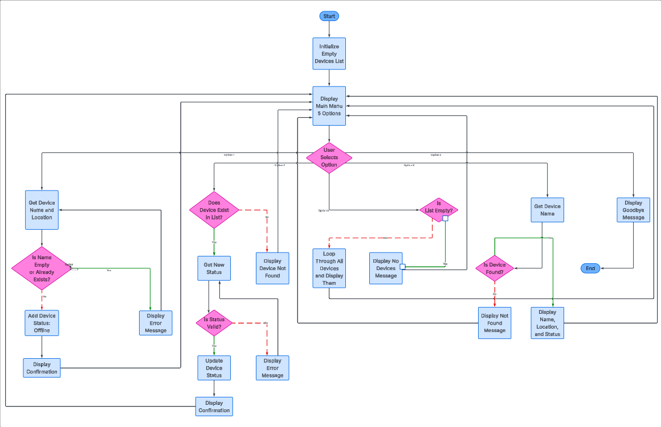
The flowchart above represents the overall flow of control through the program. It begins by initialising an empty list to hold devices, then enters a loop that displays the main menu and waits for the user to select one of five options. Each option branches into its own sequence of steps before returning control back to the main menu, so the program keeps running until the user chooses to exit [4].
Option 1 (Add Device) collects a device name and location, then checks whether the name is empty or already exists in the list; if either condition is true, an error message is shown and the user is asked to enter the details again, otherwise the device is added with a default status of offline. Option 2 (Update Device Status) first checks whether the device exists in the list; if it does not, the user is informed and returned to the menu. If it does exist, the user enters a new status, which is validated against the three accepted values before the device record is updated. Option 3 (View Device List) checks whether the list is empty and either displays a message saying no devices have been added, or loops through the list and displays every device's name, location and status. Option 4 (Search Device) asks for a device name and checks whether a match exists in the list, displaying either the device's details or a not-found message. Option 5 exits the program.
This structure was chosen because it keeps each of the four core functionalities isolated from the others while sharing the same menu loop, which mirrors how the program is organised in code: one function per option, each returning control back to main() once it finishes.

Pseudocode
The pseudocode below sets out the logic for each of the four core functionalities before they were translated into Python. Writing this first meant that decisions about validation, for example rejecting an empty device name or an invalid status, were made deliberately during design rather than being patched in after testing revealed a gap [5].
ADD DEVICE
BEGIN
REPEAT
PROMPT "Enter device name"
name <- INPUT
IF name is empty OR name already exists in devices THEN
DISPLAY error message
END IF
UNTIL name is valid
REPEAT
PROMPT "Enter device location"
location <- INPUT
IF location is empty THEN
DISPLAY error message
END IF
UNTIL location is valid
CREATE device record {name, location, status = "offline"}
APPEND device record TO devices list
DISPLAY confirmation message
END
UPDATE DEVICE STATUS
BEGIN
IF devices list is empty THEN
DISPLAY "no devices to update" AND EXIT
END IF
PROMPT "Enter device name"
name <- INPUT
SEARCH devices list FOR matching name
IF not found THEN
DISPLAY "device not found" AND EXIT
END IF
REPEAT
PROMPT "Enter new status"
status <- INPUT
IF status NOT IN {online, offline, under maintenance} THEN
DISPLAY error message
END IF
UNTIL status is valid
SET device.status <- status
DISPLAY confirmation message
END
VIEW DEVICE LIST
BEGIN
IF devices list is empty THEN
DISPLAY "no devices added yet"
ELSE
FOR EACH device IN devices list
DISPLAY device.name, device.location, device.status
END FOR
END IF
END
SEARCH DEVICE
BEGIN
PROMPT "Enter device name to search"
name <- INPUT
FOR EACH device IN devices list
IF device.name matches name THEN
DISPLAY device.name, device.location, device.status
EXIT
END IF
END FOR
DISPLAY "device not found"
END

b) Implementation Decisions

Data Structures
Each device is stored as a dictionary with three keys: name, location and status. All devices are held together in a single list called devices, which is created empty when the program starts and passed into every function that needs to read or change it. A list of dictionaries was chosen over three separate lists (one for names, one for locations, one for statuses) because it keeps each device's data grouped together; adding or removing a device is a single operation on one list rather than three lists that have to stay in sync. A constant list, VALID_STATUSES, holds the three status values the program accepts, so the validation rule is defined once and reused wherever a status is checked [6].

Programming Constructs
Four main constructs hold this program together. Selection, the if/elif/else blocks, routes the menu to the right function and separates good input from bad input inside each one. Iteration shows up in two forms: while loops keep asking for input until it's valid, since there's no way to know in advance how many tries someone will need, and for loops handle searching through the list and printing it out, since the number of devices isn't fixed either [7].
Breaking the program into separate functions, add_device, update_device_status, view_devices, search_device, get_menu_choice and main, wasn't just for tidiness. It means each piece of logic stays contained to one feature instead of getting tangled up with the others, and it's much easier to test one function on its own than to untangle a single block doing everything at once.
As for error handling, this program leans on input validation rather than try/except. That fits the actual risk here: nothing in this program is calling an external service or reading a file that could fail unexpectedly, the real risk is a person typing something odd, an empty field, a status that doesn't exist. So every input gets checked before it's used, rather than wrapping things in exception handling that isn't really needed.

Python Modules and Libraries
No external libraries are used anywhere in the program, just Python's built-in stuff: lists, dictionaries, strings, and functions like input, print and len [8]. That was on purpose, not because I didn't know what else was out there. The task doesn't need file storage, network calls or any real number crunching, so pulling in something like json or datetime would just be adding extra complexity for no real benefit. Sticking to built-in Python also means any staff member at Bright Minds Academy can run this on a normal Python install without having to set up or download anything extra first.

c) Source Code
The full, functional source code for this project is available in the GitHub repository linked on the title page of this report: https://github.com/mauriciohonoratoacordi-sys/smart-home-device.
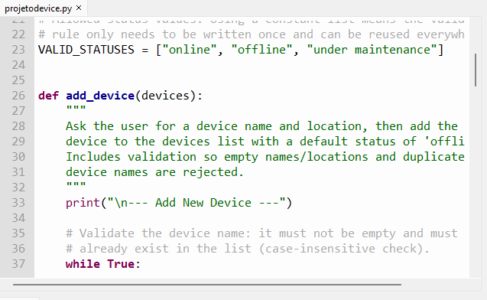
Figure 2: The add_device function validates that the device name is not empty and does not already exist in the list before accepting it, using a while loop that repeats the prompt until a valid name is entered.
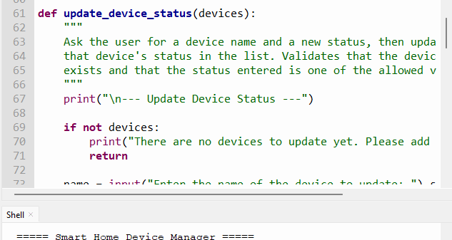
Figure 3: The update_device_status function first checks whether the devices list is empty before searching for the device, preventing the function from attempting to update a list that has no entries.

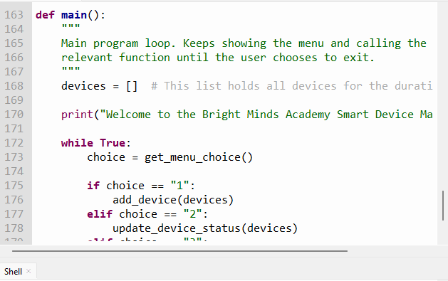
Figure 4: The main function routes the user's menu choice to the corresponding function using an if/elif structure, and the shell output shows the menu as displayed to the user

The complete listing is reproduced below with comments explaining each function.
"""
Smart Home Device Manager
--------------------------
A simple console program for Bright Minds Academy to keep track of
smart classroom devices (name, location and connectivity status).

Data structure used:
devices = [
{"name": "Smart Light A1", "location": "Room 101", "status": "online"},
{"name": "Projector B2", "location": "Room 204", "status": "offline"},
...
]

Each device is a dictionary and all devices are stored together in a
list. A list of dictionaries was chosen because:
- it keeps every device's data (name, location, status) grouped together
- it is easy to loop through when viewing or searching devices
- it does not require a database, which matches the task requirements
"""

# Allowed status values. Using a constant list means the validation
# rule only needs to be written once and can be reused everywhere.
VALID_STATUSES = ["online", "offline", "under maintenance"]

def add_device(devices):
"""
Ask the user for a device name and location, then add the new
device to the devices list with a default status of 'offline'.
Includes validation so empty names/locations and duplicate
device names are rejected.
"""
print("\n--- Add New Device ---")

# Validate the device name: it must not be empty and must not
# already exist in the list (case-insensitive check).
while True:
name = input("Enter device name (e.g. Smart Light A1): ").strip()
if name == "":
print("Device name cannot be empty. Please try again.")
continue
if any(device["name"].lower() == name.lower() for device in devices):
print(f"A device named '{name}' already exists. Please use a different name.")
continue
break

# Validate the location: it must not be empty.
while True:
location = input("Enter device location (e.g. Room 101): ").strip()
if location == "":
print("Location cannot be empty. Please try again.")
continue
break

# New devices start as 'offline' until the staff update them.
new_device = {"name": name, "location": location, "status": "offline"}
devices.append(new_device)
print(f"Device '{name}' added successfully in {location} (status: offline).")

def update_device_status(devices):
"""
Ask the user for a device name and a new status, then update
that device's status in the list. Validates that the device
exists and that the status entered is one of the allowed values.
"""
print("\n--- Update Device Status ---")

if not devices:
print("There are no devices to update yet. Please add a device first.")
return

name = input("Enter the name of the device to update: ").strip()

# Search for the device first (linear search through the list).
device_found = None
for device in devices:
if device["name"].lower() == name.lower():
device_found = device
break

if device_found is None:
print(f"No device named '{name}' was found.")
return

# Validate the new status against the allowed list.
while True:
print(f"Valid statuses: {', '.join(VALID_STATUSES)}")
new_status = input("Enter new status: ").strip().lower()
if new_status not in VALID_STATUSES:
print("Invalid status entered. Please choose one of the valid statuses shown above.")
continue
break

device_found["status"] = new_status
print(f"Device '{device_found['name']}' status updated to '{new_status}'.")

def view_devices(devices):
"""
Display every device currently stored, along with its location
and status, in a simple table format.
"""
print("\n--- Device List ---")

if not devices:
print("No devices have been added yet.")
return

# Simple formatted table using string formatting for alignment.
print(f"{'Name':<20}{'Location':<15}{'Status':<20}")
print("-" * 55)
for device in devices:
print(f"{device['name']:<20}{device['location']:<15}{device['status']:<20}")

def search_device(devices):
"""
Ask the user for a device name and display its status and
location if found. Handles the case where the device does not
exist and where the search term is left empty.
"""
print("\n--- Search for a Device ---")

if not devices:
print("There are no devices to search yet. Please add a device first.")
return

name = input("Enter the device name to search for: ").strip()
if name == "":
print("Search term cannot be empty.")
return

for device in devices:
if device["name"].lower() == name.lower():
print(f"Name: {device['name']}")
print(f"Location: {device['location']}")
print(f"Status: {device['status']}")
return

print(f"No device named '{name}' was found.")

def get_menu_choice():
"""
Display the main menu and validate that the user enters a
number between 1 and 5.
"""
print("\n===== Smart Home Device Manager =====")
print("1. Add new device")
print("2. Update device status")
print("3. View device list")
print("4. Search for a device")
print("5. Exit")

while True:
choice = input("Enter your choice (1-5): ").strip()
if choice in ["1", "2", "3", "4", "5"]:
return choice
print("Invalid choice. Please enter a number between 1 and 5.")

def main():
"""
Main program loop. Keeps showing the menu and calling the
relevant function until the user chooses to exit.
"""
devices = [] # This list holds all devices for the duration of the program

print("Welcome to the Bright Minds Academy Smart Device Manager.")

while True:
choice = get_menu_choice()

if choice == "1":
add_device(devices)
elif choice == "2":
update_device_status(devices)
elif choice == "3":
view_devices(devices)
elif choice == "4":
search_device(devices)
elif choice == "5":
print("Exiting program. Goodbye!")
break

if __name__ == "__main__":
main()

3. Testing and Debugging Report

a) Importance of Programme Testing
Testing matters because the program is meant to be used by staff who are not developers and will not read the source code before relying on it. A feature that looks correct while writing it can still fail once someone enters something the developer did not anticipate, such as leaving a field blank or typing a status that does not exist. Working through each function with both correct and incorrect input is what actually confirms the validation rules behave as intended, rather than assuming they do because the code compiles and runs without an error on the first attempt. Testing early also makes problems cheaper to fix: a mistake in how add_device checks for duplicate names is straightforward to correct before other functions are built on top of it, and much harder to trace once several features depend on the same data [9].

b) Types of Errors
Two types of errors showed up while building this. Syntax errors are the easy ones, a missing colon, a bracket that doesn't close, a line indented wrong. Python won't even run the file, it just stops and points to the line, so fixing these is usually just reading the error and going straight there.
Logical errors are more annoying because the program runs fine, no error at all, it just gives the wrong result. The search function is a good example: it wouldn't match a device if the capitalisation was different, since "smart light a1" and "Smart Light A1" aren't treated as equal by default even though they're clearly the same device. Research on this shows developers often miss exactly this kind of issue unless they're specifically looking for it [10], which matches what happened here, it was only caught by deliberately typing names in different cases and checking the output against what it should have been. The fix was small, adding .lower() to both sides of the comparison, but easy to miss without testing for that case on purpose.

c) Test Cases
The following test cases were run against the finished program to confirm that both the four core functionalities and the validation built around them behave correctly. Each test case is followed by a space to insert the corresponding screenshot and a short comment on the actual result observed.

Test 1: Add a new device with valid input
Steps: From the main menu, choose option 1. Enter 'Smart Light A1' as the name and 'Room 101' as the location.
Expected result: The device is added and a confirmation message is displayed, showing the device's default status as offline.
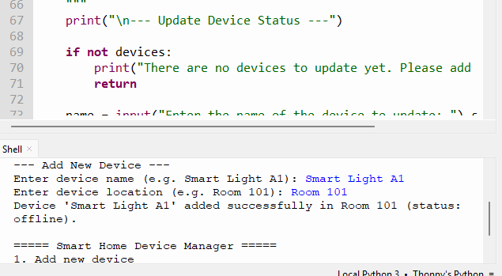

Test 2: Add a device with an empty name
Steps: Choose option 1. When prompted for the device name, press Enter without typing anything.
Expected result: The program rejects the empty input and asks the user to try again, without adding a blank device to the list.
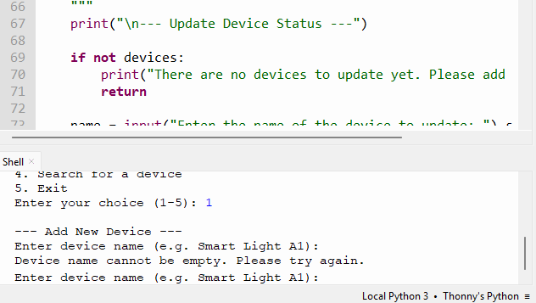

Test 3: Add a device with a name that already exists
Steps: Choose option 1. Enter a device name that has already been added (e.g. 'Smart Light A1' again).
Expected result: The program displays a message stating that a device with that name already exists and prompts for a different name.
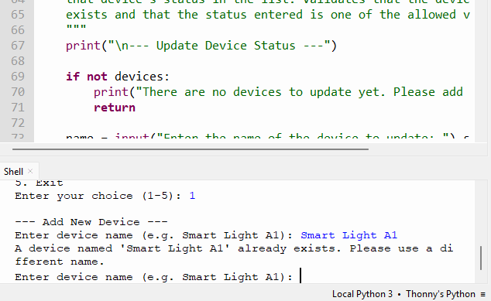

Test 4: Update an existing device to a valid status
Steps: Choose option 2. Enter the name of a device already in the list, then enter 'under maintenance'.
Expected result: The device's status is updated and a confirmation message is shown
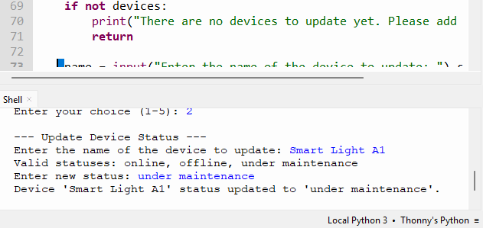

Test 5: Update a device with an invalid status value
Steps: Choose option 2. Enter an existing device name, then enter a status that is not one of the three allowed values (e.g. 'broken').
Expected result: The program rejects the value, lists the valid statuses, and asks the user to enter the status again.
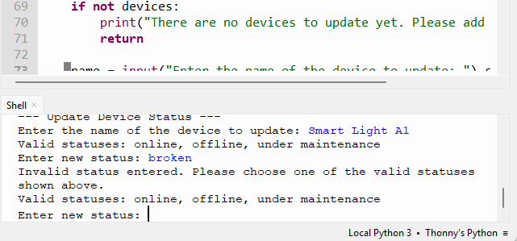

Test 6: Update a device that does not exist
Steps: Choose option 2 and enter a device name that has not been added.
Expected result: The program displays a message stating that no device with that name was found.
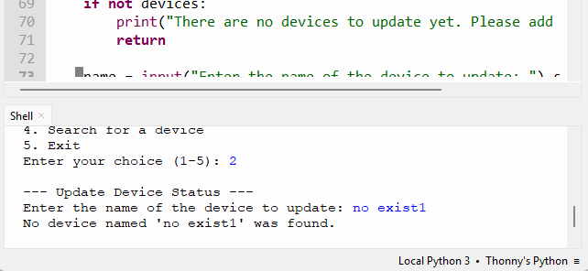

Test 7: View the full device list
Steps: Choose option 3 after at least one device has been added.
Expected result: All devices are displayed in a table showing name, location and status.
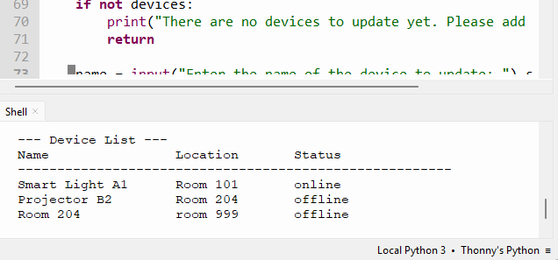

Test 8: Search for a device that exists
Steps: Choose option 4 and enter the exact name of a device already added.
Expected result: The device's name, location and status are displayed.
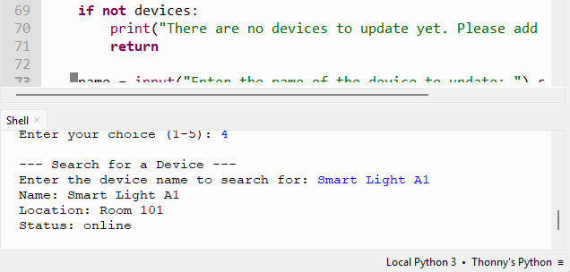

Test 9: Search for a device that does not exist
Steps: Choose option 4 and enter a name that has not been added to the list.
Expected result: The program displays a message stating that no device with that name was found.
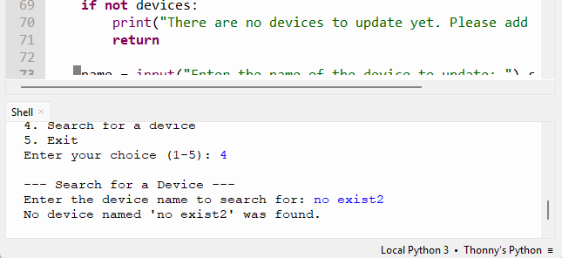.

4. Evaluation

Challenges Faced
Most of the difficulty came less from the logic itself and more from not being fully familiar yet with Python's syntax and the tools around it, which meant repeating steps more than once to get things working properly. Working out how the validation should behave, empty inputs, duplicates, devices not found, also took some trial and error.
The flowchart had its own learning curve too, mapping out the loops and validation branches in a way that was still easy to follow took a few attempts, even having built flowcharts before.
There were also a few small mistakes during testing, like mixing up which prompt I was answering and entering a location where a device name was expected. The program just accepted it as normal input, a reminder that validation only catches what it's specifically told to check.
Getting comfortable with tools outside of just writing code, properly using Thonny and pushing the file to GitHub as plain text, also took some adjusting.

Future Improvements
Looking at what I've done here, it's clear this is still quite basic, and I think that comes down to not being fully prepared going into it, in terms of practice with Python rather than the project itself. With a bit more effort put into coding regularly, and better organisation of the time I had available for this project, I believe I could have handled it in a better and faster way than I did, rather than working things out step by step as I went. It's less about needing to add specific features and more about recognising that this version reflects where I'm at right now, and that a bit more preparation, both practice and planning, would likely make a real difference next time.

Self-Reflection
Most of my previous experience with Python had been through smaller, isolated exercises rather than something built from a real scenario, so this project gave me a better sense of how programming actually works in practice, beyond just writing code that runs without errors. Testing made that especially clear: deliberately trying to break my own code, rather than just running it once, showed me that a working demo and reliable software are two different standards, and closing that gap was probably the most valuable part of this project. Seeing all of this play out in practice, rather than just reading about it, is something I expect to carry into future modules as well.

Conclusion

In conclusion, this project successfully provided Bright Minds Academy with a simple and effective way to manage the devices used in its smart classroom pilot. The program meets the four main requirements of the project by allowing users to add devices, update their status, view the complete device list, and search for a device by name. Device information is stored using a list of dictionaries, providing a straightforward structure suitable for the current requirements.
Validation was implemented to prevent empty fields, duplicate device names, and invalid device statuses from being entered. The program was tested using both valid and invalid inputs, confirming that the main functions operate as intended. Testing also identified a case-sensitivity issue within the search function, which was subsequently corrected.
Overall, the project achieved its intended objectives and demonstrates the practical application of fundamental Python programming concepts, including data structures, functions, input validation, conditional logic, and testing. While the current solution is relatively simple, it provides a suitable foundation that could be further developed in the future, for example by introducing permanent data storage, a graphical user interface, or additional device management features.

References

[1] J. O. Grady, "System requirements analysis," 2010.
[2] A. A. Adanna and O. F. Nonyelum, "Criteria for choosing the right software development life cycle method for the success of software project," IUP Journal of Information Technology, vol. 16, no. 2, pp. 39–65.
[3] J. Dooley and J. Zukowski, "Software development and professional practice," 2011.
[4] N. Ensmenger, "The multiple meanings of a flowchart," Information & Culture, vol. 51, no. 3, pp. 321–351.
[5] W. S. Davis, "Pseudocode," pp. 465–472.
[6] E. Horowitz, S. Sahni, and S. Anderson-Freed, "Fundamentals of data structures," vol. 20, 1976.
[7] R. Loogen, "Programming language constructs," pp. 63–92.
[8] F. Lundh, "Python standard library," 2001.
[9] W. E. Howden, "Functional program testing," IEEE Trans. Software Eng., no. 2, pp. 162–169.
[10] B. Hailpern and P. Santhanam, "Software debugging, testing, and verification," IBM Syst J, vol. 41, no. 1, pp. 4–12.

