


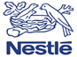
MARKETING ANALYSE
NESTLE-Baby Food product
/ Report /

2020

Table of Contents
Introduction 3
Findings and analysis 3
The concept for Marketing Communication 3
Marketing Communication Model 3
MKIS Design for Marketing Environment 4
Integrated Marketing Communication for Buying Behaviour Nature 5
Current Promotional Strategies of Nestle 6
New promotional strategies for Nestle 7
Branding and brand equity determining its technique as well as management 8
Aaker’s Brand Equity 9
Internal organisational marketing, marketing the corporate brand, product and service quality audit 10
Market Analysis 11
Customer journey and customer touchpoints for Nestle 11
Customer journey map 12
Total Engagement Model 13
Recommendations over the current issues 14
Conclusion 14
References 15

Introduction
Marketing in the business helps in reaching customers in which most of the potential customers are targeted by creating new products. Contribution of marketing for the business can help in promoting product and services with the increase of purchasing chance. In the study, Nestle Company of UK has been taken which is a multinational food and drink conglomerate company providing various products such as cereals, drinks, pet care, nutrition and other dairy products. Illustration of baby products that are sold by Nestle Such as organic, infant cereals with milk and other Nestle products is done. Marketing activities of the company contributed by the marketing department have been illustrated using different communication and marketing models. Major roles of the Marketing mix concept and brand management as well as techniques are discussed for engaging customers of Nestle.

Findings and analysis

The concept for Marketing Communication
Marketing communication generally involves marketing departments of business organisations and potential consumers for products and services. In this context, such marketers’ distinctive strategies and idea to further develop the product or service as per customer perspective and consumer demand (Hänninen and Karjaluoto, 2017).Marketing communication of Nestle includes media relations, public affairs, event management and internal communication that provide information on baby products and nutritional aspects of products to target consumers for acquiring feedback. The company uses media relations and event management to promote products to target markets. Nestle’s marketing communication includes social media marketing, television advertisement and e marketing to contemplate the communication chain between marketers and consumers.

Marketing Communication Model
In this regard, Macro-model of marketing communication can organise internal connection between sender (market analysts) and receivers (targeted consumers) that can construct effective communication between business organisations and customers. In macro-marketing communication model, the marketing department of business firms acquires elaborated understanding of targeted audience and sends product or service information through marketing tools, media or digital messages (Klepek and Starzyczná, 2018). Receivers or intended consumers receive such information or promotions and decode messages for understanding. Consumers create responses relevant to acquired information and provide feedback regarding product or services in the promotion. As a result, business organisations acquire a general understanding of customer perspective, consumer preferences and demand regarding service or product acquisition. The macro-marketing model avoids complexity regarding data transfer and acquisition, which develops an effective marketing strategy to identify target customers and demand. In the case of Nestle’s baby food promotions, the company holds expertise in Product differentiation and positioning strategy to promote products. On the other hand, Nestle intends to develop existing marketing communication through the consumer-marketing channel and e-marketing approaches to reach an increased range of consumers for baby food promotions.

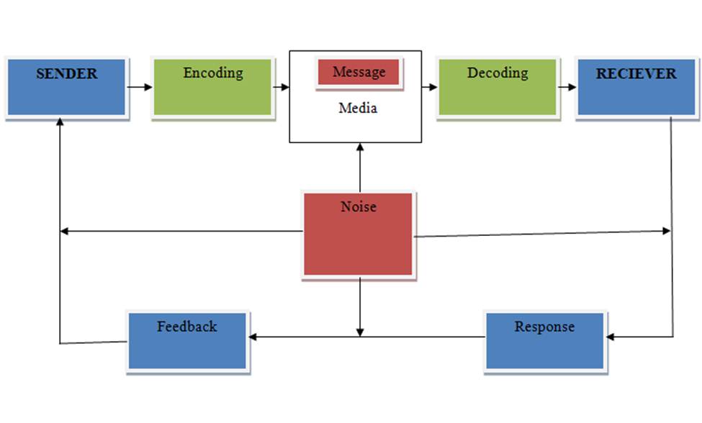

Figure 1: Macro-model of Marketing Communication
(Source: Created by learner)

MKIS Design for Marketing Environment
Marketing Information System (MKIS) provide support and optimal management of marketing communication within the implemented Information System. Business firms integrate information system within marketing communication to acquire business effectiveness and prompt promotion of products or services. Marketing Information System performs specific functionalities such as data acquisition, information storing, analytical decoding and distribution to designated markets, customers or managers of companies. MKIS’ information distribution and relevant data acquisition help marketers to make effective decisions regarding marketing operations of business firms that involves packaging or products, pricing, promotion, product development and distribution. Marketing communication helps businesses to develop effective service and product as per consumer demands, whereas, MKIS sort out information and acquire recent market trends to provide efficient decision making within marketing departments. Main components within the marketing information system involve Marketing Intelligence System, Internal Records, Marketing Research and Marketing Decision Support System. The components perform distinctive functions and programmes within the information system and MKIS develops relevant marketing communication through acquired data and functionalities (Dimyati, 2018). Internal records in MKIS gather customer database, product data, financial information, sales data and operation information of companies. Internal records acquire information from billing documents, invoices and transmit to organise information regarding financial forecast, frequency of purchase and rate of sales increase. In the case of Nestle’s marketing information system, the company has integrated IT systems that include a marketing intelligence system, recent market research and marketing decision support system to develop effective MKIS for communication purpose.

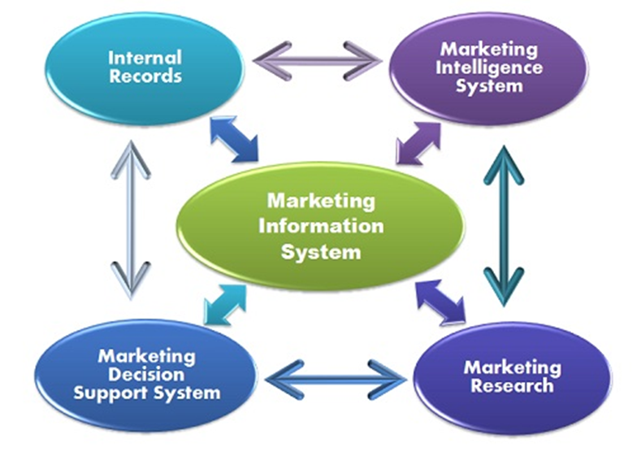
Figure 2: Marketing Information System
(Source: nestle.co.uk, 2020)

Integrated Marketing Communication for Buying Behaviour Nature
Integrated Marketing Communication (IMC) constructs internal links between different mode of marketing communications and messages for promoting products or services. Promotional tools and media used in marketing communications form interconnection through IMC to perform uninterrupted work and effective performance. Disoriented linkage or lack of integrated communications can create disruption in marketing strategies and marketers may receive irrelevant consumer feedback. IMC considers factors such as direct marketing, sales promotions, advertising, public relations, social media marketing and sponsorships to develop marketing communication without interruptions (Šķiltere and Bormane, 2018). In this context, business firms conduct promotion in terms of marketing mix and product positioning to acquire feedback from consumers. Business marketers adopt different IMC strategies such as Vertical, Horizontal, Data Integration and External Integration to promote products in the existing marketing mix. In horizontal in integration, business organisations consider marketing information from production, distribution and finance that can develop effective IMC (Pluta-Olearnik, 2018).
Nestle’s IMC tools involve advertisements, social media marketing, public relation and sales promotion of baby food products to targeted customers. In the initial stages, the company acquire relevant information through Information Technologies to develop marketing communication with marketers and customers. The concerned organisation implements public relations within community levels to promote products through social media marketing, direct mails and e marketing for product orientation and describe the concept of products. The company’s marketing communication sends information through such media to consumers for feedback or response acquisition. Nestle improves existing products as per customer feedback and relevant responses that can increase the sales of products. In recent marketing communication, the concerned company intends to include direct marketing approach to reach wholesalers and individual customers to acquire feedback and initiate product sales within the distribution chain. On the other hand, the organisation considers various IMC components such as corporate culture, brand focus, communication and promotional tools to develop effective marketing communication between the company and customers. As a result, the organisation has recently employed marketing functions such as e-business, sales, R&D involvement and technical application to increase the effectiveness of marketing communication.

Current Promotional Strategies of Nestle
Current promotional strategies of Nestle identify several consumer facing marketing initiatives to attract consent of potential consumers. The ongoing strategies have mainly focused on the elimination of competition in market by considering requirement and demand of the consumers. Offline promotional platform is stronger for Nestle in comparison with online platform of promotion. However, the management has been working efficiently and effectively to achieve the objectives of online platform. For the purpose of promotion Nestle is identified to adapt consumer marketing channel especially for the producers and or numerous with the help of retailers or wholesalers. As per the information, it is identified that promotional management of the discussed organisation has been following e-marketing strategies to reach their consumer directly. On the other hand, lack of innovation and research regarding the digital platform of marketing has exposed with certain limitations of e-marketing. Based on the statistics it is identify that powder and liquid beverages is the most popular segment of promotion and sale, which is followed by nutritional, and health supplement product. Before implementing a promotional strategy, the management has a tendency to conduct a deep analysis on the target market to identify the ongoing status and requirement of the new launching. Nestle is identified as one of the popular brands among the children food item product therefore the promotion has to be included health benefit dimension to attract the concept of consumers. Current promotional strategies of Nestle also highlight the discount and additional gifts for attracting the consumer base in terms of cost saving and free product. Being an international brand, the management have to be conscious regarding demographic requirement of different countries by considering the core value and ethics. However, advancement and incorporation of technology as well as digital specification are required to explore and enhance the promotional initiatives of Nestle.

New promotional strategies for Nestle
New promotional strategies for Nestle can adopt online and offline strategies to achieve the consent of potential customers. Digitalisation of the supply chain can avail several innovative services for new promotion.
Social Media Promotion
Involvement of social media is considered as new promotional strategies for Nestle in online platform. It can develop a consistent communication with the potential consumers for identifying the requirement and specification of market. In develop technological pace social media is identified as one of the prominent place to collect the viewpoint of consumer based on their consent. The management can develop a particular team to handle the social media regarding the promotional activity of new launching from the end of Nestle.
Point-of-Sale Promotion
POS is specialised equipments for sales promotion to receive a systematic record of transaction, which may be clarified for market demand and its requirement. By considering the digital platform it can we prove as an important initiative to attract the consumers consent even for home delivery option.
E marketing
E-marketing consider as excellent platform for multinational companies to enhance marketing communication and its associated outcomes. Publicity and advertisement are considered as important instrument for the sales promotion to develop a strong platform for public relation and potential customers.

Electronic media
The management of the organisation can maintain assertive communication with the consumers through electronic media in terms of email or smartphone regarding new product launch information. Furthermore, best wishes can be exchanged in festive season to attract potential consumer by feeling them special.
Besides online promotional strategy, Nestle can adopt offline strategy for the purpose of new promotion.
End-Cap Marketing
It is important to make the consumer feel better in the physical store by providing flexibility and freedom of decision-making and purchasing choice.
Print media promotion
Print media is a conventional method of promotion as it is identified with several assertive option of new launch therefore the management can utilise this tool of new promotion in offline platform.
Precise entertainment media promotion
There are several consumers especially from the elderly age group are not adaptable which digital platform therefore entertainment media promotion can be appropriate to attract their consent towards business. However, the management has to be serious regarding the quality of the product in terms of hygiene and health safety along with competitive price.
Free sample regarding new launch
In order to get notified the potential consumer Nestle management can provide free sample of their new launch product in terms of promotion and can collect the perception and feedback regarding the quality.
This kind of promotional strategies before launching of a new product can provide scope to the promotional management based on the response and viewpoint of the potential consumers in the food and baby product market.

Branding and brand equity determining its technique as well as management
Branding is the recognisable symbol in which customers can be attracted using its logo giving the opportunity to identify the brand of a company. Brand equity determines the significance of brand towards customers referring its superiority, recognisability and usability in reliability and quality of products (Keller and Brexendorf, 2019). It can be seen that Nestle having good brand equity for its product that needs to be more recognisable for baby product in the market of UK. It shares its values with the core concept of corporate brand in which food quality is measured for a good life. Brand building techniques need to be developed by the company for generating promotion and Awareness of its goods through campus or sponsorship in which thinking, imagery, experience and self-expression are judged. It can be suggested to Nestle Company is that it can focus on establishing individual branding for baby products using their approach of user experience. Brand management is important for improving, managing and developing a brand with unique knowledge of promise into the market. Individual branding can be managed using the strategy of Unique Identity for which baby products are segmented from adult products or pet care.

Aaker’s Brand Equity
Care rand equity model of Aaker helps in determining the brand value in which interest of customers towards the product of the company can be evaluated. It is important to build brand equity into the competitive environment because customer’s images desire can create a challenge which is important to meet by the company (Tanveer and Lodhi, 2016). It is the combination of brand Associations, brand loyalty and brand awareness for which brand identity development is important. 4 elements can be derived using this model such as Product, Organisation, Person and Symbol as a brand.

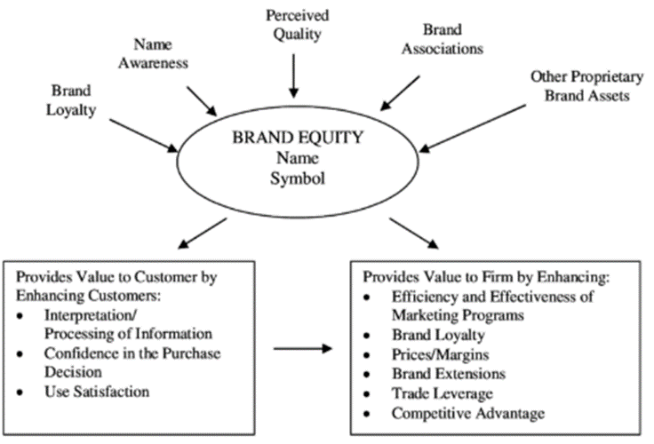
Figure 3: Aaker’s Brand Equity
(Source: Tanveer and Lodhi, 2016)

Advantage can be gained using this model is due to its components such as brand awareness, perceived quality, brand associations, brand loyalty and other proprietary assets. With the help of this model, evaluation can be made that can reinforce the motivational reasons towards the purchase of products by customer. For the Nestle Company, marketing activities of baby products can be enhanced at a premium price depending upon the promotional activities. This model can help in mitigating the strong barrier of competition with the developed brand extensions in accordance with distribution channels in the market of UK. Disadvantages can be seen in terms of investment cost by the company for developing brand equity. The model does not deliver financial Estimation and expense for the company to arrange promotional tools as well as innovative strategies to complete within the environment.

Internal organisational marketing, marketing the corporate brand, product and service quality audit
Internal marketing helps in ensuring the company for understanding employees in order to achieve corporate Bond. Internal organisational marketing depends upon anticipation of management process in terms of satisfying customers creating higher profitability (Baker, 2004). Corporate branding is important for the company in terms of delivering overall advertising efforts by enhanced communication with stakeholders. It is important for the company to influence the perception of customers based on corporate branding and product offering into the target market. For the Nestle Company, it is important to research upon competitor’s brand in which they can offer baby products into the target among target audience with unique product quality. Product audit is important it that can help in assessing final product or services to the customers benefiting its suppliers as well as customers ensuring high-quality product and customer satisfaction level. For the managers and quality auditors, it is important to do manufacturing audits for identifying the long-term capability of the organisation to fight into the extremely competitive market (Smith, 2019). It is suggested for the Nestle Company to have a systematic examination of baby products in terms of examining its quality system by an internal quality auditor for enhancing organisational marketing internally.

Market Analysis
In the market of the UK, it has able to create strong brand reputation driving its performance and sales growth with various brands (nestle.co.uk, 2020). Marketing of Nestle has been a b2c type in which multiple paradigms can be just based on Innovation and e-commerce sales. It is accommodated with the monopolistic market structure that helps to sustain into the Global market in which increased selling of baby products in the UK market is recently targeted. The market can be seen in Switzerland regarding the selling of chocolate as well as other dairy products (nestle.co.uk, 2016). It has explored its professional customer demand in the UK due to its coffee determining convenience customer behaviour. Government intervention has been done over safeguarding children while providing food from the various food companies such as Nestle, Unilever or Mondelez.

Customer journey and customer touchpoints for Nestle
Customer journey determines the experience of the customer while interacting with the company based on their experience or transaction. The customer journey of Nestle can be seen in terms of segmenting the product based on age, education, income, gender and age. It has targeted offering milo to the children while offering coffee to adults as a business strategy. For the customer development Scheme, the company has the best experience of 18 months while delivering customers with nutritional value products from the year 2017 (nestle.co.uk, 2019).
The customer touchpoints can be determined for Nestle regarding pre purchase, purchase and post purchase.

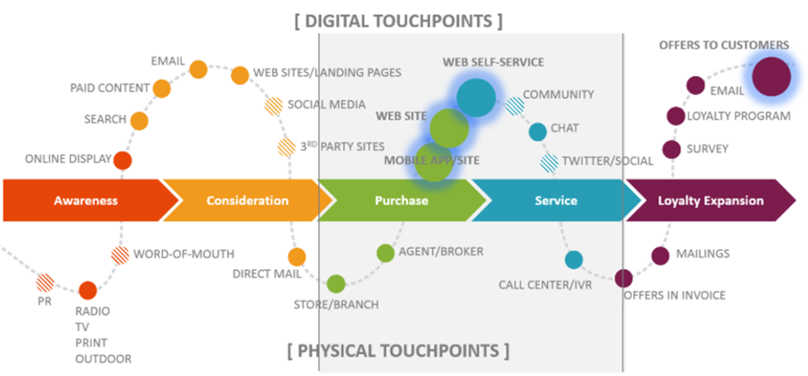
Figure 4: Marketing owns Customer Experience
(Source: Lee, 2018)
Customers journey in Nestle have been full filled with loyalty and Pride in which they have delivered the essence of Mount Everest ascent. A customer touch point is the development of interaction between customer and business in terms of direct marketing message or advertisement campaigns. It is effective for Service communication management in which the quality of service can be improved for preventing customer complaints as well as customer lifetime value (Lee, 2018). According to customer touch points, Nestle has been branded as the largest Food Company in terms of revenue as well as the quality of the product by targeting physical locations.

Customer journey map
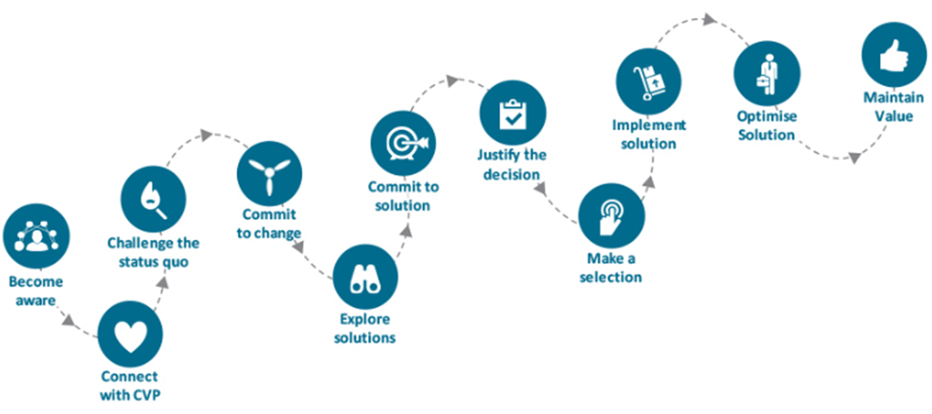
Figure 5: Customer journey map
(Source: Rosenbaum, Otalora and Ramírez, 2017)
A customer journey map is a strategic management tool that can be used by the organisation for understanding the preferences of customers (Rosenbaum, Otalora and Ramírez, 2017). From the above-illustrated mapping, it can be highlighted that Nestle can support with the correct selection of product quality for babies along with justifying decision and optimised solution. In the context of Nestle digital activation space can be seen in which they are engaged with offline and online marketing through digital advertisement. With the help of the map, the digital impression can be converted into genuine interest for customers by adding a Loyalty program. Social media conversation can help in allowing forming a baseline of Nescafe Discount, Nescafe Promo, Nescafe Deals and baby products. Offline customer engagement can be enhanced with tactical decision making in celebrating the anniversary of a group with the improved quality of baby products.

Total Engagement Model
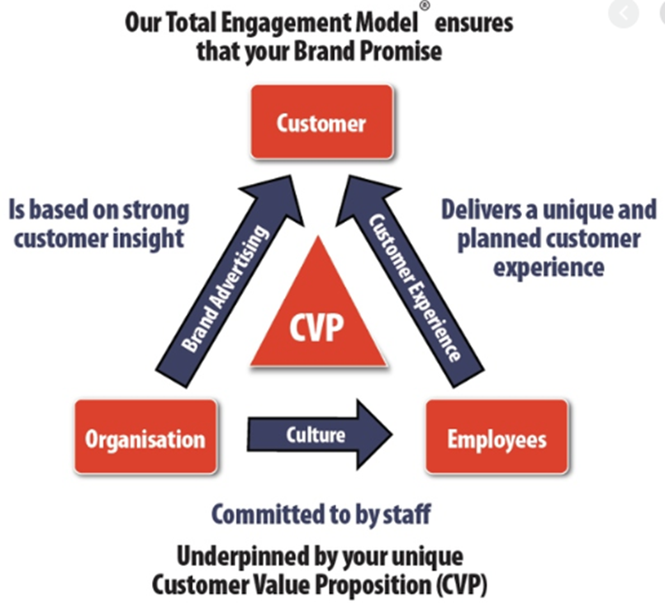
Figure 6: Total Engagement Model
(Source: Grover and Kar, 2020)
Total engagement model can be taken into the organisation for aligning and designing a key strategic element in which growth can be achieved easily. It is important to recognise the various acts of the company in terms of advertising, products, internal culture, services as well as customer engagement (Grover and Kar, 2020). Nestle Company can engage with the model for developing its total brand strategy that can influence its customer engagement process with comprehensive marketing activity. It is regarded as the mass marketing models that can help in advising the company to deal with the degree of customer engagement. Effective engagement of customer for purchasing baby food product from the Nestle company can be optimised based on advertising campaigns or promotional offering to the customers. It can deliver the benefit of creating engaging customer based on the customer value proposition, internal culture element, and brand and customer experience.

Recommendations over the current issues
Regarding the current issues, it can be highlighted that ethical problems in the marketing e can be determined with a market audience group due to conflict of interest. In respect to Green Marketing, some issues can be faced by the company such as improving effectiveness, performance, competitiveness and significance of incorporating green and ethical marketing. Current practices of Cyber marketing by the organisation, there is an issue of facing confidentiality laws of customers running successful software and cyber hack. Apart from determining the issues of marketing activity, future development can be seen in relation to Cyber marketing, Green Marketing as well as ethical marketing. Cyber marketing can help in improving the dynamics of the company to become the latest, smart, agile, flexible and alert (Stoica and Stancu, 2017). With the help of Green Marketing, the company can able to sell eco-friendly products in terms of gaining more experience in purchasing products and services. Ethics in marketing is important for practising fairness standard within the company e to provide ethical values towards the customer in future.

Conclusion
It can be concluded that Nestle group in the UK can establish its good customer base of the baby product by integrating marketing activities. A critical evaluation has been made regarding marketing activities in terms of marketing mix concept, Integrated Marketing Communication Marketing Information System and STP strategy. Brand building importance has been shown for Nestle along with its marketing analysis that can help in surveying the customer journey. Market analysis of Nestle shows strong brand reputation driving its performance and sales growth in the market of UK. Customer journey and customer touch points for Nestle has delivered the process of interacting for customers with the company Customer journey map has been drawn for Nestle to satisfy the demand of customer. Total engagement model is interpreted for the identification of customer engagement process with comprehensive marketing activity. Current analysis of issues along with future development in relation to Cyber marketing, green marketing and ethics have been done. Therefore, future development through marketing can be enhanced using technology for Nestle regarding its baby product.

References
Baker, M. 2004. Marketing Theory. London: Thomson Learning.
Dibb, S. and Simkin, L., 2016. Market segmentation and segment strategy. Marketing theory: A student text, pp.251-279.
Dimyati, M., 2018. The role of customer satisfaction in mediating marketing communication effect on customer loyalty.
Grover, P. and Kar, A.K., 2020. User engagement for mobile payment service providers–introducing the social media engagement model. Journal of Retailing and Consumer Services, 53.
Isoraite, M., 2016. Marketing mix theoretical aspects. International journal of research granthaalayah, 4(6), pp.25-37.
Hänninen, N. and Karjaluoto, H., 2017. The effect of marketing communication on business relationship loyalty. Marketing Intelligence & Planning.
Keller, K.L. and Brexendorf, T.O., 2019. Measuring brand equity. In Handbuch Markenführung (pp. 1409-1439). Springer Gabler, Wiesbaden.
Klepek, M. and Starzyczná, H., 2018. Marketing communication model for social networks. Journal of Business Economics and Management, 19(3), pp.500-520.
Lee, S.K., 2018. A Customer Touch Point Management System for Effective Service Communication. Business Communication Research and Practice, 1(1), pp.46-49.
nestle.co.uk (2020). MARKETING: At the heart of all our brand activities is a single, powerful, big idea. Available at: https://www.nestle.co.uk/en-gb/careers/career-area/marketing [Accessed on 10 July 2020]
nestle.co.uk. (2016). Nestlé timeline 1866-today. Available at: https://www.nestle.co.uk/en-gb/media/newsfeatures/nestle-150-years-timeline [Accessed on 10 July 2020]
nestle.co.uk. (2019). Customer Development Scheme – Olly. Available at: https://www.nestle.co.uk/en-gb/media/news/customer-development-scheme-olly [Accessed on 10 July 2020]
nestle.co.uk. (2020). Brands. Available at: https://www.nestle.co.uk/en-gb/brands [Accessed on 10 July 2020]
Pluta-Olearnik, M., 2018. Integrated marketing communication—concepts, practice, new challenges. Marketing of Scientific and Research Organizations, 28(2), pp.121-138.
Rosenbaum, M.S., Otalora, M.L. and Ramírez, G.C., 2017. How to create a realistic customer journey map. Business Horizons, 60(1), pp.143-150.
Šķiltere, D. and Bormane, S., 2018. Integrated Marketing Communication as a Business Management Tool in the Context of Sustainable Development. Open Economics, 1(1), pp.115-123.
Smith, J.L., 2019. The Real Audit Benefit. Quality, 58(9), pp.18-18.
Stoica, L.C. and Stancu, A.M.R., 2017. Marketing And Cybermarketing. Knowledge Horizons. Economics, 9(4), pp.65-68.
Tanveer, Z. and Lodhi, R.N., 2016. The effect of brand equity on customer satisfaction: An empirical study based on David Aaker's Brand Equity Model. IUP Journal of Brand Management, 13(3), p.43.
Varma, G.R. and Ravi, J., 2017. Strategic Analysis on FMCG Goods: A Case Study on Nestle.

