
Fundamentals of construction
New Build Dwelling: Technical Report with Drawings

April 28, 2022
Jack goodridge

Brief

In this assignment I will be creating a technical report for a timber framed dwelling, explaining the method of timber frame construction, creating and explain several sketches to assist ion my report, as well discussing the advantages and disadvantages of roof structure methods and discussing offsite construction. I will also discuss an alternative method I believe they could use for the dwelling.

Ground Floor Construction

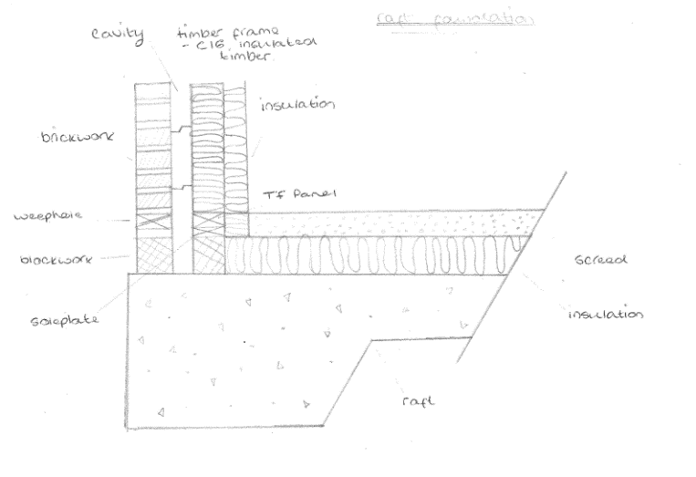
The sketch to the left shows an example of a foundation I believe would be suitable for the clients new dwelling. It details a raft foundation to be used for the project. We are told in the brief that the ground where the dwelling will be, was used for agricultural land, this is likely to mean that the ground will be soft therefore having a low load bearing capacity, therefore, a raft foundation would be used so that the weight of the building is spread out over a large are to create a stable foundation. Insulation is then laid atop of the concrete, with a layer of screed atop of that for whatever flooring is chosen to be laid on the screed.
On the external wall you can see that it begins with blockwork and then once the wall is visible above ground level this will then be changed to smaller sized bricks. The external wall will then be rendered with a smooth finish and the bricks will not be visible. Between the external and internal wall is the cavity, cavity walls are used more often now as opposed to solid walls because they have better insulation properties. You can see wall ties inside the cavity, these are used to hold the external and internal walls together and prevents them from separating.

First Floor Construction
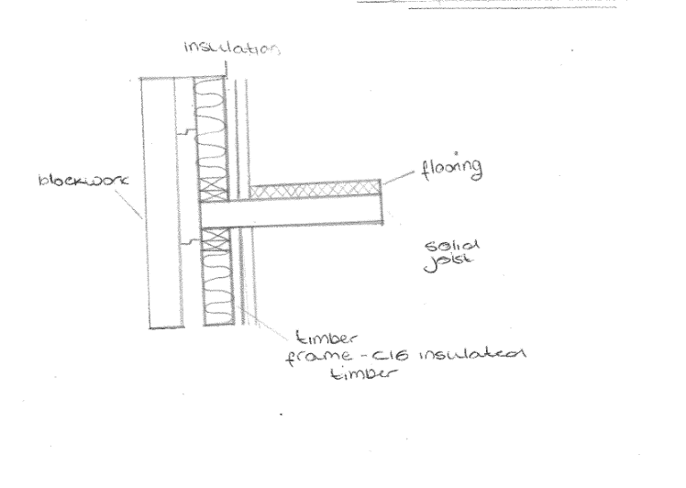
This sketch shows how the timber frame would look on the first floor of the building, The internal and external walls are the same of that on the ground floor. In this sketch you can see that inside the internal wall has a layer of insulation, this is the type of insulation that we see inside our houses. The image to the right shows how rooms inside a timber frame house are created, either side of these frames are covered with plasterboard and then painted to create the finish we know inside our own homes. Inside these frames is where we will find the insulation.
To create the floor, you have solid joists which creates the floor space which are then covered with wood panels for the flooring material to be laid on top of. These joists sit upon the frame below and create the floors for levels above the ground floor.

Eaves Detailing and Roof Covering
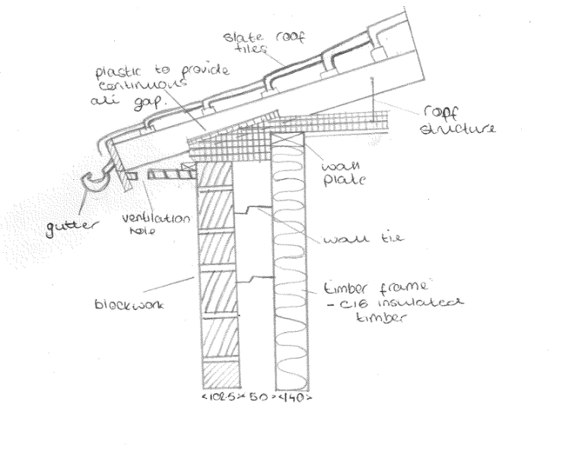

Roof structure
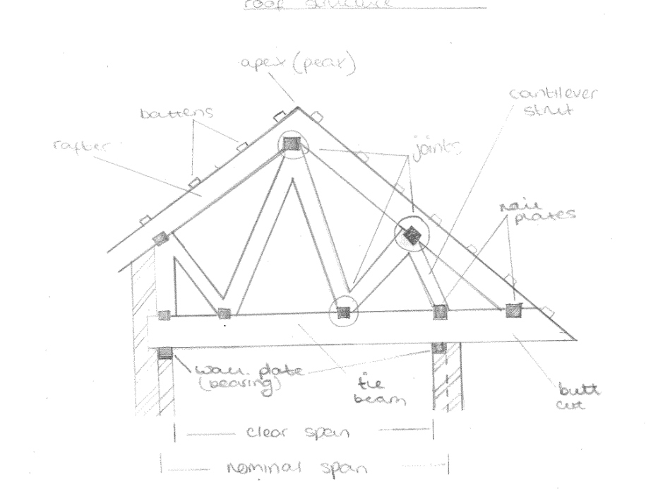

Above you will see the drawing for the roof structure. The rafters are what creates the overall shape of the roof and the angle and therefore slope of these will vary on different roofs. The struts bridge the space between the tie beam and the rafters, providing support to the roof structure and transferring the load to load bearing walls throughout the structure. The nail plates connect the different components of the timber frame together, where these components connect via the plates is called the joint. The nail plates are made of steel and have been punched so that the side that is in contact with the timber small prongs that grip the wood and hold it in position and stop it from moving. You will find a layer of insulation inside the roof, boards a usually laid on top of the rafters. Once the boards have been placed, it is most common today for a ‘felt and batten’ system to be used, a layer of felt is laid on top of the boards with wooden battens placed horizontally at equal distances up the slope of the roof. These battens create a ledge for the tiles to be laid upon, starting from the bottom, and nailed to the batten, laying the tiles from bottom to top allows for the tile in the row above to weigh down the tile below while also creating a staircase effect for rainwater to run down into the gutters.

Alternative Roofing Method

I believe a good alternative option for the roof structure would be to use a flat roof.
Advantages of flat roof construction include it being a more basic roof structure compared to a pitched roof making it easier to construct and maintain. It is easier to construct as it does not require as much support due to its pitch being a much smaller angle than that of a traditional pitched roof. It is required to have a pitch of at least 3 degrees, any less than this and the roof can hold water which could result in the roof collapsing due to the strain placed upon it from the water.
Another advantage of a choosing a flat roof is that it is much cheaper than a pitched roof not only to construct due to it requiring less materials than that of a pitched roof due to its simplicity but also due to its ease of installation. the finish of a flat roof can also be much cheaper, a commonly used method to finish a flat roof is torch-on roofing, this is where a roll of modified bitumen and other minerals, this is then melt-welded on to the roof and provides an impenetrable layer of protection for the roof. Torch on systems can last anywhere from 15-25 years but unlike tiles, there is not potential for them to shatter or blow away in high winds. The materials for a torch-on system are much more cost effective than tiles used on a pitched roof.
However, there are also disadvantages to flat roof systems, one being that they are much less attractive than a traditional pitched roof. Flat roof construction is common on single storey extensions, garages, and garden sheds but much less so on houses as pitched roofs are often much more aesthetically pleasing. A flat roofed house can also look out of place if it is among houses that have pitched roofs. Tiles also offer a much wider variety of colour options than flat-roofed systems which usually come in blacks, greys, reds and occasionally greens, although green would not be many peoples first choice for their roof.

Offsite construction
Offsite construction is a method in which a product is manufactured inside a factor prior to its installation on site. Offsite construction can add value to a product as it can be manufactured perfectly before being installed at its final location. I will look at 4 categories of offsite construction - panellised systems, volumetric systems, sub-assemblies and components, and hybrid systems.

Offsite construction provides a cleaner place for the products to be made meaning that production is often more efficient which results in costs being reduced as material usage is optimised and operations can be done in tandem with others as opposed to onsite where one thing would have to be done before another can begin. Building the products in a factory also allows for better quality control meaning that offsite contraction often results in better quality construction with less defects and consequently higher customer satisfaction levels. Timber frames are an example of offsite construction as the frames are made in a factory and then fitted together at their final location.

Panellised Systems
This is where panels are constructed away from site and then incorporated to existing structures or assembled on site. The type of panels vary widely from the option to have no openings and essentially being a plain wall, open panels, in which the panel is transported to site with features such as doors and windows being fitted once the panels have arrived to site, or closed panels where the features are fitted before the panels are transported.

Volumetric Systems

This is also referred to as modular construction. The units are built totally away from site which often results in them being able to be constructed much more quickly than traditional methods. Once completed, the units are transported to site and then lifted and stacked in to place as required. These can be constructed from steel or timber and are commonly used to create office space on construction sites.

Sub-assemblies and Components
Individual housing components like roofs and chimneys which are built so that they can be easily incorporated into existing structures. They have the ability to be added to buildings constructed using traditional methods or offsite construction. Many of the things you would find in a house are sub-assemblies like door handles and windows but things to the size of full roof trusses can be made offsite and transported.

Hybrid Systems

Hybrid systems are made of a combination of several construction methods. The best method is chosen for specific components where it will provide superior performance and benefits over other methods.

