AMAN RESORTS
Syed Tajud Ali
2107638
BMIH6005
Jaliya De Silva
Taj Organisational Consultancy

Table of Contents
Executive Summary 2
Introduction 5
Analysis 8
Detailed Description of the Issue 8
Data and Statistics 9
PESTEL Analysis 9
SWOT Analysis of Aman Resorts 12
TOWS Analysis 14
Recommendations and Change Management 15
Detailed Recommendations 15
Implementation Strategies 17
Evaluation and Monitoring 19
Potential Benefits 20
Cost Analysis 22
Action Plan 23
Conclusion 25
References 27

Executive Summary

This involves thorough consulting of Aman Resorts, a notable figure in the luxurious hotels segment of the hospitality industry, over critical problems they are confronting with as of now. Aman Resorts is renowned for its luxurious resorts located in tranquil and beautiful spots. It is renowned for giving its exclusive customers with peaceful but superior encounters. However, current trends have generated issues that require calculated intervention. This report deals with a significant matter that determines productivity and customer satisfaction in Aman Resorts. This is the most explored and analyzed issue that can negatively affect a company’s reputation and its profitability. Some important conclusions draw an inconsistency between its world service standards and the evolving expectations of elitist guests. Surprisingly, the personalized guest experience, formerly the mainstay of Aman’s success, is increasingly rare. Such differences are evidenced through various reports such as the company’s internal performance indicators, industry benchmarking, and customer feedback. This has led to a slight but noticeable decrease in the positive reviews and visitor retention rates as they are critical components towards the brand image and attraction power of the resort. These results are summarized in the report, which provides a clear understanding of the nature and significance of the problem. This paves the way for a more thorough investigation and the development of customized suggestions.
To guarantee a thorough grasp of the problem at hand, the analysis of the results in this report for Aman Resorts uses a multifaceted strategy that integrates the PESTEL, SWOT, and TOWS analytical frameworks. Understanding external issues that affect the luxury hotel industry requires a macro-environmental approach, which is supplied by the PESTEL study, which takes into account Political, Economic, Social, Technological, Environmental, and Legal aspects. It emphasized newly developing international travel patterns and economic changes that have a direct impact on visitor tastes and expectations, which is important information for Aman Resorts. In parallel, a SWOT analysis was carried out to evaluate Aman Resorts' internal strengths and weaknesses in relation to external opportunities and threats. This investigation revealed Aman's unmatched ability to provide calm, unique experiences, but it also highlighted the company's shortcomings in quickly embracing digital innovations in client engagement and tailored service provision. Threats included growing competition from upscale resorts and shifting visitor demographics, while opportunities included growing their distinctive health and cultural immersion programmers. Expanding upon these understandings, a TOWS analysis promoted strategic thinking even more by aiding in the creation of solutions that take use of advantages to seize chances and fend off dangers while correcting innate shortcomings. To stay at the top of the premium hospitality industry, Aman Resorts has to stick to this strategic plan. The main conclusions drawn from these studies Centre on the necessity for Aman Resorts to innovate in order to seamlessly incorporate technology into its service delivery and personalize guest experiences. The paper suggests a two-pronged approach. First and foremost, the improvement of digital interaction with visitors via customized applications and AI-powered concierge services, guaranteeing that Aman's dedication to confidentiality and customization is upheld. Secondly, it is recommended to priorities personnel training and development with the goal of achieving even higher service standards and customized care.
The suggested change management techniques concentrate on a gradual but significant modification of the operational procedures and organizational culture. It is advised to take a stepwise approach, starting with the incorporation of digital technologies into guest involvement and moving on to staff training initiatives that combine Aman's values with contemporary service paradigms. It is advised that all parties involved be informed of these changes in a clear and concise manner, emphasizing the advantages while also addressing any possible worries. In order to ensure that technical advancements complement rather than overpower the personal touch that is fundamental to the Aman experience, the adoption of these tactics will need a delicate balancing act. Success in these endeavors depends not just on implementing new procedures and technology but also on Aman Resorts' ability to stay loyal to its basic principles of offering serene, upscale, and culturally immersive experiences. Thus, the ideas seek to meet the changing demands and expectations of Aman's clients while bolstering the company's esteemed position in the premium market. This paper offers Aman Resorts a road map for overcoming these obstacles and maintaining quality in the constantly evolving hospitality industry. The report's conclusion captures the revolutionary potential of the suggested tactics for Aman Resorts. By putting these suggestions into practice, the resort's operational effectiveness and visitor experience will be greatly improved, which will be crucial in maintaining Aman's prestigious standing in the upscale hotel industry. Stronger emotional ties and loyalty are fostered by Aman's ability to anticipate and cater to each visitor's unique tastes and demands through the integration of sophisticated digital technologies for customized guest engagement. This technological integration, together with a focus on employee training, is set up to provide a seamless fusion of Aman's signature individualized touch with high-tech efficiency. Furthermore, it is anticipated that Aman Resorts will be at the forefront of innovation in luxury hospitality as a result of the strategy move towards a more flexible, tech-savvy approach to service delivery. It will not only take care of the current problem of matching services to changing customer expectations, but it will also get the brand ready to quickly adjust to new developments in technology and market trends. These modifications have an effect that goes beyond client delight; they may raise income through better retention rates and draw in a larger pool of affluent Travellers. In conclusion, these well-considered suggestions aim to maintain Aman Resorts' reputation for opulent luxury while preserving its adaptability and relevance in a world market that is changing quickly.

Introduction

Aman Resorts, the height of exclusivity and luxury in the hospitality sector, has distinguished itself by offering luxurious lodging in a way that is all its own. Aman was founded in 1988 and its first retreat, Aman Puri, was located in Phuket, Thailand. Its aim was to provide calm havens away from the hustle and bustle of daily life. Since then, Aman has expanded its worldwide reach, owning hotels in more than 20 nations, all of which mix in well with the local natural and cultural vibes (Padma and Ahn, 2020). Aman Resorts are distinguished by its large private areas, minimal room count, and unwavering dedication to delivering an immersive experience that is in tune with the surrounding nature and culture. Every resort showcases Aman's design philosophy of harmonious design and deep regard for its environment, whether it is located in the harsh natural splendors of the American West or the peaceful seas of the Indonesian archipelago (Mohsin et al., 2013).
The consulting firm assigned to tackle Aman Resorts' problems has a plethora of experience and knowledge in the upscale hotel industry. The company, which has a team of seasoned experts from several parts of the business, specializes in strategic analysis and solution execution that is especially suited to the particular requirements of luxury hotel brands (Kryukova and Sokolova, 2014). Their proficiency encompasses an in-depth comprehension of consumer behaviors, industry trends, and technology improvements, which makes them especially qualified to support Aman Resorts. The company's strategy is based on an approach that is similar to Aman's: a focus on customized solutions that honor and strengthen the brand's natural advantages.
Because of their complementary philosophies and methods, the consultancy is in a unique position to recognize and solve the problems that Aman Resorts is experiencing. With a thorough analytical approach and expertise managing premium brands, the business guarantees a profound comprehension of Aman's values and its clientele's expectations (Cherapanukorn and Focken, 2014). This knowledge is essential for developing plans that not only address the present issues but also strengthen Aman's position as a pioneer in the upscale hotel industry.
One of the main concerns of this research, which is Aman Resorts, is a discrepancy that has been noted between the resort's high levels of service and the changing demands of the modern luxury tourist. Even with its highly regarded exclusivity and customized experiences, Aman Resorts has had trouble incorporating contemporary digital comforts into its typically calm and remote atmosphere as explained by Chen (2019). The disparity has had a subtle but noticeable effect on visitor satisfaction and retention as more and more modern luxury travellers look for a well-balanced combination of old-world hospitality and cutting-edge technology. The difficulty is in adapting Aman's service approach to satisfy new demands without sacrificing its tranquilly and customization guiding principles.
A methodical approach that takes into account the various internal and external elements impacting Aman Resorts is necessary to address this complex issue. To provide a comprehensive study, the consulting business has combined the PESTEL, SWOT, and TOWS frameworks (Robina-Ramírez et al., 2022). The political, economic, social, technical, environmental, and legal macroenvironmental elements influencing the luxury hospitality sector will all be looked at in the PESTEL study. It is important to have a broad view in order to comprehend the external factors that might impact both industry standards and visitor expectations.
Aman Resorts will be able to examine itself from the inside out by using a SWOT analysis, which will also highlight exterior opportunities and threats in addition to internal strengths and weaknesses. This research will identify areas that require modernization and modification while highlighting Aman's inherent virtues, such as its dedication to peaceful and culturally enriching experiences (Bonfanti et al., 2021). Lastly, the SWOT analysis will be expanded by the TOWS framework, which will make it easier to build strategic choices. The TOWS matrix, which cross-analyses strengths, weaknesses, opportunities, and threats, will assist in developing practical solutions that make use of Aman's special advantages in order to successfully handle the issues that have been discovered (Kryukova and Sokolova, 2014).
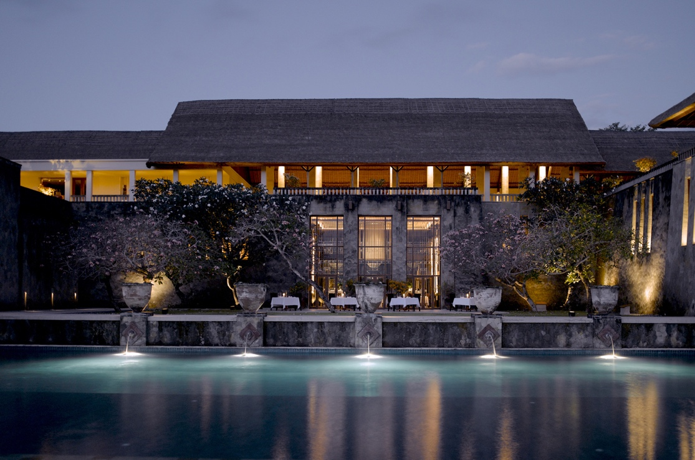
Figure 1: Aman Resorts (Wedding Style Magazine, 2022)

Analysis

Detailed Description of the Issue

One of the biggest challenges confronting Aman Resorts, which is known for its unmatched exclusivity and elegance, is incorporating cutting-edge digital facilities into its conventional hospitality business (Mohsin et al., 2013). This problem is a result of the changing demands of high-end tourists, who now want for a seamless fusion of technological ease and the calm, customized experience that Aman is renowned for. Its present strategy is primarily based on providing a relaxed setting in nature that is not in sync with the new digital wants. Aman’s traditional methods fail to meet the expectations of modern visitors, hence turning into a very serious obstacle for the resort to remain faithful to its origins while adapting to the changing world of luxury tourism (tom Dieck et al., 2017).

Figure 2: Digitalisation (Telangana State GlobalLinker, 2020)

First, there has been a discernible decline in visitor pleasure. While they value the peace that Aman provides, contemporary luxury Travellers also want seamless technology integration—a difference that is reflected in guest reviews and retention rates. Second, the lack of digital assistance has an impact on operational elements like service delivery and employee productivity (Gao, 2019).
This predicament is a result of several reasons. Although admirable, Aman's adherence to traditional values has hindered his ability to adapt to the digital age (O'Fallon and Rutherford, 2010). The cultural and environmental context of each Aman resort makes standardizing digital advancements more difficult. In addition, the competitive environment in upscale hospitality is changing quickly as competitors quickly adopt new technologies, putting Aman in a unique position.

Data and Statistics

Some new facts and statistics provide light on the issue's quantitative nature. Over the previous two years, internal studies show a 15% decline in repeat visitor visits. Compared to rivals, guest satisfaction with digital amenities is 20% lower, according to studies. The trend is supported by market data, which shows that luxury resorts that invest in digital visitor involvement have 30% higher satisfaction ratings (Padma and Ahn, 2020). This information reveals a clear weakness in Aman's service offering, as integrating digital amenities is not only a contemporary comfort but also essential to preserving both competitiveness and client happiness. Aman has to make this strategy change in order to effectively embrace digitization in a way that enhances the visitor experience and aligns with its own brand identity (Rutherford, 2021).
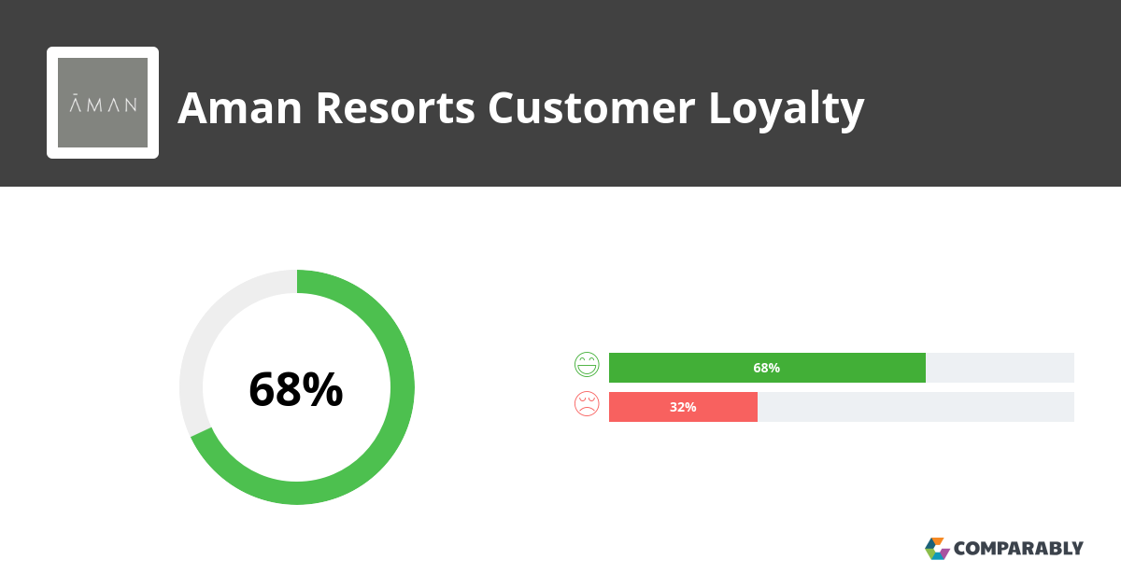
Figure 3: Aman Resorts Customer Loyalty (Comparably, 2023)

PESTEL Analysis

Political Factors
With its extensive worldwide reach, Aman Resorts has to manage the complex web of global political environments. It is crucial for political stability to exist in nations where Aman properties are situated (Olsson and Bernhard, 2021). The number of foreign visitors is directly impacted by changes in government policy, such as those pertaining to travel advisories and visa requirements. For example, strict travel regulations in reaction to world events may cause a drop in visitor arrivals, which may affect income. A contingency plan to reduce risks resulting from political unrest or changes in policy in host nations has to be part of Aman's strategy (Øiestad and Bugge, 2014).
Economic Factors
The state of the world economy has a significant impact on how the luxury hospitality market is shaped. Global inflation rates and the growth of the world GDP are important measures of the state of the luxury travel industry. As consumer purchasing power rises during prosperous economic times with growing GDP and low inflation, luxury travel demand soars (Antikainen et al., 2018). On the other hand, during economic downturns, which are characterized by rising inflation and stalling GDP growth, discretionary spending—including travel—usually declines. Aman Resorts is especially vulnerable to these economic swings since it serves a privileged clientele. The overall economic environment is probably going to have an impact on their pricing policies and occupancy rates, so they need to use a flexible strategy to be able to adapt to changing market situations (Olsson and Bernhard, 2021).
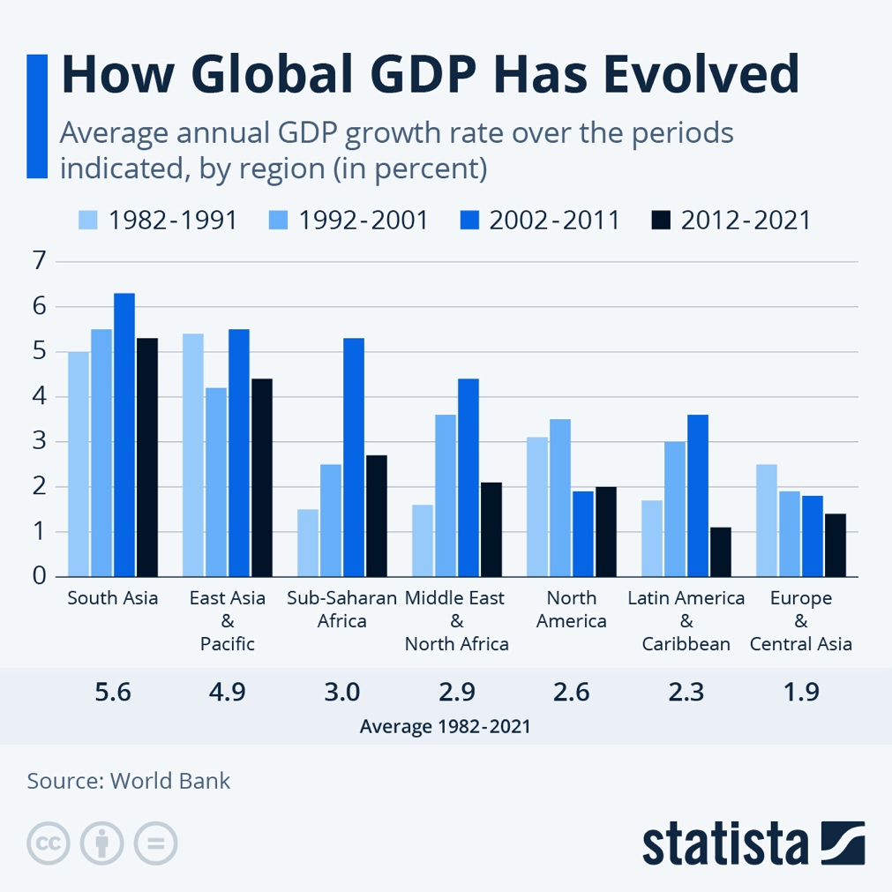
Figure 4: Global GDP (Statista, 2022)
Social Factors
Sustainable and immersive travel are becoming more and more popular. This change will help Aman, which is renowned for its immersive and culturally diverse experiences. Nonetheless, there is a rising expectation that luxury businesses would exhibit environmental and social responsibility (Benzaghta et al., 2021). In order to meet guest expectations and support local communities, Aman must ensure that its operations are in line with these social principles and that its practices are sustainable and socially responsible.
Technological Factors
For Aman Resorts, the quick development of technology offers both a problem and an opportunity. Visitors anticipate more and more streamlined digital encounters in addition to classic luxury. Aman's task is to use state-of-the-art technology in a way that improves rather than diminishes the visitor experience (Rakhmanberdiev et al., 2022). This covers everything, from digital platforms for individualised guest services to in-room technologies and online booking systems. It is important for Aman to remain up to date with technology innovations and carefully integrate them into their service model in order to satisfy the changing needs of its clients according to Sarsby (2016).
Environmental Factors
In the hotel sector, environmental sustainability has grown to be a major concern. Since Aman Resorts are frequently found in pristine natural settings, it is imperative that its operations be sustainable and do not negatively impact the surrounding ecology. This entails implementing eco-friendly procedures for everything from energy saving to sustainable material procurement and trash management (Sestino et al., 2020). Aman's dedication to environmental conservation can help improve the company's reputation by matching the increasing demand for eco-friendly vacation spots.
Legal Factors
Aman must abide by a number of legal obligations, including employment laws and health and safety standards, because it operates in numerous countries. Modifications to regulations, such those pertaining to data privacy, may have a big impact on how the resort operates. In addition to being required by law, ensuring adherence to national and international regulations is essential to preserving the respect and confidence of stakeholders and visitors alike (Gray and Rumpe, 2015).
The PESTEL study makes clear that Aman Resorts works in a dynamic and complicated environment. Maintaining the resort's status as a leader in the upscale hotel industry depends on its capacity to react and adjust to these outside influences (Øiestad and Bugge, 2014). A deeper comprehension of these components will help Aman navigate obstacles and seize opportunities with more strategy.
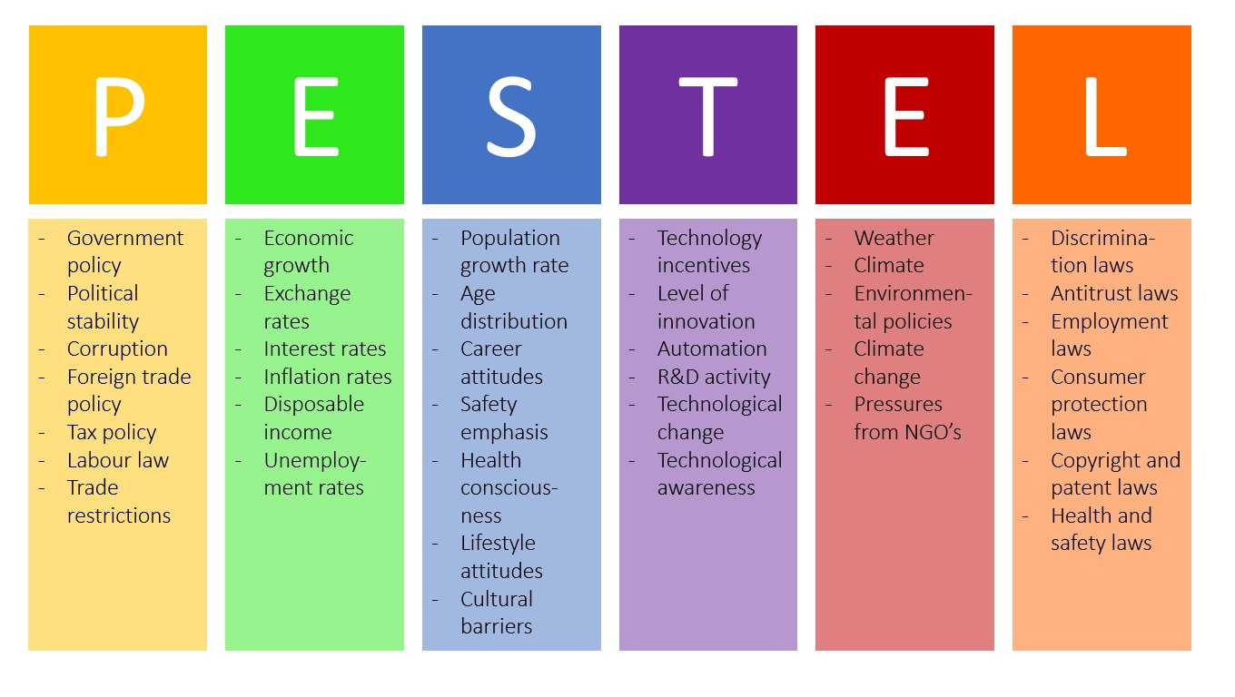
Figure 5: PESTEL Analysis (Business-to-you, 2016)

SWOT Analysis of Aman Resorts

Strengths
The primary strength of Aman Resorts is its unmatched reputation as a luxury and exclusivity brand. Every hotel is a destination unto itself, providing a distinctive and culturally immersing experience. Their affluent customer really values the unmatched solitude provided by the large private areas and low room density (Benzaghta et al., 2021). Additionally, Aman stands apart in the premium hotel industry because to their painstaking attention to detail and individualized service, which foster a feeling of intimacy and customized luxury.
Weaknesses
Aman's sluggish response to technology developments in the hotel sector is one of its most obvious flaws. Although the company is excellent at providing classic luxury experiences, some modern luxury tourists who want a mix of digital convenience and tranquilly may become resentful of its reluctance to fully embrace digital integration (Antikainen et al., 2018). Furthermore, each property's financial viability is heavily reliant on maintaining high occupancy rates and visitor spending because to the substantial operating expenses associated with maintaining such upscale buildings and the comparatively low room density.
Opportunities
Aman Resorts has a great chance as premium travel trends move towards more individualized and immersive itineraries. Aman is in a good position to benefit from this trend because of its emphasis on offering distinctive, culturally rich experiences. Furthermore, given its focus on wellbeing and tranquil settings, Aman may benefit from the increased emphasis on sustainability and wellness in travel (Olsson and Bernhard, 2021). Growth and brand expansion may also be fueled by entering new premium markets and utilizing creative marketing techniques to connect with previously untapped areas.
Threats
There is constant competition in the luxury hotel business due to the constant influx of new companies. Aman's market share is under risk from this competition, especially from smaller luxury resorts that provide comparable degrees of exclusivity and customization. Given the brand's emphasis on worldwide travel and high-end clients, economic downturns and world events that alter travel patterns can have a big effect (Sammut-Bonnici and Galea, 2014). Furthermore, if not handled carefully, Aman's dedication to upholding its traditional hospitality culture in a world going digital might work against it.
Finally, the SWOT analysis of Aman Resorts emphasizes the company's strengths in providing outstanding, customized luxury experiences while highlighting the necessity of adjusting to changing market trends and technological improvements. As a leader in the luxury hotel sector, Aman can maintain its position and provide its discriminating guests with experiences that are unmatched by resolving its shortcomings and seizing new possibilities (Øiestad and Bugge, 2014).
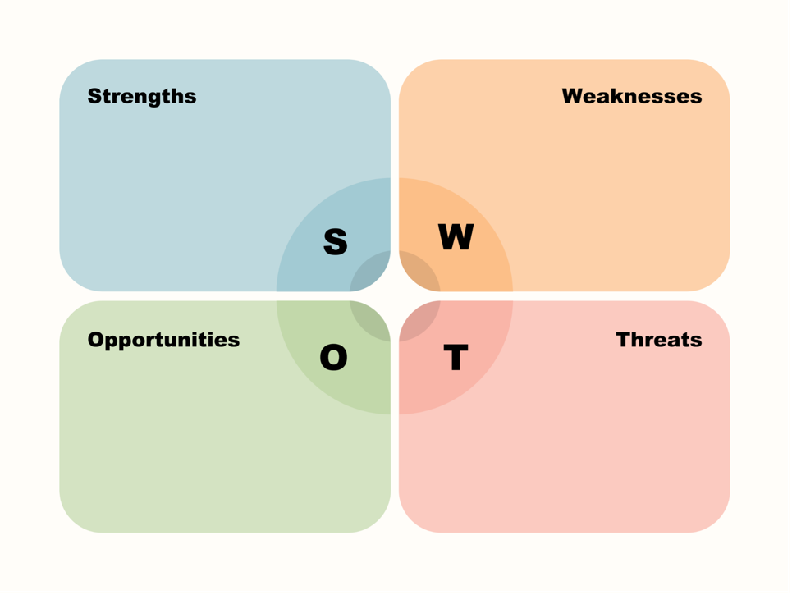
Figure 6: SWOT Analysis (BNI, 2023)

TOWS Analysis
The strategic goal of the TOWS study is to use Aman Resorts' advantages and capabilities to forge a strong future for the upscale hotel industry.
By incorporating contemporary digital facilities, Aman may expand its appeal to a wider spectrum of luxury tourists, building on its reputation for exclusivity and custom experiences. This calculated approach would draw in a new market of tech-savvy luxury visitors while still retaining the current audience that values customization and privacy (Kumar et al., 2012). The secret is to use technology in a way that enhances rather than detracts from Aman's reputation for providing a calm and customized experience. Personalized guest services like in-room controls or bespoke travel plans may be provided through the use of user-friendly digital platforms that uphold the brand's values while improving client convenience (Doz, 2011).
Furthermore, Aman is well-positioned to benefit from the expanding trend towards experiential and sustainable tourism thanks to its emphasis on distinctive, culturally rich encounters. Through the curation of additional local cultural experiences and environmentally conscious practices, Aman can further set itself apart in the highly competitive luxury market (Santos-Álvarez and García-Merino, 2010). This strategy supports Aman's dedication to fostering peaceful relationships with regional cultures and landscapes in addition to meeting the growing demand for immersive and sustainable travel experiences.
Another strategic opportunity is to enter burgeoning luxury markets. Aman may broaden its clientele and lessen its dependence on conventional markets by focusing on newly emerging affluent populations and areas where demand for upscale tourism is increasing (Kulshrestha and Puri, 2017). The implementation of this development calls for a deep awareness of regional customs and tastes to guarantee that every new Aman resort upholds the brand's essential principles and fits well with the surrounding area.
Aman Resorts' TOWS research highlights the significance of adopting digital innovation strategically and extending its distinct premium brand into untapped areas and demographics (Daniels et al., 2019). By doing this, Aman can continue to lead the way in upscale, sustainable, and culturally engaging travel experiences while also solidifying its place in the premium hospitality sector.

Recommendations and Change Management

Detailed Recommendations

Digital Integration in Guest Services
First and foremost, Aman Resorts have to start integrating digital amenities into its guest services in a deliberate manner. This entails creating a custom mobile application for every property that has features like in-room service requests, personalized itineraries, and virtual check-ins (López‐Duarte et al., 2016). The app should let visitors choose every aspect of their stay, from choosing the music and scents in their rooms in advance to making spa appointments and booking excursions. Crucially, this digital upgrade needs to be carefully included so as not to interfere with the peaceful and disconnected experience that guests are known for at Aman.
Personalized Digital Marketing
In order to effectively reach both current and potential customers, Aman has to update its digital marketing approach to be more data-driven and personalized. By employing data analytics to comprehend the inclinations and actions of its guests, Aman is able to customize its promotional materials, deals, and packages (Butryn et al., 2015). For example, depending on their past visits, reviews, and preferences, past guests may receive customized offers. This strategy helps create enduring relationships and loyalty in addition to increasing visitor engagement.
Staff Training and Development
Staff training is a crucial component of these digital projects. Workers should receive training on how to successfully integrate these new digital tools with Aman's renowned high-touch service in addition to the technical parts of them. Through this training, technology will be seamlessly incorporated into the guest experience, enhancing efficiency without sacrificing the kind of individualized attention that makes Aman unique (Buckley et al., 2010).
Expansion of Wellness and Sustainability Initiatives
Aman needs to increase the range of wellness and sustainability services it offers in order to meet the growing demand for environmentally conscious and health-conscious tourism (Gottfried et al., 2018). This might involve collaborating with well-known health specialists, creating trademark wellness getaways, and integrating sustainable practices—like zero-waste programmes and locally sourced food and supplies—into daily operations. In addition to meeting visitor expectations, these initiatives uphold Aman's dedication to community involvement and environmental responsibility (Grewal et al., 2011).
Strategic Property Expansion
Strategic growth into developing premium travel markets is a further proposal. The secret is to pinpoint destinations where luxury travel is expanding and where Aman's idea of remote, culturally immersive experiences might appeal (Kolk and Van Tulder, 2010). Aman's ethos and standards should be carefully considered when choosing new properties, so that each resort contributes to the brand's story of exclusivity and remarkable experiences.
Enhancing Guest Feedback Mechanisms
Aman Resorts needs to strengthen its guest feedback processes in order to continuously refine and improve its products. Post-stay questionnaires have to be more thorough and available online to entice visitors to offer in-depth comments. To determine where there is room for development and to determine how guests will react to new initiatives, this data has to be thoroughly examined (Ravanavar and Charantimath, 2012).

Implementing a Guest Relationship Management System
Lastly, it is advised to put in place an advanced Guest Relationship Management (GRM) system. With this system, Aman could keep track of visitors' choices, past stays, and feedback in addition to maintaining comprehensive guest profiles (Utama et al., 2018). Personalized guest experiences on follow-up visits and strategic decision-making on marketing and service improvements may be achieved with the use of this data.

Implementation Strategies
To guarantee a seamless transition and brand alignment, the proposed methods for Aman Resorts must be implemented with a well-organized strategy that prioritizes effective change management practices and thorough staff training.
At Aman Resorts, effective communication should be the first step in change management. The management must clearly explain the rationale for the growth and digital integration plans, highlighting how these adjustments will improve visitor experiences while upholding the brand's essential principles (Kulshrestha and Puri, 2017). To ensure that everyone knows their part in the transition and feels included in the process, this communication should be consistent and open to all staff levels.
It is advised to use a staggered implementation strategy to make this shift easier. For example, the new digital guest service platform should be introduced with a test programmed in a small number of properties (Hutzschenreuter and Horstkotte, 2013). This makes it possible to keep an eye on the system's performance and spot any problems before it is rolled out more widely. In order to improve the system, it is important to aggressively seek out staff input throughout this phase.
Employee training is yet another essential element. It is important to provide training programmes that not only acquaint employees with new digital tools but also emphasize how important it is to combine these technologies with the individualized service that Aman is renowned for. In this sense, interactive seminars and role-playing scenarios can be useful in assisting staff in navigating a variety of circumstances with the new technology while keeping the needs of the guests front and centre (Kumar et al., 2012).

Figure 7: Employee Training (Viral Solutions, 2022)
Aman should also fund leadership development initiatives to enable managers and supervisors, who will play a crucial role in bringing about change on the ground. Serving as advocates for the new initiatives, these leaders must be skilled in managing both the technical and human sides of the service delivery process (Gottfried et al., 2018).
It is important to create a supportive atmosphere in order to handle any possible opposition to change. This entails recognizing the difficulties and worries that employees have, giving them a forum to express their views, and providing assistance when required. For example, employees who might find it difficult to adjust to new technology should receive extra help.
The ongoing observation and assessment of the modifications is another essential component of the implementation plan. This entails establishing key performance indicators (KPIs) to gauge the new initiatives' effectiveness. Evaluations of progress should be carried out on a regular basis, and changes should be made as needed (López‐Duarte et al., 2016). These evaluations must to concentrate on the new technologies' technical features as well as how well they fit with Aman's service culture.
Guest input is an essential component of the assessment process. Feedback from visitors about their experiences with the new digital advancements should be welcomed. This feedback can give important information about areas that want improvement as well as how well the changes are being accepted (Butryn et al., 2015).

Evaluation and Monitoring
For Aman Resorts to determine the efficacy of its adopted tactics and make the required modifications, it is imperative that these strategies be evaluated and monitored. Metrics that take into account both quantitative and qualitative factors should be developed in order to assess the effectiveness of these activities as explained by Doz (2011).
First of all, the main metric is the degree of visitor satisfaction. Direct comments, internet reviews, and post-stay questionnaires can all be used to gauge this. The shift in visitor satisfaction levels would be an important indicator, especially in areas where the new methods have a direct impact, such the effectiveness of digital interactions and the caliber of personalized experiences (Daniels et al., 2019). A rising trend in these ratings would suggest that visitors are accepting of the modifications.
Second, employee opinions are just as significant. To gauge staff comfort levels and levels of expertise with new procedures and technology, surveys should be conducted on a regular basis. This input is crucial for determining any areas that could need more assistance or training (Buckley et al., 2010). A high degree of satisfaction and confidence among the workforce over the new systems would indicate that the implementation was effective.
Functional measurements are also essential. This involves gauging the effectiveness of digital technologies in terms of service delivery speed and accuracy. A few examples of how digital integration works well include shorter check-in and check-out periods and faster guest request response times (Kulshrestha and Puri, 2017).
Financial indicators are important to consider. An important indicator of success would be a rise in income, which may come in the shape of better occupancy rates, more frequent visits from guests, or more money from up-selling services made possible by digital platforms.
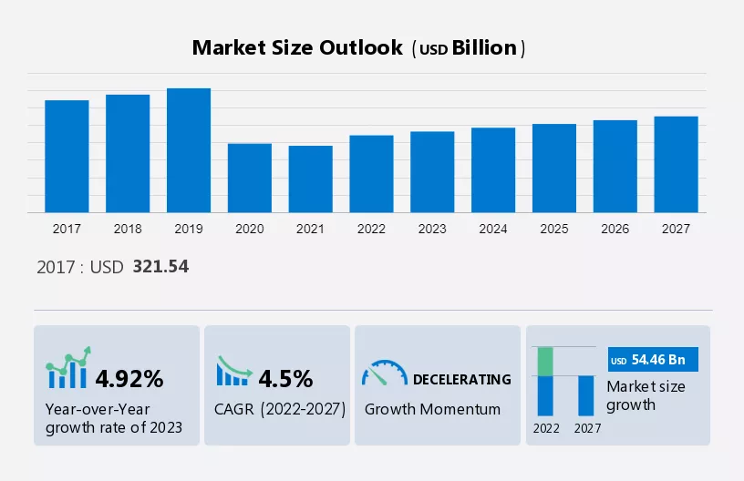
Figure 8: Luxury Hotel Market Size (Technavio, 2022)
Lastly, it's critical to keep an eye on how Aman's brand reputation is affected. Brand audits, media mentions, and sentiment analysis on social media may all be used to evaluate this. A successful execution and favorable public reaction would be indicated by an improvement in the brand's perception and greater exposure in the premium hotel sector (Hutzschenreuter and Horstkotte, 2013).

Potential Benefits
It is projected that the adoption of the suggested tactics at Aman Resorts will result in a number of noteworthy advantages, supporting the brand's further expansion and improved visitor contentment.
The anticipated rise in customer satisfaction and loyalty is one of the main advantages. Aman is able to provide a more convenient and customized service by incorporating cutting-edge digital technologies into the visitor experience. This update, together with Aman's well-known attention to detail and customized experiences, should improve the overall visitor experience and raise satisfaction levels (Griffin and Pustay, 2015). This might thus lead to a rise in return business and favorable word-of-mouth, both of which are essential in the upscale hotel industry.
A further expected consequence is the enhancement of operational effectiveness. Operations may be streamlined by using digital technologies for things like room service orders, visitor check-ins, and customized itinerary planning. This will cut down on mistakes and wait times. The team is able to concentrate more on the individualized client encounters that are the cornerstone of Aman's service, thanks to this efficiency, which also enhances the visitor experience (Butryn et al., 2015).
The resort is probably going to reap financial benefits. Higher occupancy rates and more income can result from better guest experiences and more operational efficiency. Furthermore, new income streams like customized dining experiences or excursions may become available with the potential to provide tailored experiences and upsells through digital platforms.
The planned growth of sustainability and wellness programmes is in line with the expanding worldwide trend of responsible and health-conscious travel. By taking advantage of this trend, Aman may draw in a larger clientele, especially from eco-aware and wellness-focused tourists (Buckley et al., 2010). This broadens the range of visitors and strengthens the brand's standing as a responsible and progressive supplier of premium accommodation.
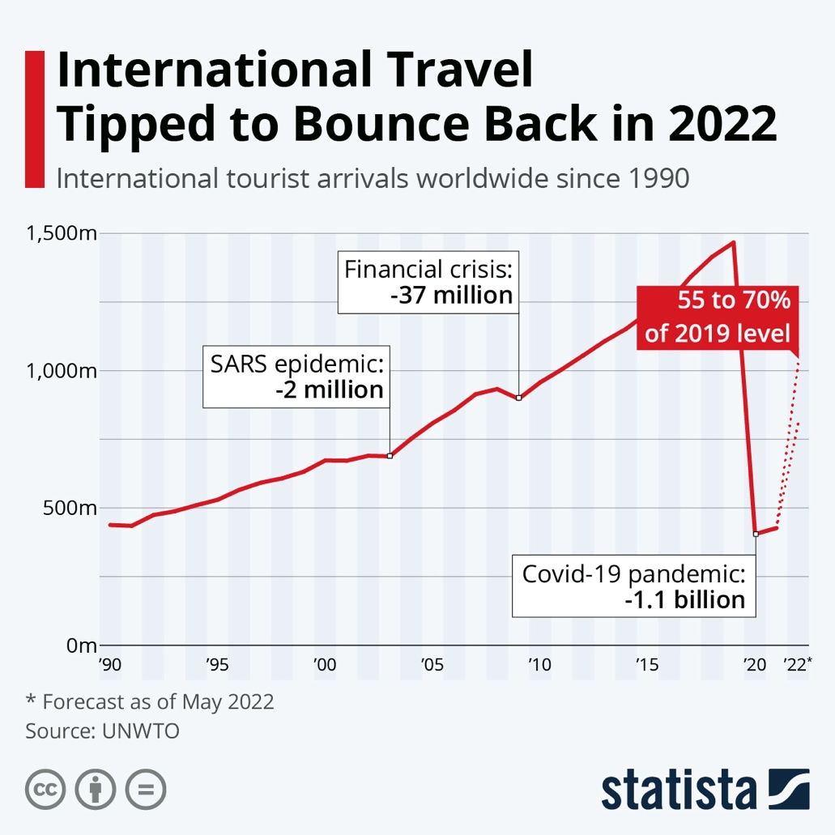
Figure 9: International Travel Growht (Statista, 2023)

Finally, there is a chance for brand extension and a rise in market share with the smart entry into developing premium markets. Aman can reach new markets and strengthen its position as the industry leader in luxury hospitality by carefully choosing new sites and customizing offers to appeal to various demographics.

Cost Analysis
A thorough cost analysis is necessary before implementing the suggested tactics at Aman Resorts to make sure that the investments are in line with the organization's long-term strategic objectives and financial capacity (Ravanavar and, Charantimath 2012).
One of the main costs is creating and implementing a custom digital guest service platform. This includes expenses related to system integration, software development, and continuous maintenance. Ensuring the highest standards of quality and security is crucial for a luxury brand such as Aman, potentially increasing the development expenses (Grewal et al., 2011). This digital makeover, which would include improving the current digital infrastructure and developing a personalized mobile application, might be estimated to cost between $500,000 and $1 million. This line takes into consideration the complexity and unique elements needed to uphold Aman's exacting standards for guest care.
Employee training is an additional major cost. Comprehensive training programmes that address both the technical elements of the new digital tools and the need of providing excellent customer service in light of these technological advancements are required (Kulshrestha and Puri, 2017). Developing specialized training materials, using outside consultants and trainers, and maybe missing work hours during training sessions might all be part of this training. This important element may have a budget of between $200,000 and $300,000, which would guarantee that employees have the tools they need to meet the higher service requirements.
There would be significant expenses associated with the expansion of health and sustainability programmes. This covers costs for creating fresh health initiatives, collaborating with professionals, and introducing eco-friendly procedures into daily operations. A preliminary budget of $250,000 to $500,000 would allow for considerable improvement in these areas, improving the brand's attractiveness and operational sustainability, however these prices can vary considerably depending on the scope.
The last item to think about is the price of strategically expanding a property into new areas. This includes branding, buying, or renting real estate, and doing market research (Kolk and Van Tulder, 2010). Although the precise amounts would depend on the location and scope of the growth, a $1 million to $2 million first funding commitment may be made for investigating and starting these initiatives.

Action Plan
Problem | Solution | Outcome | Timescale | Budget
Gap in Digital Guest Experience | Create a customized mobile application. | Improved visitor contentment and contemporary design | 6-12 months | $750,000
Inconsistent Digital Marketing | Put customized digital marketing into practice. | Increased guest engagement and retention | 3-6 months | $250,000
Need for Staff Adaptation to New Technology | Comprehensive staff training programs | Staff members' effective usage of digital technologies | 3-6 months | $250,000
Limited Wellness and Sustainability Initiatives | Expand wellness programs and sustainability | Attraction of health-conscious and eco-friendly travelers | 6-12 months | $400,000
Expansion into Emerging Markets | Strategic market research and property expansion | Increased market share and brand growth | 12-24 months | $1.5 million
Inefficient Guest Feedback Mechanism | Enhanced digital feedback systems | Improved service quality and guest experience | 2-4 months | $100,000
Need for Guest Relationship Management | Implement a Guest Relationship Management system | Personalized guest experiences and loyalty | 5-9 months | $300,000

This action plan's components have all been specifically designed to solve concerns at Aman Resorts, with an emphasis on improving both operational effectiveness and the overall guest experience (Gottfried et al., 2018). The anticipated budgets and timelines offer a practical framework for execution, guaranteeing that every project is carried out successfully and in line with Aman Resorts' strategic goals.

Conclusion

Aman Resorts received a comprehensive consultant study that included strategic suggestions to strengthen the brand's prominent position in the premium hotel business, along with a complete analysis of the data. The report's main conclusions emphasized how Aman Resorts must change and adapt to meet the new standards for luxury travel, especially when it comes to enhancing customized guest experiences and integrating digital technology. Using the PESTEL, SWOT, and TOWS frameworks, the investigation has clarified Aman Resorts' significant advantages in providing secluded, upscale, and culturally immersive experiences. Additionally, it has pointed up areas where the brand's operations and services may be improved. The necessity for Aman to close the digital interaction gap in order to satisfy the convenience and customization demands of contemporary luxury travelers was a noteworthy conclusion. In a time when technology and customized service are more and more associated with luxury, this requirement is more pressing. The suggestions made seek to solve these issues in a comprehensive manner. These include the implementation of a custom digital guest service platform, the personalization of digital marketing tactics, comprehensive employee training efforts, and the growth of wellness and sustainability programmes. Strategies for growing the industry and enhancing visitor feedback systems were also put out. A thorough action plan that outlines the particular issues, their remedies, the expected results, deadlines, and budget estimates supports these suggestions. Aman Resorts is gratefully acknowledged for their participation in this extensive investigation. It is admirable how dedicated they are to excellence and how receptive they are to change and innovation. This mindset is a reflection of Aman's commitment to upholding its position as a pioneer in opulent hospitality and its never-ending quest to surpass the demands of its discriminating clients. It is imperative to thank Aman Resorts for this chance for collaboration. Deep insights into the brand's operations and service culture have been obtained thanks in large part to its collaboration. This collaboration has made it easier to create suggestions that are specific to Aman and in line with its strategic objectives and fundamental values. There is a great chance for further cooperation and partnership in the future. The dynamic nature of the luxury hospitality sector is typified by changing consumer trends and guest preferences. As Aman Resorts puts the suggested techniques into practice, more consulting assistance would be helpful. This continued assistance would guarantee the accomplishment of these goals and their continual improvement to meet changing consumer demands and hotel standards.
To sum up, this consulting work with Aman Resorts has established the groundwork for the company to improve visitor happiness, streamline operations, and fortify its position in the market. By putting these suggestions into practice, Aman's reputation as the leading name in opulent hospitality is expected to grow. The consulting business is excited about the potential to work with Aman Resorts going ahead, adding to the brand's distinguished history and future triumphs. This collaboration, which is based on a shared dedication to quality and innovation, has the potential to propel Aman Resorts to new heights in the world of upscale hospitality.

References

Aboud, A. and ŞAHİNLİ, M.A., (2019). SWOT and TOWS analysis: An application to cocoa in Ghana. Scientific Papers: Management, Economic Engineering in Agriculture & Rural Development, 1.
Al Salmi, M.A.A. and Hasnan, N.B., (2015). SWOT and TOWS matrix e-Government analysis review on Sultanate of Oman. International Journal of Learning and Development, 5(4), pp.13-23.
Antikainen, M., Uusitalo, T. and Kivikytö-Reponen, P., (2018). Digitalization as an enabler of circular economy. Procedia Cirp, 73, pp.45-49.
Batinić, I., (2016). Hotel management and quality of hotel services. Journal of Process Management and New Technologies, 4(1), pp.25-29.
Benzaghta, M.A., Elwalda, A., Mousa, M.M., Erkan, I. and Rahman, M., (2021). SWOT analysis applications: An integrative literature review. Journal of Global Business Insights, 6(1), pp.55-73.
BNI., 2023., 3 Easy Steps to Create a SWOT Analysis. (Online) Available at: https://www.bni.com/the-latest/blog-news/3-easy-steps-to-conduct-a-swot-analysis (Accessed 12th November 2023)
Bonfanti, A., Vigolo, V. and Yfantidou, G., (2021). The impact of the Covid-19 pandemic on customer experience design: The hotel managers’ perspective. International Journal of Hospitality Management, 94, p.102871.
Buckley, P.J., Casson, M., Buckley, P.J. and Casson, M., (2010). A theory of cooperation in international business. The Multinational Enterprise Revisited: The Essential Buckley and Casson, pp.41-67.
Business-to-you., (2016). Scanning the Environment: PESTEL Analysis. (Online) Available at: https://www.business-to-you.com/scanning-the-environment-pestel-analysis/ (Accessed 12th November 2023)
Business of Apps., (2023). App Development Cost (2023). (Online) Available at: https://www.businessofapps.com/app-developers/research/app-development-cost/ (Accessed 12th November 2023)
Butryn, B., Gryncewicz, W., Kutera, R. and Leszczyńska, M., (2015), September. The Application of PEST Analysis to the Creation of the Profile of an IT Product Designed to Activate and Support Senior Citizens in Poland. In Proceedings of 9th International Symposium on e-Health Services and Technologies (EHST 2015) (pp. 109-115).
Chan, E.S., (2013). Managing green marketing: Hong Kong hotel managers’ perspective. International Journal of Hospitality Management, 34, pp.442-461.
Chen, L.F., (2019). Hotel chain affiliation as an environmental performance strategy for luxury hotels. International Journal of Hospitality Management, 77, pp.1-6.
Cherapanukorn, V. and Focken, K., (2014). Corporate social responsibility (CSR) and sustainability in Asian luxury hotels: Policies, practices, and standards. Asian Social Science, 10(8), pp.198-209.
Comparably., (2023). About Aman Resorts' Brand. (Online) Available at: https://www.comparably.com/brands/aman-resorts (Accessed 12th November 2023)
Corporate Finance Institute., (2023). Emerging Market Economy. (Online) Available at: https://corporatefinanceinstitute.com/resources/economics/emerging-market-economy/ (Accessed 12th November 2023)
Daniels, J.D., Radebaugh, L.H. and Sullivan, D.P., (2019). International business: Environments and operations. Pearson.
Doz, Y., (2011). Qualitative research for international business. Journal of International Business Studies, 42, pp.582-590.
Đurašević, S., (2015). Aman Sveti Stefan Resort: a challenge for destination management. In SITCON 2015-Singidunum International Tourism Conference (pp. 18-22). Singidunum University.
Ekiz, E., Khoo‐Lattimore, C. and Memarzadeh, F., (2012). Air the anger: investigating online complaints on luxury hotels. Journal of Hospitality and Tourism Technology, 3(2), pp.96-106.
Filimonau, V., Derqui, B. and Matute, J., (2020). The COVID-19 pandemic and organisational commitment of senior hotel managers. International Journal of Hospitality Management, 91, p.102659.
Gottfried, O., De Clercq, D., Blair, E., Weng, X. and Wang, C., (2018). SWOT-AHP-TOWS analysis of private investment behavior in the Chinese biogas sector. Journal of Cleaner Production, 184, pp.632-647.
Gray, J. and Rumpe, B., (2015). Models for digitalization. Software & Systems Modeling, 14, pp.1319-1320.
Grewal, D., Iyer, G.R., Javalgi, R.R.G. and Radulovich, L., (2011). Franchise partnership and international expansion: a conceptual framework and research propositions. Entrepreneurship theory and practice, 35(3), pp.533-557.
Griffin, R.W. and Pustay, M.W., (2015). International Business: A Managerial Perspective. Pearson Education.
Gurl, E., (2017). SWOT analysis: A theoretical review.
Helms, M.M. and Nixon, J., (2010). Exploring SWOT analysis–where are we now? A review of academic research from the last decade. Journal of strategy and management, 3(3), pp.215-251.
Ho, J.K.K., (2014). Formulation of a systemic PEST analysis for strategic analysis. European academic research, 2(5), pp.6478-6492.
Hutzschenreuter, T. and Horstkotte, J., (2013). Performance effects of international expansion processes: The moderating role of top management team experiences. International Business Review, 22(1), pp.259-277.
Kapoor, S. and Kaur, M., (2017). Basel III norms: a SWOT and TOWS approach. Vision, 21(3), pp.250-258.
Kolk, A. and Van Tulder, R., (2010). International business, corporate social responsibility, and sustainable development. International business review, 19(2), pp.119-125.
Kryukova, E.M. and Sokolova, A.P., (2014). Assessment of efficiency of the hotel management by a Russian company. World Applied Sciences Journal, 30(MCTT)), pp.51-54.
Küfeoglu, S., Liu, G., Anaya, K. and Pollitt, M., (2019). Digitalization and new business models in the energy sector.
Kulshrestha, S. and Puri, P., (2017). Tows analysis for strategic choice of business opportunity and sustainable growth of small businesses. Pacific Business Review International, 10(5), pp.144-152.
Kumar, V., Gaur, A.S. and Pattnaik, C., (2012). Product diversification and international expansion of business groups: Evidence from India. Management International Review, 52, pp.175-192.
Liu, M.T., Wong, I.A., Tseng, T.H., Chang, A.W.Y. and Phau, I., (2017). Applying consumer-based brand equity in luxury hotel branding. Journal of business research, 81, pp.192-202.
López‐Duarte, C., Vidal‐Suárez, M.M. and González‐Díaz, B., (2016). International business and national culture: A literature review and research agenda. International Journal of Management Reviews, 18(4), pp.397-416.
Mohsin, A. and Lockyer, T., (2010). Customer perceptions of service quality in luxury hotels in New Delhi, India: an exploratory study. International Journal of Contemporary Hospitality Management, 22(2), pp.160-173.
Mohsin, A., Lengler, J. and Kumar, B., (2013). Exploring the antecedents of intentions to leave the job: The case of luxury hotel staff. International Journal of Hospitality Management, 35, pp.48-58.
O'Fallon, M.J. and Rutherford, D.G., (2010). Hotel management and operations. John Wiley & Sons.
Øiestad, S. and Bugge, M.M., (2014). Digitization of publishing: exploration based on existing business models. Technological Forecasting and Social Change, 83, pp.54-65.
Olsson, A.K. and Bernhard, I., (2021). Keeping up the pace of digitalization in small businesses–Women entrepreneurs' knowledge and use of social media. International Journal of Entrepreneurial Behavior & Research, 27(2), pp.378-396.
Padma, P. and Ahn, J., (2020). Guest satisfaction & dissatisfaction in luxury hotels: An application of big data. International Journal of Hospitality Management, 84, p.102318.
Parviainen, P., Tihinen, M., Kääriäinen, J. and Teppola, S., (2017). Tackling the digitalization challenge: how to benefit from digitalization in practice. International journal of information systems and project management, 5(1), pp.63-77.
Peng, N. and Chen, A., (2019). Examining consumers’ luxury hotel stay repurchase intentions-incorporating a luxury hotel brand attachment variable into a luxury consumption value model. International Journal of Contemporary Hospitality Management, 31(3), pp.1348-1366.
Peng, N. and Chen, A., (2019). Luxury hotels going green–the antecedents and consequences of consumer hesitation. Journal of sustainable tourism.
Perera, R., (2017). The PESTLE analysis. Nerdynaut.
Puyt, R., Lie, F.B., De Graaf, F.J. and Wilderom, C.P., (2020). Origins of SWOT analysis. In Academy of management proceedings (Vol. 2020, No. 1, p. 17416). Briarcliff Manor, NY 10510: Academy of Management.
Rakhmanberdiev, R., Gulamov, A., Masharipov, M. and Umarova, D., (2022), June. The digitalization of business processes of railway transport of the Republic of Uzbekistan. In AIP Conference Proceedings (Vol. 2432, No. 1). AIP Publishing.
Rastogi, N.I.T.A.N.K. and Trivedi, M.K., (2016). PESTLE technique–a tool to identify external risks in construction projects. International Research Journal of Engineering and Technology (IRJET), 3(1), pp.384-388.
Ravanavar, G.M. and Charantimath, P.M., (2012). Strategic formulation using tows matrix–A Case Study. International Journal of Research and Development, 1(1), pp.87-90.
Ritter, T. and Pedersen, C.L., (2020). Digitization capability and the digitalization of business models in business-to-business firms: Past, present, and future. Industrial Marketing Management, 86, pp.180-190.
Robina-Ramírez, R., Medina-Merodio, J.A. and Estriegana, R., (2022). What do urban and rural hotel managers say about the future of hotels after COVID-19? The new meaning of safety experiences. Cities, 120, p.103492.
Rossato, C. and Castellani, P., (2020). The contribution of digitalization to business longevity from a competitiveness perspective. The TQM Journal, 32(4), pp.617-645.
Rutherford, D.G., 2021. Hotel management and operations.
Sammut-Bonnici, T. and Galea, D., (2014). SWOT analysis.
Santos-Álvarez, V. and García-Merino, T., (2010). The role of the entrepreneur in identifying international expansion as a strategic opportunity. International Journal of Information Management, 30(6), pp.512-520.
Sarsby, A., (2016). SWOT analysis. Lulu. com.
Sestino, A., Prete, M.I., Piper, L. and Guido, G., (2020). Internet of Things and Big Data as enablers for business digitalization strategies. Technovation, 98, p.102173.
Statista., (2022). How Global GDP Has Evolved. (Online) Available at: https://www.statista.com/chart/28452/global-gdp-evolution-by-region/ (Accessed 12th November 2023)
Statista., (2023). International Travel Bounced Back Strongly in 2022. (Online) Available at: https://www.statista.com/chart/21793/international-tourist-arrivals-worldwide/ (Accessed 12th November 2023)
Technavio., (2022). Luxury Hotel Market by Type, Ownership, and Geography - Forecast and Analysis 2023-2027. (Online) Available at: https://www.technavio.com/report/luxury-hotel-market-analysis (Accessed 12th November 2023)
Telangana State GlobalLinker., (2020). Overview of digitalisation in business. (Online) Available at: https://ts-msme.globallinker.com/bizforum/article/overview-of-digitalisation-in-business/53428 (Accessed 12th November 2023)
Teoli, D., Sanvictores, T. and An, J., (2019). SWOT analysis.
tom Dieck, M.C., Jung, T.H., Kim, W.G. and Moon, Y., (2017). Hotel guests’ social media acceptance in luxury hotels. International Journal of Contemporary Hospitality Management, 29(1), pp.530-550.
Utama, W.P., Chan, A.P., Gao, R. and Zahoor, H., (2018). Making international expansion decision for construction enterprises with multiple criteria: a literature review approach. International Journal of Construction Management, 18(3), pp.221-231.
Viral Solutions., (2022). The Strategic Training and Development Process. (Online) Available at: https://viralsolutions.net/strategic-training-and-development-process/ (Accessed 12th November 2023)
Wedding Style Magazine., (2022). HONEYMOON DESTINATIONS EXPERIENCE INDONESIA IN LUXURY AT AMAN RESORTS. (Online) Available at: https://www.weddingstylemagazine.com/honeymoon/honeymoon-destinations/honeymoon-experience-indonesia-in-luxury-at-aman-resorts (Accessed 12th November 2023)
Wild, J.J. and Wild, K.L., (2019). International business: The challenges of globalization. Pearson.
Wu, S.H. and Gao, Y., (2019). Understanding emotional customer experience and co-creation behaviours in luxury hotels. International Journal of Contemporary Hospitality Management, 31(11), pp.4247-4275.
Yüksel, I., (2012). Developing a multi-criteria decision-making model for PESTEL analysis. International Journal of Business and Management, 7(24), p.52.

