Marketing Fundamentals Analysis and Evaluation

Table of Contents
Introduction 3
Company Overview of Next Plc 4
Processes and Stages of Marketing 5
Marketing Process 5
Stages of marketing 6
Role Of the Marketing Environment and Situational Analysis Models 7
Internal Analysis 7
External Analysis 10
Segmentation, Targeting, Positioning and Marketing Mix Strategies for Next Plc 14
Market targeting 15
Market positioning 15
Marketing mix strategy 16
Conclusion 17
References 18

Introduction
Marketing is one of the core activities of a business organisation that deals with promoting and selling products and services (Nandonde, 2019). Its process goes through different stages in marketing planning to explore the market by meeting customers’ needs. The marketing process is influenced by the internal and external factors in the marketing environment. The internal environment encompasses organisational objectives, mission, structure, culture, human resources, suppliers and the customers. The external environment encompasses the factors in PESTLE analysis and five forces of Porter’s model.
This report aims at analysing and critically evaluating the impacts of internal and external marketing environmental factors on the chosen company Next plc which is one of the leading fashion retailers in the world. It will examine the impact of Covid-19 pandemic on the performance of the company. The report will also develop segmentation, targeting and product mix strategies to tackle the challenges.

Company Overview of Next Plc
Next plc is a multinational retailer founded in 1864 in England. It is headquartered in Enderby, England. It sells clothing, footwear, home products etc across Europe, Middle East and Asia. As of 2020 it has 700 stores of which 500 are in the UK and the rest 200 are across the world. It is a public limited company listed in London Stock Exchange and FTSE 100 Component. As of 2021 its net revenue is GBP286.7 million. It has a large workforce of 44,193 employees. Its major competitors are ASOS plc, Marks and Spencer, Harveys Furniture etc.

Processes and Stages of Marketing

Marketing Process
According to Fahy and Jobber (2019), marketing involves the ways by which a company creates and increases the value in their products by understanding and fulfilling the customers' needs and demands and provides best customer satisfaction. Next plc follows several crucial steps in the process of marketing that are demonstrated below:
Identifying the customer needs and demands
Next plc first identifies and understands the customers’ requirements and preferences over clothing products as well as the marketplace where the company wants to offer the products (Oliya et al., 2012). For that, it conducts periodic market research through which it gets valuable insight about the marketplace and gains essential customer data about their needs and demands.
Developing a customer driven strategy
After gaining a complete understanding of customers' demands, Next plc develops a strategy where it selects the target market and the value offerings. At first, the company segments the entire market based on various factors and targets a suitable market to whom it will offer their products (Elbe, Hallén and Axelsson, 2009). Then, the company decides on how to provide the best services to the targeted market in a profitable way.
Creating an integrated plan
Next plc develops an integrated marketing plan about how the strategy can be turned into actions that will create superior customer value. This plan includes the ways with which the company can communicate with its targeted customers and provide them great services.
Establishing profitable relationships
According to Sahaf (2019), the company focuses on establishing strong customer relationships by offering them great services and satisfaction. In this step, the company also maintains good relationships with marketing partners who co-operate in attaining the marketing aims.

Obtaining value from customers
In the final step, the company captures value from customers by creating high customer equity and generating maximum profit. Thus, by fulfilling the customers' expectations effectively, the company has been able to retain its loyal customers and hold a large customer base in the competitive market.

Stages of marketing
The marketing process goes through several stages where products are developed and customers’ expectations are met. Here are four major stages of marketing.
Production orientation
This is the early stage in the marketing process where all the efforts were made to produce products or services (Nandonde, 2019). In this stage manufacturers produce mass products with standards and customers have no choice except buying the products. The main philosophy of this stage is that customers would purchase whatever products are available in the market.
Product orientation
The next stage of marketing is the product orientation where marketers solely focus on the products that a company intends to sell. The management focuses on improving the quality of the products and services rather than the demands of the customers (Bock, Bracke and Capraro, 2017). One of the problems in this stage is that all the customers cannot afford to purchase superior products at higher costs.
Sales orientation
The sales orientation focuses on selling an existing product to an existing market by using promotional techniques. The marketers focus on stock clearance and quick sales in high volume by making promotional approaches (Mehrabi et al.,2012). For instance, Next plc often adopts promotional strategies to sell its dead stock by offering a sales discount. It allows the company to increase its sales volume before its demands start diminishing.

Marketing orientation
This orientation is popularly used in contemporary marketing models. Unlike product orientation it emphasizes on customers’ needs, tastes and demands. According to Adi and Adawiyah, (2018), the markets observe the competitors’ response to the customers’ needs and develop its products to meet customers’ requirements. Next plc always focuses on customer’s requirements and designs and innovates its products so that it can have a competitive edge over its competitors.

Role Of the Marketing Environment and Situational Analysis Models

Internal Analysis
Internal environment is the combined factors of an organisation that defines the business atmosphere where it operates. According to Sasagawa (2019), it includes several factors such as organisational mission, objectives, structure, culture, human resources, suppliers, customers etc. The internal factors in the business environment of the company Next plc are evaluated below.
Mission and objectives
The main objective of Next plc is to provide beautifully designed, quality clothing, footwear and homeware products that will meet customers’ expectations. Its mission is to become the first choice of the men and women who desire stylish and quality fashion clothing.
Organisational structure
Next plc follows the hierarchical structure where authority and responsibility are distributed in a hierarchical manner. It has in total 700 outlets of which 500 outlets are from the UK and 200 are from the European, Middle East and Asian countries. Its website serves customers from 70 countries in the world (Statista, 2021).
Organisational culture
The company uses task-based culture to ensure efficiency in the performance of the employees. It supports ethical conduction and behaviour at the workplace. The management of the company ensures the core values like accountability, passion, integrity, leadership, collaboration and diversity in the organisational context (Wheelen et al., 2017).

Human resources
Next plc has employed more than 44,100 employees who are highly skilled. The HR department employs staff through recruitment and selection processes. The company considers employees as a critical resource for productivity and organisational growth. However, the company had to sack many employees during the Covid-19 pandemic as it had to shut down many of its physical stores.
Customers
Next plc serves a huge customer range of more than 70 countries around the world. It has more than 9 million customers in its physical stores and about 3 million active customers on its websites (Next Plc.co.uk. 2018). It targeted the age range of 20 to 46 focusing on the 25-35 age group. Its prices are affordable to the targeted middle-class customers.
SWOT Analysis
SWOT analysis is popularly used by organisations to conduct situational analysis. Next plc can use this tool to evaluate its strengths, weaknesses, opportunities and threats (Pandya, 2017). The company maintains its leading position by analysing SWOT analysis as follows.
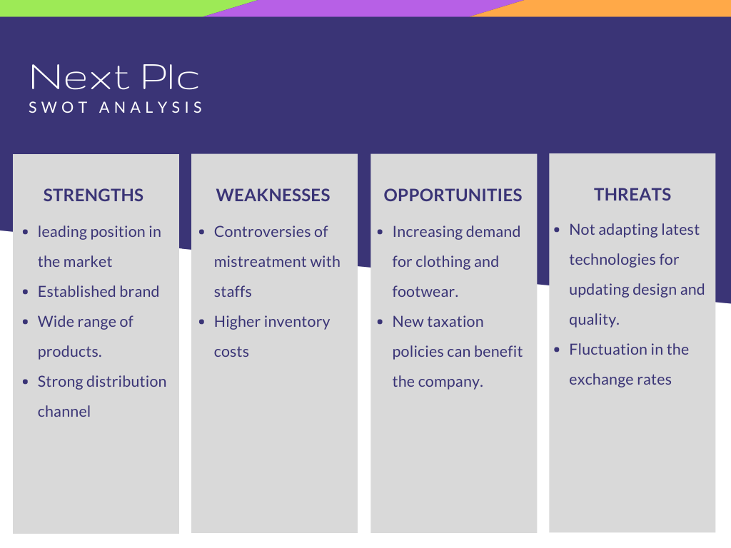
Figure: SWOT Analysis for Next Plc. (Source: Author generated)

Strengths
- Next plc is one of the leading retailers with a strong brand portfolio.
- It sells a wide range of products that are collected from reliable suppliers.
- It has built a strong distribution network across Europe, Asia and the Middle East.
Weaknesses
- It has controversies having mistreated its employees and factory workers.
- Its inventory costs are relatively higher than its competitors that affect its profitability.
Opportunities
- The increasing demand for clothing and footwear can avail scopes to the company.
- The new taxation policy can benefit the retailer industry like Next plc in the UK.
Threats
- The company fails to adopt new technologies to meet design, value and demands of the customers.
- As it operates in numerous countries the fluctuation in exchange rate due to Covid-19 pandemic poses threats to the company.

External Analysis
PESTLE Analysis
According to Nandonde (2019), PESTLE analysis is used to evaluate the external forces in the business environment that influences the decision making of an organisation. The PESTLE analysis is provided in below:
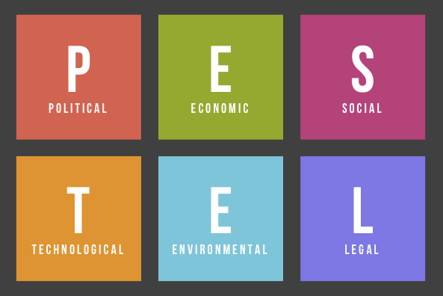
Figure: PESTLE Analysis. (Source: research-methodology.net)
Political factors
A wide range of political factors affect the performance of next plc. One of the recent issues is the tax rates levied by the UK government for the retailers. The government lowered the corporation tax rates which is positive for the company. Another issue that affected most is the decision by the government to exit from the European Union. This resulted in increase in the tax rates, exchange rates, prices of raw materials etc. as the company imports its raw materials from the EU countries (Godwin, Kalapana and Valli, 2013).
Economic factors
The economic factors such as exchange rates, per capita income, inflation rate, GDP etc. influences the performance of the company. The world economy has largely been affected by the outbreak of Covid-19 pandemic.
Social factors
Fashion industry is largely influenced by socio-cultural trends. As Next plc sells clothing, footwear and household products it evaluates socio-cultural factors for developing design, value and prices. It segments its customer base according to geographic, age and income. For instance, Asos plc ensures that its products appeal to both the young and aging population.
Technological factors
Next adapts technological advancement in its operations. With the increased demand for online shopping the company started selling through a website (Nandonde, 2019). The company leverages the social media marketing facility to improve marketing and promotional performance. It also uses different technologies to innovate new products.
Ecological factors
The company conducts ethical performance that does not affect the environment and the society. With the growing concern of environmental pollution due to technological advancements, the company adopted innovative recycling and waste management in its operations.

Legal factors
The company had a controversy regarding unethical treatment with the workforce. After the issue it considers employees’ health and safety laws. As Next plc sells through online platforms it has access to the customers’ information. It needs to ensure customers' data protection and security concerns.
Porter’s Five Forces Model
Next plc can build a sustainable competitive position in the market by assessing its competitive factors through Porter’s five forces model analysis (Bruijl, 2018). The five forces that shapes the competitiveness for the company is stated in below:
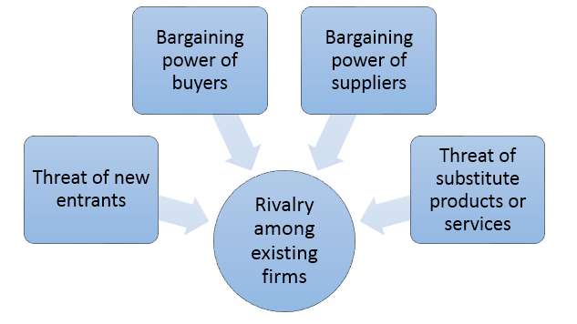
Figure: Porter’s Five Forces Model. (Sources: research-methodology.net)
Threats of new entrants
The threats of new entrants in the fashion retail; industry is high as there are limited barriers for the new companies to enter into the market (Liefers et al., 2020). It brings necessity for innovation and lower prices for the products of Next plc. However, the company can manage such challenges and build safeguard for its competitive edge by adapting technologies and innovation in its process.
Bargaining power of suppliers
The bargaining power of the suppliers in the fashion industry is relatively low as there are numerous suppliers in the market. Next plc sources its raw materials and products from various suppliers from European countries. The switching cost for the company is low. Moreover, it has developed an efficient supply chain with multiple suppliers from different countries. However, due to the Covid-19 pandemic the supply chain has been disrupted for a while.
Bargaining power of buyers
The fashion retail market in the UK is a marketplace where numerous suppliers meet the limitless demands of the customers. Consequently, the buyers in the market are in a powerful position over the suppliers. However, customers tend to purchase from branded stores like Next plc and agree to pay the tag prices as the products are reliable.
Threats of substitutes
When a new product meets customer’ expectations the profitability of a retailer suffers (Liefers et al., 2020). Fashion industry is dominated by cultural trends and innovation. As a fashion retailer company Next plc faces the challenges for emerging new products in the market. However, the company can tackle the challenge by increasing switching costs through price optimization strategy.
Rivalry among the competitors
The fashion retail industry is highly competitive in the global market. Next plc has giant rivals like ASOS plc. Mark and Spencer, John Lewis etc. have posed challenges for the company. The company can tackle the intense competition in the market by building differentiation in its product segments.

Segmentation, Targeting, Positioning and Marketing Mix Strategies for Next Plc
Market segmentation
According to Ahani et al., (2019), market segmentation refers to the process of creating approachable sub-groups of a targeted market on the basis of various criteria such as preferences of potential customers, demographic and geographic factors etc. This marketing strategy helps to identify the suitable groups to offer products according to various needs of the targeted audience. Different ways of market segmentation are stated below:
Demographic segmentation
Demographic segmentation is based on differences in people's likelihood to have a product (Nurbaiti and Soehardi, 2021). The factors that are considered in demographic segmentation are gender, age, occupation, religion, profession, income, education etc. Next plc collects this demographic information about customers from surveys and market research. It generally targets mainly middle-class customers within the 25-45 age range. Its centre of attention is on usual fashion for both gender - male and female customers.
Geographic segmentation
Geographic segmentation means dividing the market according to the customer’s physical location. The variables of geographic segmentation used by the marketers are country, city, region, climate zone, population density or postal code (Liefers et al., 2020). As Next plc is conducting business on both national and international level, it considers the climate zone factor for different regions such as producing both winter and summer clothing. It also produces and distributes its product based on various cultures of different countries.
Behavioural segmentation
Behavioural segmentation considers the customers' behaviour and attitude about making decisions for purchasing a product. Customer’s purchasing habits, spending pattern, online shopping tendency, interactions and reliability with the brand - all these are considerable factors in this segmentation. Next plc carefully observes the buying behaviour and purchasing habits of the customers. The company also tracks users' interactions with the brand during online shopping and categorizes them according to usage rate (Pilik, 2020).
Psychographic segmentation
The grouping process that depends on the customer's personality, choices, lifestyle, opinions, social status is referred to as psychographic segmentation (Dolnicar, 2018). Next plc gathers information about customer’s needs and preferences by reliable market research. It even changes the production pattern with the latest trend that attracts the customers more effectively.

Market targeting
According to George (2021), market targeting is a strategy by which a company focuses on putting full energy to develop a connection with a specific segment and prioritize solely on functioning with it. By choosing the right segments to target, marketers can easily reach potential customers and satisfy them with the best services. The process of market targeting includes two steps –
Evaluating market segments
Whether the segment is appropriate or not can be measured on the basis of attractiveness as well as potentiality of each segment. Next plc evaluates market segments considering several characteristics like size, profitability, accessibility etc. The company also considers if it has adequate resource capacity to offer services to the targeted customers.
Selecting market segments
After evaluation of market segments, the company aims at selecting the suitable groups as the target market to whom it will offer its products to attain the organisational objectives. The company selects one or more suitable segments that can create content in an effective way.

Market positioning
Market positioning refers to the process of establishing a unique position that can influence customers' perception for a brand or product in comparison to competitors (Guo et al., 2019). Its purpose is to attract potential customers by developing a brand image that puts the company in a strong and favourable position in the targeted segments. Next plc adopts the appropriate positioning map that assists in determining the company’s present and desired future position in the targeted market. The company strengthens its position by identifying unique opportunities in the competitive market and comparing competitors' position. The company adds modern and unique features in their products that are highly preferred by the customers. Its affordable pricing and high quality in the products also greatly attract the buyers. The company also focuses on product development and promoting their products in various marketing channels to enhance its brand value that facilitates the company to hold their strong position in the clothing industry.

Marketing mix strategy
The methods through which a company generates expected response from the targeted market can be referred as marketing mix (Nurbaiti and Soehardi, 2021). A proper arrangement of marketing mix can strengthen the company’s market position. The marketing mix generally consists of four major factors which is known as 4 Ps of marketing mix that works together like a foundation model (Dadzie et al., 2017). Combination of these factors allows customers to get a product at the right price and in the right place.
Product: The items or goods that are offered or sold by a company are known as products. Next is offering especially mainstream fashion and maintaining the best quality in products that are fashionable and trendy as well. The company offers both male and female clothing and considers young generation preferences in designing the product.
Price: Price is the value that is set for a product to sell by considering cost of production and profit. Pricing strategy should meet customer expectations as well as the company’s expected target. Next plc provides its product at an affordable price for the customers without making any compromises in quality (Nurbaiti and Soehardi, 2021).
Place: Place is the location for selling or distributing a product which is appropriate and easily accessible for customers (Wahyudi and Amri, 2021). Products can be sold through online or social media. Next plc also uses social media platforms to sell the products though it has several outlets for the local customers.
Promotion: The activities that provide attractive information about a product and influence customers preferences regarding purchasing the product is known as promotion. To promote products, Next arranges several marketing campaigns where its products are advertised. The company also remains active in social media platforms and posts various information about products to stay connected with national and international customers.

Conclusion
The process of marketing involves determining customers’ needs, manufacturing products that meet their needs and selling to the customers (Nurbaiti and Soehardi, 2021). It evolves in several stages. The marketing orientation emphasizes on customers’ requirements and offers products that meet their expectations. Many internal and external forces impact the marketing performances of Next Plc. The rapid changes in the tastes and demands on customers’ requirements affected most in the fashion industry. The company should develop contemporary marketing strategies to tackle the challenges encountered by the Covid-19 pandemic. It needs to invest more in its research and development to implement innovation in its production so that it can hold a sustainable position in the market.

References
- Adi, P.H. and Adawiyah, W.R., 2018. The impact of religiosity, environmental marketing orientation and practices on performance: A case of Muslim entrepreneurs in Indonesia. Journal of Islamic Marketing.
- Ahani, A., Nilashi, M., Ibrahim, O., Sanzogni, L. and Weaven, S., 2019. Market segmentation and travel choice prediction in Spa hotels through TripAdvisor’s online reviews. International Journal of Hospitality Management, 80, pp.52-77.
- Bock, W., Bracke, M. and Capraro, P., 2017, February. Product orientation in modeling tasks. In CERME 10.
- Bruijl, G.H.T., 2018. The relevance of Porter's five forces in today's innovative and changing business environment. Available at SSRN 3192207.
- Dadzie, K.Q., Amponsah, D.K., Dadzie, C.A. and Winston, E.M., 2017. How firms implement marketing strategies in emerging markets: An empirical assessment of the 4A marketing mix framework. Journal of Marketing Theory and Practice, 25(3), pp.234-256.
- Dolnicar, S., 2018. Understanding and Satisfying Consumer Needs: Segmentation, Targeting and Positioning. The SAGE Handbook of Tourism Management: Applications of Theories And Concepts to Tourism, p.257.
- Elbe, J., Hallén, L. and Axelsson, B., 2009. The destination‐management organisation and the integrative destination‐marketing process. International journal of tourism research, 11(3), pp.283-296.
- Fahy, J. and Jobber, D., 2019. EBOOK: Foundations of Marketing, 6e. McGraw Hill.
- George, R., 2021. Market Segmentation, Targeting, and Positioning. In Marketing Tourism and Hospitality (pp. 221-246). Palgrave Macmillan, Cham.
- Godwin, B.J., Kalapana, D. and Valli, S., 2013. Foreign direct investment in Indian retail sector–PESTLE & SWOT analyses. International Journal of Managment, IT and Engineering, 3(3), pp.265-274.
- Guo, X., Ansari, N., Hu, F., Shao, Y., Elikplim, N.R. and Li, L., 2019. A survey on fusion-based indoor positioning. IEEE Communications Surveys & Tutorials, 22(1), pp.566-594.
- Liefers, B., Colijn, J.M., González-Gonzalo, C., Verzijden, T., Wang, J.J., Joachim, N., Mitchell, P., Hoyng, C.B., van Ginneken, B., Klaver, C.C. and Sánchez, C.I., 2020. A deep learning model for segmentation of geographic atrophy to study its long-term natural history. Ophthalmology, 127(8), pp.1086-1096.
- Mehrabi, J., Noorbakhash, K., Shoja, M. and Karim, M., 2012. Impact of Customer Orientation and Sales Orientation on Sales' Performance in International Market of Bilehsavar County. International Journal of Business and Social Science, 3(17).
- Nandonde, F.A., 2019. A PESTLE analysis of international retailing in the East African Community. Global Business and Organizational Excellence, 38(4), pp.54-61.
- Nextplc.co.uk. (2018). Our customers and products. [online] Available at: https://www.nextplc.co.uk/corporate-responsibility/our-customers-and-products.
- Nurbaiti, B. and Soehardi, S., 2021. The Effect of the Marketing Mix of MSME Products on Sales Volume During the Covid-19 Pandemic. Journal of Strategic and Global Studies, 4(2), p.3.
- Oliya, E., Owlia, M.S., Shahrokh, Z.D. and Olfat, L., 2012. Improving marketing process using Six Sigma techniques (case of Saman Bank). International Journal of Lean Six Sigma.
- Pandya, S., 2017. Improving the learning and developmental potential of SWOT analysis: introducing the LISA framework. Strategic Direction.
- Pilik, D.I.M., 2020. The evolution of the internet and the advantages of online marketing in this context. Zlin: Tomas Bata University.
- Sahaf, M.A., 2019. Strategic marketing: making decisions for strategic advantage. PHI Learning Pvt. Ltd.
- Sasagawa, Y., 2019. Internal environment of footwear is a risk factor for tinea pedis. The Journal of dermatology, 46(11), pp.940-946.
- Statista. (2021). Next plc: value of cancelled stock due to coronavirus 2020. [online] Available at: https://www.statista.com/statistics/1134621/coronavirus-crisis-impact-on-next-plc-stock/ [Accessed 11 Nov. 2021].
- Wahyudi, R. and Amri, M.T.F.D., 2021, January. Analysis of Marketing Mix Strategy on Consumer Value in Small and Medium Enterprises in Palembang, South Sumatra. In 4th Forum in Research, Science, and Technology (FIRST-T3-20) (pp. 142-146). Atlantis Press.
- Wheelen, T.L., Hunger, J.D., Hoffman, A.N. and Bamford, C.E., 2017. Strategic management and business policy (Vol. 55). Boston, MA: pearson.

