Michele CHIARELLO
Student id: 1805745
module tutor: terry walcott

ACCC5003
NETWORK OPERATING SYSTEMS AND SECURITY
assignment 2 - report
April 28, 2020
Table of Contents

TABLE OF FIGURE 2
INTRODUCTION 3
INFORMATION SECURITY 3
CIA TRIAD MODEL 4
CONFIDENTIALITY 5
INTEGRITY 6
AVAILABILITY 7
CIA TRIAD MODEL CONSIDERATIONS 8
SECURITY PRACTICES 8
IDS AND IPS 10
INCIDENT SUMMARY 11
MITM – ARP POISONING 11
PASSWORD CRACKING 14
WIRELESS HACKING 15
COMPLY WITH THE CURRENT GDPR REGULATIONS 16
CONCLUSIONS 17
RECOMMENDATIONS 17
REFERENCES 18

TABLE OF FIGURE

Figure 1. CIA Triad 4
Figure 2. Confidentiality 5
Figure 3. Integrity 6
Figure 4. Availability 7
Figure 5. Password tips 9
Figure 6. CIA Triad related attacks 9
Figure 7. IDS and IPS 10
Figure 8. OSI model 11
Figure 9. ARP Cache 12
Figure 10. ARP Protocol explanation 13
Figure 11. MiTM attack 14
Figure 12. MFA Authentication 16

INTRODUCTION

The following report has been written in relation to the security incident that Republic of Snowdenia County Council (RSCC) has experienced recently.
The main purpose of the document is to analyse and provide counselling to RSCC, helping the organisation to better understand the risks due to bad security practices and put in place a strategy to protect its data in order to comply to the actual regulations required by the GDPR.
The following chapters discuss the incident in detail, analysing the hacking techniques used by the author of the damage against the Council and providing suggestions to avoid this happening again.
The first part is focused on the showcasing of security concepts related to the CIA (Confidentiality, Integrity and Availability), which is the practice to keep the data safe in case a security-related issue arises. In this chapter are also explained the best practices that both employer and employee should follow.
The second part, instead, is focused on the in-depth analysis of the incident suffered by RSCC, examining the attack vectors used by the threat actor to exfiltrate data, evaluating the possible preventions/mitigations to the various typologies of attacks.
Subsequently, it is illustrated how, Jones Smith Truman Consultants, which name’s will be abbreviated in JSTC, approached the problem, putting in place strategies that could protect RSCC data against possible future bad actors and disasters, in order to have better compliance to the GDPR legislation.

INFORMATION SECURITY

Information Security, also known as Infosec, is a set of practices that aim to prevent, detect and protect data against unauthorised access.
These practices rely on the adoption of security methodologies, such as CIA Triad (Confidentiality, Integrity and Availability) and in most organisations are managed by a dedicated team that provides this service while trying to minimise the impact that security practices could have on business performances.
Threats in Infosec are often related to software attacks, but not only.
Data loss can also be due to natural disasters that physically destroy the location where the data is stored and unauthorised access, due to poor implementation of security measures that prevent internal or external bad actors from physically access critical devices, such as networking equipment. This is the reason because is important to have always in place a backup strategy to allow the organisation to quickly recover data and some deterrents to avoid misbehaviours (security guards, CCTVs etc).
The failure to implement proper measures to comply with the current GDPR regulations and ensure the reliability of a system could result in a fine that can be up to the 4% of the organisation’s annual turnover or 20 million euros, in proportion to the severity of the damage (European Parliament, 2016).

CIA TRIAD MODEL

To ensure that an IT infrastructure is safe, there are three primary characteristics that must be kept into consideration. As visible in the picture below, this are: Confidentiality, Integrity and Availability and are the goals the CIA triad data security model focus on.
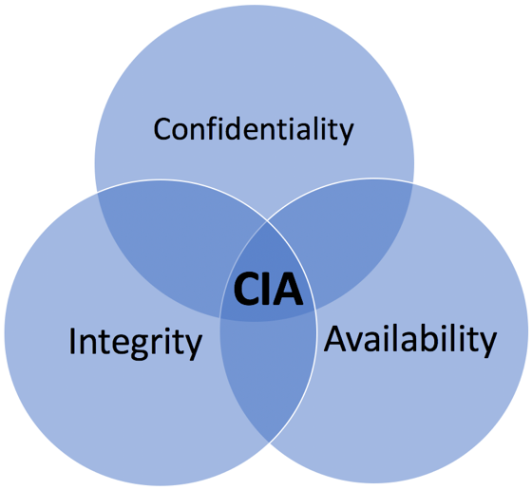
Figure 1. CIA Triad
CIA Triad is a widely used model during the development of safe IT infrastructures.
In the following paragraphs is explained the meaning of the three terms and how they could affect RSCC.

CONFIDENTIALITY

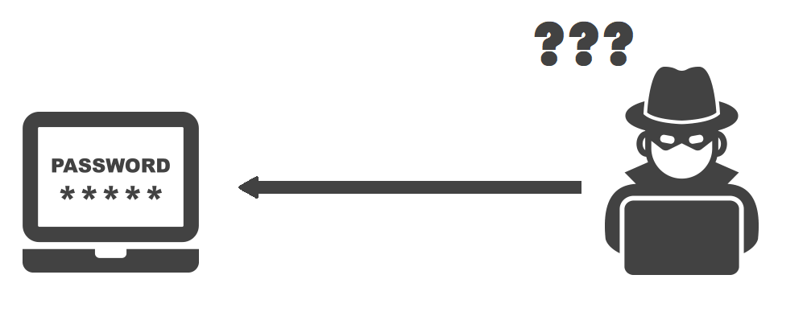
Figure 2. Confidentiality

Confidentiality is the ability to protect the data from unauthorised entities.
It is a set of strategies that can be applied in physical and virtual environments and is one of the most critical issues for organizations in every field.
Common examples of tools that aim to maintain confidentiality in a virtual environment are:
- Passwords
- Encryption
- Authentication mechanisms
While in the physical environment could be:
- CCTVs
- Security personnel
- Locks

INTEGRITY

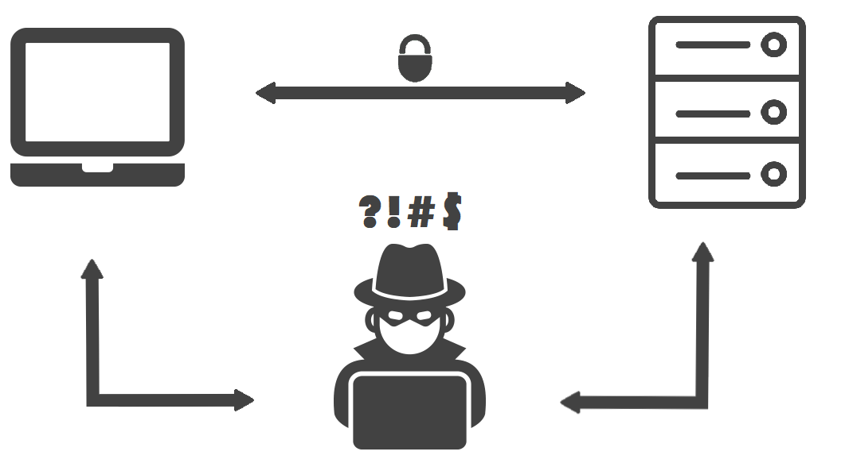
Figure 3. Integrity

Integrity is the ability to keep the data intact, more in detail, is referred to the methodologies that prevent data interception and alteration/deletion by bad actors.
The term is mainly referred to the virtual environment, where an attacker could intercept and modify data by diverting the network traffic to an evil host, using a MITM attack.
Obviously, there are different types of attack vectors that an evil party could use to achieve the goal but, in general, this kind of attacks can be made only once compromised the network.
Common tools used to ensure that the data is safe and travel unaltered from Point A to Point B are:
- Digital signatures
- Checksums
- Hashing

AVAILABILITY

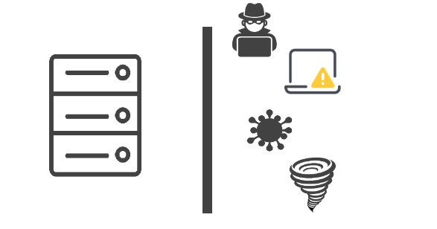
Figure 4. Availability

The last property of the CIA Triad model is availability. The term refers to the ability to maintain the uptime of the infrastructure as higher as possible and accessible to authorised users in every moment. This implies redundancy.
Redundancy is useful in different scenarios like, for example, in case of a natural disaster or a Denial of Service attack (DoS), but even in case of faulty equipment.
These but not only, could be possible causes of threats to Confidentiality and is important for any organisation to have a strong infrastructure in order to avoid possible loss in revenue.
The most used strategies to circumvent these types of damage are:
- Replication
- Firewalls

CIA TRIAD MODEL CONSIDERATIONS

A consideration that must be done about the model is that, in real world, is almost impossible to have a balanced approach on all the fronts and this is the reason why is compulsory to understand as better as possible the needs of an organisation.
It is possible to have different configurations of confidentiality, integrity and availability, based on the company need to rely more on certain aspects rather than others.

SECURITY PRACTICES

Understanding the meaning of security and implement a safe infrastructure is just the first step to ensure that the information is secured. In fact, the infrastructure can be compromised even by the inside.
Policies and rules that allow safeguarding data are one of the most important tools against internal threats.
Is important indeed to keep passwords away from prying eyes, configure the systems to enforce length and complexity checks and do not personal information (name/date of birth) to avoid brute force/dictionary attacks.
Organisations must ensure to do not use a schematic approach during passwords generation and should set expiring dates to be sure that, even in case of leaks, the access may be limited to a certain period of time.
The following table contains some of the possible attack scenarios against passwords and how these can be prevented.

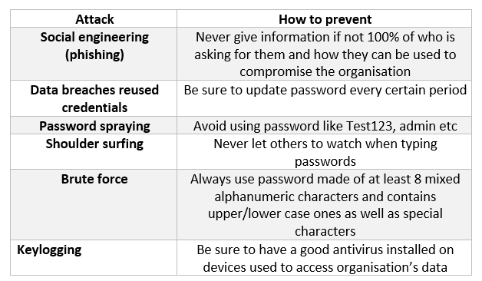
Figure 5. Password tips

The one below, instead, a list of different attacks that can mine the integrity of the CIA model.

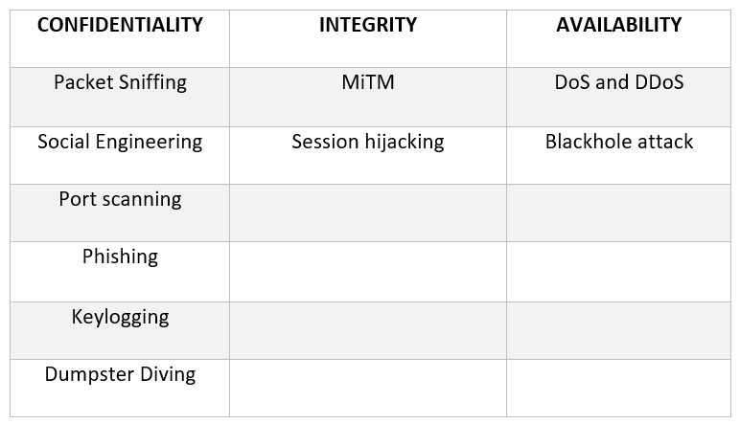
Figure 6. CIA Triad related attacks

IDS AND IPS

Protecting the integrity of network infrastructure and the devices that rely on it, means to be aware of what happens inside. To achieve this goal, IDS and IPS are often used.
IDS, that stands for Intrusion Detection System, is a software that analyse the network traffic, scanning the packets that travel through it and recognising signs of possible threats, based on a database that contains signatures patterns that are attributable to previous and known attacks (Petters, 2020).
What it does, is basically to check if the intercepted data is suspicious.
An IDS always requires human intervention, because is just a tool to monitor the system.
IPS, that stands for Intrusion Prevention System is instead a tool that, not only, monitors the network traffic but takes also decisions based on a certain set of rules.
It operates between the public and the private network of a company and can be compared to a firewall for the fact that is able to block suspicious network traffic. The difference between a firewall and an IPS is that the second can reconfigure the first to deny received packets.
It is a software that works without human interaction.
The following picture represents the similarities and characteristics of the two typologies of software.
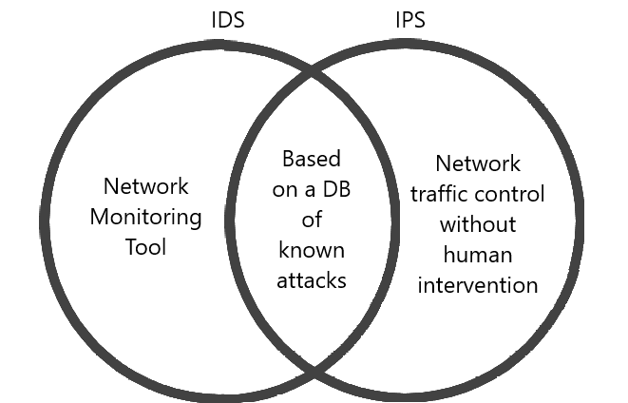
Figure 7. IDS and IPS

INCIDENT SUMMARY

The hacking incident against RSCC, has been the result of an insider threat and ended with the publication of private and sensitive data on the black market, allowing further bad actors to use them for any kind of illegal activity.
The hack has been carried out making use of three different attack vectors that successfully exploited security flaws in the protection systems that RSCC had previously implemented.
Since the attacks are not sophisticated, they could have been prevented by improving the security standards that the Council adopted in its infrastructure.
The following paragraphs are used to explain every attack the hacker implemented, trying to suggest a possible solution in order to ensure that RSCC could have better protection on the same attack surfaces.

MITM – ARP POISONING

To understand the first type of attack, it is a good idea to explain how devices communicate within a local network. The following picture shows the OSI (Open System Interconnection) standard model for computer systems communication.
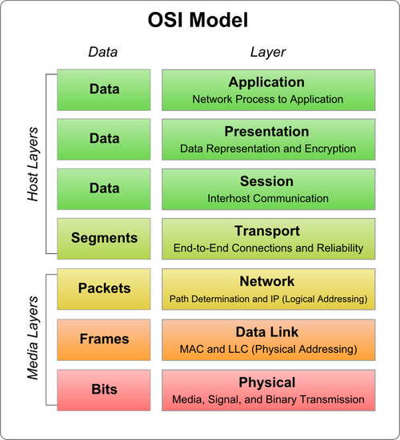
Figure 8. OSI model
As visible in the above figure, the model is composed of 7 different layers and each of them has a different purpose.
ARP Poisoning is a type of attack that takes place at Layer 2 or Data Link Layer of the OSI model, more precisely where the host gains access and permissions to data transmission, making use of its MAC address.
MAC address is a unique identifier assigned to every NIC (Network Interface Controller) and is what allow devices to communicate with each other over a LAN.
It relies on Address Resolution Protocol (ARP) which involves the use of a table (ARP Table) where IP and MAC addresses of the network devices which the host needs communicate with are stored and, that in some cases, can be used as an attack vector.
Every host needs two things in order to communicate in a LAN:

- IP address of the device which wants to communicate with
- MAC address of the IP associated to that particular device

The screenshot below shows how the ARP Table or, ARP Cache, looks like on a Windows PC.
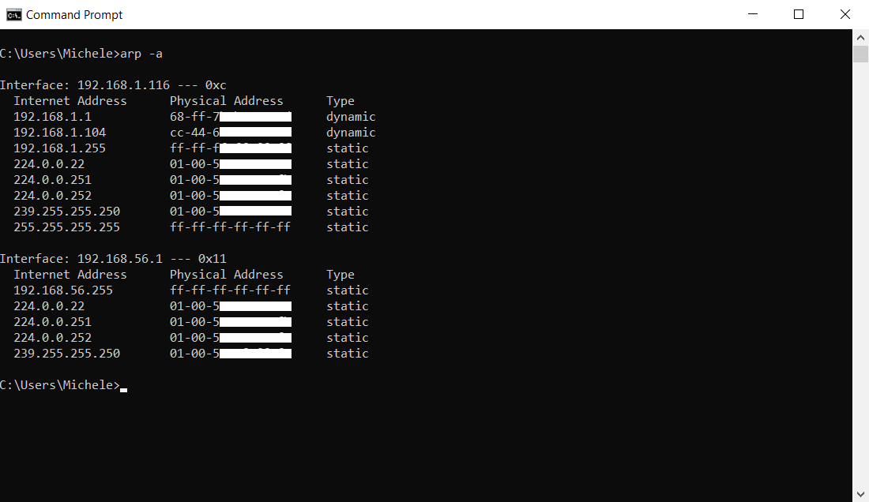
Figure 9. ARP Cache

The diagram below, instead, the concept of what happens when a hypothetical Computer A wants to communicate with another device, Computer B in this case.

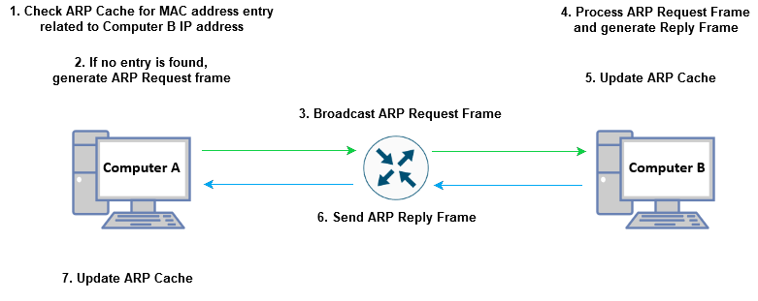
Figure 10. ARP Protocol explanation

But, what if at some point a bad actor starts to flood the network with fake ARP Reply frames that contain the attacker MAC address instead of the victim’s one? The answer is simple.
All the other hosts on the network, start to update their ARP Caches with the new address and all the traffic is diverted through the attacker device that will be defined as “man in the middle”.
In the picture below, is possible to see how a MiTM looks like.
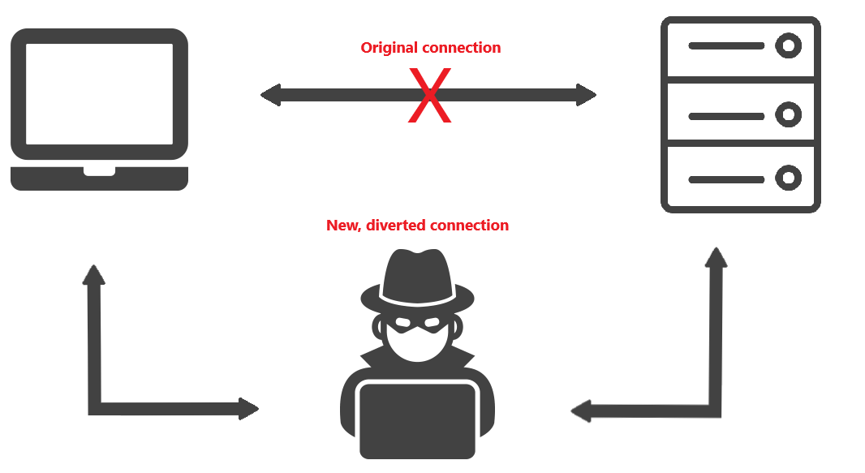
Figure 11. MiTM attack

These kinds of attacks can be prevented by making use of:
- HTTPS connections instead of old and unencrypted HTTP ones
- VPN
- IDS/IPS

PASSWORD CRACKING

The second technique used to exfiltrate data during the hack has been something related to password cracking.
As previously seen in the SECURITY PRACTICES paragraph, there are different techniques that allow a bad actor to crack passwords and they can go from the use of dedicated tools to the physical cracking, making use of spying and social skills.
It is hard to say how the author has been able to crack the credentials used to access the data because he could have even intercepted them via an unsecured connection since he used the MiTM technique to sniff on unencrypted connections on different hosts, but as explained previously, the ways to prevent password cracking are:
- Use strong passwords
- Change them frequently
- Use good antivirus/malware to avoid keylogging
- Use multi factors authentication (MFA)

WIRELESS HACKING

The last attack carried out by the rogue employee has been against the Wi-Fi facility that RSCC offered to allow the staff to work from home.
There are different typologies of attacks that can be used to exploit security flaws in wireless infrastructures, but most of them rely on the fact that APs use weak authentication systems and simple passwords.
To give an example, dictionary attacks are the most famous against WPA password types. In these attack typologies, the evil host sniffs beacons from the AP and generates a hash that is compared against others generated on a list of words present in a dictionary file.
When the captured hash corresponds to one of the generated ones, the password is found.
It is important to understand that these kinds of attacks are slow but most of the times effective, and this is the reason because is important to use complex passwords when deploying wireless APs.
To protect the network from intruders is always a good practice to use strong passwords as well as authentication systems like Captive Portals that use MFA, to ensure that who is connected to the network is a legit user, coupled with the fact that the service should only be shared to who strictly needs it. Sensitive data, in fact, should be accessed only locally, to avoid leaks in case a personal device may be compromised.
Access the company network without a valid reason increases the risk to get hacked.
The following image shows how MFA authentication works.
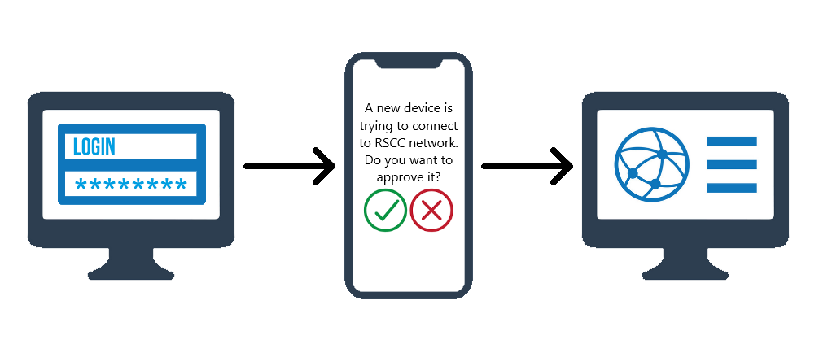
Figure 12. MFA Authentication

COMPLY WITH THE CURRENT GDPR REGULATIONS

As explained during the introduction, the goal of this report is to give counselling to RSCC to better comply to the regulations imposed by the GDPR.
For this reason, JSTC has come up with an audit plan that can be represented by the following points:
- Identification of possible risks
- Audit of the actual protection system
- Deployment of suitable solutions
The first phase involves the identification of key data and the threats that could compromise it and the regulations related to the processing of this data.
The second part, instead, involves the use of pentesting by JSTC team, in order to find any possible security flaw that could be used by an attacker to compromise RSCC facilities, such as website, Wi-Fi, software and policies etc.
Last, JSCC would ensure that in case of poor security measures or flaw would be found, the Council would be advised on how to implement the proper protection system to prevent unauthorised access to the infrastructure.

CONCLUSIONS

The topics treated in the report, aim to give the reader a brief introduction to data security.
Cybersecurity is an important topic that must be taken seriously.
The non-compliance to security standards required by the data protection legislation can not only impact organisations revenue but even the privacy of customers that rely on those organisations.
It is important to prevent security incidents and grant that data is safe not only by cyber threats but even natural calamities.
Every employee should be aware of good and bad practices that could give data access to unauthorised parties and should prevent to share sensitive information to who is not allowed to access those.
The case that the Council has faced should be proof of this and should be seen as an example, to avoid committing the same errors.

RECOMMENDATIONS

The following bullet points contain a few recommendations that can be useful to RSCC to improve its security.
- Pentesting on RSCC infrastructure should be carried once per year
- IDS/IPS should be implemented over possible
- IT department should be strict with policies and release services just to who needs them
- Devices should be always updated
- Sensitive data should only be accessed locally in maximum privacy respect

REFERENCES

Andress, D. J., 2014. The basics of information security second edition. s.l.:Syngress.
European Parliament, 2016. Official Journal of the European Union, L 119, 4 May 2016. Official Journal of the European Union, 04 05.pp. 1-88.
EUROPEAN PARLIAMENT, 2016. Official Journal of the European Union, L 119, 4 May 2016. Official Journal of the European Union, pp. 1-88.
National Cyber Security Centre, 2018. Password administration for system owners. [Online]
Available at: https://www.ncsc.gov.uk/collection/passwords/updating-your-approach
Petters, J., 2020. IDS vs. IPS: What is the Difference?. [Online]
Available at: https://www.varonis.com/blog/ids-vs-ips/
Umawing, J., 2018. When three isn’t a crowd: Man-in-the-Middle (MitM) attacks explained. [Online]
Available at: https://blog.malwarebytes.com/101/2018/07/when-three-isnt-a-crowd-man-in-the-middle-mitm-attacks-explained/

