
The Connection Between Management,
Emotional Intelligence, and Stress in the Workplace.

University of Wales Trinity Saint David

Alina Georgiana Mucenic
UWTSD Number: 2108840
5th July 2024

BMSW6009

DECLARATION
This work has not previously been accepted in substance for any degree and is not being concurrently submitted in candidature for any degree.
Signed ..............Alina Georgiana Mucenic............... (candidate)
Date ................05/07/2024..........................

STATEMENT 1

This work is the result of my own investigations, except where otherwise stated.
Other sources are acknowledged by footnotes giving explicit references. A bibliography is appended.
Signed ..............Alina Georgiana Mucenic.......... (candidate)
Date ...................05/07/2024......................

STATEMENT 2
I hereby give consent for my work, if accepted, to be available for photocopying and for inter-library loan, and for the title and summary to be made available to outside organisations.
Signed ..........Alina Georgiana Mucenic............. (candidate)

Date ..............05/07/2024.............................

BMSW6009

Acknowledgements

My study on this subject has been fruitful, as it has taught me a lot about how emotional intelligence in the engineering sector is changing the face of business and leadership. The engineering sector, known for its focus on technical skills and innovation, is increasingly recognizing the importance of emotional intelligence in enhancing team dynamics and project outcomes. During this research project, I have also improved my own emotional intelligence, which has been invaluable in both my personal and professional development. I am grateful to my supervisor, Marie Pitson, who has been very helpful, and I'm thankful for the chance she gave me to learn more about the relationship between emotional intelligence management and stress in the workplace in the engineering industry. Until now, I had no prior knowledge of this subject. Both my spouse and daughter were essential in making sure I had a place to stay and in supporting me during my studies.

Table Content

Abstract
The study was designed to investigate the relationship as well as the impact of Emotional Intelligence (EI) on to the perception of role stress on engineering managers in the workplace, specifically addressing their work attitudes, behaviors, and outcomes. This emphasizes the significance of emotional intelligence in managing job-related stress and establishing a conducive work atmosphere. The research shows that the emotional intelligence of leaders greatly impacts the way subordinates react to and perform under stressful circumstances. Studies indicate a significant impact of emotional intelligence (EI) on leadership and management in several industries, particularly in engineering companies. The study investigated the impact of emotional intelligence (EI) on leadership and management strategies, the obstacles encountered in implementing these approaches, and potential methods for improving organisational practices. The research substantiated its assertions by using positivist, logical, and several other approaches. The results demonstrate a significant association between the leadership and management approaches of the leading global organisations, implying that using emotional intelligence (EI) to enhance leadership and management might enhance corporate development and achievement. Emotional intelligence is essential for achieving success in life, especially when it comes to establishing and nurturing personal and professional connections. During the last years, the idea of working in corporate organizations has undergone substantial changes, which have had a profound impact on their work culture and performance which link with EI.

BMSW6009

Chapter One

Introduction

Emotional intelligence in the engineering sector
The publication of Daniel Goleman’s (1995) work on emotional intelligence (EI) has highlighted its importance across various fields, including the engineering sector. Emotional intelligence, defined as 'social intelligence,' was first introduced in 1920 as a modern idea. Subsequently, other social scientists and psychologists conducted extensive studies in this field and made diligent attempts to explain this concept using alternative terminology (Dasgupta and Arora, 2012).
Goleman’s EI theory comprises four core components and introduced the specific definition of EI

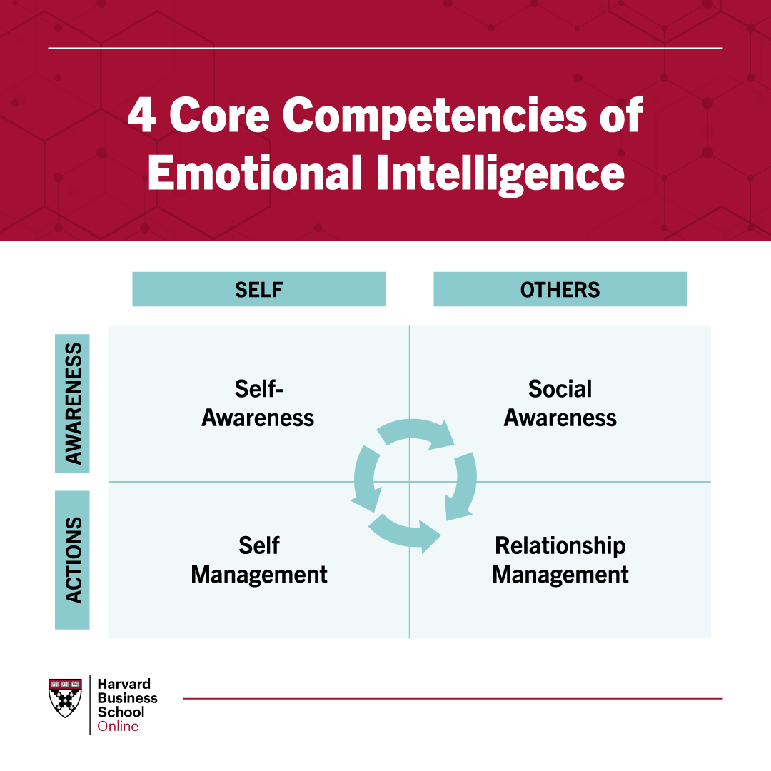 (Landry 2019)

Self-awareness has been considered as the most significant dimension (Goleman, 1996; Bar-On, 1997). Engineers with high EI are skilled at identifying their own stress triggers and emotional responses (Hirudayaraj et al. 2021). By recognizing early signs of stress, they can take proactive steps to manage their emotions, preventing these emotions from negatively affecting their work.
Self-regulation: Goleman (1996); Elegbe (2015) define that individuals with high EI emphasize that self-regulation is crucial for engineers, enabling them to control their emotions and prevent stress from escalating and affecting their performance and decision-making. This skill ensures that stressors do not disrupt project timelines and quality standards.
Social awareness: Goleman (1996) claimed that without self-awareness, one cannot understand the emotions of others as one cannot know themselves. This allows engineers to recognize and understand the stress experienced by their team members. Also, it is crucial for fostering a supportive work environment and ensuring cohesive team dynamics, especially in collaborative projects typical of the engineering sector.
Relationship management is the ability of controlling emotions in other people. Studies made by Landry (2019) indicate that each unresolved issue has the potential to consume around eight hours of corporate resources. Emotionally sensitive individuals, according to Goleman (1996), are more successful in many sectors of life and organizational politics by recognising and controlling their own emotions and properly handling those of others.
Effective communication, a core aspect of EI, reduces misunderstandings and conflicts, which are common sources of stress in team-based projects. Enhancing emotional intelligence among engineers facilitates smoother interactions and more efficient project execution (Chaves, 2019).

Motivation EI helps maintain high levels of motivation even in stressful situations by focusing on positive outcomes and goal orientation. This is essential for sustaining productivity and enthusiasm when facing project challenges or deadlines. Singh and Singh (2008) share that implementing targeted training sessions that focus on developing EI competencies, such as empathy, self-regulation, and social skills, is crucial. These programmes equip engineers with the tools needed to manage their emotions and support their colleagues effectively. Establishing mentoring programmes where experienced engineers coach younger staff on EI development is vital for professional growth. This not only enhances EI skills but also reinforces a culture of emotional understanding and regulation within the team. According to Elegbe (2015), creating a culture of open and constructive feedback helps individuals understand and manage their emotions effectively. This is fundamental in engineering, where feedback can have a direct impact on a project's success and the team's well-being. Integrating wellness programmes that promote overall well-being and stress management, including mindfulness practices and EI workshops, supports engineers in managing stress and maintaining mental health. Goleman provided many reasons for the positive link between EI and individual work success (Cherniss & Goleman, 2001). Enhancing EI among engineers through training, mentoring, feedback, and wellness programmes can lead to better stress management, improved teamwork, and overall project success (Baker and Waring, 1999). The engineering industry, historically focused on technical skills and innovation, should realise the value of emotional intelligence (EI) in team relations and project success (Tang et al. 2020). Company leadership development may benefit from emotional intelligence training by increasing emotion management and monitoring. According to research by Walter et al. (2012), facial expressions may reveal emotions that unskilled viewers may overlook. Signal awareness training improves these abilities. This dissertation examines engineering company management techniques, emotional intelligence, and job stress (Martin, 2008). This research examines leadership and EI to find ways to promote employee well-being and organisational effectiveness.

Chapter Two

Literature Review

Theoretical Frameworks

Various researchers have worked to identify the determinants of leadership, two significant bodies of work on emotional intelligence (EI) are pivotal to recent theorizing in the field. Daniel Goleman’s proposed these are the framework and the model developed by Peter Salovey and John Mayer. It was highlighted by Pfeiffer (2001) and Antonopoulou (2024) the importance of five essential elements of the employee: self-awareness, self-regulation, motivation, empathy, and social skills. These components are essential for understanding the influence of EI on leadership and teamwork in engineering environments, where developing these competencies is crucial for effective stress management. Current research suggests that successful leadership requires an understanding of people's unique traits and characteristics. Leadership is generally regarded as highly stressful environment, Elankumaran (2002) suggests that EI helps managers and staff recognise and interpret emotions, contributing to self-control and social harmony. In the workplace, EI supports group projects, individual development, and corporate expansion. The development of scales to measure EI, as detailed by Mayer et al. (1999), provides a more in-depth description of tasks defining the four tiers or branches of EI. Introduces a four-branch model of EI, including perceiving emotions, using emotions to facilitate thinking, understanding emotions, and managing emotions (Olsson, 2024).

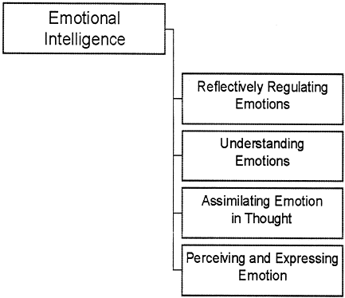
(Mayer and Salovey, 1997).
In his 1995 groundbreaking work, Daniel Goleman brought attention to the importance of emotional intelligence (EI) in many professions, including engineering. This helped propel the idea of EI to the forefront of professional discourse. Important abilities that make up EI include motivation, self-awareness, social skills, empathy, and self-regulation. Researchers Mayer and Salovey (1997) laid forth a system for gauging EI, drawing attention to its function in efficient leadership and stress reduction.
Emotional intelligence (EI) is becoming increasingly crucial for leaders in problem-solving and decision-making. Problem-solving requires enthusiasm, determination, and a strong desire to achieve goals, where emotional intelligence often surpasses intellectual intelligence (Coronado-Maldonado; Benítez-Márquez 2023). However, there is a lack of consensus among researchers regarding the relationship between IQ and EI. Some regard EI as the most sophisticated form of intelligence, though opinions vary.
Studies consistently conclude that effective leadership involves EI traits like empathy, motivational power, intuition, and honesty (Ahmad Bashir, 2017). EI aids in recognising stressors through mental processes, as stress is known to impair cognitive function. This study explores the connection between leadership, emotional intelligence, and stress in the workplace.
Emotional intelligence, often compared to cognitive ability or IQ, has evolved from the debunked notion of intrinsic intelligence to encompass multiple intelligences. This theory, proposed by a Harvard psychologist, emphasises the importance of interpersonal intelligence for engaging effectively with others (Cherry, 2023). The MIS theory focuses on the cultivation of cognitive abilities over hereditary factors. EI is a component of social intelligence that involves observing and understanding one's own emotions and those of others, then using this information to guide behavior. Goleman (1995) defines EI as the ability to understand, control, inspire, identify, and govern emotions and interpersonal connections.
An Overview of Emotional Intelligence
Emotional intelligence (EI) plays a crucial role in achieving success in both personal and professional life by enabling individuals to recognise, manage, and evaluate emotions (Houston, 2024). This skill, which can be naturally present or developed over time, is essential in various domains, including the engineering sector (Cherry, 2018). Four main categories classify EI: ability-based, trait-based, and two mixed models. The ability model focuses on mental processes related to emotions, while the trait model views EI as a personality trait encompassing emotion-related behaviours and self-perceptions. Mixed models, proposed by Bar-On (2006) and Boyatzis et al. (2019), emphasise the interaction between social behaviour, characteristics, and skills related to emotions. Bar-On’s theory categorises emotional components into intrapersonal and interpersonal skills, stress management, adaptability, and overall emotional well-being.
Understanding and wisely using one’s emotions are fundamental aspects of EI, significantly affecting behaviour, decision-making, physical health, and relationships (Takacs, 2020). These abilities are crucial for mental and physical health and success in various aspects of life, including education, work, and relationships. Emotional intelligence is particularly relevant in leadership roles within the engineering sector. Leaders must manage their own emotions, recognise emotions in others, and handle relationships effectively. This involves self-awareness, self-management, social awareness, and relationship management—key components of Goleman’s EI dimensions. These skills empower leaders to regulate their emotions and impulses, thereby averting overwhelm (Ikpesu, 2017). Managers with high EI tend to have better psychological and physical health, job performance, and stress-handling abilities. EI has a positive impact on transformational and charismatic leadership styles, helps to create a supportive feedback environment, and increases employee satisfaction. Overall, EI is essential for effective leadership and significantly impacts an organisation’s financial results.
Recently, interest in EI in the engineering sector has grown, stemming from Gardner's Theory of Multiple Intelligences, which includes interpersonal and intrapersonal intelligence. EI, as defined by Goleman in the mid-1990s, entails recognising one's own and others' feelings, motivating oneself, and managing emotions in relationships (Lozano et al., 2022). Emotions significantly influence cognitive aspects and behaviour, affecting workers’ attitudes towards success or failure. Weiner’s attribution theory suggests that engineers with leaders who have low EI may experience negative emotions, leading to a rejection of growth and productivity. Conversely, those who succeed generate positive emotions, attract and motivate. Active methods can stimulate positive emotions, enhancing employee interest. EI promotes problem-solving and prevents negative behaviour among workers.

Emotional intelligence plays a significant role in leadership within the engineering sector.
In the engineering sector, EI is vital for leadership, particularly in managing employee motivation and performance. Research by Ashkanasy (2003) and others suggests that leaders with high EI are better equipped to manage teams, resolve conflicts, and create a positive work environment. Leaders influence the overall mood and emotions of their team, impacting productivity and workplace harmony. According to Goleman's (1995) resonant leadership theory, emotional influence is a key component of leadership, suggesting that leaders can effectively use their own and their employees' emotions to create a positive emotional environment. To foster this environment, leaders must interact with employees, share important experiences, and express emotions. Leaders with high EI can build trust, create a comfortable work environment, share knowledge, involve employees in decision-making, encourage teamwork, and ensure high organisational performance. Ashkanasy (2003) outlines organisational EI in five steps, starting from the individual level and extending to the organisational level. Leaders can improve performance by fostering positive emotions and moods among team members, aligning with Goleman’s resonant leadership theory. Being aware of their own emotions, managing them, and demonstrating emotionally intelligent behaviour enables leaders to positively influence their entire team, ensuring organisational effectiveness.
In Conclusion
Over the last twenty years, there has been a growing focus on EI, particularly in relation to leadership. Empirical research has substantiated that various aspects of EI, including self-awareness, others' emotional awareness, self-management, social awareness, and relationship management, may have a more significant impact on leadership effectiveness and the ability to cope with work-related stress compared to traditional measures of intelligence (IQ). Prior research has demonstrated the significance of EI in social settings. While IQ is undoubtedly a crucial and essential factor in leadership, our findings suggest that EI holds greater importance for leaders in various contexts, such as dealing with work-related stress, compared to general intelligence. Based on the literature review, Vrontis et al, (2021) shows that there is a positive relationship between managers' emotional intelligence and the performance of employees in the engineering sector.
Enhancing emotional intelligence
Training Programmes
Implementing targeted training sessions focusing on developing EI competencies such as empathy, self-regulation, and social skills is crucial. These programmes provide engineers with the tools they need to manage their emotions and effectively support their colleagues.
Mentoring and coaching
Establishing mentoring programmes in which experienced engineers coach younger staff on EI development is critical for professional growth. This enhances EI skills and reinforces a culture of emotional understanding and regulation within the team.
Feedback Culture
According to Elegbe (2015), creating a culture of open and constructive feedback helps individuals understand and manage their emotions effectively. This is fundamental in engineering, where feedback can have a direct impact on a project's success and the team's well-being.

Wellness Programmes
Integrating wellness programmes that promote overall well-being and stress management, including mindfulness practices and EI workshops, help engineers manage stress and maintain mental health (Zhang and Fan, 2013). Goleman provided many reasons for the positive link between EI and individual work success. Enhancing EI among engineers through training, mentoring, feedback, and wellness programs can lead to better stress management, improved teamwork, and overall project success.
Gaps in the Literature
Although there has been much study conducted on emotional intelligence (EI), there are still areas where our grasp of its precise effects on the engineering industry is lacking (Mukhtar Olalekan Iyanda et al., 2024). This research seeks to address these deficiencies by investigating the impact of emotional intelligence on management practices and stress levels among engineers. Goswami & Banerjee (2023) highlight gaps in EI research in the engineering sector, including inconsistencies across different contexts and populations, ongoing debate on theoretical frameworks, and a lack of practical applications in real-world settings. More robust, context-specific studies and further theoretical refinement are necessary to address these gaps and improve employee performance and adaptability in the engineering sector, as suggested by Knott et al. (2022). All the afore mentioned studies provided distinct perspectives on emotional intelligence, nevertheless they also affirmed that individuals who possess emotional intelligence are capable of seeing, comprehending, and harnessing emotions in a proficient manner. According to Bru-Luna et al, (2021), the current gap in understanding emotional intelligence (EI) includes disputes over its definition and discrepancies in its assessment. There is a need for a more cohesive and concentrated delineation of EI. Additionally, there is little exploration of the correlation between EI and the processing of emotional information (EIP) in existing research. The influence of cultural factors on the emotional processes underlying EI skills is also limited in understanding. Furthermore, there is a lack of study on the correlation between EI and general intelligence, as well as verbal and nonverbal intelligence. Lastly, emotional intelligence is not often recognized.

BMSW6009

Chapter Three

Research Methodology

Goals and Objectives
This research aims to describe the link between emotional intelligence (EI) management and workplace stress, considering its potential impact (Dirk and Cartwright, 2010).
Assess Emotional Intelligence Level Using standardized instruments, measure emotional intelligence levels among engineers.
Evaluate the Relationship Between Emotional Intelligence and Stress Management Examine how emotional intelligence influences stress management.
Investigate the Impact of Emotional Intelligence on Management Practices Analyse how emotional intelligence affects management effectiveness and decision-making in engineering roles.
Research Rationale
The rationale for this study links to existing literature, demonstrating the importance of emotional intelligence (EI) in various domains. Research by Rezvani and Khosravi (2019) highlights the role of EI in improving performance and well-being. The current study seeks to fill gaps in the literature by exploring the specific impact of EI on management and stress within the engineering sector.
Research Design
Research questions play a vital role in directing the research process by providing clarity on the specific discoveries you want to make. Bell, Bryman, and Harley (2019) highlight the distinction between researchers who begin their studies with a clearly defined topic and those who, particularly in qualitative research, allow the question to develop and change during the study. This methodology facilitates the construction of knowledge via induction and prevents the imposition of preconceived limitations. Developing a research design involves setting out appropriate procedures to acquire relevant information and material to answer the research question (Abutabenjeh and Jaradat, 2018).
We conducted a quantitative component by distributing surveys to 100 engineers to assess their levels of emotional intelligence (EI), stress management techniques, and leadership effectiveness judgements. The poll included standardized items such as the Emotional Intelligence Appraisal and the Perceived Stress Scale (Tessesma, 2010). The qualitative component of the study included conducting semi-structured interviews with 10 engineers to get an in-depth understanding of their personal experiences with emotional intelligence and professional stress (Chan et al. 2018). The study adopts a mixed-methods approach, integrating both qualitative and quantitative methods to provide a comprehensive understanding of the impact of emotional intelligence in the workplace. This approach allows for detailed exploration of qualitative insights, supported by quantitative data, to form a well-rounded view of the phenomena studied. According to Knott et al. (2022), this dynamic mixed method introduces a range of methodological, analytical, and ethical challenges.
Surveys provide a complete option for scholars seeking to do research. Questionnaire surveys are a flexible platform for developing and conducting research projects (Bhat, 2024). They offer a user-friendly interface, extensive data gathering and analysis capabilities, and the ability to combine findings from numerous sources.
Research Onion Model Overview
- Research Philosophy Ontology, Epistemology, and Axiology.
- Theories Developed Deduction, Induction, and Abduction.
- Quantitative and qualitative methodologies.
- Strategies experimental, survey, archival research, case study, ethnography, action research, grounded theory, and narrative inquiry.
- The study focuses on two types of time frames cross-sectional and longitudinal.
- Methods data collection and analysis, sample group selection, questionnaire content creation, and interview preparation.

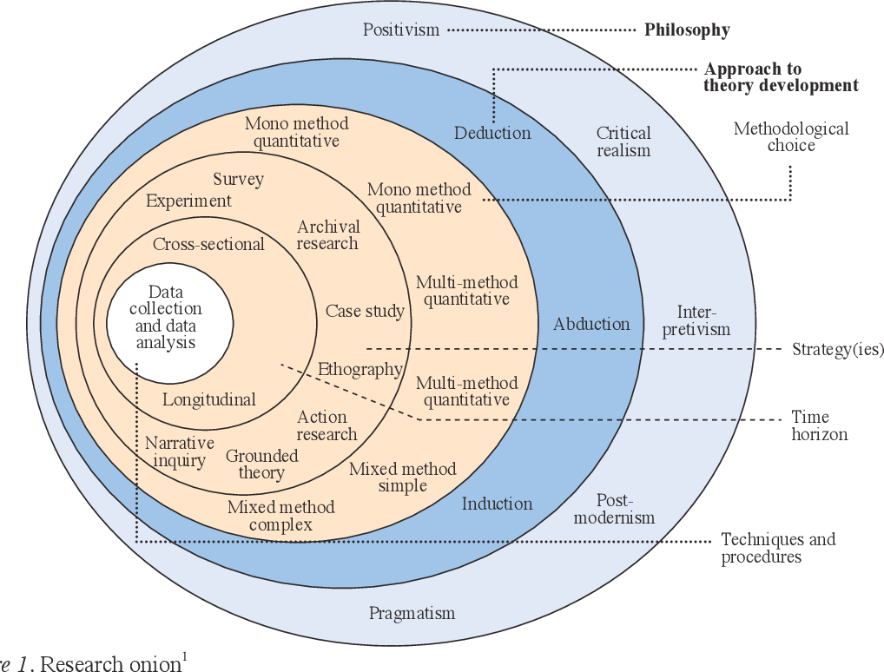
(Melnikovas, 2019)
Saunders et al. (2016) proposed the research onion, which aids in organizing research and developing research design by following its layers step by step (Melnikovas, 2019).
Research Paradigm
The pragmatic paradigm, combining positivist and interpretivist paradigms, is suitable for educational research. It focuses on practical outcomes and real-world applications, allowing for quantitative and qualitative data to address research questions. This paradigm is particularly suitable for mixed-methods research in educational settings. Mixed research is an innovative strategy that enhances standard qualitative and quantitative methodologies (Johnson and Onwuegbuzie, 2004). It combines practicality with a framework for developing and executing mixed-methods research. The technique, renowned for its methodological heterogeneity, often produces greater outcomes compared to monomethod research. Success in mixed research depends on the involvement of other investigators and consistent practice.
Data Collection
We will use a survey to measure the emotional intelligence, stress, and perceived management effectiveness among engineers. This approach provides statistical data to understand trends and correlations among the variables studied.
According to Leong and Austin (2006)
Surveys are distributed electronically, focusing on key EI components and stress factors.
Interviews conducted in person or via video conferencing, following a set of open-ended questions designed to explore participants' views on EI and stress management.
Data gathering is a fundamental aspect of every research endeavor. As stated by Bell, Bryman, and Harley (2019), this phase of the research process is of utmost importance and often necessitates additional resources and focus. Common methods include interviews and surveys. Some methodologies require a systematic approach in which the researcher predefines the overall framework of their inquiry and then tailors the study to align with it. According to Di Benedetto (2023), exploratory research using foundational principles serves as a base for future studies, offering a comprehensive understanding of the subject matter.
Qualitative Component
We will conduct semi-structured interviews with selected participants to gain deeper insights into their personal experiences and perceptions regarding emotional intelligence and stress in their workplace. This method captures detailed, contextual narratives that enrich the quantitative findings.
Population and Sample
Sampling is the act of choosing a sample that accurately represents the general population, as highlighted by Bell and Bryman. This is important for generalizing results across various forms of research. Stratified sampling provides benefits such as enhanced accuracy of data within certain subgroups and improved precision of estimations for variables representing the whole population. Drawbacks include the selection of sample sizes and the challenge of stratifying populations (Barreiro and Albandoz, 2001). The study will employ a purposive sampling technique to select participants currently studying and working in engineering roles within various organizations. This strategy ensures that the sample specifically includes individuals who can provide relevant information about the research topic. We will target approximately 100 survey participants, ensuring sufficient data saturation in qualitative responses and a manageable scope for quantitative analysis.

Data Analysis
Considering that EI-related talents seem to be more important in roles that require extensive interpersonal contacts within and outside the company (Sharma & Tiwari, 2023). The primary data collection and subsequent analysis focused on comparative analysis of the mock and summative examination results (Ritchie and Lewis, 2003). Excel analysis of the construct enabled the researcher to describe, summarie, search for patterns in the data, and organise the data for ease of understanding. Our conceptual approach is specifically suited for managerial-level professionals in the Engineering business.

Quantitative Data Analysis
We will conduct statistical analysis using software such as SPSS or R (Bryman, 2002). We will export and analyse the data collected from Google Forms using these statistical tools. Techniques will include descriptive statistics, correlation analysis, and regression analysis to understand the relationships between variables.
Analysis of qualitative data
We will use thematic analysis to interpret the interview data (Willig and Rogers, 2017). This will involve coding responses, identifying patterns, and categorising the data into themes that relate to the study’s research questions.

Reliability and validity
We assess valid research as acceptable to the research community based on tried and tested research methods. There are strengths and weaknesses in all research methods for data collection and analysis; therefore, researchers need to carefully consider the way they conduct and approach their research (Mack et al., 2005). For the results to be reliable and valid, it is crucial to align the research method with the topic under study (Thomas, 2013). All 100 participants' item replies underwent main component factor analysis using the eigenvalue-one technique to evaluate the construct validity of the questionnaire data collection (Besharat, 2007).
Limitations
The researcher identified several research limitations, including gaps in the literature and potential biases in self-reported data. The primary limitation of this research is the engineers' preference for online questionnaires and their refusal to conduct interviews, which significantly impacts the results. Future research on the relationship between management emotional intelligence and stress in the workplace could focus on presentations and training to resolve this issue (Slaski and Cartwright, 2022). Limitations such as sample size, type, and measurements necessitate additional research on the relationship between emotional intelligence management and workplace stress (Besharat, 2007).
Research Ethics
When undertaking any form of research project, particularly insider research, it is imperative that the researcher ensures all applicable ethical and credibility issues have been considered, assessed, and appropriately covered (Holian and Coghlan, 2012). Every participant was provided with information on the objective of the research and their prerogative to withdraw at any given moment (Petrova et al. 2014). Data confidentiality was maintained (Govil, 2013) by the process of anonymizing the data and restricting its use only for academic reasons. When undertaking research, especially within one's own organisation, it is unavoidable to encounter political and ethical difficulties. Coghlan (2019) defines journaling as a technique for expressing and contemplating events in a more introspective environment. This method enables researchers to navigate the intricate dynamics of organisational politics and ethics by offering them a private space to analyse and record their thoughts and emotions without facing external criticism.
All tools used in the research were standardised and verified by a small-scale qualitative assessment specifically designed for managerial-level personnel in the Engineering business. Every participant was provided with information on the objective of the research and their prerogative to withdraw at any given moment (Petrova et al. 2014). Data confidentiality was maintained (Govil, 2013) by the process of anonymizing the data and restricting its use only for academic reasons.
Conclusion
This chapter has laid out the research methodology for studying the impact of emotional intelligence on management and stress in the engineering workplace. The input highlights the necessity of emotional intelligence courses in the workplace. Zobi et al, (2024), It emphasizes the impact of Covid-19 on mental health and working conditions, and the need for interventions to improve the situation. We design the mixed methods approach to provide a holistic view of the research problem, ensuring both breadth and depth in the findings. Emotional intelligence represents an alternative grouping of tasks to social intelligence.

BMSW6009

Chapter Four

Findings

Introduction
This chapter presents the analysis of the data collected from the survey on the connection between emotional intelligence and stress management among engineers. It includes a detailed examination of the responses to each question, with an emphasis on identifying trends and drawing insights. The search yielded 100 questionnaires. Regarding research methods At that juncture, we would be able to address research inquiries.
Demographic Profile of Respondents
The demographic profile helps contextualise the survey responses and ensures a diverse representation of the engineering workforce (Inclusive Cultures in Engineering 2023 Commentary, n.d.).

Question - What is your age?
Age Group | Number of Respondents
Under 18 | 2
18- 24 | 7
25- 34 | 20
35- 44 | 33
45- 54 | 23
55 and above | 15
Table 1

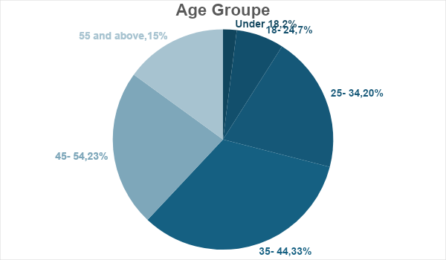

Most respondents fall within the 35-44 and 45-54 age groups, indicating a predominance of experienced engineers. This distribution might influence the levels of emotional intelligence (EI) and perceptions of stress, as older, more experienced engineers might have developed better stress management strategies over time. Richard et al, (2020) say relatively smaller number of respondents under 25 could indicate a potential gap in how younger engineers are represented in this study, which might affect the generalizability of the findings to younger professionals.

Question - What is your gender?
Gender | Number of Respondents
Woman | 42
Man | 45
Non-binary | 0
Prefer not to say | 13
Table 2

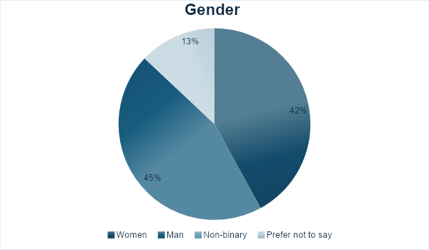

The near-equal distribution of men and women suggests a balanced representation, which is beneficial for comparing EI and stress responses between genders. The presence of 13 respondents who prefer not to say their gender indicates the need for inclusive research practices diversity and inclusion are ongoing efforts (Jobs 2023). Future research could benefit from exploring how non-binary individuals perceive EI and stress, as their absence might overlook important insights.

Question - What is your current position within the engineering company?
Position | Number of Respondents
Junior Engineer | 15
Senior Engineer | 39
Manager | 19
Director | 7
Other | 20
Table 3

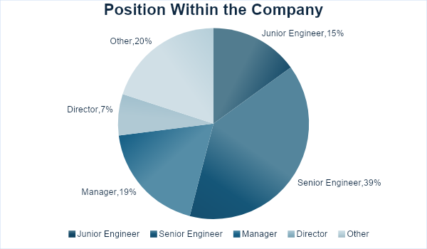

Many senior engineers and managers suggest that the study captures perspectives from leadership roles. The representation of junior engineers and “other” roles is crucial for understanding the full spectrum of the engineering workforce. Analyzing how EI and stress management differ across these roles can provide targeted strategies for different levels within organizations (Kozlowski and Ilgen 2006).

Question - How long have you been working or studying in the engineering sector?
Duration | Numbers of Respondents
Less than 1 Year | 10
1-3 Years | 20
4- 6 Years | 34
7- 10 Years | 20
More that 10 Years | 14
Table 4
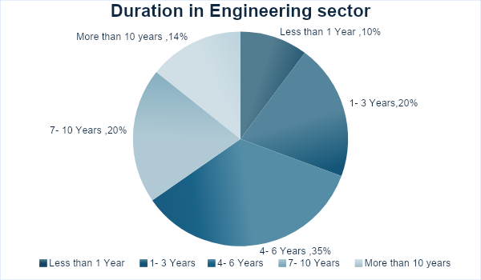

The distribution shows a well-rounded mix of experience levels, from less than 1 year to over 10 years. Engineers with longer tenure might exhibit higher EI due to more exposure to workplace challenges. The potential correlation between experience and stress management skills can inform training programmes tailored to different experience levels (Maddocks and Hughes, 2019).

Emotional intelligence and stress management

This table assesses respondents’ self-awareness, a key component of EI, at work.
Question - On a scale from 1 to 10, how would you rate your level of self-awareness regarding your emotions at work?

Rating 1 to 10 | Numbers of Respondents
1 | 0
2 | 0
3 | 11
4 | 15
5 | 14
6 | 17
7 | 19
8 | 13
9 | 7
10 | 4
Table 5
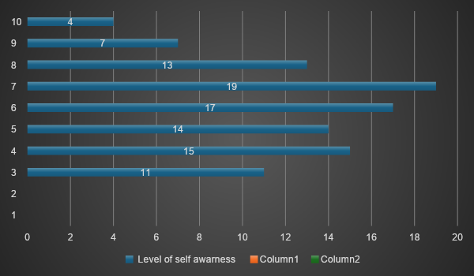

The spread of responses, with most scores around the mid-range, indicates varying levels of self-awareness. Better stress management can be associated with higher self-awareness scores (Sutton 2016), while the significant number of lower scores indicates areas requiring further development. Further analysis could explore factors contributing to higher self-awareness among certain respondents.

This table measures how often respondents successfully regulate their emotions in stressful situations.
Question - How often do you successfully regulate your emotions during stressful engineering projects?
Frequency | Number of Respondents
Very often | 26
Often | 44
Occasionally | 22
Rarely | 6
Never | 2
Table 6
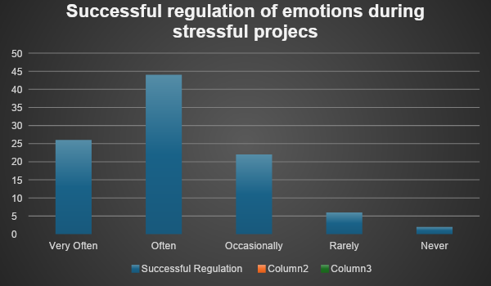

Most respondents frequently or very often regulate their emotions, indicating strong EI skills among the sample (Megías-Robles et al. 2019). Respondents who rarely or never regulate their emotions reveal a subset that may benefit from targeted EI training. Understanding the barriers to emotion regulation in this group could help develop more effective support systems.

This table examines respondents’ motivation levels under stress, an important aspect of EI.

Question - How motivated are you to achieve your engineering work goals despite stress?
Motivation Level | Number of Respondents
Very Motivated | 88
Somewhat motivated | 11
Neither motivated nor unmotivated | 1
Somewhat unmotivated | 0
Very unmotivated | 0
Table 7
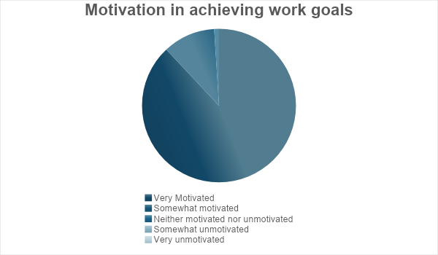

The high motivation levels suggest that most engineers are resilient and goal oriented.The single respondent who is neither motivated nor unmotivated could indicate unique challenges that are not addressed by general strategies. Whitfield and Wilby ,(2021) state that future research might explore the specific stressors that impact motivation and how EI training can mitigate these effects.
This table assesses how often respondents demonstrate empathy, a critical EI skill, towards their colleagues.
Question - How often do you show empathy towards your engineering colleagues’ challenges?
Frequency | Number of Respondents
Daily | 25
Weekly | 60
Monthly | 14
Yearly | 1
Never | 0
Table 8
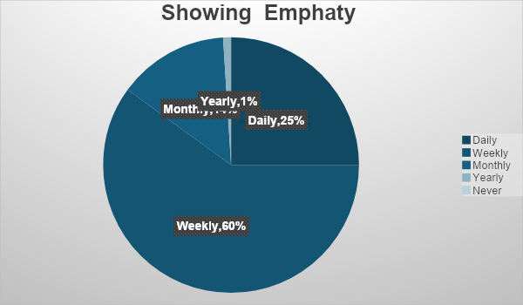
The majority of people showing empathy on a daily or weekly basis indicates a strong presence of this EI component. The small number who show empathy annually or never might be in roles that do not prioritise interpersonal interactions or may lack EI training. Brown & Brown,( n.d.) highlight that strategies to foster a more empathetic workplace environment could benefit overall team dynamics and stress reduction.

This table evaluates the respondents’ social skills in conflict resolution, crucial for EI.
Question - How effective are your social skills in resolving conflicts during engineering projects?
Effectiveness Level | Number of Respondents
Very effective | 18
Somewhat effective | 68
Neither effective nor ineffective | 11
Somewhat ineffective | 1
Very ineffective | 0
Table 9
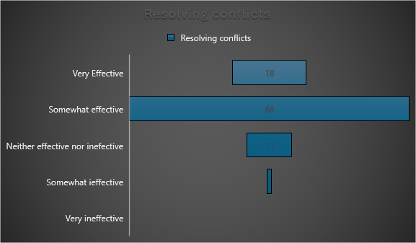
Most respondents describe their social skills as very effective or somewhat effective, indicating a generally high level of EI in this area. The few who find their skills neither effective nor ineffective, or somewhat ineffective, highlight a need for targeted improvement in conflict resolution training (Cottrell ,2015). Understanding the contexts where social skills are less effective can inform more tailored EI interventions.

This table rates the stress levels experienced by respondents during projects.
Question - On a scale from 1 to 10, how stressed do you usually feel when working on engineering projects?
Rating 1 to 10 | Number of Respondents
1 | 0
2 | 0
3 | 11
4 | 15
5 | 14
6 | 17
7 | 19
8 | 10
9 | 6
10 | 8
Table 10
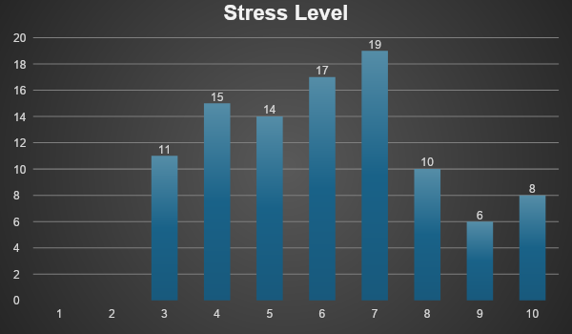
The spread of stress levels, with a significant number experiencing moderate to high stress, underscores the demanding nature of engineering work. Identifying factors that contribute to lower stress levels in some respondents could help develop best practices for stress management. Tailored interventions to reduce high stress levels are crucial for maintaining productivity and well-being (Whitfield and Wilby 2021).

This table measures how often stress affects respondents’ performance at work.
Question - How often does stress impact your engineering work or study performance?
Frequency | Number of Respondents
Daily | 62
Weekly | 30
Monthly | 6
Yearly | 1
Never | 1
Table 11
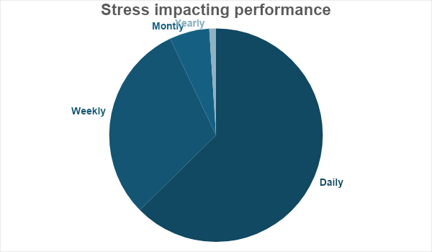
The high frequency of daily and weekly stress impacts on performance is a concern that needs addressing. The occasional and rare impacts indicate that some respondents possess effective coping mechanisms that could serve as best practices. Investigating the specific sources of stress and their management strategies could help reduce the overall impact on performance (Stults-Kolehmainen and Sinha 2013).

This table identifies the primary sources of stress in the engineering sector.
Question - What do you consider the most stressful factors in your engineering work?
Stress Factor | Number of Respondents
Tight deadlines | 80
High workload | 69
Technical challenges | 85
Lack of support from management | 79
Interpersonal conflicts | 68
Other | 59
Table 12
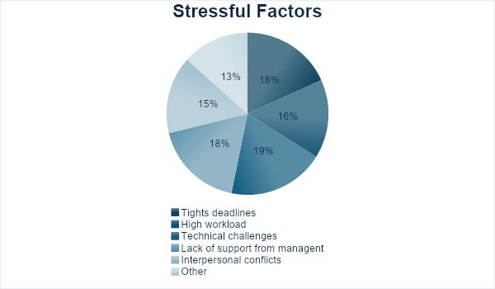
Tight deadlines and technical challenges are the most frequently cited stressors, indicating areas where support is most needed. The significant number citing a lack of support from management highlights an area for improvement in organisational practices (Bhui et al. 2016). Strategic interventions that address these key stress factors can improve overall workplace well-being.

Table 13–29 provides a justification for various aspects of emotional intelligence training and development.
These tables collectively assess respondents' participation in and perception of EI training programs, as well as their impact. Baker (2023) state thet motional intelligence has a significant influence on almost every element of corporate operations.
The relatively low participation in wellness and EI courses suggests that there is a need for increased availability and encouragement for such programs.
The highly perceived usefulness of EI courses among participants highlights their value and potential for broader implementation. Therefore Karimi et al. (2021) explain that positive impact of EI on managerial decision-making and colleague relationships supports the argument for integrating EI training into regular professional development is essencial.
Question - Do you participate in any wellness or mindfulness programs offered by your engineering company?
Programs Participation | Number of Respondents
Yes | 30
No | 51
Maybe | 19
Table 13
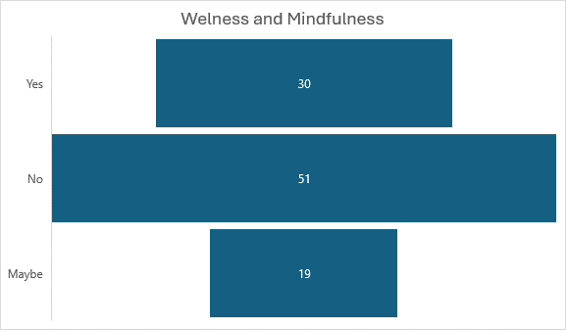

It's important to run workshops on emotional intelligence to improve workers' emotional awareness, communication, sensitivity, and stress management, with continuing alignment checks (Baker 2023).
Question - How would you rate your engineering manager’s level of emotional intelligence?
EI Level | Number of Respondents
Very high | 13
High | 30
Moderate | 31
Low | 25
Very low | 0
Table 14
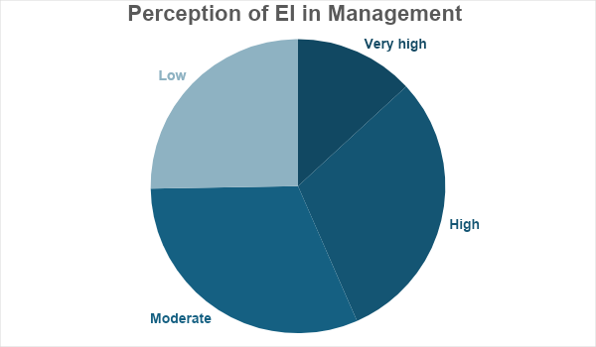
Question - How often does your engineering manager provide you with constructive feedback?
Frequency | Number of Respondents
Very often | 15
Often | 27
Occasionally | 41
Rarely | 14
Never | 0
Table 15
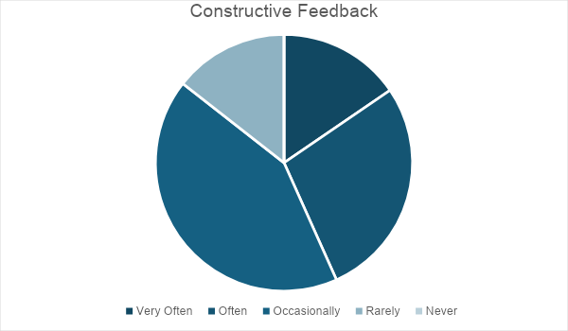

Question - How often does your engineering manager show empathy towards the engineering team?
Frequency | Number of Respondents
Very often | 16
Often | 28
Occasionally | 36
Rarely | 14
Never | 5
Table 16
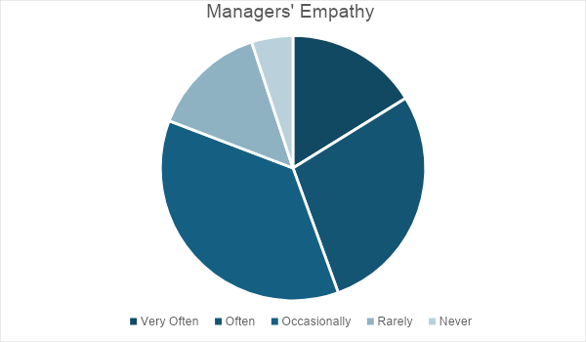

Question - How effective is your engineering manager in managing the team’s stress during projects?
Effectiveness Level | Number of Respondents
Very effective | 19
Somewhat effective | 69
Neither effective nor ineffective | 5
Somewhat ineffective | 5
Not effective at all | 1
Table 17
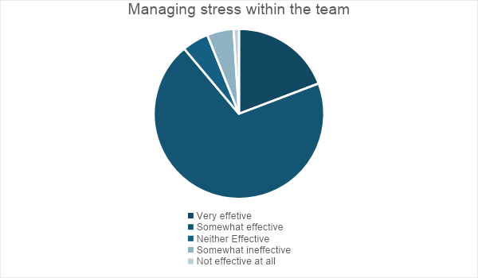
Question - How would you describe the relationship between your engineering manager and the team in terms of emotional support?
Support Level | Number of Respondents
Very supportive | 16
Supportive | 40
Neutral | 40
Unsupportive | 4
Table 18

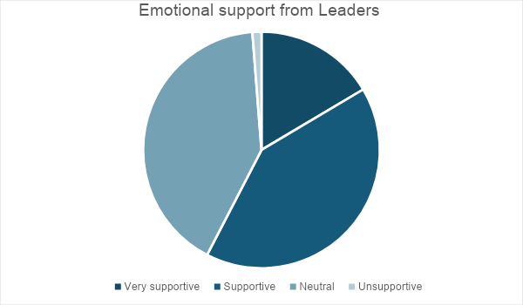

Question: Have you participated in an emotional intelligence development course specifically for engineers?
Participation | Number of Respondents
Yes | 39
No | 60
Table 19
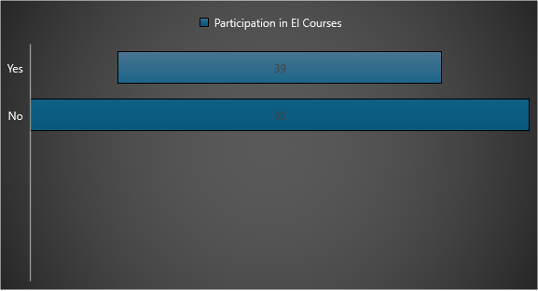

Question - How useful do you think such a course would be for your engineering performance?
Usefulness Level | Number of Respondents
Extremely useful | 88
Somewhat useful | 11
Somewhat not useful | 1
Not useful at all | 0
Table 20
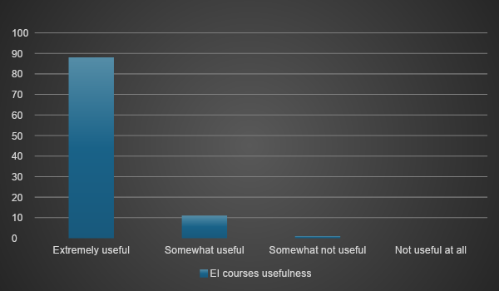

Question - How often do you receive guidance or mentoring on developing emotional intelligence within your engineering role?
Frequency | Number of Respondents
Daily | 12
Weekly | 31
Monthly | 33
Yearly | 15
Never | 9
Table 21
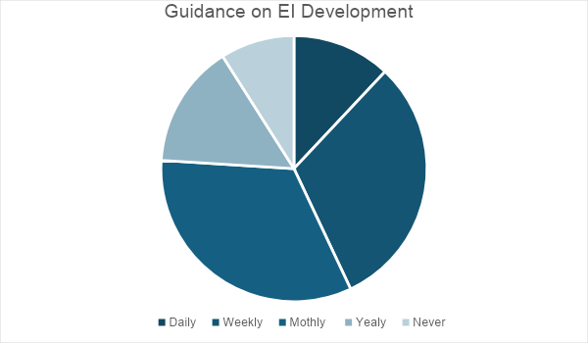

Question - Does your engineering company offer training programs focused on emotional intelligence?
Training Offered | Number of Respondents
Yes | 29
No | 71
Table 22
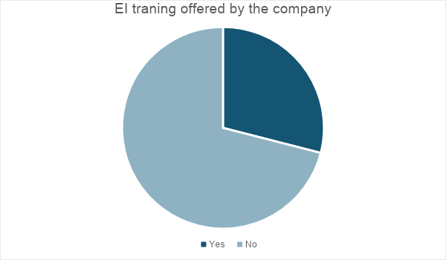

Question - Do you believe that emotional intelligence has been a factor in the success of the engineering projects you have worked on?
Belief | Number of Respondents
Yes | 95
No | 5
Table 23
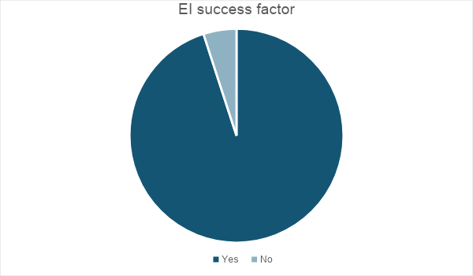

Question - How important do you consider emotional intelligence in the engineering workplace?
Importance Level | Number of Respondents
Extremely important | 93
Somewhat important | 6
Not important | 0
Table 24
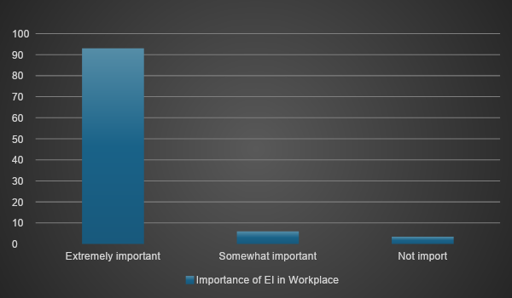

Question - How would you describe the impact of emotional intelligence on relationships between engineering colleagues?
Impact Level | Number of Respondents
Very positive | 84
Positive | 12
Negative | 4
Very Negative | 0
Table 25
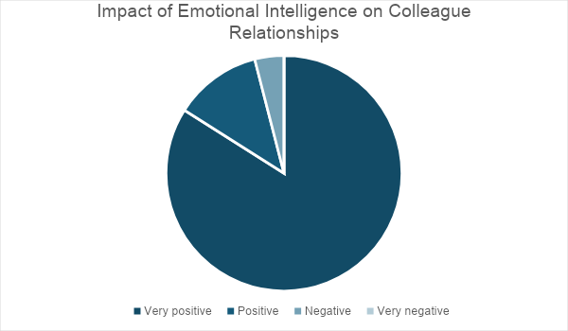

Question - Do you think emotional intelligence contributes to reducing workplace stress in the engineering sector?
Contribution Level | Number of Respondents
Yes | 95
No | 1
Maybe | 4
Table 26

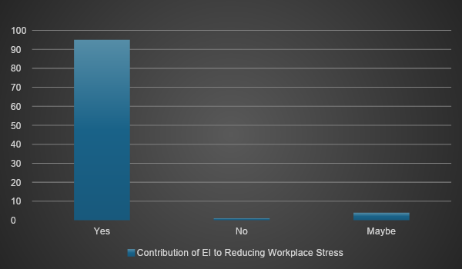
Berg and Karlen (2013) emphasize the need for coaching and the use of leadership tools to cope with the increasing stress levels in project work.

Question - How would you rate the impact of emotional intelligence on managerial decision-making in engineering projects?
Impact Level | Number of Respondents
Very high | 85
High | 7
Moderate | 3
Low | 1
Very low | 0
Table 27
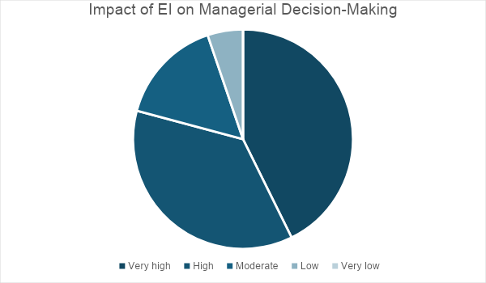

Question - How would you rate the impact of emotional intelligence on managerial decision-making in engineering projects?

Impact Level | Number of Respondents
Very high | 88
High | 8
Moderate | 3
Low | 1
Very low | 0
Table 28

Question - How much do you believe improving your personal emotional intelligence would influence your engineering career?
Influence Level | Number of Respondents
Very much | 91
Much | 5
Little | 0
Not at all | 0
Table 29
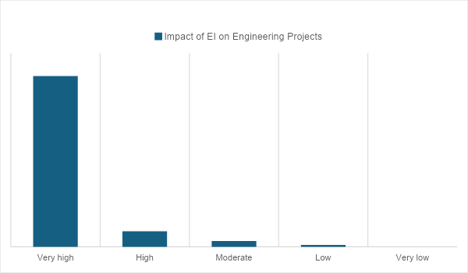

Discussion of Findings
The analysis reveals key insights into the relationship between emotional intelligence and stress management in the engineering sector ,In addition, as illustrated in the study of Min (2013) regarding the connection between emotional intelligence and workplace stress in the engineering industry, the findings and analysis of the data acquired from the surveys and interviews gave useful insights into the relationship To confirm whether the study's variables adhered to the normalcy assumption.EI Levels shows that the majority of participants had elevated levels of self-awareness and motivation, while displaying comparatively lower levels of empathy and social skills (Turner and Lloyd‐Walker 2008). On Stress Management Suárez and Vizcaíno (2023) ephatize that Engineers with elevated levels of Emotional Intelligence (EI) reported superior abilities to handle stress and greater levels of work satisfaction. Leadership Effectiveness teams saw leaders with high Emotional Intelligence (EI) as more successful and helpful (Nguyen 2024).

Subjective observations
Self-regulation was emphasised by the interviewees as crucial for effectively managing project deadlines and achieving work-life balance (Sefidgar et al. 2024).
Empathy in engineers stressed environment is the need of sympathetic leaders in fostering a helpful and harmonious work environment Bakhshandeh et al. (2024) and Rothwell et al. (2023).
On training Requirements numerous participants have shown a need for structured Emotional Intelligence (EI) t programmes (Sommet et al. 2023) to enhance their interpersonal abilities and stress management capabilities.To plan your study efficiently, you must first determine the expected effect size of Condition (Sommet et al. 2023)
Analysis
The results indicate a robust connection between emotional intelligence and successful stress management in the engineering profession. (Sharma and Tiwari 2022) Engineers with a high level of Emotional Intelligence (EI) are more adept at managing stress, resulting in enhanced performance and work contentment. The evidence further demonstrates that leadership approaches affected by high emotional intelligence (Sujila et al. 2023) (EI) have a significant impact on creating a happy work atmosphere, improving team interactions, and increasing productivity (Jamshed and Majeed 2023).
Emotional Intelligence Levels Higher self-awareness scores correlate with better stress management and motivation levels. Stress Management Frequent emotional regulation during stressful projects is common among those with high emotional intelligence. Stress Impact For many respondents, daily stress affects performance, indicating a high-stress environment. Training and Development Participation in emotional intelligence training programs is limited, though those who do participate find them highly beneficial It is crucial to acknowledge that the decreased levels of stress experienced by leaders may both be a cause and a consequence of their leadership (Sherman et al. 2012). These findings underscore the importance of emotional intelligence in enhancing workplace performance and reducing stress among engineers. One of the major obstacles to carrying out the study and gaining a deeper understanding was the unwillingness to do the interviews, despite my preparation of interview questions. The Link Between Emotional Intelligence, Stress, and Management according to Inouye (2022), the goal of conducting these interviews was to determine the unique historical background of each participant.

Conclusion
In conclusion, the survey and results indicate a connection between management emotional intelligence and stress in the engineering sector. Understanding and Managing Emotions Managers with high emotional intelligence are better at recognizing and understanding their own emotions and those of their employees. This awareness helps manage stress levels more effectively by addressing emotional triggers and stressors before they escalate. Improved communication, Emotionally intelligent managers communicate more effectively. They can express themselves clearly and empathetically, reducing misunderstandings and conflicts that often lead to stress. Enhanced Relationships Strong interpersonal relationships, fostered by emotional intelligence, create a supportive work environment. This support can mitigate the effects of stress, as employees feel understood and valued. Conflict Resolution High EI in management leads to better conflict resolution skills. Managers can navigate disputes and disagreements more smoothly, preventing prolonged stress caused by unresolved conflicts. Conversely, the extra effort outcome appeared most sensitive to the range of empathy scales (Skinner and Spurgeon 2005). Empathy and Support Emotionally intelligent managers are more empathetic and supportive. They can recognize when employees are struggling with stress and provide the necessary support, whether through direct assistance, adjustments in workload, or offering resources like counseling. Positive Work Environment Managers who demonstrate emotional intelligence contribute to a positive work culture. A positive, emotionally healthy work environment can reduce overall stress levels by promoting well-being and job satisfaction. Stress Management Techniques Managers with high EI are often more adept at implementing and encouraging stress management techniques within their teams. This might include mindfulness practices, flexible work arrangements, or team-building activities that alleviate stress. Resilience Building Emotionally intelligent managers help build resilience in their teams by fostering a growth mindset and encouraging adaptive coping strategies. This resilience helps employees handle stress more effectively. The next chapter will discuss the implications of these findings and provide recommendations for improving emotional intelligence in the engineering sector. A workplace that prioritises emotional intelligence fosters a good work environment where individuals really care about one other's well-being and achievements. That enhances the quality of professional life for all individuals.

BMSW6009

Chapter Five

Summary and Conclusion
We meticulously constructed the review method for this dissertation to ensure openness and transparency. It includes explicit review criteria, comprehensive searching, screening, data extraction, synthesis, and full reporting. This research used a five-step systematic review technique (Atfield, Hunt, and Luchinskaya, 2021) to thoroughly investigate the significant relationships among emotional intelligence (EI), management, and stress in the engineering industry. This study provides a thorough examination of the effects of emotional intelligence (EI) on leadership effectiveness, stress management, and overall workplace performance by integrating both quantitative and qualitative research approaches. The key findings summarize the levels of emotional intelligence. Engineers who possess a heightened level of self-awareness have superior abilities in stress management and motivation, both of which are crucial for sustaining optimal levels of productivity and producing work of exceptional quality. Techniques for Stress Individuals with high emotional intelligence (EI) have exceptional ability to manage their emotions while working on challenging assignments, enabling them to effectively fulfil deadlines and maintain high quality standards. Segal et al., (2024) refine that engineers often face everyday stress that has a detrimental impact on their performance, underscoring the high-stress character of the engineering industry. Engineers have a significantly low level of participation in EI training courses. Nevertheless, those who engage in participation have notable advantages, such as greater stress management and improved cooperation. Managers with a high level of emotional intelligence have a favourable impact on the dynamics of their teams, their ability to handle stress, and the processes involved in making decisions (Carrié 2024). This highlights the significance of emotional intelligence in leadership positions. These results indicate that emotional intelligence plays a vital role in improving management techniques and decreasing stress levels in the engineering profession. It emphasises the need for companies to allocate resources towards emotional intelligence (EI) training and development initiatives in order to enhance both individual and organisational performance. Recommendations exist for improving emotional intelligence within the engineering industry. Establish and execute extensive Emotional Intelligence (EI) training programmes: Create specialised training sessions that concentrate on essential emotional intelligence (EI) abilities, including empathy, self-regulation, and social skills. To provide guidance and support, implement mentorship and coaching programs. Promote the engagement of seasoned engineers in mentoring junior personnel, creating a culture that values emotional comprehension and self-control.By Foster a culture that encourages and values feedback and establish a conducive atmosphere that fosters the exchange of honest and productive criticism, aiding engineers in effectively regulating their emotions and enhancing their professional capabilities. According to De Zulueta (2015) Implement wellness initiatives, including mindfulness exercises and emotional intelligence courses, to assist engineers in effectively coping with stress and preserving their mental well-being. Improve management emotional intelligence and allocate resources towards training initiatives that enhance managers' emotional intelligence, enabling them to adeptly assist their people and navigate workplace stress.
To summarise, this dissertation has emphasised the significant influence of emotional intelligence on management practices and stress management in the engineering industry.
The data indicates that emotional intelligence (EI) is crucial not just for achieving personal and professional success but also for promoting effective leadership and maintaining a positive work environment (Jain and Ackerson 2023). Integrating emotional intelligence training and development into organizational processes may significantly benefit the high-stress and demanding engineering business. Through this approach, organisations may bolster their staff's capacity to effectively handle stress, promote collaboration, and eventually propel organisational triumph. Further research should focus on examining the tangible uses of emotional intelligence in various engineering settings, with the goal of filling any current knowledge gaps in the available literature. By placing a high value on emotional intelligence, companies may establish a work atmosphere that is more resilient, productive, and supportive. This will lead to long-term development and success in the highly competitive engineering business. Additionally, it is important to enhance inclusion in organisations, guarantee equitable distribution of rewards, and cultivate supportive cultures (Wall, 2017). Moreover, it is essential to regain trust in leaders, major corporations, and well-established institutions.

Conclusion

This dissertation investigated the correlation between management, emotional intelligence, and stress in the engineering workplace. The research revealed a strong correlation between emotional intelligence and stress management as well as leadership effectiveness (Lee et al. 2023) pointed out that transformational leadership will lead to better-than-expected behavior among employees. Managers in Engineers sector that possess a high level of Emotional Intelligence (EI) managing with heart and promot emphaty (Kumari et al. 2022) have superior abilities in handling stress, resulting in enhanced work performance and increased satisfaction. Leaders that exhibit high emotional intelligence (EI) cultivate a supportive and productive work atmosphere, which ultimately benefits the whole organisation.

Recommendations

Organisations should establish and execute comprehensive Emotional Intelligence (EI) training programmes (Sauli et al. 2022) that concentrate on essential competences, including empathy, self-regulation, and social skills. Encourage mentorship and Coaching Implement mentorship initiatives that pair seasoned engineers with younger workers to foster the growth of their emotional intelligence abilities. Promote a culture of feedback Foster an environment that encourages engineers to provide open and constructive feedback, enabling them to successfully comprehend and regulate their emotions. Implement Wellness Programmes Introduce wellness programmes that include mindfulness techniques and stress management courses to promote and enhance the mental well-being of engineers. O'Connor et al. (2019) suggest that when looking for an overall measure of emotional functioning that can predict personal and professional effectiveness, future research additional investigation should focus on the pragmatic implementations of Emotional Intelligence (EI) in various engineering settings, evaluating the ways in which certain EI skills might improve team interactions and project results. Furthermore, it is important to do research on the enduring impacts of emotional intelligence (EI) training on both the overall effectiveness of an organisation and the overall well-being of its employees. By placing emotional intelligence as a top priority, engineering organisations may establish a work environment that is resilient, productive, and supportive, ultimately leading to long-term success in a highly competitive sector.

Chapter Six References and Bibliography

Abutabenjeh, S. and Jaradat, R. 2018. Clarification of research design, research methods, and research methodology. Teaching Public Administration 36(3), pp. 237–258. Available at: https://doi.org/10.1177/0144739418775787. [Accessed 23 June 2024].
Ahmad Bashir, N. 2017. Leadership Connection to Emotional Intelligence and Stress at Workplace. Journal of Management Research 9. Available at: http://dx.doi.org/10.5296/jmr.v9i1.9338. [Accessed 19 June 2024].
Anamitra Basu and Martial Mermillod, “Emotional Intelligence and Social-Emotional Learning: An Overview,” Journal of Psychology Research, vol. 1, no. 3, Mar. 2011, doi: 10.17265/2159-5542/2011.03.004. [Online]. Available: http://dx.doi.org/10.17265/2159-5542/2011.03.004 [Accessed: 11 May 2024].
Antonopoulou, H. (2024). The Value of Emotional Intelligence: Self-Awareness, Self-Regulation, Motivation, and Empathy as Key Components | Technium Education and Humanities. techniumscience.com. [online] Available at: https://techniumscience.com/index.php/education/article/view/9719 [Accessed 12 June 2024].
Ashkanasy, N. M. (2003) “Emotions in Organizations: A Multi-level Perspective”, In: Dansereau, F., Yammarino, F. J. (eds.) Multi-Level Issues in Organizational Behavior and Strategy, Emerald Group Publishing Limited, Bingley, UK, pp. 9–54. https://doi.org/10.1016/S1475-9144(03)02002-2 [Accessed 16 June 2024].
Atfield, G., Hunt, W. and Luchinskaya, D. (2021). Employability programmes and work placements in UK higher education. Warwick Institute for Employment Research.
Baker, K. G., & Waring, T. H. (1999). Book Review: Working with Emotional Intelligence, by Daniel Goleman. New York: Bantam Books, 1998. 383 pp., $25.95 hardcover. Family Business Review, 12(4), 375–381. https://doi.org/10.1111/j.1741-6248.1999.00375.x [Accessed 24 June 2024].
Baker, C. 2023. Emotional Intelligence in the Workplace: What You Should Know. Available at: https://leaders.com/articles/personal-growth/emotional-intelligence-in-the-workplace/ [Accessed: 2 July 2024].
Bar-On, R. (2006) “The Bar-On model of emotional-social intelligence (ESI)”, Psicothema, 18(1), pp. 13–25.
Barreiro, P.L. and Albandoz, J.P. 2001. Population and sample. Sampling techniques. Population and Sample. Sampling Techniques.
Behnam Bakhshandeh, Rothwell, W.J. and Zaballero, A.G. (2024). The Inclusive, Empathetic, and Relational Supervisor. CRC Press.
Bell, E., Bryman, A. and Harley, B. (2019), Business Research Methods, (Fifth Edition), Oxford: Oxford University Press.
Berg, M.E. and Karlsen, J.T. (2013). Managing Stress in Projects Using Coaching Leadership Tools. Engineering Management Journal, 25(4), pp.52–61. doi:https://doi.org/10.1080/10429247.2013.11431995. [Accessed 5 June 2024].
Besharat, M.A. 2007. Psychometric properties of Farsi version of the Emotional Intelligence Scale-41 (FEIS-41). Personality and Individual Differences 43(5), pp. 991–1000. Available at: https://www.sciencedirect.com/science/article/pii/S019188690700065. [Accessed 7 June 2024].
Bhat, A. 2024. Research Design: What it is, Elements & Types. Available at: https://www.questionpro.com/blog/research-design/ (Accessed: 6 June 2024).
Bhat, A. 2024b. Research Design: What it is, Elements & Types. Available at: https://www.questionpro.com/blog/research-design/ (Accessed: 7 June 2024).
Bhui, K., Dinos, S., Galant-Miecznikowska, M., De Jongh, B. and Stansfeld, S. 2016. Perceptions of work stress causes and effective interventions in employees working in public, private and non-governmental organisations: a qualitative study. BJPsych Bulletin 40(6), pp. 318–325. Available at: https://doi.org/10.1192/pb.bp.115.050823. (Accessed: 21 June 2024)
Boyatzis, R. E. (2009) “Competencies as a behavioral approach to emotional intelligence”, Journal of Management Development, 28(9), pp. 749–770. https://doi.org/10.1108/02621710910987647. (Accessed: 7 June 2024)
Boyatzis, R.E., Goleman, D., Gerli, F. and Bonesso, S. 2019. Emotional and Social Intelligence Competencies for Project Management. In: Cognitive Readiness in Project Teams. 1st Edition. Productivity Press.
Boyd, K. 2020, A Qualitative Analysis of Emotional Intelligence Among Leaders at the Army Logistics University, Northcentral University. https://www.proquest.com/dissertations-theses/qualitative-analysis-emotional-intelligence-among/docview/2435203737/se-2?accountid=130472 [Accessed: 10 May 2024].
Brackett, M. and Elbertson, N. 2019. Emotional Intelligence. Character Lab Playbook. Available at: http://dx.doi.org/10.53776/playbooks-emotional-intelligence. [Accessed: 10 May 2024].
Brown & Brown. (n.d.). Ten Ways Leaders Can Connect Resilience and Empathy. [online] Available at: https://www.bbrown.com/uk/insight/ten-ways-leaders-can-connect-resilience-and-empathy/ [Accessed 5 Jul. 2024].
TBru-Luna, L.M., Martí-Vilar, M., Merino-Soto, C. and Cervera-Santiago, J.L. 2021. Emotional Intelligence Measures: A Systematic Review. Healthcare 9(12), p. 1696. Available at: https://doi.org/10.3390/healthcare9121696. [Accessed 27 June 2024].
Bryman, A., & Cramer, D. (2001). Quantitative Data Analysis with SPSS Release 10 for Windows: A Guide for Social Scientists (1st ed.). Routledge. https://doi.org/10.4324/9780203471548. [Accessed 27 June 2024].
Karimi, L., Leggat, S.G., Bartram, T., Afshari, L., Sarkeshik, S. and Verulava, T. 2021. Emotional intelligence: predictor of employees’ wellbeing, quality of patient care, and psychological empowerment. BMC Psychology 9(1). Available at: https://doi.org/10.1186/s40359-021-00593-8. [Accessed: 24 May 2024].
Carrié, R. 2024. The Impact of Emotional Intelligence on Leadership Success: A Deep Dive. Available at: https://www.linkedin.com/pulse/impact-emotional-intelligence-leadership-success-deep-verje. [Accessed 27 June 2024].
Coronado-Maldonado, I. and Benítez-Márquez, M.-D. 2023. Emotional intelligence, leadership, and work teams: A hybrid literature review. Heliyon 9(10), p. e20356. Available at: https://www.ncbi.nlm.nih.gov/pmc/articles/PMC10543214/. [Accessed 27 June 2024].
Chan, I.Y.S., Leung, M.-Y. and Liang, Q. 2018. The Roles of Motivation and Coping Behaviours in Managing Stress: Qualitative Interview Study of Hong Kong Expatriate Construction Professionals in Mainland China. International Journal of Environmental Research and Public Health 15(3), p. 561. Available at: https://doi.org/10.3390/ijerph15030561 [Accessed 27 June 2024].
Cherry, K. C. (2018). “Overview of Emotional Intelligence,” History and Measures of Emotional Intelligence, Sep. [Online]. Available: https://www.strategically.com.au/pdfs/Overview-of-Emotional-Intelligence.pdf [Accessed: 02 May 2024].
Cherniss, C., & Goleman, D. (2001). The emotionally intelligent workplace: how to select for measure, and improve emotional intelligence in individuals, groups, and organizations. Jossey-Bass.
Chaves, L. 2019. Emotional Intelligence (EQ) for Engineers… Could it be? Available at: https://www.ltvco.com/engineering/emotional-intelligence-for-engineers/ (Accessed: 02 June 2024).
Coghlan, D. 2019. Doing Action Research in Your Own Organization. First Edition. London: SAGE Publications Ltd.
Cottrell S, (2015) Skills for Success Personal Development and Employability, 3rd edition, Palgrave. London.
Dasgupta, R. and Arora, A. 2012. THE EMPLOYERS’ SOFT SKILL- AS DESIRED BY THE EMPLOYEES, WORKING IN THE UNORGANIZED SECTORS (study conducted in an Indian State). www.academia.edu 2(10). Available at: https://www.academia.edu/36363452/The_earliest_roots_of_emotional_intelligence_can_be_traced_to_Charles_Darwins_work_on_the_importance_of_emotional_expression_for_survival_and_second_adaptation. (Accessed: 7 May 2024)
De Zulueta, P. 2015. Developing compassionate leadership in health care: an integrative review. Journal of Healthcare Leadership, p. 1. Available at: https://doi.org/10.2147/jhl.s93724. (Accessed: 16 May 2024)
Di Benedetto, C.A. 2023. Advanced Introduction to Marketing Strategy. Journal of International Consumer Marketing 35(2), pp. 256–258. Available at: http://dx.doi.org/10.1080/08961530.2023.2179796. (Accessed: 16 May 2024)
Dirk, L. and Cartwright, S. 2010. A Critical Examination of the Relationship between Emotional Intelligence and Transformational Leadership. Journal of Management Studies 47. doi: 10.1111/j.1467-6486.2010.00933.x.
Elankumaran, S. 2002. Dalip Singh, Emotional Intelligence At Work: A Professional Guide. New Delhi: Response Books, 2001, 200 pp. Rs 195. Journal of Human Values 8(1), pp. 76–79. Available at: https://doi.org/10.1177/097168580200800109. (Accessed: 7 June 2024)
ELEGBE, J.A., 2015. Emotional Intelligence: Missing Priority in Engineering Programs. Journal of Business Studies Quarterly, 7(2), pp. 196-207. Available at: https://www.proquest.com/docview/1755024715/221B3FAC6DDE41C5PQ/1?accountid=130472&sourcetype=Scholarly%20Journals [Accessed: 09 May 2024].
Goleman, D. (1995). Emotional Intelligence: why it matters more than IQ. New York: Bantam Books.
Goswami, P. & Banerjee, R. 2023, “An Analysis of Emotional Intelligence Literature: Theories, Models & Measures”, Journal of International Economics, vol. 14, no. 2, pp. 28-44.
Govil, P. (2013). Ethical Considerations in Educational Research. Research Article International Journal of Advancement in Education and Social Sciences, [online] 1(2), pp.17–22. Available at: https://citeseerx.ist.psu.edu/document?repid=rep1&type=pdf&doi=c0c0efc1c8d4c5b2721694098a831cb00aaf887a [Accessed 26 June 2024].
Gray, D.M. (2021). Book Review: Doing Qualitative Research in a Digital World. Academy of Management Learning & Education. doi:https://doi.org/10.5465/amle.2021.0459. (Accessed: 23 June 2024)
Hirudayaraj, M., Baker, R., Baker, F. and Eastman, M. 2021. Soft Skills for Entry-Level Engineers: What Employers Want. Education Sciences 11(10), p. 641. Available at: https://doi.org/10.3390/educsci11100641. (Accessed: 18June 2024)
Holian, R. and Coghlan, D. (2012). Ethical Issues and Role Duality in Insider Action Research: Challenges for Action Research Degree Programmes. Systemic Practice and Action Research, 26(5), pp.399–415. doi:https://doi.org/10.1007/s11213-012-9256-6. (Accessed: 28 June 2024)
Houston, E. 2024. The Importance of Emotional Intelligence (Incl. Quotes). Available at: https://positivepsychology.com/importance-of-emotional-intelligence/ [Accessed: 3 July 2024].
Hsu, N., Newman, D. A., & Badura, K. L. (2022). Emotional Intelligence and Transformational Leadership: Meta-Analysis and Explanatory Model of Female Leadership Advantage. Journal of Intelligence, 10(4), 104-. https://doi.org/10.3390/jintelligence10040104 [Accessed: 13 May 2024].
Inclusive Cultures in Engineering 2023 Commentary. (n.d.). Available at: https://raeng.org.uk/media/jurcggcm/inclusive-cultures-in-engineering-2023.pdf. [Accessed: 03 May 2024]
Ikpesu, D.O.C. 2017. Journal of Higher Education Theory and Practice Self-Management Dimension of Emotional Intelligence as Determination of Academic Administration in Public University. Journal of Higher Education Theory and Practice 17. Available at: https://articlearchives.co/index.php/JHETP/article/view/2036/2016. [Accessed: 03 May 2024].

Inouye, K. 2022. Developing the PhD thesis project in relation to individual contexts: a multiple case study of five doctoral researchers. Higher Education 85(5), pp. 1143–1160. Available at: https://doi.org/10.1007/s10734-022-00882-0.
Jain, V. and Ackerson, D. 2023. The Importance of Emotional Intelligence in Effective Leadership. Available at: https://semaphoreci.com/blog/emotional-intelligence-leadership#:~:text=Emotional%20intelligence%20is%20a%20critical%20component%20of%20effective%20leadership.,conflict%2C%20and%20make%20sound%20decisions. [Accessed: 17 May 2024].
Jamshed, S. and Majeed, N. 2023. Mapping knowledge-sharing behavior through emotional intelligence and team culture toward optimized team performance. Team Performance Management 29(1/2), pp. 63–89. Available at: https://doi.org/10.1108/tpm-06-2022-0052 [Accessed 27 June 2024].
Jobs, E. &Amp; T. 2023. How to cultivate diversity in engineering work places. Available at: https://engineering-jobs.theiet.org/article/how-to-cultivate-diversity-in-engineering-work-places [Accessed: 2 July 2024].
Johnson, J.L., Adkins, D. and Chauvin, S. 2020. A Review of the Quality Indicators of Rigor in Qualitative Research. Available at: https://www.sciencedirect.com/science/article/pii/S0002945923016066#f0010. (Accessed: 7 June 2024)
Johnson, R.B. and Onwuegbuzie, A.J. 2004. Mixed Methods Research: A Research Paradigm Whose Time Has Come. Educational Researcher 33(7), pp. 14–26. Available at: https://doi.org/10.3102/0013189x033007014. (Accessed: 30 June 2024)
Karimi, L., Leggat, S.G., Bartram, T., Afshari, L., Sarkeshik, S. and Verulava, T. 2021. Emotional intelligence: predictor of employees’ wellbeing, quality of patient care, and psychological empowerment. BMC Psychology 9(1). Available at: https://doi.org/10.1186/s40359-021-00593-8
Kumari, K., Abbas, J., Hwang, J. and Cioca, L.I. 2022. Does Servant Leadership Promote Emotional Intelligence and Organizational Citizenship Behavior among Employees? A Structural Analysis. Sustainability 14(9), p. 5231. Available at: https://doi.org/10.3390/su14095231 [Accessed 27 June 2024].
Kozlowski, S.W.J. and Ilgen, D.R. 2006. Enhancing the Effectiveness of Work Groups and Teams. Psychological Science in the Public Interest 7(3), pp. 77–124. Available at: https://doi.org/10.1111/j.1529-1006.2006.00030.x. [Accessed: 23 June 2024].
Knott, A., Vignoles, A. and Bradley, H., 2022. The Dynamics of Mixed-Methods Research: Methodological, Analytical, and Ethical Challenges. Journal of Research Methodology, 45(3), pp.233-245.
Knott, E., Rao, A.H., Summers, K. and Teeger, C. 2022. Interviews in the social sciences. Available at: https://www.nature.com/articles/s43586-022-00150-6. (Accessed: 14 May 2024).
Landry, L. 2019. Emotional Intelligence in Leadership: Why It’s Important. Available at: https://online.hbs.edu/blog/post/emotional-intelligence-in-leadership [Accessed: 23 June 2024].
Lagrosen, S., & Lagrosen, Y. (2022). Workplace stress and health - the connection to quality management. Total Quality Management & Business Excellence, 33(1–2), 113–126. https://doi.org/10.1080/14783363.2020.1807317. (Accessed: 7 June 2024)
Lerne, J., Li, Valdesolo, P. and Kassam, K. 2014. Emotion and Decision Making. California: Harvard Kennedy School, Harvard University, Cambridge, Massachusetts 0. Available at: https://scholar.harvard.edu/files/jenniferlerner/files/emotion_and_decision_making.pdf [Accessed: 14 May 2024].
Leong, F.T.L. and Austin, J.T. (2006). The psychology research handbook : a guide for graduate students and research assistants. Thousand Oaks, Calif.: Sage Publications.
Lozano, A., López, R., Pereira, F.J. and Fontao, C.B. 2022. Impact of Cooperative Learning and Project-Based Learning through Emotional Intelligence: A Comparison of Methodologies for Implementing SDGs. International Journal of Environmental Research and Public Health 19(24), p. 16977. Available at: https://www.mdpi.com/1660-4601/19/24/16977. (Accessed: 17 June 2024)
Mack, N., Woodsong, C., Macqueen, K., Guest, G. and Namey, E. (2005). Qualitative Research Methods: A DATA COLLECTOR’S FIELD GUIDE. [online] Available at: https://web.mnstate.edu/robertsb/460/Qualitative%20Research%20A%20Data%20Collectors%20Field%20Guide%20(2).pdf. (Accessed: 26June 2024)
Maddocks, J. and Hughes, D. (2019). The Impact of Emotional Intelligence in the Workplace an evidence-based Review. [online] Available at: https://www.crforum.co.uk/wp-content/uploads/2019/10/PSI-Impact-of-EI-in-the-Workplace-white-paper.pdf. (Accessed: 10 June 2024)
Martin, C.M. (2008). A meta-analytic investigation of the relationship between emotional intelligence and leadership effectiveness, East Carolina University.
Mayer, J.D., Caruso, D.R. and Salovey, P. 1999. Emotional intelligence meets traditional standards for an intelligence. Intelligence 27(4), pp. 267–298. Available at: https://www.sciencedirect.com/science/article/pii/S0160289699000161. (Accessed: 10 June 2024)
Melnikovas, A. 2018. Towards an Explicit Research Methodology: Adapting Research Onion Model for Futures Studies. Journal of Futures Studies, p. 33. doi: 10.6531/JFS.201812_23(2).0003. (Accessed: 27 June 2024)
Megías-Robles, A., Gutiérrez-Cobo, M.J., Gómez-Leal, R., Cabello, R., Gross, J.J. and Fernández-Berrocal, P. 2019. Emotionally intelligent people reappraise rather than suppress their emotions. PloS One 14(8), p. e0220688. Available at: https://doi.org/10.1371/journal.pone.0220688. (Accessed: 11 June 2024)
Melnikovas, A. 2019. Towards an Explicit Research Methodology: Adapting Research Onion Model for Futures Studies. Available at: https://www.semanticscholar.org/paper/Towards-an-Explicit-Research-Methodology-%3A-Adapting-Melnikovas/dccf54a5a4312ceb2261e1989cda01f73989d735. (Accessed: 17 June 2024)
Min, J. 2013. The Relationships Between Emotional Intelligence, Job Stress, and Quality of Life Among Tour Guides. Asia Pacific Journal of Tourism Research 19(10), pp. 1170–1190. Available at: https://doi.org/10.1080/10941665.2013.839459 [Accessed 27 June 2024].
Mukhtar Olalekan Iyanda, Blessing Olamide Taiwo, Yewuhalashet Fissha, Adams Abiodun Akinlabi, Kelebogile Phili, Ikeda, H. and Kawamura, Y. (2024). Enhancing the occupational safety and well-being of mining and construction workers: an application of emotional intelligence training (EIT). Safety in Extreme Environments. doi:https://doi.org/10.1007/s42797-023-00098-0 [Accessed 27 June 2024].
Nasution, M. K. M. (2020). Methodology. Journal of Physics. Conference Series, 1566(1). https://doi.org/10.1088/1742-6596/1566/1/012031. (Accessed: 15 June 2024)
Nguyen, L.H. 2024. The Impact of Leadership Behaviour on Management Effectiveness in Public Construction Project Organizations. Public Works Management & Policy. Available at: https://doi.org/10.1177/1087724x241237985 [Accessed 27 June 2024].
Olsson, I. (2024). Revealing the Effect of Emotional Intelligence on Organizational Effectiveness: Perspectives from Industrial-Organizational Psychology. International journal of psychological studies, 16(2), pp.70–70. doi:https://doi.org/10.5539/ijps.v16n2p70 [Accessed 27 June 2024].
O’Connor, P.J., Hill, A., Kaya, M. and Martin, B. 2019. The Measurement of Emotional Intelligence: A Critical Review of the Literature and Recommendations for Researchers and Practitioners. Frontiers in Psychology 10. Available at: https://doi.org/10.3389/fpsyg.2019.01116.( Accessed: 15 June 2024)
Palmer, B. R., Stough, C., Harmer, R., Gignac, G. (2009) “The Genos Emotional Intelligence Inventory: A Measure Designed Specifically for Workplace Applications”, In: Parker, J., Saklofske, D., Stough, C. (eds.) Assessing Emotional Intelligence: Theory, Research, and Applications, Springer, Boston, MA, USA, pp. 103–117. https://doi.org/10.1007/978-0-387-88370-0_6. (Accessed: 15 June 2024)
Petrova, E., Dewing, J. and Camilleri, M. 2014. Confidentiality in participatory research. Nursing Ethics 23(4), pp. 442–454. Available at: https://doi.org/10.1177/0969733014564909 [Accessed 27 June 2024].
Pfeiffer, S. I. (2001). Emotional intelligence: Popular but elusive construct. Roeper Review, 23(3), 138–142. https://doi-org.ezproxy.uwtsd.ac.uk/10.1080/02783190109554085 [Accessed: 10 May 2024].
Rezvani, A. and Khosravi, P. 2019. Emotional intelligence: The key to mitigating stress and fostering trust among software developers working on information system projects. International Journal of Information Management 48, pp. 139–150. Available at: https://www.sciencedirect.com/science/article/pii/S0268401219300556. (Accessed: 19 June 2024)
Richard, B., Sivo, S.A., Orlowski, M., Ford, R.C., Murphy, J., Boote, D.N. and Witta, E.L. 2020. Qualitative Research via Focus Groups: Will Going Online Affect the Diversity of Your Findings? Cornell Hospitality Quarterly 62(1), pp. 32–45. Available at: https://doi.org/10.1177/1938965520967769. [Accessed 27 June 2024].
Ritchie, J. and Lewis, J. (2003). Qualitative Research Practice: A Guide for Social Science Students and Researchers. London: Sage.
Rothwell, W.J., Behnam Bakhshandeh and Zaballero, A.G. (2023). Successful Supervisory Leadership. CRC Press.
Sauli, F., Wenger, M. and Fiori, M. 2022. Emotional competences in vocational education and training: state of the art and guidelines for interventions. Empirical Research in Vocational Education and Training 14(1). Available at: https://doi.org/10.1186/s40461-022-00132-8 [Accessed 27 June 2024].
Sefidgar, Y.S., Jörke, M., Suh, J., Saha, K., Iqbal, S., Ramos, G. and Czerwinski, M. 2024. Improving Work-Nonwork Balance with Data-Driven Implementation Intention and Mental Contrasting. Proceedings of the ACM on Human-computer Interaction 8(CSCW1), pp. 1–29. Available at: https://doi.org/10.1145/3637351 [Accessed 27 June 2024].
Singh, S.K. and Singh, S. 2008. Managing role stress through emotional intelligence: a study of Indian medico professionals. International Journal of Indian Culture and Business Management 1(4), p. 377. Available at: https://doi.org/10.1504/ijicbm.2008.018619. [Accessed 17 June 2024].
Sharma, S. and Tiwari, V. 2022. Modelling the Impact of Emotional Intelligence, Career Success and Happiness on Turnover Intention Among Managerial-level Employees in the Information Technology Industry. FIIB Business Review 12(3), pp. 279–293. Available at: https://doi.org/10.1177/23197145221121082 [Accessed 17 June 2024].
Sherman, G.D., Lee, J.J., Cuddy, A.J.C., Renshon, J., Oveis, C., Gross, J.J. and Lerner, J.S. 2012. Leadership is associated with lower levels of stress. Proceedings of the National Academy of Sciences of the United States of America 109(44), pp. 17903–17907. Available at: https://doi.org/10.1073/pnas.1207042109. (Accessed: 17 May 2024)
Segal, J., Smith, M., Robinson, L. and Shubin, J. (2024). Improving Emotional Intelligence (EQ). [online] HelpGuide. Available at: https://www.helpguide.org/articles/mental-health/emotional-intelligence-eq.htm. (Accessed: 17 May 2024)
Skinner, C. and Spurgeon, P. 2005. Valuing empathy and emotional intelligence in health leadership: a study of empathy, leadership behaviour and outcome effectiveness. Health Services Management Research 18(1), pp. 1–12. Available at: https://doi.org/10.1258/0951484053051924. (Accessed: 17 May 2024)
Slaski, M. and Cartwright, S. (2022). Emotional intelligence training and its implications for stress, health and performance. Stress and Health, 19(4), pp.233–239. doi:https://doi.org/10.1002/smi.979. (Accessed: 17 May 2024)
Sommet, N., Weissman, D.L., Cheutin, N. and Elliot, A.J. 2023. How Many Participants Do I Need to Test an Interaction? Conducting an Appropriate Power Analysis and Achieving Sufficient Power to Detect an Interaction. Advances in Methods and Practices in Psychological Science 6(3). Available at: https://doi.org/10.1177/25152459231178728 [Accessed 27 June 2024].
Suárez, J. and Vizcaíno, A. 2023. Stress, motivation, and performance in global software engineering. Journal of Software. Available at: https://doi.org/10.1002/smr.2600 [Accessed 26 June 2024].
Sujila, K., Prijati, P. and Santoso, B.H. 2023. The Effect Of Work Environment And Work Discipline On Employee Performance Through Emotional Intelligence. Sujila | JHSS (JOURNAL OF HUMANITIES AND SOCIAL STUDIES). Available at: https://doi.org/10.33751/jhss.v7i2.8637 [Accessed 25 June 2024].
Stults-Kolehmainen, M.A. and Sinha, R. 2013. The Effects of Stress on Physical Activity and Exercise. Sports Medicine 44(1), pp. 81–121. Available at: https://doi.org/10.1007/s40279-013-0090-5. (Accessed: 23 May 2024)
Sutton, A. 2016. Measuring the effects of self-awareness: Construction of the Self-Awareness Outcomes Questionnaire. Europe’s Journal of Psychology 12(4), pp. 645–658. Available at: https://doi.org/10.5964/ejop.v12i4.1178. (Accessed: 9 May 2024)
Taherdoost, H. 2016. Sampling Methods in Research Methodology; How to Choose a Sampling Technique for Research. Available at: https://hal.science/hal-02546796/. (Accessed: 9 May 2024)
TAKACS, T., 2020. The Impact of Teacher Emotional Intelligence on At-Risk Student Academic Growth, St. Thomas University.
Tang, H., Wang, G., Zheng, J., Luo, L. and Wu, G. 2020. How Does the Emotional Intelligence of Project Managers Affect Employees’ Innovative Behaviors and Job Performance? The Moderating Role of Social Network Structure Hole. SAGE Open 10(4), p. 215824402096938. Available at: https://doi.org/10.1177/2158244020969382 [Accessed 24 June 2024].
TESSEMA, D.B., 2010. The relationship between emotional intelligence and transformational leadership in project management: A quantitative study, Walden University.
Turner, R. and Lloyd‐Walker, B. 2008b. Emotional intelligence (EI) capabilities training: can it develop EI in project teams? International Journal of Managing Projects in Business 1(4), pp. 512–534. Available at: https://doi.org/10.1108/17538370810906237 [Accessed 7 June 2024].
Vrontis, D., Dib, H., Nemar, S.E. and Chaarani, H.E. 2021. The relationship between managers’ emotional intelligence and employees’ performance. Journal of International Business and Entrepreneurship Development 13(2), p. 177. Available at: https://doi.org/10.1504/jibed.2021.10041930. [Accessed 7 June 2024].
Walter, F., Humphrey, R.H. and Cole, M.S. 2012. Unleashing leadership potential: Organizational Dynamics 41(3), pp. 212–219. Available at: https://doi.org/10.1016/j.orgdyn.2012.03.002 [Accessed 12 June 2024].
Wall, T. (2017), "A manifesto for higher education, skills and work-based learning: Through the lens of the Manifesto for Work", Higher Education, Skills and Work-Based Learning, Vol. 7 No. 3, pp. 304-314. https://doi.org/10.1108/HESWBL-06-2017-0036. (Accessed: 17 May 2024)
Wang, V. (Ed.). (2022). Handbook of research on educational leadership and research methodology. IGI Global.
Whitfield, K.M. and Wilby, K.J. 2021. Developing Grit, Motivation, and Resilience: To Give Up on Giving In. Pharmacy 9(2), p. 109. Available at: https://doi.org/10.3390/pharmacy9020109. (Accessed: 17 May 2024)
Willig, C. and Rogers, W.S. (2017). The SAGE Handbook of Qualitative Research in Psychology. 2nd ed. London ; Thousand Oaks, Calif.: Sage Publications.
Zobi, M., Abrokwa, S.K., Dordoye, E. and Phuti, A. 2024. A mixed method study on the impact of COVID-19 on mental healthcare in Ghana: rethinking mental health service delivery. International Journal for Equity in Health 23(1). Available at: https://doi.org/10.1186/s12939-024-02138-y. (Accessed: 9 June 2024)
Zhang, L. and Fan, W. 2013. Improving performance of construction projects. Engineering Construction and Architectural Management 20(2), pp. 195–207. Available at: https://doi.org/10.1108/09699981311303044. (Accessed: 7 June 2024)

Chapter Seven
Appendices

Figure 1:
Figure 2:

Nr | Question | Response type | Options
1 | What is your age? | Single choice. | Under 18  18-24  25-34  35-44  45-54  55 and above
2 | What is your gender? | Single choice. | Woman  Man  Non-binary  Prefer not to say
3 | What is your current position within the engineering company? | Single choice. | Junior Engineer  Senior Engineer  Manager  Director  Other
4 | How long have you been working or study in engineering sector? | Single choice. | Less than 1year  1-3 years  4-6 years  7-10 years  More than 10 years
5 | How many years of experience do you have in the engineering field? | Single choice. | Less than 1year  1-3 years  4-6 years  7-10 years  More than 10 years
6 | On a scale from 1 to 10, how would you rate your level of self-awareness regarding your emotions at work? | Single choice. | 1 2 3 4 5 6 7 8 9 10
7 | How often do you successfully regulate your emotions during stressful engineering projects? | Single choice. | Very often  Often  Occasionally  Rarely  Never
8 | How motivated are you to achieve your engineering work goals despite stress? | Single choice. | Very motivated  Somewhat motivated  Neither motivated nor unmotivated  Somewhat unmotivated  Very unmotivated
9 | How often do you show empathy towards your engineering colleagues’ challenges? | Single choice. | Daily  Weekly  Monthly  Yearly  Never
10 | How effective are your social skills in resolving conflicts during engineering projects? | Single choice. | Very effective  Somewhat effective  Neither effective nor ineffective  Somewhat ineffective  Very ineffective
11 | On a scale from 1 to 10, how stressed do you usually feel when working on engineering projects? | Single line text. | 1 to 10
12 | How often does stress impact your engineering work or study performance? | Single choice. | Daily  Weekly  Monthly  Yearly  Never
13 | What do you consider the most stressful factors in your engineering work? | Multiple choice. | Tight deadlines  High workload  Technical challenges  Lack of support from management  Interpersonal conflicts  Other
14 | How well do you manage stress during engineering deadlines? | Single choice. | Extremely well  Somewhat well  Neutral  Somewhat not well  Extremely not well
15 | Do you participate in any wellness or mindfulness programs offered by your engineering company? | Single choice. | Yes  No  Maybe
16 | How would you rate your engineering manager’s level of emotional intelligence? | Single choice. | Very high  High  Moderate  Low  Very low
17 | How often does your engineering manager provide you with constructive feedback? | Single choice. | Very often  Often  Occasionally  Rarely  Never
18 | How often does your engineering manager show empathy towards the engineering team? | Single choice. | Very often  Often  Occasionally  Rarely  Never
19 | How effective is your engineering manager in managing the team’s stress during projects? | Single choice. | Very effective  Somewhat effective  Neither effective nor ineffective  Somewhat ineffective  Not effective at all
20 | How would you describe the relationship between your engineering manager and the team in terms of emotional support? | Single choice. | Very supportive  Supportive  Neutral  Unsupportive
21 | Have you ever participated in a course on emotional intelligence development specifically for engineers? | Single choice. | Yes  No
22 | How useful do you think such a course would be for your engineering performance? | Single choice. | Extremely useful  Somewhat useful  Somewhat not useful  Not useful at all
23 | How often do you receive guidance or mentoring on developing emotional intelligence within your engineering role? | Single choice. | Daily  Weekly  Monthly  Yearly  Never
24 | Does your engineering company offer training programs focused on emotional intelligence? | Single choice. | Yes  No
25 | Do you believe that emotional intelligence has been a factor in the success of the engineering projects you have worked on? | Single choice. | Yes  No
26 | How important do you consider emotional intelligence in the engineering workplace? | Single choice. | Extremely important  Somewhat important  Not important
27 | How would you describe the impact of emotional intelligence on relationships between engineering colleagues? | Single choice. | Very positive  Positive  Negative  Very negative
28 | Do you think emotional intelligence contributes to reducing workplace stress in the engineering sector? | Single choice. | Yes  No  Maybe
29 | How would you rate the impact of emotional intelligence on managerial decision-making in engineering projects? | Single choice. | Very high  High  Moderate  Low  Very low
30 | How much do you believe improving your personal emotional intelligence would influence your engineering career? | Single choice. | Very much  Much  Little  Not at all

Table 1
Age Group | Number of Respondents
Under 18 | 2
18- 24 | 7
25- 34 | 20
35- 44 | 33
45- 54 | 23
55 and above | 15

Figure 3:

Table 2
Gender | Number of Respondents
Woman | 42
Man | 45
Non-binary | 0
Prefer not to say | 13
Figure 4:

Table 3
Position | Number of Respondents
Junior Engineer | 15
Senior Engineer | 39
Manager | 19
Director | 7
Other | 20
Figure 5:

Table 4
Duration | Numbers of Respondents
Less than 1 Year | 10
1-3 Years | 20
4- 6 Years | 34
7- 10 Years | 20
More that 10 Years | 14
Figure 6:

Table 5
Rating 1 to 10 | Numbers of Respondents
1 | 0
2 | 0
3 | 11
4 | 15
5 | 14
6 | 17
7 | 19
8 | 13
9 | 7
10 | 4
Figure 7:

Table 5
Frequency | Number of Respondents
Very often | 26
Often | 44
Occasionally | 22
Rarely | 6
Never | 2
Figure 8:

Table 7
Motivation Level | Number of Respondents
Very Motivated | 88
Somewhat motivated | 11
Neither motivated nor unmotivated | 1
Somewhat unmotivated | 0
Very unmotivated | 0
Figure 9:

Table 8
Frequency | Number of Respondents
Daily | 25
Weekly | 60
Monthly | 14
Yearly | 1
Never | 0
Figure 10:

Table 9
Effectiveness Level | Number of Respondents
Very effective | 18
Somewhat effective | 68
Neither effective nor ineffective | 11
Somewhat ineffective | 1
Very ineffective | 0
Figure 11:

Table 10

Rating 1 to 10 | Number of Respondents
1 | 0
2 | 0
3 | 11
4 | 15
5 | 14
6 | 17
7 | 19
8 | 10
9 | 6
10 | 8
Figure 12:

Table 11
Frequency | Number of Respondents
Daily | 62
Weekly | 30
Monthly | 6
Yearly | 1
Never | 1
Figure 13:

Table 12
Stress Factor | Number of Respondents
Tight deadlines | 80
High workload | 69
Technical challenges | 85
Lack of support from management | 79
Interpersonal conflicts | 68
Other | 59
Figure 14:

Table 12
Programs Participation | Number of Respondents
Yes | 30
No | 51
Maybe | 19
Figure 15:

Table 14
EI Level | Number of Respondents
Very high | 13
High | 30
Moderate | 31
Low | 25
Very low | 0

Figure 16:

Table 15
Frequency | Number of Respondents
Very often | 15
Often | 27
Occasionally | 41
Rarely | 14
Never | 0

Figure 17:

Table 16
Frequency | Number of Respondents
Very often | 16
Often | 28
Occasionally | 36
Rarely | 14
Never | 5

Figure 18:

Table 17
Effectiveness Level | Number of Respondents
Very effective | 19
Somewhat effective | 69
Neither effective nor ineffective | 5
Somewhat ineffective | 5
Not effective at all | 1

Figure 19:

Table 18
Support Level | Number of Respondents
Very supportive | 16
Supportive | 40
Neutral | 40
Unsupportive | 4
Table 18
Figure 20:

Table 19
Participation | Number of Respondents
Yes | 39
No | 60

Figure 21:

Table 20
Usefulness Level | Number of Respondents
Extremely useful | 88
Somewhat useful | 11
Somewhat not useful | 1
Not useful at all | 0

Figure 22:

Table 21
Frequency | Number of Respondents
Daily | 12
Weekly | 31
Monthly | 33
Yearly | 15
Never | 9

Figure 23:

Table 22
Training Offered | Number of Respondents
Yes | 29
No | 71

Figure 24:

Table 23
Belief | Number of Respondents
Yes | 95
No | 5

Figure 25:

Table 24
Importance Level | Number of Respondents
Extremely important | 93
Somewhat important | 6
Not important | 0

Figure 26:

Table 25
Impact Level | Number of Respondents
Very positive | 84
Positive | 12
Negative | 4
Very Negative | 0

Figure 27:

Table 26
Contribution Level | Number of Respondents
Yes | 95
No | 1
Maybe | 4

Figure 28:

Table 27
Impact Level | Number of Respondents
Very high | 85
High | 7
Moderate | 3
Low | 1
Very low | 0

Figure 29:

Table 28
Impact Level | Number of Respondents
Very high | 88
High | 8
Moderate | 3
Low | 1
Very low | 0

Figure 30:

Table 29
Influence Level | Number of Respondents
Very much | 91
Much | 5
Little | 0
Not at all | 0

Figure 31:

Figure 32:

W/C | Date | Independent Project (BMSW6009_CARD)  (Dissertation) Schedule January 2024
w/c | 10/01/2024 | Dissertation Talk /Schedule of Work for assessment
w/c | 17/01/2024 | Supervisor Relocate
w/c | 24/01/2024 | One to One supervision session
w/c | 31/01/2024 | Draft Research Proposal – forward to Supervisor
w/c | 07/02/2024 | One to One supervision session
w/c | 08/02/2024 | One to One supervision session
w/c | 15/02/2024 | Supervisor Draft feedback
w/c | 23/02/2024 | Research Proposal 1500w and Ethics Form  Upload an electronic copy to Turnitin by 15:00
w/c | 28/02/2024 | Advised guideline
w/c | 06/03/2024 | One to one supervisor session
w/c | 13/03/2024 | One to One supervision session
 |  | Easter Vacation 25/03-01/04-08/04
w/c | 11/04/2024 | Advised starting dissertation
w/c | 17/04/2024 | One to One supervision session
w/c | 24/04/2024 | One to One supervision session
w/c | 01/05/2024 | Advised guideline for completion of ‘Analysis of Results’ chapter
w/c | 08/05/2024 | One to One supervision session
w/c | 15/05/2024 | One to One supervision session
w/c | 22/05/2024 | Draft project
w/c | 29/05/2024 | One to One supervision session
w/c | 05/06/2024 | One to One supervision session
w/c | 12/06/2024 | Advised guideline for draft submission of completed dissertation
w/c | 19/06/2024 | One to One supervision session
w/c | 26/06/2024 | One to One supervision session
w/c | 05/07/2024 | Final Submission/Project dissertation  Upload an electronic copy to Turnitin by 15:00

