

Student name: Omotayo Obadina
Student ID: 2212878
Module name: Introduction to Public Health
Module code: LCHS4004
Lecturer name: Bianca Sanfilippo

Content

Introduction……………………………………………………………………………….3
Strategies Used in the UK to Measure Tuberculosis……………………………….3.
Strategies Used in the UK to Monitor Tuberculosis………………………………....4
Strategies Used in the UK to Control Tuberculosis………………………………….4.
Case study D………………………………………………………………………………...5
Conclusion………………………………………………………………………………….6
References…………………………………………………………………………………..7

Introduction

Tuberculosis (TB) is a contagious airborne disease that commonly attacks the lungs but can affect any body part, from the bloodstream to the brain, and droplets from the cough or sneezes of an infected person. Despite being preventable, detectable and curable, 10 million people were newly infected with the disease in 2020 alone and 1.5 million died from it, as many more cases remain undetected (Campaign guide, Feb 2022).

Case study D
1, Screening/testing
To be diagnosed with TB, Mr John must undergo a test. When the result comes out positive, actions will be implemented to control TB.
2, Notification/Surveillance
The Public Health Act 1984 is the mandatory guidance for all TB cases
3, Isolation precautions in hospitals and other inpatient facilities
An individual who might be affected by TB should be isolated and all the people around should protect themselves with a face mask.
4, Start Treatment
Starting therapy or treatment based on the patient's severity of tuberculosis prevents him from working until he fully recovers. A course of antibiotics will need to be taken for 6 months.
Systems and diagnosis
A persistent cough that has lasted more than 3 weeks and usually brings up phlegm, which is bloody, weight loss, and breathlessness that at the end of the day it gets worse. Swollen glands, confusion, abdominal pain, a persistent headache, fits (seizures) pain and loss of movement in an affected bone or joint appetite loss and throat swellings (NHS, 2022).

Strategies used in the UK to measure Tuberculosis.
Morbidity Data
Incidence
Tuberculosis has decreased dramatically since 2011, with most new cases being caused by an infection that has been developed outside the UK and about 25% of cases being caused by transmission in England. However, the rate of decline reversed in 2019, increasing by 2.4% and then increasing to 2929. The Covid-19 epidemic will have a major effect on the TB outbreak, as well as the outcomes of those affected by the disease (GOV.UK, 2023).
Strategies used in the UK to monitor Tuberculosis.
Monitoring TB alerts, rates and trends, both on a monthly and annual basis, locally, regionally, and nationally. Monthly and annual reposts on TB incidence and trends in TB data are available. This is carried out by Public Health England (PHE) and through surveillance. As part of the national new entrant LTBI testing and treatment program, increasing the number of people tested for latent TB disease (LTBI) to minimize the number of people who are eligible for LTBI testing. LTBI program outcomes are reported quarterly and annually (GOV.UK,2023).

Strategies used in the UK to control Tuberculosis.
Reduce active TB disease in people entering the UK after having negative TB tests overseas for a UK visa application using the 3-year average, 2017 to 2019, to reduce the number of active TB cases diagnosed in people born outside the United Kingdom by 5% annually. The UK government has published an action plan called TB. Action Plan for England, 2021 to 2026. Several preventive measures can be taken, such as:
Immunisation: BCG Vaccination
The BCG (Bacille Calmette-Guerin) vaccine provides TB protection and is recommended by the NHS for infants, children, and adults under the age of 35 who are at risk of contracting TB. Since there is no evidence that the BCG vaccine is safe for people over the age of 35, it is not recommended for anyone over the age of 35 (NHS, 2O22).
Screening/Testing
There are different types of testing such as chest X-ray, blood sample and TB skin test.
Managing your environment with basic precautions
You are contagious for the first 2 to 3 weeks of treatment if you are being diagnosed with pulmonary TB, but you should take some precautions to prevent TB from spreading to others, such as:
- Isolation
- Open windows
- Safe disposal of all tissues used.
- Avoid sharing rooms (NHS,2022).

Number of TB notifications and rates, England, 1971 to 2020 (provisional data)

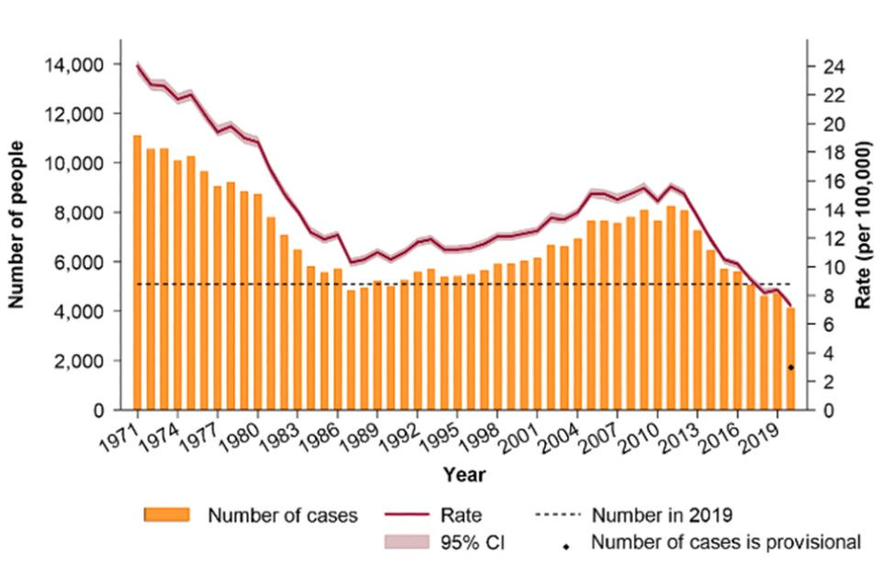

The graph shows the trend in TB incidence in England since 1971, with the most recent peak in notifications seen in 2011, at 8,250, declining to just over 4,000 cases in 2020.
In the following tables, the year referred to is the financial year.

Conclusion
The success of tuberculosis prevention, detection, and control in England can be seen in the dramatic decrease in TB incidence since 2011, when there were almost 9,000 cases recorded, making it one of Western Europe’s highest incidence rates. The UK government and NHS have released five-year strategies to assist the UK in meeting its commitment to the World Health Organisation (WHO) to end tuberculosis (TB) by 2035 initiative. This report will focus on five main priority areas, building on the achievements made in TB prevention, detection, and control in England over the past ten years, and it will give partners the tools they need to reduce the incidence of TB in all of our communities. These are the main strategies:
- Overcoming coronavirus.
- Implement a prevention and protection action plan.
- Track and control TB cases.
(UK Health Security Agency).

References
Campaign guide (2022) An introduction to Tuberculosis (TB). Available at: https://www.results.org.uk/sites/default/files/files/An%20introduction%20to%20TB%20%28Plain%20Text%29.pdf (Accessed: 20 February 2023).

NHS (2022) Tuberculosis (TB). Available at: https://www.nhs.uk/conditions/tuberculosis-tb/ (Accessed: 20 April 2023).
GOV.UK (2023) Action-plan-for-England/tuberculosis. Available at: https://www.gov.uk/government/publications/tuberculosis-tb-action-plan-for-england/tuberculosis-tb-action-plan-for-england-2021-to-2026 (Accessed: 20 March 2023).
UK Health Security Agency (2021) TB Action Plan for England, 2012 to 2026 England: Crown Copyright.

