
Skills for the Workplace
Module Assignment Submission
Student Name: | Holly Gauci
Student Number: | 1910922
Module No: | BMSK4001
Module Title: | Academic and Employability Skills

Statement of Confirmation of Authenticity
By the act of making this submission, the student declares that this is the work of the student named above. The work has not, in whole or in part, been knowingly presented elsewhere for assessment, or where assessment has been built on a previous assessment, this has been identified. Where materials have been used from other sources it has been properly acknowledged. If this statement is untrue, the student acknowledges that an assessment offence has been committed.
Attention is drawn to the plagiarism and unfair practice policies of both the University and of ILM.

Table of Contents
Introduction 4
Part 1 Employability 4
1.0 Explore ‘Leadership Employability Skills’ in general 4
1.2 Evaluate own Leadership Employability skills 7
1.2.1 Current Employability skills 7
Gap Analysis to identify ‘gaps’ in knowledge/skills 9
1.2.2 Action Plan for Improvement 10
Part 2: Academic Skills 11
2.0 Reflection on Academic Skills required for University Level Study 11
2.1 Evaluate own Academic Skills 13
2.1.1 14
Current Academic Skills 14
Gap Analysis to identify ‘gaps’ in knowledge/skills 15
2.1.2 Action Plan for Improvement 16
Conclusion 17
References 18
Bibliography 19
Appendix 21

Introduction

This report will take a look at the most sought after employability and academic skills. It aims to look at the authors current employability and academic skills and through research will influence the report writers understanding of what is needed to obtain any missing attributes. They will do this by making a Gap analysis to identify what needs to be attained as a skillset and furthermore produce an action plan to plan for improvement.

Part 1 Employability

Explore ‘Leadership Employability Skills’ in general

Employability skills are a group of hard and soft skills that are sought by employers to secure an employee’s job position and to bring value to a company. It has been found that employers look for certain skills when employing personnel, according to STEM Learning (2019) there are ten skills employers will look at in terms of employability. Individuals in leadership and management roles should also demonstrate these skills in addition to the top ten skills that Doyle (2019) recommends for leaders. Doyle also suggests that employers look for these skills in the individuals they choose for leadership and management roles and that leadership skills are also a valuable asset to all job applicants.

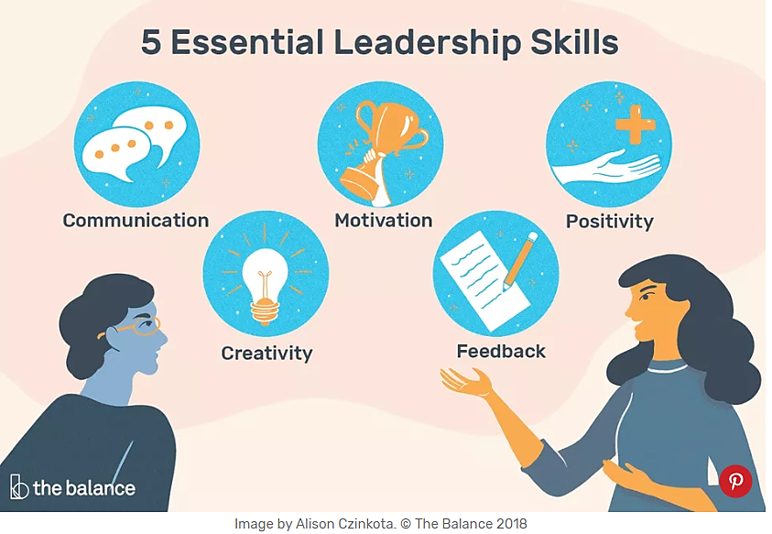
Doyle (2019)

Out of the top ten leadership skills in the Doyle article, the report writer will look at the five essential skills illustrated above. The report writer understands that communication is a key skill for all employers and employees and is ultimately needed to deliver the 4 other essential leadership skills being discussed here. Communication skills are a widely sought skill for both leaders and normal members of staff, both should be able to explain and listen clearly. Doyle states that:
As a leader, you need to be able to clearly and succinctly explain to your employees everything from organizational goals to specific tasks. Leaders must master all forms of communication, including one-on-one, departmental, and full-staff conversations, as well as communication via the phone, email, and social media.
Stem Learning suggests that a productive way to develop communication skills and improve confidence could be to do a presentation or by giving instructions to others and delegating tasks. Whilst Doyle suggests that to develop communication skills, leaders should adopt an open door policy and hold regular conversations with staff. Whilst Doyle explains the reason communication is needed and STEM Learning suggest solutions for these skills. Rogers (Cited in Parker and Begnaud, 2004, p. 6) suggests empathy and genuineness are needed to form effective leadership and until this is actioned, communication with others can be restricted.
Doyle also suggests that to motivate workers leaders need to inspire them and should learn what motivating factors work best for their team. STEM Learning indicates that employees should work with initiative and self-motivation. Employees can demonstrate this by doing work without being told what to do and when, they can also develop this skill by knowing when to ask for help or even by suggesting new ideas. However having examined The Hierarchy of Needs Maslow (1943) when explaining human motivation, Maslow suggests that there are a number of levels to the hierarchy, In order to obtain a higher level of motivation the lower level must be satisfied first. It’s now necessary to consider that a leader may need deeper understanding into the needs of their staff and is not down to a simple feeling of motivation. When applying Maslow’s Hierarchy of Needs to leadership in the workplace, to be able to motivate someone you should ask yourself, has that persons basic needs been met in terms of food and the correct environment? Does that person feel safe in their job and possibly even their personal life? Has the leader enforced a friendly relationship with the team member and made them feel like a part of the team and has their self-esteem been boosted by praise during reflection? Maslow suggests that to have those basic and physiological needs met, only then can they develop awareness for achieving their full potential. To meet these needs the leader or manager would rely on skills such as interpersonal skills and the ability to gain trust from the individual.
Positivity is to practice an optimistic attitude and is a skill that contributes to a happy work environment. Doyle suggests that in a positive environment staff will want to be at work and contribute to the business’s success and that a leader can invoke positivity by being caring, encouraging and empathetic whilst displaying humour and respect. When applying positivity to the workplace Luthans (2002) believes that there is a connection between positive feelings in employees and their performance. Reassuring to the belief that positivity drives businesses forward and encourages work based relations.
When looking at creativity as a skill for the work place, it could be assumed that the general idea of creativity is to use imagination, form original ideas and to create and produce innovate ideas. However when assessing creative leadership and the development of creative thinking (Parker and Begnaud, 2004, p. 4) argue that creativity should exist in many skills that make an effective leader. These include visualisation that forms insight, vision and innovative ideas and the ability to communicate that vision. The ability to resist the temptation to evaluate before examining ideas to withhold judgement and be open to new ideas. The flexibility to adapt to changing circumstances, the knowledge to use resources in technological, human and economical resources to help solve problems. The ability to commit to productive change by thinking divergently to give up a status quo and the ability to creatively and logically solve problems that have been identified.
Feedback in the workplace is an informative reaction to a person’s performance, Doyle informs the reader that leaders should always look for ways to convey key information to team members regarding their performance. Although it should be considered that a staff member could feel they are being micromanaged rather than being advised. A leader may also feel more confident in delegating tasks by teaching and suggesting ways to improve work and make their own decisions using initiative. Feedback can also be put in place to help leaders and staff members to self-evaluate and reflect on their work.

1.2 Evaluate own Leadership Employability skills

1.2.1 Current Employability skills

Having examined the Leadership Quiz results (Appendix A) of the report writer, it has been discovered that positivity, self-confidence, motivating staff and managing performance are being applied. However, although still scoring high, transformational leadership is an area that can be and should be explored further. Further research was conducted to measure time management skills (Appendix B) where a mediocre score was calculated. To further evaluate current skills a SWOT analysis has been documented below to help recognise areas of strength and weakness, as a result the report writer has examined their strengths and weaknesses from these findings to help conduct a thorough gap analysis and action plan as well as actioned a contribution to self-awareness of leadership skills.
SWOT Analysis Leadership Skills

STRENGTHS  Confidence and positivity  Critical thinking  Presentation skills, IT skills and written communication  Working independently  Motivation  Creativity  Leadership  Resourceful  Networking  Problem solving  Self-awareness  Group working | WEAKNESSES  Emotional intelligence  Time management  Teamwork  Oral communication and projecting thoughts and ideas effectively to others.  Listening  Quantitative skills  Numeracy
OPPORTUNITIES  To be able to think of innovative ideas, problem solve and grow as a leader.  To be able to present work to staff in terms of communication and new ideas.  Working independently enables the leader time to think and get tasks done.  Networking and past connections provides resources that can benefit the leader in building the business, can be used to gain knowledge, save money and time. | THREATS  Lack of understanding staff and lack of empathy and the weakness of listening means that the individual will not be able to support their staff, this also applies to communication.  Time management will delay jobs from being completed and possibly not done at all as other more important jobs arise.

Gap Analysis to identify ‘gaps’ in knowledge/skills
Objective | Current Position | Deficiency | Action
What do I want to do? | What can I already do? | What am I lacking? | How do I fix this?
Numeracy- Become more confident at book keeping be able to work out profit and loss for the business. | Collate data on takings, work out pay and set targets based out outgoings. | Knowledge on book keeping and confidence with numbers. | Take a small course on book keeping and accounts.  Speak to accountant about ways in which the business can store data more efficiently.
Teamwork and interpersonal communication-  Work closer with team to ensure they are hitting their own goals. | Ability and knowledge to train team members to re-create styles and looks for the industry. | Planning and time management.  . | Set goals each week to spend at least 3 hours training a junior. Must be planned using a weekly planner.
Teamwork- and interpersonal communication-  Start weekly staff meetings for goal setting and monthly reflection meetings. | 121 discussions with staff, usually unplanned and not measured. | Communication with other senior members to set a date for this to start and continue. The apparatus for the staff room. | Immediately purchase a staff room whiteboard for planning and goal setting. Set a date with other seniors for first weekly meeting.
Time management-  Stick to timescales when setting goals. | Effectively plan out weeks and months, colour code different subjects. | The ability to re-arrange targets if something unexpected stops goals being achieved. The motivation to do all tasks in the week. Communication with seniors required to get jobs done. | Set a goal to remind that any incomplete targets get put as the next weeks priority. Communicate with seniors during their own brief before staff meetings and explain the importance of leading by example.

1.2.2 Action Plan for Improvement

Objectives | Tasks | Success Criteria | Time Frame | Resources
List your Goals | What do you need to do to achieve these goals? | How will you identify your success? | When do they need to be done by? | Who or what do you need to help you?
To be able to produce and store data of figures correctly and produce profit and loss reports by the first tax return. | Collate all takings from the booking system and fill into a spreadsheet. Then take away all bills and spending on the business including training and product loss. | Ask accountant for feedback on the information produced to them for the tax return. | June 1st 2020 | Assistant from business partner in double checking figures and learning the process together.
To train junior to senior level by the end of 2020. | Set a weekly goal of at least 3 hours to train the junior. | Produce a personal development plan for the junior and sign each weeks achievements off. | The junior needs to be trained by November 31st to fall in line with the seniors plans to fall back from front of shop. | A personal development plan, correct styling equipment for hair training and online training platform which is paid for by the company.
To set SMART goals with all staff on a weekly basis. | Prepare weekly meetings with a pre-set brief and take minutes. Make all staff a goal setting template for meetings. | Reflect and celebrate success of each month with a monthly focus at the beginning of the next month. | Weekly meetings need to be started on Wednesday the first of April, when all staff can be present. | Co-operation from business partner to produce briefs and set guidelines together for what we want to achieve in each meeting.
To effectively hit goals each week. | Any targets that are listed for the week that don’t get completed will go at the top of the list for the following week. This will also be taught to senior members during meetings. | Measure the success by ticking off the completed tasks from top to bottom. The teams success will be measured at weekly and monthly meetings when assessing what went well for them. | This needs to be fully practised by senior members by may 23rd 2020. All other staff will be taught how to do this and expected to be competent by September the 1st 2020. | My Pro Planner, stationary, booking system and a forecast of events to schedule into plans. You will also need staff holidays to plan for expected loss of income.

Part 2: Academic Skills

2.0 Reflection on Academic Skills required for University Level Study

Using the skill of reflection I will be using the Gibbs’ Model of Reflection (1988) to form my reflective review. When researching the skills required for university study I found that My university states that during the Skills for the workplace, South Wales (CertHE):
You will develop the confidence to anticipate problems and find solutions, to work independently and communicate effectively with other people at all levels within the workplace, to plan things out before you’ve started, in short, to develop the skills that employers want. (University of Wales Trinity Saint David, 2020)
As outlined by the university the modules covered during the study time includes skill building subject areas such as:- Problem Solving and Decision Making, Effective team working and Communication, Research and Digital Skills, Academic and Employability Skills and will also cover key career building areas such as Managing Enterprise in the 21st Century and Professional Career Development. These areas have all pressed on the skills essential for university study including professional writing and knowing how to produce assignment templates, edit section headings and contents tables and following line spacing and font selection which have been applied in this report. Professional writing also requires focus on grammar and punctuation and the use of signposting and writing frames which are being practised and monitored. When learning about communicating and presenting information in assignments I have discovered I need the ability to analyse and form opinions and arguments and this needs to be developed with more practice. Professional writing will be made easier now I have access to the university guides online and keeping a glossary of words so I can research their meaning helps to build my vocabulary
The digital skills required for university study rely vastly on my use of the online library to access journals and books, the ability to search the internet using google scholar and by evaluating findings by asking if the work is current, reliable, accurate, authoritative and what purpose does the information serve and to be critical in my reading means I will not be taking information at face value. Therefore by being discerning I can take data from an article, examine it and extract the information I need for my assignment. I have also experienced areas of statistical and graphical research and applied that where I feel is necessary to back up claims. The use of digital technology to research effective and reliable sources of information is something that has proved difficult despite gaining the knowledge from classes, therefore this is also an area for development and is recognised in part 2.1.1 and part 2.1.2. I find it hard to reach original sources of information therefore will contact Student services if I need help in the future as I want to be learn how to find original sources with ease.
Harvard refencing skills are needed to apply to assignments, to show the reader how Ideas are formulated and to document where Information was found. By referencing sources it helps to demonstrate my understanding and gives my work credibility. I solely use The Downes and Evans (2018) Referencing handbook to support my work. Harvard referencing is difficult to get used to but its easy to refer back to university guides to check work, as documented in the gap analysis in section 2.1.1, I will continue to cross refence work with peers that use the Harvard referencing style. It is a skill that I am becoming more confident in and using more references in assignments will help with the well-known theory ‘Practice makes Perfect’.
Reflection is a skill that will help bring deeper understanding and learning, by using reflective logs and applying the Gibbs Reflective Model and SMART Objectives to the end of any study will help formulate information into larger bodies of work such as this report. The idea of reflection can seem daunting but when keeping learning logs this should be an easier task to complete for future assignments.
Time management is a skill that is essential to university study that enables students to meet deadlines, work should be planned and goals should be set and according to Covey (1989) Time management requires prioritising work in urgency and importance and explains this well with the use of his Time Management Matrix. Time management is something I plan for but don’t necessarily execute well and can cause some level of anxiety, as discovered in the Time Management Quiz (Appendix B) It is an area that needs significant development and this has further been evaluated in the gap analysis and action plan. I will continue to use My Pro Planner (Appendix C) but any work that doesn’t get completed in that week will go as a top priority for the following week and future goals will be set by applying SMART Objectives to my planner.
The use of office to access programs such as Word, Excel and PowerPoint allows for proper documenting of work and knowledge is required in how to use this. Office programs are easily navigated for myself but I believe their will be room for improvement as situations arrive where I need to develop certain work.
When looking at the academic skills needed during the process of undertaking modules alone, it has prompted research and better understanding as well as the ability to reflect. Therefore to be able to do well at these subjects and develop my academic skills I know I will need to read, use the internet and university sources and organise my findings in a way that enables me to find my own learning style. I understand that developing these skills are imperative to contribute to the success of assignments and grades. Knowing the skills required is reassuring to know that through applying these skills where possible it will give myself better understanding and experience. This will not only be beneficial to academic study but also in employability and leadership. The following gap analysis in section 2.1.1 indicates a breakdown of areas for development and the action plan in section 2.1.2 indicates what action can now be done .

2.1 Evaluate own Academic Skills

When evaluating my current academic skills It has been considered that professional writing and the use of office software are easily carried out as it was a key skill in secondary education, although it’s believed it can still be developed. Networking is already a skill that is practised for the workplace so I don’t believe this will be a difficult skill to acquire during academic learning. When taking notes from class the use of a laptop makes it easier to edit and transfer data and information to assignments however, colour coding work so that anything in other people’s words are in red and my own are in black, ensures plagiarism is avoided. Although not a complete list I have used Table 2.1 (Morgan, 2017, p.22) I have noticed that I have already started to acquire skills in some of the subjects including adapting to my own style of assignment writing, resourcefulness and being able to work independently, however it has been acknowledged through this report that there are some more skills that need to be developed. The SWOT analysis and Gap analysis have both contributed to the understanding that the key areas for focus are, Time Management, Digital and Library skills, applying critical thinking to written work, Harvard referencing

2.1.1

Current Academic Skills

Strengths and Weaknesses have been examined in the following SWOT Analysis to conduct a thorough gap analysis and action plan for Academic success.

SWOT Analysis for Academic Skills
STRENGTHS  Critical Thinking  Group working  Reading skills  Presentation and IT Skills  Problem solving  Decision making | WEAKNESSES  Time management  Applying critical thinking to written work  Harvard referencing  Research, digital and library skills
OPPORTUNITIES  Opportunity to use group working as a tool as long as ideas and thoughts are written down and reflected upon.  Reading skills will enable the collection of knowledge and data and presentation skills can be presented to the reader effectively using IT. | THREATS  Assignments not being completed ahead of deadline, meaning the work quality may be effected.  Not being able to apply thoughts to work and communicate effectively to the reader will result in poor marks.  Analytical skills will be needed to complete some assignments.  Improper Harvard referencing will result in lower grades.  Lack of research and library skills will effect quality of work and submission of credible references.

Gap Analysis to identify ‘gaps’ in knowledge/skills

Objective | Current Position | Deficiency | Action
What do I want to do? | What can I already do? | What am I lacking? | How do I fix this?
Improve Digital Research and Library skills | I can vastly find information on websites and perform CRAAP testing on the sources and information.  provided and I can access the student library and find key subject areas. | The knowledge in what to search for and how to pick out relevant articles and how to breakdown searches by specifics. | Search for tutorials on Moodle, ask lecturer for support and call student services.
Time management  I want to manage my time efficiently to be able to complete assignments ahead of deadlines and to be able to do this effectively around personal activities and work. | Plan and set targets | Focus and ability to rearrange plans and prioritise. | Set reminders for plans, goals and targets. Religiously refer to my planning diary. Use My Pro Planner daily and religiously.
Applying Critical thinking | I can understand links in ideas that are presented to me and I can think clearly and rationally. | I lack the ability to confidently form arguments on them both written and public. | Study and Apply frameworks for critical thinking, for example ‘Blooms Taxonomy’ (Morgan, 2017, p.81)  Ref this above
Confidently reference using Harvard Refencing | Reference by using others work as a guideline and by making sure information is correct by cross referencing with the Harvard referencing handbook supplied by my university. | The complete knowledge on what to do if certain information is missing from the source. | Research more and cross reference with trusted peers. Practice referencing by including more in each assignment.

2.1.2 Action Plan for Improvement

Objectives | Tasks | Success Criteria | Time Frame | Resources
List your Goals | What do you need to do to achieve these goals? | How will you identify your success? | When do they need to be done by? | Who or what do you need to help you?
The goal is to be competent in Digital Research and Library skills | Practice these skills and increase knowledge with each assignment. | Identify success by asking for feedback from class tutor after each module. | The goal is to be competent in this field by August the 7th 2020. | Access to subject modules, past and present to refer to any guides and podcasts as well as access to the online library and search engines such as google scholar.
The goal is to be completing assignments 1 week ahead of its due date | Plan time for reading and research ahead of starting the written work, continuously store references and sources for bibliography and plan enough time to conduct the written work. | Success will be identified by measuring completed tasks using My pro Planner diary. | The goal is to be completing assignments ahead of its due date by June the 1st 2020. | Planning materials.
To expand and develop critical thinking and applying it to situations for better grades. | Research critical thinking in Chapter 4 of The Business Students Guide to Study and employability (Morgan, 2017, pp.68-92) and understand the importance of ‘Blooms Taxonomy’ in relation to better grades. | Identify success by asking for feedback from tutor and reading feedback from submitted assignments. | The goal is to have expanded this skill by the end of the course and to be able to apply it in year two. Starting October 2020. | Business Students Guide to Study and Employability and online searching to clarify meanings. Reading materials.
The goal is to be competent in Harvard referencing | Follow guidelines set in the Harvard refencing handbook supplied with my modules | I will identify this success by asking the tutor for specific feedback on my referencing work. | I will continue to monitor this on each assignment but want to be fully competent by August the 7th | Confirm information is correct with tutor before submitting an assignment.

Conclusion
By researching and applying knowledge to this report it has been concluded that academic skills are also replied upon in the workplace despite an overlap in certain skills such as essay writing and library skills noted by (Morgan, 2017. P.44) It has also been discovered that the development of these skills will reflect in university grades as well as job competency, as Morgan (2017 p.19) recommends that developing skills is vital to university performance and workplace promotions. In addition an argument presented by Blaxell and Moore (2012) backs the theory that when connecting academic to employability skills both areas can have a place in the curriculum and both can be developed concurrently.

References

Blaxell, R. and Moore, C. (2012) Connecting academic and employability skills and attributes. [online] Available at: www.clt.curtin.edu.au/events/conferences/tlf/tlf2012/refereed/blaxell.html (Accessed:27.03.20).
Covey, S. R. (1989) The Seven Habits of Highly Effective People. New York: Simon & Schuster
Doyle, A (2019) Important Leadership Skills for Workplace Success. [online] Available at: https://www.thebalancecareers.com/top-leadership-skills-2063782 (Accessed: 09.03.020).
Gibbs, G. (1988) Learning by doing: A guide to teaching and learning methods. London: FEU
Luthans, F (2002) ‘The need for and meaning of positive organizational behaviour’ Journal of organizational behaviour; Chichester Vol.23, iss. 6 (Accessed 25.03.2020) DOI:10.1002/job.165
Morgan, P. (2017). The Business Students guide to study and employability. Ed. Los Angeles: Sage. p. 19.
Morgan, P. (2017). The Business Students guide to study and employability. Ed. Los Angeles: Sage. p. 22.
Morgan, P. (2017). The Business Students guide to study and employability. Ed. Los Angeles: Sage. p. 44.
Morgan, P. (2017). The Business Students guide to study and employability. Ed. Los Angeles: Sage, p. 81.
Parker, J.P. and Begnaud, L.G. (2004) Developing Creative Leadership. Portsmouth: Teacher Ideas Press, p. 4.
Parker, J.P. and Begnaud, L.G. (2004) Developing Creative Leadership. Portsmouth: Teacher Ideas Press, p. 6.
STEM Learning (2019) Top ten employability skills. [online] Available at: https://www.stem.org.uk/rxesdf (Accessed: 10.03.2020).
University of Wales Trinity Saint David (2020) Skills for the workplace, South Wales (CertHE). [online] Available at: https://www.uwtsd.ac.uk/certificate-of-higher-education-skills-for-the-workplace/ (Accessed: 24.03.2020).

Bibliography

Ault, J. (2020) Skills for the Workplace Guides: Complete Guide to your University Office 365 Account. [online] Available at: https://moodle.uwtsd.ac.uk/pluginfile.php/173224/mod_resource/content/2/Complete%20Guide%20to%20UWTSD%20Office%20365%20Account%202020.pdf [login required] (Accessed: 23.03.20).
Blaxell, R. and Moore, C. (2012) Connecting academic and employability skills and attributes. [online] Available at: www.clt.curtin.edu.au/events/conferences/tlf/tlf2012/refereed/blaxell.html (Accessed:27.03.20).
Covey, S. R. (1989) The Seven Habits of Highly Effective People. New York: Simon & Schuster
Downes, E. and Evans, A. (2018) REFERENCING HANDBOOK, HARVARD, UWTSD Library and Learning Resources. [online] Available at: https://www.uwtsd.ac.uk/media/uwtsd-website/content-assets/documents/library-and-learning-resources/infoskills/harvard-eng.PDF (Accessed: 09.03.20).
Doyle, A (2020) Hard Skills vs. Soft Skills: What's the Difference? [online] Available at: https://www.thebalancecareers.com/hard-skills-vs-soft-skills-2063780 (Accessed: 10.03.20).
Doyle, A. (2019) Important Leadership Skills for Workplace Success. [online] Available at: https://www.thebalancecareers.com/top-leadership-skills-2063782 (Accessed: 09.03.20).
Gibbs, G. (1988) Learning by doing: A guide to teaching and learning methods. London: FEU
Morgan, P. (2017). The Business Students guide to study and employability. Ed. Los Angeles: Sage. p. 19.
Morgan, P. (2017). The Business Students guide to study and employability. Ed. Los Angeles: Sage. p. 22.
Morgan, P. (2017). The Business Students guide to study and employability. Ed. Los Angeles: Sage. p. 44.
Morgan, P. (2017). The Business Students guide to study and employability. Ed. Los Angeles: Sage, p. 81.
Parker, J.P. and Begnaud, L.G. (2004) Developing Creative Leadership. Portsmouth: Teacher Ideas Press, p. 4.
Parker, J.P. and Begnaud, L.G. (2004) Developing Creative Leadership. Portsmouth: Teacher Ideas Press, p. 6.
SKILLS YOU NEED, Critical Thinking Skills. [online] Available at: https://www.hskillsyouneed.com/learn/critical-thinking.html (Accessed: 23.03.20).
SfWP (2018) Complete Guide to Assignment Writing, [online] Available at: https://moodle.uwtsd.ac.uk/pluginfile.php/152215/mod_folder/content/0/Advanced%20Writing%20Guides/SfWP%20Complete%20Guide%20to%20Assignment%20Writing.pdf [login required] (Accessed: 09.03.20).
STEM Learning (2019) Top ten employability skills. Available at: https://www.stem.org.uk/rxesdf (Accessed: 10.03.2020).
University of Wales Trinity Saint David (2020) Skills for the workplace, South Wales (CertHE). [online] Available at: https://www.uwtsd.ac.uk/certificate-of-higher-education-skills-for-the-workplace/ (Accessed: 24.03.2020).

Appendix

- Leadership Questionnaire

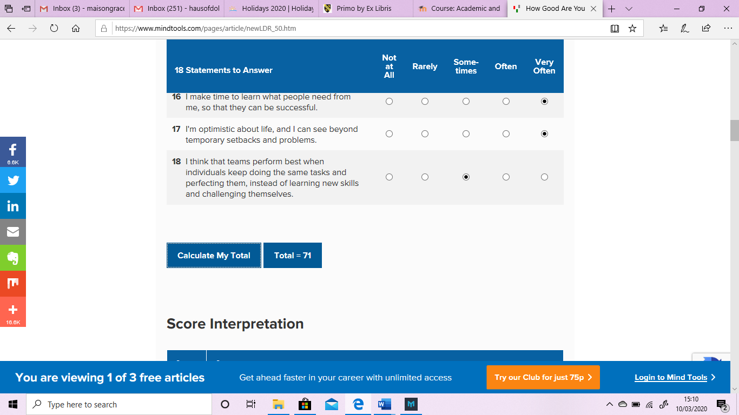

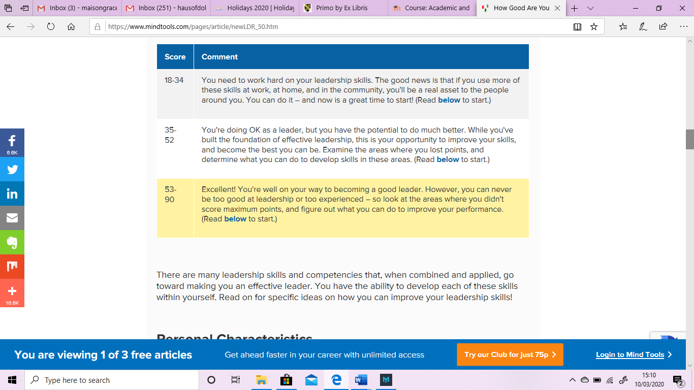

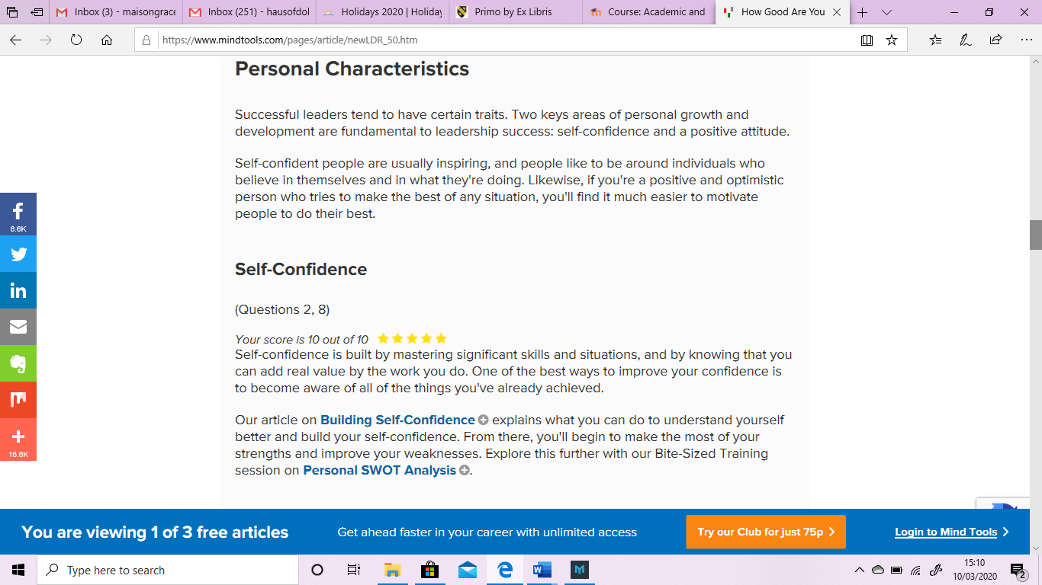
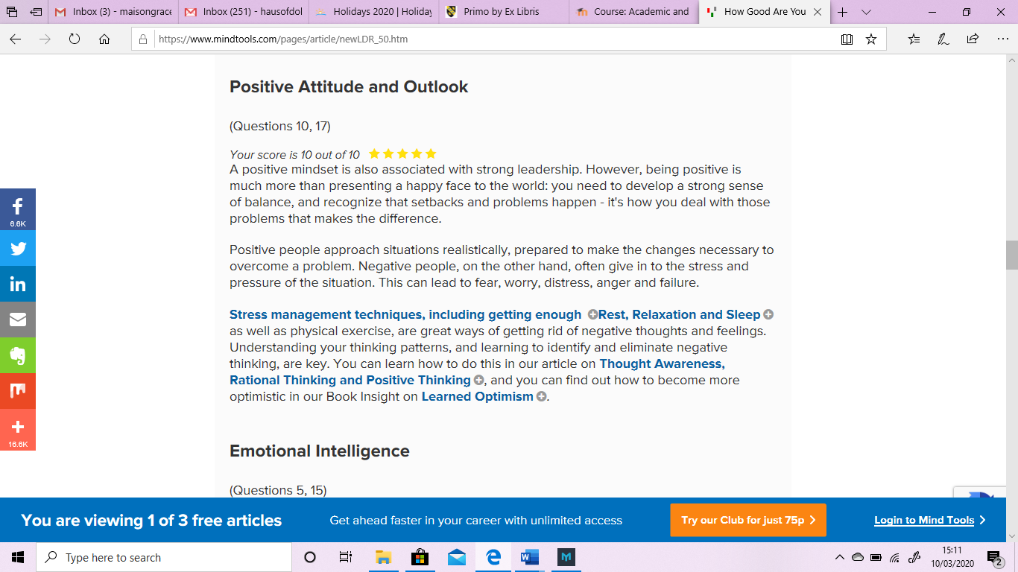
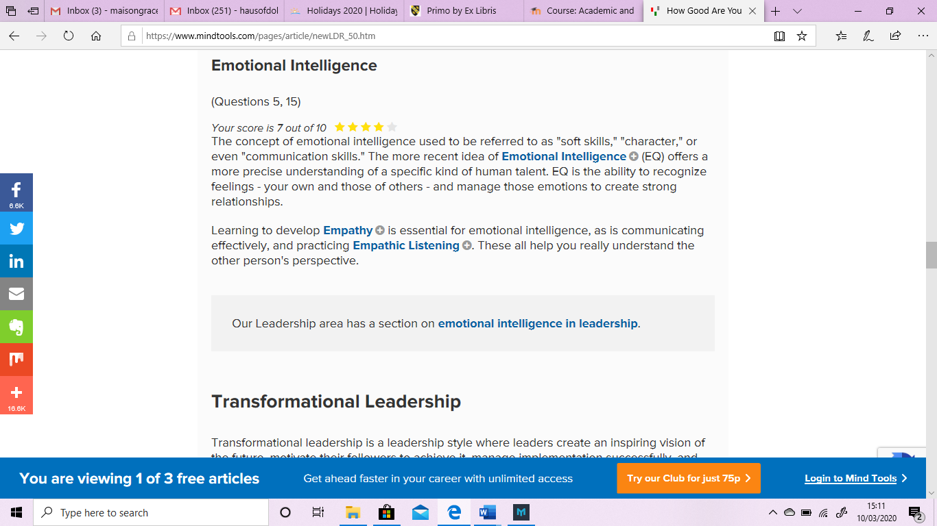
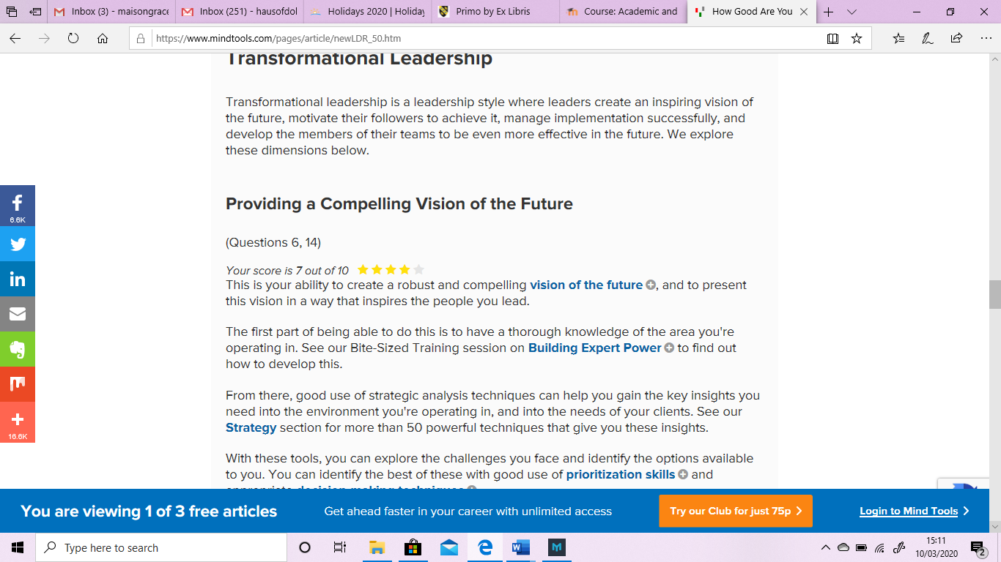
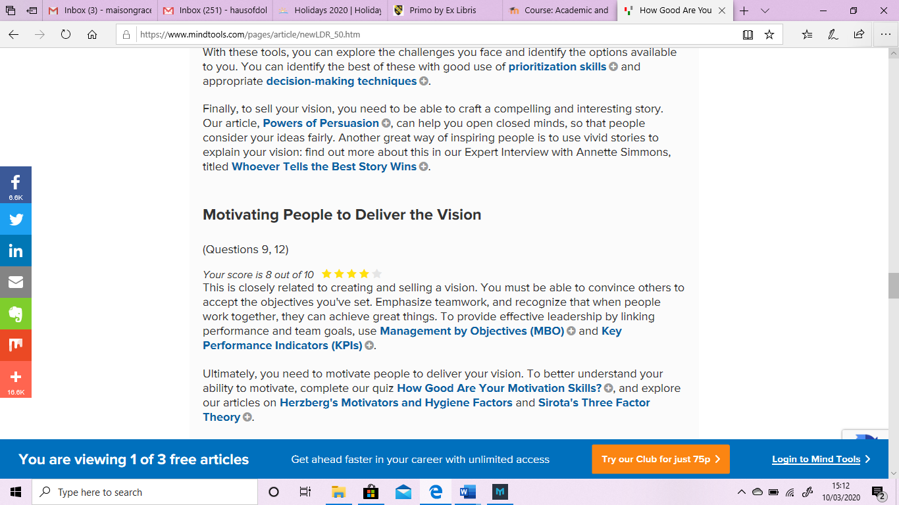
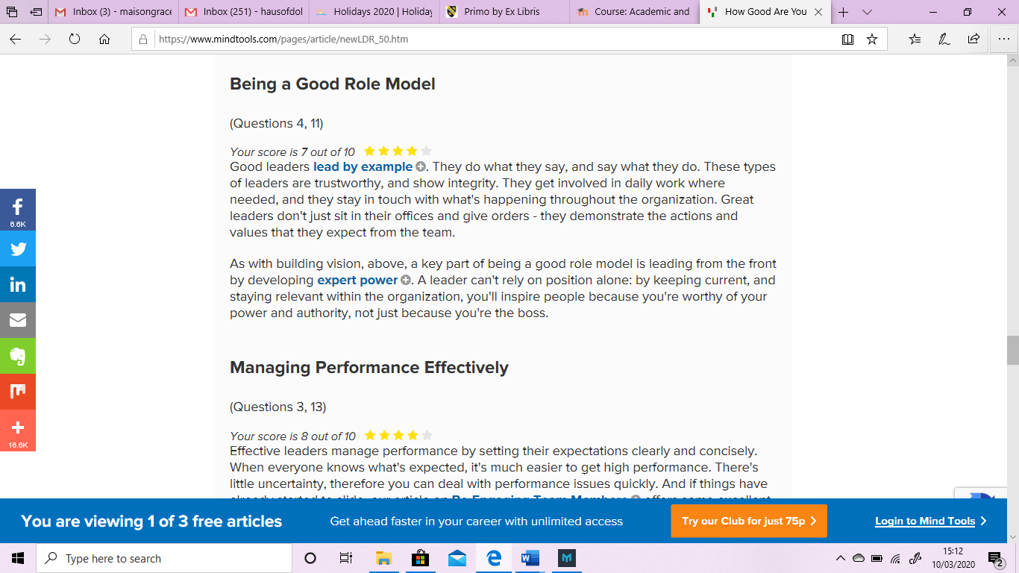
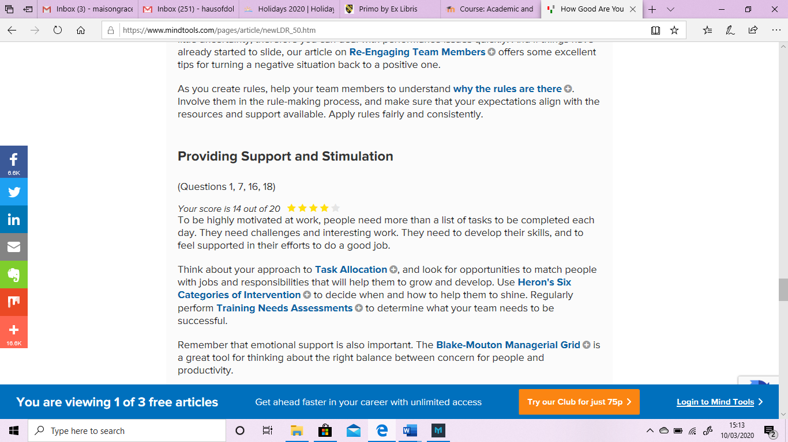
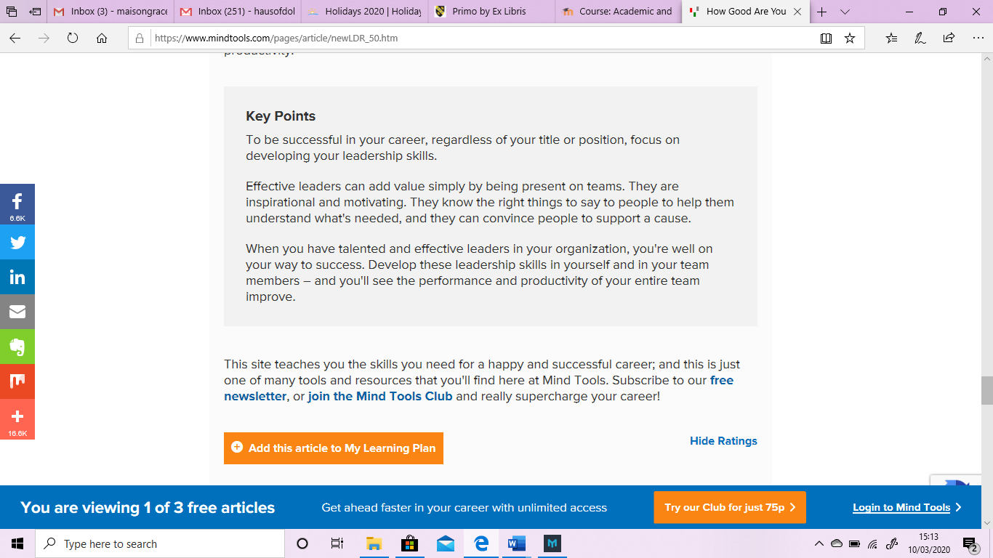

B. Time Management Quiz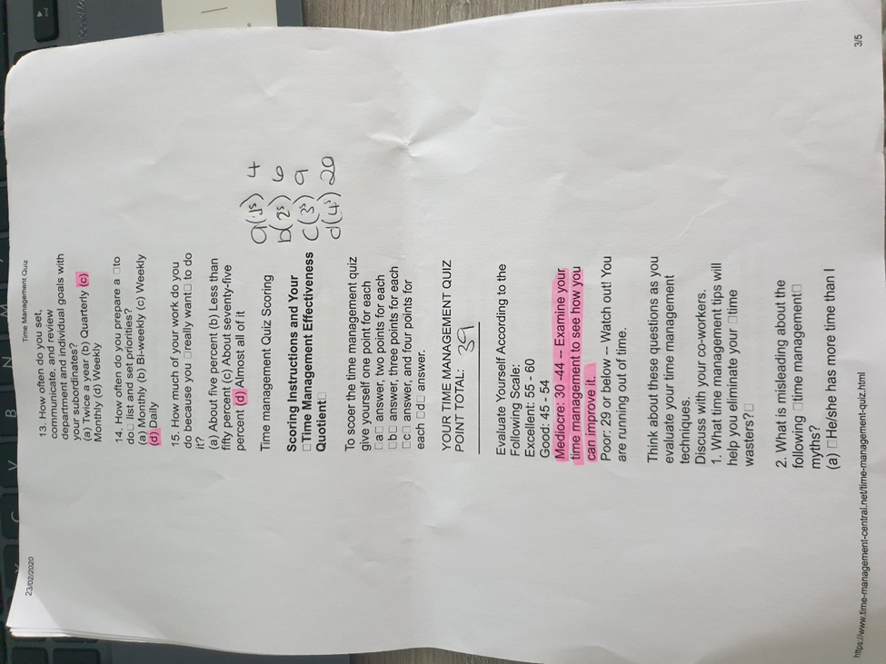

C. My Pro Planner


