Academic and Employability Skills

LEVEL – 4
LECTURER NAME – SHA YUN
MODULE CODE: BMSK 4001

STUDENT NAME – LUBNA BEGUM
STUDENT ID - 1707901
Contents
Introduction 3
1. The relevant skills for the recruitment process 3
1.1 The skills audit for the post of Assistant Marketing Manager 4
1.2 Analysis of the necessary skills 5
Conclusion 11
References 13

Introduction
The employability skills are essential for every individual to be recruited or employable in any type of position within organisation. Here the educational qualification is also significant for every job as well as employability skills that helps an employee to be employed or recruited. The employers are mainly looking forward to those employees who have both employability skills and educational qualifications. The assignment is mainly providing different kinds of analyses based on employability skills from employer perceptions. It also make focus on the necessary skills that is fundamental for the assistant management of Tesco which is largest supermarket in UK.

1. The relevant skills for the recruitment process
Tesco is one of the largest supermarkets in UK and it has done their operation in Asia, Europe and South America also. It is looking forward to recruiting an assistant management so that the human resource department of Tesco has defined the necessary skills and academic qualification for position (Finch and Fafinski, 2016). Generally, academic qualification means a type of quality which is achieved through studying in their academic level like school, college or universities. The academic qualification which is necessary for Tesco’s assistant manager is given below:
The main task of assistant manager is to support their marketing manager for doing their market campaign properly so that here the employee should have necessary analytical and technical knowledge as well as graduation degree from any business perspective backgrounds. The assistant manager should meet the criteria for the required position.
Tesco should prepare the job description properly because it helps an applicant to analyse the roles and responsibilities for this particular job. Before preparing a proper job description, the human resource department should analyse which type of skills are necessary for this position that is mainly called a skill audit (Vishnu, 2012). Generally, skills an audit helps to understand the skills that are necessary for the employees for this position.

1.1 The skills audit for the post of Assistant Marketing Manager
Skills audit is mainly a procedure to define the skills which are actually looking forward to by an organisation for a specific position. Here the position is for an assistant marketing manager of Tesco, the necessary skills that are necessary for this post are given below through skills audit:
Serial | Employability Skills | Required skills
 | Presentation Skills | High
 | Problem solving and critical thinking ability | High
 | Communication skills | High
 | Technical skills | Medium
 | Teamwork skills | Medium
 | Motivational and leadership skills | High
Table: The necessary employability skills which are required for the post of assistant marketing manager of Tesco
Source: (Pitan, 2016)

1.2 Analysis of the necessary skills
Generally, this skills audit mainly helps to understand what type of necessary skills is fundamental for this assistant manager post of Tesco. The following sections will provide the requirements of this assistant manager:
Presentation skills: According to Rippner, (2011), it is one type of skills that mainly informing others properly and clearly. This skill should have possessed by an employee because it is essential for the position of marketing manager. Sometimes, the manager should work as spokesperson so in this case presentation skills are required for convince them properly as well as it helps to disburse the overall planning of organisation in an efficient way.
The presentation skills are also fundamental to reduce the stress among peer and subordinates may understand properly by this presentation skills. The person who possesses this quality may control the situation properly as well as they have the ability to increase satisfaction level of both employee and customers. It is necessary to make consideration on the public image of organisation in this case a proper presentation skill helps to achieve this so that it is the responsibility of employer of Tesco to recruit those employees which have necessary presentation skills. The key roles of assistant marketing manager of Tesco is to coordinate the overall sales activities within marketing campaign so in this situation the marketing manager should present properly the goals and objectives of organisation properly to their following parties (Behrens and McCulloch, 2014).

Figure: Effective Presentation Skills
Source: (Haasler, 2013)

Today it is easy to get necessary presentation skills by employees through their academy life because it provides ample opportunities for the students to improve this presentation skill. The workshops and seminars may a great source to improve the presentational skills as well as group work may help a learner to understand different skills and abilities regarding presentation.
Problem solving and critical thinking skills: In every organisation, the dynamic type department is only marketing department so that the marketing manager should have necessary skills of problem solving and critical thinking (Miller, Biggart and Newton, 2013). Here Tesco’s assistant marketing manager should create a proper marketing strategy which has critical thinking and problem solving abilities. The other significant role of this assistant marketing manager is to create a marketing campaign for Tesco in this case the decisions of manager is considered properly. The biggest competitors of Tesco are Morrison and ASDA so that the marketing manager should develop the campaign in proper way which brings success for the organisation (Kendall and French, 2018).
Generally, the problem solving and critical thinking skills are essential to influence on subordinates which helps to increase their motivational level that in turn achieve the goals of organisation. It also helps an employee to become more effective and efficient towards the goals of organisation. Here the employees have to read carefully all the related journals, books, cases and magazines to improve their skills on critical thinking and problem solving.
Communication skills: It is one type of skills which is essential for the assistance marketing manager of Tesco to make communication with other properly. Generally, a marketing manager has to communicate with their upward and downward members of their organisation chart (Mahajan et al., 2012). Here this communication skill mainly includes writing, listening, perceiving and speaking skills of the marketing manager. As one of assistant marketing manager of Tesco, it is necessary to maintain a proper communicational channel with their parties. Here the employers of Tesco have to make focus on this communication skills in the recruitment process because the success of business much depends on this communication skill. The employees who have necessary communication skills may solve the problem properly than other within proper time. The main task of assistant marketing manager is to make communication with mainly two parties one is their manager and other one is employees so that they should have higher level of skills in this perspective.
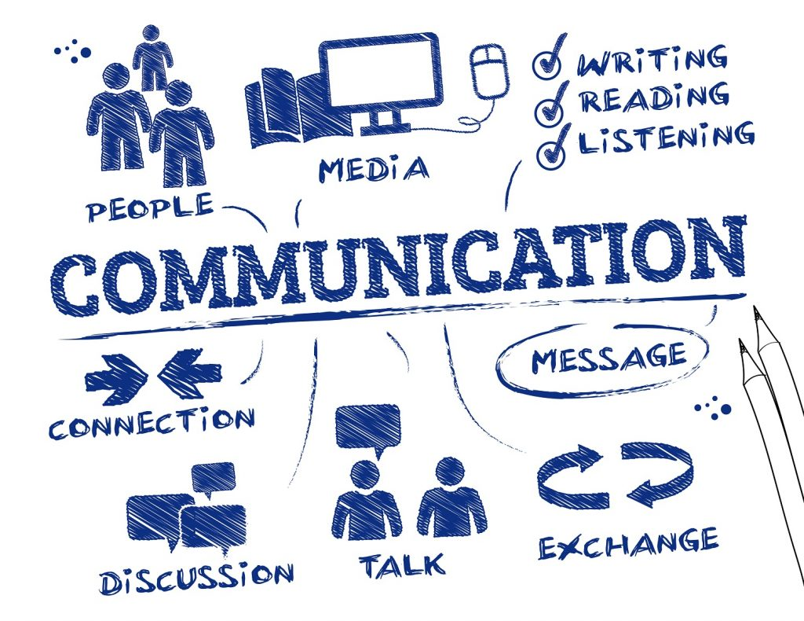
Figure: Proper Communication Process
Source: (Miller, Biggart and Newton, 2013)
In every organisation, there is necessary to make focus on the level of customer satisfaction in this case a proper communication help to achieve it (Kendall and French, 2018). Here an employee should attend different workshops and seminars properly to increase proper communication skills which help them in future to get the higher position. The employees have to possess these communicational skills like empathy, open minded, respectfulness and friendliness in time of communication with others.
Technical skills: It means one type of special knowledge to do a specific job properly. Generally, technical skills include mathematical, mechanical, skills and information technology. Here the assistant marketing manager of Tesco should have necessary technical skills like the ability to make communication through electronic process, analysis data over software, writing of report, data entry skills and developing a presentation etc.
Here the fundamental role of assistant marketing manager of Tesco is to analyse and make research over the current trend that mainly requires the abilities to analyse data by using software for getting proper decisions (Behrens and McCulloch, 2014). The development of presentations and reports are the regular task of this assistant manager so for that technical skills are significant in this perspective. The employer of Tesco should recruit those numbers of employees in this assistant manager post who have the excellent abilities in this technical skill. Those who have necessary skills regarding technical then they have properly performs all the roles and responsibilities in this particular position.
It is the challenge for the employers of Tesco to recruit numbers of skilled employees and it is one type of objectives for every organisation. Here assistant marketing managers of Tesco have the ability to make focus on work, hardworking ability, punctuality and self- management ability other than necessary employability and educational skills. These types of skills help employee to develop their career as well as it help an organisation to get their objective within proper time period. The process of the development of this technical skill mainly depends on the professional and personal development through executing and planning the task properly.
Teamwork skills: The success of organisation much depends on the performance of team. Generally, a successful teamwork mainly helps to get the objectives and gaols of organisation within proper time period (Rippner, 2011). Here the key roles and responsibilities of an assistant marking manager is to create a plan regarding research, campaign, current marketing trend, developing budget and maintaining a proper communication channel etc. Generally, a employee of marketing should work with team because team mainly provides cooperation among the members which assist to perform the task properly.
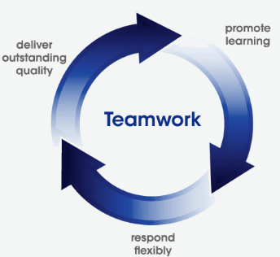
Figure: Teamwork
Source: (Mahajan et al., 2012)
An effective teamwork helps an organisation to solve difficult problems more easily and tried to get most valuable answer quickly as well as it helps to analyse the market in most efficient way than other systems. It is generally known that the output of the team work is much more than individual work because a particular number of employees are mainly involving in team work for making decisions on the other way single person is engaged in decision making so that the skills of teamwork is significant for every organisation. When Tesco makes promotional campaign then it makes an impact on their competitors so that Tesco should create a proper team by which they can develop a proper strategy to increase their position in market than competitors.
Motivational and leadership skills: This skill mainly helps the assistant marketing manager of Tesco to achieve the goal in more accurately (Finch and Fafinski, 2016). Here the manager should ensure the employee’s motivation and team’s leadership are the fundamental parts of their roles and responsibilities within Tesco. Generally, the proper leadership skill helps assistant marketing manager to do the work by their subordinates properly to achieve the goal on the other way motivational type skills help to increase their engagement in organisation. The significant task of assistant marketing manager is to do their work with marketing staffs and creates a proper plan for the organisation which ensures higher level of efficiency for this reason the employees should motivate to do their task properly.
Generally, an assistant marketing manager’s leadership skills are significant to ensure a proper teamwork. Here the marketing manager of Tesco is mainly playing the role of a leader. This motivational and leadership skills is essential for the professional and personal improvement for each employees. According to Vishnu, (2012), it is achieved through reading different books on the motivation and leadership towards employees as well as business magazines and business cases regarding this subject helps to increase the knowledge of motivation and leadership.

Conclusion
The employability skills are significant types of skills which are fundamental to get a particular job. Generally, the skills are different from one to another based on the requirement skills of the job. The employers are mainly looking forward to recruiting those numbers of employees who have necessary leadership, communication, technical and presentational skills. The employees who have these skills are effective for the every type of post. Today, it is the age of competition so that only having the academic qualification is not enough to get a particular job besides there is necessary to get other skills that are mainly helpful to make the better performances in workplace. There is no alternative to make emphasise on skills development with academic qualification to get a desired level of position by the employees.

References
- Behrens, T. and McCulloch, M. (2014). Transitions employability skills curriculum.
- Finch, E. and Fafinski, S. (2016). Employability skills for law students.
- Haasler, S. (2013). Employability skills and the notion of ‘self’. International Journal of Training and Development, 17(3), pp.233-243.
- Kendall, A. and French, A. (2018). Re-thinking employability with a literacies lens. Higher Education, Skills and Work-Based Learning.
- Mahajan, D., Verma, D., Shahane, S. and Bajaj, M. (2012). A Study of Task Based Teaching Methodology and its Impact on Employability Skills of Learners. Paripex - Indian Journal Of Research, 3(4), pp.157-160.
- Miller, L., Biggart, A. and Newton, B. (2013). Basic and employability skills. International Journal of Training and Development, 17(3), pp.173-175.
- Naanda, R. (2010). The integration of identified employability skills into the Namibian vocational education and training curriculum.
- Pitan, O. (2016). Employability development opportunities (EDOs) as measures of students’ enhanced employability. Higher Education, Skills and Work-Based Learning, 6(3), pp.288-304.
- Rippner, M. (2011). Using Businesses as On-Site-Schools To Increase Academic Achievement and Develop Employability Skills of At-Risk Students. [Washington, D.C.]: Distributed by ERIC Clearinghouse.
- Vishnu, P. (2012). Handbook on employability skills. [Place of publication not identified]: Lap Lambert Academic Publ.

