
‘Research and Case Scenario in Data Security and Compliance’
Data Security and Compliance (ACCA5034)

Jonathan Lesmond (2300728)
BSc Applied Computing

Table of Contents
Introduction 4
Research on Data Security Frameworks 4
NIST Cybersecurity Framework 4
Evaluations of NIST Cybersecurity Framework 5
COBIT 2019 6
Evaluations of COBIT models 7
CIS Controls Framework 8
CIS Controls Implementation Guide for SMEs 8
Evaluations of the CIS Controls Framework 9
Conclusion 9
Case Study (CyStresSolutions) 10
Introduction 10
Department Structure 10
Policies and Procedures 11
Compliance to Laws and Regulations 11
Risk Management 12
Contingency Planning 13
Protection Measures 14
Appendix A 19
NIST Cybersecurity Framework Tiers 19

Table of Figures
Figure 1 - Image of NIST Cybersecurity Framework.[7] 4
Figure 2 - Image of NIST Framework Tiers.[7] 5
Figure 3 - Image of COBIT 2019 Principles.[14] 6
Figure 4 - Image of COBIT Core Model.[14] 6
Figure 5 - Image of CIS Controls.[22] 8
Figure 6 - Proposed Information Security Team Structure. 10
Figure 7 - Example of Weighted Factor Analysis Sheet.[9] 12
Figure 8 - Example of Threat Vulnerability Analysis Table.[34] 13
Figure 9- NIST Framework Tiers Description.[7] 19

Research and Case Scenario in Data Security and Compliance
Jonathan Lesmond
Student, University of Wales Trinity St David, Swansea, Wales
2300728@student.uwtsd.ac.uk

Introduction
The internet nowadays brings millions of devices and networks in constant communication with each other, the number of devices connecting to the internet will continue to grow which also leads to a continuously increasing attack vector giving more methods for hackers to attack a system or network and so the need for information security will also continuously increase. Information security (also known as Data Security) can be described as the protection of information and important assets relating to it such as the systems that interact with the information.[1][2]
This report examines widely known cybersecurity frameworks that are implemented within the computing industry, this report will also delve into a case study that covers setting up a new information security department for a consultancy company, within the case study will cover aspects including; organisational structure, Policies and Procedures, Compliance, Risk Management, Contingency Planning and Protection Measures.

Research on Data Security Frameworks
Cybersecurity frameworks are a general set of guidelines that cover a broad range of topics in information security within an organisation, although not required by law to follow a cybersecurity framework it is still highly recommended to implement one or multiple frameworks to operate an effective information security department.[3] Popular frameworks that are implemented into organisations around the world include; NIST Cybersecurity Framework, COBIT 2019, CIS Controls Framework etc.[4][5][6]

NIST Cybersecurity Framework
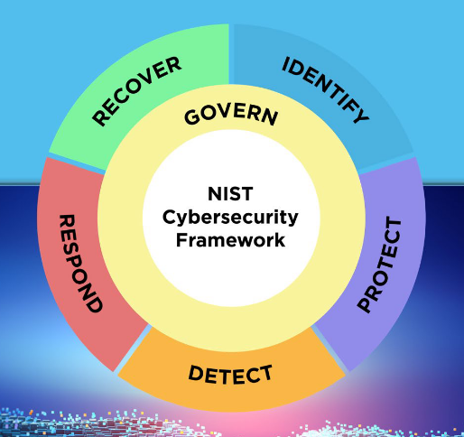
Figure 1 - Image of NIST Cybersecurity Framework.[7]
The National Institute of Standards and Technology (NIST) Cybersecurity Framework was created to assist organisations in improving risk management across many important company assets, The framework consists of 6 core functions; Govern, Identify, Protect, Detect, Respond and Recover.[7]
The govern function is the initial stage of creation of a risk management strategy, in this stage the C-suite and stakeholders establish roles, responsibilities and resources to the strategy.[7]
The identify function is the stage where company assets are evaluated based on their level of risk, this is where keywords such as risk appetite and residual risk enter the frame, Risk appetite is a measurement of how much risk a company can tolerate,[8][9] while residual risk refers to the risks that still exist after the implementation of protection measures. Other publications such as the FIPS 199 by NIST gives guidance on how to categorise company assets based on potential impact in the event of an incident.[7][10] The NIST 800-53 is another publication that gives more details on specific protection measures ranging from content protection to access controls and more.
The protect function focuses on the implementation of physical and logical protection measures and technologies to important company assets.[7]
The detect function initiates in the detection of a potential threat or confirmed threat where firewalls or intrusion detection and protection systems are used to track and analyse suspicious behaviour on a network or system.[7]
The respond function relates to the company’s response to an incident, The usual actions done in response to an incident mitigation of further damage during the incident and the production of an incident report in the aftermath of it.[7]
The recover function is where the affected assets are returned to normal operational level, most companies would have created a contingency plan for the event of a cybersecurity incident.[7]
The NIST framework also has tiers which give context on how companies at different sizes look at risk management, the tiers go from 1 to 4 with 1 being the lowest.[7]
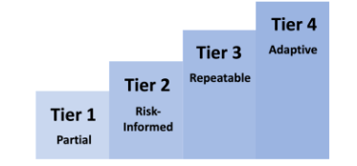
Figure 2 - Image of NIST Framework Tiers.[7]
Appendix A of the NIST framework document provides more detail on what should be considered within each of the functions mentioned, Appendix B describes some of characteristics of companies that would be in each tier.[7]

Evaluations of NIST Cybersecurity Framework
An example of successful implementation of the NIST framework can be found in an energy suppliers in the called Aramco, who operates in globally and had problems due to the different regulations across continents resulting in communication struggles between their facilities, which prompted them to use the NIST framework alongside other frameworks for a risk assessment of company assets and to create new practices to achieve their objectives, this resulted in a new universal framework for Aramco that is adaptable across their multiple facilities across multiple continents that made it easier to communicate and govern.[11]
However, researchers say that the NIST framework struggles to minister the security and threats relating to Internet of Things (IoT) devices, for example the physical size of most IoT devices gives it limited hardware specifications which makes it difficult to instate any sophisticated security measures onto these devices which relates to the PR.PS section of appendix A in the NIST framework document.[12][7] Another gap that was found in the NIST framework was that it does not specifically cover real time threat detection despite mentioning continuous monitoring in the DE.CM section of appendix A,[13][7] continuous monitoring may sound like a broad term but in comparison to real time monitoring they are likely referring it to checks done repeatedly in intervals, which if so suggests that continuous monitoring leaves gaps in between checks which may lead to a delayed response to threats if the threat happens to occur between checking periods while real time monitoring could be defined as instantaneous checks as information is received or transmitted.

COBIT 2019
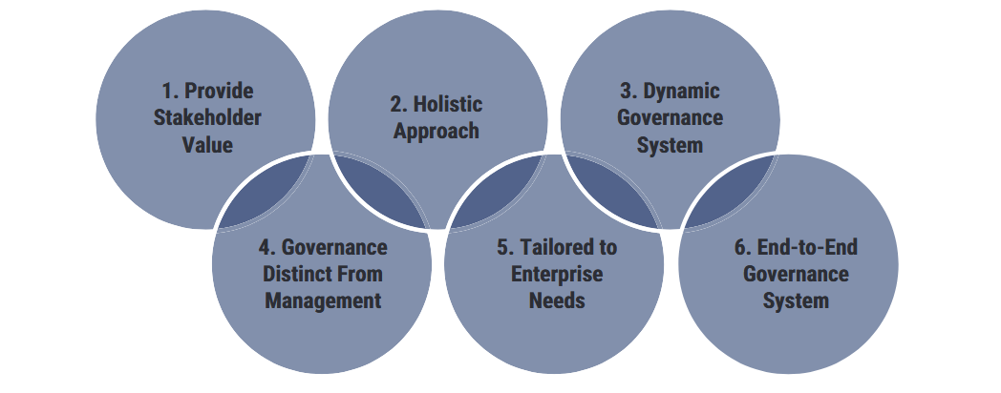
Figure 3 - Image of COBIT 2019 Principles.[14]
The Control Objectives for Information and Related Technology (COBIT) is a framework created by ISACA to provide guidance on governance, governance in the information security can be seen as the process of maintaining or enforcing a security framework to ensure the fulfilment of objectives made by management relating to information security, these processes may include the creation of policies, having a procedure when interacting with a system etc.[12] COBIT 2019 specifically is an updated version of COBIT 5 adding a 6th principle (‘Tailored to Enterprise Needs’) and rearranging the order of the preexisting five that were stated in COBIT 5. As previously mentioned COBIT 2019 is made up of 6 principles that are based on the COBIT core model’s 5 domains (Evaluate, Direct, Monitor (EDM). Align, Plan, Organise (APO). Build, Acquire and Implement (BAI). Deliver, Service and Support (DSS). Monitor, Evaluate and Assess (MEA)) which are: Provide stakeholder value, Holistic approach, dynamic governance, governance distinct from management, tailored to enterprise needs, end to end governance system.[15]
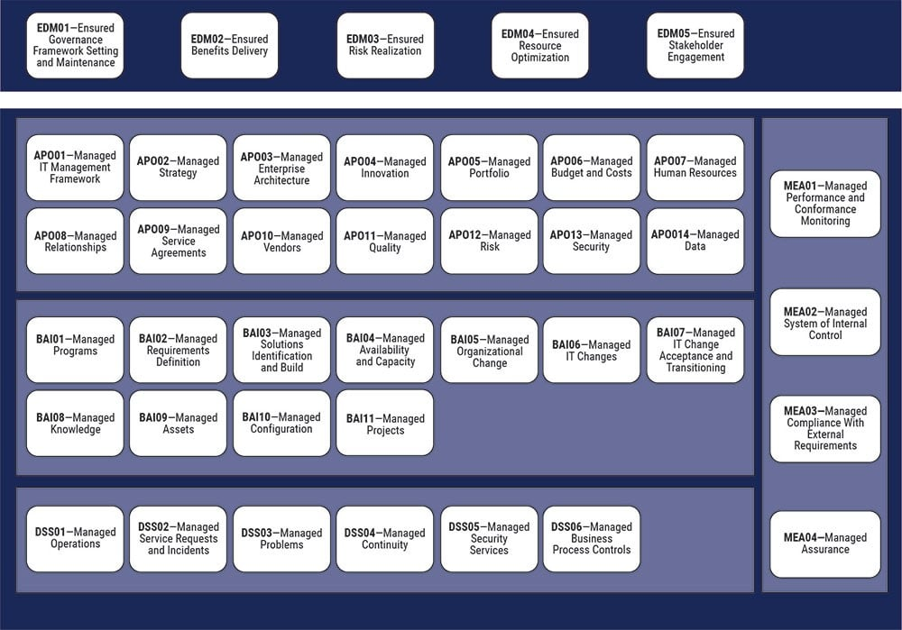
Figure 4 - Image of COBIT Core Model.[14]
‘Provide stakeholder value’ focuses on acquiring the agreement between departments and stakeholder’s objectives.[16]
‘Holistic approach’ refers to the importance of accountability and responsibility when it comes to governance, this principle covers how managers in a company manage the use of IT in the group that they supervise.[16]
‘Dynamic governance system’ looks at whether the governance system that they are creating is adaptable and how certain changes affect the system.[15]
‘Governance distinct from management’ looks at getting employees to know the difference between governance processes and management processes. Governance processes are focused on the practices done to optimize resources and risk management etc. while management process focus on maintaining infrastructure.[16][15]
‘Tailored to enterprise needs’ simply states that the governance systems continuously adapted to the enterprises requirements.[15]
Finally, ‘End-to-End Governance System’ is like the 5th principle and states how the governance needs to be applicable across all departments and assets of the company.[15]

Evaluations of COBIT models
The COBIT model(s) have been considered the popular choice of assessment for auditors, managers or executives, this could be justified by the fact that the COBIT 5 documentation includes something called the Process Capability Assessment in chapter 7, which evaluates the usefulness of a company’s processes in relation to their goals, the evaluation is represented by grades which are: N (Not achieved), P (Partially Achieved), L (Largely achieved) and F (Fully achieved).[17] There are also early studies that strongly suggest the improvement of performance and a degree of usefulness when implementing the COBIT models.[18]
However, there is an apparent lack of research critiquing the COBIT models itself, but there are a lot of assessments of companies using the model,[18][19][20] for example, the most recent success story on the COBIT model on the ISACA’s website is from 2016 despite the existence of the COBIT 2019 model which is an upgrade from COBIT 5 which was the current model at the time,[21] so there may be some difficulty in seeing how well the COBIT 2019 model holds up in the current world.
Another problem that IT professionals and researchers talk about is the practicality of the framework, in particular the complexity of the model was a criticism, the COBIT 4 states more than 200 control objectives and 34 IT processes among other things, which causes organisations to use COBIT at a later stage or even overlooked for other security frameworks due to the time it may take to understand and actually use the model. Another criticism relating to the practicality of the COBIT models is that there is a lack of guidance when it comes to implementation, they say that the model does no give specific guidelines of procedures to take and that the model is too generic or flexible.[20] The fact that the COBIT 2019 model focuses on governance suggests that a company would ideally already have another more implementable security framework in place before the model becomes viable to use, due to the concept of governance being more concerned about the practical enforcement or maintaining of security frameworks instead of creating them.

CIS Controls Framework
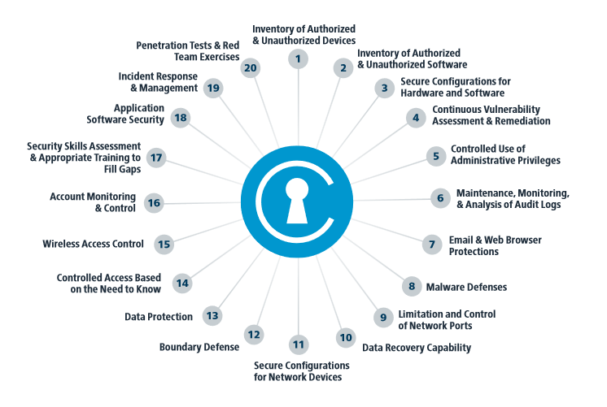
Figure 5 - Image of CIS Controls.[22]
The Centre for Internet Security’s (CIS) Critical Security Controls, is a collection of recommended controls that organisations should implement to improve data and system security, these controls are split into 3 categories: Basic, Foundational and Organisational.[4][23]
The basic category can be described as very basic measures to improve security such as make sure software is updated and passwords are secure etc. The foundational category can still be described as basic controls but are more advanced than the ones mentioned in the basic category, these include access controls, baselines tests of systems etc. And the organisational category focuses more on controls that should be implemented to create an effective governance system which include policies, procedures, training etc.[4]
The framework also recommends which type of organisation should use certain controls, they categorise these different types of organisations into 3 ‘Implementation Groups (IGs)’, IG1 refers to SMEs with limited assets and/or personnel specialising in cybersecurity, IG2 refers to an organisation that have cybersecurity staff but they have to work across multiple departments simultaneously due to more but still limited resources and IG3 refers to an organisation that has cybersecurity personnel that specialises in different aspects relating to cybersecurity such as risk assessments, penetration testing etc.[23]

CIS Controls Implementation Guide for SMEs
There are other documentations directly related to the CIS controls such as the CIS controls implementation guide for SMEs (CIS-CIGS) which provides a summarized set of controls to use, the CIS-CIGS divides each control into 3 phases; Know your environment, Protect your assets and Protect your organization.[22]
Phase 1 (‘Know your environment’) techniques used to monitor networks or systems these techniques include using network analysers, content protection/filters.
Phase 2 (‘Protect your assets’) focuses on security measures that can be implemented on devices such as removable media, Laptops/Desktops etc. recommending baseline tests on systems, opting for cloud storage instead of removable media, using encryption on all devices etc. [22]
Phase 3 (‘Prepare your organisation’) looks at procedures a company should take for incident response which include using and managing backups, creating an incident response team, having the contact information of staff or other 3rd party service providers etc.[22]

Evaluations of the CIS Controls Framework
The CIS controls framework is considered a very useful, versatile and easier to implement due to the fact that it gives detailed tools and practices to have, the CIS controls documentation also categorises the security controls into implementation groups based on the size of the organisation which allows them to incrementally add more advanced measures as the organisation grows,[23] the framework is also compliant with the Federal Information Security Management Act (FISMA)[4][24] which is a law relating to the protection of government information within other organisations.[25] The NIST also recommend documents relating to baseline testing in Microsoft applications by the CIS within their checklist repository, which suggests the active use of the framework in various government departments in the USA,[26] making it a strong framework to recommend.
However, there are some major criticisms of the CIS controls framework according to a researcher, a criticism that was made was the contradictory nature of it,[27] for example, the CIS controls describes itself as a list of security measures all organisations should be implementing, in the introduction of the document it says that it aims to change the question of ‘What should my company do?’ to ‘What should we all do?’, but later on in the introduction says that the framework is not a ‘one size fits all solution’ and that you are still required to do an internal assessment of your organisation to see what fits best and suggests that the framework does not fulfil its purpose properly.[23][27] Another criticism of the CIS controls is that part of its target audience does not need to use the framework, they say that it is possible that large organisations also known as IG3 don’t need the framework as they may already have effective security structures in place, making the framework potentially sound more applicable than it may be in reality,[27] this can be also proven by the fact that there isn’t an implementation guide for large enterprises despite one existing for SMEs, but the whole point of most security frameworks is not to strictly follow everything but adapt its implementation based on an organisation’s objectives, large organisations may use alternatives to services/processes that the documentation recommends, alternatively if you are categorised as IG3 instead of directly following the framework’s recommendations you can adapt it to use it entirely as risk assessment criteria.

Conclusion
In conclusion, I think that using the NIST and CIS Controls frameworks in tandem seem to be the most effective way of improving security, one of the reasons why is that the NIST framework can be used to provide guidance on what objectives to achieve while the CIS controls provides specific procedures, technologies, and software to achieve the objectives stated in the NIST framework, in addition companies can use the COBIT 2019 framework to maintain security through ways such as the process capability assessment

Case Study (CyStresSolutions)

Introduction
CyStresSolutions (CSS) is a developing UK based consultancy company that provides services to businesses to help them combat cyberattacks and other threats, CSS receive funding from shareholders to improve operations and infrastructure. CSS has a website and other social media accounts such as X and LinkedIn that they use to promote their services to a wider audience

Department Structure
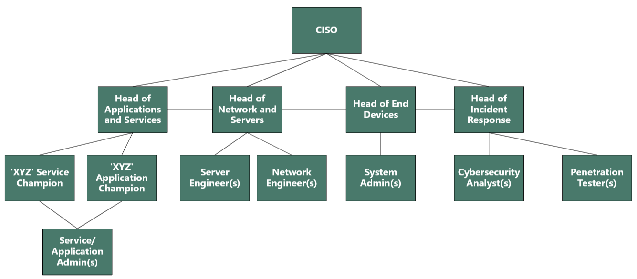
Figure 6 - Proposed Information Security Team Structure.
At the top of the information security team hierarchy, there will be a Chief Information Security Officer (CISO) who can relay the information received from the various team members to the Chief Information Officer, The CISO will also be responsible the creation and governance of policies and procedures in the team and will lead the response to a cybersecurity incident.[28][29]
A risk assessment specialist or cybersecurity consultant who only communicates to the CISO on security recommendations for them to evaluate but does not communicate with the rest of the team.[1]
Below the CISO and security consultant/risk assessment specialist there will be ‘Heads of’ the different aspects relating to information security who will report directly to the CISO, these aspects include Applications and Services, The Network and Servers, End Devices and Incident Response. On the Applications and Services team specifically, a manager/champion for each service and application as CSS may have access to a lot of services.[29] The Incident Response team will also be responsible for the testing the security of systems within the organisation, hence the inclusion of penetration testers.
Below the managers/directors there will be the entry and mid-level roles such as the system admins, analysts and engineers who will actively manage and implement new policies/procedures on organisation’s assets and to report vulnerabilities or threats.[28]

Policies and Procedures
Regular risk assessments will be done as part of CSS’ procedures to identify which assets are at risk, CSS will also categorise information or systems based on their level of impact in the event of a cybersecurity incident the keywords we will use for this are: Low, Moderate, High, Severe.[10] Which will be easier when it comes to risk assessments.
An inventory list of all assets the CSS owns will be created, within the inventory list we will use the serial number and IP address of systems to keep track of them, we will also include the manufacturer’s contact details in the event of a malfunction or damage of the equipment.[23]
A procedure that will be done after an incident is an incident report, which will provide details on what happened during the incident, affected systems, estimated cost of damage, affected systems etc. we will also notify the relevant governing bodies and stakeholders of the incident if a breach of regulations occurred during the incident.[30] The incident reports will be used for in depth analysis of the incident after recovery from the incident.
Some of the policies that will be implemented into CSS is requiring employees to create strong passwords that consists of special characters, numbers etc. to protect organisational accounts which also includes the organisation’s social media accounts, we will also keep systems and software updated to their latest versions.

Compliance to Laws and Regulations
One of the regulations that CSS will follow is the General Data Protection Regulation (GDPR), this is because the company will be handling data on their employees and other businesses that they are providing services to. The objective of the GDPR is to state rules citing the processing and transmission of personal data. Article 5 of the GDPR presents the 6 principles relating to the processing of personal data which include processing data in a transparent manner and lawfully, collecting data only for its specified purpose, you must have the correct amount of relevant data relating to its purpose, the data must be up-to-date and accurate, not allowed to store personally identifiable data longer than necessary.[31]
The PCI DSS is another set of regulations that CSS must comply with, mainly for the salaries of the employees and for when a client is looking to buy their services. The Payment Card Industry Data Security Standards (PCI DSS) is a set of 12 requirements that all organisations that handle payment card data must follow, these include using and maintaining a firewall, changing passwords from the defaults, encryption the transmission of card information, using a regularly updated antivirus software, maintain the security of systems, appoint a unique identifier to any employees that can access company systems, monitoring access to card information, regularly test the security of systems etc.[32]
If CSS wants to provide services to a company that is based in the USA, a regulation that they may have to comply is the EU-US data privacy framework. The EU-US Data Privacy Framework (EU-US DPF) is a law that covers the transmission of data specifically between European countries and the USA and states rules relating to 7 principles which are: Notice, Choice, Accountability for transfer, Security, Purpose limitation, Access, Enforcement.
The notice principle relates to companies being required to notify users that they follow the EU-US DPF, companies are also required to state the purpose of which the data they collect is being used for similar to the GDPR, The choice principle requires users to be able to choose whether their data can be used by a 3rd party or not, Accountability covers the transfer of personal data to a 3rd party assuming they have permission to do so, this principle also exercises purpose limitation to 3rd parties that have access to the personal data, The security principle covers the protection of data from unauthorised access, Purpose limitation refers to using data only for its intended purpose like the GDPR, The access principle requires that the data subject is given access to perform CRUD style operations on their data, and enforcement relates to governance over the use of data.[33]

Risk Management
Risk assessments are an essential part of risk management that will be included into CSS’ information security team, the main types of risk assessments we want to use include a Weighted Factor Analysis and a Threat Vulnerability Assessment.
A weighted factor analysis includes assigning a score to an asset based on different criteria and then calculating the average of those scores to create the final ‘weighted score’.[9]
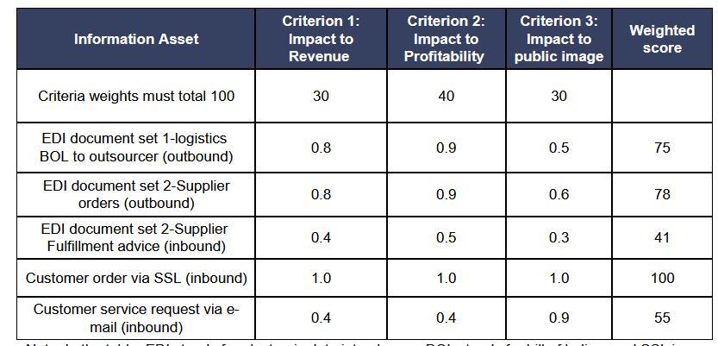
Figure 7 - Example of Weighted Factor Analysis Sheet.[9]
A threat vulnerability assessment involves a table where columns are labelled with the different assets an organisation wants to examine while the rows are labelled with threats that the organisation are aware of, the remaining empty cells will then be used to note where protection measures have and have not been implemented.[34][35]
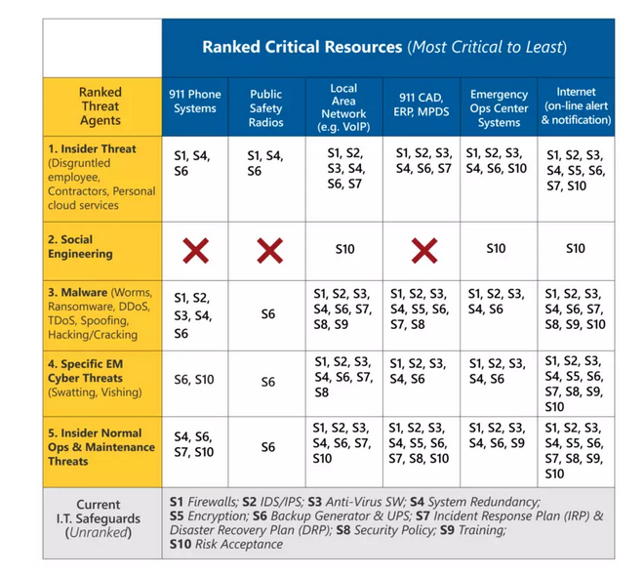
Figure 8 - Example of Threat Vulnerability Analysis Table.[34]

Contingency Planning
Some extra measures CSS will utilise as a part of their contingency plan include having access to an offsite storage service from a 3rd party if a natural disaster or other physical forms of attacks affect any organisational data.[36] using a 3rd party storage will be cheaper to use for CSS however the security of the information in that storage is fully dependant on the provider and not CSS.
A cold site may also be viable if enough physical damage has been made to the main office to be considered inoperable whether it is from a natural disaster or from vandalism. A cold site refers to an emergency facility with basic equipment to operate computer systems that is ready to use if a team has to relocate from their main office, cold sites are also cheaper than warm or hot sites but also have less equipment installed than them and so transferring to a cold site in an emergency may take longer.[36] Both the cold site and the offsite storage may be located in the Berkshire or Hampshire regions due to their lower risk of flooding despite Berkshire’s close proximity to the river Thames.[37][38]
CSS also look to include using multiple power supplies for each individual critical system e.g. servers being powered by 2 power supplies simultaneously, this will ensure that critical systems are still operational if a power supply malfunctions.
Part of the incident report will include if any laws/regulations were breached from the incident, if so, CSS will then be able to provide a notification to the corresponding governing body.[30] Rolling back affected data to its most recent version before an incident is a procedure that will take place during the recovery stage of an incident if any data was affected.
A contingency fund will also be allocated within CSS to quickly fix any unexpected minor problems such as a broken desktop.

Protection Measures
The physical protection measures CSS will include are RFID cards which will be accompanied by an access controls system so that only the necessary staff have access to certain assets,[7] Fire suppression systems will be put in place to limit physical damage to infrastructure.[39] fences will be setup and a barrier will also be setup outside the office to stop non-employees from accessing the office, employees can bypass the barrier by presenting the RFID card.[40]
Firewall will also be included as they are a necessity for network security, alongside an intrusion detection and prevention system to monitor and establish baseline activity on the network and its endpoints and antivirus software to protect individual machines,[41] in addition to the offsite storage, regular backups, encryption of data and backups will be used. this can be helpful if the organisation’s website is taken down as a backed up version of the website can be reinstated.
Multi factor authentication will also be used to prevent unauthorised access if login details were stolen, and to ensure that end users are protected in addition to hardening computer systems. A VPN will also be used to encrypt communication to and from the network
An email quarantine will also be set up for all employees’ inboxes, an email quarantine prevents emails that contain malware or any other suspicious attachments from being sent to the user’s inbox, quarantining suspicious emails can help prevent phishing emails, ransomware etc.[42] Web content filters will also be used on systems in the office to control access to content while utilising the system[40]

References
[1] C. Campbell, "Lecture 1 - Introduction to Information Security,"
[2] R. von Solms and J. van Niekerk, "From information security to cyber security," Comput.Secur., vol. 38, pp.97–102, 2013. doi: 10.1016/j.cose.2013.04.004. Available: https://www.sciencedirect.com/science/article/pii/S0167404813000801
[3] H. Taherdoost, "Understanding Cybersecurity Frameworks and Information Security Standards—A Review and Comprehensive Overview," vol. 11, no. 14, 2022. doi: 10.3390/electronics11142181. Accessed: 2024/11/08/11:26:37, [Online]. Available: https://www.proquest.com/docview/2693981307/abstract/810A83FC16BF4D60PQ/1
[4] S. K. Shukla, et al., "Cybersecurity Frameworks and Models: Review of the Existing Global Best Practices," vol. 65, no. 1, pp.29–42, 2024. doi: 10.32381/PROD.2024.65.01.4. Accessed: 2024/11/07/17:01:24, [Online]. Available: https://www.proquest.com/docview/3069279617/abstract/8A55C83094C5411BPQ/1
[5] C. Campbell, "Lecture 4 - Information Security Management,"
[6] S. K. Venkatachary, et al., "Cybersecurity and cyber-terrorism challenges to energy-related infrastructures – Cybersecurity frameworks and economics – Comprehensive review," International Journal of Critical Infrastructure Protection, vol. 45, 2024. doi: 10.1016/j.ijcip.2024.100677. Accessed: 2024/11/08/11:05:52, [Online]. Available: https://www.sciencedirect.com/science/article/pii/S1874548224000180
[7] National Institute of Standards and Technology, "The NIST Cybersecurity Framework (CSF) 2.0," Gaithersburg, MD. 2024. Accessed: 2024/11/08/11:37:01. [Online]. https://nvlpubs.nist.gov/nistpubs/CSWP/NIST.CSWP.29.pdf
[8] R. Barfield, "Risk appetite – How hungry are you?"
[9] C. Campbell, "Lecture 5 - Risk Management,"
[10] National Institute of Standards and Technology (US), "Standards for security categorization of federal information and information systems," Washington, D.C. 2004. Accessed: 2024/11/08/12:05:51. [Online]. https://nvlpubs.nist.gov/nistpubs/FIPS/NIST.FIPS.199.pdf
[11] "Success Story: Saudi Aramco," 2020. Accessed: 2024/11/21/12:03:59, [Online]. Available: https://www.nist.gov/cyberframework/success-stories/saudi-aramco
[12] M. Fagan, "Cybersecurity for IoT: The Road We’ve Traveled, The Road Ahead", https://www.nist.gov/blogs/cybersecurity-insights/cybersecurity-iot-road-weve-traveled-road-ahead
[13] C. Varol, "Enhancing and Adapting Security Risk Assessment Strategies on Critical Infrastructure Utilizing IoT Devices using NIST Cybersecurity Framework 2.0," Accessed: Nov 30, 2024, [Online]. Available: https://shsu-ir.tdl.org/server/api/core/bitstreams/fe2ebcfe-c619-4235-a8dd-1c5da0249de7/content
[14] "COBIT 2019 Framework Introduction and Methodology," Accessed: Nov 28, 2024, [Online]. Available: https://community.mis.temple.edu/mis5203sec003spring2020/files/2019/01/COBIT-2019-Framework-Introduction-and-Methodology_res_eng_1118.pdf
[15] G. Braga. "COBIT 2019 and the IIA 2019 Guiding Principles of Corporate Governance: Two Frameworks, Many Similarities." https://www.isaca.org/resources/news-and-trends/industry-news/2020/cobit-2019-and-the-iia-2019-guiding-principles-of-corporate-governance (accessed /11/14/17:03:31).
[16] L. Bunnell and H. R. Weistroffer, "Integration of the COBIT 5 Framework into the SDLC for Development of a User Access Attestation System,"
[17] COBIT 5: a business framework for the governance and management of enterprise IT: an ISACA® framework, Rolling Meadows, Ill: ISACA, 2012.
[18] A. Abu-Musa, "Exploring the importance and implementation of COBIT processes in Saudi organizations: An empirical study," Information Management & Computer Security, vol. 17, pp.73–95, 2009. doi: 10.1108/09685220910963974. Available: https://www.researchgate.net/publication/220208187_Exploring_the_importance_and_implementation_of_COBIT_processes_in_Saudi_organizations_An_empirical_study
[19] G. Mangalaraj, A. Singh and A. Taneja, "IT Governance Frameworks and COBIT - A Literature Review,"
[20] S. Zhang and H. L. Fever, "An Examination of the Practicability of COBIT Framework and the Proposal of a COBIT-BSC Model," JOEBM, vol. 1, no. 4, pp.391–395, 2013. doi: 10.7763/JOEBM.2013.V1.84. Accessed: 2024/11/22/16:09:01, [Online]. Available: http://www.joebm.com/index.php?m=content&c=index&a=show&catid=33&id=353
[21] ISACA. "COBIT Case Studies." https://www.isaca.org/resources/cobit/cobit-case-studies (accessed /11/21/16:58:42).
[22] Center for Internet Security. "Mapping and Compliance." https://www.cisecurity.org/cybersecurity-tools/mapping-compliance/ (accessed /11/25/11:46:30).
[23] "Federal Information Security Modernization Act (FISMA) | CMS Information Security & Privacy Group." https://security.cms.gov/learn/federal-information-security-modernization-act-fisma (accessed /11/25/11:46:19).
[24] "NCP - National Checklist Program Checklist Repository." https://ncp.nist.gov/repository?sortBy=modifiedDate%7Cdesc&keyword=CIS (accessed /11/25/11:53:54).
[25] S. Groš, "A Critical View on CIS Controls," 2021 16th International Conference on Telecommunications (Con℡), 2021. doi: 10.23919/Con. [Online]. Available: https://ieeexplore.ieee.org/abstract/document/9495982
[26] C. Campbell, "Lecture 11 - Security and Personnel,"
[27] R. Neal, "Service-Oriented Security Architecture and its Implications for Security Department Organization Structures." Information Security Journal: A Global Perspective, vol. 17, no. 4, pp.188–200, 2008. doi: 10.1080/19393550802369818. Accessed: 2024/11/15/12:15:53, [Online]. Available: https://research.ebsco.com/linkprocessor/plink?id=1a2e8faf-0c5e-3cad-82ab-f35718378f39
[28] B. L. Hatchett-Bodle, "Group Health Plan Cybersecurity Considerations: Protecting Participant Information," vol. 31, no. 3, pp.45–47, 2024. Accessed: 2024/11/23/16:55:15, [Online]. Available: https://www.proquest.com/docview/3041529509/abstract/5BEE868AD8FF4DF2PQ/1
[29] E. Participation. "Regulation (EU) 2016/679 of the European Parliament and of the Council of 27 April 2016 on the protection of natural persons with regard to the processing of personal data and on the free movement of such data (United Kingdom General Data Protection Regulation)(Text with EEA relevance)." https://www.legislation.gov.uk/eur/2016/679/article/1 (accessed /11/16/16:46:04).
[30] G. Ataya, "PCI DSS audit and compliance," Information Security Technical Report, vol. 15, no. 4, pp.138–144, 2010. doi: 10.1016/j.istr.2011.02.004. Accessed: 2024/11/18/16:22:33, [Online]. Available: https://www.sciencedirect.com/science/article/pii/S136341271100015X
[31] "EU-U.S. DATA PRIVACY FRAMEWORK PRINCIPLES
ISSUED BY THE U.S. DEPARTMENT OF COMMERCE," Accessed: Nov 28, 2024, [Online]. Available: https://privacyshielddev.blob.core.windows.net/publicsiteassets/Full%20Text_EU-U.S.%20DPF.pdf
[32] R. J. Mejias, M. A. Shepherd, M. D. Gonzales and S. Baccam, "Threat Vulnerability Asset (TVA) Methodology to Identify Cyber Threats and Sysstem Vulnerabilities in Emergency Management." https://iem.com/using-tva-methodology/ (accessed /11/28/11:39:22).
[33] Fortinet. "Vulnerability Assessment: Types, Tools, And Processes." https://www.fortinet.com/resources/cyberglossary/vulnerability-assessment (accessed Nov 29).
[34] M. Swanson, et al., "Contingency planning guide for federal information systems," Gaithersburg, MD. 2010. Accessed: 2024/11/23/17:05:48. [Online]. https://nvlpubs.nist.gov/nistpubs/Legacy/SP/nistspecialpublication800-34r1.pdf
[35] Anonymous "Preliminary Flood Risk Assessment for England," Environment Agency, Bristol. 2018. Accessed: Nov 30, 2024. [Online]. https://www.newcastle.gov.uk/sites/default/files/Flooding/English_PFRA_December_2018%20accessible.pdf
[36] "Map 1 - Lead Local Flood Authority areas where groundwater flood incidents are reported," Accessed: Nov 30, 2024, [Online]. Available: https://assets.publishing.service.gov.uk/media/60ca0e26e90e0743ae8c2997/Groundwater_flood_risk_management_in_England_-_appendix_D.pdf
[37] C. Campbell, "Lecture 9 - Physical Security,"
[38] S. (Zech) Lee, "A Basic Principle of Physical Security and Its Link to Cybersecurity," International Journal of Cyber Criminology, vol. 14, no. 1, 2020. Available: https://www.proquest.com/scholarly-journals/basic-principle-physical-security-link/docview/2404395113/se-2?accountid=130472 https://libkey.io/libraries/1422/openurl?ctx_ver=Z39.88-2004&ctx_enc=info:ofi/enc:UTF-8&rfr_id=info:sid/ProQuest&rft_val_fmt=journal&rft.genre=article&rft.jtitle=International+Journal+of+Cyber+Criminology&rft.atitle=A+Basic+Principle+of+Physical+Security+and+Its+Link+to+Cybersecurity&rft.au=%2528Zech%2529+Lee%252C+Seungmug.&rft.aulast=%2528Zech%2529+Lee&rft.aufirst=Seungmug&rft.date=2020-01-01&rft.volume=14&rft.issue=1&rft.spage=203&rft.isbn=&rft.btitle=&rft.title=International+Journal+of+Cyber+Criminology&rft.issn=&rft_id=info:doi/
[39] A. Taylor, et al., Information Security Management Principles : An ISEB Certificate, Swindon: British Computer Society, 2008.
[40] "Quarantined email messages in EOP and Defender for Office 365," April 24 2024. Available: https://learn.microsoft.com/en-us/defender-office-365/quarantine-about

Appendix A

NIST Cybersecurity Framework Tiers
Tier | Approach to Governance | Approach to Risk Management
1 (Partial) | - Governance strategies are managed when necessary instead of regularly  - Prioritisation of procedures may not be derived from threats or objectives set by supervisors | - Tier 1 companies are described as having little knowledge or awareness of cybersecurity risks  - Risk management strategies are implemented on a ‘case by case’ manner
2 (Risk Informed) | - Governance strategies are verified by supervisors but may not be instated across the entire company  - Creates objectives to establish governance strategies | - Tier 2 companies are well informed on the risks to the assets  - Risk assessments are carried out or at least have been in its lifetime and cybersecurity insights are sometimes communicated throughout the company
3 (Repeatable) | - Governance strategies verified by executives and implemented across the entire company  - Governance strategies aligned with the company’s objectives are reviewed regularly | - Risk management strategies are instated across each department within a company  - Adaptable risk management methods to counter various types of risks  - Specialised personnel are appointed to perform tasks to high standard  - Risk assessments are done accurately on a regular basis
4 (Adaptive) | - Governance strategies implemented across the entire company that focus on potential threats/incidents  - Clear understanding of objectives, provisional risks are used to create objectives | - Continuously learn new risk management practices from old practices  - Uses continuous monitoring systems to detect threats  - Cybersecurity insights are shared across the company and with other institutions regularly
Figure 9- NIST Framework Tiers Description.[7]

