

Postgraduate/Distance Learning
Assignment coversheet & feedback form

THIS SHEET MUST BE THE FIRST PAGE OF THE ASSIGNMENT YOU ARE SUBMITTING (DO NOT SEND AS A SEPARATE FILE)

For completion by the student:
Student Name: E. J. Yeong

Student University Email: 2404836@student.uwtsd.ac.uk
Module code: HPCA7015  Module title: Foundations in Cultural Astronomy and Astrology | Student ID number:  2404836 |  |  | Educational support needs:  Yes/No
Assignment title: Essay 2

Assignment due date: Thursday 28th November
This assignment is for the 1st 2nd 3rd 4th 5th 6th module of the degree
I confirm that this is my original work and that I have adhered to the University policy on plagiarism.
Signed ……………………………………………………………
Email submission:if you are submitting this form via email, please tick this box □
(as a substitute for your signature) to confirm that you agree to the above declaration.
Assignment Mark
1st Marker’s Provisional mark
2nd Marker’s/Moderator’s provisional mark
External Examiner’s mark (if relevant)
Final Mark

NB. All marks are provisional until confirmed by the Final Examination Board.

For completion by Marker 1 :
Comments:

Marker’s signature: |  |  | Date:
For completion by Marker 2/Moderator:

Comments:

Marker’s Signature: |  | Date:
External Examiner’s comments (if relevant)

External Examiner’s Signature: |  | Date:

Essay Based on a Sky Journal
The Cowherd and The Weaver Girl

- Introduction

This essay is an analysis of a sky journal made between October and November 2024, recording observations of stars Vega and Altair, known as the Cowherd and the Weaver Girl in Chinese mythology. It explores the rich literature and culture associated with the two stars, as well as the author’s personal experience with the night sky through observations, in relation to Vincent Van Gogh’s statement that ‘be clearly aware of the stars and infinity on high. Then life seems almost enchanted after all.’ The author takes on K. J. Schneider’s definition of Awe, or enchantment, as ‘a sense of the magnificence and mystery of living’. It discusses how the stars enchanted, and why it may no longer be the case. It argues that the overdependence on artificial lighting deprive of imaginations and cultural heritage of the dark skies.

- Method

The observations were conducted from 11th October to 25th November 2024 between 6 pm and 10 pm at three locations in Somerset (Table 1) that vary in level of light pollution. Observations were made with the naked eyes, and the celestial objects were identified via the interactive sky chart by Sky & Telescope. Photographs were taken with the smartphone Pixel 6a using the Night Sight mode without being digitally enhanced by Photoshop. The celestial objects were then labelled and the number of visible stars was calculated, and the Moon illumination level (MIL) was also recorded. A selection of results was made into comparison (Table 2).

- Discussion
3.1 The Cowherd and the Weaver Girl

The tale of the Cowherd (Chinese Niulang) and the Weaver Girl (Chinese Zhinü) is one of the oldest East and Southeast Asian starlore, with its earliest appearance in the Lesser Court Hymns in the Book of Songs (Shijing) written in approx. 9th to 8th century BC. The story’s details vary in different local traditions, such as the Japanese and Vietnamese, but the Chinese version is primary. The central theme of the myth is the forbidden love between the Cowherd (a human) and the celestial Weaver Girl (an immortal), and the creation of the Silver River of Stars, i.e. the Milky Way, by the Queen Mother of West as a punishment to separate the lovers. The central characters Niulang and Zhinü are represented by two bright stars on opposite sides of the Milky Way, Altair and Vega. And the seventh day of the seventh month in Chinese lunar calendar, Gregorian months of July to September, on which the annual meeting of the young couple is held – assisted by a group of magpies – over the Silver River, has been observed as a festival called Qiqiao since the Eastern Han (25 – 220 CE), as the earliest evidence suggests. The original elements of Qiqiao can be found in the Han dynasty story collection Miscellaneous Records of the Western Capital (Xijing Zaji) which includes needle threading, music playing and tying beloved with five-coloured cords. The customs gradually developed into its current form, an equivalent to Valentine’s Day. Wu Tianming argues that the origin of Qiqiao may come from a much older tradition of star worship, dating back to 2000 BCE, when the matriarchal society revered Zhinü as an associated female deity to the Moon – the goddess of love and longevity, and as the society transit into patriarchal, the worship of Niulang was added in. The colour change of the two stars also holds astrological significance, as recorded in the Tang dynasty.

As J.P. Phillips phrases in his translation of the New Testament, ‘Love knows no limit to its endurance… It is, in fact, the one thing that still stands when all else has fallen.’, the story of Niulang and Zhinü symbolises the endurance of love. It has been a source of inspiration for many artists, musicians and writers throughout history, such as the contemporary percussionist Beibei Wang. The tenth-century Chinese court official Wang Wenxi depicts the frustration of Zhinü in his poem:

The Milky Way shallow and clear with thin clouds.
The toad’s light [meaning the Moon] and the shadow of the magpie bridge. The Bull-headed shrikes fly.
Resentment often rises to the loud cries of cicadas, who are confiding love to each other.
As soon as Zhinü hears, she abandons her loom in great jealousy.

Tolkien argues that enchantment is to add a spiritual dimension and imaginations to an existing world without a certain purpose or to manipulate the reality. The myth of Zhinü is a typical example of how a celestial body, initially seen as a mystical object that provokes awe, fear and devotion, then gradually develops its own myths, lore, and spiritual meanings, fulfilled by imaginations, and eventually develops a culture tradition that carries for thousands of years.

  - Lost Stars and Brightened Sky

Contrary to Van Gogh’s statement, the author’s experience with the night sky over the six weeks is far less enchanted. The observation was constantly interrupted by stormy and cloudy weather. On the days that the observations were conducted, the experience was dramatically affected by the Moon illumination and by the light pollution (Figure 1). The optimal observation results were achieved at the suburb area when the moon illumination was relatively low (Figure 2), or at the edge of the city centre before or after the new moon (Figure 3). The author could view Vega on most occasions, and Altair on some, both as fainted tiny dots. The Yale Catalogue of Bright Stars estimates that 9095 stars can be detected by the naked eyes, that is 4548 from the northern hemisphere. In comparison, the observation result (on average less than 20 stars in the western sky) is dramatically less in number. And frustratingly, even at their best effort, the author was still unable to sight the Milky Way which is the focal point of the Cowherd and the Weaver Girl myth. Since the author resides in the historical centre of Bath, where the majority of the observations were made, it is hard not to notice how the increased use of outdoor lighting and the light-emitting diode (LED) technology, and at times aviation, contribute to the light pollution (Figures 4,5,6). Even at Location A, where the surrounding area is much less polluted by lights, as long as the observer stands close to a lighting source, such as lights emitted through nearby buildings, their vision of the sky is brightened up and little can be detected by the naked eyes (Figure 7). Furthermore, on cloudy nights, the moon radiates much more light, despite its illumination level being far from full level (Figure 8). And these discoveries, the author later found, are fully supported by scientific data. Early study shows that cloud coverage significantly amplifies the light from artificial luminance. And in a ground-breaking study by Fabio Falchi, et. al. (2016), researchers found that light pollution is a combined effect of outdoor lighting and LEDs, and the latter is highly polluting due to its higher correlated colour temperature (CCT) which can also slow down the eyes’ adaption in darkness – an ability much required for stargazing . In addition, the same study demonstrates shockingly that 60% of Europeans and almost 80% of North Americans cannot see the Milky Way. When the medieval Chinese poet Bai Juyi (772 – 846 CE) wrote down the verse ‘The lights from myriads households light up the four walls of the city, a river of stars reflected in the middle of the water’, he would never have imagined that one day it will become a binary choice between the artificially and the celestial. Roy Willis and Patrick Curry argues that enchantment requires participation. If human can no longer observe the stars as they used to do, then it is impossible for the experience to evoke the same sense of enchantment, and our cultural heritage will ultimately cease to exist.

- Conclusion

When assigned to the sky journal task, the author anticipated a much enriched process, an opportunity for holistic learning about the two stars Altair and Vega, which holds important cultural values in the Chinese history, inspiring myths, lore and traditions. Through examining historical texts and literature it becomes apparent how the enchantment occurred, which aligns with Van Gogh’s statement. While the author expected an enchanted experience as the ancient did through the observations, the reality proved otherwise. A combination of light pollution, moon illumination and cloud coverage largely distorted the experience, and this proven to be a global phenomenon. As a result, the author advocates for a less use of artificial lighting and a preservation of dark skies as a valuable cultural heritage.

- Tables and Figures

NAME | LOCATION | NIGHT LIGHT  (Nano Watts/cm2/sr)
Location A | Ammerdown Park, UK (suburb) | 0.5-1
Location B | Assembly Room, Bath, UK (city centre) | 16-32
Location C | Landsdown, Bath, UK (city’s edge) | 4-8
Table 1: list of observation sites and corresponding light pollution level. The lower the night light is, the less light pollution the area receives.

LOCATION | MOON ILLUMINATION LEVEL | NUMBER OF STARS | FIGURE NUMBER
A | 50% | 16 | Figure 2
 | 100% | 2 | Figure 7
B | 23% | 5 | Figure 4
 | 75% | 6 | Figure 5
 | 92% | 4 | Figure 6
C | 12% | 23 | Figure 3
Table 2: Numbers of stars observed at sites A, B and C at various moon illumination level.

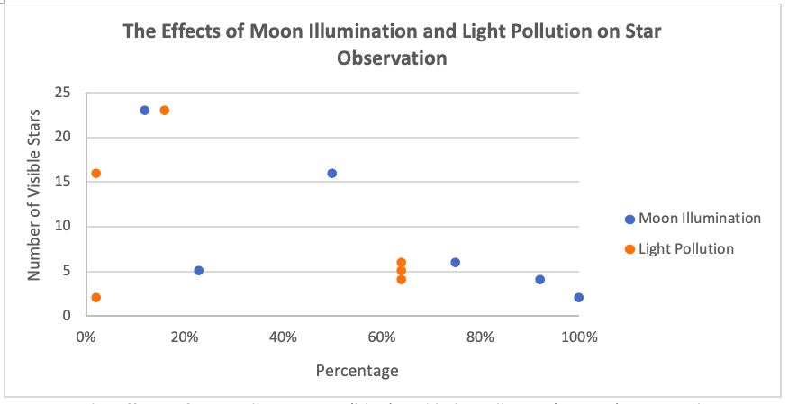
Figure 1: The effects of Moon illumination (blue) and light pollution (orange) on star observation at sites A, B and C. The data assumes that at 50 Nano Watts/cm²/sr the light pollution reaches 100%.

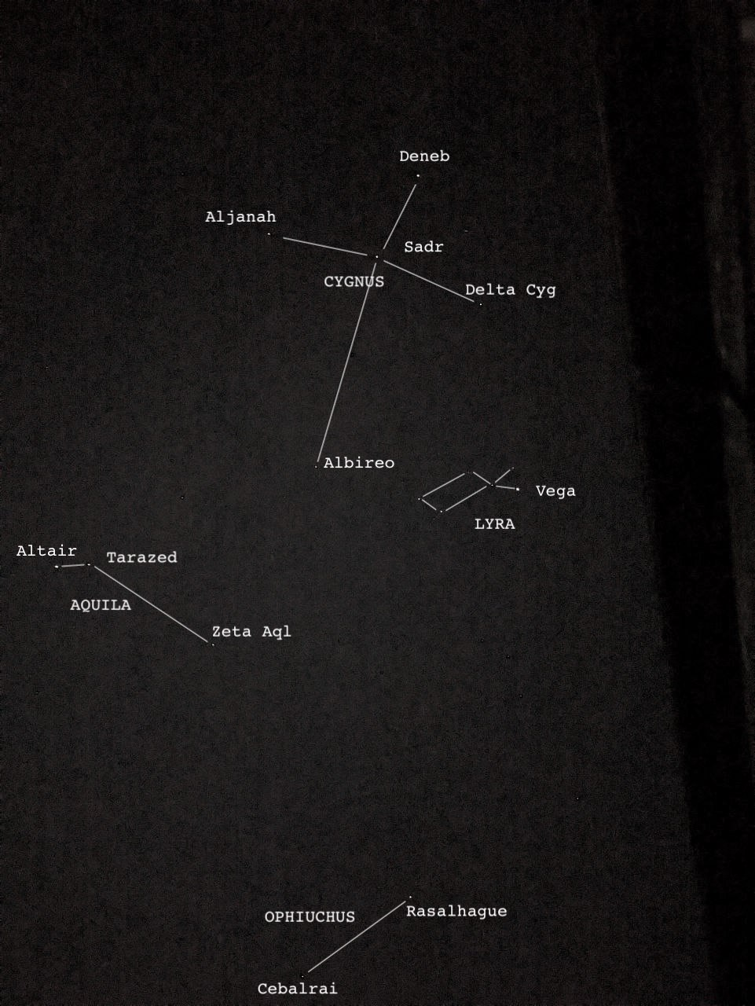
Figure 2: view of constellations Cygnus, Lyra, Aquila and Ophiuchus in October at 10pm at Location A. MIL at 50%.

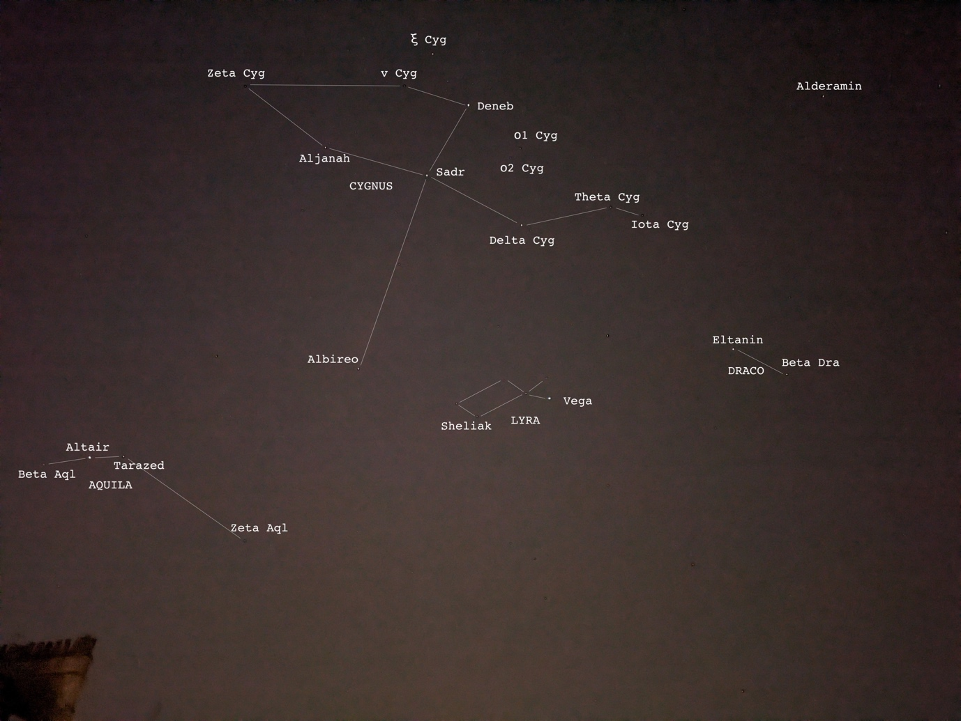

Figure 3: view of constellations of Cygnus, Lyra, Aquila and star Alderamin in late-October at 7pm, at location C. MIL at 12%.

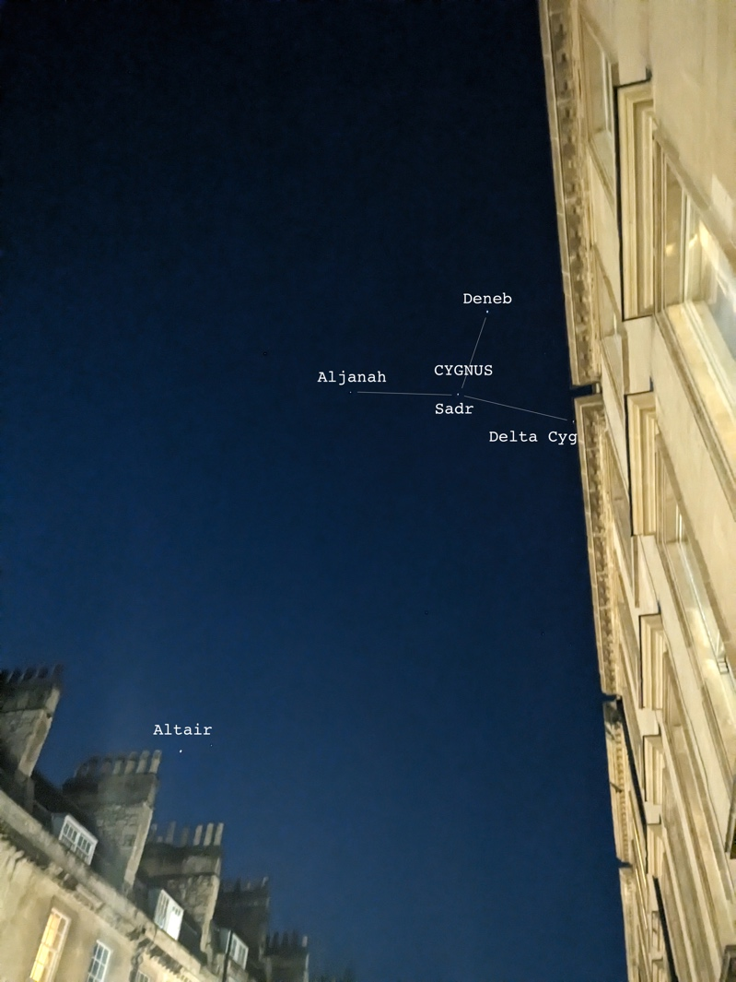
Figure 4: view of constellation Cygnus and the star in early-November night at 8:30pm at Location B. MIL at 23%.

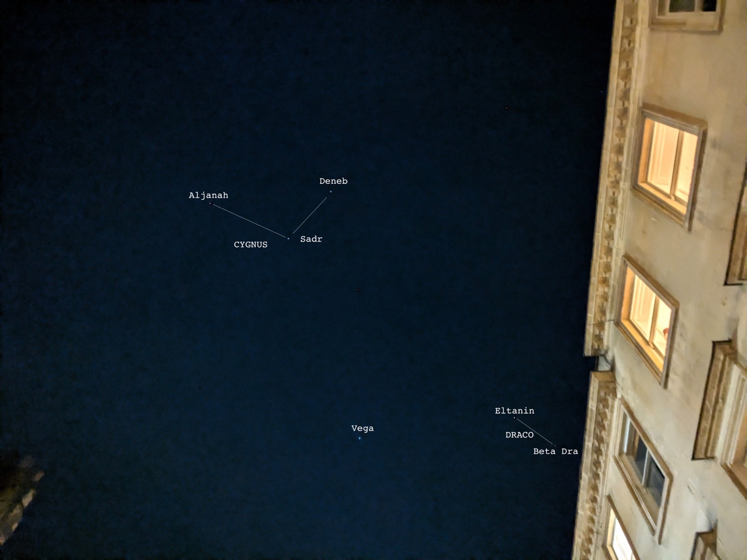
Figure 5: view of constellations Cygnus and Draco, and the star in mid-November night at 10pm at Location A. MIL at 75%.

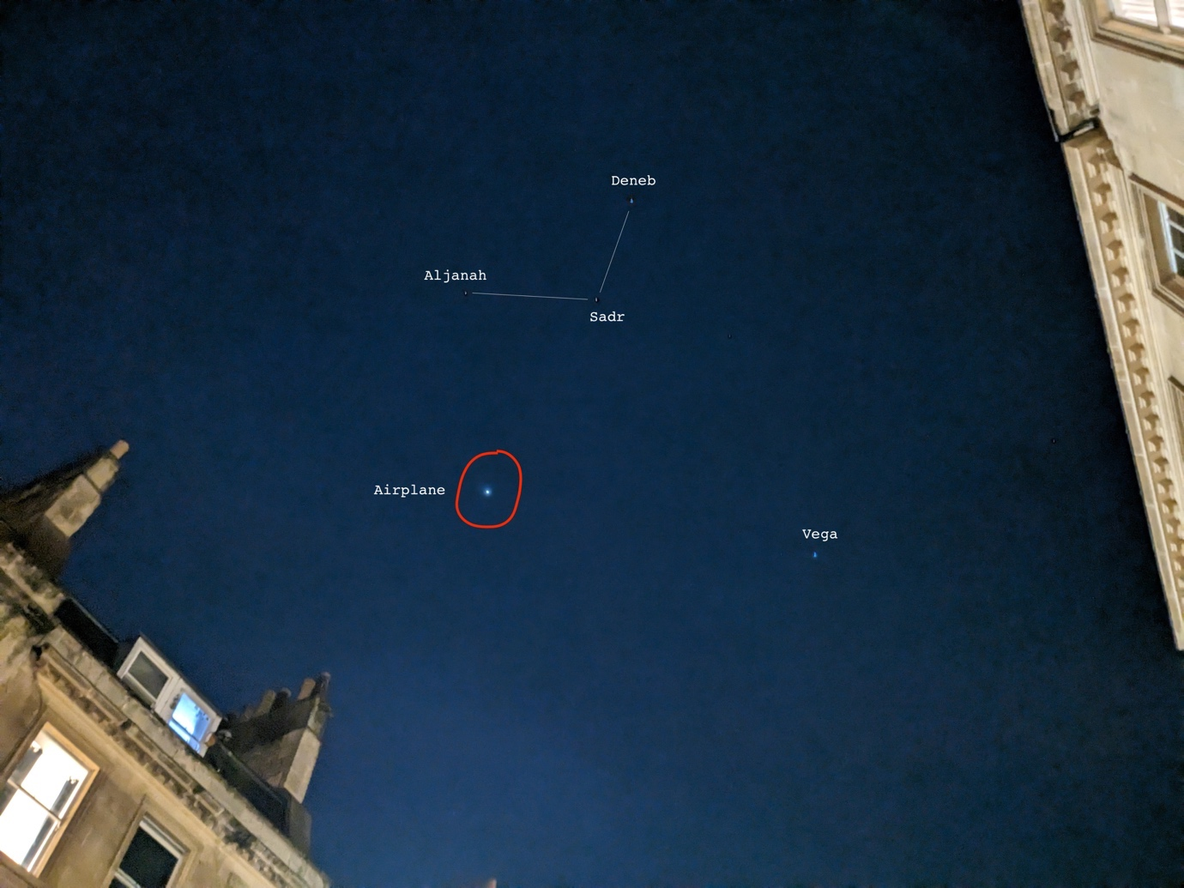
Figure 6: view of constellation Cygnus and star Vega, and an airplane passing by, in a late-November evening at 7pm at Location B. MIL at 92%.

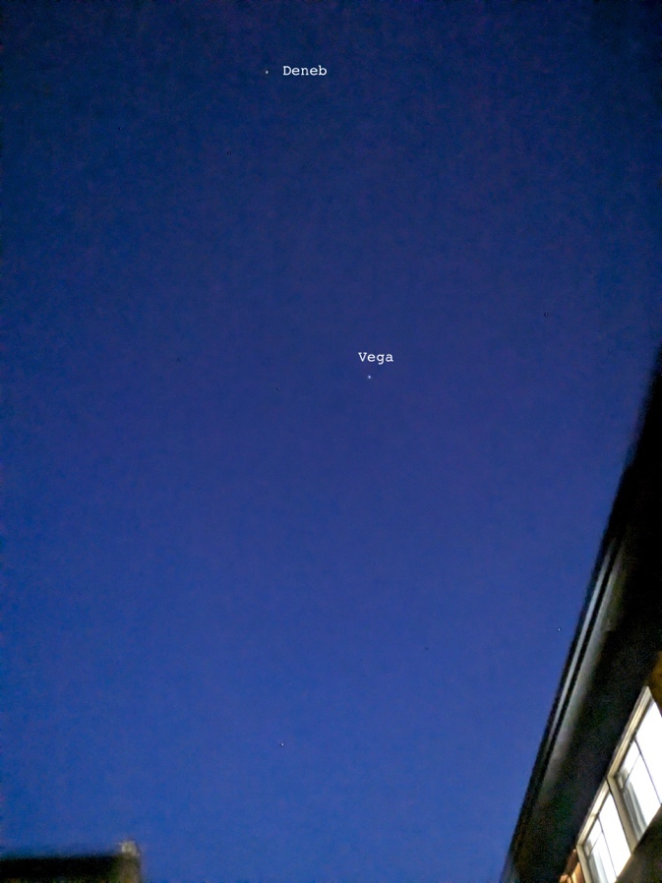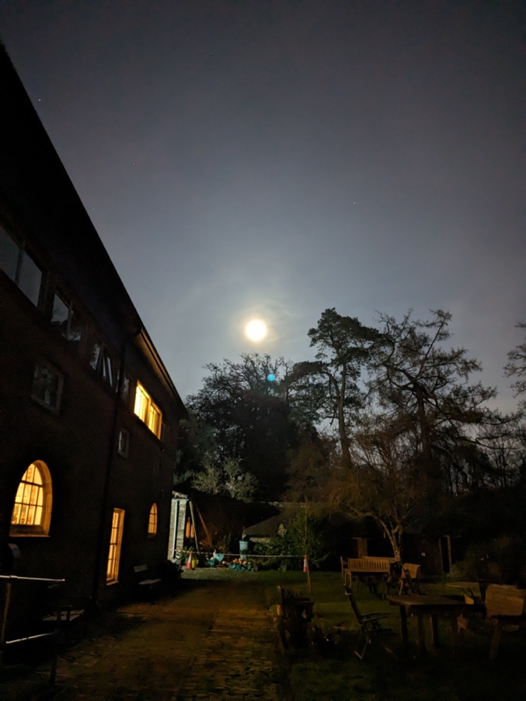
Figure 7: view of stars Deneb and Vega on a full-moon evening in November at 6:30pm at location A, UK (left), with the Moon on the eastern sky (right). MIL at 100%.

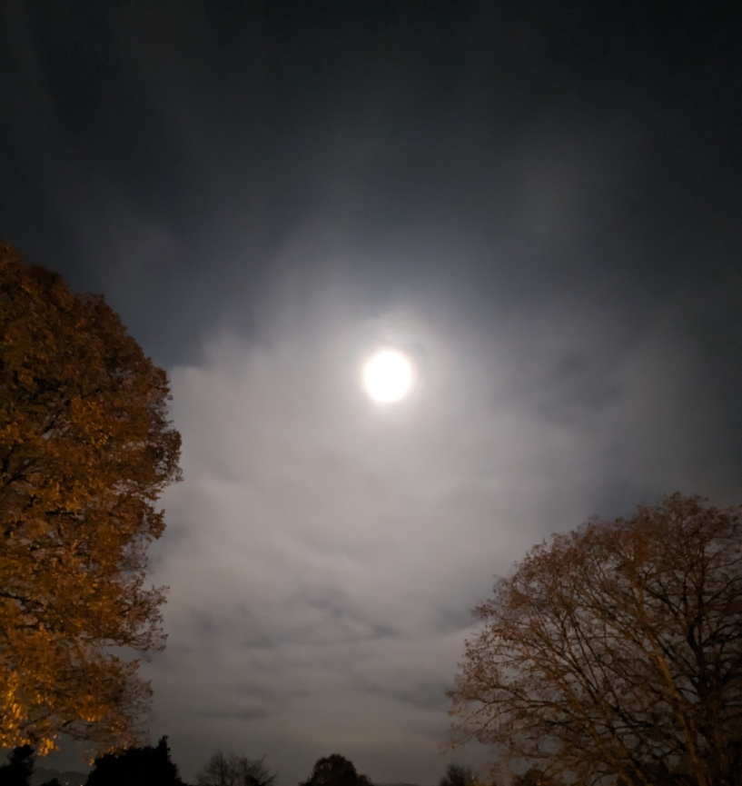
Figure 8: A night sky completely brightened by moonlight in Bath. MIL at 22%.

Bibliography

- Bai Juyi, Jiang Lou Xi Wang Zhao Ke (Climbing Up the WangJiang Tower in Twilight) <https://www.gushiwen.cn/mingju/juv.aspx?id=a5906f26a558> [accessed on 05 November 2024]
- England’s Light Pollution and Dark Skies Map (2016) <https://www.cpre.org.uk/light-pollution-dark-skies-map/> [accessed 16 November 2024].
- Falchi, Fabio and others, ‘The new world atlas of artificial night sky brightness’. Science Advances. Volume 2, issue 6 (2016).
- Kyba, Christopher C.M. and others, ‘Cloud Coverage Acts as An Amplifier for Ecological Light Pollution in Urban Ecosystems’, PLOS ONE. 6, e17307 (2011).
- Light pollution map (2023) <https://gostargazing.co.uk/light-pollution-map/> [accessed 16 November 2024]
- Liu, Xin, Xijing Zaji. (Zhonghua Shuju, 2022).
- Mao, Wenxi, HuanXiSha: <https://www.gushiwen.cn/shiwenv.aspx?id=13771e46284e> [accessed on 15 November 2024]
- Phillips, J.P., Corinthians 13: 10-12, The New Testament in Modern English (1960) <https://www.biblegateway.com/passage/?search=1%20Corinthians%2013&version=PHILLIPS> [accessed on 03 November 2024]
- Schafer, Edward H., Astrology. Pacing the Void: Tang Approaches to the Stars. (Berkeley: University of California Press, 1977).
- Schneider, K. J. ‘Biology and awe: Psychology’s critical juncture’, Pyschologist, 33.2
- (2005), 167 – 173.
- Sky and Telescope (2019) <https://skyandtelescope.org/observing/interactive-sky-chart/> [accessed 12 October 2024]
- Tolkien, J. R. R., Tree and Leaf, 2nd Edition. (London: Unwin Hyman, 1988).
- Hoffleit, D. & W.H. Warren Jr., Bright Star Catalogue, 5th revised edition. (Yale University Observatory, 1991).
- Van Gogh, Vincent and Ronald de Leeuw, The Letters of Vincent Van Gogh. (London: Penguin Books, 1997)
- Waley, Aurther (translated), Book of Songs: Ancient Chinese Classic of Poetry. (New York: Grove Press, 1960).
- Wang, Beibei Wang, Percussion Concerto The Legend of Cowherd and Weaver Girl (music): <https://deritis.com/music/the-legend-of-cowherd-and-weaver-girl/> [accessed 20 November 2024]
- Willis, Roy and Patrick Curry, Astrology, Science and Culture. (Berg: Oxford International Publishers Ltd., 2004).
- Wu, Tianming, ‘Textual Researches into Qixi from Five Aspects’. Journal of South-Central University of Nationalities (Humanities and Social Sciences). 23(3). 2003, 75-85 (p. 77-82).
- Yang, Yu: From early Qin to the Northern and Southern dynasties: the Origin, Formation and Development of Qiqiao. DaZhongWenYi. 24. (2023), 218-222.

Vincent van Gogh and Ronald de Leeuw: The Letters of Vincent Van Gogh. (London: Penguin Books, 1997), p.392.
K. J. Schneider. ‘Biology and awe: Psychology’s critical juncture’, Pyschologist, 33.2 (2005), 167 – 173.
Calculations were made based on Light Pollution Map, 2023 and England’s Light Pollution and Dark Skies Map, 2016.
Sky and Telescope, 2019.
Aurther Waley (translated), Book of Songs: Ancient Chinese Classic of Poetry. (New York: Grove Press, 1960), pp. 316-319.
Yu Yang, ‘From early Qin to the Northern and Southern dynasties: the Origin, Formation and Development of Qiqiao’. DaZhongWenYi. 24. (2023), 218-222. (p.219) 杨宇：先秦至南北朝：七夕节的起源、成型与发展. 大众文艺. 24期. 2023年. 218-222页. (219 页).
Xin Liu, Xijing Zaji. (Zhonghua Shuju, 2022), p43.
Tianming Wu, ‘Textual Researches into Qixi from Five Aspects’. Journal of South-Central University of Nationalities (Humanities and Social Sciences). 23(3). 2003, 75-85 (p. 77-82).
Edward H. Schafer, Astrology. Pacing the Void: Tang Approaches to the Stars. (Berkeley: University of California Press, 1977), p.85-86, 90.
J.P. Phillips, Corinthians 13: 10-12, The New Testament in Modern English (1960) <https://www.biblegateway.com/passage/?search=1%20Corinthians%2013&version=PHILLIPS> [accessed on 03 November 2024]
Beibei Wang, Percussion Concerto The Legend of Cowherd and Weaver Girl (music): <https://deritis.com/music/the-legend-of-cowherd-and-weaver-girl/> [accessed 20 November 2024]
Wenxi Mao, HuanXiSha: <https://www.gushiwen.cn/shiwenv.aspx?id=13771e46284e> [accessed on 15 November 2024], original texts银河清浅白云微，蟾光鹊影伯劳飞. 每恨蟪蛄怜婺女，几回娇妒下鸳机， English translated by the author.
J. R. R. Tolkien, Tree and Leaf, 2nd Edition. (London: Unwin Hyman, 1988), p59-84.
D. Hoffleit & W.H. Warren Jr., Bright Star Catalogue, 5th revised edition. (Yale (University Observatory, 1991), p. 3-5.
Christopher C.M. Kyba and others, ‘Cloud Coverage Acts as An Amplifier for Ecological Light Pollution in Urban Ecosystems’, PLOS ONE. 6, e17307 (2011).
Fabio Falchi and others, ‘The new world atlas of artificial night sky brightness’. Science Advances. Volume 2, issue 6 (2016).
Bai Juyi, Jiang Lou Xi Wang Zhao Ke (Climbing Up the WangJiang Tower in Twilight) <https://www.gushiwen.cn/mingju/juv.aspx?id=a5906f26a558> [accessed on 05 November 2024] The original text writes: 海天东望夕茫茫，山势川形阔复长. 灯火万家城四畔，星河一道水中央. English translated by the author.
Roy Willis and Patrick Curry, Astrology, Science and Culture. (Berg: Oxford International Publishers Ltd., 2004), p88.

