Marius-Catalin
Bobitiu
Cloud Computing
Project Management
ACCC5005

Table of Contents
Introduction 3
What is project management? 3
What is an integrated system? 3
Rapid prototyping Methodology 3
Project 4
Mission 4
Tables 4
Work-breakdown structure 15
Communication plan 16
Stakeholder Management Plan 17
Gantt Chart 17
References 18

Introduction

What is project management?

Project management practices attempt of finishing the project as planned. Getting it done most efficiently by minimizing the cost and achieving external goals related to customer needs. Goals appear straightforward and achievable; however, projects continue to run late, exceed their budgets or fail to meet project objectives. Modern project management was introduced during the Manhattan project in the early 50’s. (Assem Al-Hajj, 2018)

What is an integrated system?

An integrated management system is a single framework intended to manage multiple aspects of an organization’s operations in accordance with various principles. In this case the principles are the booking, payment and sales of spare parts system.

Rapid prototyping Methodology

Rapid prototyping is a pattern of recreating challenging designing since last decade with a potential area of uses. Different kinds of rapid prototyping have been presented since Cold War for the improvement of advanced state of defense and space articles. Depending on the purpose, it is probably going to be implemented. (Sharda Gupta, 2018)

Project

Mission

To develop a medium level prototype for the integrated system for Japher Motors using Rapid Prototyping Methodology.

Tables

The database consists of 10 tables. The tables are as follows:

- Booking: This table consists of appointment details of the customer in the service.

- Car problems: This table shows all the problems that the service can do.

- Car Spare Parts: This table contains the information about any part of the car, including its price.

- Customers: This table contains all the information about the customers that have been to the service.

- Invoice: This table shows all the data regarding the bill of the customer.

- Payment: This table contains the information about any payment made at the service.

- SP Invoice: This table shows all the data regarding the bill of the customer when purchasing a spare part (SP).

- Spare Parts Inventory: This table contains the data regarding the spare parts left in the stores.

- Staff: This table shows all details of the staff working in the service.

- Suppliers: This table shows all details of the suppliers.
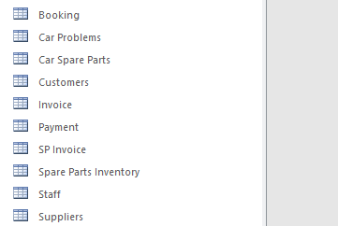

Each table has several fields to enter data, and all fields have several field proprieties.
Booking

Field name | Data Type | Field Properties
ID | Short text | Field size – 10  Input mask – “BOOKNR”000  Caption – Booking ID  Required - Yes
Customer ID | Short Text | Field size – 7  Input mask – “C” 000000  Caption – Customer ID  Required - Yes
Customer title | Short Text | Field size – 3  Caption – C title  Display control – Combo box  Row source type – Value list  Row source – “Mr”;”Mrs”
Customer First Name | Short Text | Field size – 40
Customer Last Name | Short Text | Field size – 40
Booking Date | Date/Time | -
Car Manufacturer | Short text | Field size - 25  Display Control – Combo box  Row Source Type – Value list  Row Source – “Audi";"BMW";"Ford";"Mercedes-Benz";"Porsche";"Vauxhall";"Volkswagen"
Car Model | Short Text | Field size – 30  Caption – Car Model
Problem | Short Text | Field size – 50  Display Control – Combo box  Row source Type – Table/Query  Row source – Select [Car Problems].[Problem Description] from [Car Problems];

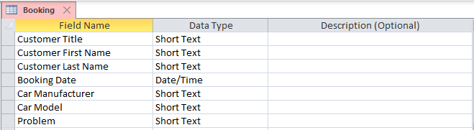
This is the Booking table in design view:

This is the Booking table in datasheet view with some testing records.

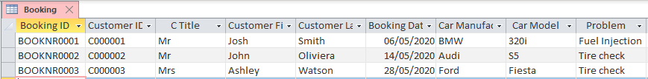

Car Problems

Field Name | Data Type | Field Properties
Problem Identification No | Short Text | Field size – 8  Input Mask – “SERV” 000000  Caption – Problem ID  Required – Yes
Problem Description | Short text | Field Size – 255  Caption – Problem Description  Required – Yes
Approximate Cost | Currency | Decimal places – 2  Caption - Cost
Time Required | Short Text | Field size – 10  Required – Yes  Display Control – List Box  Row Source Type – Value List  Row Source – "15min";"30min";"45min";"1h";"2h";"4h";"6h";"8h"
Parts Required | Short Text | Field size – 50  Display control – List Box  Row Source Type – Table/Query  Row Source - SELECT [Car Spare Parts].[Spare Part Name] FROM [Car Spare Parts];

This is the Car Problems table in design view:

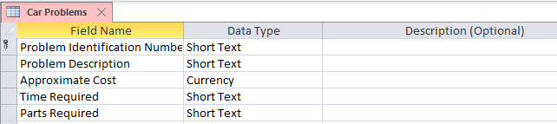

This is the Car Problems table in datasheet view with some test data.

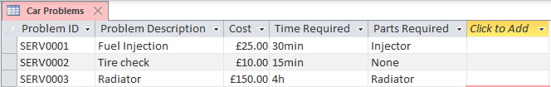

Car Spare Parts

Field | Data type | Field Properties
Spare Part ID | Short text | Field size – 10  Input Mask – “PARTPP” 0000  Caption Part ID  Required – Yes
Spare Part Name | Short text | Field size – 40
For Car/s | Short text | Field Size 25  Display control – List box  Row Source Type – Value List  Row Source – “Audi";"BMW";"Ford";"Mercedes-benz";"Porsche";"Vauxhall";"Volkswagen"
Spare Part Description | Short text | Field Size – 255  Caption Part Description
Spare Part Price | Currency | Decimal places - 2
Supplier Name | Short text | Display Control – Combo box  Row Source Type – Table/Query  Row Source - SELECT Suppliers.[Supplier Name] FROM Suppliers;
Supplier ID | Short text | Display Control – Combo box  Row Source Type – Table/Query  Row Source - SELECT Suppliers.[Supplier ID] FROM Suppliers;

This is the Car Spare Parts table in design view:

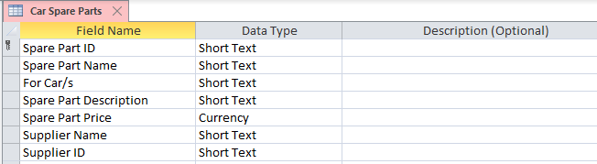

This is the Car Spare Parts table in datasheet view with some testing records:

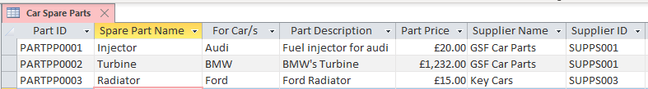

Customers

Field | Data type | Field Properties
Customer ID | Short text | Field size – 10  Input Mask – “C” 000000  Caption – Customer ID  Required – Yes
Title | Short text | Field Size – 40  Display Control – Combo box  Row Source Type – Value list  Row Source – “Mr”;”Mrs”
First Name | Short text | Field Size – 40  Caption – First Name
Last Name | Short text | Field size – 40  Caption – Last Name
Date of Birth | Date/Time | -
Phone Number | Short text | Input Mask “+”00” (0) “00” “0000”;;#  Caption – Phone Number
Address | Short text | Field size 255

This is the Customers table in design view:

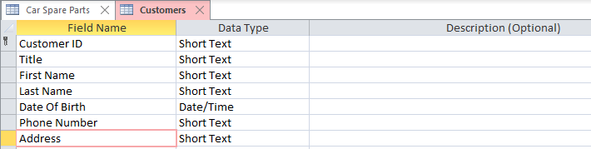

This is the Customers table in datasheet view with some testing data:

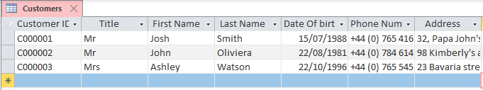

Invoice

Field Name | Data Type | Field Properties
Invoice ID | Short text | Field size – 50  Input Mask – “INVOICE NO”000000  Required – Yes
Customer ID | Short text | Field Size – 12  Input Mask – “C” 000000  Caption – Customer ID
Problem ID | Short text | Field Size – 8  Input Mask – “SERV” 0000
Problem Description | Short Text | Display Control – Combo box  Row Source Type – Table/Query  Row Source – SELECT [Car Problems].[Problem Description] FROM [Car Problem]
Problem Cost | Short text | Display Control – Combo box  Row Source Type – Table/Query  Row Source SELECT [ Car Problems].[Approximate cost] FROM [Car Problems];
Date of Service | Short Text | Display Control – List box  Row Source Type – Table/Query  Row Source – SELECT Booking. [Booking Date] FROM Booking;
Spare Parts used | Short text | Display Control – List Box  Row Source Type – Table/Query  Row Source – SELECT [Car Spare Parts].[Spare Part Name] FROM [Car Spare Parts];
Spare Parts Cost | Short Text | Display Control List Box  Row Source Type – Table/Query  Row Source – SELECT [Car Spare Parts].[Spare Part Price] FROM [Car Spare Parts]
Total Cost | Currency | Decimal places - 2

This is the Invoice table from design view:

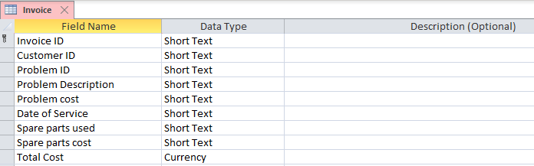

This is the Invoice Table from datasheet view with some testing records:

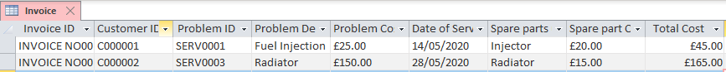

Payment

Field Name | Data Type | Field Properties
Payment ID | Short text | Field Size – 11  Input Mask – “P-PPP” 000000  Caption – Payment Id
Customer ID | Short text | Field size – 10  Input Mask - “C”000000  Caption – Customer ID  Required - Yes
Date of Payment | Date/Time | -
Payment Method | Short text | Display Control – Combo box  Row Source Type – Value List  Row Source - "Cash";"Credit Card";"Debit Card";"Cheque";"Pay Order"
Problem ID | Short text | Display Control – Combo box  Row Source Type – Table / Query  Row Source - SELECT [Car Problems].[Problem Identification Number] FROM [Car Problems];
Problem Description | Short text | Display Control – Combo box  Row Source Type – Table / Query  Row Source - SELECT [Car Problems].[Problem Description] FROM [Car Problems];
Total Cost | Currency | Decimal Places - 2

This is the Payment table from design view:

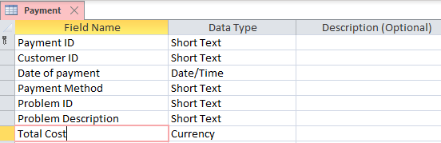

This is the Payment table from datasheet view with some testing records:

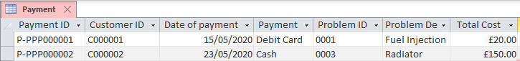

SP Invoice

Field Name | Data Type | Field Properties
SP_Invoice ID | Short text | Input Mask – “SPINVOICE NO” 00000  Caption – Spare Parts Invoice ID
Customer ID | Short text | Input Mask – “C” 000000  Required - Yes
Store ID | Short text | Display Control – Combo box  Row Source Type – Table/Query  Row Source – SELECT[Spare Parts Inventory].[Store ID] FROM [Store Parts Inventory];
Spare Part ID | Short text | Display Control – Combo box  Row Source Type – Table/Query  Row Source – SELECT[Spare Parts Inventory].[Spare Part ID] FROM [Store Parts Inventory];
Spare Part Name | Short text | Display Control – Combo box  Row Source Type – Table/Query  Row Source – SELECT[Spare Parts Inventory].[Spare Part Name] FROM [Store Parts Inventory];
Price | Short text | Display Control – Combo box  Row Source Type – Table/Query  Row Source – SELECT[Car Spare Parts].[Spare Part Price] FROM [Car Spare Parts];
Quantity | Number | -
Total Cost | Currency | Decimal places - 2

This is the SP Invoice table in the design view:

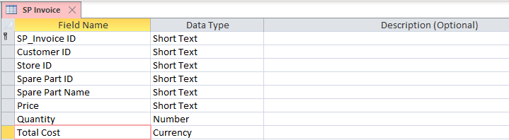

This is the SP Invoice table in the datasheet view with some testing data:

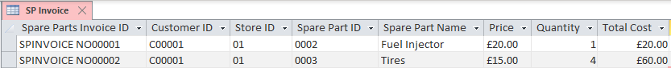

Spare Parts Inventory

This is the Spare Parts Inventory table from the design view:
Field Name | Data Type | Field Properties
Spare Part ID | Short text | Field Size – 50  Input Mask – “PARTPP”0000  Caption – Part ID
Spare Part Name | Short text | Field Size – 40  Caption - Part Name
Store ID | Short text | Field size – 12  Input Mask – “STORE/ JM” 00  Required – Yes
Quantity | Short text | Field size – 5  Input Mask – 000” PCS”  Default Value – 0  Required – Yes

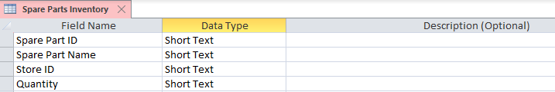

This is the Spare Parts Inventory table from the datasheet view with some testing records:

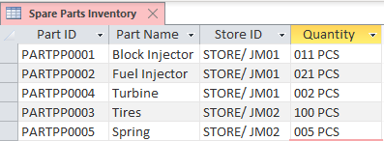

Staff

Field Name | Data Type | Field Properties
Staff ID | Short text | Field size – 11  Input Mask – “STAFF-“LL000  Required – Yes
Title | Short text | Field size – 3  Display Control – Combo box  Row Source Type – Value List  Row Source – “Mr”;”Mrs”
First Name | Short text | Field Size – 40  Caption – Staff First Name
Last Name | Short text | Field Size – 40  Caption – Staff Last Name
Password | Short text | Input Mask – Password
Phone Number | Short text | Input Mask - "+"00" (0) "000" "000" "0000;;#
Email address | Short text | Field Size – 255  Caption – Staff Email Address
Position | Short text | Display Control – Combo box  Row Source Type – Value List  Row Source – “Boss”;”Receptionist”;”Mechanic”;”Electrician”
PayRate | Currency | Decimal Places – 2  Default Value – 8.72

This is the staff table from design view:

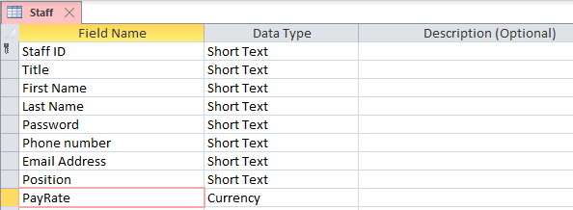

This is the Staff table from the datasheet view with some testing records:

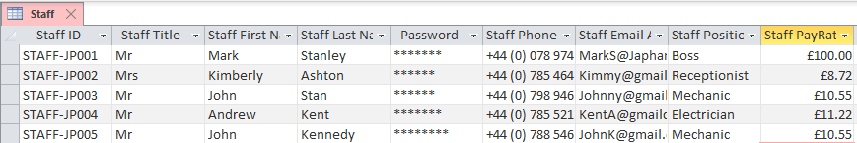

Supplier

Field Name | Data Type | Field Properties
Supplier ID | Short text | Field Size – 30  Input Mask – “SUPPS” 000
Supplier Name | Short text | Field size – 40  Caption – Supplier Name
Supplier Address | Short text | Field Size – 255
Supplier City | Short text | Field Size – 30
Supplier PostCode | Short text | Field size – 8  Input Mask >LL00/0LL; 0;#
Supplier Phone Number | Short text | Field size - 15  Input Mask "+"00" (0) "000" "000" "0000;;#
Supplier Email Address | Short text | Field Size – 60  Caption – Supplier Email address

This is the Supplier table from the design view:
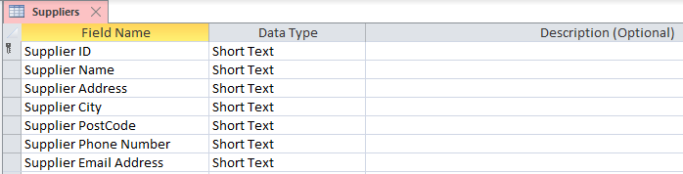

This is the Supplier table from the datasheet view with some testing records:

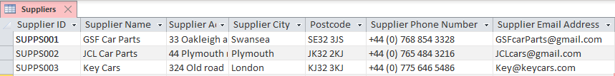

Work-breakdown structure

A work-breakdown structure (WBS) in project management is a deliverable-oriented breakdown of a project into smaller components. It is a key project deliverable that organizes the team’s work into manageable sections.
This is the work-breakdown structure for this project:

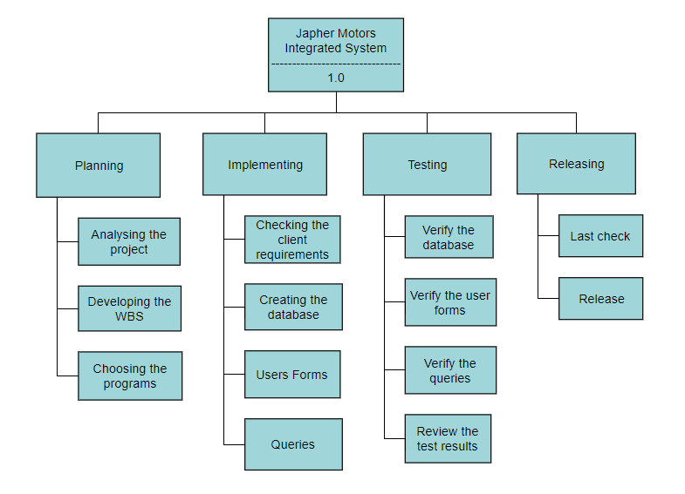

Communication plan

A communications plan enables you to effectively deliver information to appropriate stakeholders. The plan will identify the messages you need to promote, to whom you are targeting those messages, and on which channel(s). (Carmicheal, 2019)

Stakeholder Name | Engagement Action | Owner | Channel | Frequency
Marius Bobitiu | Manage Closely | Project Manager | Personal check-in meetings, email notifications from software | Daily

Stakeholder Management Plan

Put simply, stakeholder management is the concept of managing the stakeholders involved in any major project. Because of how much power they wield, the project manager needs to balance the requirements from key stakeholders with finesse. (Blackburn, 2019)

Stakeholder name | Title | Role | Power (H/L) | Interest (H/L) | Requirements | Concerns
Marius Bobitiu | Project Manager | Developer, Tester | H | H | Finish implementing the database and testing it. | Finishing the project in time.

Gantt Chart

A Gantt Chart is a simple to use framework that shows a visual representation of large projects, broken into smaller activities with each of these activities spread out over time. A Gantt Chart shows what the individual activities are, when it should begin and end, if there is any overlap between activities and how the project can be completed within a given time limit.(Stanley, 2015)

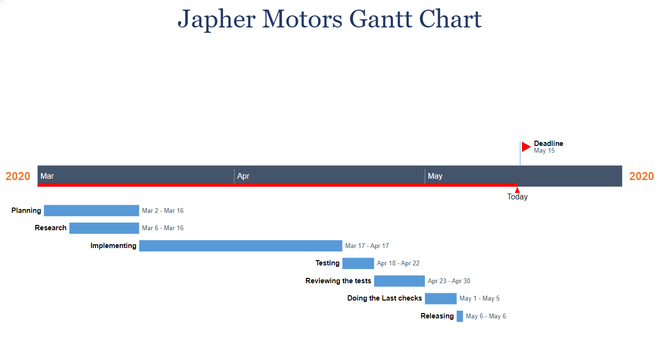

References

Assem Al-Hajj, M. M. Z., 2018. The impact of Project Management Implementation on the Successful Completion of Projects in Construction. International Journal of Innovation, Management and Technology., 9(1), p. 21.

Blackburn, M., 2019. How to Make a Stakeholder Management Plan. [Online]
Available at: https://www.projectmanager.com/blog/stakeholder-management-plan
[Accessed 13 May 2020].

Carmicheal, K., 2019. How to Write an Effective Communications Plan. [Online]
Available at: https://blog.hubspot.com/marketing/communications-plan
[Accessed 13 May 2020].

Sharda Gupta, A. B., 2018. Rapid prototyping for polymeric gels. Polimeryc Gels.

Stanley, L., 2015. Gantt Chart In Project Management: Definition & Examples. [Online]
Available at: https://study.com/academy/lesson/gantt-chart-in-project-management-definition-examples.html#lesson
[Accessed 13 May 2020].

Thank You!

