Executive Summary

This report explores emerging marketing trends within the hospitality sector through both theoretical analysis and practical application, beginning with an experiment – a mini marketing campaign devised for The Celtic Collection (TCC). The four-week digital initiative, ‘Rediscover Celtic Luxury’, aimed to enhance brand visibility and increase direct bookings by leveraging micro-influencer partnerships and hyper-personalised content. The campaign aligned with evolving consumer preferences for authenticity, wellness, and domestic luxury travel, employing the SOSTAC (Situation, Outcomes, Tactics, Action, Control) planning framework and an extended marketing mix to ensure strategic consistency.

Three key marketing trends are also critically examined: hyper-personalisation, sustainability, and the rise of micro-influencers. Hyper-personalisation, driven by big data and AI, is positioned as essential for cultivating guest loyalty and enhancing revenue, though it presents ethical challenges around privacy and data governance. Sustainability has evolved from a peripheral concern to a central brand imperative, particularly among Gen Z and Millennials, necessitating transparency and third-party certification to build consumer trust. Micro-influencer marketing, supported by Social Identity Theory, is shown to generate high engagement and brand affinity through relatable storytelling and authenticity, especially when aligned with brand values.

A case study of Premier Inn demonstrates both the potential and operational challenges of hyper-personalisation, revealing that successful implementation depends not only on technology but also on cross-functional organisational integration and robust ethical practices.

A reflection on the experiment is summarised, with the outcome of micro-influencer partnerships increasing website traffic by 40% and bookings by 12%, validating the shift from traditional advertising to trust-based engagement. However, the campaign also highlighted sensitivities surrounding data usage.

Finally, the report concludes that hospitality marketing must integrate these three trends into an integrated and holistic strategy grounded in ethical practice, customer-centricity, and long-term brand value if competitive advantage is to be achieved and sustained. Tailored recommendations are provided for small boutique hotels, mid-tier chains, and global brands, including community-focused influencer programmes, integrated data systems for scalable personalisation, and predictive analytics supported by privacy-first frameworks. Strategic adoption of these approaches, underpinned by models such as SOSTAC, Relationship Marketing, and the Triple Bottom Line, are determined as essential for future competitiveness in the sector.

Contents

1. Introduction 3
2. Main Findings 5
2.1 Hyper-Personalisation 5
2.2 Sustainability as a Core Marketing Approach 6
2.3 The Rise of Micro-Influencers 6
2.4 Case Study Analysis: Premier Inn 7
2.5 Personal Reflection 8
3. Conclusion 9
4. Recommendations 10
4.1 Small and Boutique Hospitality Businesses 10
4.2 Mid-tier chains 10
4.3 Large, global brands 11

Introduction

This assignment will critically examine emerging trends in marketing within the hospitality sector, whilst also offering reflections from real world examples.

I opted to plan and execute a mini marketing campaign for The Celtic Collection (TCC); a family of luxury resort, hotels and lodges born from the legacy of the Celtic Manor Resort. The campaign – a four-week ‘Rediscover Celtic Luxury’ digital campaign, sought to enhance brand awareness and booking conversions for TCC properties. Rooted in a strategy of micro-influencer partnerships adopting a multi-platform content approach, followed by hyper-personalisation, the campaign aim was to reposition TCC properties as desirable short break destinations for UK travellers with a specific interest in wellness, nature and the outdoors, particularly affluent Millennials and Gen X. The campaign was designed around growing consumer trends towards domestic luxury travel and wellness tourism, exacerbated by the post-COVID shift in travel behaviours and the increasing roles of social media in discovering destinations (Chissom, 2024). Influencer marketing was selected as the campaign’s central strategy, based on its effectiveness in generating engagement, peer credibility and conversion orientated storytelling under the principles of source credibility theory (Hovland and Weiss, 1971).

The campaign was structured using the SOSTAC (Situation, Objectives, Strategy, Tactics, Action, Control) planning model (Ayman, 2024) to ensure a robust, academically grounded strategy.

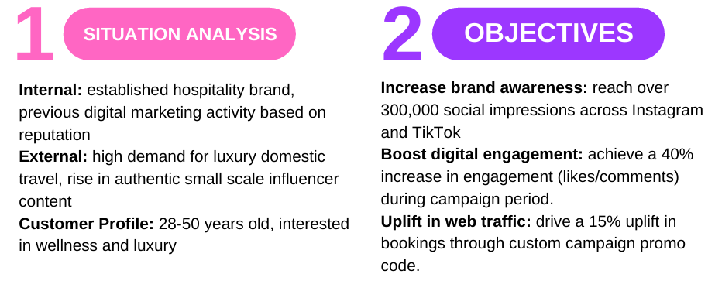

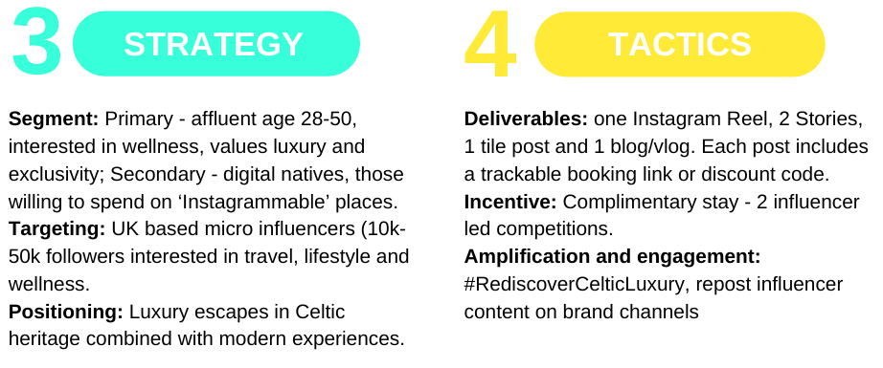
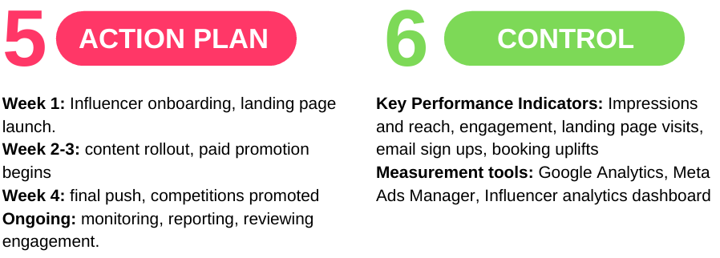

The campaign strategy was also developed under McCarthy’s 4Ps marketing mix, with the extension of people, physical evidence and processes:

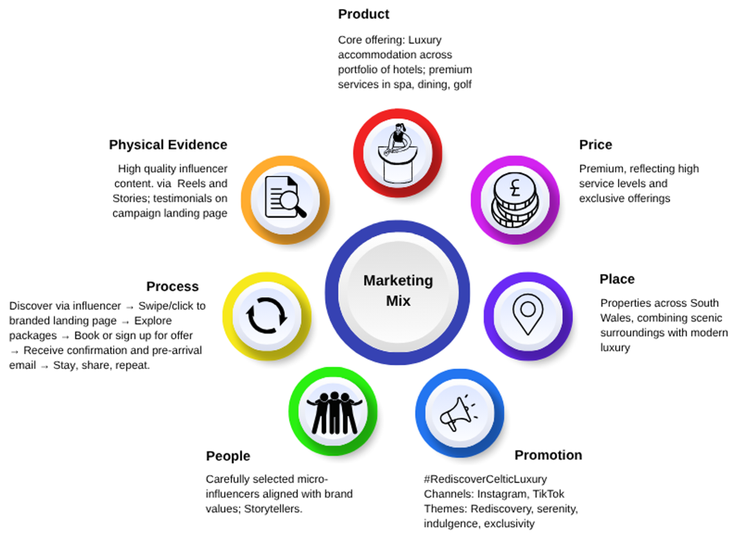

Content was published across Instagram Reels and Stories (highlighting spas, golf and nature immersion), blog articles (providing search friendly content) and TikTok: trends using native storytelling (‘Spend a Day with Me’). A campaign hashtag #RediscoverCeltic encouraged user-generated content and community engagement with a distinct promo code to follow conversions into bookings. Retargeting ads were served to users who had engaged with influencer posts or visited the campaign landing page. Additionally, a curated email campaign was sent to previous guests, offering a booking incentive tied to the campaign.

The campaign was designed to deliver both short term conversions and long-term brand loyalty with the following intended outcomes:
- Enhance brand perception among a younger demographic, positioning TCC as an aspirational yet accessible destination.
- Increase direct bookings, bypassing online travel agents or platforms such as Booking.com to improve profit margins.
- Obtain insight from influencer content performance, which could inform future campaign targeting and creative direction.

The ‘Rediscover Celtic Luxury’ campaign served as a targeted, resource-efficient intervention aimed at leveraging micro-influencer partnerships to drive immediate commercial impact but also establish competitive advantage for long term brand growth in a highly competitive luxury hospitality market.

Main Findings

Marketing in the hospitality industry is in period of profound change ‘driven by innovation, personalisation, and sustainability... cutting-edge AI technology enhancing guest experiences, the industry is adapting to meet evolving expectations’ (Lüthy, 2025). Three pivotal trends shaping the future of hospitality marketing currently are hyper-personalisation, the integration of sustainability as a core strategy, and the strategic shift towards micro-influencer collaborations (Singh, 2025). These trends, whilst distinct, are interconnected by a common thread: the growing consumer demand for authenticity, trust, and personalised value.

2.1 Hyper-Personalisation
Hyper-personalisation, which leverages big data and machine learning to deliver individually tailored content and experiences, represents the technological actualisation of established marketing theory. This approach directly aligns with the foundational principles of Relationship Marketing, where success is achieved through activities directed toward ‘establishing, developing and maintaining successful relational exchanges’ (Morgan and Hunt, 1994). In today's dynamic marketplace, hyper-personalisation is how these relationships are forged at scale. A recent study by research company Medallia highlights this, revealing ‘a strong link between personalisation and overall satisfaction’, with 61% of consumers willing to spend more with brands that offer a customised experience (Hertzfeld, 2024).

Industry leaders like Hilton have successfully adapted to this trend. By collecting granular data on guest preferences, Hilton has moved beyond generic marketing to offer bespoke experiences, from specific room attributes to curated local activities. This strategy has resulted in more targeted and effective email campaigns, driving superior engagement and revenue (Zhou, 2025). However, this pursuit of deep personalisation is burdened with ethical complexities. The immense data required raises significant concerns regarding privacy and security, placing brands under the stringent scrutiny of regulations like GDPR. The constant threat of cyber-attacks means a data breach could irreversibly damage the very trust that personalisation aims to build. For hospitality brands, failing to adopt this trend is not an option; it invites reduced guest loyalty, lower revenue, and a significant competitive disadvantage against more agile disruptors (Faiz et al., 2024).

2.2 Sustainability as a Core Marketing Approach
Sustainability has assertively shifted from a minimal concern to a central pillar of brand identity and marketing strategy, driven by a powerful combination of consumer expectation and regulatory pressure. This is particularly true for younger demographics; 57% of Gen Z and 53% of Millennials in the US actively consider sustainability when making purchasing decisions (Statista, 2023). This sentiment directly impacts revenue, with research indicating that Gen Z are willing to pay a premium of up to $36 per night for hotels with demonstrable environmental features (Fei, Kim and Kim, 2024). The rising importance of a hotel’s environmental credentials among younger travellers signals that sustainability is no longer a peripheral issue but a core business imperative (Clatworthy, 2025).

The critical challenge for marketers lies in communicating sustainability authentically and avoiding the pitfall of ‘greenwashing’, which can irreparably damage brand credibility. Transparency is paramount, and claims must be substantiated by credible, third-party certifications like Green Key or LEAD to build consumer trust (Sustainable Hospitality Alliance, 2021). IHG Hotels Group provides a solid example, having integrated sustainability filters into its booking app and securing third-party certification for over 340 properties (IHG Hotels, 2024). This trend can be viewed through the lens of the Triple Bottom Line (People, Planet, Profit), where a more advanced perspective is offered by the concept of 'regenerative hospitality', which aims not just to sustain but to actively improve the well-being of local communities and ecosystems (Binder and de Fraguier, 2025). This approach transforms sustainability from a marketing message into an authentic brand purpose.

2.3 The Rise of Micro-Influencers
Paralleling the demand for authenticity is the strategic turn from celebrity endorsements to micro-influencer marketing. This trend is a direct response to consumer cynicism towards traditional advertising, with a Nielsen study finding that 92% of consumers trust influencer recommendations that feel authentic, compared to just 33% for conventional ads (Reynolds, 2025). This phenomenon can be explained by Tajfel and Turner’s (1979) Social Identity Theory (Trepte, 2006). Consumers categorise themselves into social groups and are more likely to be influenced by individuals whom they perceive as part of their ‘in-group’. These influencers offer relatable, trustworthy narratives that resonate on an emotional level, rather than the polished, impersonal messages of mass marketing.

Airbnb’s ‘Live There’ campaign masterfully leveraged local nano-influencers to generate authentic travel stories, evoking wanderlust and driving brand affinity through emotional connection (Apte, 2024). Critically, however, the success of this strategy hinges on the alignment of the influencer’s persona with the brand’s values. A misalignment, as seen in their previous campaign (2018’s ‘Belong Anywhere’), can undermine the message and damage brand reputation - an influential element of the experience-centric hospitality industry. While micro-influencer marketing offers a powerful tool for segmentation, targeting, and positioning (STP), and for generating compelling, trust-building content, the potential for reputational harm from a poor partnership necessitates robust and comprehensive due diligence when working with influencers.

Within my experiment, I specifically took an approach of micro-influencer partnerships and multi-platform content as it directly aligned with the marketing trends of hyper-personalisation and influencer-based marketing: offering a move away from transactional, mass-market approaches towards a model built on trust, authenticity, and relational value.

It has been seen how influencer partnerships favour micro influencers because they tend to have higher engagement rates, build stronger trust with audiences and offer cost effectiveness in brand marketing (Chen, 2024). In applying this approach to TCC campaign, I could partner with influencers that had a local or niche following for their interests in wellness, golf or gastronomy, showcasing the Collections resorts to a segmentation of individuals interested in spa treatments, fine dining, world renown golf courses - creating credible content that felt personal and relatable to followers.

Additionally, the multi-platform approach aligned with hyper-personalisation by tailoring content to consumer behaviour and preferences across different digital touchpoints and demographics. Using Instagram supported visual appeal (luxury visuals, Reels of the grounds, spas and suites) with TikTok offering immersive experiences and storytelling (‘spend the day with me’). Hashtag clicks and promo codes also supported a deeper opportunity to hyper personalise emails or web content, utilising impressions, exposure and conversions to show relevant packages or offers, leading to bookings.

In planning the campaign, the aim was to target a specific audience and mirror current consumer expectations of authenticity, relevance and personalisation. By strategically integrating these trends, TCC not only amplifies its brand voice but also creates meaningful experiences that resonate across the demographic segments, making the campaign future-forward and rooted in modern marketing best practices.

2.4 Case Study Analysis: Premier Inn
Premier Inn’s strategic move towards hyper-personalisation exemplifies a growing imperative within the hospitality sector: the leveraging of granular guest data to deliver bespoke, one-to-one engagement at scale. This shift transcends traditional segmentation by employing real-time analytics to anticipate and respond to individual preferences, ranging from room temperature and pillow type to dining selections. Such hyper-personalisation, as Nagy (2024) theorises, is associated with deepening emotional engagement and fostering long-term customer loyalty.

Premier Inn’s launch of an enhanced mobile application and integrated customer-profile platform represents a significant advancement in data consolidation. By synthesising booking history, spend, and in-stay feedback into a unified customer view, Premier Inn effectively operationalises predictive analytics to optimise upselling opportunities at moments of peak receptivity (e.g., WiFi or breakfast bundles). This data-driven agility has translated into tangible performance outcomes, with Premier Inn leading its hotel category across multiple YouGov BrandIndex measures including satisfaction, value perception, and likelihood to recommend (Stephenson, 2023). Such metrics suggest that, at the interface of customer experience and digital innovation, hyper-personalisation can create differentiated competitive advantage (Rust and Huang, 2014).

However, beneath the surface successes lie persistent organisational challenges that complicate the realisation of seamless hyper-personalisation. The enduring presence of internal data silos - segregating online marketing, front-desk operations, and third-party booking channels - undermines the coherence of customer touchpoints and risks fragmenting the guest experience. This disconnect reflects not only technological constraints but also deeper cultural and structural lag within Premier Inn’s operational model. As Lemon and Verhoef (2016) articulate, seamless personalisation demands not merely technological integration but organisational alignment, where data flows and cross-functional collaboration are harmonised to present a consistent and frictionless brand experience.

Moreover, the pursuit of hyper-personalisation raises significant ethical and strategic considerations concerning data privacy and consumer trust. While predictive analytics enables highly tailored interactions, it simultaneously heightens sensitivities around personal data usage. Premier Inn’s ability to embed robust data governance frameworks - ensuring transparency, consent, and security - will be critical in maintaining customer trust and mitigating potential backlash (Martin and Murphy, 2017). This balancing act exemplifies the dilemma of distinction versus discretion, where brands must differentiate their offerings through intimate customer knowledge without overstepping privacy boundaries (Culnan and Bies, 2003).

Premier Inn’s adoption of hyper-personalisation demonstrates strides toward enhanced guest engagement and commercial performance. However, to evolve beyond promising implementation and towards competitive leadership, they must address entrenched silos through comprehensive digital and cultural transformation. Future research might explore the organisational change management practices necessary to support such integration, as well as the evolving consumer expectations in an increasingly data-conscious landscape (Boudet et al., 2019).

2.5 Personal Reflection
Using Gibb’s Reflective Cycle (1988), in the ‘Rediscover Celtic Luxury’ campaign, I led two core tactics: hyper-personalised guest journeys and micro-influencer partnerships. At the outset, I felt uncertain about shifting budget away from tried-and-tested search engine optimisation methods and promotions. I was concerned that micro-influencers would not offer the return on investment given the small number of followers. However, the anxiety gave way to excitement when initial engagements spiked.

Positives of the campaign were the influencer posts saw website traffic increase by 40% in the period as well as a 12% uplift in bookings. However, guest concerns were encountered when personalisation edged into their concerns over use of their data.

Ki and Kim (2019) argue that tightly targeted influencer collaborations ‘affect consumers’ attitudes positively and significantly’ because followers seek to emulate them - turning a tactic into a strategic imperative. Embedding these partnerships in a long-term plan allowed the cultivation of trust over time rather than chase one-off reach spikes. Meanwhile, Bhandari and Sin (2023) highlight that although hotels allocate healthy budgets to promotions, they underinvest in digital strategies that foster real interaction. The campaign looked to cover this gap: without hyper-personalisation and fresh channels, loyalty and engagement plateau.

Following the campaign, I now appreciate that micro-influencer authenticity and hyper-personalisation are not optional add-ons but foundational to future hospitality campaigns. Yet, they must be balanced with respectful data-handling and transparency to avoid eroding guest trust.

Further actions I would consider in future include:
- Develop an Influencer Scorecard to track not just reach but sentiment shifts and brand affinity over six-month cycles.
- Prototype a privacy-first personalisation dashboard, giving guests granular controls over the data they share.
- Expand storytelling frameworks to weave sustainability and responsible travel into guest interactions, ensuring eco-credentials are as visible as luxury.

Conclusion

The experiment crystallised three interlocking truths for hospitality marketing. First, micro-influencer partnerships are not merely tactical but strategic conduits for authentic storytelling. By collaborating with UK-based micro-influencers - each steeped in wellness, nature or gastronomy - a 40% surge in site visits and a 12% uplift in bookings was generated, validating Source Credibility Theory and Social Identity Theory in practice. These results imply that emotionally resonant narratives, distributed across social media, can shift perceptions more powerfully than anonymous brand broadcasts.

Secondly, hyper-personalisation emerges as a necessity, not optional enhancement. Tailoring content and offers through dynamic emails, bespoke landing pages and trackable promo codes not only deepens engagement but builds trust. However, this practice demands rigorous ethics: transparent data handling, GDPR-aligned consent flows and privacy-first design. Missteps can risk eroding loyalty faster than any conversion gains.

Thirdly, sustainability must anchor branding. Gen X, Z and Millennials now weigh environmental credentials as heavily as star ratings. Embedding third-party certifications, weaving regenerative-tourism stories into every touchpoint, and empowering guests to filter stays by eco-criteria can transform ‘green’ from a buzzword into a brand cornerstone.

Successful hospitality campaigns hinge on theoretically grounded frameworks like SOSTAC for planning, Relationship Marketing for loyalty and Triple-Bottom-Line thinking for purpose. Practically, they demand cross-functional alignment to dissolve data silos, amalgamating digital innovation with cultural change.

Recommendations

The below recommendations offer innovative approaches tailored to boutique, mid-tier chains and global brands, to drive engagement, loyalty and competitive advantage.

4.1 Small and Boutique Hospitality Businesses
For smaller establishments, agility and authenticity are the most effective assets. The challenge lies in leveraging limited resources to create disproportionate impact. The strategies must be high-touch, community-focused, and financially wise.

- High-Touch Hyper-Personalisation: AI efforts have proven expensive and unsuccessful (Ackerman, 2024) suggesting large-scale AI-driven personalisation is unfeasible for small businesses. Instead, they should embrace ‘artisanal personalisation’. This involves leveraging simple systems that can track guest preferences from booking correspondence and past stays. A pre-arrival email asking about the purpose of the trip or dietary needs can be followed by a handwritten welcome note or curated recommendations based on their stated interests. This approach directly applies the principles of Relationship Marketing, aiming to establish, develop, and maintain successful relational exchanges on an intimate, manageable scale, fostering the loyalty that drives repeat bookings.
- Community-Centric Influencer Collaborations: Small businesses should avoid costly celebrity endorsements and focus on building a community of nano/micro-influencers. Boutique hotels should create an Ambassador Programme for local influencers, offering complimentary stays or experiences in exchange for authentic content. The focus should be on creators who genuinely align with the hotel’s values. To measure effectiveness beyond vanity metrics, an 'Influencer Scorecard' should be developed to track not just engagement but audience sentiment and referral traffic quality over time, as suggested in the campaign reflection. This embodies Social Identity Theory, where consumers are influenced by relatable individuals rather than wealthy celebrities.
- Authentic, Story-Driven Sustainability: Rather than pursuing expensive global certifications, boutique hotels can embed sustainability as a core part of their brand through transparent storytelling - focusing on tangible, local initiatives: sourcing produce from a local farm, showcasing efforts to reduce water consumption, or highlighting partnerships with community projects. This narrative can be powerfully communicated through influencer collaborations and on social media, demonstrating a commitment to the 'People, Planet, and Profit' of the Triple Bottom Line framework. This authentic approach would resonate deeply with conscious and responsible travellers.

4.2 Mid-tier chains
Medium-sized groups face the challenge of scaling success, standardising quality, and avoiding the operational silos that can plague larger organisations.

- Scaled Personalisation through Integrated Data: Investment in a unified data platform creating a single customer view, synthesising information from property management systems, online bookings, and marketing engagement should be prioritised. This directly addresses the data silo issue identified at Premier Inn. By implementing marketing automation tools, targeted email campaigns can be deployed based on past behaviour, similar to Hilton's successful strategy of sending fewer, more relevant emails. This allows for the delivery of personalised offers, such as mid-week booking incentives or add-on service bundles, thereby increasing website sessions and driving direct bookings with a clear return on investment.
- Group-Wide Sustainability Certification and Communication: To build credibility, medium-sized groups should pursue recognised third-party sustainability certifications like Green Key. This provides tangible proof of their commitment, which can be a powerful marketing tool. As demonstrated by IHG Hotels, this information should be integrated into the booking process, allowing guests to filter for sustainable properties. This strategy directly caters to the growing number of consumers who consider a hotel's environmental credentials to be an important factor in their decision-making.

4.3 Large, global brands
Large chains must leverage their scale to lead on innovation while navigating the complexities of big data, organisational change, and ethical governance.

- Predictive Personalisation with Ethical Governance: Global chains should move beyond reactive personalisation to a predictive model, using AI and machine learning to anticipate guest needs at an individual level. However, this pursuit must be balanced with a robust ethical framework. A key innovation would be to develop a ‘privacy-first personalisation dashboard’, in-line with the campaign reflection. This would give guests granular control over how their data is used, building critical trust.
- In-House Influencer Platforms and Advanced Metrics: Managing influencer relationships requires a sophisticated, data-driven approach. Large chains should consider developing in-house platforms to manage a global network of micro-influencers. This allows for precise matching of influencers to campaign objectives, target demographics, and brand values, mitigating the risk of misalignment that can undermine a campaign's integrity. Performance measurement must evolve beyond reach and engagement to track attitude shifts and long-term brand affinity, providing true insight into the campaign's impact on brand perception. This strategic, long-term cultivation of influencer partnerships transforms a tactic into a sustainable competitive advantage.

Future competitive advantage will not be secured by implementing hyper-personalisation, influencer marketing, and sustainability as campaign tools in isolation, but by strategically integrating them into a cohesive, ethical, and customer-centric framework. The integration of SOSTAC, Triple Bottom Line and Relationship Marketing frameworks ensures both strategic accuracy and creative innovation. To ensure manageability, businesses could pilot one recommendation in a given timeframe (e.g., per quarter, bi-annually), measuring indicators around engagement uplift, booking conversions, etc. to iteratively refine and scale initiatives. This approach not only enables businesses to understand what works but also sets the stage for continued growth.

