
The challenging faced by energy sector
Problem Solving and decision making

December 9, 2022
Ovidiu ioan paulencu
1816786

Contents
1.0 Introduction 2
2.0 Main Findings 3
2.1 Nature, Scope and Impact 3
2.2 SWOT Analysis 4
2.3 PESTLE Analysis 5
3.0 Conclusion 6
4.0 Recommendations 7
5.0 Planning, Monitoring and Reviewing the Solution 8
6.0 Appendices 9
7.0 Reference List 10

Introduction

This report is based on the challenge faced by energy sector and the current situation on energy Crisis, why this is happening and how to react to it is the major aspect of discussion in this research study. Will be discussed the Nature, Scope, and Impact of the problem. The Nature of the problem will be detected by using Ishikawa Diagram (fish bone). SWOT and Pestle analysis will be discussed which area will be affected by the energy crisis, what are the strength and the weaknesses.

Main Findings

Nature, Scope, and Impact
Russia restricts Nord Stream 2 gas supplies to Europe. Is a strategic issue for the EU.
Ukraine Invasion is the problem. Russia is a petrol state, meaning oil and gas contribute for 40% of its budget. The Russians might threaten to cut off Ukraine's energy supply by offering cheap gas. Energy is vital in this fight because if it's switched off, either by European sanctions or by Russia, it will affect both Russia and the EU. Ishikawa Diagram revealed the problem's cause.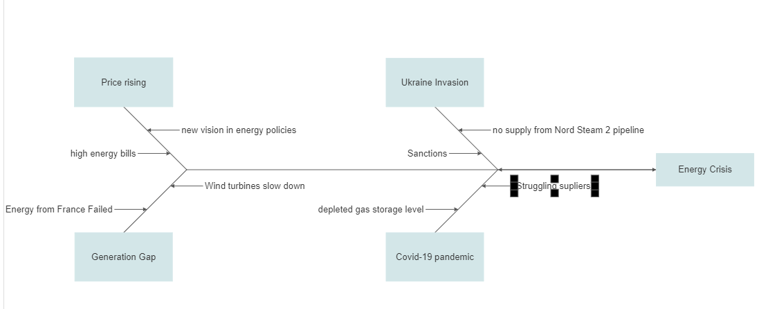
The energy crisis will harm the health and well-being of many low-income individuals. The economy, companies, houses, and industries are affected. The energy problem harms the UK economy and everyone else. The energy crisis impacts employees and customers. High energy prices harm employees, owners, partners, and managers. They couldn't create employment or save businesses. The energy crisis will affect customers, banks, industries, manufacturers, and the government.

The illegitimate Russian invasion of Ukraine has disrupted demand and supply fluctuations and long-term economic collaboration. The rising price of energy impacts families, enterprises, and whole economies worldwide. In poor nations, people can't afford it. It might also make it tougher to swiftly decrease global greenhouse gas emissions to address climate change. We can't allow Russia's enmity hinder climate change efforts again. Russia's actions have generated a worldwide energy crisis and market turmoil, making it difficult for governments, corporations, and investors to select which energy projects to support, develop, or finance.
Leaving the matter unsolved would be disastrous. Imagine if War continues and no one acts. 3-days without energy. Water is a problem. No power, water treatment, or water. Rainwater would be contaminated. If cold caused power outage, hot would follow. Elderly and ill died. Our island's wood supply would revive old fires. Animal skins may warm people. Pumps need gas, halting food supplies. Food would be scarce without power. Without trees to cook with or pick fruit from and fridges to keep food, we'd starve (Nast, 2010).

SWOT Analysis

Swot analysis is used to determine the many aspects and concerns involved in creating a SWOT diagram, as well as how to get started. A SWOT analysis is a crucial component of any business or strategic plan. It strands for S-strength, W-weakness, O-opportunities, T-threats.
Anex 1 is showing all for elements regarding energy crisis.
Rising global demand for gas and coal alternatives caused a global gas scarcity before Russia attacked Ukraine. UK households rely on gas more than most, and with electricity connected to gas for now, energy expenses have surged. Centrica's CEO Chris O'Shea told the BBC in January 2022 that high gas prices will last 18 to 24 months. Before Russia attacked Ukraine, Europe shifted away from Russian energy, prompting Russia to curtail its supplies. This compounded a dangerous scenario for the UK, which had minimal gas storage and relied significantly on European nations who acquired their energy from Russia.
National Grid, an energy-transmission company, presented winter gas-and-electricity projections on October 6. They highlight the problems ahead as Europe learns to operate without Russian gas, boosting the prospect of import gaps for Britain to heat homes and generating energy. National Grid's basic case is that it can get through the winter without electrical outages, but rolling blackouts are conceivable.
Geographical position with numerous renewable power sources is the greatest potential for energy independence with Renewable Energy. However, the natural digester, the global economy, and the cost of fuel continue to be obstacles to the deployment of renewable energy.

PESTLE Analysis

PESTLE analysis is one of the most thorough ways to understand the business environment. From a macroeconomic point of view, it can be thought of as a seeing perspective where an organisation or person tries to figure out the exact trends of the market. In this section, we will discuss more about PESTLE analysis.
Political. Politics might have a huge impact on the future energy issue, bringing both possibilities and threats for existing energy advances. World and European politics influence the UK government's policy.
Economical. In addition to wage rate, labour force, and income distribution, the most influential economic determinants on the growth of renewable energy are employment, gross domestic product (GDP), inflation, economic stability, and foreign investments. Increasing energy costs increase the expense of living.
Social. As a result of the energy crisis and the conflict in Ukraine, there may be alterations in demography, as well as changes in lifestyles, social cultural structures, and corporate cultures. The changes that are going to come along with the crisis will be known to the general public as well as the local communities as a whole.
Technological. The monitoring and control, network design, tariff system, and research facilities in the UK are just few examples of the technology that is being utilised at this challenging period.
Legal. Energy is carefully regulated to safeguard consumer interests and maintain an uninterrupted supply. Sections 160-164 of the Energy Act 2004, as well as the requirements of standard supply licences, restrict insolvency proceedings for energy suppliers and need court and Ofgem authorisation for voluntarily winding up. Unlike uncontrolled firms, energy suppliers can't quit. Energy is a necessity; thus, providers can't abandon their clients. Energy companies must keep delivering energy until they can convince Ofgem they are bankrupt and should lose their licences.
Environmental. If properly managed, marine energy devices have the potential to contribute to meeting EU targets on climate change, which the government of the United Kingdom has committed itself to achieving. These devices are able to produce energy while reducing greenhouse gas emissions, air pollution, and damage caused by acid rain.

3.0 Conclusion

Recent environmental, socioeconomic, and geopolitical developments have all had significant influence on the energy system, illustrating how difficult it will be to make the shift to a new energy source. In particular, disruptions in the energy market and the unpredictability and economic consequences that these disruptions have had on the global economy have shown that the global energy transition needs to find the right balance between the affordability of energy, the security of energy, and the sustainability of energy. According to the findings of the SWOT and Pestle analyses, what is required is for everyone to collaborate in order to steer a resilient energy transition that can continue to make progress even when circumstances are difficult. There are already compromises to be made between the price of energy, the degree to which it can be trusted, and the impact it has on the natural world. Countries are required to manage them with care so that the transition may continue.

4.0 Recommendations

Fatih Birol said at the Energy Outlook: Overcoming the Crisis panel on the first day of Davos 2022 that the world needs to invest in energy in ways that are sustainable for the long term.
He said that the best way to solve the current energy crisis is to get the most out of the oil and gas fields that already exist, use shale oil and gas because it can be brought to market quickly, cut down on methane emissions from fossil fuel operations, and make sure that liquefied natural gas terminals can store ammonia or hydrogen in the future.
"But, in my opinion, the biggest part of the solution is to focus on clean energy, renewables, energy efficiency, and increasing nuclear production in countries that already have the ability to do so," he said.
"We don't have to choose between a climate crisis and an energy crisis. With the right investment, we can solve both."
In Anex 2 is well presented the best decision according to the highest score in the Decision Matrix.

5.0 Planning, Monitoring and Reviewing the Solution

The question of how far we have progressed with the energy transition was posed to the monitoring system called "Energy of the Future" that has been set up by the federal government to measure the energy transition on a continuous basis. Which of these actions have been put into action at this point? What kind of repercussions does it bring about? Will we be able to achieve what we set out to do, or will we have to make some changes in order to be successful?

In the process of monitoring, one of the most important steps is to first analyse the vast amounts of statistical data on energy that have been gathered, and then to summarise and simplify the data so that it is easier to understand. This is one of the steps that makes up one of the most important tasks. Because of this, it is necessary to conduct a review of the activities that have already been carried out, as well as the identification of certain areas in which more efforts are needed. In this way, each annual report provides a synopsis of the energy transition as well as an evaluation of the stage it is in at the current time. Before we can choose what actions to do next, we need to have an accurate grasp of where we presently are and the options available to us.

The Federal Ministry for Economic Affairs and Energy has been tasked with the responsibility of acting as the lead ministry for the process of overseeing the transition to a cleaner energy source. This responsibility was given to the ministry after it was given the responsibility of acting as the lead ministry. The Monitoring Report is a document that is distributed on a yearly basis. It acts as the document that serves as the nerve centre for the monitoring process that is being done for the energy transition.

6.0 Appendices
Anex 1
Strength  - possibility of getting energy from renewable sources (solar, wind, hydro)  - chance of installing in gas infrastructure (fossil fuel) | Weakness  - ineffective use of resources within the globe  - reduce access to Smart Technology
Opportunities  - distribute solar and wind energy  - transitioning to renewable energy.  - installing smart meters and air source heat pumps and using apps to measure and control power consumption. | Threats  - high generation costs  - blackout

Anex 2
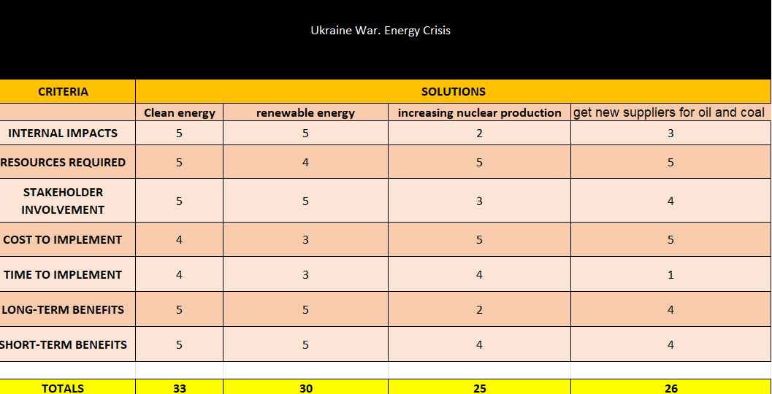

7.0 Reference List

- Ambrose, Jillian. “What Caused the UK’s Energy Crisis?” The Guardian, 21 Sept. 2021, www.theguardian.com/business/2021/sep/21/what-caused-the-uks-energy-crisis. [Accessed 18 Oct. 2022]
- Bradshaw, M. (2021). Energy crisis: why the UK will be at the mercy of international gas prices for years to come. [online] The Conversation. Available at: https://theconversation.com/energy-crisis-why-the-uk-will-be-at-the-mercy-of-international-gas-prices-for-years-to-come-186069. [Accessed 14 Oct. 2022].
- Davos 2022: The world's first energy crisis and how to fix it (2022) World Economic Forum. Available at: https://www.weforum.org/agenda/2022/05/first-global-energy-crisis-how-to-fix-davos-2022/ (Accessed: December 5, 2022).
- Islam, F.M.R., Mamun, K.A. and Oo, A.M.T. (2018) Smart Energy Grid Design for island countries challenges and opportunities. Cham: Springer International Publishing.
- Kolios, A. and Read, G. (no date) “A Political, Economic, Social, Technology, Legal and Environmental (PESTLE) Approach for Risk Identification of the Tidal Industry in the United Kingdom,” MPDI. Available at: https://www.mdpi.com/1996-1073/6/10/5023 (Accessed: December 3, 2022).
- Monitoring the energy transition (2019) BMWK- Federal Ministry for Economics Affairs and Climate Action. Available at: https://www.bmwk.de/Redaktion/EN/Artikel/Energy/monitoring-implementation-of-the-energy-reforms.html (Accessed: December 9, 2022).
- Nanji, N. (2022) “Homes face winter power cuts in worst-case scenario, says National Grid,” BBC, 7 October. Available at: https://www.bbc.co.uk/news/business-63155827?at_medium=RSS&at_campaign=KARANGA (Accessed: December 8, 2022).
- Nast, C. (2010). What would happen if: Electricity and gas just stopped? [online] Wired UK. Available at: https://www.wired.co.uk/article/what-would-happen-if-electricity-and-gas-just-stopped. [Accessed 15 Oct. 2022].
- Power failure – legal aspects of the energy crisis (2022) Asserson Law Offices. Available at: https://asserson.co.uk/2022/08/24/power-failure-legal-aspects-of-the-energy-crisis/ (Accessed: December 3, 2022).
- Vowles, N. (2022) Energy Security Strategy Analysis: Huge missed opportunity not to put energy efficiency at heart of strategy, The University of Sussex. Available at: https://www.sussex.ac.uk/broadcast/read/57788 (Accessed: December 1, 2022).

