Jake Wears

Database Analysis and Design
Introduction to Web and Database Concepts

Contents
Section 1: Planning 2
Section 2: Database 3
Section 3: User Guide 6

Section 1: Planning

To create a successful database, the designer must plan aspects of it beforehand. The database that is detailed within this document had a Dataflow Diagram and Entity Relationship Diagram, these were done both for reference and to help the designer stay on track. There were many iterations of said diagrams, however both helped detail the needs of Celtic Catering.
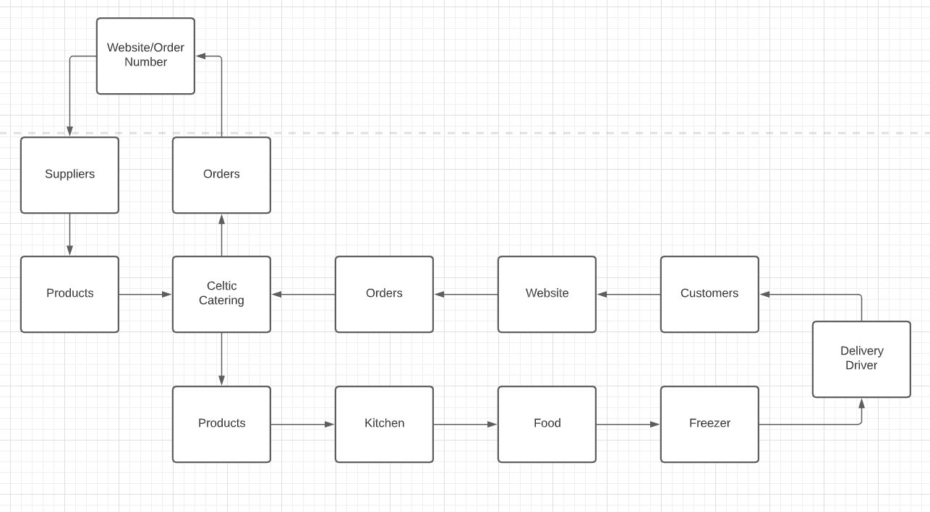
Above is a Dataflow Diagram. The purpose of this is to help visualise where data is going and how it will interact with the real world. As shown, data loops 2 ways, one towards suppliers and the intake side of the business, the other towards customers and the product creation and delivery.
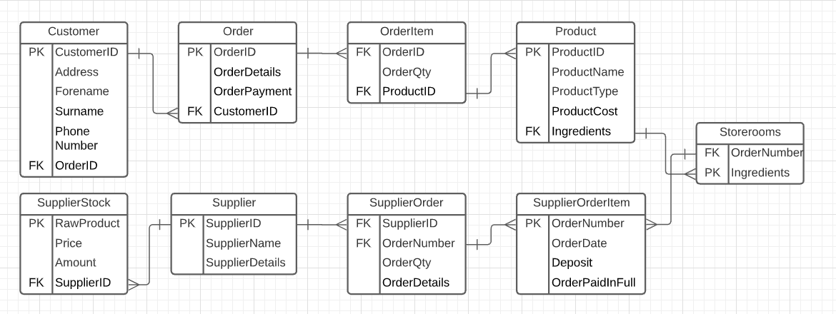
Above is the Entity Relationship Diagram (ERD). This is an easier to understand version of how the database works. Each of these is a table in the database. Data travels to and from these in specific ways. Relationships are how tables connect with each other and share this data back and forth, for instance the Customer to Order Relationship is a one to many, this means that one customer can make many orders. All of these relationships have to be split up into one to many relationships. The next relationship along is order to order item. This measns one order can have many order items.

Section 2: Database

Planning should be done for every database, however if the final database is not a functional product, it is time spent poorly. The database created for Celtic Catering is a versatile piece of software that is capable of catering to all the company’s needs. The final database was created using Microsoft Access
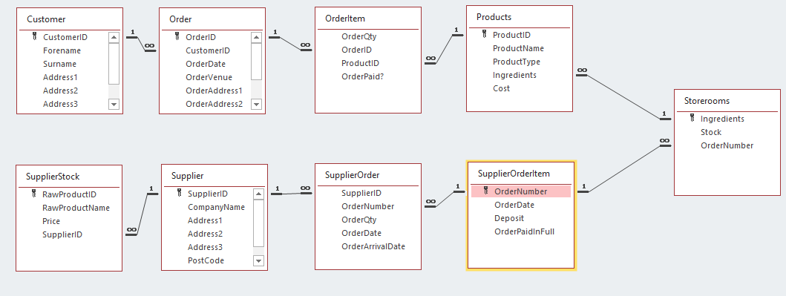
This is the relationship page of the database. It details how all the data and tables are linked up. As shown, all tables are connected through a one to many relationship, as should be. On this image, keys can be seen within some of the tables. These are Primary keys. Within access they help to link data up between tables. Primary keys can be found through a tool called the lookup wizard and the data attached to those keys can be brought into other tables. This helps link the tables up and can be used to provide an easier method to keep data clear and accurate across the entire database. Within this database, Primary Keys were primarily used with AutoNumber’s to count ID’s such as Customer ID’s and Order ID’s.
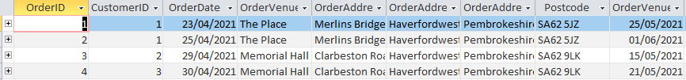
Above is a snippet of the Order Table. This table tracks the details of all the events that Celtic Catering have taken orders for. This includes the location, data, order id and customer id. This table helps the user to collate information for when products need to be created, when they need to be delivered and to where. The majority of tables have forms created for them, so that one set of data can be viewed at once, new data can be added easily and old data can be erased without worry of deleting multiple datasets.

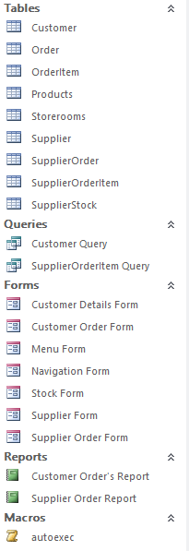
This is a screenshot of all the tables, queries, forms, reports and macros that are within the database. While the navigation page exists to take users to all of the forms they need to access, if wished, users could see the tables and queries and print off reports if they are necessary.
Queries are similar to tables but are not quite the same, they are created after all of the tables have been created. They can be used to pull data from multiple tables together to help create easier to understand and helpful forms. The ones in this database have been created to create an ordering form for both the customers and the suppliers, these help keep track of the incoming and outgoing expenditures. With further tinkering, a system could be devised to include the stock levels there too, so that Celtic Catering knows which raw ingredients need to be bought and which ingredients they have a surplus of.

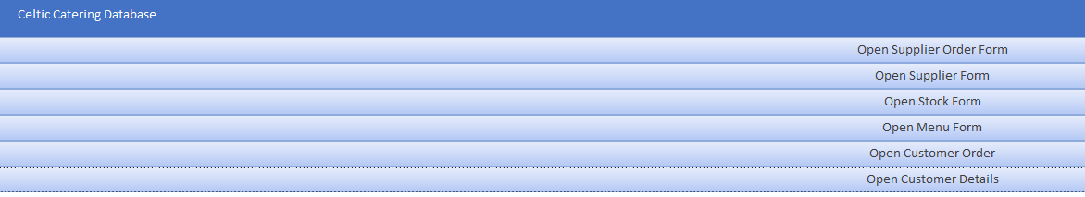
This is a snip of the databases navigation page. This page automatically opens up upon the database being opened. This allows the users to quickly navigate to the dataset they need to find. As all of the database is stored locally, this system is very fast.

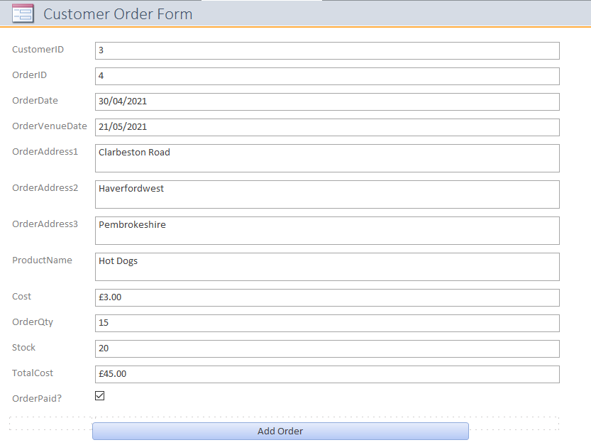
This is the Customer Order Form. It allows the user to see all the details to each order placed by a customer, what products are required, how much it costs them and if they have paid.
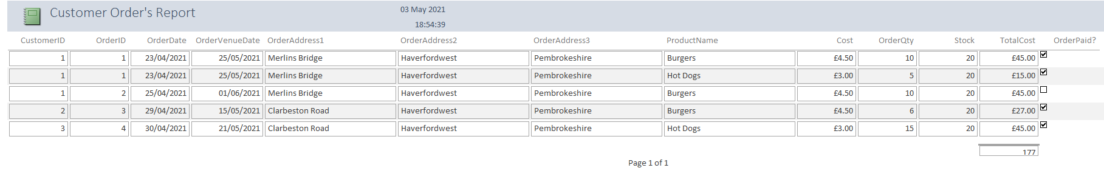
This is a picture of the Customer Order Report, it shows all the data from the Customer Order Form in one place. this includes all the orders. This allows users to see projected income, if customers have paid, what they have ordered in one place, it can also be printed off if required.
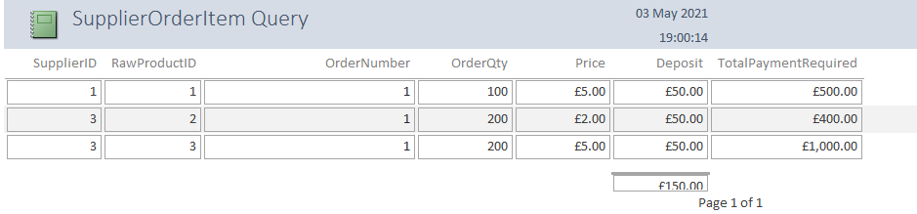
This is the Supplier Order Item Report. It shows all orders made by Celtic Catering, how much each order costs, from which supplier and adds up all the deposits. Reports also can show the data and time which can be helpful to show when screencaps were taken.

Section 3: User Guide

Upon Opening the database, the user will be greeted by the Navigation Form. This is a simple form that is used to move around the form.
It is simple but serves the purpose of navigating. It opens using the autoexec macro that is within the database. This means that it is the first thing that will show up when the database opens, from there, 6 options show up for navigation. Any one of these options will take the user to a form. These forms will include different sets of data.
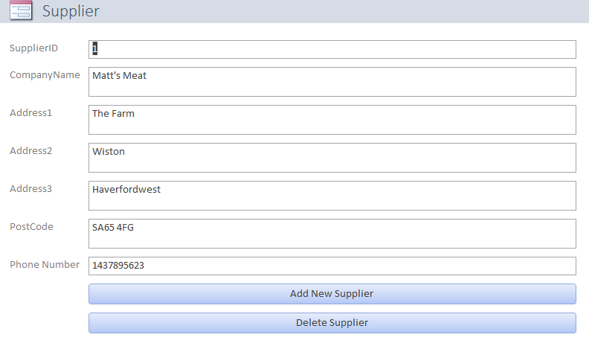
This is one of the forms within the database. This one specifically shows the location of suppliers and their contact details. It allows users to add and delete suppliers when necessary. This can be done simply by clicking on the buttons and data being entered manually.


As shown earlier this is all of the tables, queries, forms and reports. This is an alternative way of navigating if required. This should only be required if all of the data is required in one spot, or if extra categories of data are required. This could be done by adding data to the tables and queries. Specifically, this is done by clicking on the design view button. After this, the user would be able to add the data in a new column below the rest of the data. They would have to pick the correct class of data, such as number, text, or if it is in another table already, lookup wizard. If any data is added or changed, the software will automatically ask the user to save, at which point the software will save any additional data that has been added, be that an extra customer, menu item or order. Likewise it will ask to save if a piece of data has been deleted.
If a physical copy of the data is required for whatever reason, a simple Ctrl + P will bring up the printer and the printer can be selected. Then the document will print to the designated printer.
The Reports cannot be altered while they are selected. To alter them, the data needs to be added or removed. This will then show through the report.

