v


PROJECT MANAGEMENT

BA (Hons) Leadership and Management

Student Name: Janice P. Garcia
Student Number:2334590
Module Name: Project Management (LCLM5003) London
Lecturer Name: Dr. Xavier Matieni
Session: October 2025 Term

Table of Contents

- Poster
- Reflection
- Introduction
- Project description
- Scope
- Work breakdown structure
- Quad Chart
- Gantt Chart
- Stakeholders’ Involvement,
- Allocation of resources,
- Risk Analysis
- Conclusion
- References

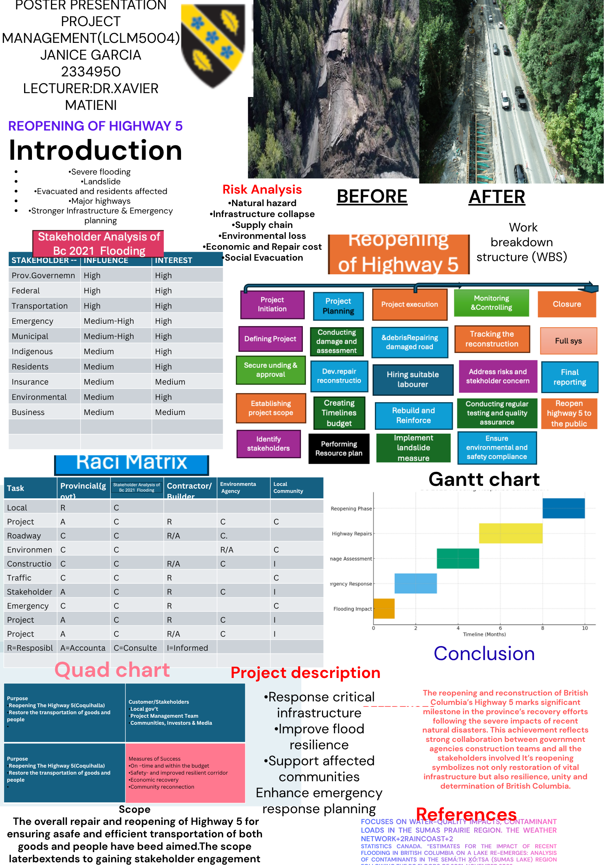

Reflection.
The reopening of Highway 5 following the 2022 flood event was a complex and demanding infrastructure recovery project that involved coordinated efforts across multiple stakeholders, including engineers, government agencies, construction teams, and local communities. Using Gibbs Reflective Cycle (1988) and Kolb’s Learning Theory (1984), these two theories help me understand and evaluates my learning from the process and how it contributed to my personal and professional development. (PMI,2021)
Feelings,
During my Poster Presentation in class, I initially worked on my project which is my Poster about the 2022 Reopening of The Highway 5, in Canva which was new to me. I have this feeling and a question to myself? Can I do it? But I managed. Just like the scale of the task and the responsibility involved in the reopening of Highway 5. As operations progresses and teams collaborated effectively, I gained confidence and felt motivated by the shared commitment to the reopening of the highways safely and quickly. I also learned using those new frameworks that were new to me like using Quad Chart, Raci Matrix, Gantt Chart, and the risk analysis. I have sent three emails to the teacher to give his feedback about my poster, and he help me about it. At the start, I felt nervous and anxious about speaking in front of others but also motivated to delivered it and contributed my ideas ‘My presentation went well overall, especially my visuals and clear explanations, but I struggled with time management and ended up rushing with the conclusion. On reflection I realized that my lack of rehearsal and unclear role divisions contributed to the rushed ending. My anxiety also played a role. I stuttered during my poster presentation but managed to answer the question and answer as I spoke faster than planned. From this, I learned the importance of structured preparation and the need to balance my confidence in front of others, In the future project I will suggest to myself to be more in practice sessions, assigned myself with a clear voice and volunteer as a timekeeper to ensure smoother delivery as plan. Despite my initial nerves, I managed to speak clearly and get my point across, I should have an eye contact and examples, kept the audience interested, the visual slides will be kept clear and very engaging to help the audience follow along. In my mind starting today I will do my very best in despite of my lack of confidence. My two initial improvement strategies for future engagement.

Evaluation:
A positive aspect was the strong leadership and collaborative teamwork which enabled problem-solving under pressure, however some communication gaps caused brief delays particularly where responsibilities were unclear.
Analysis.
These challenges highlighted the importance of structured communication systems and defined roles in high-risk projects. The project also demonstrated effective crisis management but also revealed weakness in planning and inter-department coordination.
Conclusion
I learned that infrastructure recovery requires both technical expertise and emotional resilience. Consistent communication and flexibility were essential in achieving project goals. In conclusion, reflecting on the poster presentation has highlighted both strengths and areas for improvement in my academic communication skills.
Action Plan,
In future projects, I will prioritise communication planning, clarity roles early, and promote open feedback channels. I will also seek additional training in risk management and stakeholder communication. Applying Gibbs and Kolb’s Model provided a structured way to reflect on my experience. The reopening of the Highway 5 enhanced my professional awareness and the value of organization, leadership and resilience in project management. In addition to my future presentation, I will use a clearer layout with concise headings, bullet points and relevant visuals such as charts or diagrams. I will ensure consistent font sizes and colour contrast to improve readability

Introduction
The reopening of Highway 5, also known as Coquihalla Highway, marked a significant milestone in British Columbia’s recovery efforts following Highway 5 (Coquihalla Highway) is a vital transportation artery in Canada, linking Metro Vancouver to the Interior of British Columbia. It plays a crucial role in facilitating freight movement, stimulating economic growth, supporting tourism, and enabling emergency response services. The absence of this key corridor can lead to significant logistical challenges for communities and industries.
In November 2021, the province faced unprecedented weather events due to an atmospheric river, resulting in record-breaking rainfall. This flooding severely damaged significant portions of infrastructure across various highways, including Highway 1, Highway 3, Highway 7, and Highway 5. The consequences of this weather phenomenon marked the most severe natural disaster in British Columbia’s transportation history. (BC Gov News, 2022)
This report provides an overview of the disaster response and recovery efforts for Highway 5, with a particular emphasis on the reopening strategy implemented in 2022. It examines government leadership, engineering solutions, stakeholder engagement, and the lessons learned that can enhance future infrastructure resilience. (B.C Highway Flood Recovery Projects) The highway, which connects Hope and Merrit, was closed due to extensive damage caused by the floods, including seven collapsed or washed-out bridges and over 20 damaged sites along 130 kilometres. (Government of BC,2023)
Project Description
In the BC flooding 2022, the project involves rebuilding and upgrading Highway 5, a critical transportation route in BC, which was severely damaged by the 2021 flooding. The project will include the construction of new bridges, repair of damaged road sections, and implementation of climate-resilient design features. (Kerzner,2022)
Scope
The November 2021 atmospheric river caused catastrophic damage to Highway 5 (the Coquihalla) between Hope and Merritt, resulting in the closure of one of British Columbia’s most critical transportation corridors. Flooding and washouts damaged more than 20 sites along a 130-km stretch, including seven bridges where spans collapsed or were severely compromised. Additional impacts included over 1.5 km of highway washouts, multiple undermined bridge abutments, eight culvert failures, and 24 debris-slide sites.(Lock,2020)
The BC Ministry of Transportation and Infrastructure launched an emergency recovery program, mobilizing contractors to stabilize slopes, rebuild washed-out sections, and install temporary structures. Thanks to accelerated construction and 24/7 work, Highway 5 reopened to commercial traffic only in December 2021—just one month after the disaster. Permanent reconstruction continued over the following years, with all bridges and highway sections fully restored by 2024.
The reopening was essential for restoring national supply chains, reconnecting communities, and supporting BC’s economic recovery. The project has since been recognized as one of the largest and fastest infrastructure reinstatement efforts in Canadian history, incorporating climate-resilient design to withstand future extreme weather events. The scope of this project will rebuild and upgrade Highway 5 to improve its resilience to future climate-related events, construct new bridges and repair damaged road sections, implement climate-resilient design features, such as deep pile footings and large rock protection and Improve drainage channels and culverts to reduce flood risk. (Government of British Columbia – Highway 5 Flood Recovery Overview 2022)
Work Breakdown Structure (WBS)
The project to reopen Highway 5 in BC after the 2022 flooding disaster was divided into several major phases to ensure safe, efficient, and timely restoration of traffic flow. The first phase involved Project initiation and damage assessment. This included setting up an emergency response team, inspecting the damaged areas, identifying safety hazards, and evaluating the extent of destruction to bridges, roads, and drainage systems. Engineers and survey teams conducted field investigations to determine which sections of the highway were unsafe for travel During this stage, stakeholders were identified, project objectives were defined, and an initial recovery timeline was developed. The second phase focused on planning and design. Engineering teams prepared detailed repair strategies, including geotechnical assessments, structural redesign, and hydrology studies to reduce the risk of future flood damage. Temporary traffic management plans were developed to manage limited vehicle access. Environmental assessments were carried out to minimise ecological impact, and procurement plans were prepared to ensure that materials, equipment, and skilled labour were available. Budgets and schedules were also finalised during this phase. (BC Gov News ,2024)
The third phase consisted of emergency site stabilisation and debris removal. This involved clearing landslides, washed-out roads, and debris from the highway corridor. Temporary emergency roads and bridges were built to allow work crews and essential vehicles to access isolated areas. River channels were reinforced where erosion threatened the roadway, slopes were stabilised, and temporary drainage systems were installed to control further water damage.
The fourth phase was dedicated to permanent reconstruction and repairs. Damaged bridges were rebuilt, roadbeds were re-formed, and new drainage systems were installed. Pavement resurfacing was carried out to restore driving surfaces. Additional protective infrastructure such as retaining walls, culverts, and rockfall barriers was constructed to improve resilience against future flooding and landslides.
The final phase was reopening and project closure. This included final inspections, controlled reopening of traffic lanes, and monitoring traffic conditions. Documentation was completed, financial accounts were finalised, and responsibility for the highway was transferred back to operations and maintenance teams. A project review was conducted to capture lessons learned for future disaster recovery efforts.(BC News,2023)

Quad Chart
Quad Chart: Reopening of Highway 5, British Columbia (2021 Flooding)
Problem / Situation  Severe flooding in 2020 damaged Highway 5 in British Columbia, disrupting transport, trade, and daily commuting. | Objectives  - Restore safe road access  - Reduce economic disruption  - Improve resilience against future floods
Actions Taken  - Emergency assessments  - Road reconstruction  - Drainage improvements  - Slope stabilization | Results / Outcomes  - Highway reopened  - Improved safety  - Restored connectivity  - Better flood resistance

Gantt Chart
A Gantt chart was used to plan and control the reopening project of Highway 5 in British Columbia following the 2020 flooding by visually scheduling activities over time. The chart divided the project into key phases: damage assessment, planning and design, resource mobilisation, reconstruction, inspection, and reopening. Each phase was allocated a defined timeframe to ensure logical progression and effective coordination of tasks. (Merrow, E.W., 2021) Industrial megaprojects:
Stakeholder Involvement and Resource Allocation
The reopening of Highway 5 following the 2020 flooding in British Columbia required effective coordination among multiple stakeholders to ensure public safety and minimise economic disruption. Primary stakeholders included the Ministry of Transportation and Infrastructure, local governments, construction contractors, emergency services, environmental agencies, and affected communities. Their involvement was crucial for decision-making, compliance with regulations, and addressing local concerns.
Stakeholder engagement activities included regular coordination meetings, public communications, and consultations with environmental bodies to ensure regulatory adherence.
Risk analysis
Highway 5 is a critical transport corridor in British Columbia connecting the Lower Mainland with the Interior and northern regions. Severe flooding and landslides caused by extreme rainfall events resulted in significant infrastructure damage, forcing prolonged closure. The reopening of the highway presented multiple operational, financial, and safety-related risks that required careful management, The key risks identified includes Environmental and Geotechnical Risk, Safety Risks, Schedule Risk (,Financial Risks, Political Risk, The risk Mitigation Measures, (Government of British Columbia, 2022). Reopening Highway 5 involved managing high environmental and operational risks. Through engineering controls, scheduling flexibility, and continuous monitoring, authorities reduced the likelihood and impact of failure. However, long-term climate adaptation remains critical to prevent repeat disruptions.

Conclusion
The reopening of Highway 5, better known as the Coquihalla, represents the restoration of one of British Columbia’s most critical transportation corridors after a series of closures in 2025 caused by wildfires, a sinkhole, and a vehicle fire. This highway is not only a lifeline for communities in the Interior but also a vital artery for freight, tourism, and daily travel between the Lower Mainland and the Okanagan, Kamloops, and beyond. Its reopening is therefore both a practical achievement and a symbolic milestone.
The closures highlighted the vulnerability of infrastructure to natural hazards. In September 2025, the Mine Creek wildfire forced the shutdown of the Coquihalla between Merritt and Hope, cutting off access for thousands of travellers. Just hours after reopening, a semi-truck fire south of Merritt caused another closure, underscoring how quickly unexpected events can disrupt mobility. Earlier in June, a sinkhole discovered 80 kilometres south of Merritt led to overnight closures until emergency crews stabilized the road. Each of these incidents revealed the fragility of even the most heavily engineered highways when confronted with environmental stressors and accidents.
The reopening demonstrates the effectiveness of coordinated emergency response. Fire crews, contractors, and the BC Ministry of Transportation worked tirelessly to extinguish blazes, repair damaged sections, and ensure the safety of motorists. Drive provided real-time updates, helping drivers navigate diversions and plan accordingly. This collaboration minimized the duration of closures and restored confidence in the province’s ability to manage crises.
Economically, the reopening alleviates significant pressure. The Coquihalla is the busiest mountain highway in British Columbia, carrying thousands of vehicles daily, including freight trucks that supply goods across the province. Its closure disrupted supply chains, delayed deliveries, and created congestion on alternate routes such as Highway 1 and Highway 3. By reopening, the province restored efficiency to the movement of goods and people, supporting businesses and communities that rely on dependable transport links. Socially, the reopening reconnects communities. Residents of Merritt, Kamloops, and the Okanagan depend on the Coquihalla for access to the Lower Mainland, whether for work, healthcare, or family connections. Tourists also rely on it to reach destinations in the Interior, meaning its reopening supports not only local life but also the broader provincial economy.
Symbolically, the reopening reflects resilience. Despite repeated challenges, the highway was restored quickly, showing the province’s commitment to keeping its infrastructure strong. It also serves as a reminder of the importance of preparedness. Wildfires, sinkholes, and accidents are not anomalies—they are recurring risks in a province shaped by rugged geography and changing climate. The reopening should therefore inspire continued investment in monitoring systems, fire-resistant infrastructure, and proactive maintenance.
In conclusion, the reopening of Highway 5 (Coquihalla) is more than a return to normal traffic flow. It is a reaffirmation of the highway’s role as a lifeline for British Columbia, a demonstration of effective emergency response, and a call to action for greater resilience in the face of natural and human-made hazards. As vehicles once again travel its steep grades and sweeping curves, the lessons of 2025 should not be forgotten. Instead, they should guide future planning, ensuring that the Coquihalla remains safe, reliable, and resilient for generations to come.
---
Sources: Global News, CityNews Vancouver, Drive BC, Yahoo News Canada

References

Freeman, R.E. (2010) Strategic management: A stakeholder approach. Cambridge: Cambridge University Press.
Government of British Columbia (2023) Highway 5 reopening following 2022 flooding. Available at: https://www2.gov.bc.ca (Accessed: date).
Hillson, D. (2017) Practical project risk management. 2nd edn. Vienna: Management Concepts.
Kerzner, H. (2022) Project management: A systems approach to planning, scheduling, and controlling. 13th edn. Hoboken: Wiley.
Lock, D. (2020) Project management. 10th edn. London: Gower.
Meredith, J.R., Shafer, S.M. and Mantel, S.J. (2019) Project management: A strategic managerial approach. 10th edn. Hoboken: Wiley.
PMI (2021) A guide to the project management body of knowledge (PMBOK® Guide). 7th edn. Newtown Square, PA: Project Management Institute.
British Columbia Ministry of Transportation and Infrastructure (2023) ‘Permanent climate-resilient bridges completed on Coquihalla Highway’ News Release, 15 November. Available at: https://news.gov.bc.ca/29869 (Accessed: 30 November 2025).
British Columbia Ministry of Transportation and Infrastructure (2021–2023) Highway 5 – Coquihalla Update: January 2023 Newsletter. Province of British Columbia. Available at: https://www2.gov.bc.ca/assets/gov/transportation-infrastructure-projects/2021-flood-road-recovery-projects/highway-5/highway_5_january2023_newsletter.pdf(Accessed: 30 November 2025).
British Columbia Ministry of Transportation and Infrastructure (2022) ‘Coquihalla to reopen to commercial vehicle traffic’ News Release, 20 December. Available at: https://news.gov.bc.ca/releases/2022TRAN0025-000419 (Accessed: 30 November 2025).
British Columbia Ministry of Transportation and Infrastructure (2022) Highway 5 – Coquihalla Update: December 2022. Province of British Columbia. Available at: https://www2.gov.bc.ca/assets/gov/transportation-infrastructure-projects/2021-flood-road-recovery-projects/highway-5/2022-12-20_highway_5.pdf (Accessed: 30 November 2025).
The Province of British Columbia (2024) ‘B.C. Highway Flood Recovery Projects – Highway 5 – Coquihalla’. gov.bc.ca. Available at: https://www2.gov.bc.ca/gov/content/transportation-projects/bc-highway-flood-recovery/2021-flood-road-recovery-projects-highway-5(Accessed: 30 November 2025).
Cory, C. (2023) ‘Coquihalla Highway reconstruction complete 2 years after devastating floods’,
Available at: https://vancouver.citynews.ca/2023/11/15/coquihalla-highway-flood-repairs-complete/ (Accessed: 30 November 2025).
DCN-JOC News Services (2023) ‘Coquihalla Highway’s climate-resilient bridges complete after 2021 washout’, Journal of Commerce, 16 November. Available at: https://canada.constructconnect.com/joc/news/infrastructure/2023/11/coquihalla-highways-climate-resilient-bridges-complete-after-2021-washout (Accessed: 30 November 2025).
InfoNews (2023) ‘Rebuilt Coquihalla Highway prepared for extreme weather “new normal”: BC transportation minister’, 15 November. Available at: https://infonews.ca/news/2467934/rebuilt-coquihalla-highway-prepared-for-extreme-weather-new-normal-bc-transportation-minister/(Accessed: 30 November 2025).
Global News, CityNews Vancouver, Drive BC, Yahoo News Canada
Government of British Columbia – Highway 5 Flood Recovery Overview
Canadian Consulting Engineering Awards – Highway 5 Reinstatement Program

