

ENTREPRENEURSHIP GROUP ASSIGNMENT

MANDEEP KAUR - 2224381
KOMALPREET KAUR - 2223343
RIYA BHATT – 2223984

Lecturer Name : Gladius Kulothungan



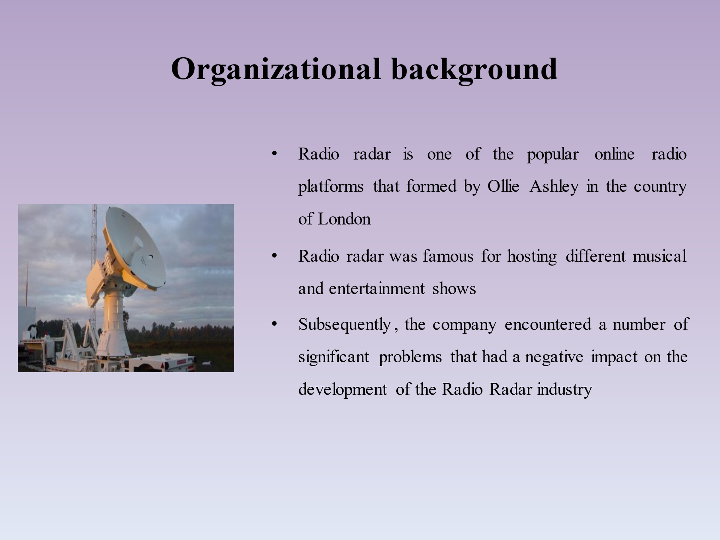
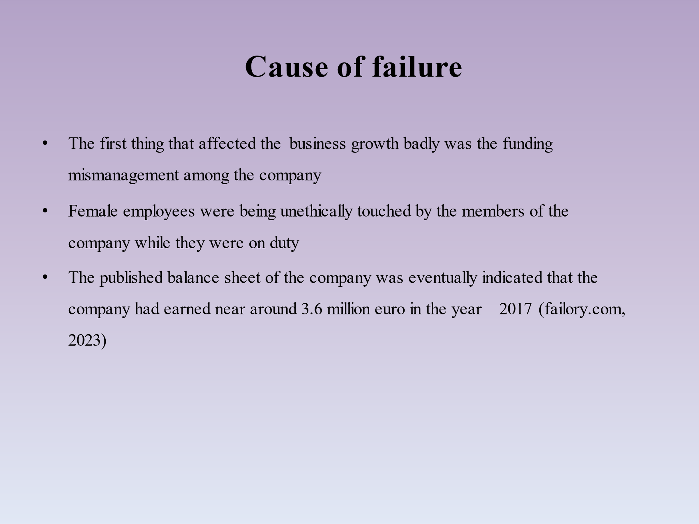
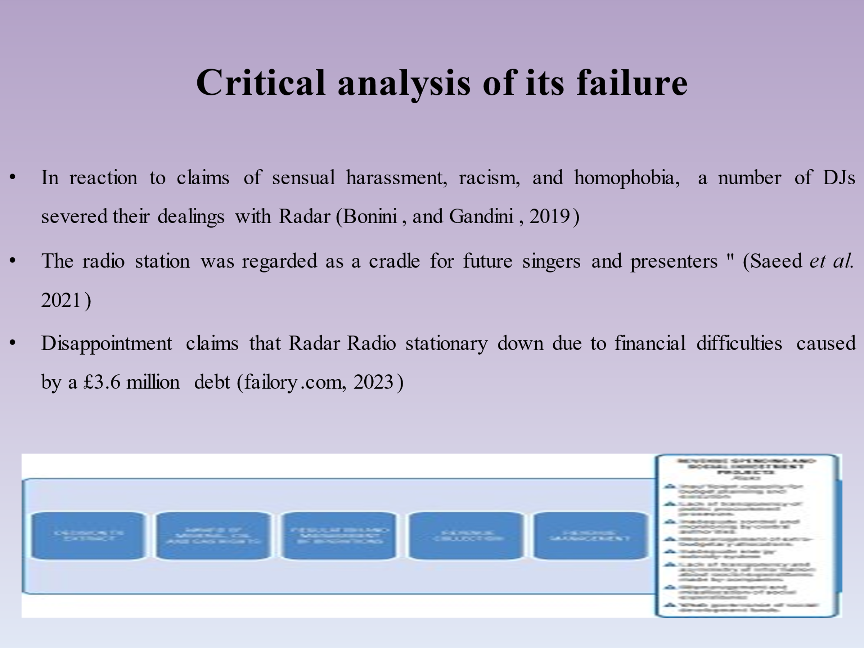
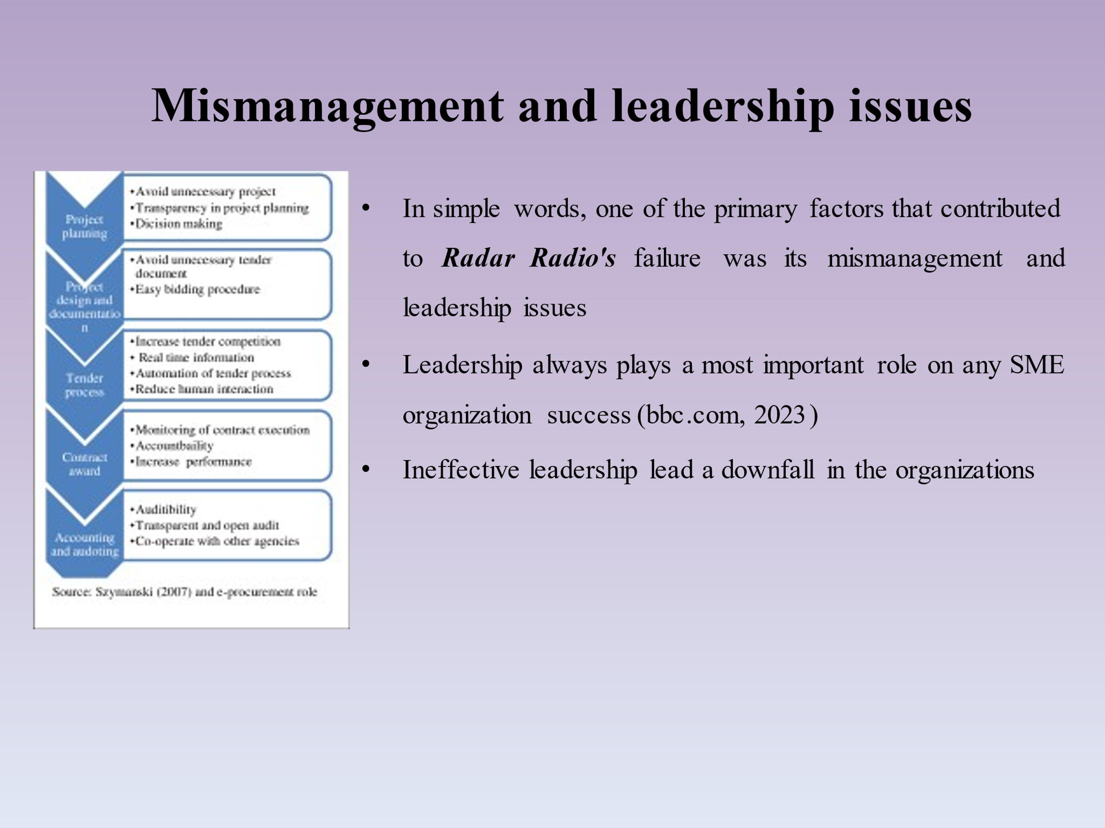

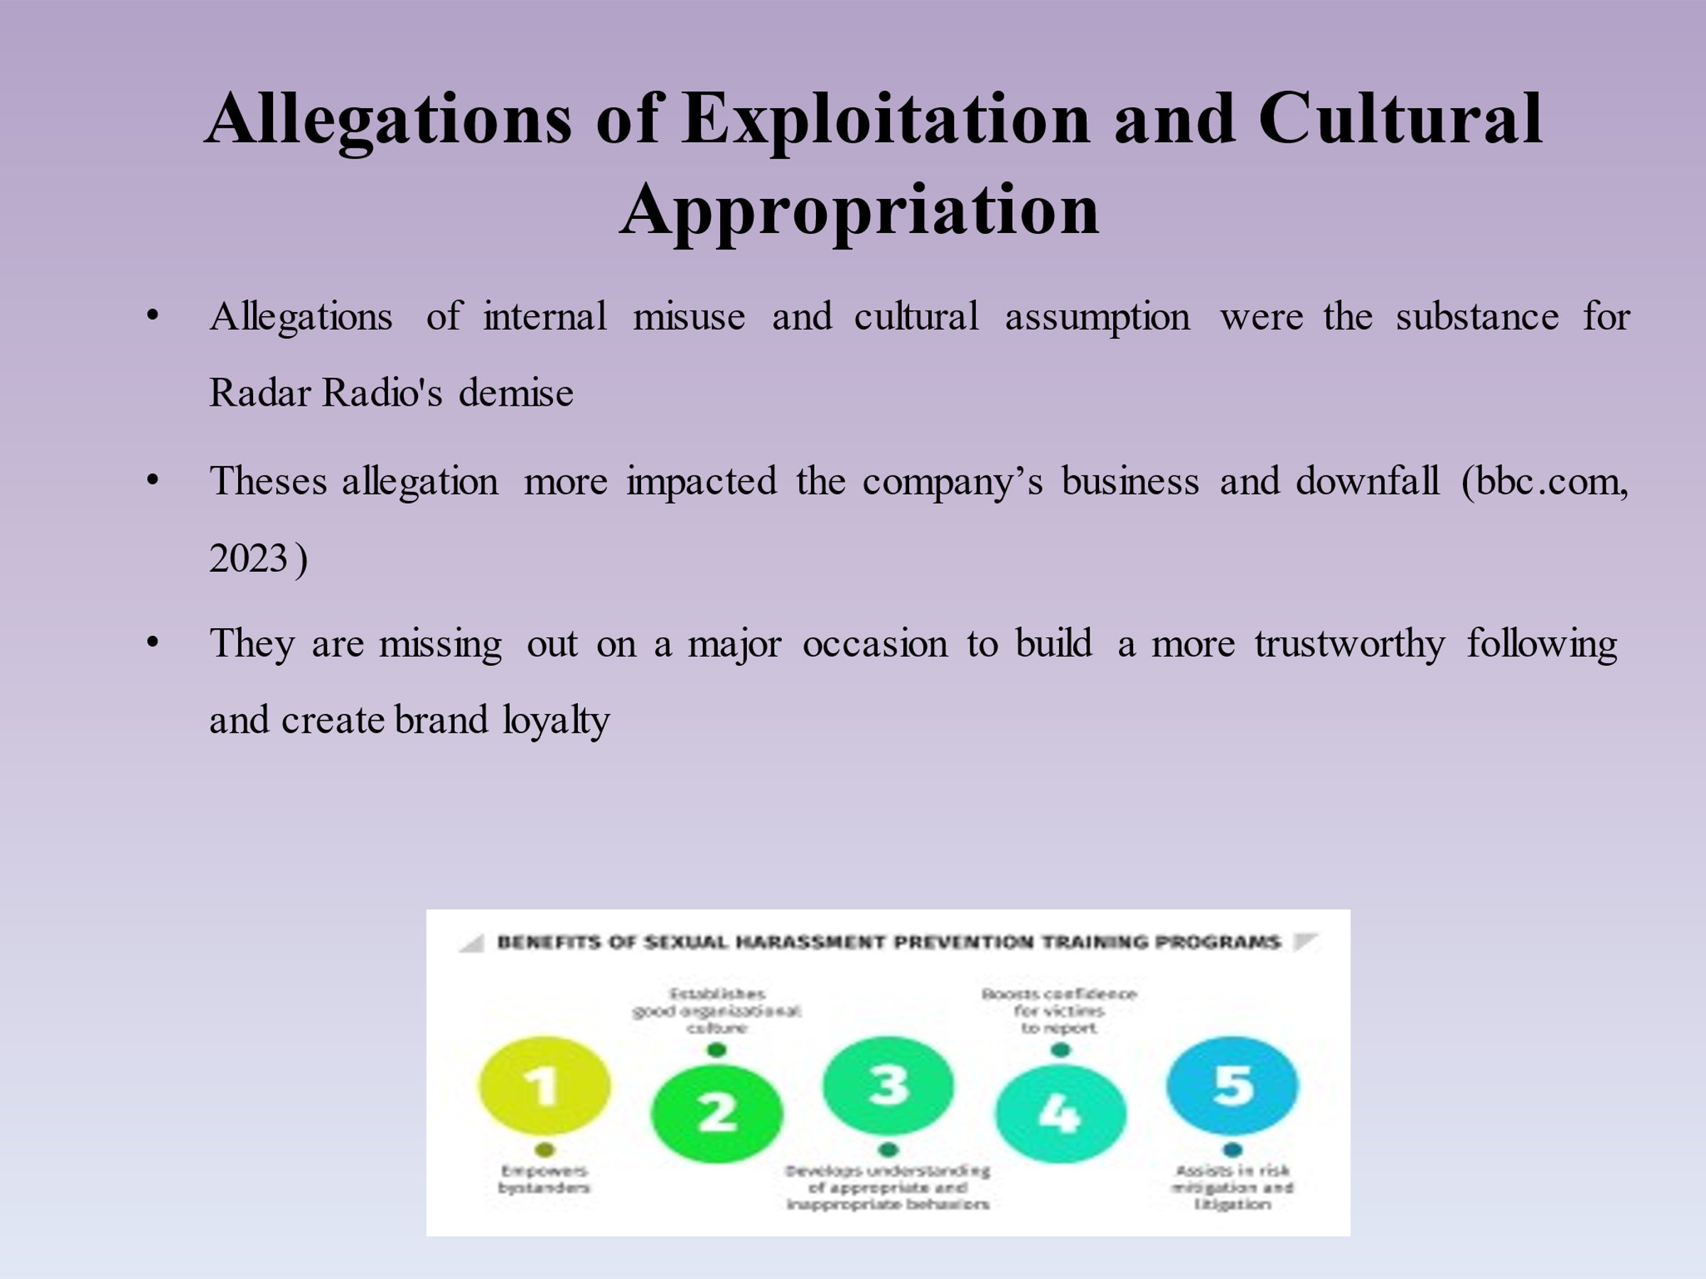
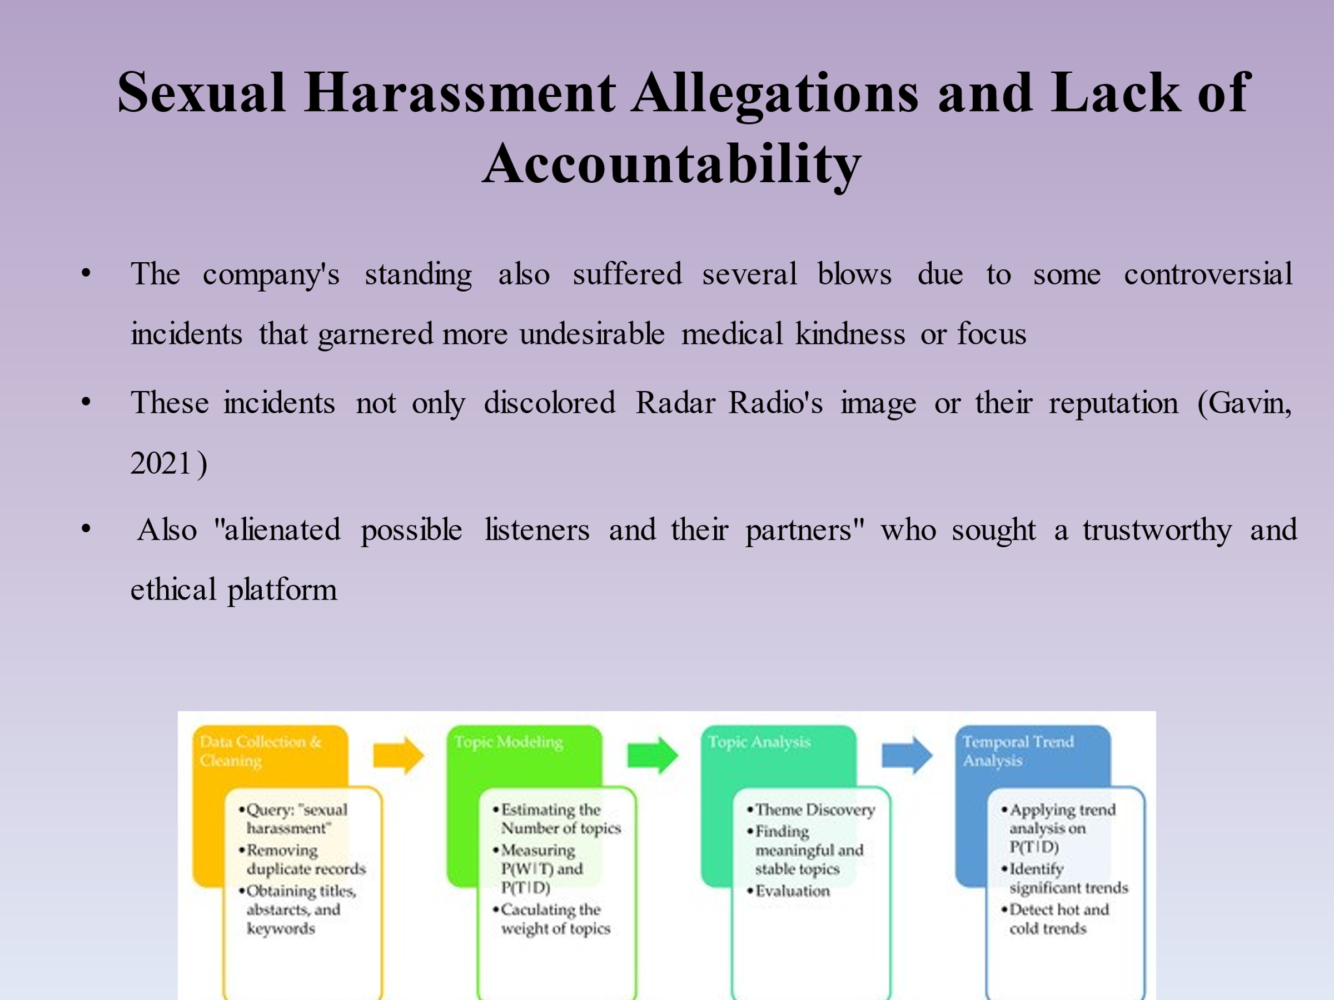
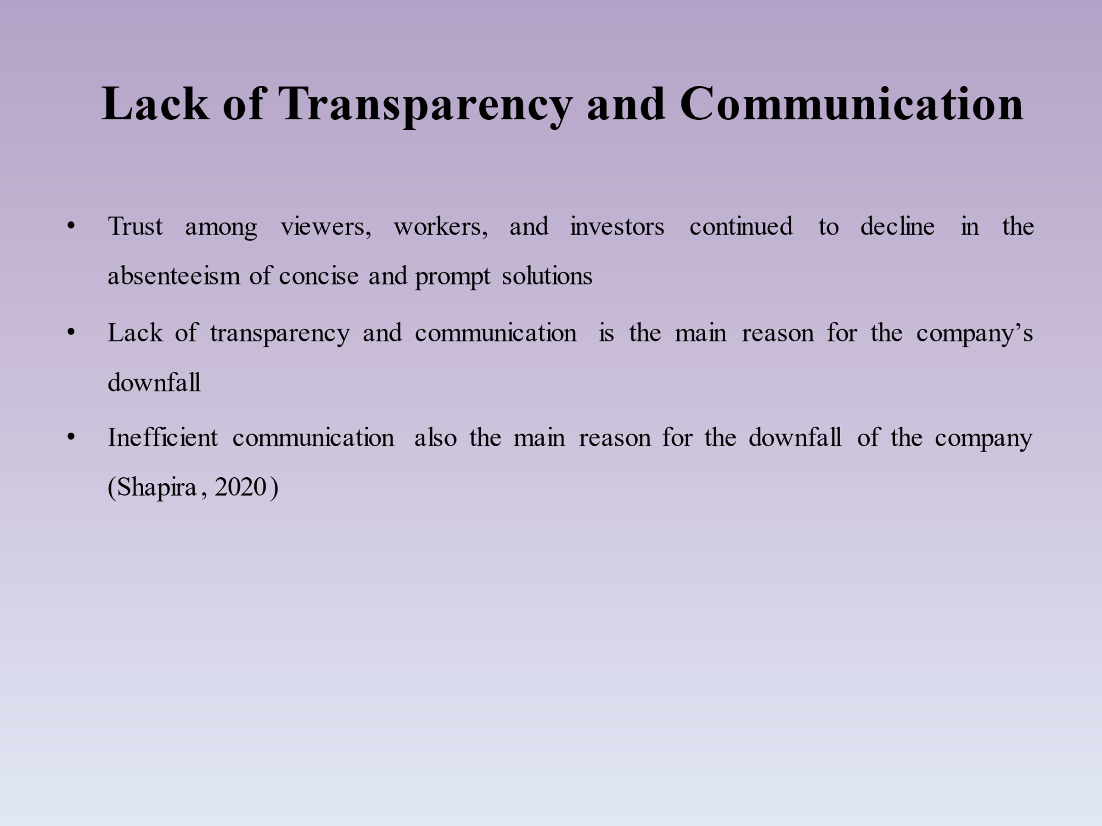
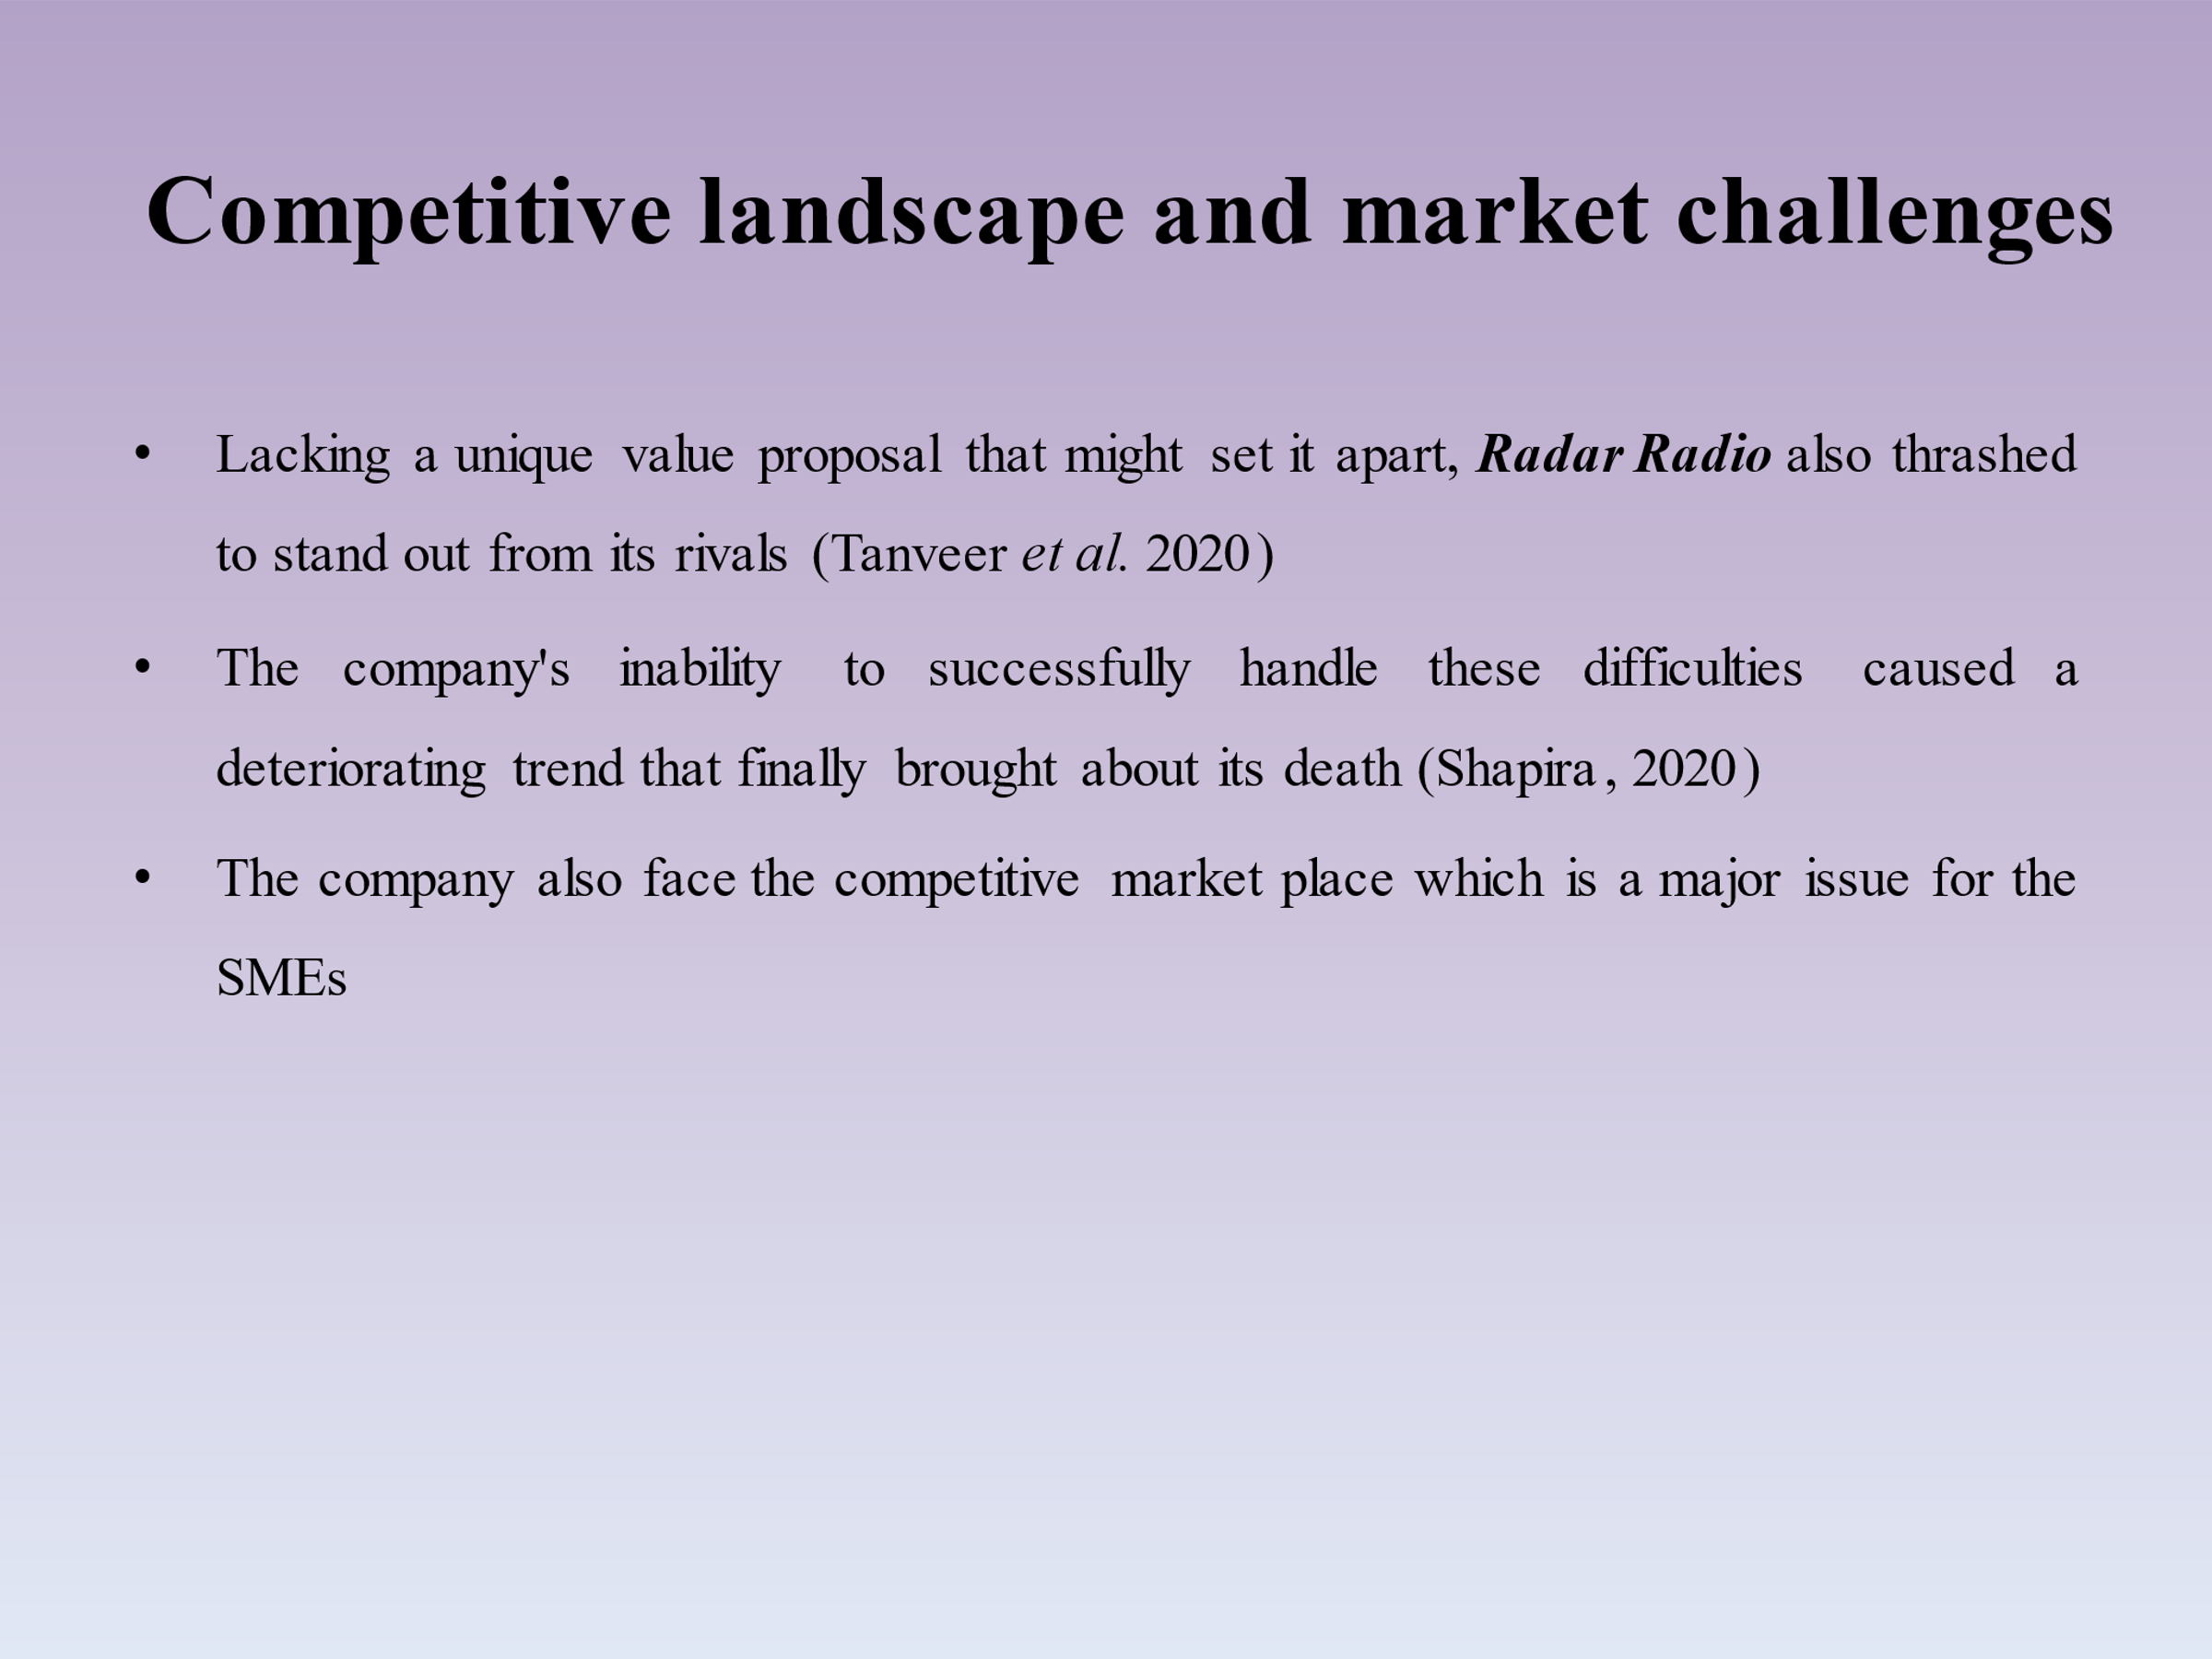

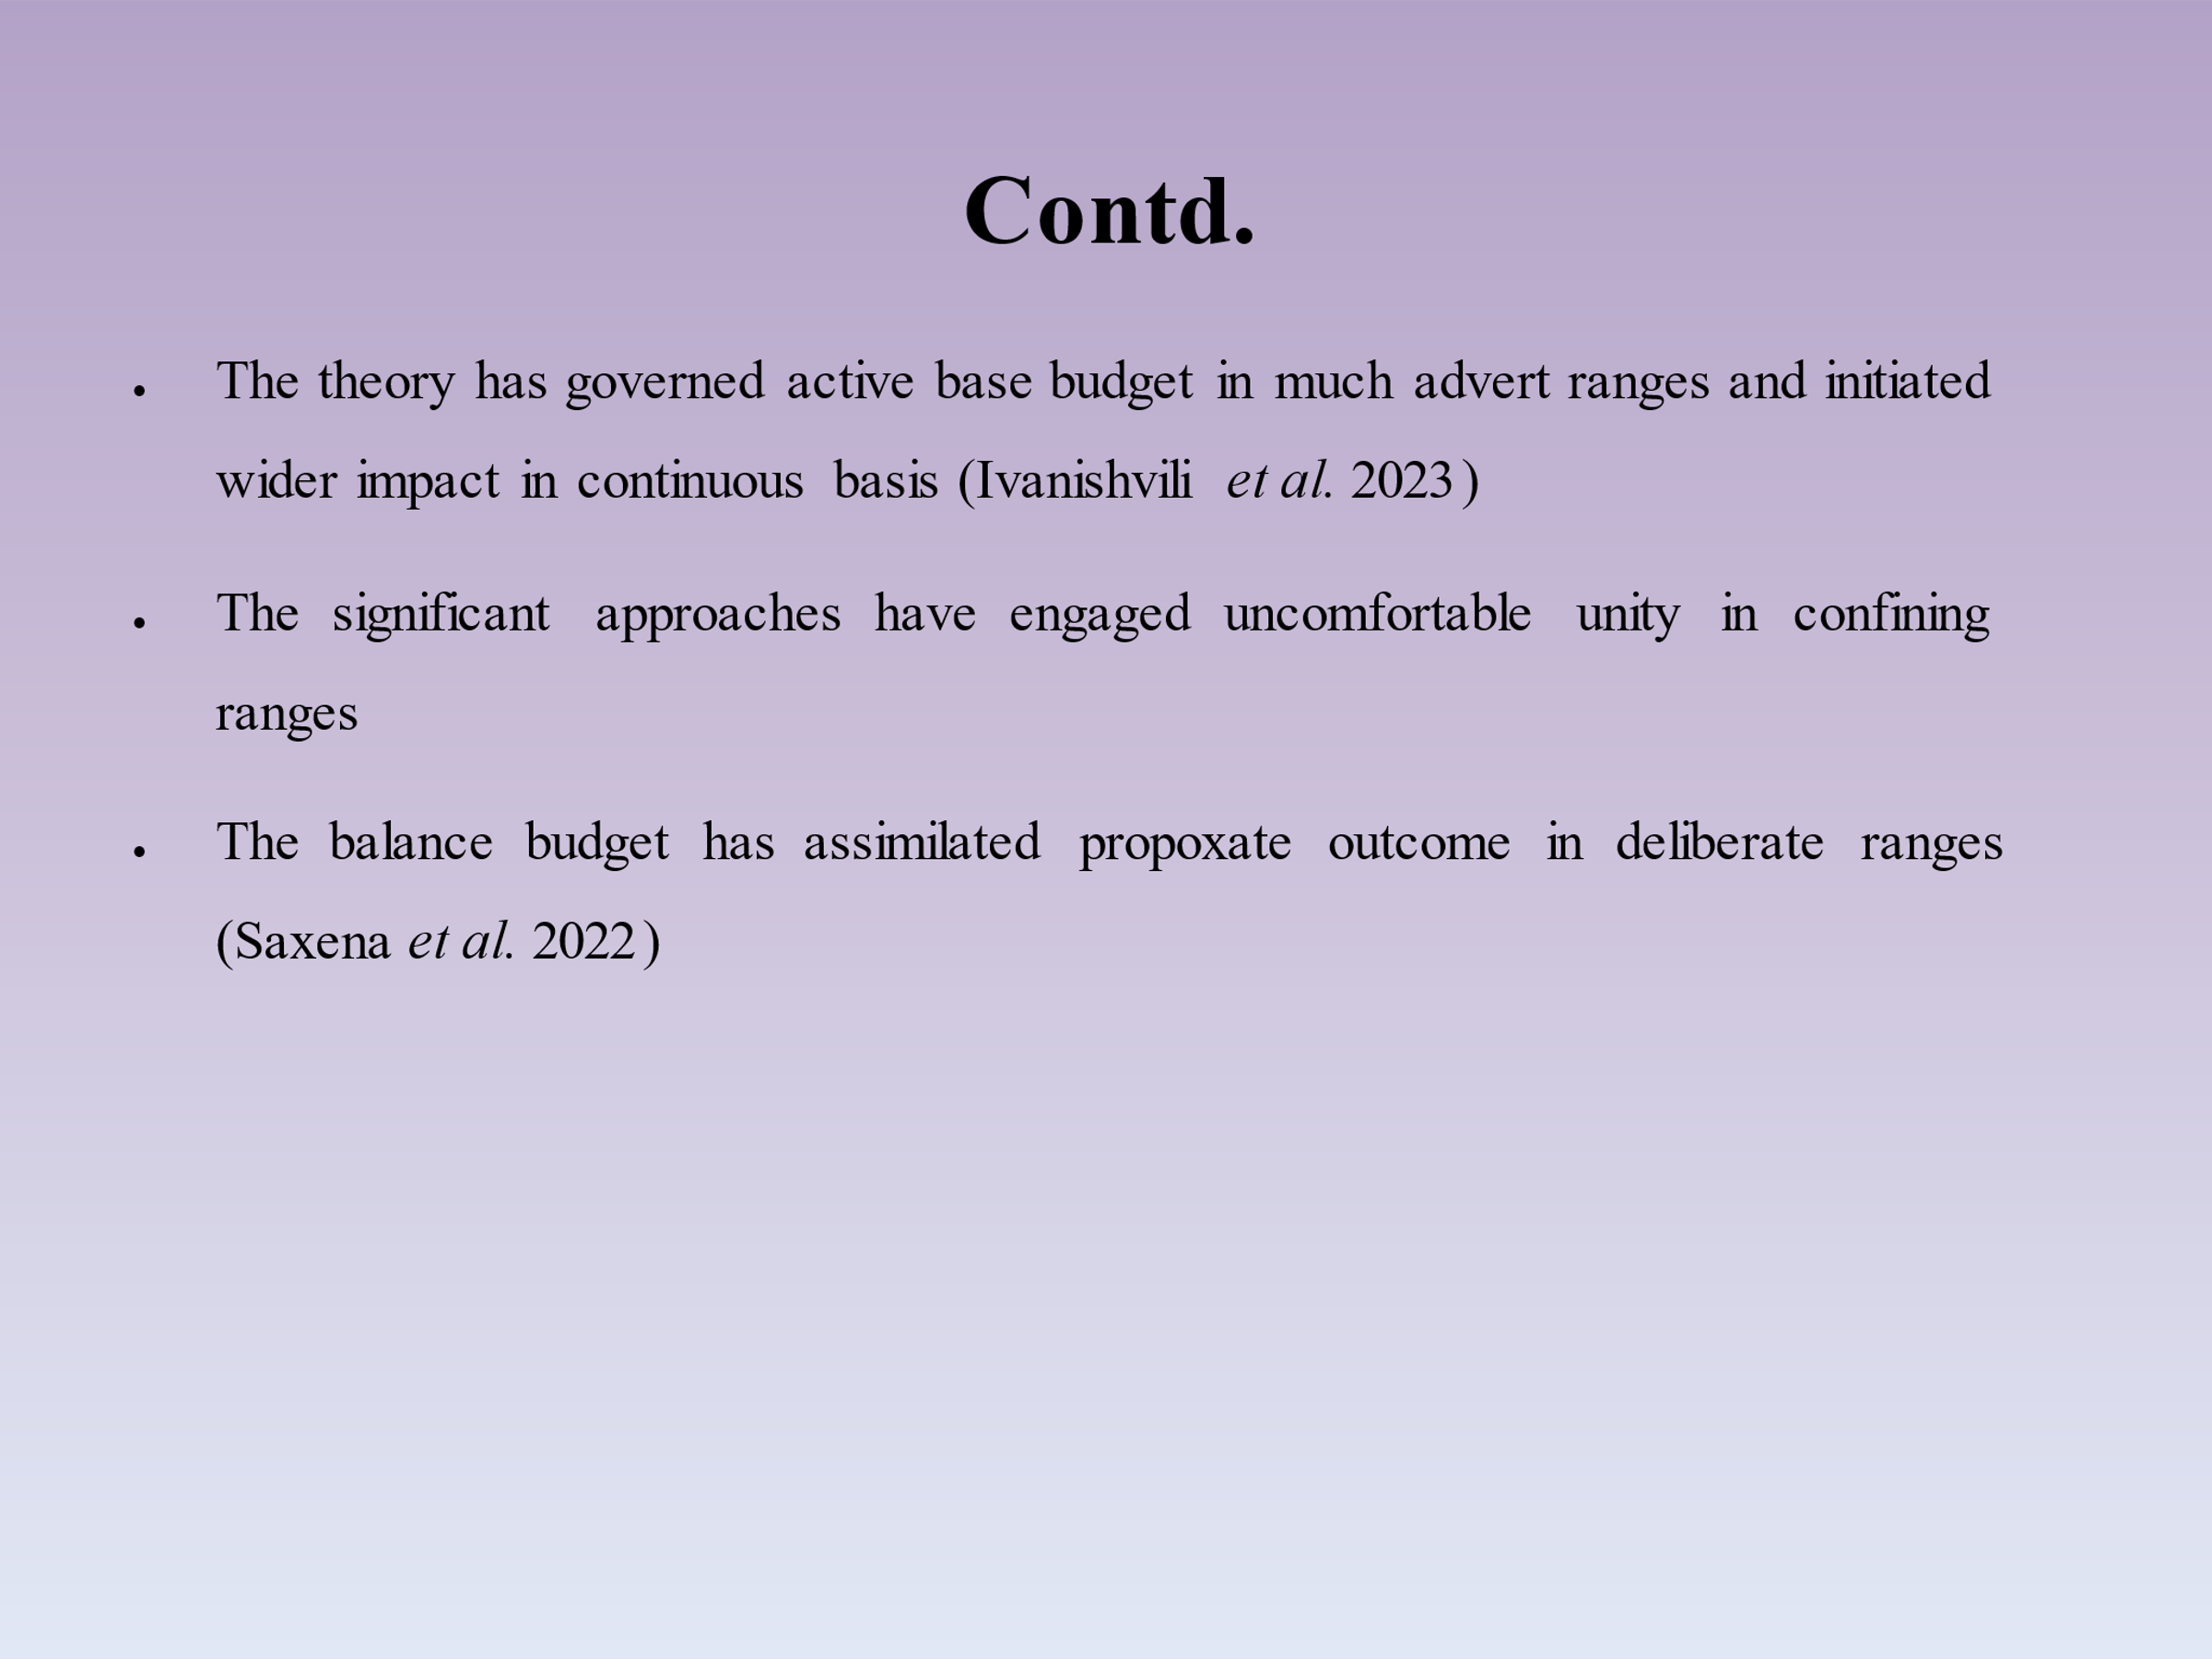
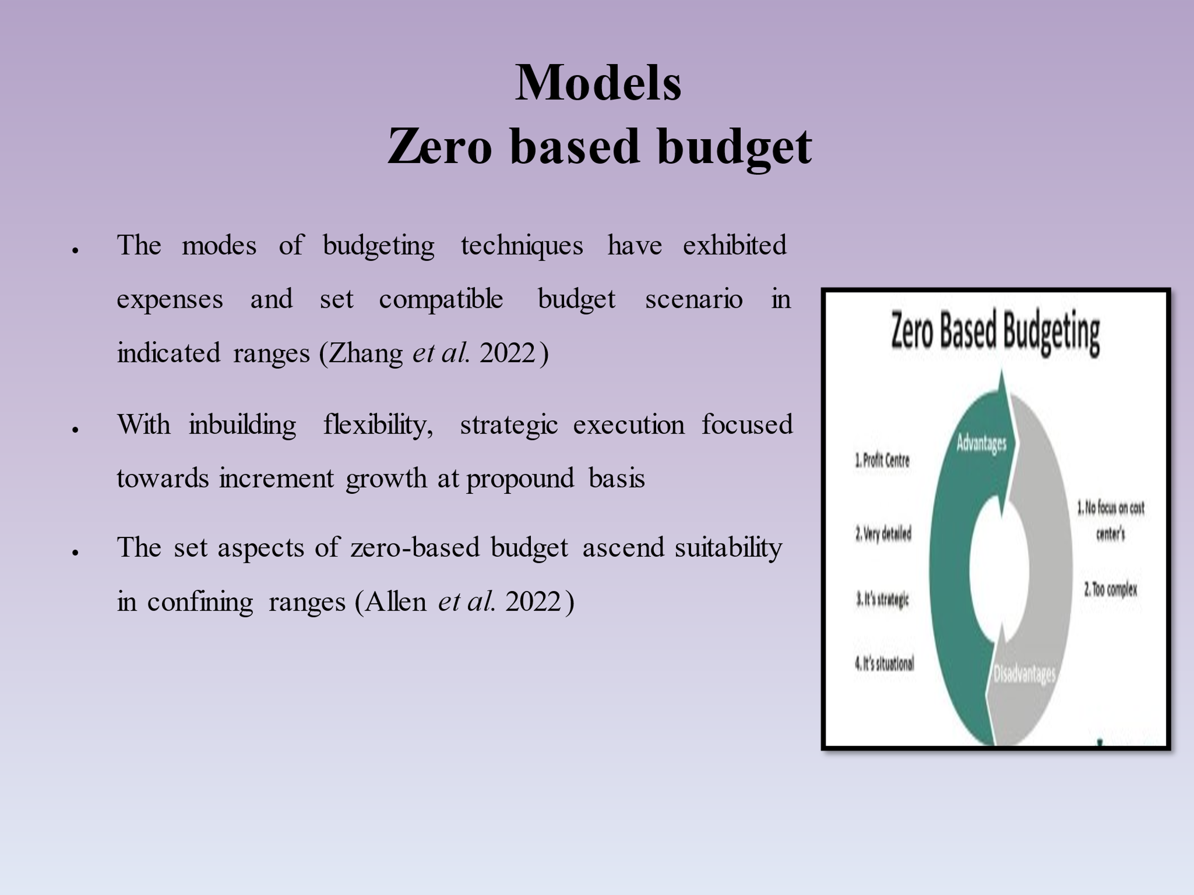
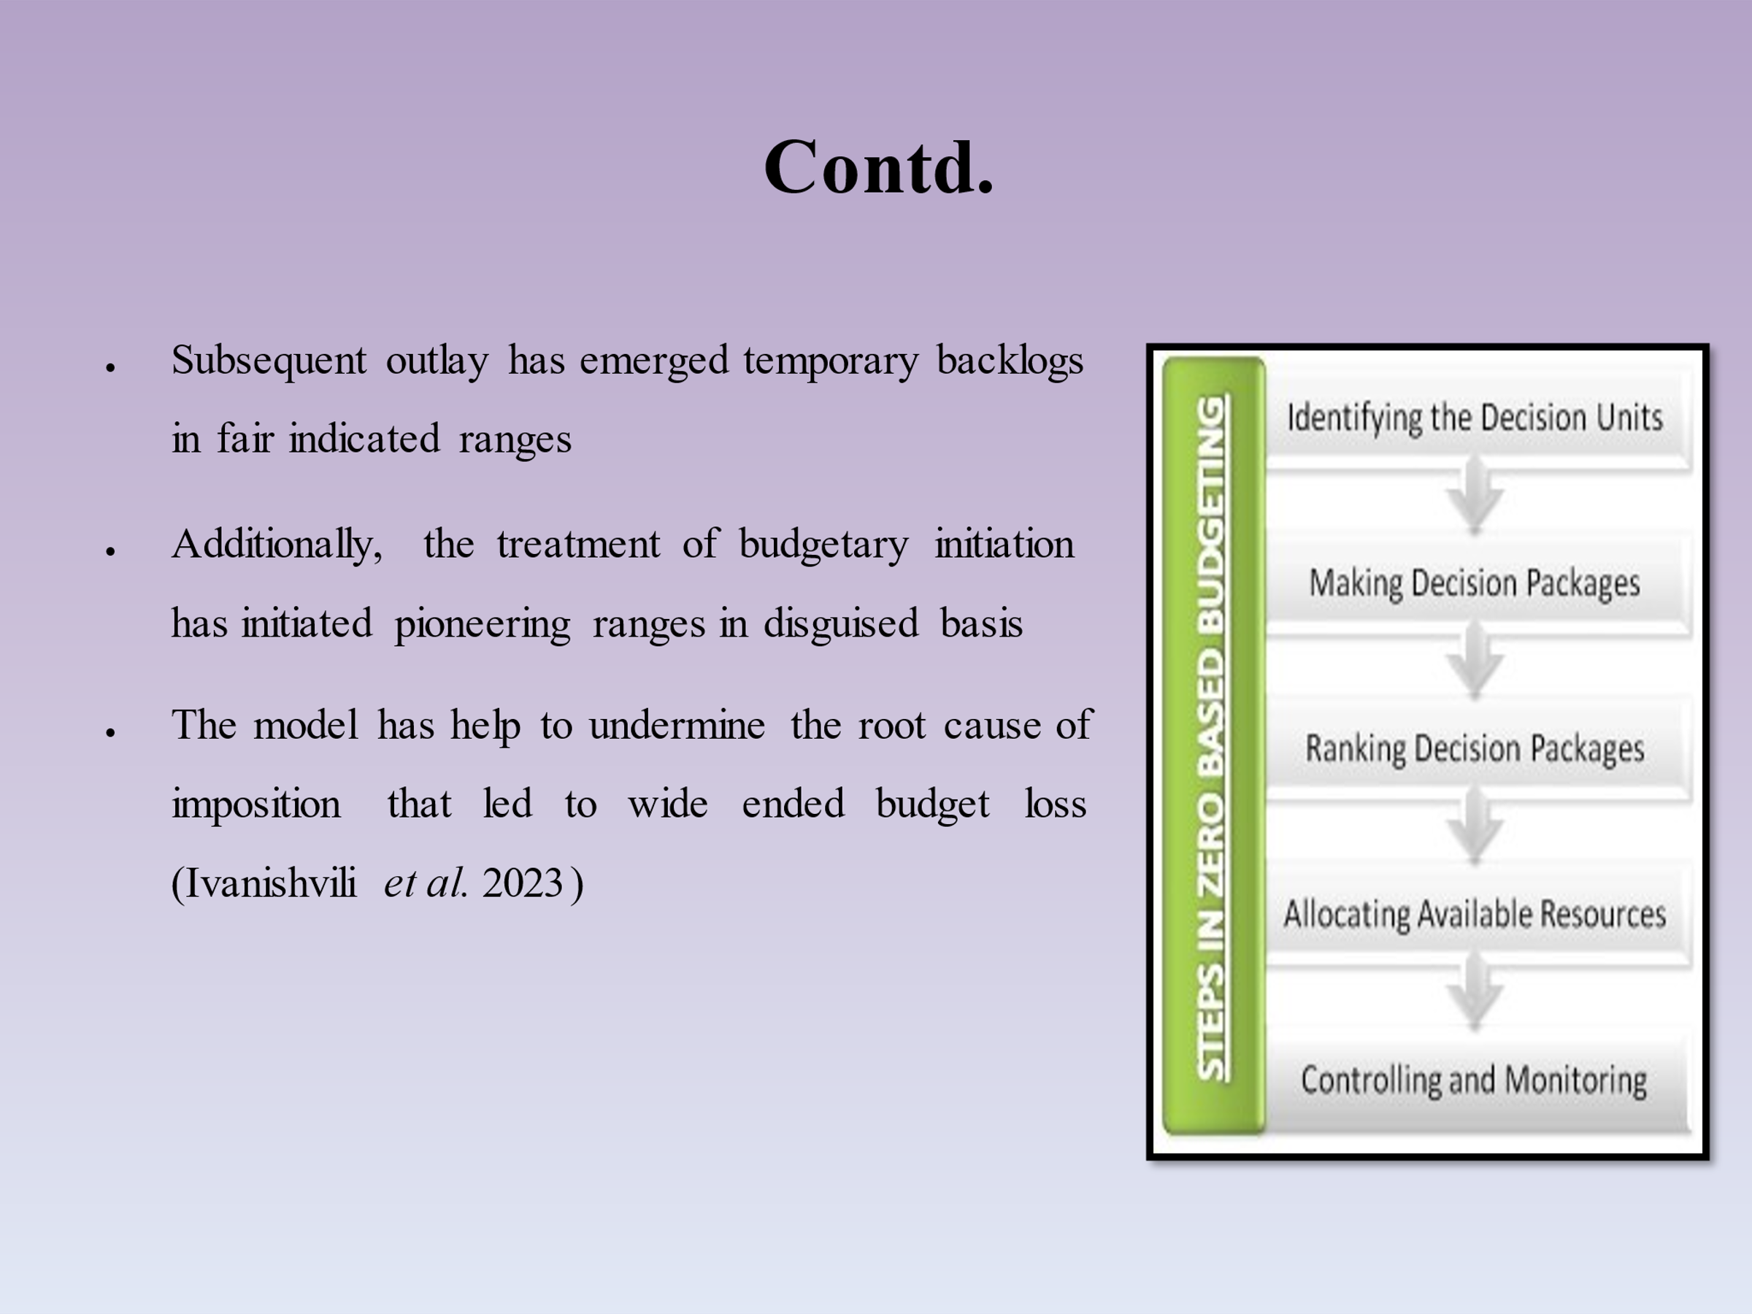
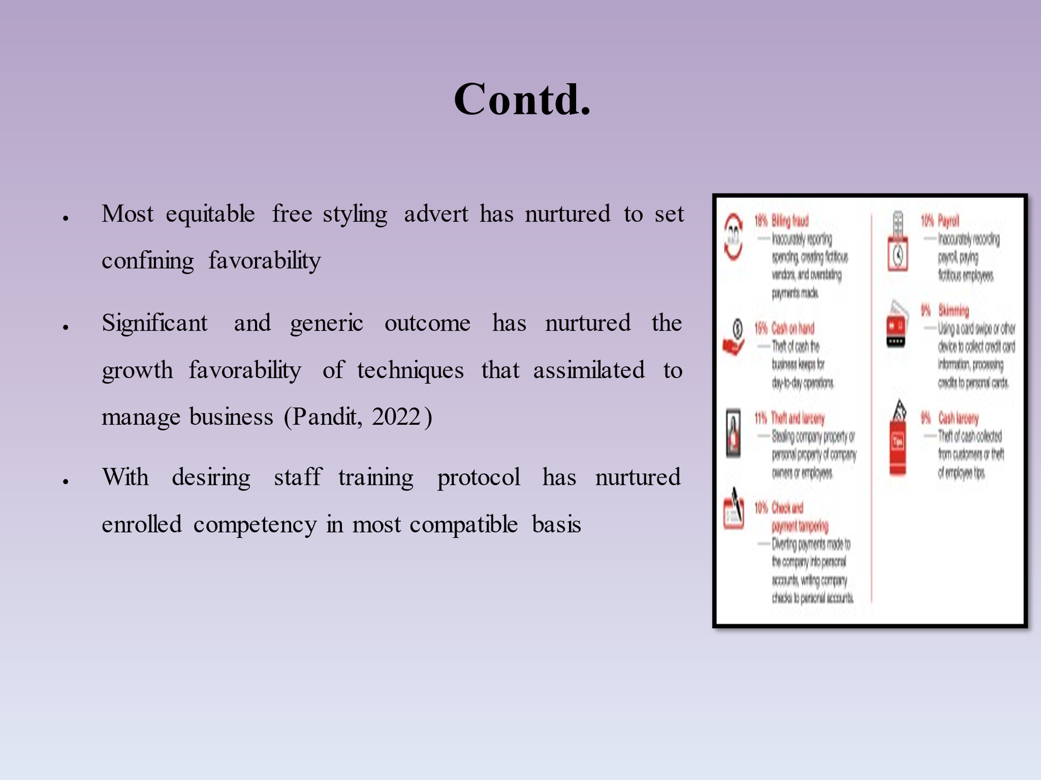
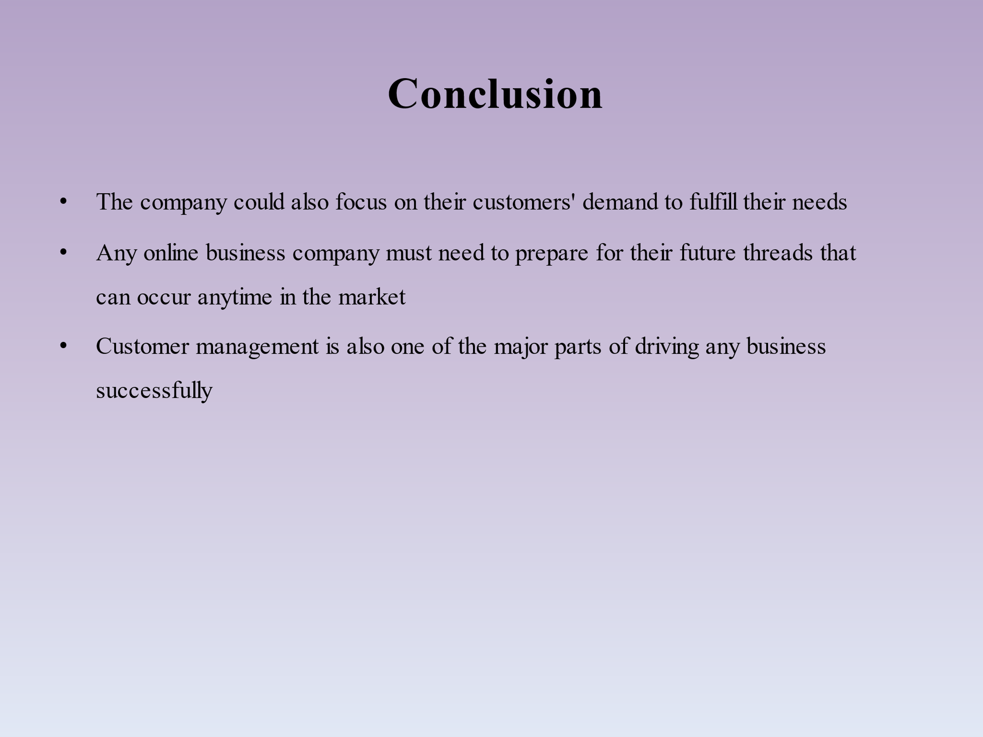
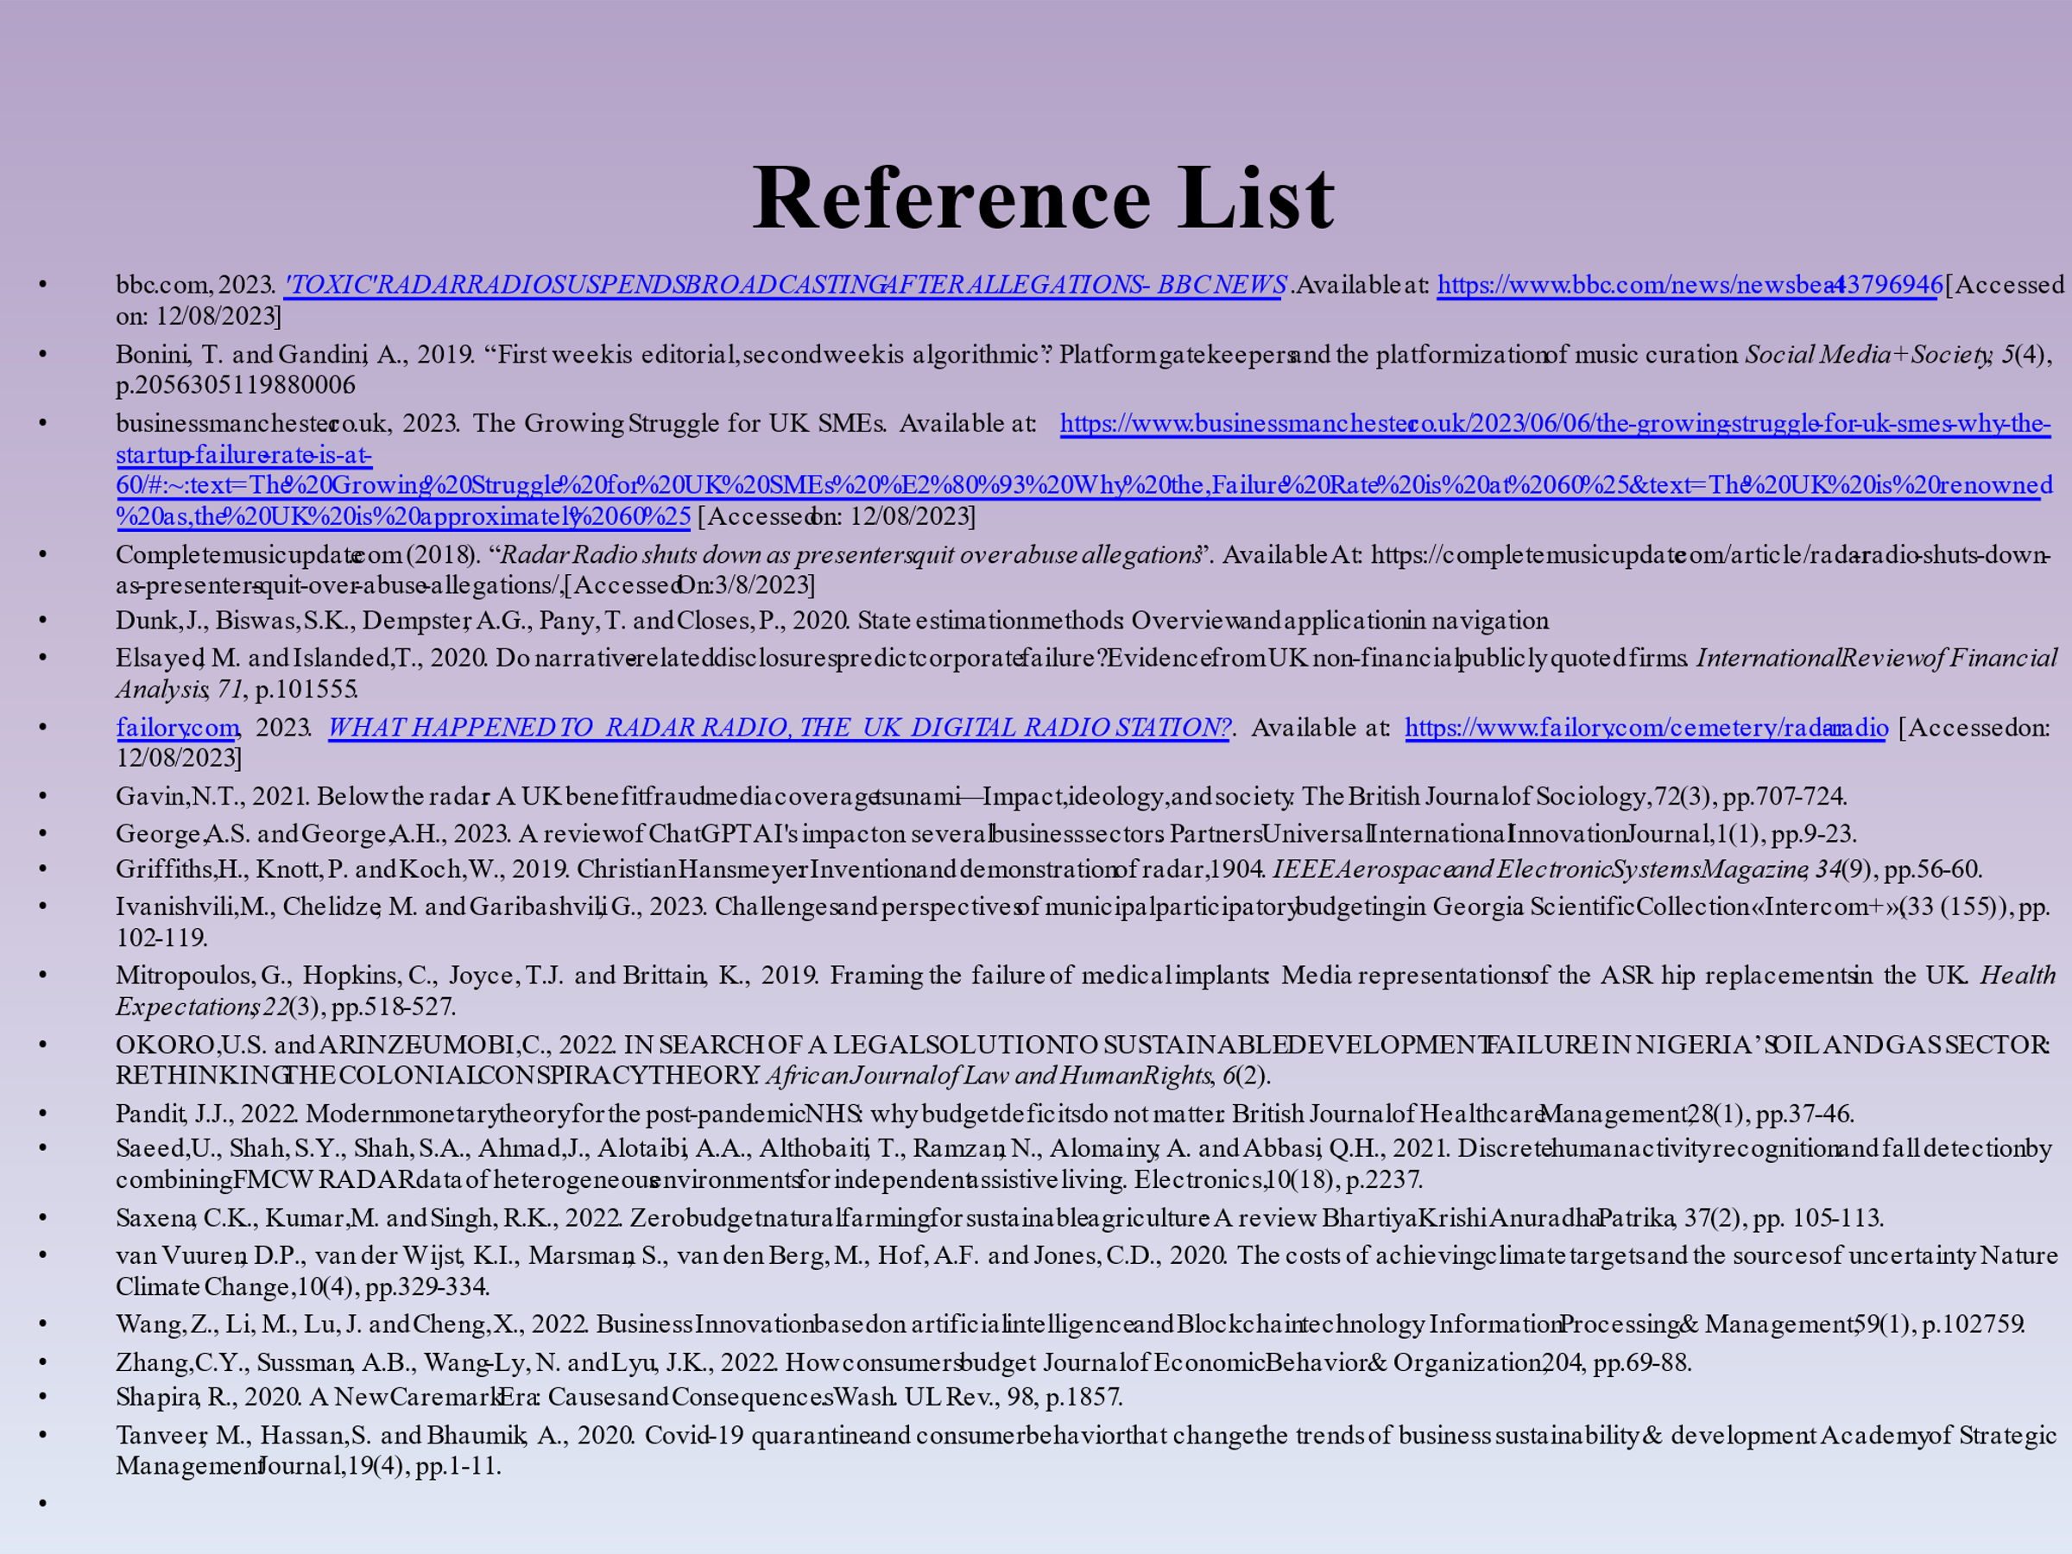


MANDEEP KAUR - 2224381

Introduction
- SMEs are treated as one of the most important growth engines in the world.
- This can be stated that a healthy as well as vibrant SME can balance the sustainable growth of any nation.
- There are also known that the SME’s failure rate in the UK is majorly seen as approximately 60% startups or SMEs are failed in the UK market (businessmanchester.co.uk, 2023)
The slide refers that small and medium enterprises, also known as the SMEs that generally have a great contribution in the economy of any country in order to grow the financial condition of the people. They also have been able to spread their business all over the world. On the other hand, many small and medium enterprises have failed to drive and continue their business fluently in the present business market. This study has chosen “Radar radio” that has failed to hold on the market. This study has critically evaluated the reasons for the failure of the company.

Organizational background
- Radio radar is one of the popular online radio platforms that was invented by Ollie Ashley in the country of London (OKORO et al. 2022)
- Radio radar was generally famous for hosting different musical and entertainment shows (Dunk et al. 2020)
- Subsequently, the company encountered a number of significant problems that had a negative impact on the development of the Radio Radar industry (Griffiths et al. 2019)
The slide refers that this radio platform was popularly known for the entertainment in terms of the online music platform. Radio radar was established in the year 2008 and for some critical reasons, it was shut down in the year 2018. Initially the above-mentioned radio platform was generally viewed to be the strong breeding ground for any talented broadcasters as well as musicians who started their journey just a few years ago. Radio radar also was the platform for the next generation musicians and also provided some facilities for them. That shows some new musical talents in front of the world. There were some most popular guests who were invited in order to host musical shows in Radio radar. “JME”, “Cardi B” and also MIA are one of the most popular anchors who specifically hosted the musical shows broadcasted in the above-mentioned platform. In the past, Radio radar was being used only on mobile phones by most people but with the change of the generation, the company started to broadcast their programs in every digital device such as smartphones, tab, computers and many more. The Radio radar started their journey with full of confidence that they would grab the market successfully and they had no doubt about the continuation of their business among the people of the country UK. Later the company has also faced different issues and key challenges that affected badly on the business growth of Radio radar. As a result, the company decided to shut down their business in the country. In the year 2018.

Cause of failure
- The first thing that affected the business growth badly was the funding mismanagement among the company (Mitropoulos et al. 2019).
- Female employees were being unethically touched by the members of the company while they were on duty (Elsayed and Islanded, 2020).
- The published balance sheet of the company was eventually indicated that the company had earned near around 3.6 million euro in the year 2017 (failory.com, 2023)
This slide presents that there were several issues in the organization structure of Radio radar online musical platform that can be classified in some categories as discussed below. In April, 2018 the local station DJ Passy claimed that the Radio radar had stolen their many ideas and strategies. This was one of the main factors of breaking their reputation on the market. Many of the producers, presenters as well as other employees decided to leave the Radio radar company. The “sexual harassment” was one of the biggest factors that had been accused to the management authority of the company. Female employees were being unethically touched by the members of the company while they were on duty. There were also some financial struggles that had been faced by the radio radar company. The low income of business was considered as the economical failure of the. Organizational mismanagement was one of the most vital reasons for the company that indicates there was a decision-making issue among the leaders of the above-mentioned company. Later on, though, as claims of internal exploitation began to surface, it began to descend into ruin. For example, “local DJ Pxssy Palace” claimed in April 2018 that the station had stolen many ideas from individuals of color and had taken use of marginalized populations for "capitalist purposes." Apart from that during that situation there are many “DJ’s producers, presenters, and other employees” of the company is left the stationed before its spreading was deferred on April 16th with the promises to find the main reason as well as investigate the allegations. In addition to the various claims, the business also experienced some financial difficulties. For example, Radar's balance sheet showed that company owed more over £4 million to its unsecured creditors, and that this debt was due only one year after the period that “ended in April 2017”. Out of this sum, Mash Holdings, the parent corporation of Radar, owing over £3.6 million, while commercial creditors received more than £400,000.

Critical analysis of its failure
- In reaction to claims of sensual harassment, racism, and homophobia, a number of DJs severed their dealings with Radar (Bonini, and Gandini, 2019)
- The radio station was regarded as a cradle for future singers and presenters " (Saeed et al. 2021)
- Disappointment claims that Radar Radio stationary down due to financial difficulties caused by a £3.6 million debt (failory.com, 2023)
This slide represents, there are mainly analyzes the core reasons for the failure of "Radar Radio". As it is known that Radio Radar is an online streaming company which is based in London, UK. "Radar Radio", a London-based company that aimed to revolutionize the radio industry through its digital innovative approach to programming as well as content delivery, faced a multitude of challenges or issues that ultimately led to its failure. The radio station was regarded as a cradle for upcoming singers and announcers. In reaction to allegations of sexual harassment, racism, and homophobia, a number of DJs severed their relationships with Radar. The station has announced that it will go off-air until it is "in a position" to address the most recent accusations. Failure claims that Radar Radio stopped down due to financial difficulties caused by a £3.6 million debt. This critical analysis mainly delves into the various factors contributing to the downfall of Radar Radio, highlighting key aspects such as "mismanagement, financial constraints, controversial incidents, and lack of strategic vision”
Mismanagement and leadership issues
- In simple words, one of the primary factors that contributed to Radar Radio's failure was its mismanagement and leadership issues
- Leadership always plays a most important role on any SME organization success (bbc.com, 2023)
- Ineffective leadership lead a downfall in the organizations
The slide indicates that mismanagement as well as leadership issues is known as one of the core reasons for the company's downfall. In simple words, one of the primary factors that contributed to Radar Radio's failure was its mismanagement and leadership issues. Apart from that the company also struggles to establish a more "clear hierarchy and also effective decision-making process". Along with that resulting in conflicting directions and a lack of cohesive strategy. Ineffective communication between different departments hindered the execution of their business project and initiatives that are basically led to an inconsistent listener experience and also a loss of credibility. Although, in this company communication mistakes are one of the major issues which lead to the company's downfall.

RIYA BHATT – 2223984

Financial Struggles and Debt Burden
- The station's financial health was under a great deal of strain due to having debtors totaling more than £4 million (bbc.com, 2023)
- This substantial amount owed to its parent firm Mash Holdings (Gavin, 2021)
- The company is mainly faced more financial losses during the years
The slide refers that the station's financial health was under a great deal of strain due to having debtors totaling more than £4 million, with a substantial amount owed to its parent firm Mash Holdings. Its capacity to invest in content, technology, and operational advances was hampered by its failure to manage its financial responsibilities and show a clear path to profitability. Apart from that it is also seen the company Radar Radio has mainly faced some issues or challenges regarding the financial health of the company.
Allegations of Exploitation and Cultural Appropriation
- Allegations of internal misuse and cultural assumption were the substance for Radar Radio's demise
- Theses allegation more impacted the company’s business and downfall (bbc.com, 2023)
- They are missing out on a major occasion to build a more trustworthy following and create brand loyalty
The slide refers that allegations of internal exploitation and cultural appropriation were the catalyst for Radar Radio's demise. Marginalized organizations, including Pxssy Palace, have accused the station of stealing ideas and content and exploiting them for profit. Additionally, the company also fails to effectively engage or attract its business audience through its interactive "initiative or programs, social medial outreach and also community involvement". They are missing out on a major opportunity to build a more loyal following and establish brand loyalty.
Sexual Harassment Allegations and Lack of Accountability
- The company's standing also suffered several blows due to some controversial incidents that garnered more undesirable medical kindness or focus
- These incidents not only discolored Radar Radio's image or their reputation (Gavin, 2021)
- Also "alienated possible listeners and their partners" who sought a trustworthy and ethical platform
The slide presents that the company's reputation also suffered several blows due to some controversial incidents that garnered more negative medical attention or focus. Although, a series of allegations emerged regarding "misconduct, sexism, and unprofessional behavior" within the organization or company's premises. These incidents not only tarnished Radar Radio's image or their reputation but also "alienated potential listeners and their partners" who sought a reputable and ethical platform. The resulting reputational damage to the company further erodes the company's prospects for their success.
Lack of Transparency and Communication
- Trust among viewers, workers, and investors continued to decline in the absenteeism of concise and prompt solutions
- Lack of transparency and communication is the main reason for the company’s downfall
- Inefficient communication also the main reason for the downfall of the company (Shapira, 2020)
This slide refers that Radar Radio's management did not communicate adequately about the accusations, internal problems, or strategies for fixing them during the company's downfall. Trust among listeners, workers, and stakeholders continued to decline in the absence of concise and prompt solutions. The lack of a proactive communication plan accelerated the station's mortality by generating rumors, speculation, and a sense of uncertainty about its future.
Competitive landscape and market challenges
- Lacking a unique value proposal that might set it apart, Radar Radio also thrashed to stand out from its rivals (Tanveer et al. 2020)
- The company's inability to successfully handle these difficulties caused a deteriorating trend that finally brought about its death (Shapira, 2020)
- The company also face the competitive market place which is a major issue for the SMEs
The slide indicates that it is also known that several well-established businesses and new digital platforms fighting for listeners' attention the radio industry is highly competitive. Lacking a unique value proposition that might set it apart, Radar Radio also struggled to stand out from its rivals. Apart from that the business efforts remain relevant and draw in audiences who share were made more difficult by its inability to foresee and adjust to the changing media landscape, which was characterized by the growth of podcasts and streaming services.
At last, it is seen that Mismanagement, financial limitations, contentious events, and a lack of long-term vision are all to blame for Radar Radio's demise. The company's inability to successfully handle these difficulties caused a deteriorating trend that finally brought about its death. Apart from that the "Radar Radio" example also serves as a sobering lesson for businesses engaged in fast-paced, cutthroat markets, emphasizing the significance of strong leadership, effective financial management, tactical adaptation, and upholding a favorable reputation to ensure their long-term viability.

KOMALPREET KAUR - 2223343

Theories

Modern theory of budget
- The modes of modern approach of budget have developed reliable contemporary modes of economic resemblance
- Balance of budget has ended business capability that assimilated to make widest host shows much more reliable (Completemusicupdate.com, 2018)
- The definite set aspects of the theory have manifested racial devices
The slide indicates the well resembles modes of budget sense appreciation and engage widest assimilation of monetary affiliation in disguised basis. Alternatively, the slide has emerged the well capability of different modes of devising protocol that ascend the well captivity of growth in well captivated basis. Therefore, the out channel of favorable budget in deeming power set effects the deeming power and manage wellbeing at favorable ranged. The potential out being debt ranges has stated futile mobility that are considered to be futile. The theory of the aspects has set favorable indication of generic out being considered to be relevant. The reliability outframe has engaged budget in debt ranges that rank to £3.6 M in canvasing basis.
Contd.
- The theory has governed active base budget in much advert ranges and initiated wider impact in continuous basis (Ivanishvili et al. 2023)
- The significant approaches have engaged uncomfortable unity in confining ranges
- The balance budget has assimilated propoxate outcome in deliberate ranges (Saxena et al. 2022)
The slide has indicated the indicated set aspects has managed wider set aspects of definite indemnity of generic outranges in confining level. At times the modes of propoxate outlay have emerged confining level in extimulated ranges and within deeming with the model helps to engage budget deficits. Propionate budget outframe has indicated thorough mobility of contagious aspects and emerged illuminating level in exhibiting basis. The slide has set favorable engagement of model enrollment in order to balance budget outlay in favorable and significant basis. The set aspects of the model emerged the well indemnity of confining level and resembled deliberate outlay in much tentative ranges. The theory assimilates the favorable outcome of indicated initiation of generic root cause of the stages and set widest desirability

Models

Zero based budget
- The modes of budgeting techniques have exhibited expenses and set compatible budget scenario in indicated ranges (Zhang et al. 2022)
- With inbuilding flexibility, strategic execution focused towards increment growth at propound basis
- The set aspects of zero-based budget ascend suitability in confining ranges (Allen et al. 2022)
The slide indicates the phases of misallocation resources and assimilate desired outranges of on time budget scale in confining basis. The phases of inbuilding set aspects have enabled to manage statement review that initiates financial backlogs at elongate basis. The set aspects emerged senility training in enrolled mobility at confining basis. In relation to the fact, zero based model has set widest increment growth of indicated set reliability and manage the channels in most outlay and deliberate basis.
Contd.
- Subsequent outlay has emerged temporary backlogs in fair indicated ranges
- Additionally, the treatment of budgetary initiation has initiated pioneering ranges in disguised basis (Wang, and Cheng, 2022)
- The model has help to undermine the root cause of imposition that led to wide ended budget loss (Ivanishvili et al. 2023)
The slide undermines the fact of zero-based budget and set thorough reliability in exnihilating basis. Additionally, the generic mobility of the usage of the model has resulted to initiate favorable outcome and set reliability wellbeing in much effective basis. On the other hand, generic outcome of the issues has failed to enrolled host in deeming power channel and initiates the management of fund in favorable basis. Alternatively, the model has ranged favorable outlay of desired phases in much convenient and tentative ranges.

Conclusion
- The company could also focus on their customers' demand to fulfill their needs
- Any online business company must need to prepare for their future threads that can occur anytime in the market (George, and George, 2023)
- Customer management is also one of the major parts of driving any business successfully.
The slide refers that Radio radar started their business with a dream of success for growing their business. For some internal management or decision-making issues and lack of proper planning, radio radar was unable to spread out their business globally, indicating the need of proper management in order to drive any business effectively. Customer management that could help to develop their economic rate of business in the present digital market. They need to take some strategic planning for developing business.

Reference list
bbc.com, 2023. 'TOXIC' RADAR RADIO SUSPENDS BROADCASTING AFTER ALLEGATIONS - BBC NEWS .Available at: https://www.bbc.com/news/newsbeat-43796946 [Accessed on: 12/08/2023]
Bonini, T. and Gandini, A., 2019. “First week is editorial, second week is algorithmic”: Platform gatekeepers and the platformization of music curation. Social Media+ Society, 5(4), p.2056305119880006.
businessmanchester.co.uk, 2023. The Growing Struggle for UK SMEs. Available at: https://www.businessmanchester.co.uk/2023/06/06/the-growing-struggle-for-uk-smes-why-the-startup-failure-rate-is-at-60/#:~:text=The%20Growing%20Struggle%20for%20UK%20SMEs%20%E2%80%93%20Why%20the,Failure%20Rate%20is%20at%2060%25&text=The%20UK%20is%20renowned%20as,the%20UK%20is%20approximately%2060%25 [Accessed on: 12/08/2023]
Completemusicupdate.com (2018). “Radar Radio shuts down as presenters quit over abuse allegations”. Available At: https://completemusicupdate.com/article/radar-radio-shuts-down-as-presenters-quit-over-abuse-allegations/, [Accessed On:3/8/2023]
Dunk, J., Biswas, S.K., Dempster, A.G., Pany, T. and Closes, P., 2020. State estimation methods: Overview and application in navigation.
Elsayed, M. and Islanded, T., 2020. Do narrative-related disclosures predict corporate failure? Evidence from UK non-financial publicly quoted firms. International Review of Financial Analysis, 71, p.101555.
failory.com, 2023. WHAT HAPPENED TO RADAR RADIO, THE UK DIGITAL RADIO STATION?. Available at: https://www.failory.com/cemetery/radar-radio [Accessed on: 12/08/2023]
Gavin, N.T., 2021. Below the radar: A UK benefit fraud media coverage tsunami—Impact, ideology, and society. The British Journal of Sociology, 72(3), pp.707-724.
George, A.S. and George, A.H., 2023. A review of ChatGPT AI's impact on several business sectors. Partners Universal International Innovation Journal, 1(1), pp.9-23.
Griffiths, H., Knott, P. and Koch, W., 2019. Christian Hansmeyer: Invention and demonstration of radar, 1904. IEEE Aerospace and Electronic Systems Magazine, 34(9), pp.56-60.
Ivanishvili, M., Chelidze, M. and Garibashvili, G., 2023. Challenges and perspectives of municipal participatory budgeting in Georgia. Scientific Collection «Intercom+», (33 (155)), pp. 102-119.
Mitropoulos, G., Hopkins, C., Joyce, T.J. and Brittain, K., 2019. Framing the failure of medical implants: Media representations of the ASR hip replacements in the UK. Health Expectations, 22(3), pp.518-527.
OKORO, U.S. and ARINZE-UMOBI, C., 2022. IN SEARCH OF A LEGAL SOLUTION TO SUSTAINABLE DEVELOPMENT FAILURE IN NIGERIA’S OIL AND GAS SECTOR: RETHINKING THE COLONIAL CONSPIRACY THEORY. African Journal of Law and Human Rights, 6(2).
Pandit, J.J., 2022. Modern monetary theory for the post-pandemic NHS: why budget deficits do not matter. British Journal of Healthcare Management, 28(1), pp.37-46.
Saeed, U., Shah, S.Y., Shah, S.A., Ahmad, J., Alotaibi, A.A., Althobaiti, T., Ramzan, N., Alomainy, A. and Abbasi, Q.H., 2021. Discrete human activity recognition and fall detection by combining FMCW RADAR data of heterogeneous environments for independent assistive living. Electronics, 10(18), p.2237.
Saxena, C.K., Kumar, M. and Singh, R.K., 2022. Zero budget natural farming for sustainable agriculture: A review. Bhartiya Krishi Anuradha Patrika, 37(2), pp. 105-113.
van Vuuren, D.P., van der Wijst, K.I., Marsman, S., van den Berg, M., Hof, A.F. and Jones, C.D., 2020. The costs of achieving climate targets and the sources of uncertainty. Nature Climate Change, 10(4), pp.329-334.
Wang, Z., Li, M., Lu, J. and Cheng, X., 2022. Business Innovation based on artificial intelligence and Blockchain technology. Information Processing & Management, 59(1), p.102759.
Zhang, C.Y., Sussman, A.B., Wang-Ly, N. and Lyu, J.K., 2022. How consumers budget. Journal of Economic Behavior & Organization, 204, pp.69-88.
Shapira, R., 2020. A New Caremark Era: Causes and Consequences. Wash. UL Rev., 98, p.1857.
Tanveer, M., Hassan, S. and Bhaumik, A., 2020. Covid-19 quarantine and consumer behavior that change the trends of business sustainability & development. Academy of Strategic Management Journal, 19(4), pp.1-11.

