

Student name: | Abdullah Al Toha | Student ID number: | 2513613
Programme: | CertHE Computing Skills for Workplace
Module: | Networks and Cyber Security Essentials
Module code: | ACCA4024 | Word count: | 2000
Lecturer: | Amit Naik | Internal Verifier: | Sadhana Jha
Assignment Title: | Synthesize a solution to a potential real-life scenario | Submission deadline: | 12/08/2026

Table of Contents
Report
Introduction 3
Identification of Threats 3
Security Policies 5
Mitigation Measures 7
Monitoring and Response 8
Training and Awareness 11
Conclusion 12
References 13
Appendix 15
Presentation 15

Report

Introduction
As a result of the implementation of Industry 4.0 technologies, SteelForm Manufacturing Ltd now faces increasing cyber threats as the attack surface increases with connected IT and OT environments. External risk factors include ransomware, phishing, compromise via the supply chain, and espionage, which all affect production and intellectual property; meanwhile, internal risks stem from malicious insiders and unintentional employee actions. SFM will address these by deploying extensive security policies based on NIST and IEC 62443 requirements, featuring network segmentation, multi-factor authentication, stringent access policies, and solid patch management. These measures include phishing simulation, endpoint protection, secure remote access gateways, and offline backups. A centralized Security Operations capability aids rapid detection of threats, and a structured incident-response plan ensures safety and production continuity. All staff will be trained about security at a mandatory, role-based level, resulting in a lowered level of vulnerabilities in the human domain. These multi-layered defense capabilities form a robust cybersecurity strategy to protect operations, data, and reputation in SFM's smart manufacturing environment.

Identification of Threats
Contrary to that, SteelForm Manufacturing Ltd (SFM) operates in a context that is saturated with the new technologies of Industry 4.0, such as sensors connected via the Internet of Things to workstations and various automation equipment, as well as a cloud-based production management system. The integrated systems spread the attack surface from information technology (IT) to operational technology (OT), opening up the company to a plethora of internal and external forms of cybersecurity threats.

External threats
These elements mostly come from outside the organization and rely on connections, legacy systems, and third parties. Ransomware is one of the most disruptive threats – criminals could encrypt OT assets or critical systems and cause production lines to shut down, and costs of downtime are now constant and immediate. Manufacturing has always been one of the most frequent sources of attacks of this nature. Phishing and business email compromise campaigns can exploit employees, including those in procurement and/or supply chain-related positions, to obtain credentials or root out and perpetrate fraudulent transactions. Because the segmentation between IT and OT networks is often not well established, malware that is delivered through e-mail or compromised Web sites can spread laterally from IT networks into OT environments [1]. Access to the production network via unsecured VPNs, remote maintenance software, or Internet-connected industrial equipment is a direct threat to the production network. Supply-chain attacks can expose risk via third-party remote access products for machine maintenance, software and firmware updates from compromised vendors. The devices exploited are generally IoT and IIoT devices, often with minimal security measures. Other threats include those from nation-state hackers targeting automotive and aerospace components.
Internal threats
Are from within SFM or trusted sources with proper access. A malicious insider, such as a disgruntled employee or contractor, could intentionally damage the system, steal their organization's intellectual property, or introduce malicious code. Typically, the inadvertent insider acts as a source of risk when an employee clicks on a phishing URL, misconfigures a controller, shares credentials, or brings in an unsecured device. The effects of deliberately or accidentally using the OT system, SCADA, PLCs, or a cloud production platform are magnified in cases of insufficient or improper privileged access [2]. Contractors or third-party technicians who have remote or on-site access to machinery are hybrid internal/external vectors if their credentials or tools are compromised.
When combined, they can lead to production disruptions and delays, bottom-line losses, security breaches of critical engineering and customer data, safety concerns if controls on the process are changed, and negative reputation effects. Integration of IT and OT, coupled with SFM's dependence on connected smart manufacturing technologies, will require a successful compromise.

Security Policies
A comprehensive suite of security policies that conforms to IEC 62443 principles and the NIST Cybersecurity Framework Manufacturing Profile (NIST SP 800-82) is needed to protect the IT and OT environments at SteelForm Manufacturing Ltd. These policies outline definitive guidelines for people, processes, and technology, with an emphasis on operational continuity and safety.
The Cybersecurity Governance Policy issues an overall directive to the IT Security Manager to take responsibility and to have oversight of cyber risk at the board level. It requires an ongoing risk assessment process, a tie to business goals, and integration of cybersecurity into every decision that is made.
Network Segmentation and Access Control Policy entails the strict separation of the IT and OT network segments with the implementation of demilitarised zones (DMZs), firewalls, and zone-and-conduit architectures based on the Purdue model [3]. Access is based on the principle of least privilege and role-based access. All remote access and privileged access must be through multi-factor authentication, and separate credentials for OT systems. Ports and services on unused systems and PLCs, HMIs, and IoT devices, and default passwords, will need to be changed, and services disabled.
Acceptable Use and Endpoint Protection Policy describes what employees and contractors may and may not do, from not using any types of software that may be deemed unauthorized to not using personal devices (not related to the job) on production networks, to not using the internet sensibly when using email. All endpoints (including engineering workstations) should be deployed with approved security solutions (including application allowlisting).
The Patch and Vulnerability Management Policy defines scheduled processes for updating systems that are controlled. Any critical systems are patched quickly; all OT systems are patched at a risk-based frequency that has minimal impact to production; compensating controls are used for unpatchable legacy systems. Vulnerability scans, etc., of assets must be done regularly.
Secure Remote Access & Third-Party Policy ensures only authenticated sessions with monitored maintenance connections from vendors and remote locations via secure gateways [4].
Incident Response, Backup and Recovery Policy clearly determines who, how, and what of detection, containment, and recovery from an incident. Offline, tested backups of critical production data and configuration are REQUIRED, and annual tabletop exercises are required.

Mitigation Measures
The following practical mitigation measures are suggested to deal with the inside and outside threats to SteelForm Manufacturing Ltd, and will be applied to support the Company's security policies, as a top priority, IT security and OT security.
Network Segmentation and Isolation will help to block the movement of ransomware and malware from IT to Production systems. There will be a separation between corporate networks and OT zones using a demilitarised zone (DMZ) & firewall rules in accordance with the Purdue model [5]. This starts with a comprehensive asset inventory, then it involves reconfiguring switches and firewalls to allow for zone and conduit controls to be implemented. There will be no unnecessary traffic between segments, and it will be monitored for abnormal traffic.
Multi-factor authentication (MFA) and privileged access management will help defend against phishing attacks, credential theft, and unauthorised access. All remote connections, Cloud Production Systems, and Admin accounts will be subject to MFA verification. Separate OT credentials will be established for use, and privileged accounts will be managed using a dedicated tool with just-in-time access. Implementation involves a phased approach beginning with procurement and engineering staff, with user training and automated enforcement of the policy through to the identity provider [6].
This will help to minimise the risk of workstations and HMIs being compromised with malware through endpoint protection and allowlisting applications. Antivirus and allowlisting will be rolled out on engineering stations and servers, which will be provided at the engineering level. Antivirus and allowlisting solutions will be provided at the engineering level and implemented on engineering stations and servers. Baseline configuration, testing for operational impact, and centralised policy management to block improper executables are key points in the implementation phase.
Multi-level security for remote access, along with vendor controls, will reduce supply-chain and third-party risk. All vendor Maintenance Sessions will be conducted through a jump box (known or monitored) or zero-trust gateway that will record the session. Security Requirements and Security Log of Access will be required by Contracts.
Human-related threats will be addressed by means of Phishing simulation and awareness training. Quarterly simulated phishing campaigns will be conducted, and remediation training will be required for phishing failures. Special modules will be held for procurement staff. Implementation involves choosing a training platform, conducting baseline tests, and monitoring improvement metrics [7].
Patching, along with implementing compensating controls and performing regular offline backups, will mitigate vulnerabilities that allow them to be exploited and ransomware actions. Critical system patches will be deployed on a schedule; network isolation with monitoring will be used for unpatchable OT devices. Production configurations and data will be backed up to be tested offline quarterly. Change-control procedures and recovery drills are needed for implementation.

Monitoring and Response
How well SteelForm Manufacturing Ltd can monitor and respond to cyber incidents quickly is essential in heading off the effects of a cyber incident on Production Systems. This plan encompasses ongoing visibility on IT and OT networks and a well-defined, safety-first approach to incident response, following NIST SP 800-82 and CISA recommendations for industrial incidents.

Network Monitoring
A centralised Security Operations capability will be able to capture the logs from Firewalls, Switches, Endpoint protection products, cloud production systems, and OT devices. Industrial protocol passive network monitoring tools will help identify anomalies passing through the network, abnormal use of remote access, or attempts to send commands to PLCs that aren't authorized. Methods of behavioural analytics will highlight issues from usual production patterns. Critical alerts will be prioritised to be reviewed 24/7, while OT dashboards will be shared with the IT security teams. All Assets Inventories will be maintained, ensuring all devices are visible and monitored [8].

Incident Response Plan
There is a clear phased response to the crisis, with emphasis given to human safety and continuity of production:
1. Detection & Triage – Alerts/reports are evaluated; 2. If there is any confirmation, incidents are categorized as critical, high, medium, or low.
2. Notification & Activation – IR Team (IT Security Manager, OT engineers, operations & management) is called in respect of the severity.
3. Containment – Segments affected are segregated with pre-defined network controls. Local or manual production will continue if it is safe to do so at a critical level.
4. Post-Incident Review – lessons learned are captured, policies change, and improvements are made [9].

Flowchart
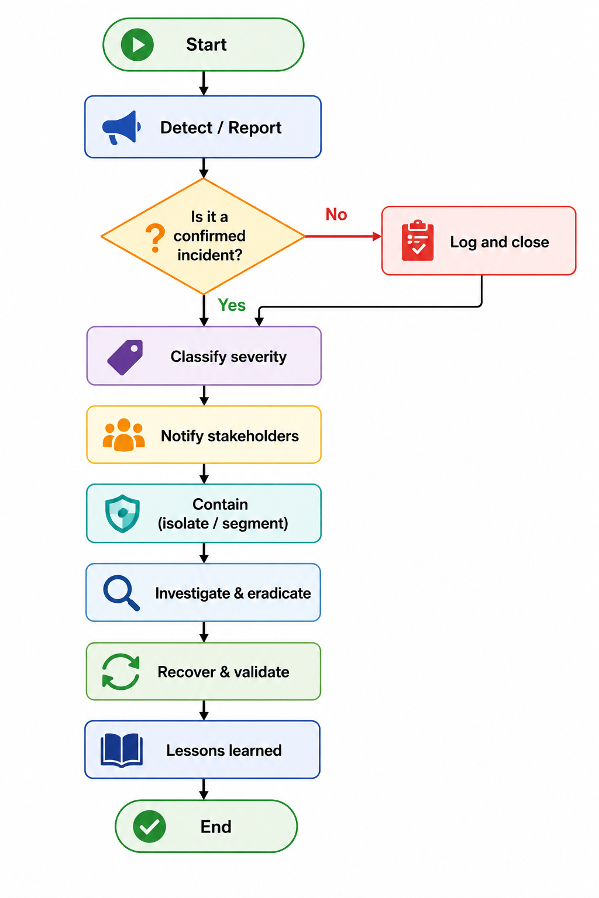
Figure: Incident Response Plan Flowchart
The plan will be tested through ongoing tabletop exercises with IT and OT staff. A relationship with outside support (incident response companies and authorities) will be established before the event. A systematic process allows the identification of threats promptly and a response without a loss of production.

Training and Awareness
A well-designed training and awareness program is key to helping all employees at SteelForm Manufacturing Ltd understand and adhere to the new cybersecurity policies. This programme will foster a security-minded culture, minimize human risk factors including phishing and insider mistakes, and instill in the users good security habits in both the IT and OT worlds.
Programme Structure
All staff will receive the basic training in the first month after the policy has been put in place, and then undertake the training again each year. The core module takes care of the acceptable use, password hygiene, phishing awareness, data handling, and reporting processes. Content will be shared through short online modules, practical, real-life examples of recent incidents with SFM, and easy-to-understand explanations of the consequences of not complying [10].
These higher-risk groups will be covered in role-based training. Buyers, procurement, and administration officers will be targeted in specific training sessions on sophisticated phishing and business email compromise. Engineering, maintenance, and OT operators will take specific courses on secure remote access, change control, physical security of control systems, risks of bringing unauthorized devices or software onto the production network. Additional training will be provided for managers and supervisors on enforcing the policy, escalating incidents, and leading by example.

Delivery and Reinforcement
Training will consist of e-learning to provide flexibility plus instructor-led workshops to give OT staff an opportunity for discussion regarding operational issues. Newsletters will be used for inspiration and awareness and will be sent quarterly and modelled with the correct training for each incorrect email marked. Short notice ‘security tips' will be sent out regularly through noticeboard & email to keep on top of the profile. Any new starters/contractors will undergo induction training before access to the system [11].
Measurement and Accountability
The completion of the program/s and simulation results will be monitored and reported to management, which will be thoroughly followed by the trends of the incidents that are connected to human error. Refresher training or disciplinary action (as appropriate) will begin upon non-compliance. Content subject to updating annually in response to new threats and policy changes. The programme will establish the new security policies as part of daily working practices and greatly enhance SFM's human defences in a blend of established expectations, hands-on practicalities and continual reinforcement [12].

Conclusion
As a company at the cusp of innovation and challenge, SteelForm Manufacturing Ltd faces a world of Industrial 4.0 connectedness in the name of efficiency, but poses exposed production systems to ever-increasing cyber threats. The security approach is based on a combination of strong security policies, multiple defenses, active monitoring, and a clear incident response plan, which creates a resilient posture of defense in depth. Most significantly, the training and awareness programme puts employees into the situation of being aware not just of them, but of helping to keep them safe. With these interdependent pillars linked together, SFM can maintain continuity of operation and help to protect critical IP assets.

References
[1] K. Stouffer et al., "Guide to Operational Technology (OT) Security," National Institute of Standards and Technology, Gaithersburg, MD, USA, NIST SP 800-82, Rev. 3, Sep. 2023.
[2] K. A. Stouffer et al., "Cybersecurity Framework Manufacturing Profile," National Institute of Standards and Technology, Gaithersburg, MD, USA, NISTIR 8183, Rev. 1, 2020.
[3] Security for Industrial Automation and Control Systems – Part 2-1: Security Program Requirements for IACS Asset Owners, IEC Standard 62443-2-1, International Electrotechnical Commission, Geneva, Switzerland, 2024.
[4] Security for Industrial Automation and Control Systems – Part 3-3: System Security Requirements and Security Levels, IEC Standard 62443-3-3, International Electrotechnical Commission, Geneva, Switzerland, 2013.
[5] "Framework for Improving Critical Infrastructure Cybersecurity," Version 2.0, National Institute of Standards and Technology, Gaithersburg, MD, USA, Feb. 2024.
[6] Cybersecurity and Infrastructure Security Agency, "Recommended Practice: Developing an Industrial Control Systems Cybersecurity Incident Response Capability," CISA, Washington, DC, USA.
[7] M. Pease et al., "Cybersecurity Framework Version 2.0 Manufacturing Profile," Initial Public Draft, National Institute of Standards and Technology, Gaithersburg, MD, USA, NISTIR 8183, Rev. 2, Sep. 2025.
[8] "Effective ICS Cybersecurity Using the IEC 62443 Standard," SANS Institute, White Paper, Dec. 2023.
[9] "Security and Privacy Controls for Information Systems and Organizations," National Institute of Standards and Technology, Gaithersburg, MD, USA, NIST SP 800-53, Rev. 5, Sep. 2020.
[10] Cybersecurity and Infrastructure Security Agency, "Cross-Sector Cybersecurity Performance Goals," CISA, Washington, DC, USA.
[11] "Guide to Industrial Control Systems (ICS) Security," National Institute of Standards and Technology, Gaithersburg, MD, USA, NIST SP 800-82, Rev. 2, May 2015.
[12] "OT Cybersecurity: Manufacturing Sector Insights and Best Practices," Dragos, Hanover, MD, USA, Ind. Rep., 2025.

Appendix

Presentation


