2205543
Katie Williams

ECGE4005P/C
E -Portfolio

Contents

Blog – What is reflection and why should we use it? …...............................................Page 3

Essay - What is good Time Management? …................................................................Page 7

Academic Poster – What is critical thinking and how can it be developed? …...…..Page 9

References for all elements ….....................................................................................................Page 10

Exploring the benefits of refection

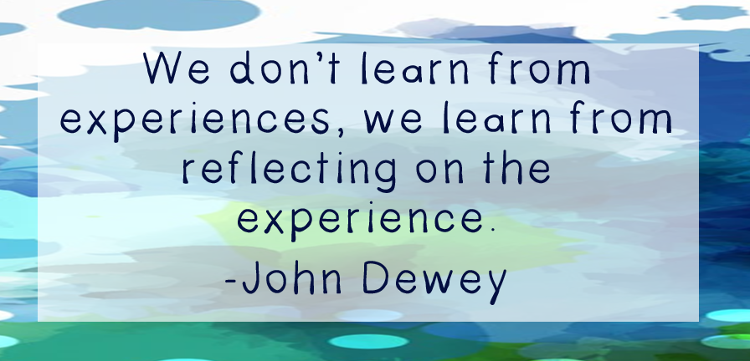
(Dewey, John Knilt 2020)

How effective reflection can improve your life?
Reflection is an essential tool, many complete this task without realising, I for one regularly reflect on tasks/activities I have completed in both my personal and professional life. Reflection is an active process of what you did? How did you do it? And what you did? It is useful to use the result of your reflection to handle the scenario better in the future.
From my own first-hand experiences and knowledge, I can think instantly by using a holistic approach as to how I will deal with a situation whilst studying as an adult learner.

According to Donald Schon’s (1991) reflective theory, there are 3 stages to reflection:
- 1. ‘Reflection in Action’ is the knowledge you already have from past experiences, for example tying my shoelaces, I learnt how to do this when I was a child, therefore, I know how to complete this task from previous experiences.
- 2. ‘Reflection in action’ is to question why? Results in making an instant professional decision.
- 3. ‘Reflection on action’ This would be my final reflection after the event including; what went well? what went not so well? what would I do differently next time to enhance my learning?

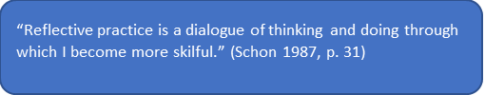

A reflective journal is essential for my adult learning as I can log all strategies, feelings, difficulties, previous knowledge, experience, thoughts, evaluate and monitor my progress throughout my studies.

Have you ever done this?

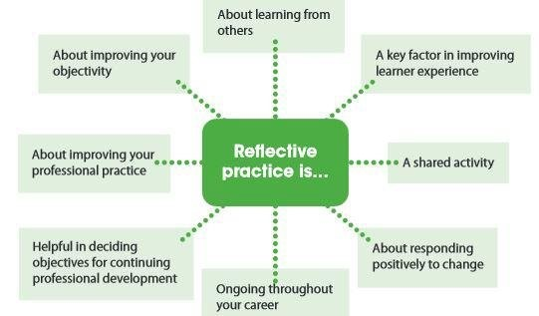
Image, Donald Schon Concept of Reflective Practice (Schon, 1983) p 73

As I focus on 3 of Schon’s ideas, I share my personal perspective on how each may be implemented;
- About learning from others – Sharing knowledge and experiences as well as communicating effectively with peers is important to me. Although I may have different views from them, I am always open to listening to alternative perspectives and learning from them. Support and discuss my own strengths and weakness. As McKay (2008, Forthcoming) says: ‘there are “compelling reasons” to do reflection in collaboration with others’.

- Ongoing throughout your career – Reflective practice is essential for the growth of your career; it is a lifelong skill once adapted simultaneously. Reflection is an essential skill to own as it helps you develop and grow throughout your professional career- it never stops. ‘Several researchers and theoreticians state that as part of their professional competence teachers should conduct some research into their own practice to enhance development’ (McNiff, 2002; Smith, 1990).

- Shared activity – share your reflections and perspectives with peers, be creative and curious. Share strategies, techniques and approaches. ‘The journey from novice to expert requires that teachers engage in numerous reflective activities involving noticing, analyzing and taking action’ (Moore-Russo & Wilsey, 2014).

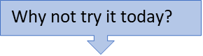

Everyone can benefit from consistent, effective reflection, it contributes to your overall learning and development throughout life.

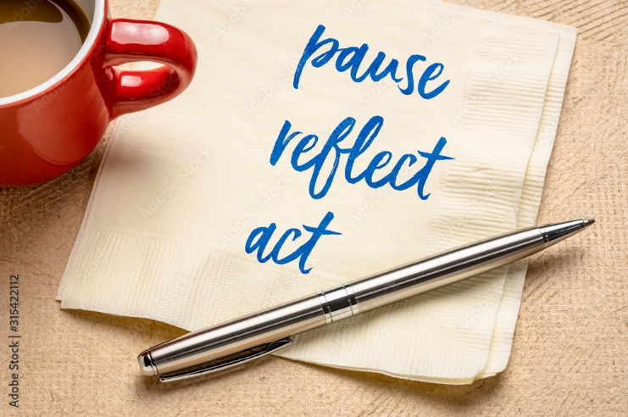

Adobe stock image. MarekPhotoDesign.com

What is good Time Management?
This essay will explore what makes good Time Management. Time management is known as the technique of organising and planning effectively and deciding how to split time between various duties and activities. Using Time Management wisely will produce impressive results in completing tasks and activities with less stress. (Aeon, Faber, Panaccio 2021). Time management is defined as a form of decision-making utilized by individuals to organize, safeguard, and adjust their time management strategies to changing circumstances. (Aeon, Faber, Panaccio 2021). Interestingly, time management is a relatively new concept. As a result of a meta-analysis to assess the impact of Time Management ‘Results show that time management is moderately related to job performance, academic achievement, and wellbeing’ (Aeon, Faber, Panaccio 2021). Their meta-analysis consisted of 53,957 participants and over 158 studies. The findings imply a moderate connection between time management and well-being, academic performance, and work performance. It is also important to note personality types and environmental factors are smaller than managing time. Interestingly, there was little evidence of a gender gap in time management skills between men and women. Furthermore, they discovered that there is a growing connection between time management and job success over time. Time management is more likely to result in positive work performance than it was in the early 1990s. The meta-analysis identifies effective time management increases both work performance and well-being.
Moreover, according to the self-regulation theory (Zhao, et al 2019). Self-monitoring is an essential part of pursuing academic goals. Based on this approach, they investigated how procrastination is influenced by and how self-monitoring and time management are linked. Results identified from their case study of 503 Chinese college students show that procrastination was negatively linked with self-regulation and effective time management procrastination and self-control. This means Time management was successfully linked with effective self-control and self-management. However, the ability to manage your time has a moderate impact on your well-being, academic success, and work performance. These three results are significant in people's lives. A stress-free, well-lived life involves doing an exceptional job at work, achieving excellent marks in school, and promoting psychological wellness. Thus, the widespread advice to improve time management is unfounded: the value of time management cannot be overstated.

Another significant factor relating to time management is procrastination. Procrastination may be defined as the deliberate postponement of a planned significant or personal activity whilst anticipating the possible consequences that outweigh the advantages of the initial postponement. (Klingsieck, 2013). ‘Procrastination is frequently influenced by various negative factors, for example, lower academic performance’ (Steel et al 2001). ‘Increased stress’ (Sirois et al 2003). and ‘poor mental health’ (Stead et al., 2010). To be able to eliminate procrastination, one must be aware of the causes and circumstances that keep it going.
However, Dewitte and Lens. (2000) completed two different studies, the results from their first study’s findings revealed that procrastinators were found to have low action identities. Their second (questionnaire-based) study revealed learners had more precise goals regarding their studying, they also postponed more of their personal activities and studied less in general than non-procrastinators. (Dewitte and Lens, 2000). Procrastination has common links to low self-regulation behaviours and poor time management issues. (Wolters et al, 2017). Moreover, the research identified learners would comprehend a better concept of time management and its role in self-regulated learning. Through these efforts, learners often regulate their time effectively as they engage in their academic activities which are compulsory for achieving their learning outcomes by implementing producible management of time. There are various approaches to procrastination: the differential psychology perspective; the motivational and volitional psychology perspective; the clinical psychology perspective; and the situational perspective (Klingsieck, 2013). The purpose of their study was to produce contrasting strategies to develop a better concept of procrastination by undertaking multiple methods.
Furthermore, Time management can play a vital role in any individual's life. Meta-analysis evidence suggests that if time management is used effectively, it can in return boost productivity and cause less stress for students. (Aeon, Faber, Panaccio 2021). Additionally, it is a critical competency for both personal and professional success. Furthermore, Time management is a significant self-regulation process. (Zhao, Meng Sun, Xu, Geng, Han, 2019) In addition, procrastination has many negative factors including little self-control, lack of time management skills and poor mental health.
Finally, during Covid learners were expected to sign up to online courses which involve self–regulated motivation to study. They found learners struggling to self–study, so they implemented a self-study intervention to see if this would help all learners succeed in completing their course. Which was identified to be successful. Unlike the learners who never interacted with the online courses offered to them, who went on to withdraw their studies shortly after. Future recommendations for teachers and education facilities could use this information to implement interventions for all courses to boost completion percentages. (Beishuizen & Steffens. 2011:Wang et al.,2013)

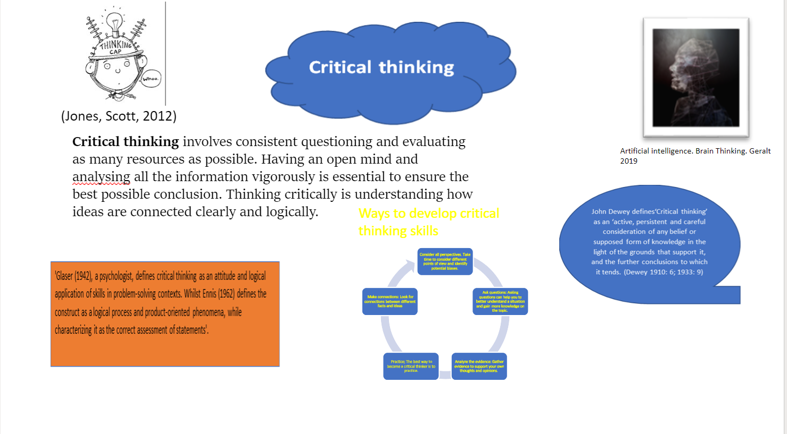
References
Aeon B, Faber A, Panaccio A (2021). Does time management work? A meta-analysis. PLoS ONE 16(1): e0245066. Available at: https://journals.plos.org/plosone/article?id=10.1371/journal.pone.0245066 (Accessed 11.December.2022)
Aeon, B. and Aguinis, H., 2017. It’s about time: New perspectives and insights on time management. Academy of management perspectives, 31(4), pp.309-330. Available at: It’s About Time: New Perspectives and Insights on Time Management | Academy of Management Perspectives (aom.org) (Accessed 28.December.2022)
Bowen, N.E.J.A. and Nanni, A., (2021). Piracy, playing the system, or poor policies? Perspectives on plagiarism in Thailand. Journal of English for Academic Purposes, 51, p.100992. Available at: https://www.sciencedirect.com/science/article/abs/pii/S1475158521000369 (Accessed 19.December.2022)
Bowen, N.E.J.A. and Nanni, A., 2021. Piracy, playing the system, or poor policies? Perspectives on plagiarism in Thailand. Journal of English for Academic Purposes, 51, p.100992. Available at:https://www.sciencedirect.com/science/article/abs/pii/S1475158521000369 (Accessed 20.December.2022)
Brain thinking (2019). Image. Available at: https://pixabay.com/illustrations/artificial-intelligence-brain-4389372/ (Accessed 20.December.2022)
Dewitte, S. and Lens, W., (2000). Procrastinators lack a broad action perspective. European Journal of Personality, 14(2), pp.121-140. Available at:https://onlinelibrary.wiley.com/doi/abs/10.1002/(SICI)1099-0984(200003/04)14:2%3C121::AID-PER368%3E3.0.CO;2-%23 (Accessed 10.December.2022)
Donald Schon Concept of Reflective Practice (Schon, 1983) p 73. Image. Available at:https://www.researchgate.net/figure/Donald-Schon-Concept-of-Reflective-Practice-Schon-1983_fig1_321300859 (Accessed 13.December.2022)
Enago Academy – common types of plagiarism –image. Available at:https://www.enago.com/academy/wp-content/uploads/2018/11/Smartshorts_11th-October-1-1-1-1.png (Accessed 22.December.2022)
Finlay, L., 2008. Reflecting on ‘Reflective practice’ Available at:http://oro.open.ac.uk/68945/1/Finlay-(2008)-Reflecting-on-reflective-practice-PBPL-paper-52.pdf (Accessed 23.December.2022)
Hailikari, T., Katajavuori, N. & Asikainen, H. (2021). Understanding procrastination: A case of a study skills course. Soc Psychol Educ 24, 589–606. Available at:https://link.springer.com/article/10.1007/s12144-019-00442-3 (Accessed 13.December.2022)
Hailikari, T., Katajavuori, N. & Asikainen, H. Understanding procrastination: A case of a study skills course. Soc Psychol Educ 24, 589–606 (2021). Available at:https://doi.org/10.1007/s11218-021-09621-2 (Accessed 09.December.2022)
Hitchcock, David, "Critical Thinking", The Stanford Encyclopedia of Philosophy (Winter 2022 Edition),[online] Edward N. Zalta & Uri Nodelman (eds.), Available at:https://plato.stanford.edu/entries/critical-thinking/history.html (Accessed 30.December.2022)
Hitchcock, David, "Critical Thinking", The Stanford Encyclopedia of Philosophy (Winter 2022 Edition),[online] Edward N. Zalta & Uri Nodelman (eds.) Available at:https://plato.stanford.edu/entries/critical-thinking/history.html (Accessed 30.December.2022)
Hitchcock, David, "Critical Thinking", The Stanford Encyclopedia of Philosophy (Winter 2022 Edition), Edward N. Zalta & Uri Nodelman (eds.), Available at:https://plato.stanford.edu/entries/critical-thinking/history.html (Accessed 30.December.2022)
Information Resources Management Association (IRMA) (2016 ) Teacher Education: Concepts, Methodologies, Tools, and Applications [online] Available at:https://books.google.co.uk/books?id=YY9JDAAAQBAJ&pg=PA155&dq=schon+reflective+practice+is+a+dialogue+of+thinking+and+doing+through+which+i+become+more+skillful;+schon+1991&hl=en&newbks=1&newbks_redir=1&sa=X&ved=2ahUKEwjyk6rlyrP8AhWVWcAKHU_LDtMQ6AF6BAgIEAI (Accessed 28.December.2022)
Iqbal, Muhammad & Ramzan, Muhammad & Arain, Amjad. (2016). Students' Feedback: A Stimulus Reflective Practice for Professional Development of the Prospective Teachers. Available at:https://www.researchgate.net/publication/321300859_Students'_Feedback_A_Stimulus_Reflective_Practice_for_Professional_Development_of_the_Prospective_Teachers (Accessed at 18.December.2022)
Jansen, R.S., van Leeuwen, A., Janssen, J., Conijn, R. and Kester, L., 2020. Supporting learners' self-regulated learning in Massive Open Online Courses. Computers & Education, 146, p.103771. Available at: https://www.sciencedirect.com/science/article/pii/S0360131519303240 (Accessed 02.January.2023)
John Dewey quote image. Available at:https://knilt.arcc.albany.edu/File:John_Dewey.png (Accessed 18.December.2022)
Jones, Scott 2012. is licensed under CC BY-SA image. Available at:http://thecollaboratory.wikidot.com/philosophy-of-thought-and-logic-2010-2011 (Accessed 30.December.2022)
Klingsieck, K. B. (2013). Procrastination: When good things don’t come to those who wait. European Psychologist, 18(1), 24–34 Available at:https://doi.org/10.1027/1016-9040/a000138 (Accessed 09.December.2022)
Odeyemi, Joshua 2020) Available at:https://dailytrust.com/want-to-avoid-plagiarism-in-your-work-see-apps-at-your-disposal/ Plagiarism image [online] Available at:This Photo by Unknown author is licensed under CC BY-NC. (Accessed 24.December.2022)
Pause, reflect, act Image. Available at:https://stock.adobe.com/uk/search/images?filters%5Bcontent_type%3Aphoto%5D=1&hide_panel=true&k=reflection&search_type=usertyped&asset_id=381966682 (Accesssed 23.December.2022)
Pecorari, (2019))
Peterbuwert (2012) Available at:https://graysreadinggroup.wordpress.com/2012/12/18/the-reflective-practitioner-by-donald-schon/ SCHON REFLECTIVE ) (Accessed 23.December.2022)
Plagiarism. Image (2017) Available at:https://digitallearning.eletsonline.com/2017/09/ugc-drafts-regulation-policy-to-prevent-plagiarism-in-academic-writing/ (Accessed 01.January.2023)
Postholm, M.B., 2008. Teachers developing practice: Reflection as key activity. Teaching and teacher education, 24(7), pp.1717-1728. Available at:https://www.sciencedirect.com/science/article/abs/pii/S0742051X08000504 (Accessed 22.December.2022)
Robertson, P.M., McFarland, L.A., Sciuchetti, M.B. and García, S.B., 2017. Connecting the dots: An exploration of how pre-service special education teachers make sense of disability and diversity. Teaching and Teacher Education, 65, pp.34-47. Available at:https://www.sciencedirect.com/science/article/abs/pii/S0742051X17303281 (Accessed 15.December.2022)
Schon, D., 1983. donald schon (schön): learning, reflection and change. p.2004. Available at:https://infed.org/mobi/donald-schon-learning-reflection-change/ (Accessed 12.December.2022)
Sirois, F. M., Melia-Gordon, M. L., & Pychyl, T. A. (2003). “I’ll look after my health, later”: An investigation of procrastination and health. Personality and Individual Differences, 35, 1167–1184. Available at:https://doi.org/10.1016/S0191-8869(02)00326-4 (Accessed 11.December.2022)
Stead, R., Shanahan, M.J. and Neufeld, R.W., 2010. “I’ll go to therapy, eventually”: Procrastination, stress and mental health. Personality and individual differences, 49(3), pp.175-180. Available at:https://www.sciencedirect.com/science/article/abs/pii/S0191886910001625 (Accessed 10.December.2022)
Steel, P., Brothen, T. and Wambach, C., et al. (2001). Procrastination and personality, performance, and mood. Personality and individual differences, 30(1), pp.95-106. Availableat:https://www.sciencedirect.com/science/article/abs/pii/S0191886900000131 (Accessed 08.December.2022)
Students' Feedback: A Stimulus Reflective Practice for Professional Development of the Prospective Teachers - Scientific Figure on ResearchGate. Available from: https://www.researchgate.net/figure/Donald-Schon-Concept-of-Reflective-Practice-Schon-1983_fig1_321300859 (Accessed 5.December.2022)
Van Vliet, V. (2012). Donald Schön biography, quotes and books. From Toolshero: Available at: https://www.toolshero.com/toolsheroes/donald-schon/ quote (Accessed 23.December.2022)
Wolters, C.A., Brady, A.C. et al. (2021) College Students’ Time Management: a Self-Regulated Learning Perspective. Educ Psychol Rev 33, 1319–1351. Available at:https://doi.org/10.1007/s10648-020-09519-z (Accessed 13.December.2022)
Zhao, J., Meng, G., Sun, Y. et al. (2019) The relationship between self-control and procrastination based on the self-regulation theory perspective. the moderated mediation model. Curr Psychol 40, 5076–5086 (2021). Available at: https://link.springer.com/article/10.1007/s10648-020-09519-z (Accessed 09.December.2022)

