Name: Garrick Hurry

Student Number: P146643

Module: Organisational Leadership – Theory into Practice (M6X00151)

Assignment No 1: Leadership in the Public sector

Submission Deadline: 2/3/18

Prepared For: Wynne Jones

Word Count: 1000

Military training is a hazardous experience that is designed to test and challenge recruits. The selection and training schedule needs to be rigorous and demanding and the Ministry of Defence (MOD) have a responsibility to oversee and manage the risks during training and selection events. Despite this, between 2000 and 2016, 135 armed forces personnel have died during training or participating in planned exercises (MOD, 2016).
In July 2013, three experienced soldiers from the Territorial Army died whilst undertaking the SAS special forces selection exercise in the Brecon Beacons. As part of the selection process, individuals are expected to complete a 24 Km hike in full kit within a 4-hour period. This exercise is known as the “Fan Dance” and in July 2013 on one of the hottest days of the year, 75 recruits completed the challenge in 29֯ Celsius (BBC, 2015).
Following the tragic deaths of the three young men, a corners inquest ruled that the deaths were a result of neglect from the organisers of the event not following the MOD code of practice. A parliamentary inquiry undertaken into military training questioned whether the high number of military training deaths are indicative of universal failings in the policies and practices within the MoD and the armed forces.
At the parliamentary inquiry Hilary Meredith, a solicitor voiced concerns that the absence of accountability by the Ministry of Defence for accidents had resulted in a “blasé culture” and she believed that the deaths of L/Cpl Edward Maher, L/Cpl Craig Roberts and Cpl James Dunsby amounted to “criminal recklessness” (House of Commons Report, 2016).
This brings into question the leadership style adopted during the Brecon Beacons training exercise. The Laissez-faire style of leadership which is sometimes adopted by specialist military training exercise is designed to encourage recruits to use their own initiative and take responsibility to complete tasks. This style of leadership is a challenge to adopt as it transfers authority and freedom to individuals. This approach can be effective when used alongside well-trained teams and motivated individuals. The “Fan Dance” exercise encouraged recruits to use their own initiative and they were motivated to complete the hike in order to achieve success on their road to SAS selection. The management of the event demonstrated a lack of control over the individuals/team and leaders stepped back from the responsibilities of the event.
This “hands off” approach is often associated with the leadership continuum model developed by Tannenbaum and Schmidt (Wong and Giessner, 2016). Instead of focusing on the extremes of leadership styles e.g. autocratic and democratic styles or task-oriented and relationship-oriented Tannenbaum and Schmidt proposed that leadership behaviour will vary along a continuum which links the relationship between the freedom that a leader decides to give to a team/individual, and the level of authority used by the leader (Rigg, 2008).
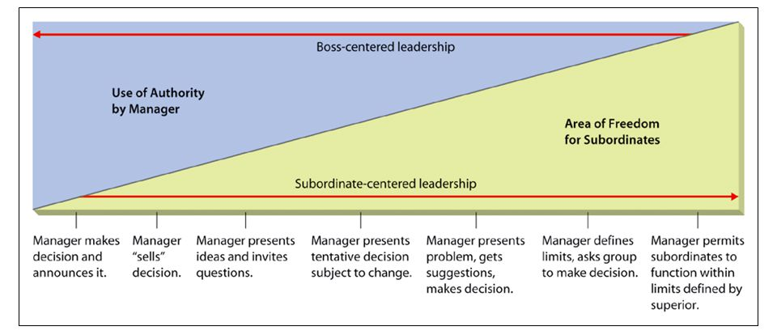
The diagram below illustrates that as leadership moves away from the autocratic extreme the amount of subordinate participation and involvement in decision taking increases.

Figure 1 – Tannenbaum and Schmidt’s Leadership Continuum (Source: Harvard Business Review 1978)
The continuum identifies the following four main leadership styles;
- Autocratic (Telling) Style: decisions made and delivered to subordinates by leaders.
- Persuasive (Selling) Style: decisions made by leader which are then disseminated to the group in a persuasive and enthusiastic way thus ensuring little resistance.
- Consultative (Consulting) Style: leader has discussions and will consider feelings and views before making decisions. Full responsibility remains with the leader.
- Democratic (Joining) Style: Leader outlines the problems/issues to the group for discussion thus allowing the decisions to evolve from within the group.

This leadership theory allows for situational flexibility which is an important consideration for any leader. However, if leaders are unable to make the appropriate situational decisions to adapt their leadership style then team outcomes may be compromised. This was evidenced in Brecon Beacons, when leaders failed to recognise the potential impact of emergency weather conditions on the recruits. They should have adopted an autocratic style of leadership to take full control of the situation to ensure the health and safety of the participants. Leaders failed to make the right decisions based on the MOD code of practice and this led to a series of neglectful actions

Leadership within the Armed services should provide opportunities for a variety of styles to be adopted along the Tannenbaum and Schmidt’s leadership continuum. Ultimately the Armed forces want their personnel to have the ability to work under a variety of circumstances and this requires different leadership approaches and the Tannenbaum and Schmidt's continuum-based theory suggests a range of styles ranging from autocratic to democratic, without signifying that any one style within the continuum is right or wrong (Anderson, 2017).

An alternative style leadership that would be suitable to the Armed Forces environments is the Action Centred Leadership Model developed by John Adair (1973). The key feature of this model is the inter relationships between three elements as outlined in the figure 2.
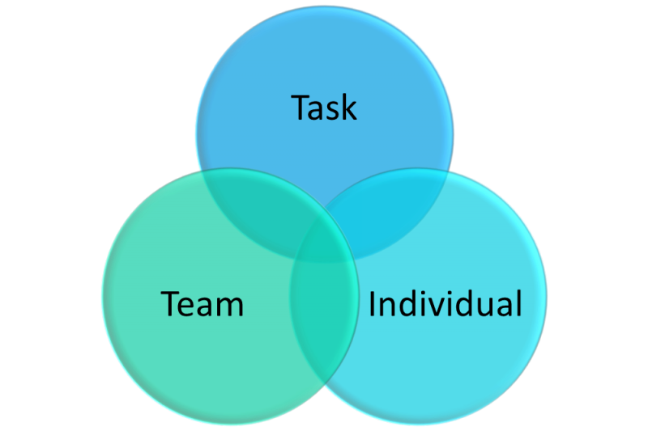

Figure 2 Action-Centred Leadership Model (Source: Adair 1973)

An explanation of the model focuses on the 3 key elements which include;
- Task – plan, structure and provide direction to get the job completed
- Team – foster cooperation, purpose and discipline within the team
- Individual – develop, praise and supporting individuals in the team

The success of this model requires the leader to carry out the functions across all three elements and adapt their responses when applied to different situations and behaviours. The challenge for a leader in the armed services is to manage all sectors within the leadership model.

In relation to the specialist forces SAS selection event in the Brecon Beacons, there needs to be a balance between the risks associated with hazardous and demanding training regime and the “must win” mind set often associated with this elite military unit. Leaders need to balance risk and safety. In conclusion, leadership styles must adhere to and implement appropriate safeguarding procedures as failure to do so would make them accountable for any failures. The outcome of the investigation into the deaths of three individuals in July 2013 resulted in MODs Service Prosecution Authority charging two soldiers who were involved in managing the event as the MOD refused to accept corporate responsibility for the deaths.

References

Adair, J. (2010) Strategic Leadership: How to Think and Plan Strategically and Provide Direction, Kogan: UK

Anderson, H. J. Baur, J. E. Griffith, J. A. Buckley, M. R. (2017) What works for you may not work for Me: Limitations of present leadership theories for the new generation, The Leadership Quarterly, Volume 28, Issue 1, Pages 245-260, Available at https://doi.org/10.1016/j.leaqua.2016.08.001
Accessed 22nd February 2018

Jackson, C. (2015) SAS deaths: The savage beauty of the Brecon Beacons, Available at http://www.bbc.co.uk/news/uk-wales-33506589 Accessed 22nd February 2018

House of Commons (2016) Defence Committee Beyond endurance? Report - Military exercises and the duty of care, House of Commons Publications: UK Available at https://publications.parliament.uk/pa/cm201617/cmselect/cmdfence/525/525.pdf Accessed 22nd February 2018

Joyce, P. (2011) Strategic Leadership in the Public Services, Routledge; UK

Lussier, L. and Achua, C (2015) Leadership: Theory, Application, & Skill Development, 6th Edition, South-Western College Publications: USA

Northhouse, P. G. (2015) Leadership: Theory and Practice, Sage Publications: UK

Rigg, C. and Richards, S. (2008) Action Learning, Leadership and Organizational Development in Public Services, Routledge: UK

Tannenbaum, R. and Schmidt, W. (1973) How to Choose a Leadership Pattern, Harvard Business Review, Available at https://hbr.org/1973/05/how-to-choose-a-leadership-pattern Accessed 22nd February 2018

Wart, M. V. (2003) Public‐Sector Leadership Theory: An Assessment, Public Administration Review, Vol 63, Issue 2 pages 214 - 228 Available at http: https://doi.org/10.1111/1540-6210.0028
Accessed 22nd February 2018

Wart, M. V. (2014) Dynamics of Leadership in Public Service: Theory and Practice, Routledge: UK

Wong, S. I. and Giessner, S. R. (2016) The Thin Line Between Empowering and Laissez-Faire Leadership: An Expectancy-Match Perspective, Research Article, Vol 22, Issue 2, pages 757 – 783 Available at https://doi.org/10.1177/0149206315574597
Accessed 22nd February 2018

Wright, B. E., Sanjay K. P. (2010) Transformational Leadership in the Public Sector: Does Structure Matter? Journal of Public Administration Research and Theory, Volume 20, Issue 1, Pages 75–89, Available at https://doi.org/10.1093/jopart/mup003
Accessed 22nd February 2018

