Module Name: Data Handling and Business Intelligence
Module Code: LCBB500
Lecturer: Amative Banik
Student: Lachezar Dimitrov
Student Number: 1915922

ASSESSMENT 2

Microsoft Excel can be a useful tool for pre-processing and exploring a hotel reservation dataset. Here's how we can evaluate its suitability for this task:
Data Cleaning:
Excel can help us quickly spot and remove duplicate records using its built-in functions.
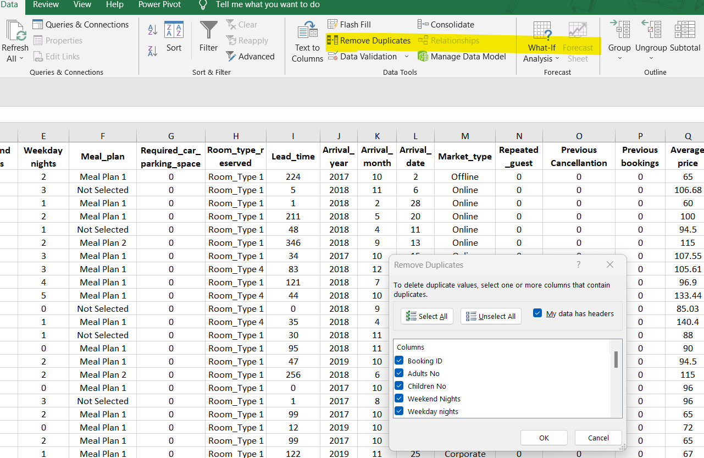
We can identify and handle missing values by sorting data and using Excel's filtering capabilities.
Check for data entry errors or inconsistencies by sorting and filtering the data to spot anomalies.

Data Transformation:
Excel allows us to convert data types easily. For example, we can convert text to numbers or dates.
We can split columns (e.g., splitting a date column into year, month, and day) using Excel's text functions.
Conditional formatting can help highlight certain values or conditions, aiding in data transformation.

Data Filtering and Sorting:
Excel excels at filtering data based on various criteria. We can filter rows based on specific conditions.
Sorting data based on columns can help us identify patterns or outliers quickly.

Data Aggregation:
Excel's functions like SUM, AVERAGE, COUNT, etc., are useful for creating summary statistics.
Pivot tables can provide more advanced aggregation options.
For determining the decline or increase in the average price (room reservation price) over the year ranging from 2017 to 2021.
Step1: Select row Arrival_year and Average Price and we will paste it into new sheet.
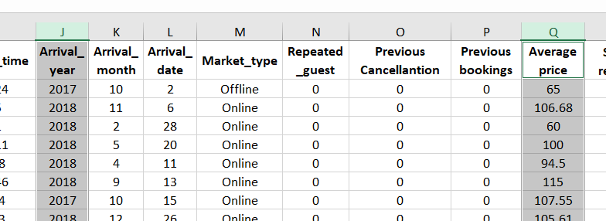
Step 2: Paste the above rows in new sheet and then we can use excel functions for further analysis.
Step 3: Sort the year and average using the filter and then segregate different year serial wise so that we can easily calculate the average.
Step4: Now we can calculate the average price of the room for different year using excel function AVERAGE in the range of cell with different years. The result we get can be maintained in tabular form as attached.
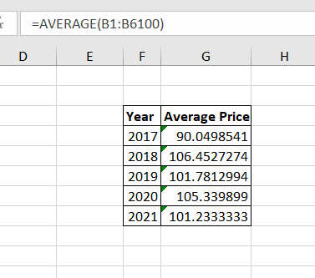
To determine the decline or increase in the average room reservation price from 2017 to 2021, we can calculate the percentage change over the five-year period using the following formula:
Percentage Change = ((New Value - Old Value) / Old Value) * 100
In this case, the old value is the average price in 2017, and the new value is the average price in 2021.
Percentage Change = ((101.2333333 - 90.0498541) / 90.0498541) * 100
Percentage Change = (11.1834792 / 90.0498541) * 100
Percentage Change ≈ 12.42%
So, the average room reservation price increased by approximately 12.42% from 2017 to 2021.

Data Visualization:
We can create basic charts and graphs in Excel to visualize data distribution or trends.
Conditional formatting can help create visual cues for certain conditions.
For the average price data, we can draw a line chart or bar chart to show the 12.42% hike in the average price of the room.

Data Validation:
Set up data validation rules to ensure that data conforms to specific criteria (e.g., age must be a positive integer).
Data Analysis:
We can perform basic statistical analysis using Excel's functions. Excel can provide quick insights through descriptive statistics.
Data Export/Import:
Import the data into Excel from various file formats. Export your pre-processed data to other tools for advanced analysis.
Microsoft Excel can be a valuable tool for basic data preprocessing and exploration tasks, especially when dealing with smaller datasets and quick ad-hoc analyses.

Performing these tasks practically using Excel functions such as: IF, LOOKUP/VLOOKUP/XLOOKUP, PIVOT TABLEs, etc.
Using AVERAGEIF function
Step1: First, create a table with two columns: one for the year (from 2017 to 2021) and another for the corresponding average price for that year.
Year Average Price
2017 [Formula]
2018 [Formula]
2019 [Formula]
2020 [Formula]
2021 [Formula]
Step 2: In the "Average Price" column (U), we will enter a formula to calculate the average price for each year. Assuming your data starts from row 2, and we have headers in row 1, enter the following formula in cell U3 for the year 2017 and drag it down for the other years:
For 2017 (cell U3):
=AVERAGEIF($J$2:$J$36276, 2017, $Q$2:$Q$36276)
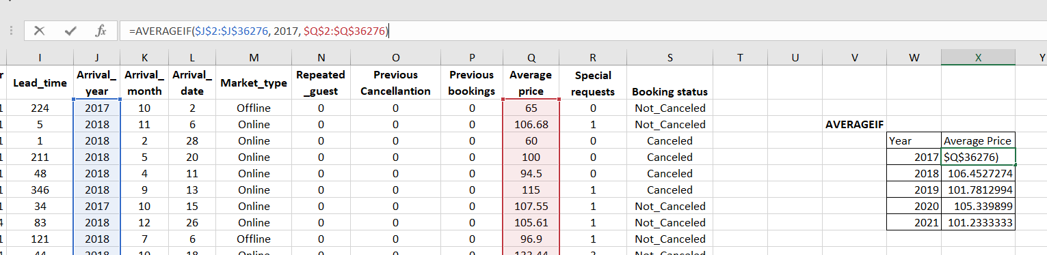
Step 3: Similarly, we will calculate for other years and that’s complete our table for the average price over the year from 2017 to 2021.
Once we have calculated the average prices for each year, we can determine the decline or increase by subtracting the average price for 2021 from the average price for 2017.
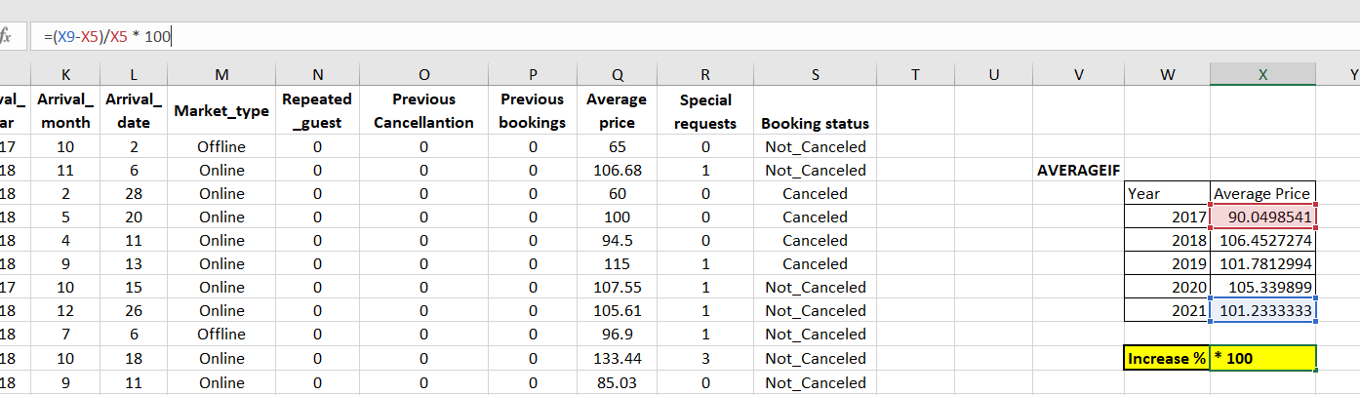
Applying the formula =(X9-X5)/X5 * 100 we get increase percentage in average price to be 12.42%.
Using PIVOT TABLE function
Step 1: Select all data, go to insert and apply PIVOT TABLE function. It will open up in the next sheet with reference selected from the data.
Step 2: Now we will select Years in the column field of the PIVOT and average price in the value field. We will make sure that the function that is selected in value field will be of average.
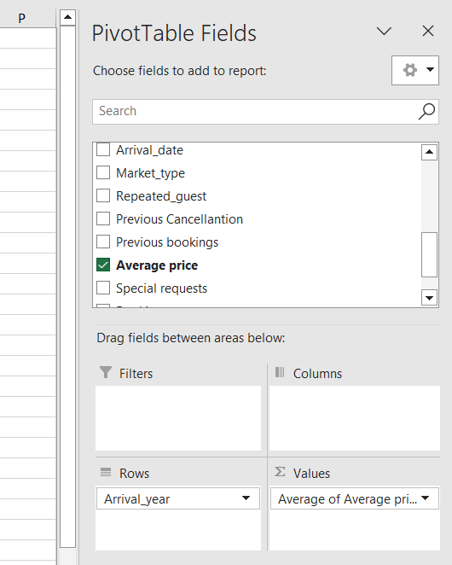
Step 3:
We will get a corresponding table from the pivot table field selection elements as shown below. We will format it to look better.
Average of Average price
Arrival_year | Total
2017 | 90.0498541
2018 | 106.4527274
2019 | 101.7812994
2020 | 105.339899
2021 | 101.2333333
2022 | 101.499242
Grand Total | 103.4235391

Step 4: We can select any empty field to calculate the increase and decrease in the average price from 2017 to 2021.
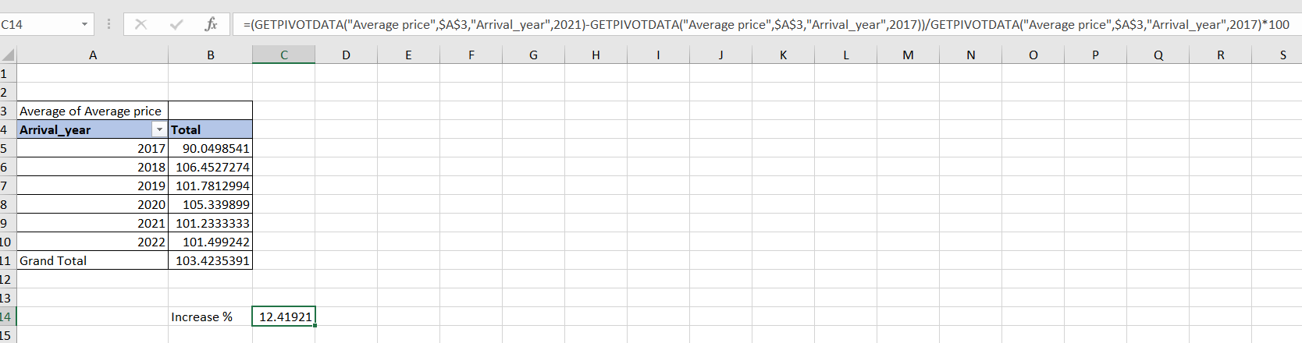
Applying the formula, we get that there is increase of 12.42% in the average hotel price during the year 2017 to 2021.

Meaningful charts/graphs/diagrams based on findings:
- Line chart

A line chart is a valuable tool for visualizing trends over time, making it ideal for analyzing the average price data from 2017 to 2021.
From 2017 to 2018, there is a noticeable increase in the average price, with the value rising from $90.05 to $106.45. This upward trend suggests a significant price increase during this period. However, from 2018 to 2019, there is a slight decrease, with the average price dropping to $101.78. The chart then shows a rebound in 2020, where the average price rises to $105.34. Finally, in 2021, the average price slightly decreases again to $101.23.
This suggests that while there were fluctuations, the overall trend appears relatively stable with no substantial upward or downward trajectory over the five-year period.

- Bar Chart

A bar chart can effectively depict the average price trends from 2017 to 2021 and help determine if prices are increasing or decreasing. Each year will be represented by a separate bar with its corresponding average price.
In the bar chart, you would observe that in 2017, the average price was $90.05, and it rose significantly in 2018 to $106.45. This initial increase is visually evident. However, in 2019, there was a slight decrease to $101.78, which is still higher than the 2017 price. In 2020, the average price increased again to $105.34, indicating an upward trend. However, in 2021, there was a minor decrease to $101.23, which is still higher than the 2017 price.
when observing the bar chart, it becomes clear that the average price generally increased from 2017 to 2021, with some fluctuations in between. Despite these fluctuations, the overall trend is upward, suggesting that the average price generally increased over the five-year period.

Part 2
Q1.
Using Excel to calculate the number of male and female in the school
We can do this using COUNTIF function as shown in the screenshot
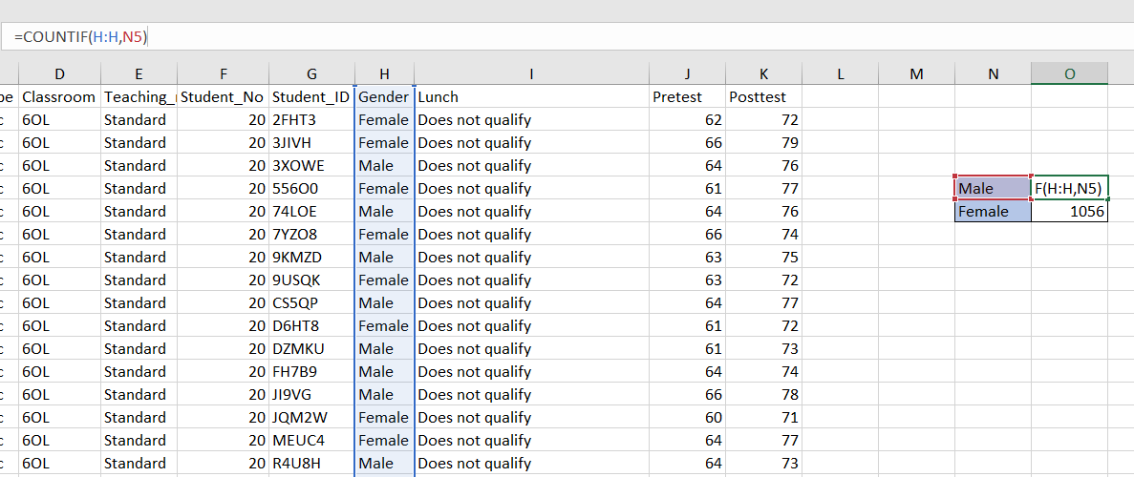
In the way shown in the figure we can count the number of Male and Female in the school.
The numbers provided indicate the count of male and female students in the school:
Male | 1077
Female | 1056

Q2.
For calculating the number of students who qualify and do not qualify for free lunch we will use the same COUNTIF function in the row with variable name Lunch.
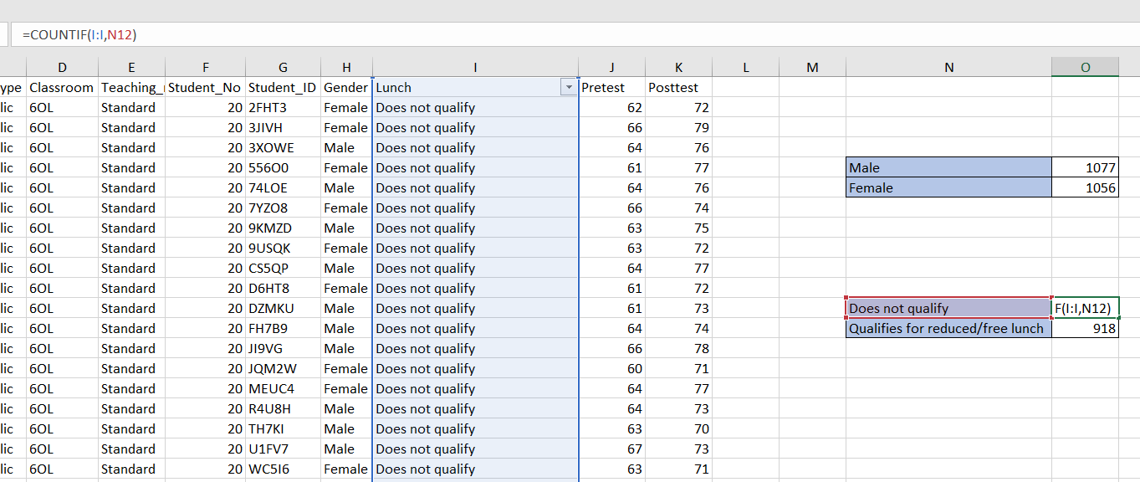

The data provided in the Excel sheet pertains to the lunch program eligibility status of the students in the school.
Does not qualify | 1215
Qualifies for reduced/free lunch | 918

Q3.
In the dataset provided, we have categorical data representing two lunch status categories: "Does not qualify" and "Qualifies for reduced/free lunch." Mean and median are statistical measures that are typically used with numerical data to describe central tendencies. They are not applicable to categorical data directly.
However, we can calculate the mode for this categorical data, which represents the most frequently occurring lunch status category. In this case, we have two categories, so we can determine which one occurs more frequently.
From the provided data, we can see that "Does not qualify" appears more frequently than "Qualifies for reduced/free lunch."
So, for this dataset: Mode: "Does not qualify"

Q4.
To calculate the mean and median difference of student Pretest and Posttest score
Step 1: Calculate the mean and median of the Pretest using the AVERAGE and MEDIAN functions of the Excel.
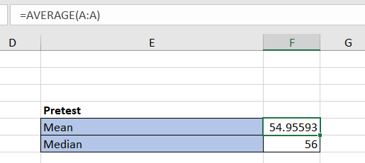
Step 2: Similarly, we can calculate the mean and median of the Posttest using the AVERAGE and MEDIAN functions of the Excel.

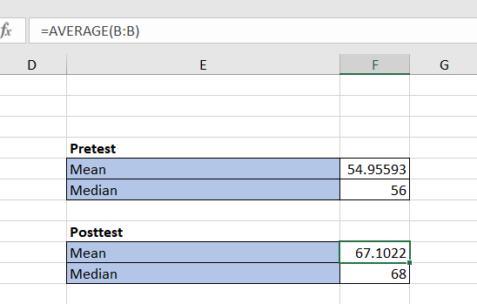
Step3: Now we will calculate the difference of mean in pretest and posttest and also the difference of median in pretest and posttest.
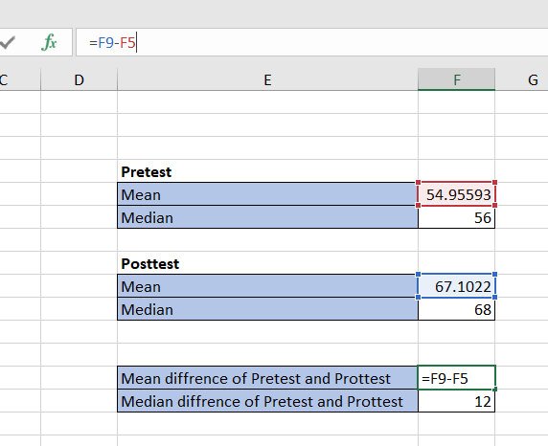
In this way we can calculate the mean and median differences of student’s pre-test and post-test scores.

Q5.
1. Import the Dataset:
- Open SPSS and create a new data file or use an existing one.
- Go to `File > Import Data > Text Data` and select the "Student_Score.csv" file.
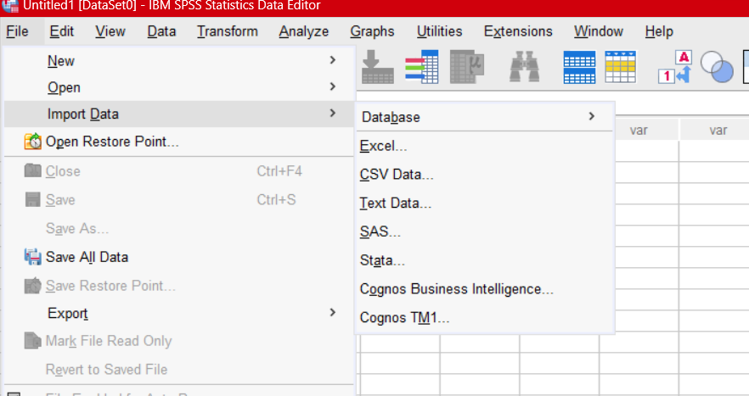

2. Data Preparation:
- Check if the data is correctly loaded and review the variable names and types. After this press OK.
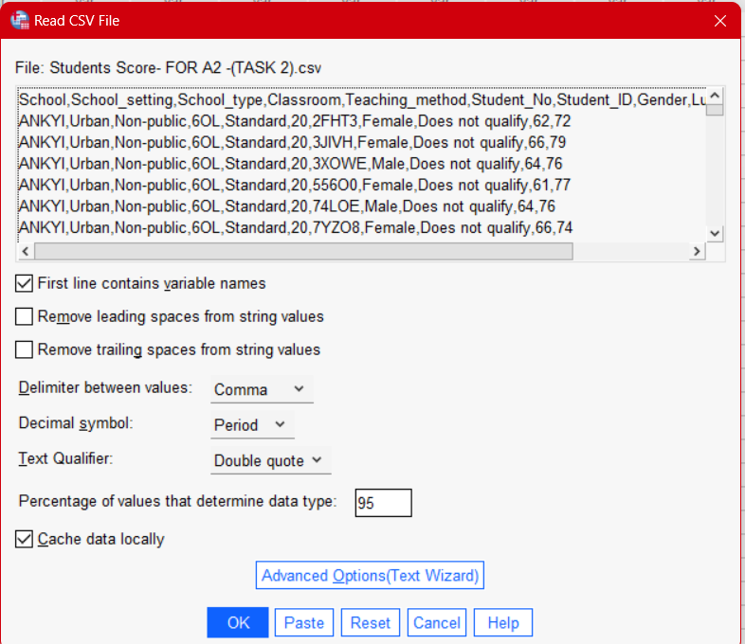

3. Select Variables:
- For clustering, we typically select numerical variables. In our case, we may want to use "Pretest" and "Posttest" as the variables for clustering.

4. Perform K-Means Clustering
- Go to `Analyze > Classify > K-Means Cluster`.
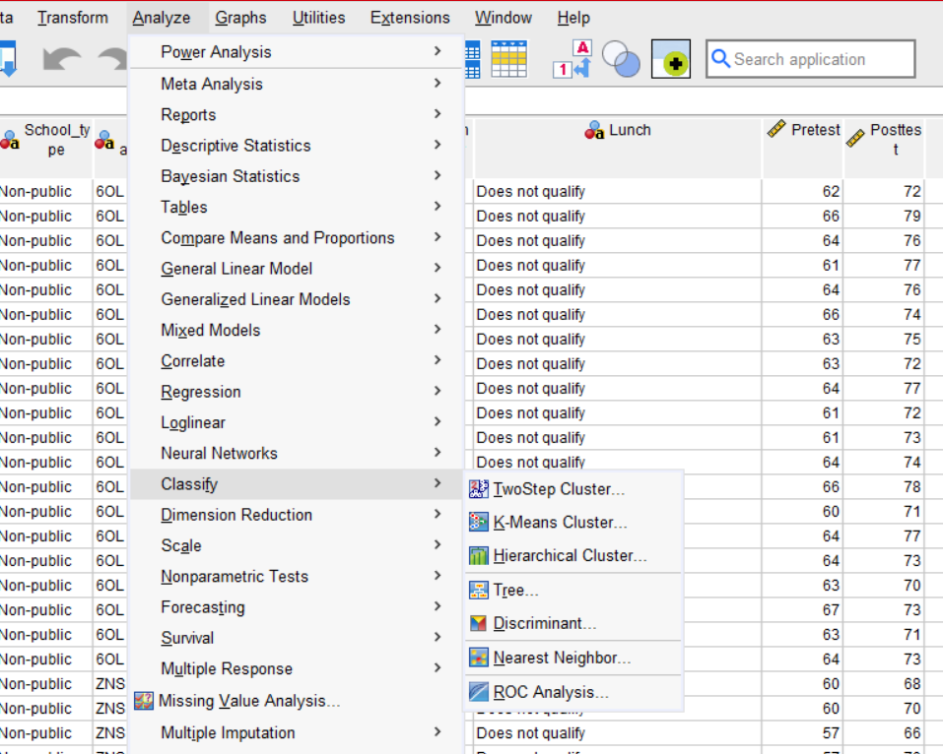
- In the K-Means Cluster dialog box, select the variables you want to use for clustering (e.g., "Pretest" and "Posttest") and move them to the Variables list.
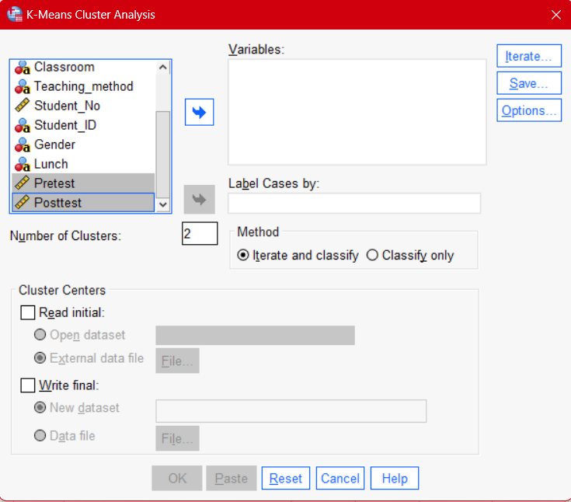
- Specify the number of clusters (K) you want to create. You may need to decide on an appropriate value for K based on your research question or use methods like the Elbow Method or Silhouette Method to determine an optimal value.
- You can also customize other settings such as initialization method and convergence criteria.
- Click "OK" to perform the K-Means Clustering analysis.
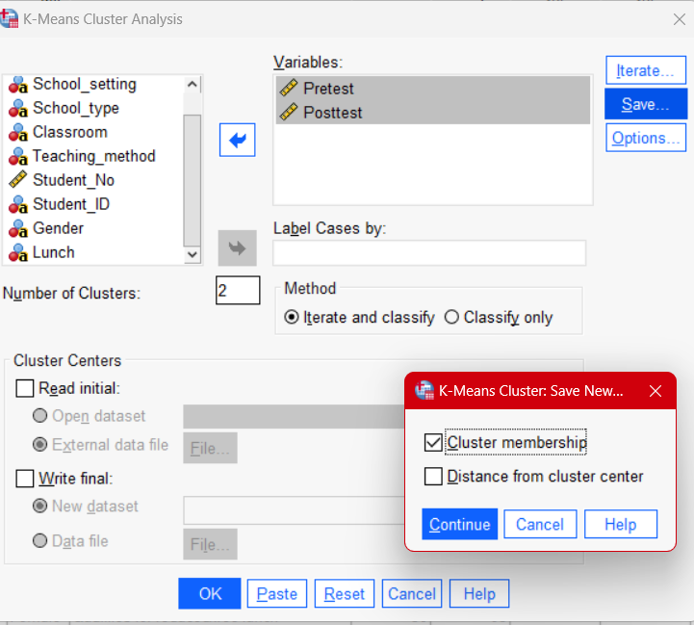
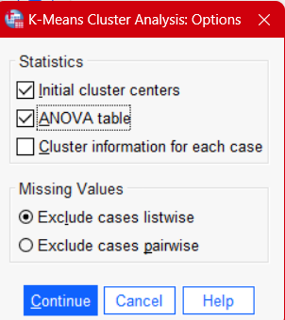

5. Review Clustering Results:
- Once the clustering analysis is complete, we can view the results.
- we can access cluster assignments and cluster centroids in the output.

6. Interpret Results:
- Interpret the results by examining the cluster centroids and characteristics of each cluster.
a.
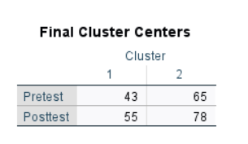
The provided cluster centers represent the means of the "Pretest" and "Posttest" scores for two clusters. Let's interpret these cluster centers:
Cluster 1:
- Pretest Mean: 43
- Posttest Mean: 55
Cluster 2:
- Pretest Mean: 65
- Posttest Mean: 78
Interpretation:
1. Differences in Pretest and Posttest Scores: The cluster centers show that there are clear differences in the mean scores between Cluster 1 and Cluster 2 for both the pretest and posttest.
2. Cluster 1:
- Students in Cluster 1 have lower mean pretest scores (43) compared to Cluster 2.
- They also have lower mean posttest scores (55) compared to Cluster 2.
- This cluster may represent students who started with lower scores and made moderate improvements.
3. Cluster 2:
- Students in Cluster 2 have higher mean pretest scores (65) compared to Cluster 1.
- They also have higher mean posttest scores (78) compared to Cluster 1.
- This cluster may represent students who started with higher scores and made significant improvements.

- Educational Insights: The clustering results suggest that there are two distinct groups of students based on their pretest and posttest performance. Cluster 2 appears to be the higher-performing group, while Cluster 1 is the lower-performing group.
b.

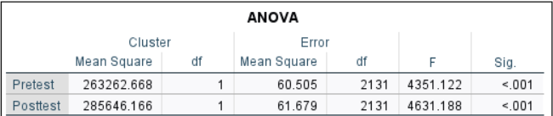
1. ANOVA Result:
- For "Pretest," the F-statistic is 60.505, and the associated p-value is less than 0.001.
- For "Posttest," the F-statistic is 61.679, and the associated p-value is less than 0.001.
2. Interpretation:
- The ANOVA tests indicate that there are statistically significant differences in the means of both "Pretest" and "Posttest" scores among the different clusters.
3. Practical Implication:
- While the ANOVA results are statistically significant, we should interpret these findings cautiously. The significant differences observed may be a result of how the clusters were created, rather than indicating a meaningful difference between the clusters in terms of the actual variables (Pretest and Posttest scores).
In summary, the ANOVA results suggest significant differences in the means of Pretest and Posttest scores among the clusters.

Q6.

Data Mining Methods:
- Association Rule Mining - Association rule mining identifies patterns or relationships between items in large datasets.
Example: In retail, analyzing transaction data to find associations between products frequently bought together. For instance, if customers often purchase bread and butter together, a store can use this information for product placement strategies (Agrawal et al., 1993).
- Clustering - Clustering groups data points into clusters or segments based on their similarity.
Example: Customer segmentation in e-commerce based on browsing and purchase history. This can help tailor marketing strategies to different customer groups (Hastie et al., 2009).
- Classification - Classification assigns data points to predefined categories or classes based on their attributes.
Example: Spam email detection, where machine learning models classify emails as either spam or not spam based on their content and characteristics (Duda et al., 2000).
- Regression Analysis - Regression analysis models the relationship between variables and predicts a continuous outcome.
Example: Predicting stock prices based on historical market data and economic indicators. Investors can use these predictions for portfolio management (Montgomery et al., 2012).
- Time Series Analysis - Time series analysis deals with data collected over time to identify patterns and make future predictions.
Example: Analyzing historical sales data to forecast future demand for products. This helps businesses optimize inventory and production planning (Hyndman et al., 2008).
Text Mining Methods:
- Sentiment Analysis - Sentiment analysis determines the emotional tone in text data, such as positive, negative, or neutral sentiments.
Example: Analyzing customer reviews on social media to gauge public sentiment towards a product or brand. This information can inform marketing strategies and product improvements (Liu, 2012).
- Topic Modeling - Topic modeling identifies hidden topics or themes within a collection of documents.
Example: Extracting topics from a large collection of news articles. Media companies can use this to organize content, recommend related articles, or track trending topics (Blei et al., 2003).
- Named Entity Recognition (NER) - NER identifies and extracts specific entities such as names, locations, and dates from text.
Example: In healthcare, identifying and extracting information about diseases, medications, and patient names from medical records. This can improve patient care and automate administrative tasks (Rink et al., 2010).
- Text Classification - Text classification assigns predefined categories to text documents based on their content.
Example: Categorizing customer support tickets into different problem categories automatically. This helps streamline ticket routing and improve response times (Sebastiani, 2002)
- Text Summarization - Text summarization condenses long documents into shorter versions while retaining key information.
Example: Automatically generating executive summaries of lengthy legal documents. Law firms can use this to quickly extract key information from contracts and legal briefs (Das et al., 2007).

Q7.
Aspect | Excel | SPSS
Data Import and Cleaning | Advantage: Excel is user-friendly and widely accessible. It allows for quick data entry and simple data manipulation. However, for complex data cleaning and transformations, Excel may be limited. | Advantage: SPSS offers powerful tools for importing, cleaning, and transforming data, making it suitable for handling large datasets with complex structures. Intuitive data handling with various data types and missing value handling capabilities.
Example | Organizing and calculating monthly sales data for a small business with straightforward data formatting needs. | Importing and analyzing survey data with hundreds of responses and various question types, including multiple-choice and open-ended questions.
Data Analysis | Advantage: Excel is suitable for basic data analysis, such as calculating averages, percentages, and creating simple charts. It is readily available and requires no additional software installation for basic tasks. | Advantage: SPSS is designed for advanced statistical analysis, offering a wide range of statistical tests (e.g., regression, ANOVA, factor analysis) and data visualization tools (e.g., charts, graphs). It provides extensive output and interpretation options.
Example | Calculating the mean, median, and mode of exam scores in a classroom and creating a bar chart to visualize the results. | Conducting a complex multivariate analysis to determine the factors influencing customer satisfaction in a retail business.
Automation and Scripts | Disadvantage: Excel's automation capabilities are limited compared to SPSS. Complex analysis workflows often require manual operations. | Advantage: SPSS allows for automation through syntax scripting, making it efficient for repetitive tasks and ensuring reproducibility.
Example | Manually copying and pasting data for each monthly report in a small business's financial tracking | Automating the process of cleaning and analyzing monthly financial data for a large corporation with consistent data structures.
Collaboration | Advantage: Excel files are universally compatible and can be easily shared via email or cloud services, allowing for collaboration with a wider audience. | Advantage: SPSS files can be shared with others who have SPSS software, ensuring compatibility and consistent results.
Example | Sharing a budget spreadsheet with multiple team members who may have different spreadsheet software preferences. | Collaborating on a research project with colleagues who all have SPSS licenses, ensuring everyone can work with the same data and analysis tools.
Cost | Advantage: Excel is often bundled with Microsoft Office, making it a cost-effective option for basic data analysis needs. | Disadvantage: SPSS can be costly, especially for individual users or small organizations. Licenses and maintenance fees can add up.
Example | A business with a Microsoft Office subscription can use Excel without additional software costs. | A small non-profit organization with a limited budget may find it challenging to afford SPSS licenses for their data analysis needs.

References:

Agrawal, R., Imieliński, T., & Swami, A. (1993). Mining association rules between sets of items in large databases. ACM SIGMOD Record, 22(2), 207-216.
Hastie, T., Tibshirani, R., & Friedman, J. (2009). The Elements of Statistical Learning. Springer.
Duda, R. O., Hart, P. E., & Stork, D. G. (2000). Pattern Classification. Wiley.
Montgomery, D. C., Jennings, C. L., & Kulahci, M. (2012). Introduction to Time Series Analysis and Forecasting. Wiley.
Hyndman, R. J., & Athanasopoulos, G. (2008). Forecasting: Principles and Practice. OTexts.
Liu, B. (2012). Sentiment Analysis and Opinion Mining. Morgan & Claypool Publishers.
Blei, D. M., Ng, A. Y., & Jordan, M. I. (2003). Latent Dirichlet Allocation. Journal of Machine Learning Research, 3, 993-1022.
Rink, B., Harabagiu, S. M., & Roberts, K. (2010). Automatic recognition of medication names in FDA labels. Proceedings of the NAACL HLT 2010 Second Louhi Workshop on Text and Data Mining of Health Documents, 21-28.
Sebastiani, F. (2002). Machine learning in automated text categorization. ACM Computing Surveys, 34(1), 1-47.
Das, D., Martins, A. F. T., & Smith, N. A. (2007). A survey on automatic text summarization. Literature Survey for Language and Statistics II.

